Appendix 1. Summary of the AI-VIA model and application workflow

A. Model development overview
The AI-VIA model uses a convolutional neural network (CNN) architecture adapted through transfer learning, based on EfficientNet-B0, and optimized for binary classification of VIA-positive versus VIA-negative images. This baseline version was developed prior to field deployment to establish feasibility and calibrate the core architecture and augmentation pipeline used in later model versions.

Training dataset
The training dataset consisted of several thousand annotated VIA images from the International Agency for Research on Cancer (IARC) Cervical Cancer Image Bank. For this model, the dataset contained 186 labeled cases (94 VIA-positive, 92 VIA-negative), corresponding to 363 images (185 positive, 178 negative). The dataset was subsequently balanced to 500 samples per class through duplication and augmentation. Ground truth labels were derived directly from the IARC Cervical Cancer Image Bank annotations. Histopathology results were available for a subset of cases and were used as reference where provided in the dataset. For the remaining cases, labels reflected the original expert clinical interpretation embedded in the source dataset. All images underwent standardized quality checks, including:
- removal of duplicates or low-quality files
- resizing and normalization
- light augmentation (rotation, cropping, and color adjustments) to improve model robustness

Classes were balanced to ensure even representation of VIA-positive and VIA-negative cases.

Training approach and evaluation
Model development followed a standard transfer-learning workflow in which early layers were retained for general image features, while later layers were fine-tuned to identify VIA-specific patterns. Performance was assessed using accuracy, precision, recall, F1-score, and confusion matrices, with cross-validation used to monitor stability and reduce overfitting. The final classification report on the held-out test set (n=200) showed an overall accuracy of 97%, with precision of 96% for VIA-negative and 99% for VIA-positive cases, recall of 99% for VIA-negative and 96% for VIA-positive cases, and F1-scores of 97% (negative) and 98% (positive).

B. Application workflow and interface
The AI-VIA mobile application was designed to align with routine VIA screening steps and support healthcare providers during image capture and documentation. The screenshots below illustrate the user workflow.

1. Welcome and login

The application opens with a secure login for authorized healthcare providers. The landing page summarizes core functions including patient registration, guided image capture, and automated feedback.

2. Patient registration

The registration module collects structured patient information across four steps:
- Basic sociodemographic data
- Medical conditions
- Reproductive history
- Lifestyle
Patient IDs are automatically generated to maintain consistency and facilitate record management.

3. Guided image capture

The image-capture interface provides step-by-step guidance, prompting the provider to take clear images before and after applying 3–5% acetic acid. On-screen cues emphasize image clarity, lighting, and focus.

4. Automated analysis and feedback

Once images are captured, the app generates an automated VIA-positive or VIA-negative classification. Results are displayed alongside the captured images, allowing providers to review findings before saving them to the secure database.

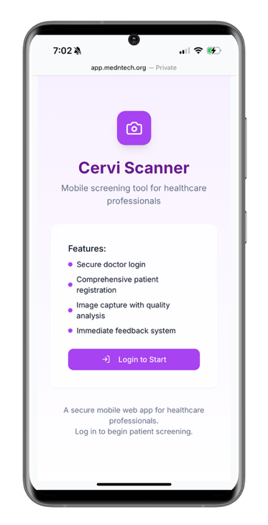
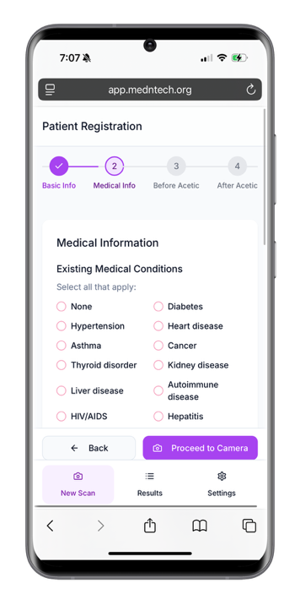
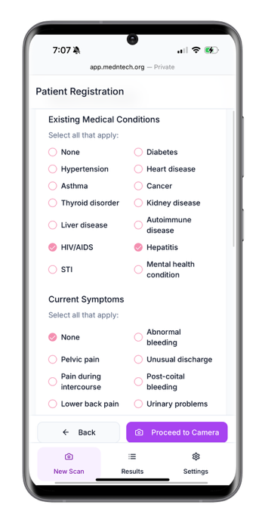

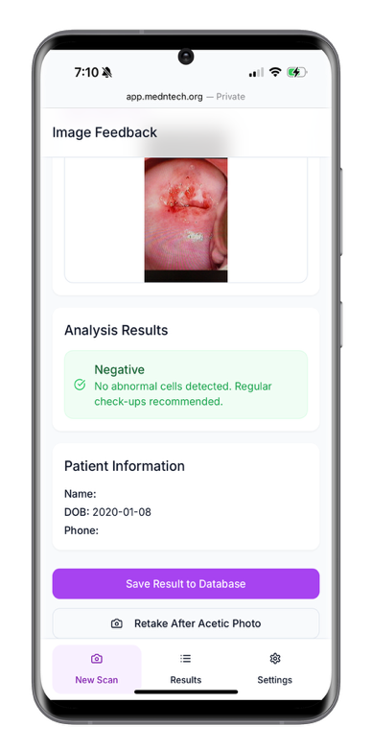
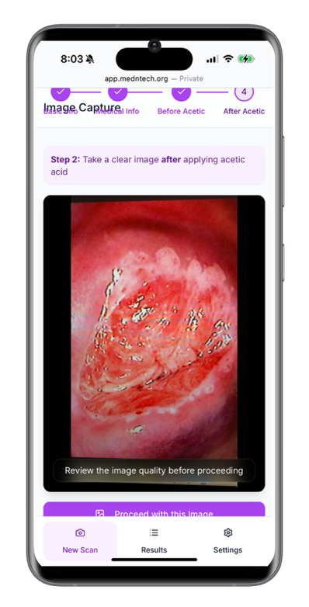
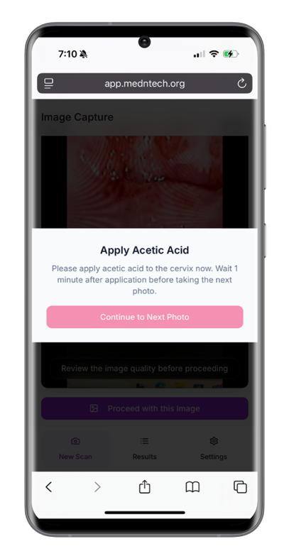

Appendix 2. Procedure at enrollment

Before the cervical screening begins, HPs will use the AI tool's mobile application to collect sociodemographic information from each patient. Informed consent will be obtained after explaining the procedure to the patient.

Step 1: Capturing pre-VIA images

To take the pre-VIA image, HPs will follow these steps:

- Position the patient comfortably on the examination table.
- Insert the vaginal speculum to ensure full visualization of the cervix.
- Clean the cervix of any discharge or mucus to avoid distortion of the image.
- Use the AI-powered tool’s camera to focus on the cervix, maintaining a distance of 4-5 inches for clarity.
- Adjust the flash settings as necessary to ensure optimal visibility.
- Capture the image by pressing the capture button on the device.
- Review the image for clarity. If satisfactory, click “OK.” If not, retake the image.

Step 2 : Capturing post-VIA images

For the post-VIA image, the following procedure will be followed:

- Apply 3-5% acetic acid to the cervix.
- Wait 1-2 minutes for any acetowhite changes to develop.
- Focus the AI tool’s camera on the cervix from the same 4-5 inch distance.
- Adjust the flash as needed to enhance visibility.
- Capture the post-VIA image by pressing the capture button.
- Review the captured image, and if satisfactory, confirm it. Retake if necessary.

Step 3: AI Tool diagnosis

Once both pre- and post-VIA images are taken, the AI tool will analyze the images and provide a screening classification:

- Negative: No abnormalities detected.
- Positive: Abnormalities or acetowhite changes indicating further investigation is required.

Appendix 3. Complete CFIR Mapping for AI-VIA Implementation

Domain | CFIR Construct | CFIR Definition | Study-Specific Definition | Emerged Themes | Facilitator | Barrier | Supporting Verbatim
Innovation | Relative Advantage | The innovation is better than other available innovations or current practice. | Perceptions of how AI-VIA compares to standard VIA screening practices | feature of capturing and storing images | ✓ |  | ""They showed me how they used that vinegar-- because I asked them, and then they showed me before applying it and after applying it, in the photos. I was also able to ask if it had any side effects at that time." - Patient representative
Innovation | Complexity | The innovation is complicated, which may be reflected by challenges in defining and measuring its performance. | AI-VIA is complicated as a black-box system with variable and difficult to predict performance | Algorithmic differentiation gaps |  | ✓ | "We could have an abnormal cervix... not a lesion, not acetowhite, but for AI it could not very well differentiate it." - Nurse and clinical coordinator
Outer Setting | Partnerships & Connections | The Inner Setting is networked with external entities, including referral networks, academic affiliations, and professional organization networks. | Existing community-level networks and structures that can support AI-VIA implementation and patient recruitment | Community uptake mechanisms | ✓ |  | "The healthcare system in Rwanda would serve well in terms of recruitment, given the grassroot coverage in terms of community outreach. Because the community workers, the messaging that comes through the local administration, all those things I think would be very helpful." - Pathologist and researcher
Outer Setting | Local Conditions | Economic, environmental, political, and/or technological conditions enable the Outer Setting to support implementation and/or delivery of the innovation | Political, technological, and healthcare system conditions that affect AI-VIA implementation and screening access | Episodic service delivery cycles  System overload and patient burden |  | ✓  ✓ | "Now we have the campaign, and afterwards if it stops... when the activity comes again, it is as if we are starting over again." - Head of a community health centre.  "If you tell people come and be screened and then when they come there and (the nurse) is busy... next time they won't come again." - Pathologist and researcher
Outer Setting | Policies & Laws | Legislation, regulations, professional group guidelines and recommendations, or accreditation standards support implementation and/or delivery of the innovation | Policy, regulatory requirements and guidelines that support or constrain AI-VIA adoption and integration | Clinical trial requirement and biopsy endpoint |  | ✓ | "We need to go further and do a clinical trial, even if it's a non inferiority clinical trial, to show that when you use this tool it provides similar impressions as VIA or even more at least, not inferior." - Pathologist and researcher
Inner setting | Structural Characteristics: Work Infrastructure | Organization of tasks and responsibilities within and between individuals and teams, and general staffing levels, support functional performance of the Inner Setting | Workforce organization and capacity for implementing and delivering AI-VIA | Workforce continuity and mentorship gaps  Specialized staffing needs for counseling |  | ✓  ✓ | " Another thing is mentorship, so that there is someone to follow up on the activities, so that we don't just have it and then abandon it. Because I think that is the problem we have." - Head of a community health centre.  "It requires many experts to provide very in-depth counselling." - Frontline Nurse working at Kicukiro Health Centre
Inner setting | Culture: Recipient-Centeredness | There are shared values, beliefs, and norms around caring, supporting, and addressing the needs and welfare of recipients | Organizational commitment to patient-centered care beyond clinical outcomes | Prioritizing patient experience beyond clinical accuracy | ✓ |  | "That's why I want us to also focus on other things, not just accuracy, but for example, a patient experience issue was very important, patient being able to see their cervix." - Medical doctor and informatics specialist
Inner setting | Compatibility | The innovation fits with workflows, systems, and processes | Perceived ease of integrating AI-VIA into existing VIA screening workflows without major disruption | Contribution to screen-and-treat approach | ✓ |  | " Another advantage is that this system will reduce the rate of women being lost to follow up after being found with precancerous lesions. but after receiving the HPV result, you may fail to find the woman at her address. However, with this system, the woman is already there; you can counsel her, treat her at the same time. You do the screening and the management at once." - Frontline Nurse, Kicukiro
Inner setting | Available Resources : Materials and Equipment | Supplies are available to implement and deliver the innovation | Material supplies needed for AI-VIA use | Equipment and physical space requirements |  | ✓ | "Another logistics, like having the phone and internet that will help us take the photos. And if it's possible, if there will be a proper location, well set up, that will help us." - Frontline Nurse working at Kicukiro Health Centre
Inner setting | Access to Knowledge and Information | Guidance and/or training is accessible to implement and deliver the innovation | Availability of training and ongoing support for AI-VIA implementation and delivery | Training in using the app | ✓ |  | "The factors that will help us, there is training in the use of this technique." - Frontline Nurse working at Kicukiro Health Centre.
Individuals - Characteristics | Capability | The individual(s) has interpersonal competence, knowledge, and skills to fulfill role | Healthcare providers' confidence and self-efficacy in using the app | Ability to use the app | ✓ |  | “It is easy to use; it’s not difficult. Any provider can be able to take the photos.” - Frontline Nurse working at Kicukiro Health Centre
Process | Planning | Identify roles and responsibilities, outline specific steps and milestones, and define goals and measures for implementation success in advance. | Development of a structured implementation roadmap that defines sequential milestones from evidence generation to policy adoption, and outlines pathways for regulatory and guideline integration | Undefined accuracy benchmarks  Unclear point-of-care workflows |  | ✓  ✓ | "There's definitely need to make sure that the algorithm is accurate. The problem is the definition of accuracy. There's no agreed upon cut off of what accuracy is... If you say you're doing a non inferiority study, what are you comparing with?" - Medical doctor and informatics specialist  "Because if, for example, a nurse is also observing an image and then I don't know what follows? What's the next step? Then we need clearly to define at what level the app can go." - Public Health Researcher
Process | Tailoring Strategies | Choose and operationalize implementation strategies to address barriers, leverage facilitators, and fit context. | Implementation strategies tailored to fit local context for AI-VIA broader deployment | Community-based engagement strategies  Building on existing VIA skills | ✓  ✓ |  | "That process should be like to the grassroots... every month 'Umuganda'. We should be saying in every community village meetings that we have screening... that message should be continuous." - Pathologist and researcher  In fact, we already have our Healthcare providers trained in use of VIA. I think it will be easy if you use AI to people who are already having some basic skills instead of starting from scratch." - Implementation specialist at RBC
Process | Engaging: Innovation Recipients | Attract and encourage recipients to serve on the implementation team and/or to participate in the innovation. | Approaches to attract and engage women in participating in AI-VIA | Intensive counseling approach  Peer influence from positive experiences | ✓  ✓ |  | "The method we used to recruit many women... first, it was in-depth counselling to explain the procedure of the examination, to explain the benefits, to give the women the necessary information about what will happen in this examination." - Frontline Nurse working at Kicukiro Health Centre  "I found this AI to be very good... Seeing how I had a good experience with it, I would encourage all my peers, whether I know them or not, because I think it would be a good opportunity for them." - Patient representative

