Supplementary Information

Separation of butane isomers using a novel ZIF-8 slurry with extremely high efficiency: from laboratory study to industrial pilot test
Mingke Yang¹, Huishan Wang¹, Julian Y. Zuo², Yu Han¹, Liya Chai¹, Kun Li¹, Wan Chen¹, Xiaowan Peng¹, Baocan Dong¹, Chun Deng¹, Changyu Sun¹*, Bei Liu¹, Guangjin Chen¹*.
¹State Key Laboratory of Heavy Oil Processing, China University of Petroleum, Beijing 102249, China
²FMG Inc., Edmonton, Alberta T6N 1M9, Canada

Supplementary Figures

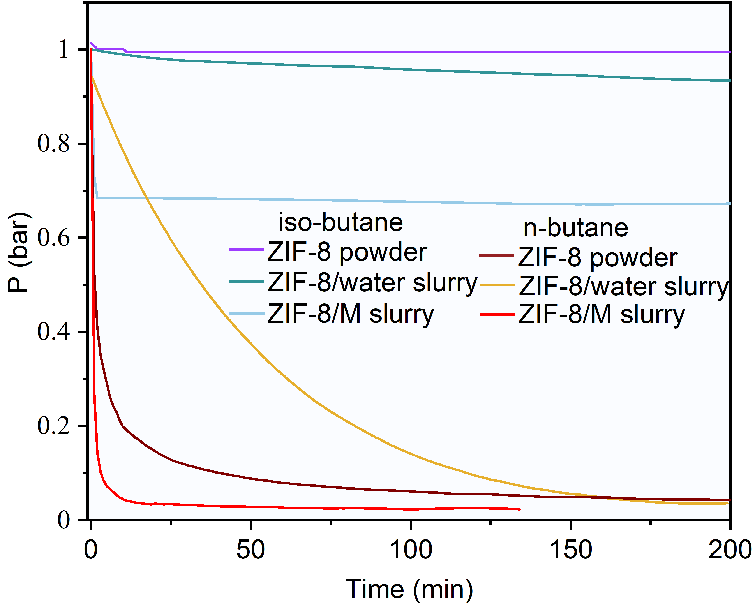
Supplementary Figure 1. The pressure variation of iso-butane and n-butane with the elapsed time on ZIF-8 powder, ZIF-8 (35wt%)/M slurry and ZIF-8 (25wt%)/water slurry, where temperature, initial pressure, initial gas-slurry volume ratio, initial gas-solid volume ratio were set to 293.15 K, ~1 bar, ~6.8, ~26.7, respectively.

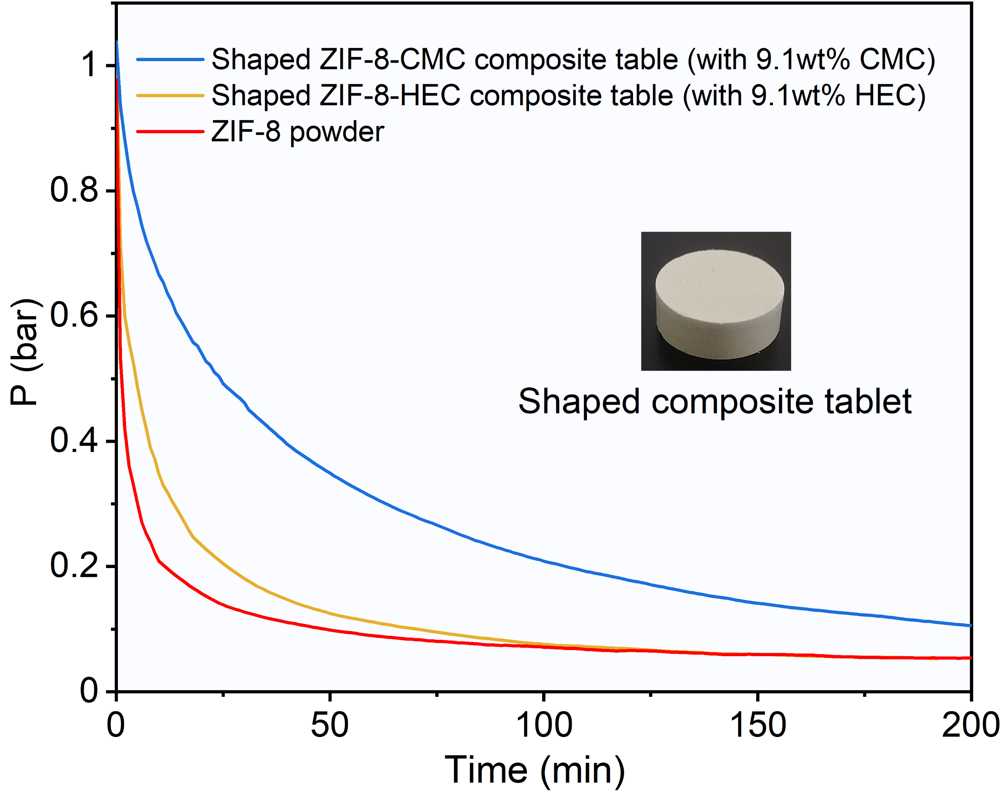
Supplementary Figure 2. The pressure variation of n-butane with the elapsed time on ZIF-8 powder and shaped ZIF-8 composite tablets at 293.15 K and an initial pressure of about 1 bar, where the mass of ZIF-8 in composite tablets is consistent with that of pure ZIF-8 powder. Carboxymethyl Cellulose Sodium (CMC) and Hydroxyethyl Cellulose (HEC) are two common adhesives.
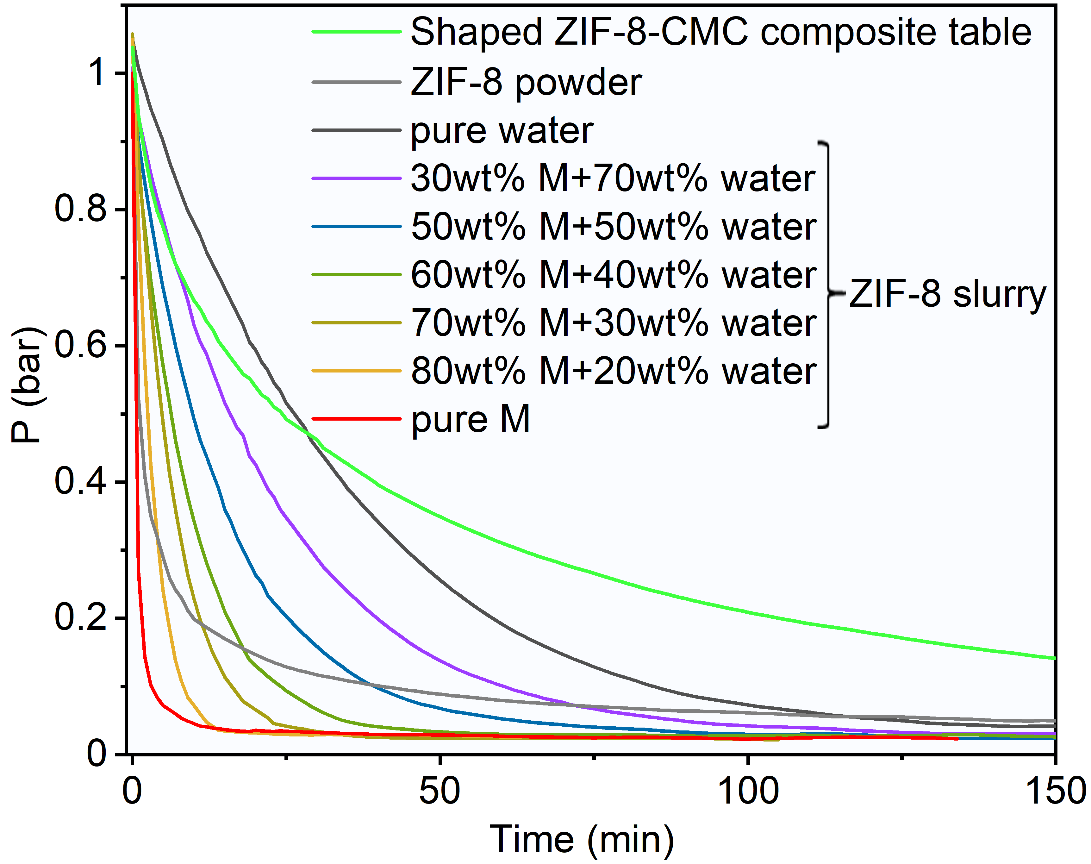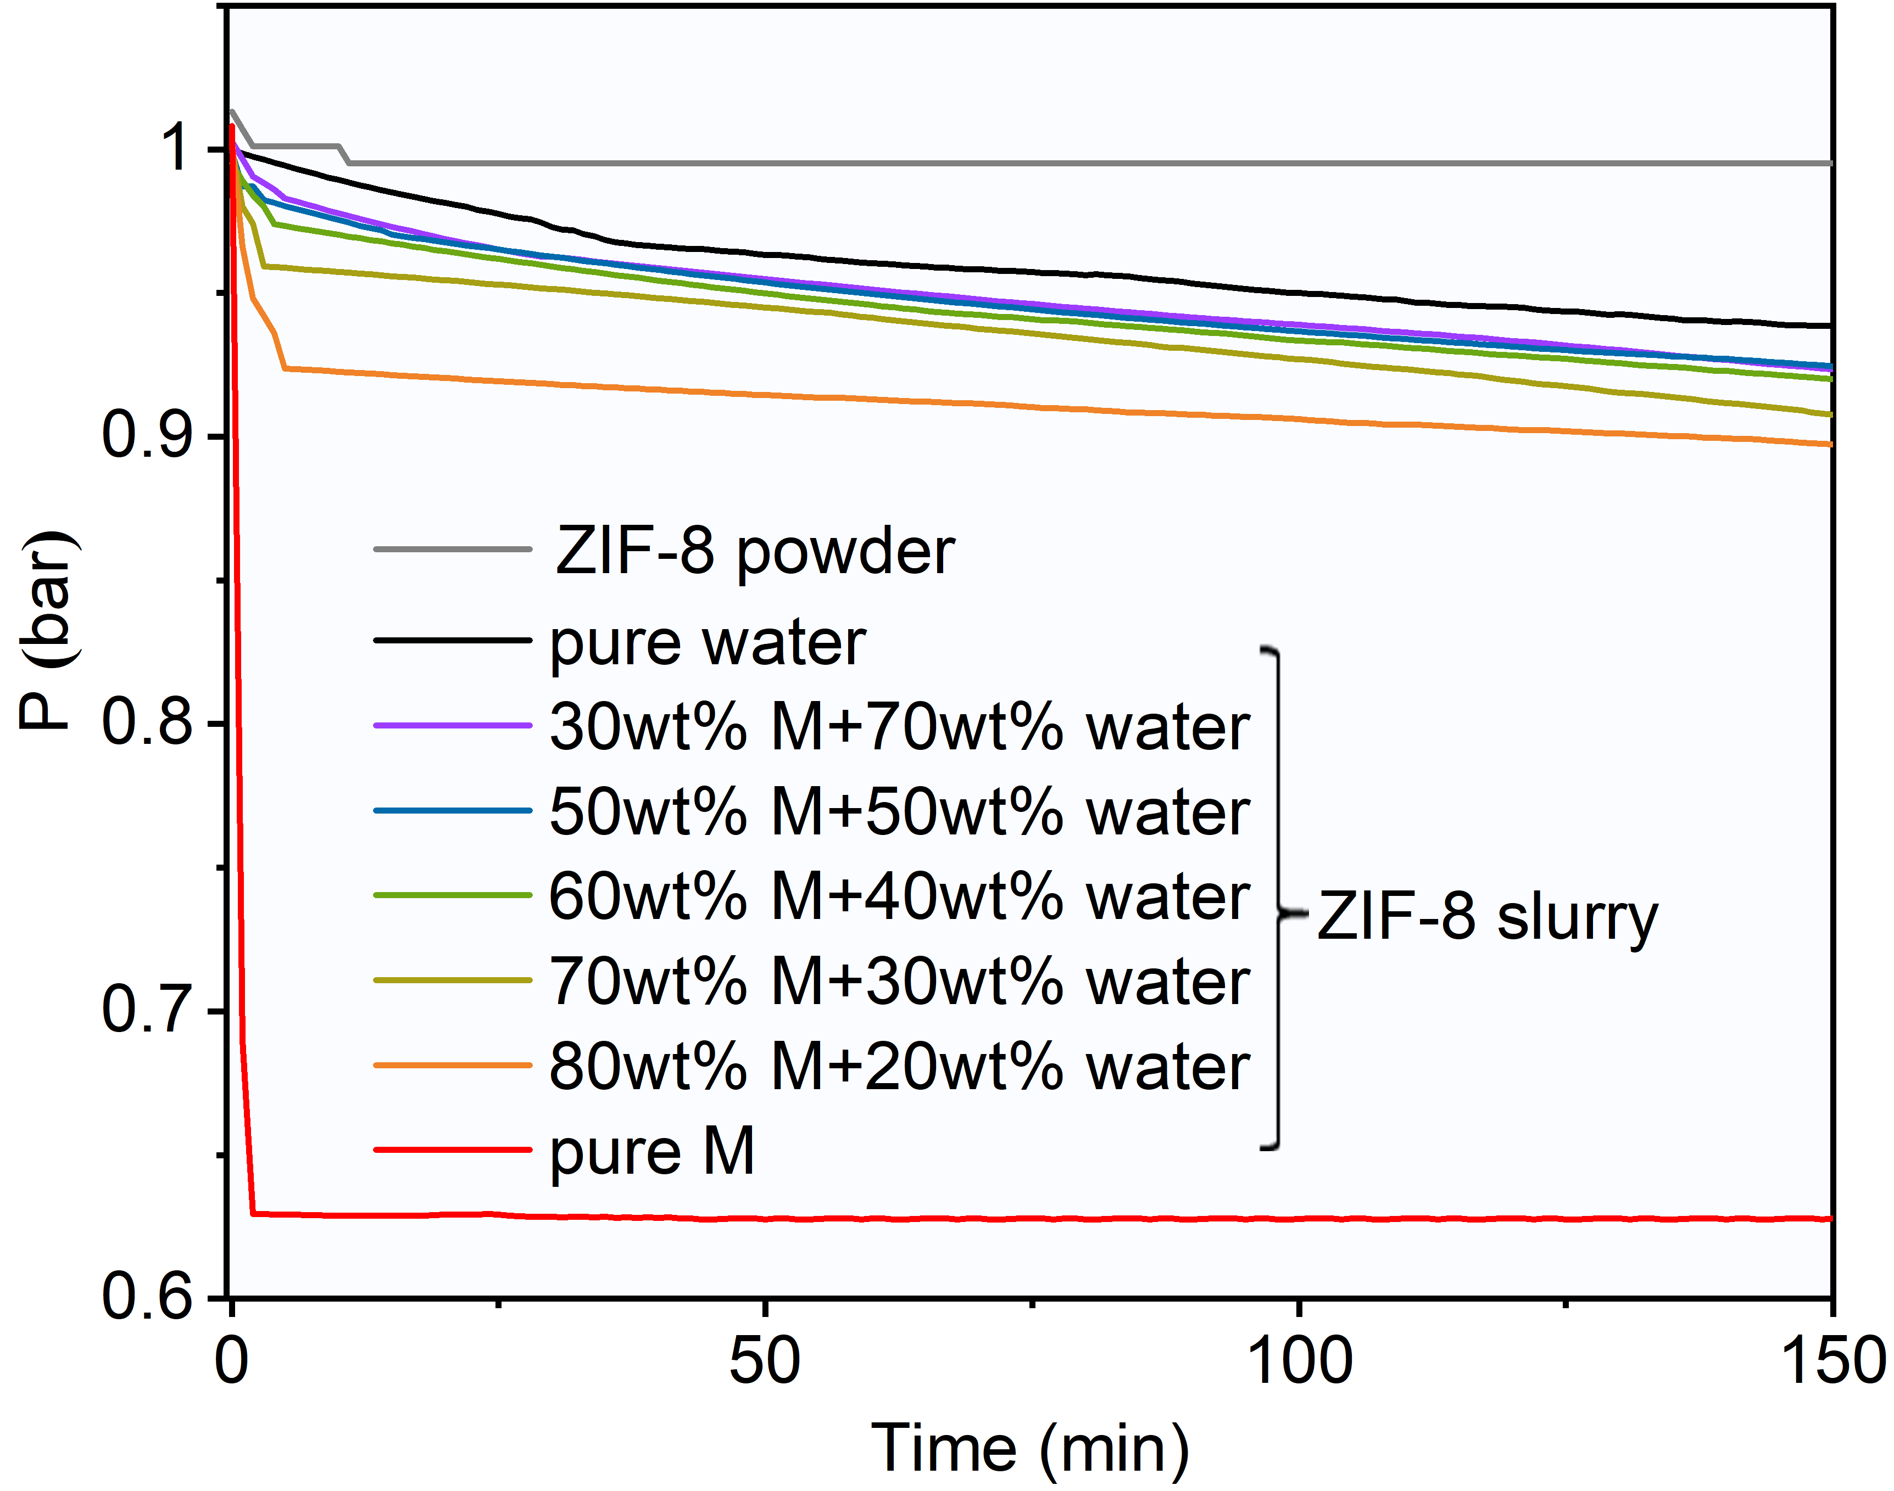
(a) (b)
Supplementary Figure 3. The pressure variation of n-butane(a) and iso-butane(b) with the elapsed time on ZIF-8 powder, shaped ZIF-8 table and ZIF-8 slurries with different liquid phase composition, where temperature, initial pressure, initial gas-slurry volume ratio, initial gas-solid volume ratio and solid ZIF-8 content in the slurries were set to 293.15 K, ~1 bar, ~6.8, ~26.7 and 30 wt%, respectively.

(a) (b)
Supplementary Figure 4. Absorption isotherms of n-butane (a) and iso-butane (b) in the M-water mixed solvents with different water content at 293.15 K.

Supplementary Figure 5. X-ray diffraction of fresh ZIF-8 and ZIF-8 recovered from ZIF-8(30wt%) slurry with solvent composition of 70 wt% M + 30 wt% water after 23 cycle sorption-desorption experiments.

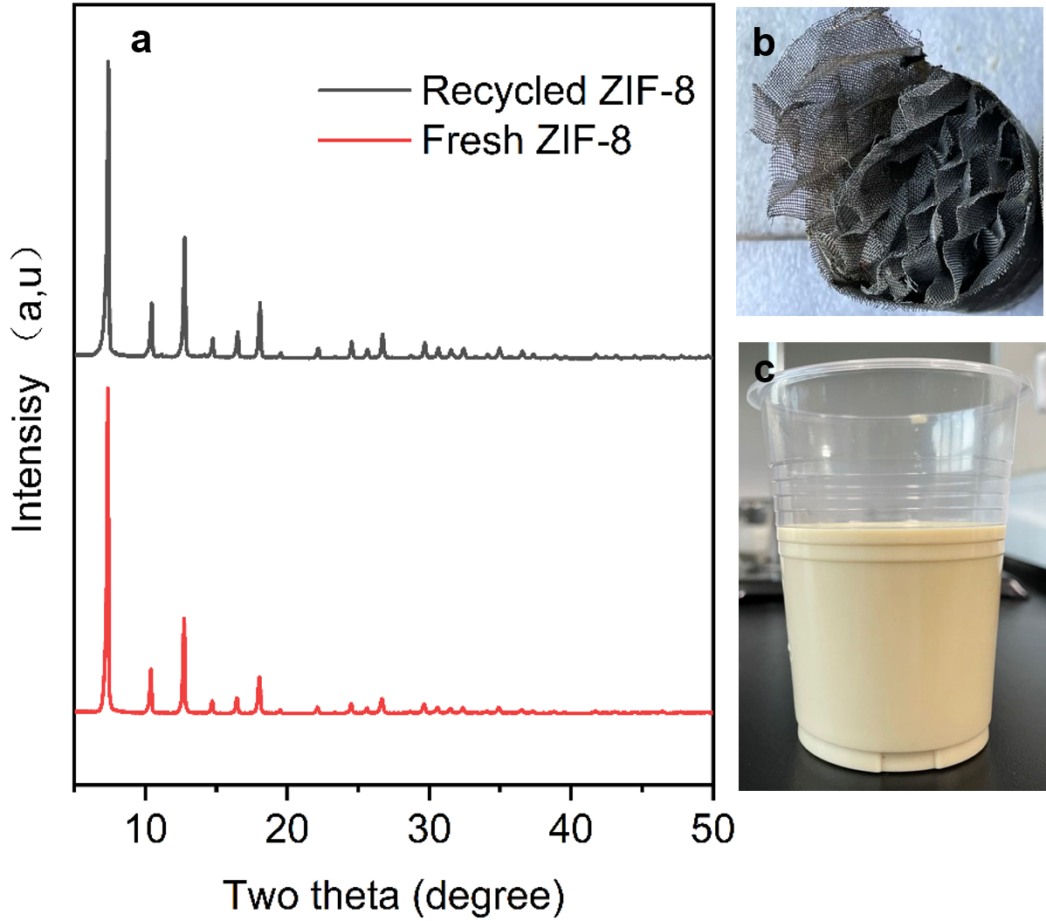
Supplementary Figure 6. (a) X-ray diffraction of fresh ZIF-8 and ZIF-8 recovered from the slurry after being used for 7 months in the pilot plant. Photographs of (b) CY700 structured packing in sorption column after water washing and (c) sampled ZIF-8 slurry with stable state after 7 months of use in the pilot plant
- (b)
Supplementary Figure 7. (a)The pressure variation of n-butane with the elapsed time in fresh and regenerated ZIF-8(30wt%)/M-water slurry at an initial pressure of about 1 bar and 293.15 K, (b) ZIF-8 particle size distribution curves in different slurries. The particle size of fresh ZIF-8/M-water slurry, fresh ZIF-8/water slurry and ZIF-8/water slurry used 4 times exceed the upper limit of the instrument range (6000 nm). The ZIF-8 content in different slurries is 8 wt%.

Fresh ZIF-8 powder
Recovered ZIF-8 powder
Supplementary Figure 8. Comparison of the SEM images of ZIF-8 powder between fresh and recovered from ZIF-8(30wt%)/M-water slurry after being used for 4 times.

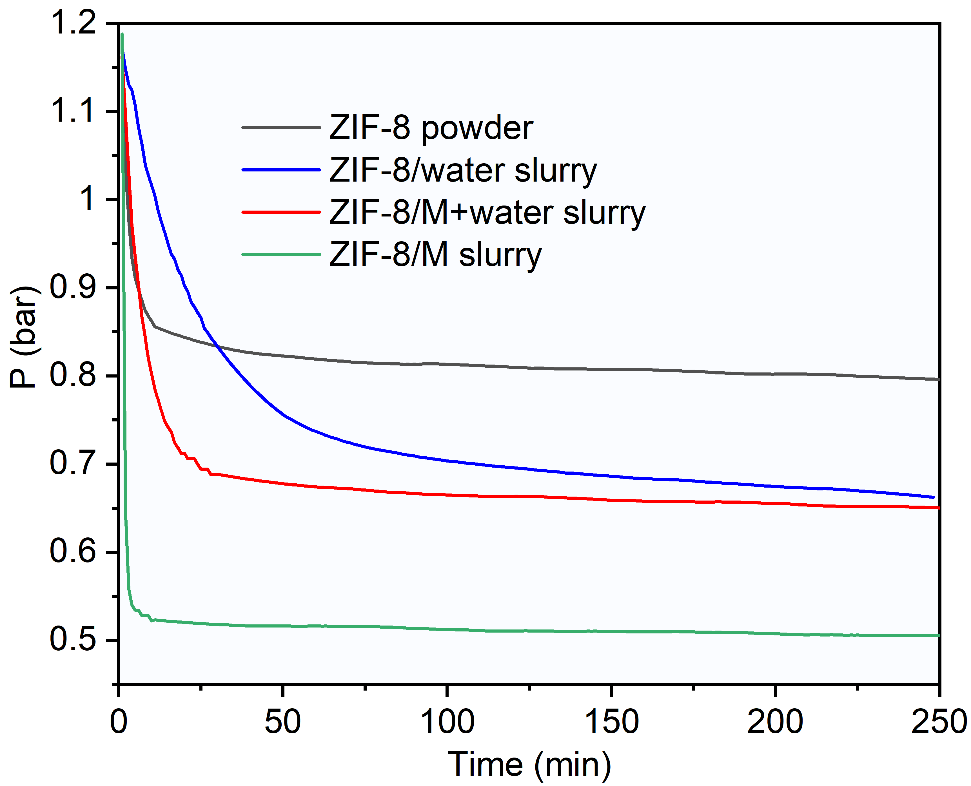
Supplementary Figure 9. The pressure variation of n-butane(1)/iso-butane(2) gas mixture (z₂ ₌ 61.8 mol%) with the elapsed time on ZIF-8 powder, ZIF-8(25wt%)/water slurry, ZIF-8(30wt%)/M-water slurry and ZIF-8(35wt%)/M slurry, where temperature, initial pressure, initial gas-slurry volume ratio and initial gas-solid volume ratio for ZIF-8 powder were specified at 293.15 K, ~1.2 bar, ~8.2, 26.4, respectively.

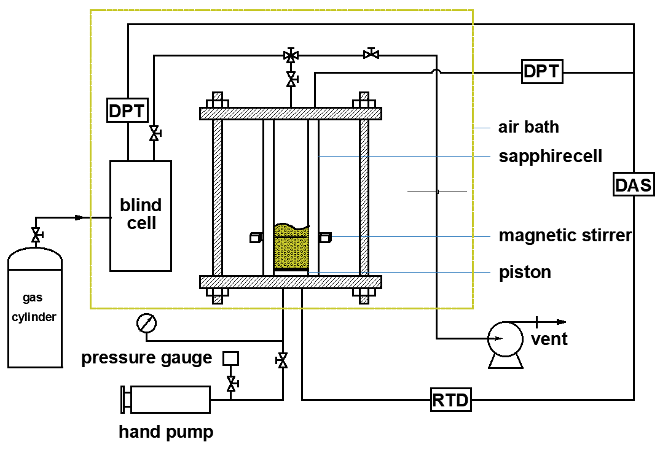
Supplementary Figure 10. Schematic diagram of experimental apparatus for phase equilibrium and kinetic experiments: DAS, data acquisition system; DPT, differential pressure transducer; RTD, resistance thermocouple detector.
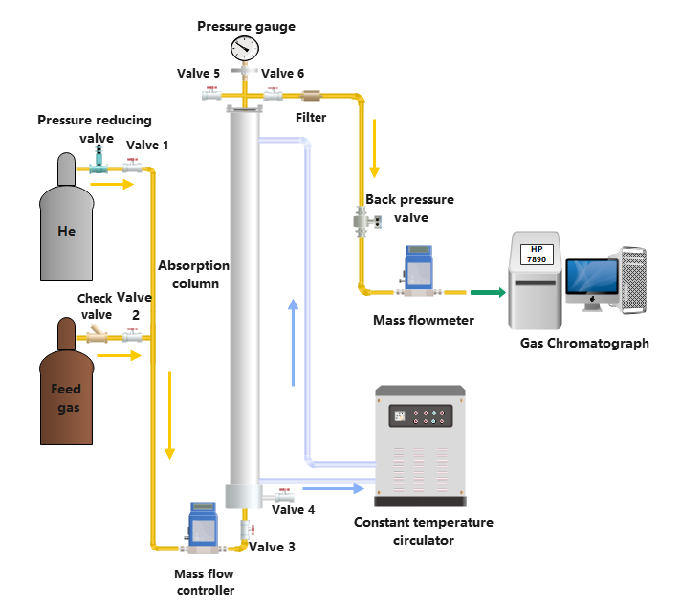
Supplementary Figure 11. Schematic diagram of the gas breakthrough experimental apparatus.

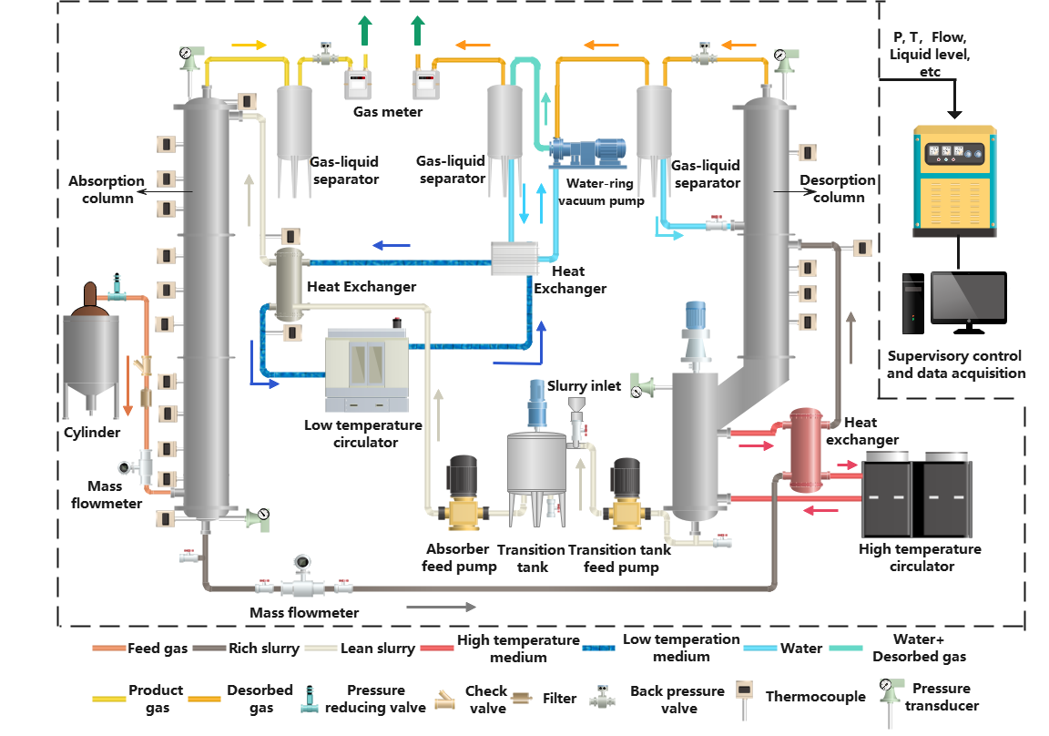
Supplementary Figure 12. Schematic diagram of the pilot plant for continuous C4 gas mixture sorption-desorption separation experiment.

Supplementary Tables
Supplementary Table 1. Separation results for n-butane(1)/iso-butane(2) gas mixture (z₂ = 61.8 mol%) using different sorbents at 293.15 K, where the ZIF-8 content of water-based, M-based, and M-water mixed-based slurries were set 25wt%, 35wt%, 30wt%, respectively.
Sorbent | Φ | P_{E}(bar) | y₂(mol%) | x₂(mol%) | S_{C1}(b) | S_{C2}(b) | $R_{1}$(%) | β
ZIF-8 powder | 39ª | 0.97 | 98.33 | 0.5 | 39.881 | 0.003 | 97.3 | 11757
ZIF-8/water slurry | 12 | 1.02 | 98.32 | 9.2 | 11.271 | 0.020 | 97.4 | 577
ZIF-8/M slurry | 19 | 0.74 | 98.20 | 32.6 | 23.648 | 0.151 | 97.9 | 113
ZIF-8/80wt%M+20wt%water | 15 | 1.04 | 98.65 | 7.6 | 17.345 | 0.019 | 97.9 | 890
ZIF-8/70wt%M+30wt%water | 14 | 1.02 | 98.97 | 6.3 | 21.819 | 0.016 | 98.3 | 1378
ZIF-8/60wt%M+40wt%water | 14 | 0.99 | 98.93 | 5.8 | 21.726 | 0.015 | 98.3 | 1494
ZIF-8/50wt%M+50wt%water | 14 | 1.02 | 98.85 | 4.9 | 20.050 | 0.012 | 98.2 | 1684
ZIF-8/30wt%M+70wt%water | 14 | 1.04 | 99.05 | 3.4 | 24.173 | 0.008 | 98.5 | 2985

Supplementary Table 2. Separation results for n-butane (1)/iso-butane (2) gas mixtures by using recycled ZIF-8/M-water slurry at 293.15 K and an initial gas-slurry volume ratio of about 20, where the ZIF-8 content in the fresh slurry and water content in the mixed solvent were both 30 wt%.
Reused time | z₂(mol%) | P_{E}(Bar) | y₂(mol%) | x₂(mol%) | S_{C2} (mol/L/bar) | $R_{1}$(%) | β
0 | 92.13 | 1.48 | 99.69 | 43.2 | 0.034 | 96.5 | 422
3 | 90.24 | 1.43 | 99.70 | 41.9 | 0.042 | 97.5 | 466
8 | 90.99 | 1.46 | 99.65 | 40.5 | 0.037 | 97.0 | 414
12 | 90.45 | 1.46 | 99.61 | 37.4 | 0.034 | 97.3 | 543
22 | 89.62 | 1.44 | 99.66 | 38.3 | 0.039 | 97.3 | 471

Supplementary Table 3. Separation results for n-butane(1)/iso-butane(2) gas mixtures by using recycled ZIF-8/M-water slurry at 293.15 K, an initial gas-slurry volume of about 20 but different desorption conditions, where the ZIF-8 content in the fresh slurry and water content in the mixed solvent were both 30 wt%.
Desorption conditions |  | z₂ (mol%) | P_{E}(Bar) | y₂ (mol%) | x₂ (mol%) | S_{C2} (mol/L/bar) | $R_{1}$(%) | β
T (℃) | t (min)
fresh |  | 92.13 | 1.48 | 99.69 | 43.2 | 0.034 | 96.5 | 422
60 | 30 | 91.24 | 1.47 | 99.78 | 45.7 | 0.044 | 97.9 | 542
50 | 60 | 90.45 | 1.46 | 99.69 | 37.4 | 0.034 | 97.3 | 543
50 | 30 | 94.07 | 1.48 | 99.81 | 57.1 | 0.046 | 97.3 | 400
50 | 20 | 90.24 | 1.43 | 99.70 | 41.9 | 0.042 | 97.5 | 466
50 | 10 | 91.49 | 1.44 | 99.63 | 48.9 | 0.048 | 96.3 | 281

Supplementary Table 4. Outlet gas concentration results of the breakthrough test for n-butane(1)/iso-butane(2) gas mixture (z₂ = 59 mol%) using ZIF-8(30wt%)/M-water slurry at 303.15K and 2 bar.(Gas flow rate: 60 mL/min)
Time (h) | $y_{iso-butane}$(mol%) | $y_{n-butane}$(mol%) | $y_{He}$(mol%) | $$\frac{y_{iso-butane}}{y_{iso-butane}+y_{n-butane}}×100\%$$
0.17 | 0.03 | 0 | 99.97 | 0
0.33 | 4.21 | 0.06 | 95.73 | 98.6189
0.50 | 22.05 | 0.16 | 77.80 | 99.3019
0.67 | 51.64 | 0.26 | 48.10 | 99.5029
0.83 | 70.66 | 0.26 | 29.09 | 99.6334
1.00 | 84.86 | 0.37 | 14.77 | 99.5647
1.33 | 94.87 | 0.43 | 4.70 | 99.5488
1.67 | 97.58 | 0.48 | 1.94 | 99.5085
2.00 | 98.50 | 0.58 | 0.92 | 99.4126
2.33 | 98.41 | 0.56 | 1.04 | 99.4372
2.67 | 98.53 | 0.51 | 0.96 | 99.485
3.25 | 98.84 | 0.55 | 0.61 | 99.4486
3.75 | 98.52 | 0.62 | 0.86 | 99.3776
4.33 | 98.70 | 0.76 | 0.54 | 99.2379
4.83 | 98.31 | 0.89 | 0.81 | 99.1078
5.33 | 98.13 | 1.07 | 0.80 | 98.9224
5.83 | 97.91 | 1.32 | 0.77 | 98.6748
6.33 | 97.77 | 1.48 | 0.76 | 98.5137
6.83 | 97.59 | 1.67 | 0.75 | 98.3185
7.42 | 97.16 | 2.41 | 0.43 | 97.5846
8.00 | 96.25 | 3.01 | 0.74 | 96.9645
8.30 | 95.68 | 3.60 | 0.72 | 96.375
8.75 | 95.01 | 4.59 | 0.40 | 95.3935
9.10 | 93.76 | 5.55 | 0.69 | 94.4143
9.38 | 93.03 | 6.59 | 0.39 | 93.3855
9.67 | 91.43 | 7.87 | 0.70 | 92.0758
9.92 | 90.44 | 9.18 | 0.38 | 90.788
10.12 | 89.25 | 10.40 | 0.36 | 89.5649
$y_{iso-butane}, y_{n-butane},y_{He}$ are the concentration of iso-butane, n-butane and He in the outlet gas.

Supplementary Table 5. Separation results for n-butane(1)/iso-butane(2) gas mixture (z₂=28.15 mol%) using ZIF-8(30wt%) slurry with solvent composition of 70 wt% M + 30 wt% water at 293.15 K.
Φ | P_{E}(Bar) | y₂(mol%) | x₂(mol%) | S_{C2}(mol/L/bar) | $R_{1}$(%) | β
14 | 0.38 | 92.35 | 0.4 | 0.005 | 96.8 | 2987

Supplementary Methods
Breakthrough curve measurement. The two-component gas breakthrough curves are measured by a dynamic breakthrough equipment, as shown in Supplementary Fig. 11. The main part of the equipment is a stainless-steel column (2.5 cm inner diameter × 160cm) with a jacket that is connected to a constant temperature circulator for temperature control. There is a kettle with a volume of about 1000 ml under the column, and a gas distributor is placed inside. The weight of the ZIF-8/M-water slurry loaded in the column and the kettle is 1800 g, and no additional activation step for adsorbent is required. First, the column is purged with pure He for 1h; the temperature and pressure are maintained at 303 K and 2 bar, respectively. Then, the feed gas [n-butane(41mol%)/iso-butane(59 mol%)] at a flow rate of 60 ml/min is introduced. The outlet gas from the column is analyzed by a gas chromatograph (HP 7890, Agilent). After the breakthrough test, the rich slurry is regenerated by He purge (100 mL/min) at 353 K for 36 h.
Pilot scale continuous separation experiment. The continuous C4 mixed gas sorption- desorption separation apparatus with an explosion-proof function was designed and set up. The physical picture and the schematic diagram of the apparatus are shown in Fig. 7 and Supplementary Fig. 12. The sorption column (5.17 m) and the desorption column (5.48 m) with packing section are the main components of the experimental setup. The effective packing section of the sorption column has an inner diameter of 4.7 cm and a height of 3.75 m (1.25 m × 3). The effective packing section of the desorption column has an inner diameter of 9.8 cm and a height of 2.5 m (1.25 m × 2). The packing type of the two columns is CY700 structured packing made of 316 stainless steel.
Each experiment begins with vacuuming the sorption and desorption columns to 0.1 bar. Then, the feed gas enters the bottom of the sorption column through a mass flow meter. When the sorption column reaches the desired pressure controlled by a back pressure valve, the lean ZIF-8 slurry is introduced into the sorption column at the top using a constant flow pump to contact with feed gas. The outlet gas at the top of the sorption column (product gas) is sampled and analyzed after passing through a gas-liquid separation tank and a gas meter. The rich ZIF-8 slurry from the outlet of the sorption column passes through a mass flow meter and a preheater, and finally enters the desorption column in the middle, driven by differential pressure between the two columns. The rich slurry is desorbed by heating together with vacuuming. A vacuum back pressure valve is used to control the vacuum degree of the desorption column. The bottom of the column (9.6 cm inner diameter × 2.98 m) without packing is equipped with an electromagnetic stirrer to prevent precipitation of the ZIF-8 slurry and a jacket that is connected to a high temperature circulator to maintain temperature at a desired value. After desorption, the desorbed gas and the lean slurry flow out from the top and bottom of the desorption column, respectively. In order to pump the slurry from the desorption column with negative pressure to the sorption column with positive pressure smoothly, an atmospheric transition tank is added between the two columns. The two columns are connected by the pipelines with double layers of insulation: a vacuum jacket and cotton insulation. A supervisory data-control-acquisition system is responsible for acquiring and displaying experimental data, such as temperature, pressure, flow rate, liquid level etc., and the control of equipment parameters. Each experiment lasts 9-10 h and when the system reaches a steady state, several samples are taken from the outlet for analysis.
Separation factor (β) of iso-butane (i) over other easily adsorbed components (e) and the recovery ratio of iso-butane (R_{iso-butane}) are two indicators for evaluating the separation efficiency of the pilot plant.
β=$\frac{y_{out-i/}y_{out-i}^{'}}{y_{out-e/}y_{out-e}^{'}}$ (S1)
where $y_{out-i and }y_{out-i}^{'}$are the molar fractions of iso-butane at the outlet of the sorption column and the desorption column, $y_{out-e and}{ y}_{out-e}^{'}$ are the sum of the mole fractions of all gases except iso-butane at the outlet of the sorption column and the desorption column.
R_{iso-butane=}$\frac{V_{out}y_{out-i}}{V_{in}y_{in-i}}×100\%$ (S2)
where $V_{in}$ and $V_{out}$ are the volumetric flow rates of the gas mixture at the inlet and outlet of the sorption column,$y_{in-i}$ is the molar fraction of iso-butane at the inlet of the sorption column. $V_{out}$ is calculated based on the mass balance of iso-butane as introduced below.
$$V_{in}y_{in-i}=V_{out}y_{out-i}+V_{out}^{'}y_{out-i}^{'}$$
$=V_{out}y_{out-i}+\left(V_{in}-V_{out}\right)y_{out-i}^{'}$ (S3)
where$V_{out}^{'}$is the volumetric flow rate of the gas mixture at the outlet of the desorption column.
$V_{out}$ can be obtained by Eq. (S3):
$V_{out}=\frac{V_{in}(y_{in-i}-y_{out-i}^{'})}{y_{out-i}-y_{out-i}^{'}}$ (S4)
Then, R_{iso-butane} can be obtained by substituting Eq. (S4) into the Eq. (S2):
R_{iso-butane}=$\frac{(y_{in-i}-y_{out-i}^{'})y_{out-i}}{(y_{out-i}-y_{out-i}^{'})y_{in-i}}×100\%$ (S5)
Characterization. ZIF-8 is characterized by a D8-Advanced X-ray diffractometer (Bruker, Germany) for the diffraction analysis under the condition of filtered Cu Ka radiation (λ=1.54 Å) at room temperature, accelerating voltage of 40 kV, tube current of 40 mA. The morphologies of the samples are obtained by a Gemini 300 scanning electron microscope (Zeiss, Germany). Particle size distribution of the slurry are measured by a Mastersizer 2000 laser diffraction instrument (Malvern, England).

