Supplementary figures
Figure S1
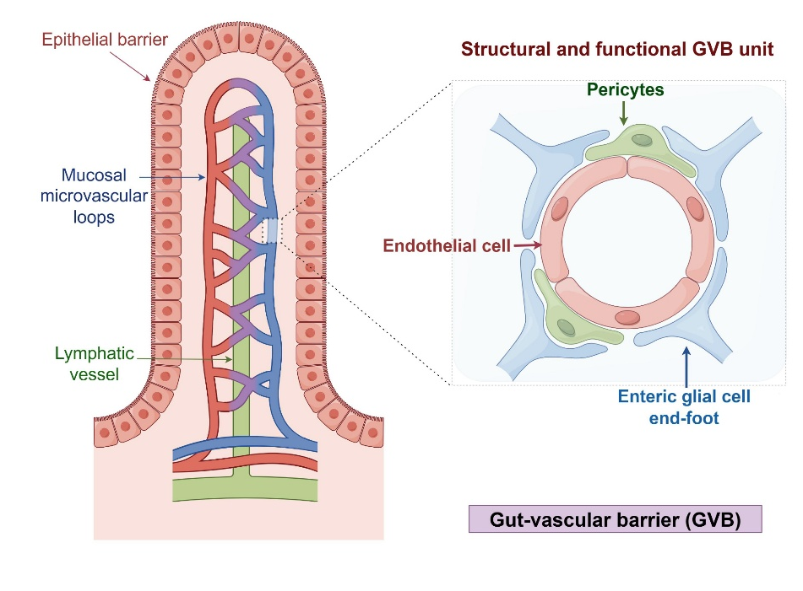
Figure S1. The schema-graph of gut-vascular barrier (GVB), which is the structural and functional unit formed by microvascular endothelial cells, pericytes and enteric glial cells.

Figure S2
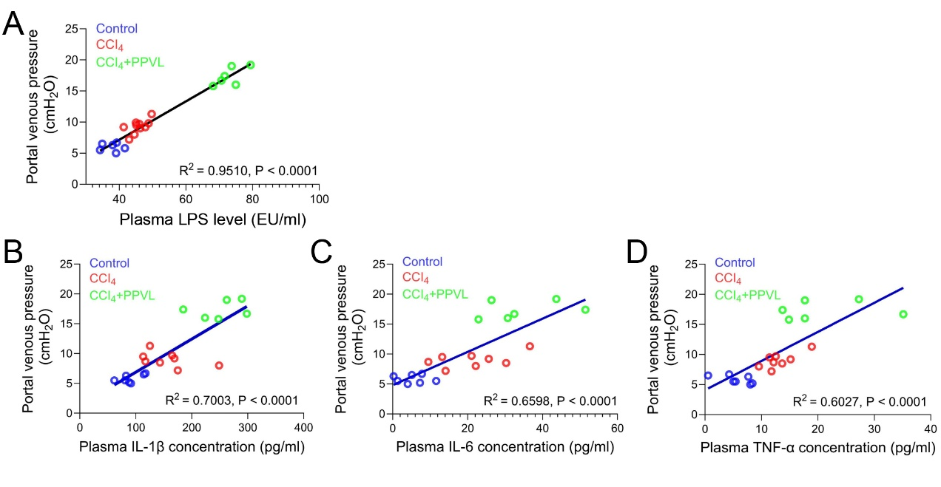
Figure S2. The Pearson correlations of portal venous pressure with levels of plasma LPS (A) and serum cytokines of IL-1β (B), IL-6 (C) and TNF-α (D). n=6 to 8 for each group; all p<0.0001. (Supplement to Fig.1)
Figure S3
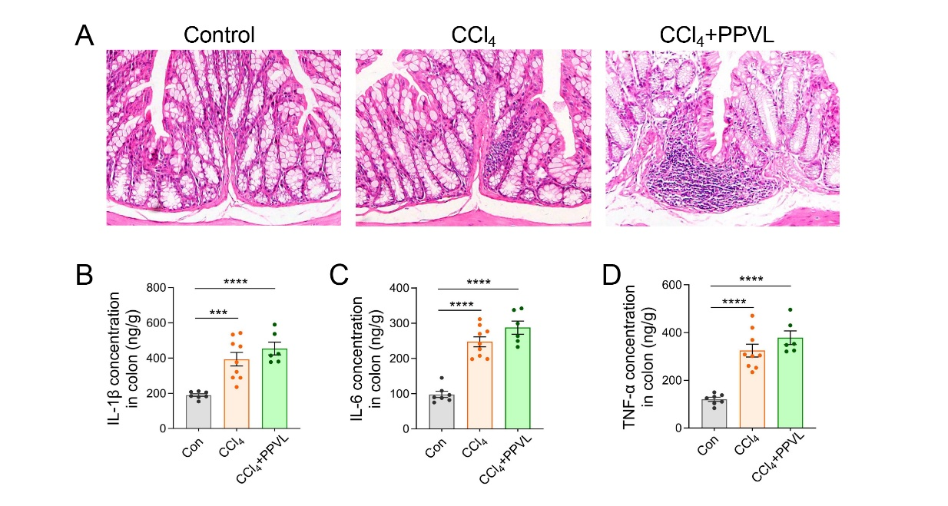
Figure S3. The HE staining images of colonic tissues of the control group, CCl₄ group and CCl₄+PPVL group (A), and the colonic levels of inflammatory cytokines of IL-1β (B), IL-6 (C) and TNF-α (D). n=6 to 8 for each group; ***p<0.001, ****p<0.0001. (Supplement to Fig.1)

Figure S4
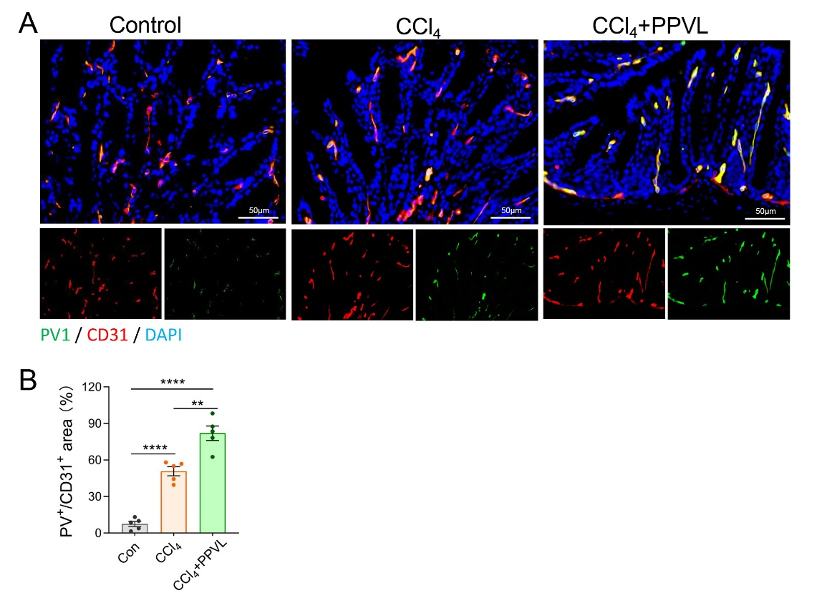
Figure S4. The PV1 expression on the colonic vascular endothelium of the control group, CCl₄ group and CCl₄+PPVL group (A), and calculated as the PV1⁺/CD31⁺ area (B). n=5 for each group; **p<0.01, ****p<0.0001. (Supplement to Fig.1)
Figure S5
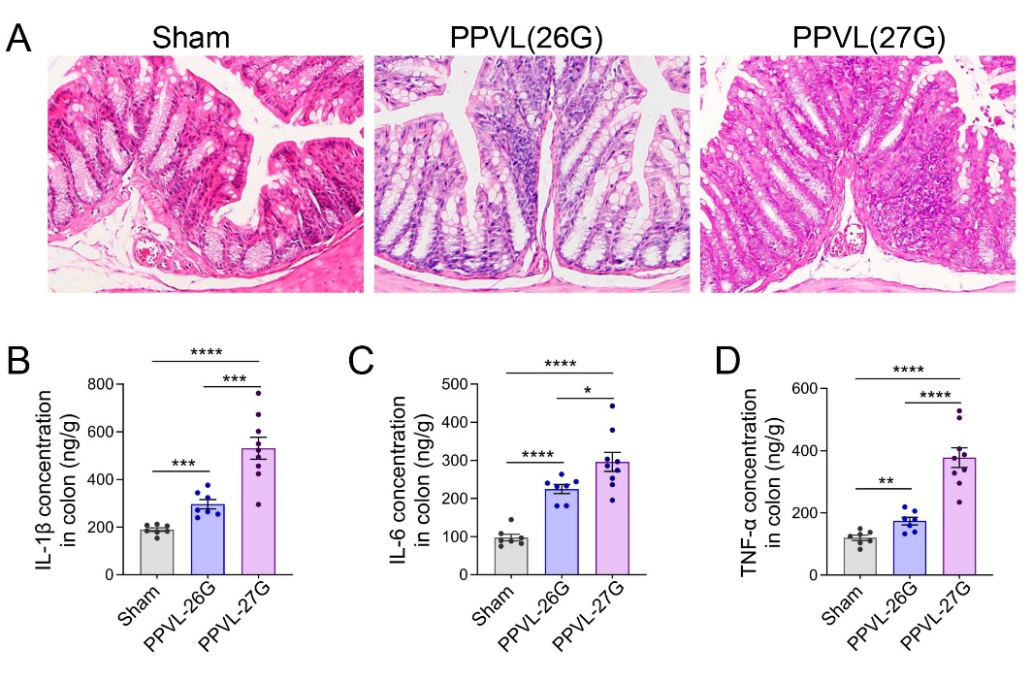
Figure S5. The HE staining images of colonic tissues of the sham group, PPVL-26G group and PPVL-27G group (A), and the colonic levels of inflammatory cytokines of IL-1β (B), IL-6 (C) and TNF-α (D). n=7 to 9 for each group; *p<0.05, **p<0.01, ***p<0.001, ****p<0.0001. (Supplement to Fig.2)
Figure S6
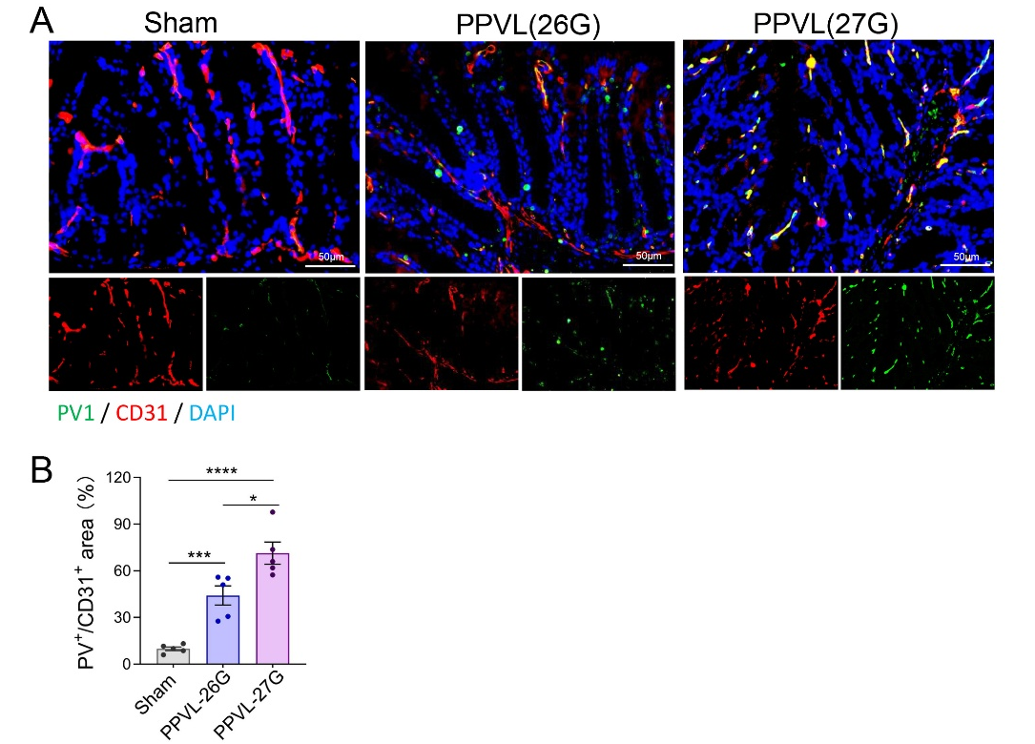
Figure S6. The PV1 expression on the colonic vascular endothelium of the sham group, PPVL-26G group and PPVL-27G group (A), and calculated as the PV1⁺/CD31⁺ area (B). n=5 for each group; *p<0.05, ***p<0.001, ****p<0.0001. (Supplement to Fig.2)
Figure S7
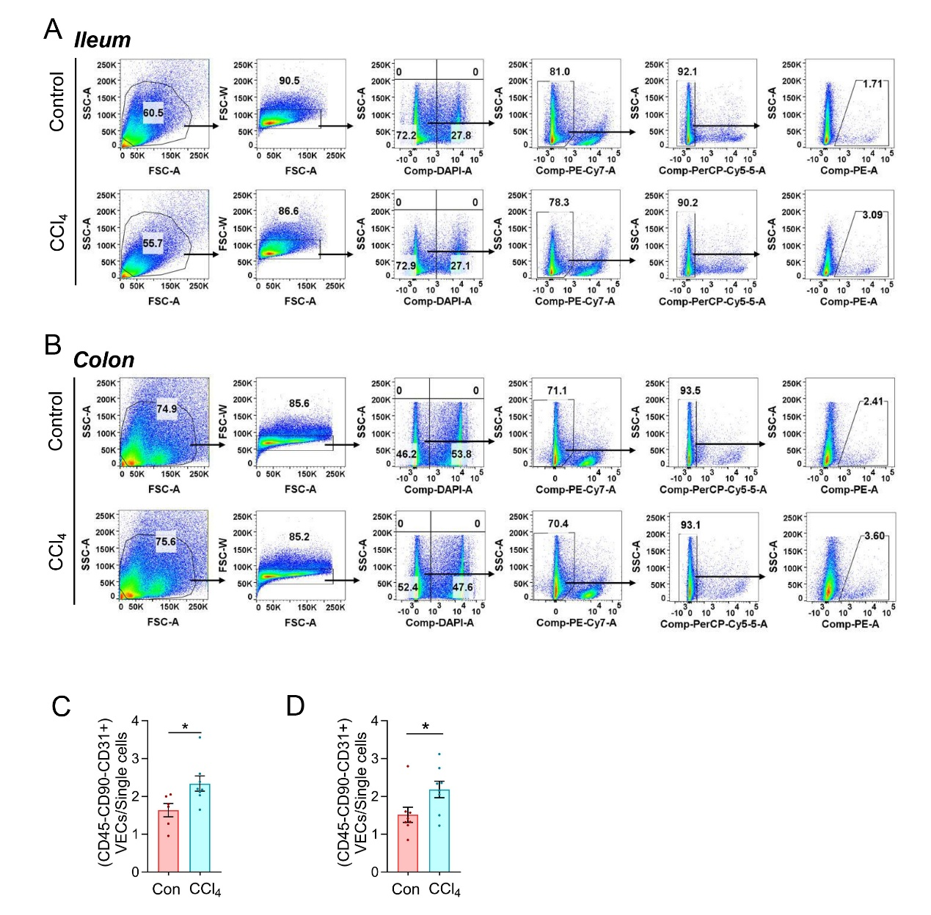
Figure S7. The protocol of identifying identified the microvascular ECls (CD45⁻CD90⁻CD31⁺) via flow cytometry with PE-Cy7-CD45 antibody, PerCP-Cy5.5-CD90 antibody and PE-CD31 antibody. Dead cells were removed from the analyses as DAPI-positive cells, and finally quantified the Piezo1 levels via FITC-Piezo1 antibody. (A-B) represented the typical flow cytometry analysis charts of samples for the ileum and colon from the CCl₄ and control mice. (C-D) showed the ratio of CD45⁻CD90⁻CD31⁺ vascular ECs in ileum and colon of the CCl₄ and control mice, respectively. n=6 to 8 for each group; *p<0.05. (Supplement to Fig.3)
Figure S8
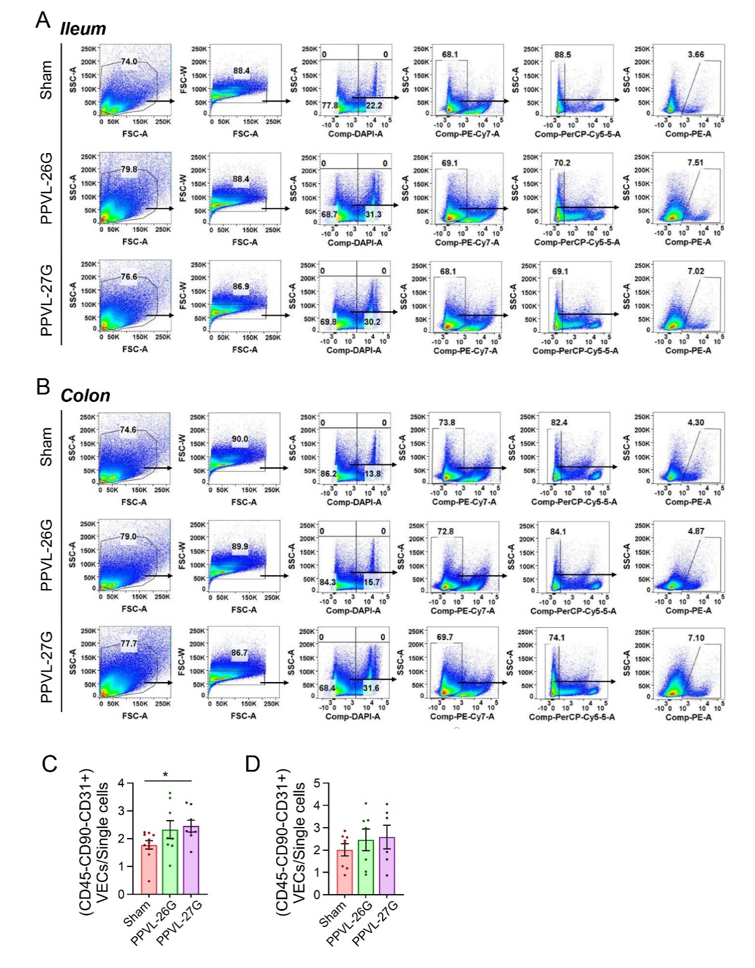
Figure S8. The protocol of identifying identified the microvascular ECs (CD45⁻CD90⁻CD31⁺) via flow cytometry, refer to Fig. S7. (A-B) represented the typical flow cytometry analysis charts of samples for the ileum and colon from the PPVL-26G, PPVL-27G and sham mice. (C-D) displayed the ratio of CD45⁻CD90⁻CD31⁺ vascular ECs in ileum and colon of the PPVL-26G, PPVL-27G and sham mice, respectively. n=6 to 10 for each group; *p<0.05. (Supplement to Fig.3)
Figure S9
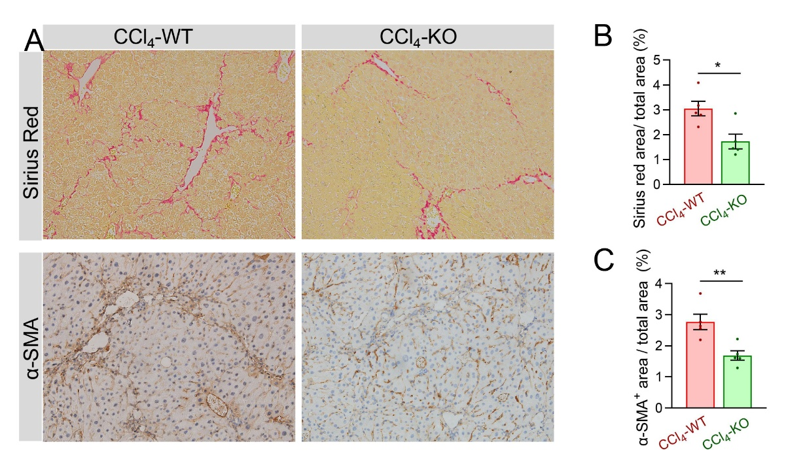
Figure S9. (A) Typical images of Sirius red staining and immunohistochemical staining (α-SMA) of liver tissues in CCl₄ mice with Piezo1^{fl/fl} (CCl₄-WT) or Piezo1^{ΔEC} (CCl₄-KO) background. (B-C) The fibrosis ratio was calculated as the Sirius red⁺ and α-SMA⁺ area relative to total area in CCl₄-WT and CCl₄-KO mice. n=5 for each group; *p<0.05, **p<0.01. (Supplement to Fig.4)
Figure S10
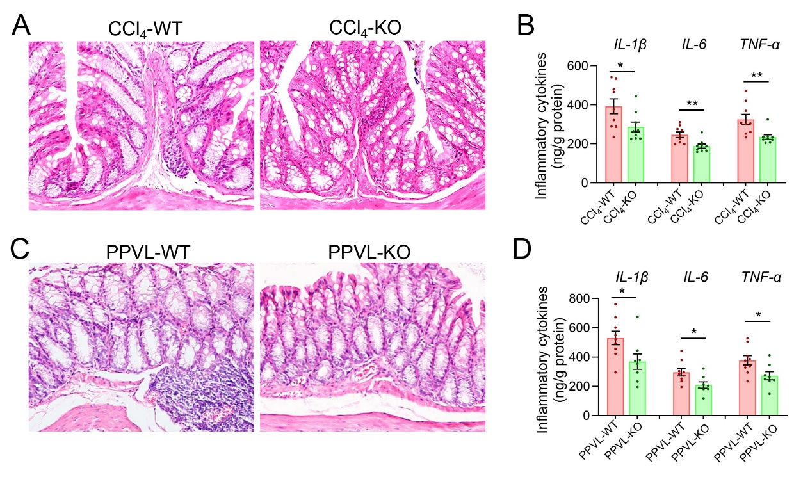
Figure S10. (A) HE staining images of colonic tissues, and (B) levels of colonic inflammatory cytokines of IL-1β, IL-6 and TNF-α in the CCl₄-WT and CCl₄-KO mice. (C) HE staining images of colonic tissues, and (B) levels of colonic inflammatory cytokines of IL-1β, IL-6 and TNF-α in the PPVL-WT and PPVL-KO mice. n=8 to 9 for each group; *p<0.05, **p<0.01. (Supplement to Fig.4)

Figure S11
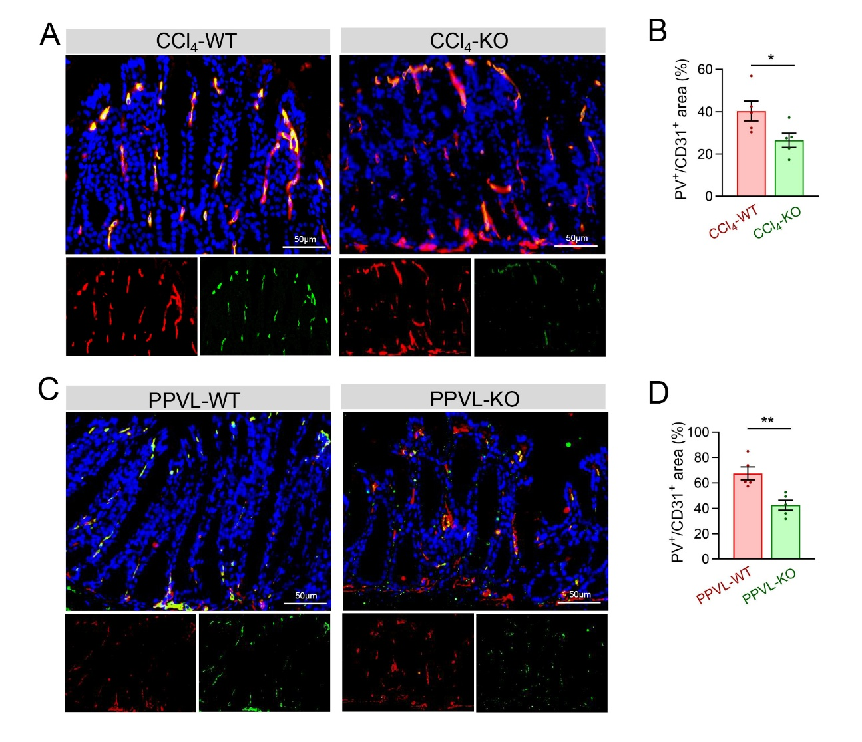
Figure S11. (A-B) The PV1 expression on the colonic vascular and the ratio of PV1⁺/CD31⁺ area in the CCl₄-WT and CCl₄-KO mice. (C-D) The PV1 expression on the colonic vascular and the ratio of PV1⁺/CD31⁺ area in the PPVL-WT and PPVL-KO mice. n=5 for each group; *p<0.05, **p<0.01. (Supplement to Fig.4)

Figure S12
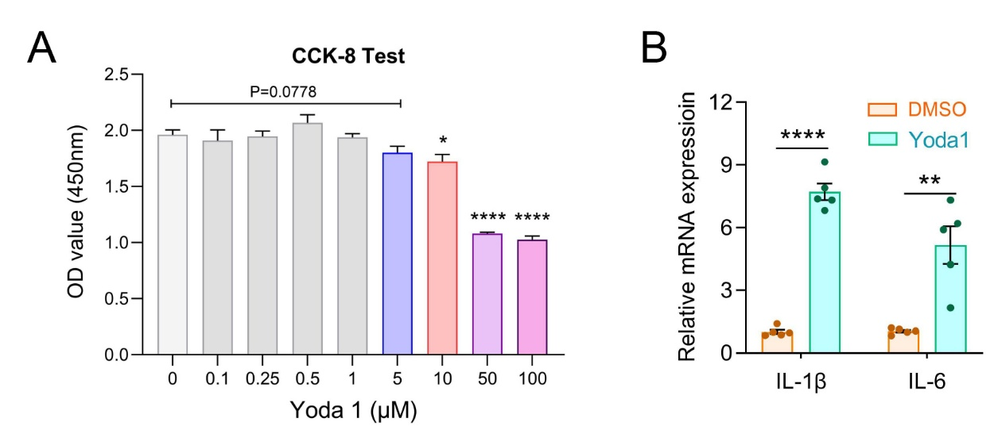
Figure S12. (A) The cell viability of intestinal microvascular ECs treated with gradient Yoda1 using the CCK-8 test. N=4 to 6 for each group. (B) Relative mRNA expression of IL-1β and IL-6 in ECs treated with Yoda1. n=5 for each group. *p<0.05, **p<0.01, ****<0.0001. (Supplement to Fig.5)

Figure S13
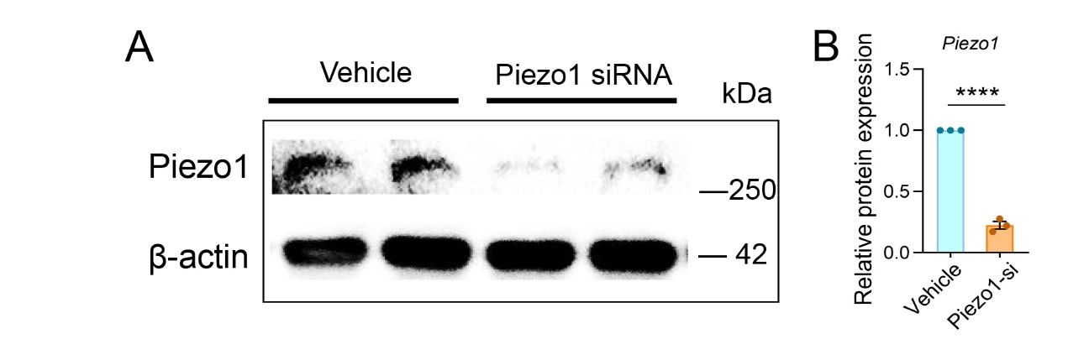
Figure S13. Piezo1 silence in ECs through precondition with specific siRNA transfection. The efficacy of Piezo1 knockdown was confirmed via western blot (A), and significantly declined Piezo1 expression was observed in Piezo1-siRNA treated ECs (B). n=3 for each group; ****<0.0001. (Supplement to Fig.6)

Figure S14
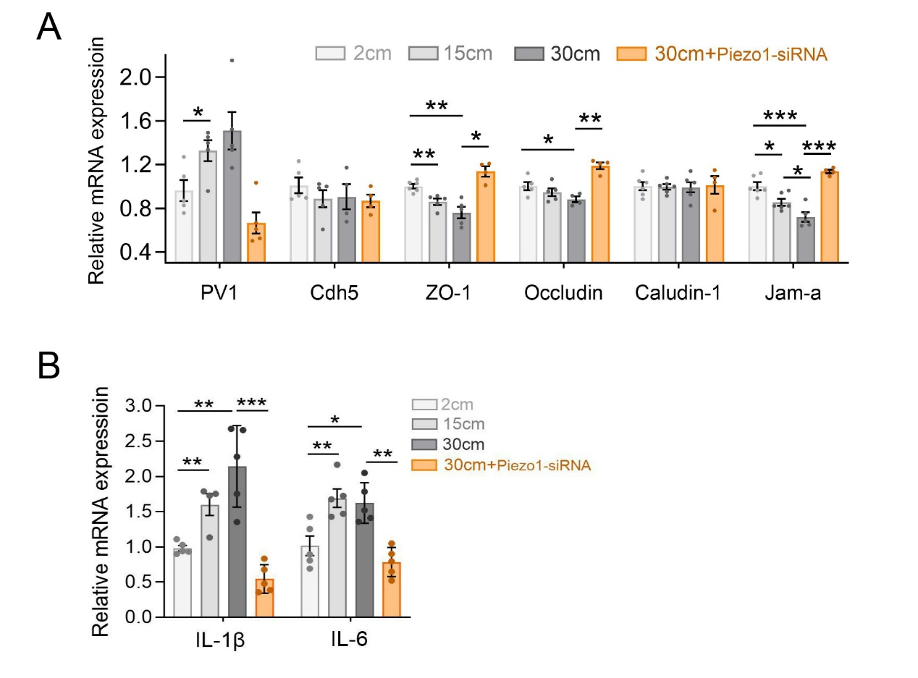
Figure S14. (A) Relative mRNA expression of PV1 and junctional proteins including VE-cadherin, occludin, claudin-1, ZO-1 and JAM-A in ECs treated with hydrostatic pressure (2cm, 15cm, and 30cmH₂O) and Piezo1-siRNA. (B) Relative mRNA expression of IL-1β and IL-6 in ECs stimulated by hydrostatic pressure and pretreating with Piezo1-siRNA. n=4 to 6 for each group; *p<0.05, **p<0.01, ***p<0.001. (Supplement to Fig.6)

Figure S15
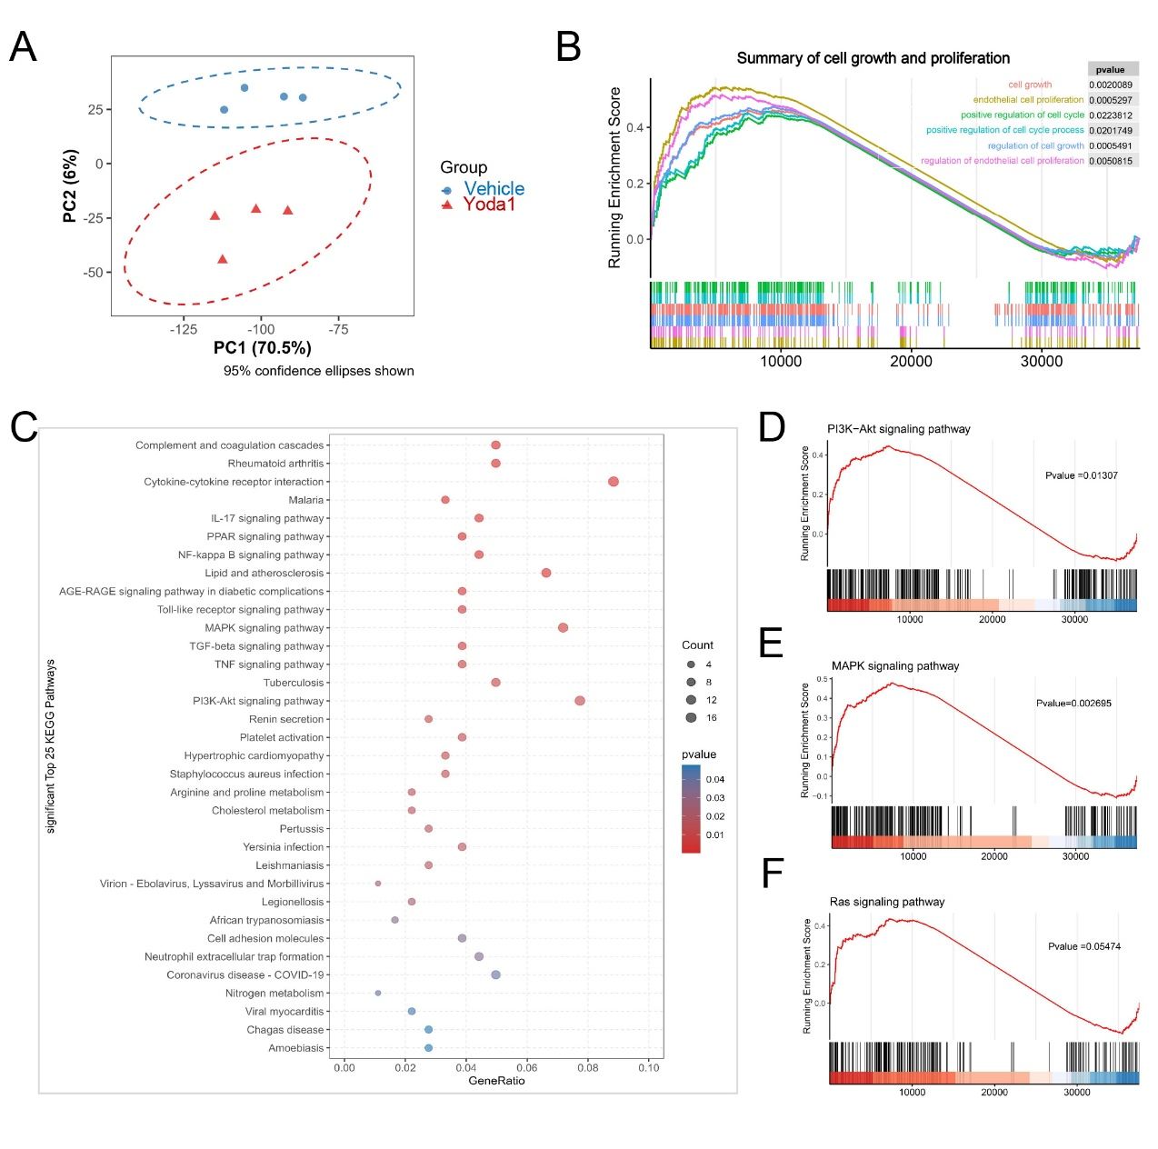
Figure S15. Analysis of RNA sequencing data from ECs treated with Yoda1 and DMSO. (A) The principal co-ordinates analysis (PCoA) showed significant difference between groups. (B) The gene set enrichment analysis (GSEA) illustrated the enrichment of pathways associated with cell growth and proliferation. (C) The significant differential pathways according to the Kyoto Encyclopedia of Genes and Genomes (KEGG) database with a False Discovery Rate (FDR) threshold of 0.05. (D-F) The enrichment of VEGFR2 downstream pathways in ECs treated with Yoda1, including PI3K/Akt signaling, MAPK signaling and Ras signaling pathways. (Supplement to Fig.7)

Figure S16
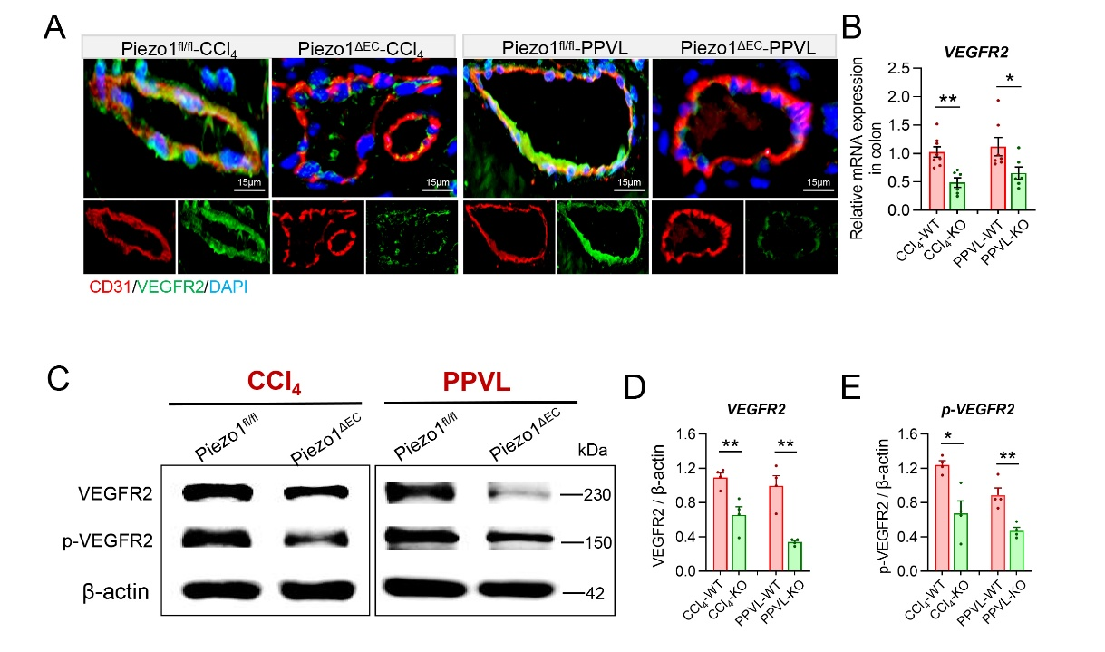
Figure S16. (A) Typical images of VEGFR2 (green) expression in colonic vascular ECs (CD31, red) in CCl₄ and PPVL mice with a Piezo1^{fl/fl} (WT) or Piezo1^{ΔEC} (KO) background. (B) The mRNA expression, and (C-E) the protein expression and phosphorylated level of VEGFR2 in colonic tissues of CCl₄ and PPVL mice and those with endothelial Piezo1 KO. n=4 for each group. *p<0.05, **p<0.01. (Supplement to Fig.7)

Figure S17
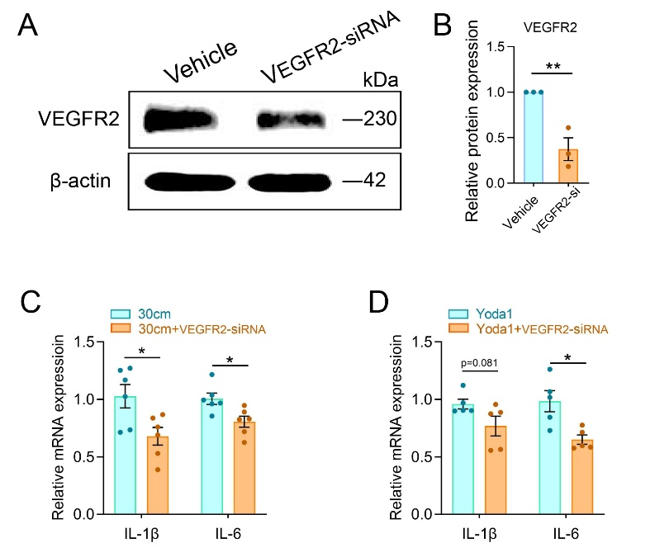
Figure S17. (A-B) VEGFR2 knockdown in ECs through precondition with specific siRNA transfection, and confirmed via western blot. N=3 for each group. (C-D) Relative mRNA expression of IL-1β and IL-6 in ECs stimulated by hydrostatic pressure (30cmH₂O) or Yoda1 (5μM), and the role of pretreating with VEGFR2-siRNA. n=5 to 6 for each group; *p<0.05, **p<0.01. (Supplement to Fig.8)

Supplementary tables
Table S1 The primer sequences used in real-time qPCR assay.
Gene | Forward primer (5′- 3′) | Reverse primer (5′- 3′)
Human
Piezo1 | GGACTCTCGCTGGTCTACCT | GGGCACAATATGCAGGCAGA
TNF-α | GAGGCCAAGCCCTGGTATG | CGGGCCGATTGATCTCAGC
IL-1β | ATGATGGCTTATTACAGTGGCAA | GTCGGAGATTCGTAGCTGGA
IL-6 | ACTCACCTCTTCAGAACGAATTG | CCATCTTTGGAAGGTTCAGGTTG
PV1 | CCGGGTCATCTACACGAACAA | CCTTGAATTGATCTCTGCATTGC
CDH5 | AAGCGTGAGTCGCAAGAATG | TCTCCAGGTTTTCGCCAGTG
Occludin | ACAAGCGGTTTTATCCAGAGTC | GTCATCCACAGGCGAAGTTAAT
Claudin1 | TCTGGCTATTTTAGTTGCCACAG | AGAGAGCCTGACCAAATTCGT
ZO1 | CAACATACAGTGACGCTTCACA | CACTATTGACGTTTCCCCACTC
JAM-A | GTGCCTACTCGGGCTTTTCTT | GTCACCCGGTCCTCATAGGAA
VEGFR2 | AACGTGTCACTTTGTGCAAGA | TTCCATGAGACGGACTCAGAA
GAPDH | CTGGGCTACACTGAGCACC | AAGTGGTCGTTGAGGGCAATG
Mouse
VEGFR2 | TTTGGCAAATACAACCCTTCAGA | GCAGAAGATACTGTCACCACC
GAPDH | AGGTCGGTGTGAACGGATTTG | GGGGTCGTTGATGGCAACA

Table S2 The key resources or reagents in the study.
Reagents or resources | Source | Catalogue number
Immunofluorescent
Piezo1 polyclonal antibody | Proteintech | 15939-1-AP
CD31 polyclonal antibody | RD-Systems | AF-3628
PLVAP/PV-1 monoclonal antibody | Abcam | ab27853
VE-cadherin monoclonal antibody | Abcam | ab205336
ZO1 polyclonal antibody | Genetex | GTX108613
Occludin polyclonal antibody | Proteintech | 27260-1-AP
Caludin-1 polyclonal antibody | Genetex | GTX134842
JAM-A/CD321 polyclonal antibody | Proteintech | 16183-1-AP
VEGFR2/KDR polyclonal antibody | Proteintech | 26415-1-AP
Alexa Fluor 488-Goat anti Rabbit IgG | ABclonal | A-11008
Alexa Fluor 488-Goat anti Rat IgG | ABclonal | A-11006
Alexa Fluor 594-Donkey anti Mouse IgG | ABclonal | A-21203
Alexa Fluor 594-Goat anti Rabbit IgG | ABclonal | A-11012
DAPI | Antgene | ANT165
Flow Cytometry
PE-CD31 antibody | BioLegend | 102407
PE-Cy7-CD45 antibody | BioLegend | 103114
PerCP-Cy5.5-CD90 antibody | BioLegend | 105338
FITC-Piezo1 antibody | Novus | NBP1-78446
DAPI | Antgene | ANT165
Collagenase D | Roche | 11088858001
Dispase II | Roche | 4942078001
Dnase I | Roche | 10104159001
Western Blot
Piezo1 Polyclonal antibody | Proteintech | 15939-1-AP
VEGFR2 polyclonal antibody | Proteintech | 26415-1-AP
Phospho-VEGFR2(Tyr1059) antibody | Affinity | AF3279
β-actin polyclonal antibody | Servicebio | GB12001-100
HRP-conjugated Goat anti‒rabbit IgG | Invitrogen | 31460
ELISA
Mouse TNF-α ELISA kit | Bioswap | MU30030
Mouse IL-6 ELISA kit | Bioswap | MU30044
Mouse IL-1β ELISA kit | Bioswap | MU30369
Mouse Lipopolysaccharides ELISA kit | Bioswap | MU30451

