7 Supplementary Material

7.1 Supplementary Figures

7.1.1 Supplementary Figure 1: Within-Site Consistency Across Resting-State Networks After Harmonization
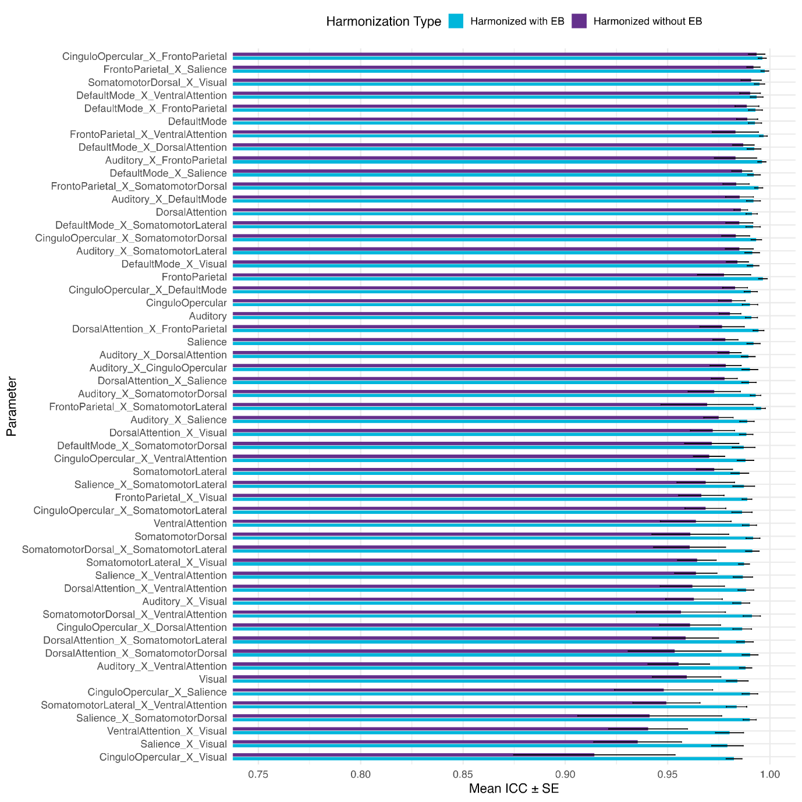

7.1.2 Supplementary Figure 2: Within-Site Consistency Across Sites After Harmonization

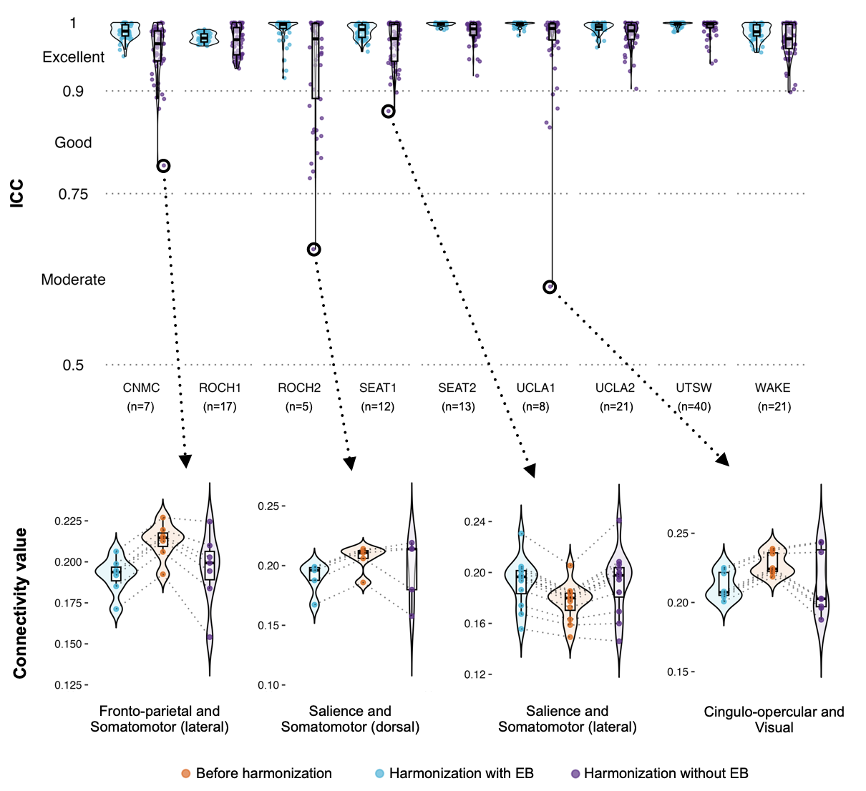
Supplementary Figure 2 shows connectivity values in smaller sites. Within-site variability was better preserved when applying EB, with more similar distribution shapes and parallel connection lines indicative of preserved original variability.

7.2 Supplementary Tables

7.2.1 Supplementary Table 1: Resting-State Network and ROI Assignments
Network | x | y | z | ROI label
Auditory | -51 | -24 | 22 | 69
Auditory | 41 | -26 | 21 | 70
Auditory | 56 | -21 | 30 | 71
Auditory | -58 | -27 | 13 | 72
Auditory | -53 | -12 | 12 | 73
Auditory | -48 | -36 | 24 | 74
Auditory | -47 | -28 | 5 | 75
Auditory | -37 | -35 | 16 | 76
Auditory | 30 | -29 | 14 | 77
Auditory | 53 | -9 | 16 | 78
Auditory | 55 | -19 | 10 | 79
Auditory | 62 | -36 | 21 | 80
CinguloOpercular | -49 | 5 | 0 | 50
CinguloOpercular | -43 | -3 | 10 | 51
CinguloOpercular | -33 | 0 | 6 | 52
CinguloOpercular | -17 | -9 | 69 | 53
CinguloOpercular | -11 | -6 | 42 | 54
CinguloOpercular | -6 | 13 | 36 | 55
CinguloOpercular | -4 | -2 | 53 | 56
CinguloOpercular | 5 | 3 | 51 | 57
CinguloOpercular | 11 | -6 | 69 | 58
CinguloOpercular | 34 | 6 | 5 | 59
CinguloOpercular | 35 | -3 | 0 | 60
CinguloOpercular | 47 | 4 | 3 | 61
CinguloOpercular | -29 | -29 | 12 | 62
CinguloOpercular | 39 | -5 | 48 | 63
CinguloOpercular | 34 | 17 | 7 | 64
CinguloOpercular | -38 | 45 | 21 | 65
CinguloOpercular | 29 | 27 | 30 | 66
CinguloOpercular | 29 | 49 | 20 | 67
CinguloOpercular | 35 | 27 | 3 | 68
CinguloOpercular | 24 | 1 | 10 | 258
CinguloOpercular | -24 | 4 | 10 | 259
CinguloOpercular | 18 | -8 | -1 | 260
CinguloOpercular | -18 | -8 | -1 | 261
CinguloOpercular | 12 | -17 | 13 | 266
CinguloOpercular | -15 | -17 | 13 | 267
CinguloOpercular | 9 | -11 | 4 | 268
CinguloOpercular | -9 | -13 | 2 | 269
CinguloOpercular | 31.69 | -49.51 | -47.73 | 274
CinguloOpercular | -30.33 | -50.75 | -48.25 | 294
DefaultMode | -65 | -42 | -6 | 82
DefaultMode | -55 | -31 | -4 | 83
DefaultMode | -53 | -15 | -9 | 84
DefaultMode | -50 | 0 | -24 | 85
DefaultMode | -47 | -43 | 0 | 86
DefaultMode | -44 | -61 | 18 | 87
DefaultMode | -44 | 27 | -9 | 88
DefaultMode | -43 | -65 | 31 | 89
DefaultMode | -41 | 9 | -30 | 90
DefaultMode | -39 | -75 | 22 | 91
DefaultMode | -38 | -75 | 39 | 92
DefaultMode | -35 | 15 | 51 | 93
DefaultMode | -20 | 39 | 42 | 94
DefaultMode | -20 | 57 | 24 | 95
DefaultMode | -17 | 57 | -3 | 96
DefaultMode | -17 | 23 | 54 | 97
DefaultMode | -12 | -41 | 1 | 98
DefaultMode | -11 | -57 | 14 | 99
DefaultMode | -11 | 33 | 54 | 100
DefaultMode | -11 | 48 | 42 | 101
DefaultMode | -11 | 39 | 12 | 102
DefaultMode | -8 | 42 | 27 | 103
DefaultMode | -7 | -56 | 25 | 104
DefaultMode | -7 | 45 | 4 | 105
DefaultMode | -3 | -50 | 12 | 106
DefaultMode | -3 | -39 | 42 | 107
DefaultMode | -3 | 39 | -4 | 108
DefaultMode | -3 | 32 | 39 | 109
DefaultMode | -3 | 36 | 20 | 110
DefaultMode | 5 | 60 | 3 | 111
DefaultMode | 5 | -60 | 33 | 112
DefaultMode | 5 | 48 | 21 | 113
DefaultMode | 5 | 57 | 27 | 114
DefaultMode | 7 | -50 | 29 | 115
DefaultMode | 7 | 37 | 0 | 116
DefaultMode | 8 | 42 | -9 | 117
DefaultMode | 8 | 48 | 9 | 118
DefaultMode | 10 | -55 | 16 | 119
DefaultMode | 11 | 48 | 42 | 120
DefaultMode | 11 | 24 | 60 | 121
DefaultMode | 11 | 30 | 24 | 122
DefaultMode | 14 | -64 | 24 | 123
DefaultMode | 20 | 33 | 42 | 124
DefaultMode | 21 | 27 | 50 | 125
DefaultMode | 41 | -73 | 26 | 126
DefaultMode | 44 | 12 | -24 | 127
DefaultMode | 44 | -52 | 28 | 128
DefaultMode | 47 | 30 | -6 | 129
DefaultMode | 49 | -61 | 34 | 130
DefaultMode | 50 | -6 | -12 | 131
DefaultMode | 50 | 3 | -24 | 132
DefaultMode | 62 | -15 | -15 | 133
DefaultMode | 62 | -33 | -6 | 134
DefaultMode | -32 | -39 | -15 | 135
DefaultMode | -24 | -40 | -2 | 238
DefaultMode | 24 | -39 | -1 | 239
DefaultMode | 3 | -11 | 10 | 262
DefaultMode | -3 | -13 | 10 | 263
DefaultMode | -29.53 | -76.64 | -38.36 | 277
DefaultMode | 31.53 | -80.15 | -37.19 | 278
DefaultMode | -22.12 | -74.98 | -28.62 | 279
DefaultMode | 23.67 | -75.48 | -27.62 | 280
DefaultMode | -4.5 | -51 | -39 | 281
DefaultMode | 8.56 | -50.39 | -37.87 | 282
DorsalAttention | -26 | -71 | 33 | 220
DorsalAttention | -35 | -30 | -24 | 221
DorsalAttention | 44 | -48 | -15 | 222
DorsalAttention | 9 | -41 | 48 | 223
DorsalAttention | -50 | -63 | 3 | 224
DorsalAttention | -40 | -60 | -10 | 225
DorsalAttention | -32 | -48 | 44 | 226
DorsalAttention | -32 | -5 | 53 | 227
DorsalAttention | -17 | -60 | 60 | 228
DorsalAttention | 8 | -63 | 57 | 229
DorsalAttention | 20 | -66 | 45 | 230
DorsalAttention | 23 | -60 | 57 | 231
DorsalAttention | 26 | -9 | 54 | 232
DorsalAttention | 44 | -60 | 4 | 233
DorsalAttention | -11.25 | -51.91 | -47.89 | 275
DorsalAttention | 14.53 | -48.36 | -49 | 276
FrontoParietal | -51 | -50 | 39 | 175
FrontoParietal | -45 | 7 | 24 | 176
FrontoParietal | -43 | -2 | 45 | 177
FrontoParietal | -41 | 33 | 24 | 178
FrontoParietal | -41 | -56 | 41 | 179
FrontoParietal | -41 | 20 | 31 | 180
FrontoParietal | -40 | 2 | 33 | 181
FrontoParietal | -40 | 40 | 2 | 182
FrontoParietal | -33 | 49 | 9 | 183
FrontoParietal | -28 | -59 | 44 | 184
FrontoParietal | -23 | 6 | 63 | 185
FrontoParietal | -4 | 21 | 46 | 186
FrontoParietal | 23 | 39 | -9 | 187
FrontoParietal | 29 | 9 | 57 | 188
FrontoParietal | 31 | -55 | 42 | 189
FrontoParietal | 32 | 48 | -6 | 190
FrontoParietal | 35 | -66 | 38 | 191
FrontoParietal | 36 | 37 | 20 | 192
FrontoParietal | 37 | 13 | 42 | 193
FrontoParietal | 41 | -55 | 45 | 194
FrontoParietal | 41 | 43 | 4 | 195
FrontoParietal | 44 | 5 | 35 | 196
FrontoParietal | 45 | 19 | 30 | 197
FrontoParietal | 46 | -45 | 44 | 198
FrontoParietal | 56 | -54 | -12 | 199
FrontoParietal | 45 | 17 | 14 | 200
FrontoParietal | 52 | -47 | 36 | 201
FrontoParietal | 13 | -5 | 20 | 250
FrontoParietal | -15 | -5 | 20 | 251
FrontoParietal | -8.75 | -77.03 | -28.43 | 284
FrontoParietal | 10.32 | -77.24 | -28.02 | 285
FrontoParietal | -31.25 | -70.75 | -47.53 | 286
FrontoParietal | 33.62 | -71.45 | -46.11 | 287
FrontoParietal | -28.31 | -65.37 | -30.09 | 288
FrontoParietal | 31 | -63 | -29 | 289
Salience | -34 | 16 | 3 | 202
Salience | -27 | 46 | 25 | 203
Salience | -11 | 21 | 27 | 204
Salience | -2 | 10 | 45 | 205
Salience | -1 | 25 | 30 | 206
Salience | 4 | 18 | 39 | 207
Salience | 9 | 17 | 30 | 208
Salience | 24 | 43 | 31 | 209
Salience | 32 | 12 | -3 | 210
Salience | 11 | 13 | 10 | 248
Salience | -13 | 13 | 10 | 249
Salience | 42.25 | -60.44 | -28.22 | 291
Salience | -40.74 | -59.53 | -30.03 | 292
SomatomotorDorsal | -8 | -54 | 57 | 13
SomatomotorDorsal | -1 | -18 | 46 | 14
SomatomotorDorsal | -52 | -25 | 41 | 15
SomatomotorDorsal | -44 | -34 | 44 | 16
SomatomotorDorsal | -39 | -22 | 52 | 17
SomatomotorDorsal | -38 | -30 | 66 | 18
SomatomotorDorsal | -38 | -18 | 66 | 19
SomatomotorDorsal | -29 | -45 | 57 | 20
SomatomotorDorsal | -23 | -33 | 69 | 21
SomatomotorDorsal | -21 | -34 | 58 | 22
SomatomotorDorsal | -17 | -48 | 69 | 23
SomatomotorDorsal | -14 | -21 | 39 | 24
SomatomotorDorsal | -14 | -21 | 72 | 25
SomatomotorDorsal | -8 | -24 | 63 | 26
SomatomotorDorsal | -8 | -36 | 69 | 27
SomatomotorDorsal | 1 | -31 | 58 | 28
SomatomotorDorsal | 2 | -21 | 57 | 29
SomatomotorDorsal | 8 | -6 | 45 | 30
SomatomotorDorsal | 8 | -48 | 69 | 31
SomatomotorDorsal | 8 | -21 | 72 | 32
SomatomotorDorsal | 11 | -36 | 72 | 33
SomatomotorDorsal | 18 | -32 | 58 | 34
SomatomotorDorsal | 20 | -45 | 66 | 35
SomatomotorDorsal | 26 | -21 | 69 | 36
SomatomotorDorsal | 26 | -42 | 57 | 37
SomatomotorDorsal | 35 | -21 | 45 | 38
SomatomotorDorsal | 39 | -24 | 54 | 39
SomatomotorDorsal | 41 | -12 | 57 | 40
SomatomotorDorsal | 44 | -33 | 48 | 41
SomatomotorDorsal | 47 | -24 | 42 | 42
SomatomotorDorsal | 17 | -12 | 63 | 43
SomatomotorDorsal | 51 | -31 | 34 | 44
SomatomotorDorsal | 27 | -11 | 10 | 252
SomatomotorDorsal | -27 | -13 | 10 | 253
SomatomotorDorsal | 15 | -25 | 10 | 272
SomatomotorDorsal | -18 | -25 | 10 | 273
SomatomotorDorsal | -4.66 | -73.04 | -41.38 | 295
SomatomotorDorsal | 8.15 | -71.32 | -38.15 | 296
SomatomotorDorsal | -11.01 | -44.84 | -17.14 | 299
SomatomotorDorsal | 11.89 | -45.09 | -16.64 | 300
SomatomotorLateral | -51 | -13 | 24 | 45
SomatomotorLateral | -48 | -14 | 34 | 46
SomatomotorLateral | 34 | -13 | 16 | 47
SomatomotorLateral | 48 | -10 | 34 | 48
SomatomotorLateral | 62 | -12 | 27 | 49
SomatomotorLateral | 27 | -10 | -2 | 254
SomatomotorLateral | -27 | -13 | -2 | 255
SomatomotorLateral | 13 | -22 | 2 | 270
SomatomotorLateral | -13 | -22 | 2 | 271
SomatomotorLateral | -9.03 | -61.98 | -18.09 | 297
SomatomotorLateral | 10.05 | -62.19 | -17.67 | 298
VentralAttention | 49 | -31 | -2 | 211
VentralAttention | -54 | -51 | 8 | 212
VentralAttention | -53 | -41 | 12 | 213
VentralAttention | 49 | -35 | 9 | 214
VentralAttention | 53 | -48 | 12 | 215
VentralAttention | -47 | 21 | 2 | 216
VentralAttention | -11 | 6 | 66 | 217
VentralAttention | 50 | 27 | 6 | 218
VentralAttention | 51 | -45 | 22 | 219
VentralAttention | 24 | -2 | 2 | 256
VentralAttention | -27 | -4 | -1 | 257
Visual | -11 | -93 | -15 | 141
Visual | 8 | -90 | -9 | 142
Visual | 17 | -90 | -15 | 143
Visual | -44 | -75 | -12 | 144
Visual | -40 | -73 | -2 | 145
Visual | -38 | -87 | -9 | 146
Visual | -31 | -78 | -15 | 147
Visual | -27 | -79 | 16 | 148
Visual | -25 | -89 | 0 | 149
Visual | -23 | -90 | 15 | 150
Visual | -17 | -68 | 3 | 151
Visual | -16 | -77 | 30 | 152
Visual | -15 | -53 | -2 | 153
Visual | -14 | -72 | -9 | 154
Visual | -14 | -90 | 27 | 155
Visual | -8 | -80 | 5 | 156
Visual | -3 | -81 | 18 | 157
Visual | 5 | -72 | 21 | 158
Visual | 6 | -81 | 4 | 159
Visual | 8 | -72 | 9 | 160
Visual | 14 | -87 | 33 | 161
Visual | 14 | -77 | 28 | 162
Visual | 17 | -48 | -9 | 163
Visual | 19 | -66 | 1 | 164
Visual | 19 | -85 | -4 | 165
Visual | 23 | -87 | 21 | 166
Visual | 25 | -79 | -16 | 167
Visual | 26 | -60 | -9 | 168
Visual | 27 | -77 | 23 | 169
Visual | 35 | -84 | 11 | 170
Visual | 35 | -81 | 0 | 171
Visual | 38 | -73 | 13 | 172
Visual | 40 | -66 | -8 | 173
Visual | 41 | -78 | -12 | 174
Visual | 18 | -31 | 2 | 264
Visual | -18 | -31 | 2 | 265
Visual | 0.71 | -73.38 | -25.17 | 283

7.2.2 Supplementary Table 2: Site Effects in Within- and Between-Network Functional Connectivity Before and After Harmonization
Parameter | Before harmonization |  |  | Harmonization with EB |  |  | Harmonization without EB
Parameter | Statistic | Cohen's f | η² | Statistic | Cohen's f | η² | Statistic | Cohen's f | η²
Auditory | F(8, 135) = 6.40, p < 0.001 | 0.62 | 0.28 | F(8, 135) = 0.58, p > 0.05 | 0.19 | 0.03 | F(8, 135) = 0.00, p > 0.05 | 0.01 | 0.00
CinguloOpercular | F(8, 135) = 8.11, p < 0.001 | 0.69 | 0.33 | F(8, 135) = 0.18, p > 0.05 | 0.11 | 0.01 | F(8, 135) = 0.00, p > 0.05 | 0.02 | 0.00
DefaultMode | F(8, 135) = 8.07, p < 0.001 | 0.69 | 0.32 | F(8, 135) = 0.09, p > 0.05 | 0.07 | 0.01 | F(8, 135) = 0.05, p > 0.05 | 0.05 | 0.00
DorsalAttention | F(8, 135) = 2.10, p < 0.05 | 0.35 | 0.11 | F(8, 135) = 0.53, p > 0.05 | 0.18 | 0.03 | F(8, 135) = 0.09, p > 0.05 | 0.07 | 0.01
FrontoParietal | F(8, 135) = 5.24, p < 0.001 | 0.56 | 0.24 | F(8, 135) = 0.23, p > 0.05 | 0.12 | 0.01 | F(8, 135) = 0.01, p > 0.05 | 0.02 | 0.00
Salience | F(8, 135) = 9.99, p < 0.001 | 0.77 | 0.37 | F(8, 135) = 0.30, p > 0.05 | 0.13 | 0.02 | F(8, 135) = 0.06, p > 0.05 | 0.06 | 0.00
SomatomotorDorsal | F(8, 135) = 5.65, p < 0.001 | 0.58 | 0.25 | F(8, 135) = 0.62, p > 0.05 | 0.19 | 0.04 | F(8, 135) = 0.03, p > 0.05 | 0.05 | 0.00
SomatomotorLateral | F(8, 135) = 11.24, p < 0.001 | 0.82 | 0.40 | F(8, 135) = 0.52, p > 0.05 | 0.18 | 0.03 | F(8, 135) = 0.02, p > 0.05 | 0.03 | 0.00
VentralAttention | F(8, 135) = 6.81, p < 0.001 | 0.64 | 0.29 | F(8, 135) = 0.17, p > 0.05 | 0.10 | 0.01 | F(8, 135) = 0.04, p > 0.05 | 0.05 | 0.00
Visual | F(8, 135) = 6.52, p < 0.001 | 0.62 | 0.28 | F(8, 135) = 0.36, p > 0.05 | 0.15 | 0.02 | F(8, 135) = 0.00, p > 0.05 | 0.01 | 0.00
Auditory_X_CinguloOpercular | F(8, 135) = 10.15, p < 0.001 | 0.78 | 0.38 | F(8, 135) = 0.33, p > 0.05 | 0.14 | 0.02 | F(8, 135) = 0.00, p > 0.05 | 0.01 | 0.00
Auditory_X_DefaultMode | F(8, 135) = 8.52, p < 0.001 | 0.71 | 0.34 | F(8, 135) = 0.08, p > 0.05 | 0.07 | 0.01 | F(8, 135) = 0.06, p > 0.05 | 0.06 | 0.00
Auditory_X_DorsalAttention | F(8, 135) = 5.13, p < 0.001 | 0.55 | 0.23 | F(8, 135) = 0.24, p > 0.05 | 0.12 | 0.01 | F(8, 135) = 0.05, p > 0.05 | 0.05 | 0.00
Auditory_X_FrontoParietal | F(8, 135) = 6.42, p < 0.001 | 0.62 | 0.28 | F(8, 135) = 0.17, p > 0.05 | 0.10 | 0.01 | F(8, 135) = 0.01, p > 0.05 | 0.02 | 0.00
Auditory_X_Salience | F(8, 135) = 10.02, p < 0.001 | 0.77 | 0.37 | F(8, 135) = 0.26, p > 0.05 | 0.12 | 0.02 | F(8, 135) = 0.00, p > 0.05 | 0.02 | 0.00
Auditory_X_SomatomotorDorsal | F(8, 135) = 5.86, p < 0.001 | 0.59 | 0.26 | F(8, 135) = 0.34, p > 0.05 | 0.14 | 0.02 | F(8, 135) = 0.02, p > 0.05 | 0.04 | 0.00
Auditory_X_SomatomotorLateral | F(8, 135) = 9.56, p < 0.001 | 0.75 | 0.36 | F(8, 135) = 0.53, p > 0.05 | 0.18 | 0.03 | F(8, 135) = 0.01, p > 0.05 | 0.03 | 0.00
Auditory_X_VentralAttention | F(8, 135) = 10.20, p < 0.001 | 0.78 | 0.38 | F(8, 135) = 0.49, p > 0.05 | 0.17 | 0.03 | F(8, 135) = 0.00, p > 0.05 | 0.01 | 0.00
Auditory_X_Visual | F(8, 135) = 7.09, p < 0.001 | 0.65 | 0.30 | F(8, 135) = 0.21, p > 0.05 | 0.11 | 0.01 | F(8, 135) = 0.00, p > 0.05 | 0.01 | 0.00
CinguloOpercular_X_DefaultMode | F(8, 135) = 9.13, p < 0.001 | 0.74 | 0.35 | F(8, 135) = 0.08, p > 0.05 | 0.07 | 0.01 | F(8, 135) = 0.05, p > 0.05 | 0.06 | 0.00
CinguloOpercular_X_DorsalAttention | F(8, 135) = 7.95, p < 0.001 | 0.69 | 0.32 | F(8, 135) = 0.09, p > 0.05 | 0.07 | 0.01 | F(8, 135) = 0.03, p > 0.05 | 0.04 | 0.00
CinguloOpercular_X_FrontoParietal | F(8, 135) = 8.77, p < 0.001 | 0.72 | 0.34 | F(8, 135) = 0.10, p > 0.05 | 0.08 | 0.01 | F(8, 135) = 0.00, p > 0.05 | 0.02 | 0.00
CinguloOpercular_X_Salience | F(8, 135) = 10.20, p < 0.001 | 0.78 | 0.38 | F(8, 135) = 0.17, p > 0.05 | 0.10 | 0.01 | F(8, 135) = 0.02, p > 0.05 | 0.03 | 0.00
CinguloOpercular_X_SomatomotorDorsal | F(8, 135) = 9.72, p < 0.001 | 0.76 | 0.37 | F(8, 135) = 0.26, p > 0.05 | 0.12 | 0.02 | F(8, 135) = 0.02, p > 0.05 | 0.04 | 0.00
CinguloOpercular_X_SomatomotorLateral | F(8, 135) = 12.38, p < 0.001 | 0.86 | 0.42 | F(8, 135) = 0.38, p > 0.05 | 0.15 | 0.02 | F(8, 135) = 0.00, p > 0.05 | 0.01 | 0.00
CinguloOpercular_X_VentralAttention | F(8, 135) = 12.00, p < 0.001 | 0.84 | 0.42 | F(8, 135) = 0.37, p > 0.05 | 0.15 | 0.02 | F(8, 135) = 0.00, p > 0.05 | 0.01 | 0.00
CinguloOpercular_X_Visual | F(8, 135) = 7.97, p < 0.001 | 0.69 | 0.32 | F(8, 135) = 0.11, p > 0.05 | 0.08 | 0.01 | F(8, 135) = 0.00, p > 0.05 | 0.01 | 0.00
DefaultMode_X_DorsalAttention | F(8, 135) = 7.12, p < 0.001 | 0.65 | 0.30 | F(8, 135) = 0.11, p > 0.05 | 0.08 | 0.01 | F(8, 135) = 0.07, p > 0.05 | 0.06 | 0.00
DefaultMode_X_FrontoParietal | F(8, 135) = 9.87, p < 0.001 | 0.77 | 0.37 | F(8, 135) = 0.08, p > 0.05 | 0.07 | 0.01 | F(8, 135) = 0.05, p > 0.05 | 0.06 | 0.00
DefaultMode_X_Salience | F(8, 135) = 9.89, p < 0.001 | 0.77 | 0.37 | F(8, 135) = 0.10, p > 0.05 | 0.08 | 0.01 | F(8, 135) = 0.05, p > 0.05 | 0.05 | 0.00
DefaultMode_X_SomatomotorDorsal | F(8, 135) = 10.32, p < 0.001 | 0.78 | 0.38 | F(8, 135) = 0.18, p > 0.05 | 0.10 | 0.01 | F(8, 135) = 0.06, p > 0.05 | 0.06 | 0.00
DefaultMode_X_SomatomotorLateral | F(8, 135) = 9.81, p < 0.001 | 0.76 | 0.37 | F(8, 135) = 0.12, p > 0.05 | 0.09 | 0.01 | F(8, 135) = 0.05, p > 0.05 | 0.06 | 0.00
DefaultMode_X_VentralAttention | F(8, 135) = 9.14, p < 0.001 | 0.74 | 0.35 | F(8, 135) = 0.11, p > 0.05 | 0.08 | 0.01 | F(8, 135) = 0.03, p > 0.05 | 0.05 | 0.00
DefaultMode_X_Visual | F(8, 135) = 7.51, p < 0.001 | 0.67 | 0.31 | F(8, 135) = 0.11, p > 0.05 | 0.08 | 0.01 | F(8, 135) = 0.02, p > 0.05 | 0.04 | 0.00
DorsalAttention_X_FrontoParietal | F(8, 135) = 6.35, p < 0.001 | 0.61 | 0.27 | F(8, 135) = 0.13, p > 0.05 | 0.09 | 0.01 | F(8, 135) = 0.03, p > 0.05 | 0.04 | 0.00
DorsalAttention_X_Salience | F(8, 135) = 7.25, p < 0.001 | 0.66 | 0.30 | F(8, 135) = 0.11, p > 0.05 | 0.08 | 0.01 | F(8, 135) = 0.07, p > 0.05 | 0.06 | 0.00
DorsalAttention_X_SomatomotorDorsal | F(8, 135) = 6.59, p < 0.001 | 0.63 | 0.28 | F(8, 135) = 0.43, p > 0.05 | 0.16 | 0.03 | F(8, 135) = 0.04, p > 0.05 | 0.05 | 0.00
DorsalAttention_X_SomatomotorLateral | F(8, 135) = 7.31, p < 0.001 | 0.66 | 0.30 | F(8, 135) = 0.22, p > 0.05 | 0.11 | 0.01 | F(8, 135) = 0.05, p > 0.05 | 0.05 | 0.00
DorsalAttention_X_VentralAttention | F(8, 135) = 5.73, p < 0.001 | 0.58 | 0.25 | F(8, 135) = 0.16, p > 0.05 | 0.10 | 0.01 | F(8, 135) = 0.06, p > 0.05 | 0.06 | 0.00
DorsalAttention_X_Visual | F(8, 135) = 6.63, p < 0.001 | 0.63 | 0.28 | F(8, 135) = 0.20, p > 0.05 | 0.11 | 0.01 | F(8, 135) = 0.01, p > 0.05 | 0.02 | 0.00
FrontoParietal_X_Salience | F(8, 135) = 8.36, p < 0.001 | 0.70 | 0.33 | F(8, 135) = 0.10, p > 0.05 | 0.08 | 0.01 | F(8, 135) = 0.01, p > 0.05 | 0.02 | 0.00
FrontoParietal_X_SomatomotorDorsal | F(8, 135) = 7.38, p < 0.001 | 0.66 | 0.30 | F(8, 135) = 0.24, p > 0.05 | 0.12 | 0.01 | F(8, 135) = 0.02, p > 0.05 | 0.04 | 0.00
FrontoParietal_X_SomatomotorLateral | F(8, 135) = 7.10, p < 0.001 | 0.65 | 0.30 | F(8, 135) = 0.07, p > 0.05 | 0.07 | 0.00 | F(8, 135) = 0.00, p > 0.05 | 0.01 | 0.00
FrontoParietal_X_VentralAttention | F(8, 135) = 7.14, p < 0.001 | 0.65 | 0.30 | F(8, 135) = 0.09, p > 0.05 | 0.07 | 0.01 | F(8, 135) = 0.00, p > 0.05 | 0.01 | 0.00
FrontoParietal_X_Visual | F(8, 135) = 8.14, p < 0.001 | 0.70 | 0.33 | F(8, 135) = 0.23, p > 0.05 | 0.12 | 0.01 | F(8, 135) = 0.00, p > 0.05 | 0.01 | 0.00
Salience_X_SomatomotorDorsal | F(8, 135) = 7.09, p < 0.001 | 0.65 | 0.30 | F(8, 135) = 0.44, p > 0.05 | 0.16 | 0.03 | F(8, 135) = 0.05, p > 0.05 | 0.05 | 0.00
Salience_X_SomatomotorLateral | F(8, 135) = 15.67, p < 0.001 | 0.96 | 0.48 | F(8, 135) = 0.44, p > 0.05 | 0.16 | 0.03 | F(8, 135) = 0.00, p > 0.05 | 0.01 | 0.00
Salience_X_VentralAttention | F(8, 135) = 13.84, p < 0.001 | 0.91 | 0.45 | F(8, 135) = 0.38, p > 0.05 | 0.15 | 0.02 | F(8, 135) = 0.01, p > 0.05 | 0.03 | 0.00
Salience_X_Visual | F(8, 135) = 6.66, p < 0.001 | 0.63 | 0.28 | F(8, 135) = 0.26, p > 0.05 | 0.12 | 0.02 | F(8, 135) = 0.00, p > 0.05 | 0.01 | 0.00
SomatomotorDorsal_X_SomatomotorLateral | F(8, 135) = 6.96, p < 0.001 | 0.64 | 0.29 | F(8, 135) = 0.62, p > 0.05 | 0.19 | 0.04 | F(8, 135) = 0.02, p > 0.05 | 0.04 | 0.00
SomatomotorDorsal_X_VentralAttention | F(8, 135) = 6.79, p < 0.001 | 0.63 | 0.29 | F(8, 135) = 0.45, p > 0.05 | 0.16 | 0.03 | F(8, 135) = 0.03, p > 0.05 | 0.04 | 0.00
SomatomotorDorsal_X_Visual | F(8, 135) = 10.25, p < 0.001 | 0.78 | 0.38 | F(8, 135) = 0.37, p > 0.05 | 0.15 | 0.02 | F(8, 135) = 0.01, p > 0.05 | 0.03 | 0.00
SomatomotorLateral_X_VentralAttention | F(8, 135) = 14.01, p < 0.001 | 0.91 | 0.45 | F(8, 135) = 0.57, p > 0.05 | 0.18 | 0.03 | F(8, 135) = 0.03, p > 0.05 | 0.04 | 0.00
SomatomotorLateral_X_Visual | F(8, 135) = 7.10, p < 0.001 | 0.65 | 0.30 | F(8, 135) = 0.23, p > 0.05 | 0.12 | 0.01 | F(8, 135) = 0.01, p > 0.05 | 0.02 | 0.00
VentralAttention_X_Visual | F(8, 135) = 6.46, p < 0.001 | 0.62 | 0.28 | F(8, 135) = 0.26, p > 0.05 | 0.12 | 0.02 | F(8, 135) = 0.00, p > 0.05 | 0.01 | 0.00

