Appendix

Appendix A- Search strategies

Risk of bias tool modification search (25/5/24)
EMBASE
8 limit 7 to (english language and yr="2014 -Current")
7 (1 or 2 or 5) and 6
6 (tool* or reviews).ti. or tools.mp. or (("rob 2" or "rob2") and (ROBINS or ROBINSI)).mp. or ("rob 2" or "rob2" or "risk of bias 2" or ROBINS or ROBINSI or cochrane).ti. or *methodology/
5 "risk of bias".kf. and (3 or 4)
4 "risk of bias".ab. and rob.ab. /freq=3
3 bias.ti. or "risk of bias".ab. /freq=3
2 (bias adj3 risk*).ti.
1 (bias adj3 (analy* or assess*)).ti. and (bias adj3 risk*).mp.

Rapid Review Search (15/7/24)
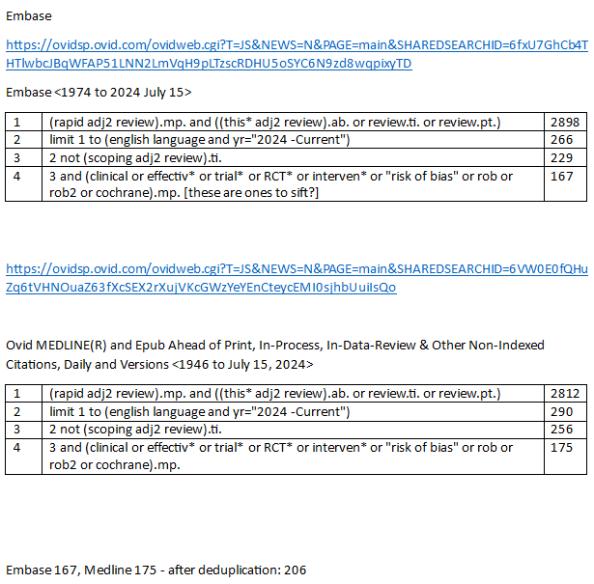

Rapid Review of Reviews Search 16/12/24
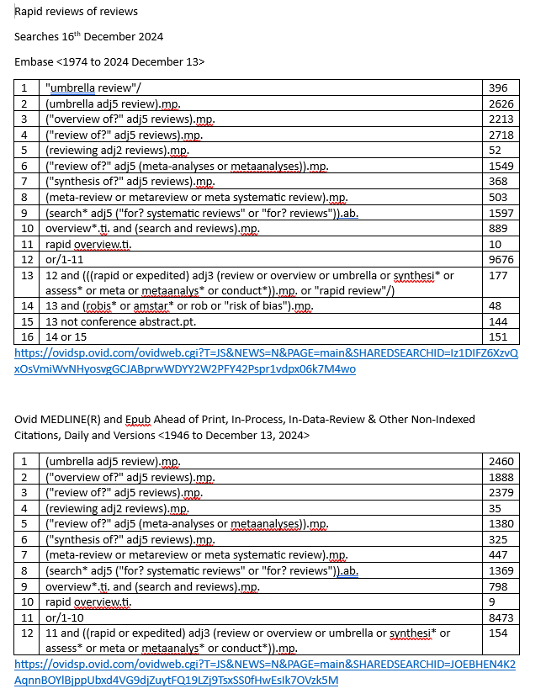

Appendix B- Exclusion Reasons

Rapid Reviews
Table 1. Exclusion reasons from the rapid review search
Exclusion reasons | Number of studies (n=156)
No RoB | 52
Doesn't include at least 1 RCT | 36
Not intervention based | 31
COVID-19 | 22
Other | 11
Scoping Review | 2
No systematic search | 2

Rapid Reviews of Reviews
Table 1. Exclusion reasons from the review of rapid reviews search
Exclusion reasons | Number of studies (n=119)
Other (not intervention based etc.) | 36
Reviews that don’t include RoB/quality appraisal | 23
Not a review of reviews | 22
COVID-19 | 16
Not rapid | 12
Conference abstracts | 5
Duplicate | 5

