Supplementary Information

Phase Engineering of Mo-V Oxides for Zinc-Ion Batteries

Experimental Procedures
Synthesis of orth-MoVO, tri-MoVO, and tetra-MoVO: 15 mmol of (NH₄)₆Mo₇O₂₄•4H₂O and 3.75 mmol of VOSO₄ were dissolved in 80 mL deionized water and poured into a 100-mL Teflon-lined stainless steel autoclave with Teflon thin sheet. Then, the solution was purged with nitrogen for 10 min and heated to 175 ºC for 48 h. The obtained grey product was purified with 0.4 M oxalic acid for 30 min at 70 ºC. After filtration, washing, and drying, the orth-MoVO was obtained. The as-prepared orth-MoVO was firstly heated to 400 ºC for 2 h in air, and then annealed at 873 K for 4 h in nitrogen to produce tetra-MoVO. For the synthesis of tri-MoVO, the pH value of the solution was mediated to 2.2 with 2 M sulphuric acid, and the reaction condition was adjusted to 175 ºC for 20 h while the other conditions were same as orth-MoVO synthesis. The orth-MoVO and tri-MoVO were annealed at 400 ºC for 4 h in air before use.
Electrochemical measurements: The electrochemical performance was evaluated with a CR2016 coin-type cell. The active material, acetylene black, and polyvinylidene fluoride (PVDF) were mixed with a mass ratio of 8:1:1 in 1-methyl-2-pyrrolidinone (NMP). After stirring for 24 h, slurry was obtained and coated on Ti foil. Subsequently, the prepared sample, Celgard 3501 membrane, and Zn foil acted as the cathode, separator, and anode, respectively. The electrolyte was 2 M of aqueous Zn(CF₃SO₃)₂. The loading mass was approximately 1.2 mg cm⁻². The CV measurement was conducted at a scan rate of 0.2 mV s⁻¹ with an electrochemical station from Princeton Applied Research. GCD and long term stability tests were carried out using a BTS 4000 (NEWARE) battery testing system.
Characterizations: SEM, TEM imaging, and EDS mapping were carried out using a field-emission scanning electron microscope (SEM, JSM-6700F, JEOL) and transmission electron microscope (JEM-F200 and JEM-ARM300F, JEOL). The ex-situ and in-situ XRD patterns were measured using a Rigaku Ultima IV diffractometer with Cu Kα radiation. The in-situ FTIR spectra were obtained using a Bruker Vertex 70v spectrometer. The XPS spectra were obtained using VG Multilab 2000 (Thermo Fisher Scientific) with monochromatized Al Kα radiation. The metallic atom ratio for the sample was obtained using ICP-AES (ICPE-9000, Shimadzu). The UV-vis diffuse reflectance spectra were characterized by a Cary 5000 UV-Vis-NIR (Agilent) spectrometer. The K-edge absorption spectra of V, Mo, and Zn were measured at room temperature with a sampling step of 3.0 eV for EXAFS.

Computational Details
The density functional theory with the Perdew-Burke-Ernzerbof (PBE) form of generalized gradient approximation functional (GGA) is used in this work.¹ The Vienna ab-initio simulation package (VASP)²⁻⁵ was employed. The plane wave energy cutoff was set as 400 eV. The electron occupancy is described by the Fermi scheme with an energy smearing of 0.1 eV. The first Brillouin zone was sampled in the Monkhorst−Pack grid with the 2×2×1 k-point mesh.⁶ The energy (converged to 1.0 ×10⁻⁶ eV/atom) and force (converged to 0.01eV/Å) were set as the convergence criterion for geometry optimization. The spin polarization was considered in all calculation. To consider the ability to accommodate Zn ion, the formation energy of Zn ion (∆E_{f}, shown in the following) embedded into the three investigated systems are employed.
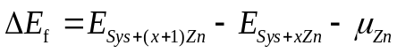 (x=0-2)
where 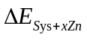and 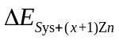are total energies of systems with xZn and (x+1)Zn, respectively. 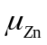 is the chemical potential of Zn, which is referred to the Zn bulk. The positive (negative) value of ∆E_{f} means the process of Zn ion embedded into the systems is favorable (unfavorable) in energy. And the more positive of ∆E_{f}, the harder for the Zn ion embedded.

Figure S1. UV-vis-NIR diffuse reflectance spectra of orth-, tri- and tetra-MoVO.
Figure S2. (a) Illustration of the temperature programming and (b) XRD patterns evolution of orth-MoVO.

Figure S3. (a) 2D pseudo-color in-situ XRD tests at increased temperature from 298 K to 873 K for orth-MoVO, (b) TG spectra of orth-MoVO from 323 K to 873 K.

The in-situ XRD spectra were processed in air under increasing temperature from 298 K to 873 K for the orth-MoVO. The temperature programming and test points of the XRD patterns are shown in Figure S4a. Figures S4b and S5a show the evolution of the XRD spectra. The XRD patterns of the orth-MoVO kept constant before 673 K. Nonetheless, the XRD patterns began to change when the temperature reached 773 K. obviously, the orth-MoVO completely converted to V₂MoO₈ and MoO₃ at 873 K (Figure S5a). Figure S5b shows the TG plot of the orth-MoVO in air. Before 673 K, the orth-MoVO lost water and ammonium amongst the tunnel structures. Then, a slight weight increase from 773 K to 873 K was induced by the oxidation of the orth-MoVO. Based on the above mentioned results, the molecular formula of the orth-MoVO can be defined as Mo_{2.55}VO_{9.43}.

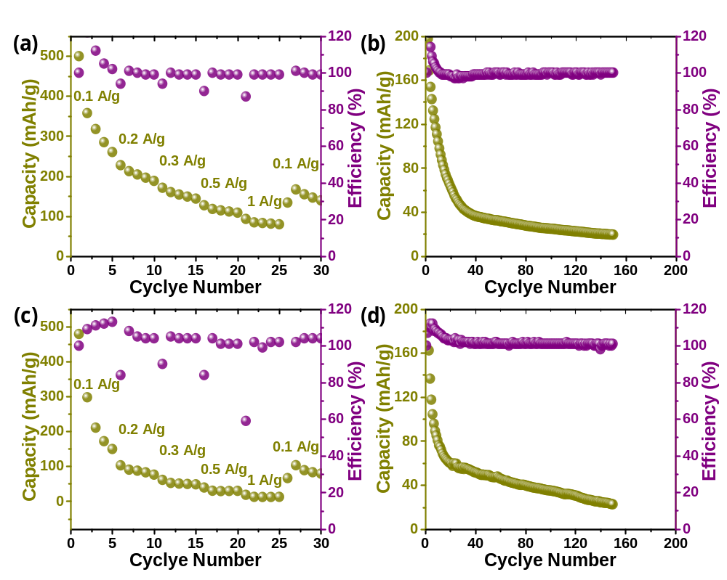
Figure S4. (a, c) Rate capability and (b, d) cyclic stability at 0.1 A g⁻¹ for (a, b) tri- and (c, d) tetra-MoVO.

Galvanostatic intermittent titration technique (GITT) were employed to analyze the kinetic behavior of materials by the following equation:
$$D_{GITT}=\frac{4}{πτ}{\left(\frac{m_{B }V_{M}}{M_{B}S}\right)}^{2}{\left(\frac{∆E_{S}}{∆E_{τ}}\right)}^{2}$$
Where $m_{B}$, $V_{M}$and $M_{B}$ are the mass, molar volume and molecular weight of the materials, respectively; $τ$is the time for an applied galvanostatic current; $S$ is the contacting area of the electrode; $∆E_{S}$ and $∆E_{τ}$ are the quasi-equilibrium potential and the change of cell voltage during the galvanostatic current pulse, respectively.

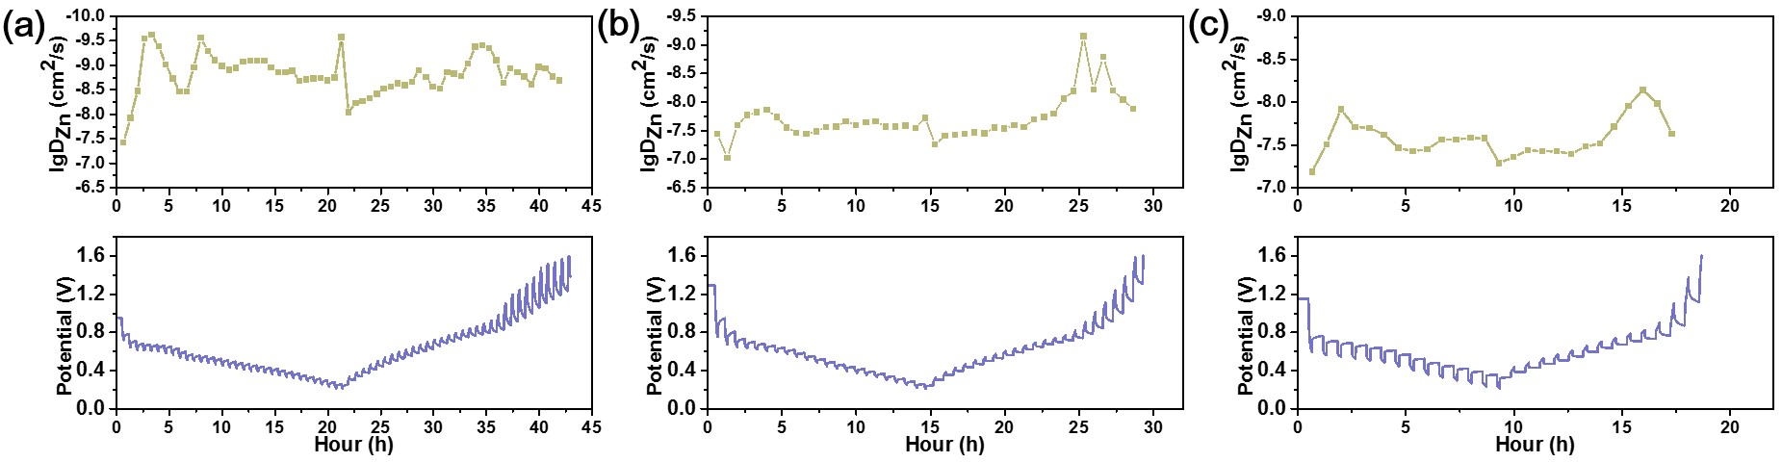
Figure S5. GITT profiles and the corresponding Zn²⁺ diffusion coefficient for the orth-, tri- and tetra-MoVO cathode.

Figure S6. GCD curves of orth-MoVO when Zn(CF₃SO₃)₂ dissolved in (a) H₂O and (b) (CN)₂.
Figure S7. (a, b) In-situ XRD patterns evolution of orth-MoVO at a discharge and charge processes.

Figure S8. In-situ FT-IR spectra evolution of orth-MoVO at the 1st discharge and charge processes.

Figure S9. K-edge FFT function spectra (a) Mo, (b) V and (c) Zn.

Figure S10. (a–e) XPS spectra of Mo from orth-MoVO at pristine, discharged-0.55 V, discharged-0.2 V, charged-0.65 V and charged-1.6 V. (f–j) XPS spectra of V from orth-MoVO at blank, discharged-0.55 V, discharged-0.2 V, charged-0.65 V and charged-1.6 V. (k–o) XPS spectra of C from orth-MoVO at blank, discharged-0.55 V, discharged-0.2 V, charged-0.65 V and charged-1.6 V.

The XPS spectra of Mo in the pristine sample were divided into two peaks centred at 231.8 and 235 eV (Figure S11a), corresponding to Mo (VI) 3d_{5/2} and Mo (VI) 3d_{3/2}. When discharged to 0.55 V, two new peaks at 231.3 and 234.4 eV emerged in the XPS spectra of Mo (V) (Figure S11b), while the peak intensity assigned to Mo (VI) decreased. At 0.2 V, the XPS peaks at 230 and 232.8 eV are attributed to the appearance of Mo (IV) (Figure S11c). Moreover, the peaks assigned to Mo (VI) weakened, while the peaks from Mo (V) strengthened. Then, the XPS peaks of Mo (V) and Mo (IV) weakened (Figure S11d) when charged to 0.65 V. Moreover, when charged to 1.6 V, the peaks from Mo (IV) disappeared, as shown in Figure S11e. The XPS signals of Mo (V) indicate the presence of Zn²⁺ in the tunnel at 1.6 V. In Figures S11f-j, the peaks centred at 516 and 523.5 eV are attributed to V (V), while the peaks at 515.5 and 522.5 eV belong to V (IV). The signals of V (IV) gradually strengthen from 0.55 to 0.2 V and weaken from 0.65 to 1.6 V. Figures S11k-o shows the C information evolution in the XPS spectra. The peak at 287.7 eV is attributed to PVDF, while the peak at 292.5 eV is attributed to CF₃. Obviously, the CF₃ information strengthened during the Zn²⁺ insertion process and weakened during the Zn²⁺ extraction process.
Figure S11. (a) EDS images of Mo, V and O from the orth-MoVO at (a) the pristine (b) discharged-0.2 V, and (c) charged-1.6 V.

Figure S12. TEM images of orth-MoVO at (a) blank, (b) 0.2 V and (c) 1.6 V.

Figure S13. Voltage-time plots of orth-MoVO (a) before and (b) after dipping in HCl.
Figure S14. (a) Cs-corrected STEM image of orth-MoVO and (b) the corresponding FFT pattern.
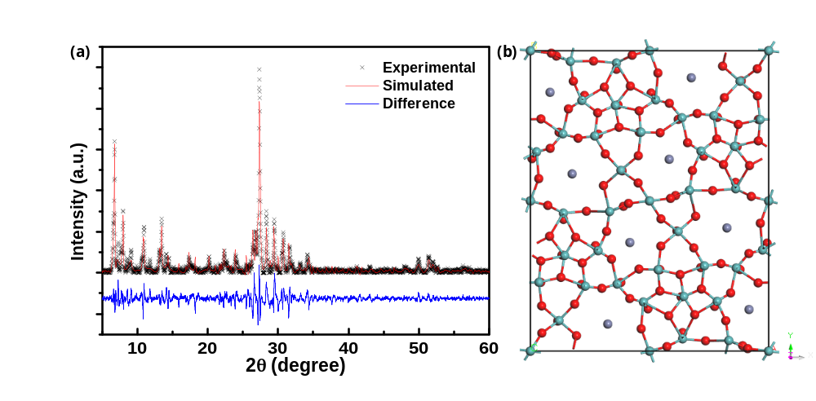
Figure S15. (a) Rietveld-refined XRD of orth-MoVO at 0.2 V and (b) the corresponding atomic structure in [001] direction.

Figure S16. The adsorption energy evolution for the possible zincation process of orth-MoVO; for (x, y), x and y represent the number of zinc in seven- and six-member rings, respectively.

Figure S17. The corresponding atomic structure in [001] direction; for (x, y), x and y represent the number of zinc in seven- and six-member rings, respectively.
Figure S18. The adsorption energy evolution for the possible zincation process of tri-MoVO; for (x, y), x and y represent the number of zinc in seven- and six-member rings, respectively.

Figure S19. The corresponding atomic structure in [001] direction; for (x, y), x and y represent the number of zinc in seven- and six-member rings, respectively.

Figure S20. (a) The adsorption energy evolution for the possible zincation process of tetra-MoVO; (b) the corresponding atomic structure in [001] direction; for (x, y), x and y represent the number of zinc in penta-member rings.
References
1. Perdew, J. P., Burke, K., Ernzerhof M. Generalized Gradient Approximation Made Simple. Phys. Rev. Lett. 77, 3865-3868 (1996).
2. Kresse, G., Furthmüller, J. Efficiency of Ab-initio Total Energy Calculations for Metals and Semiconductors Using a Plane-Wave Basis Set. Comp. Mater. Sci. 6, 15-50 (1996).
3. Kresse, G., Hafner, J. Ab initio Molecular Dynamics for Liquid Metals. Phys. Rev. B 47, 558-561 (1993).
4. Kresse, G., Hafner, J. Ab initio Molecular-Dynamics Simulation of the Liquid-Metal–Amorphous-Semiconductor Transition in Germanium. Phys. Rev. B 49, 14251-14269 (1994).
5. Kresse, G., Furthmüller, J. Efficient Iterative Schemes for Ab Initio Total-Energy Calculations Using a Plane-Wave Basis Set. Phys. Rev. B 54, 11169-11186 (1996).
6. Monkhorst, H. J., Pack, J. D. Special Points for Brillouin-Zone Integrations. Phys. Rev. B 13, 5188-5192 (1976).

