Supplementary Information for
Energy inequality under the toughest-ever clean air policy in China
Wang et al.

Table of Contents

Supplementary Note 3
Supplementary Note 1 3
Supplementary Figures 5
Supplementary Figure 1 5
Supplementary Figure 2 6
Supplementary Figure 3 7
Supplementary Figure 4 8
Supplementary Figure 5 9
Supplementary Figure 6 10
Supplementary Figure 7 11
Supplementary Figure 8 12
Supplementary Tables 13
Supplementary Table 1 13
Supplementary Table 2 14
Supplementary Table 3 15
Supplementary Table 4 16
Supplementary Table 5 17
Supplementary Table 6 18

Supplementary Note

Supplementary Note 1：Panel data regression
To understand which factors influence the household energy burden, in particular to examine the influence of the energy transition on households’ financial burden, a cross-sectional time-series dataset of household- and regional-level variables is needed. This study employed a panel pool data on 7308 households across the China in 2013, 2015, and 2017. To examine whether statistically significant relationships exist between the dependent variable (Ln Ene_burden) and independent continuous variables, we performed a series of tests as follows:
First, two types of panel unit root tests, Harris–Tzavalis (HT) (Harris and Tzavalis , 1996)¹, and Breitung (Breitung and Meyer,1994;Breitung and Das , 2005)^{2,3}, were employed to identify the stationarity of the time series. Specifically, we considered the following seven variables: household energy burden (Ln Ene_burden), family size (Ln Fam_size), the share of cost on health care and education (Ln Sha_health&education), the age of the youngest member in the household (Ln Age_child), the age of the eldest member in the household (Ln Age_adult), the penetration rate of gas facilities (Ln Pen_gas), and the share of salary in the household annual income (Ln Sha_salary). Supplementary Table 4 shows that the variables are stationary, which suggests all variables should be incorporated into the regression model.
On the basis of the existence of stationary relationship between the variables, panel data regression techniques can be used to estimate the relationship between independent and dependent variables. There are three main types of panel data models (citation), including Pooled OLS model (POLS), Fixed effects model (FE), and Random effects model (RE). POLS ignores the time and individual characteristics and focuses only on dependencies between the individuals, which is inappropriate for our objective. The FE-model determines individual effects of unobserved and independent variables as constant over time, which can be defined as:
$y_{it}{=α_{i}+β*x}_{it}+ε_{it}$(1)
where $y_{it}$ is the dependent variable; the $x_{it}$ is the matrix with the independent variables, and $α_{i}$ denotes the individual effects, namely, the unknown intercept for each entity; $ε_{it}$ is error terms; i=1, …,N represents the number of households in the panel, t=1, 2,3 refers to the surveyed year. By contrast, individual effects of unobserved and independent variables are defined as random over time in RE-model, and the model can be expressed as follows:
$y_{it}{=β*x}_{it}+{α+μ}_{it}+ε_{it}$(2)
where $μ_{it}$ is the between-entity error.
To determine which model is appropriate for this study, we conducted the Hausman test in Stata 15, which is calculated by estimating RE and FE and then comparing the estimates. The results are shown in Supplementary Table 5. The Hausman test result suggests that $μ_{it}$ is not correlated with the regressors, indicating the FE-model is more appropriate for our study. Therefore, FE-model was chosen to explore the relationship between household energy burden and its determining factors.
Finally, the robustness test was conducted based on the entire sample, as well as on the four regions (East, Northeast, Middle and West). Based on prior studies, we defined the four regions in terms of geographical proximity and economic development stage; we integrated the “northeast” into the “middle” region, considering the difference between the two regions is not obvious. As shown in Supplementary Tables 6, the regression results for the three regions are reasonably consistent with those from the entire sample. However, we also find that there is a dramatic difference in the impact of energy transition on household energy burden among three regions. The results for the east sample indicate that the effect of energy transition significantly differs between the rural and urban households, which is consistent with the results for the whole sample. But for the middle and the west, this feature is not statically significant.

Supplementary Figures
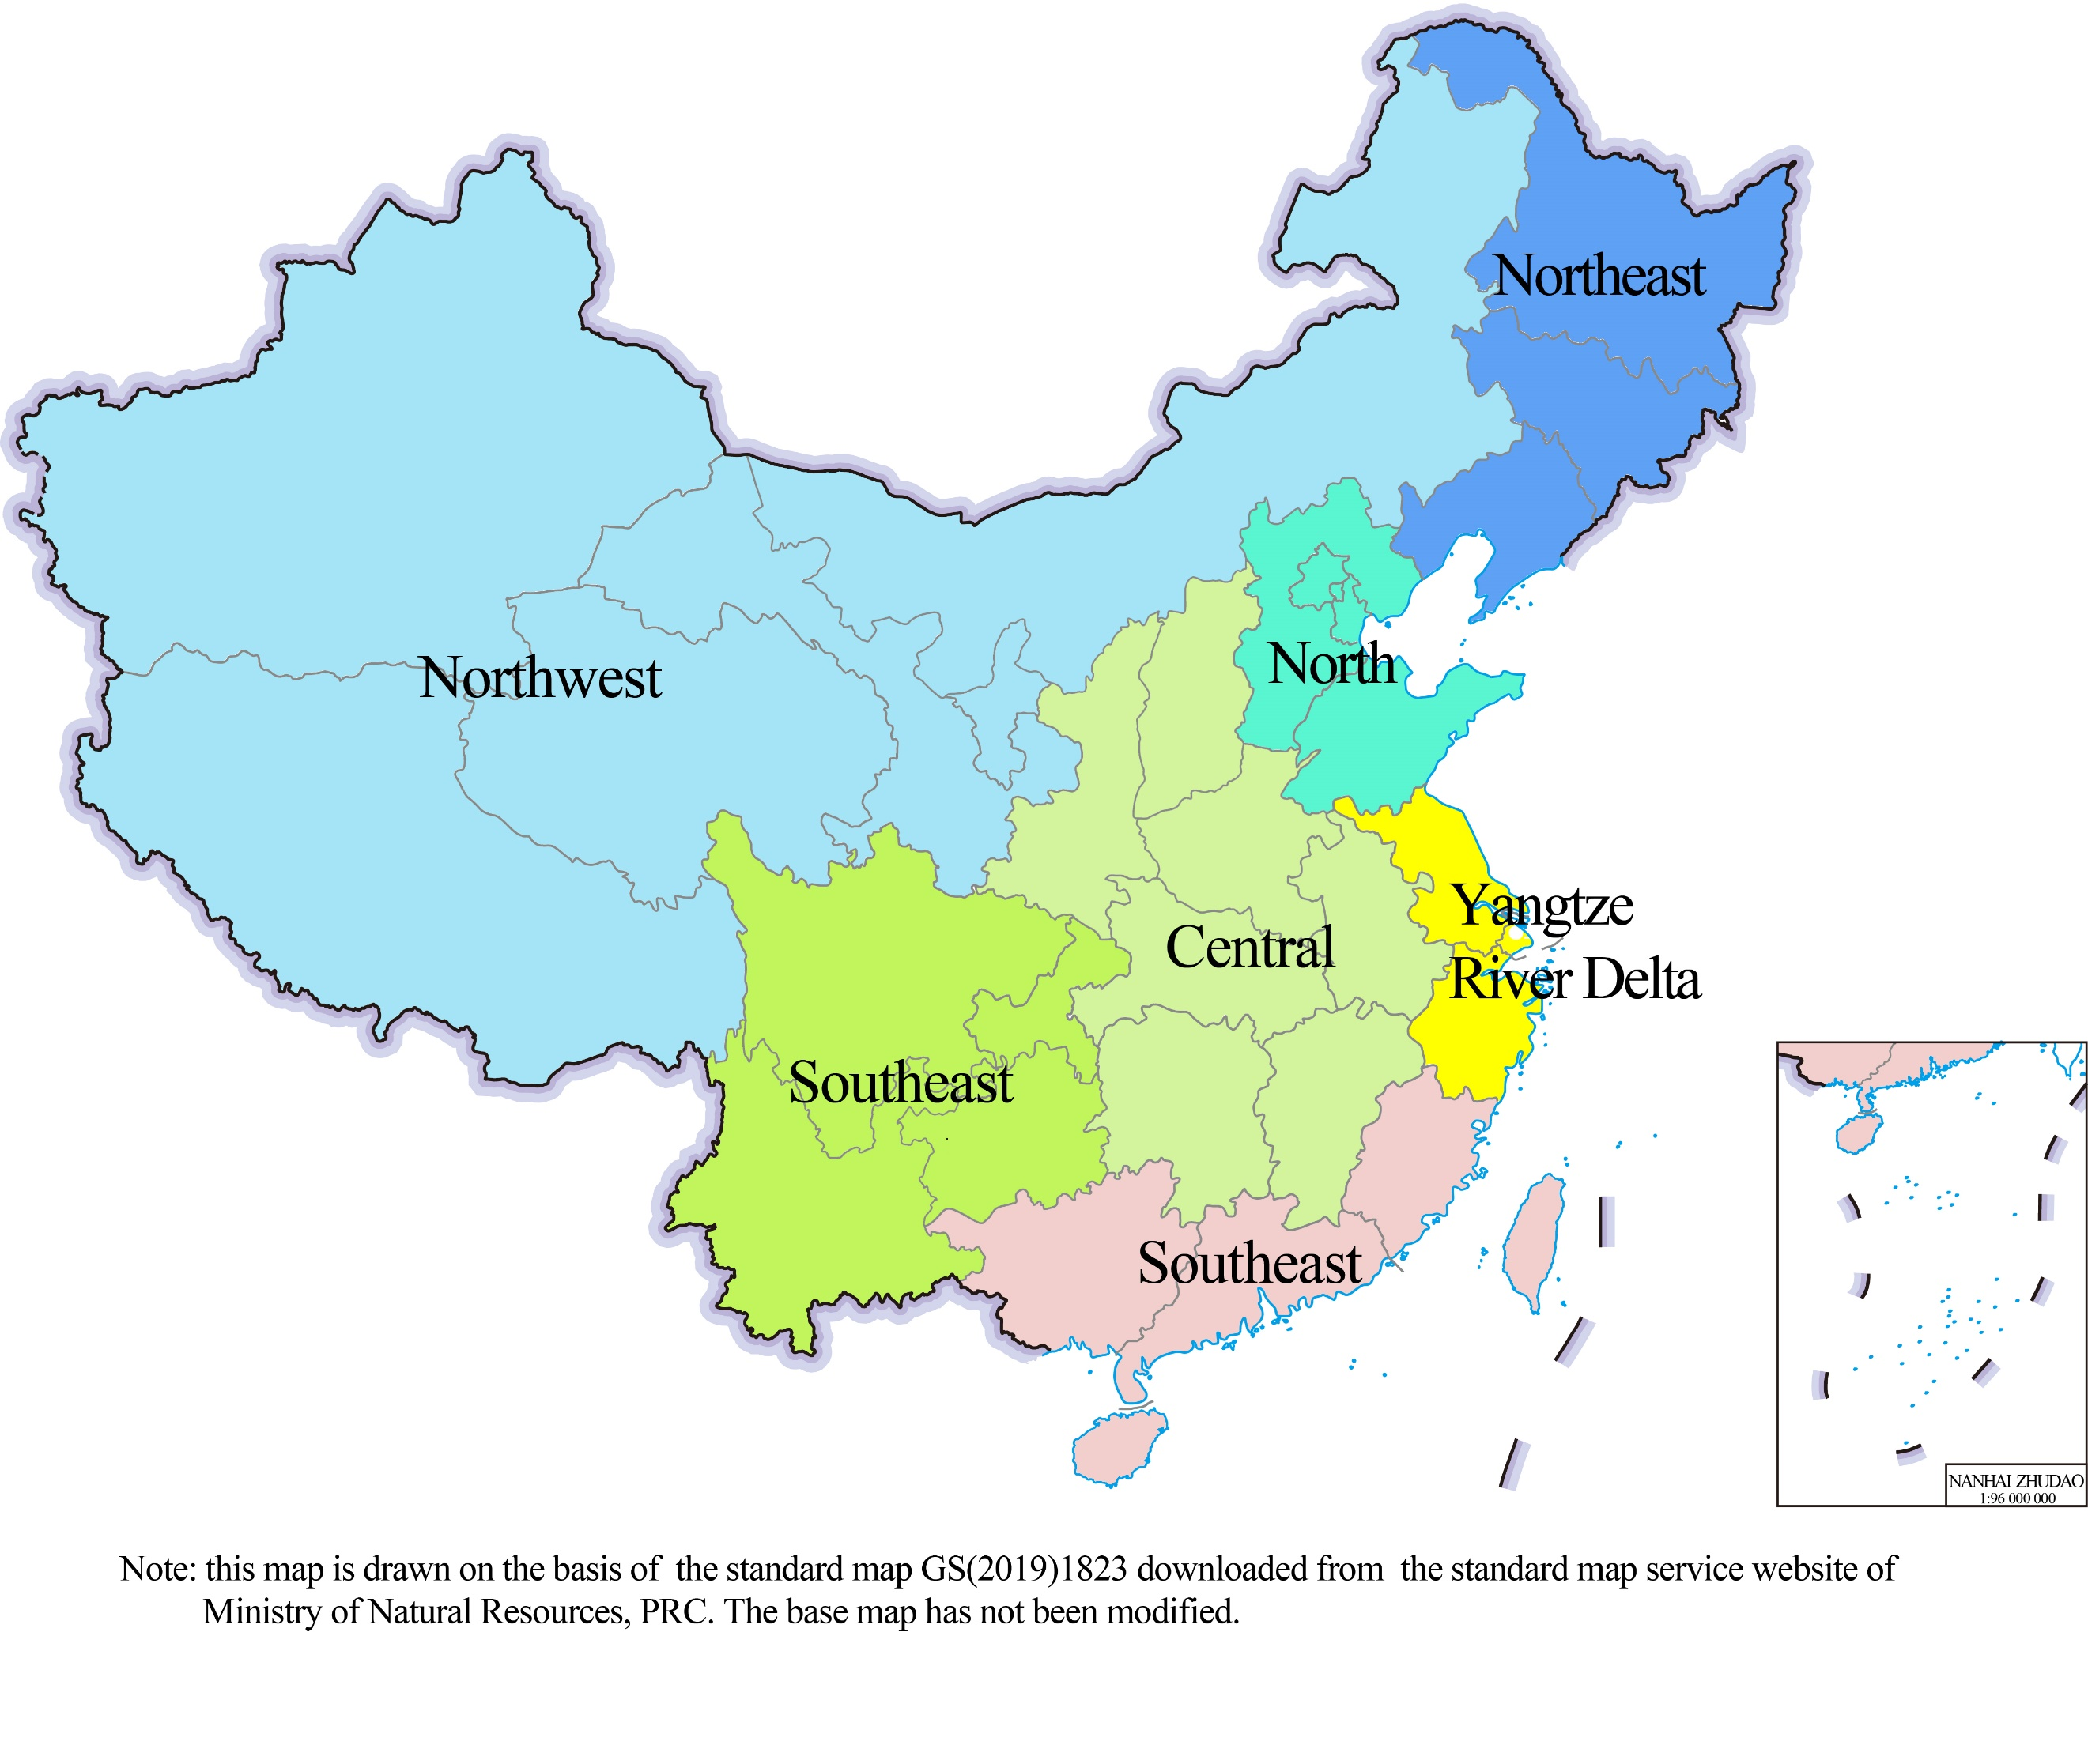 |  | 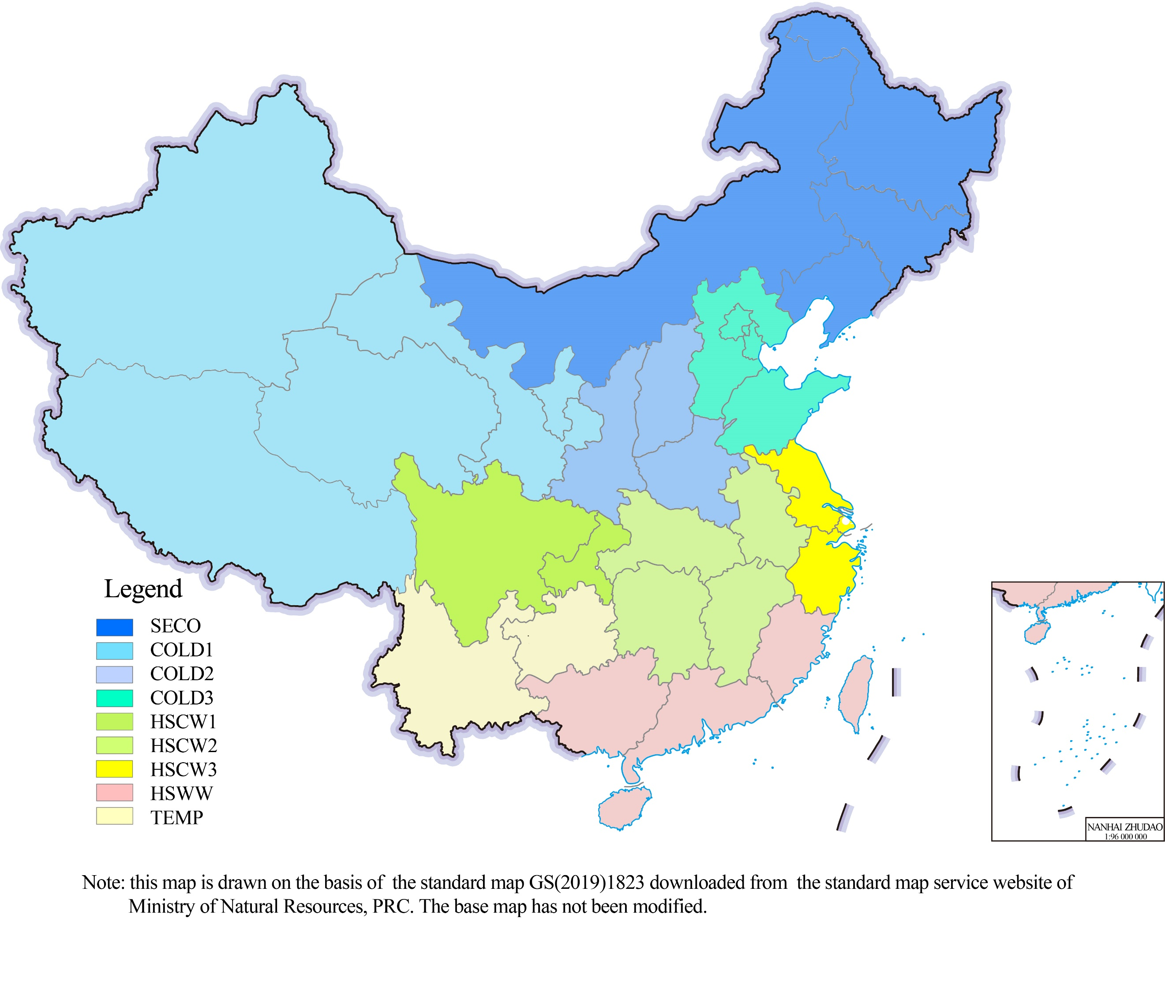
a |  | b
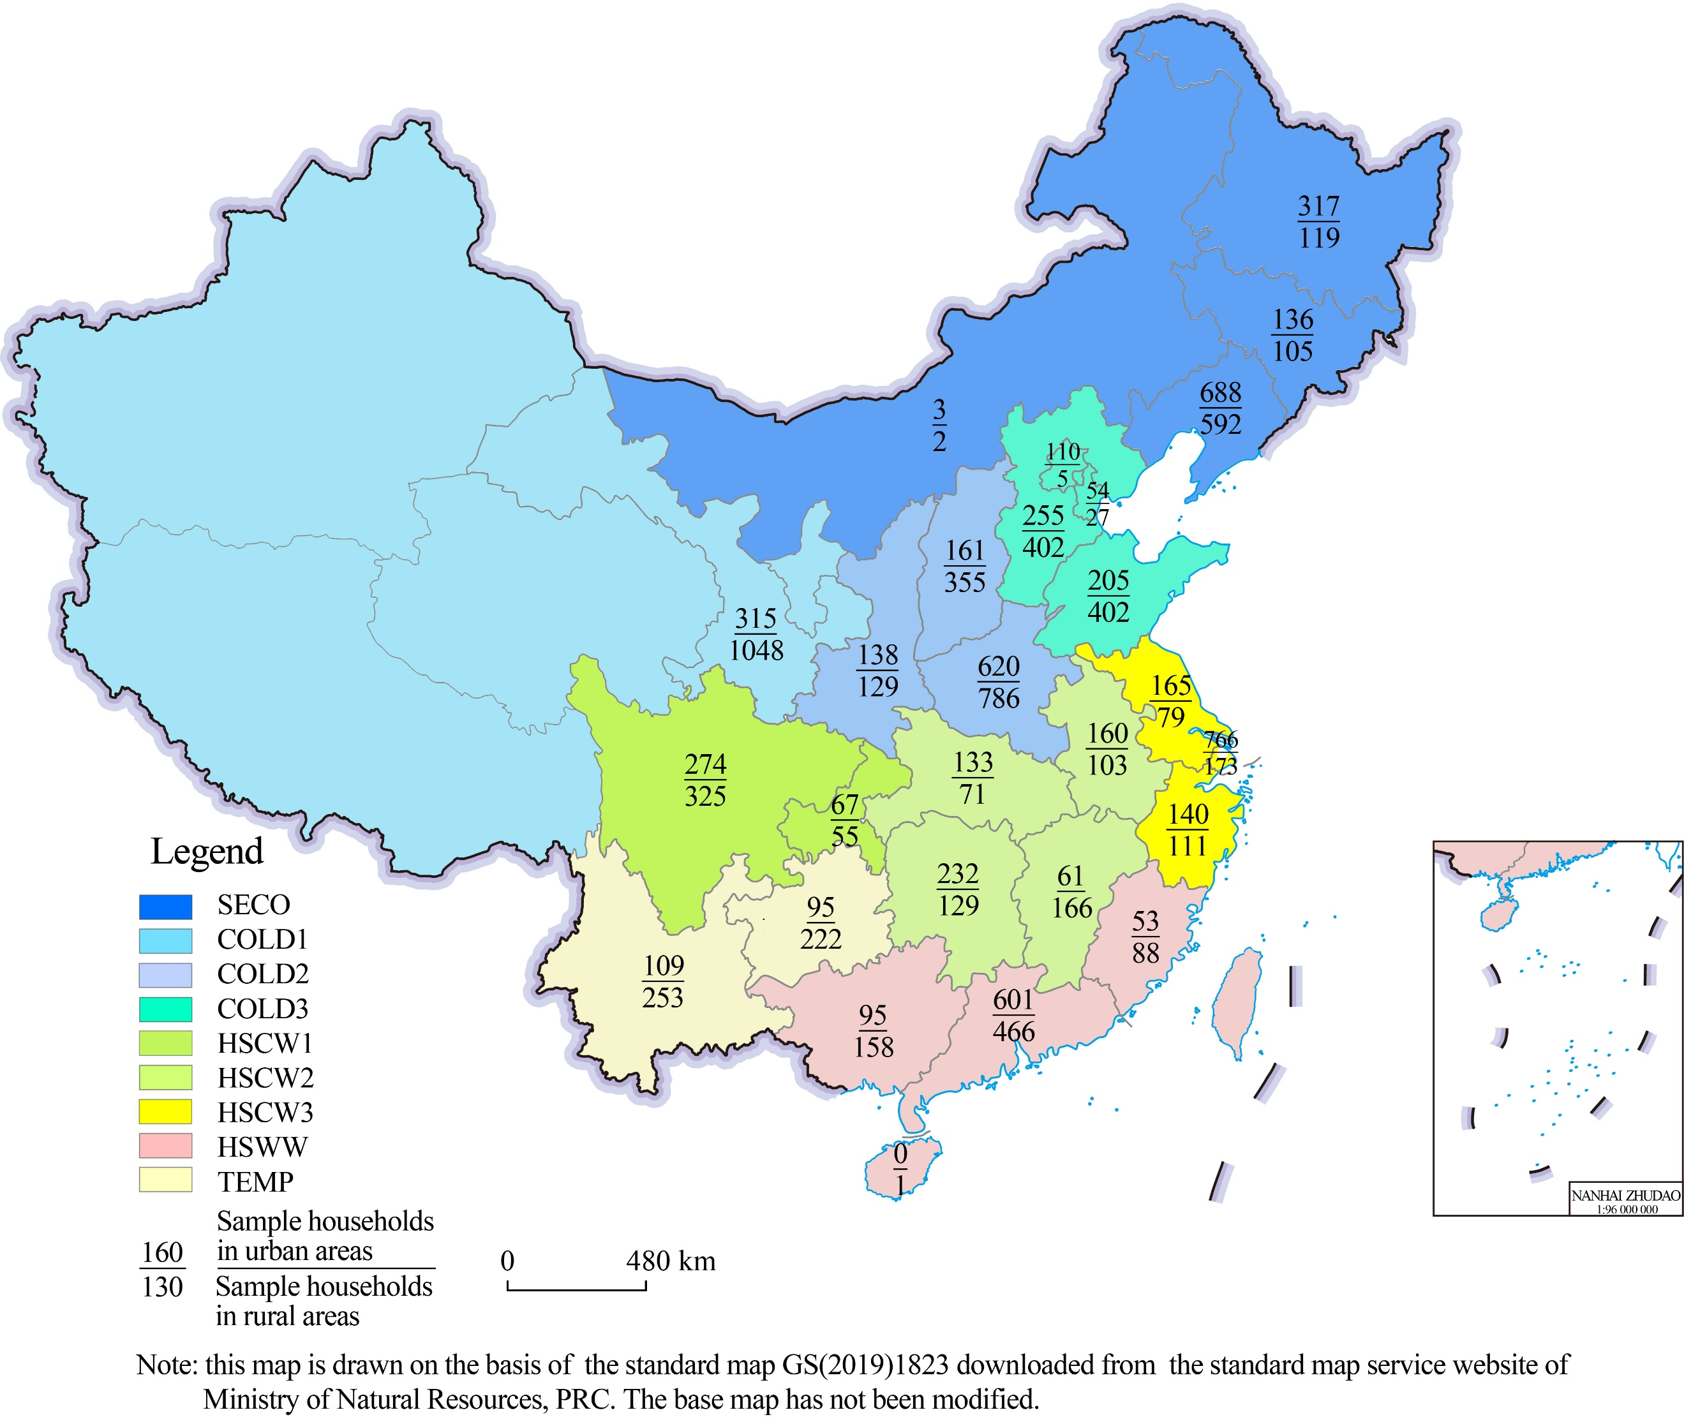 | 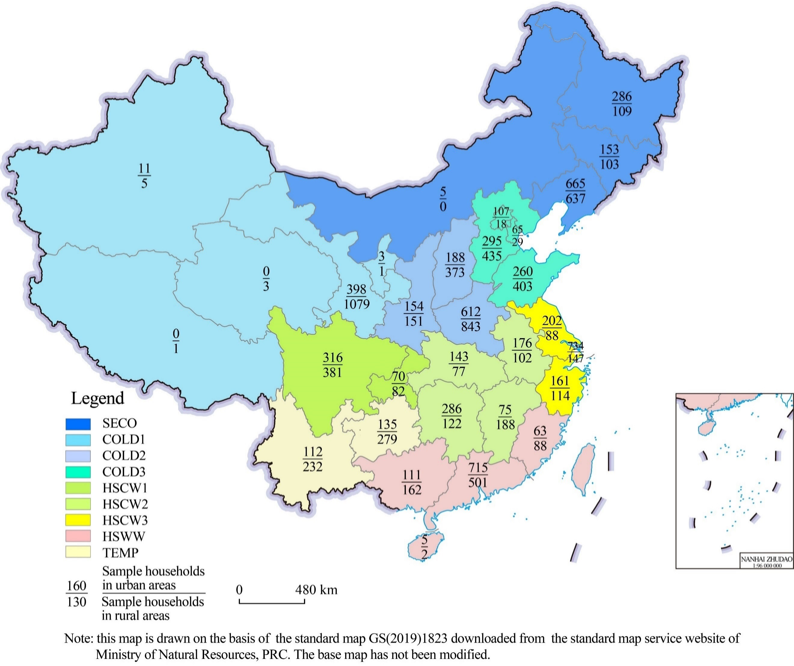 |  | 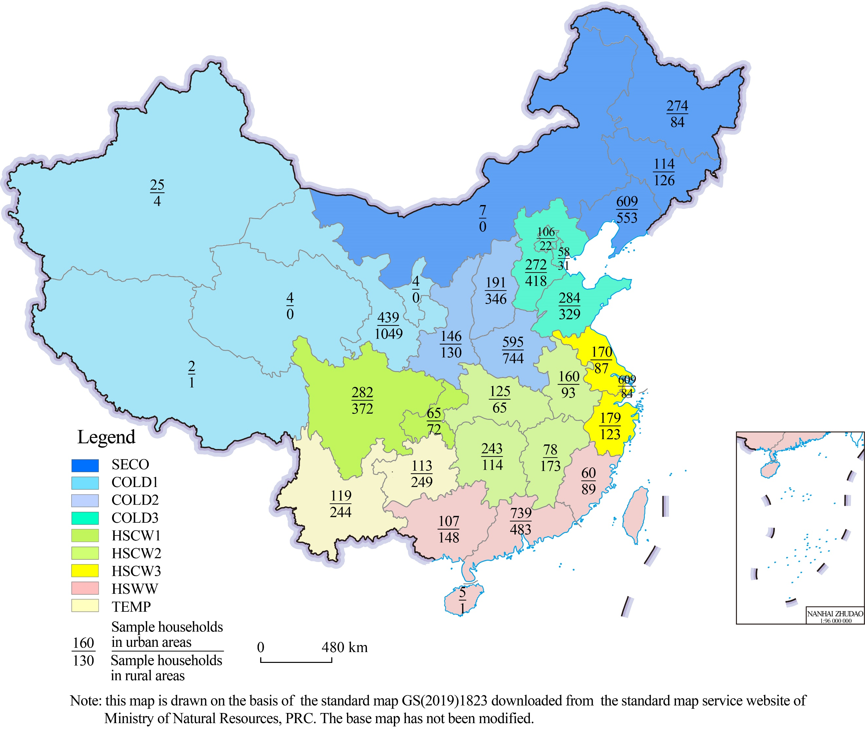
c | d |  | e
Supplementary Figure 1 | Region definitions and sample distribution. a. Classification of regions based on geographical proximity and economic development stage at the provincial scale; b. Regrouping A out of consideration for the regional differences in climate condition.; c. Geographical distribution of sample at the provincial level in 2013; d. Geographical distribution of sample at the provincial level in 2015; e. Geographical distribution of sample at the provincial level in 2017.

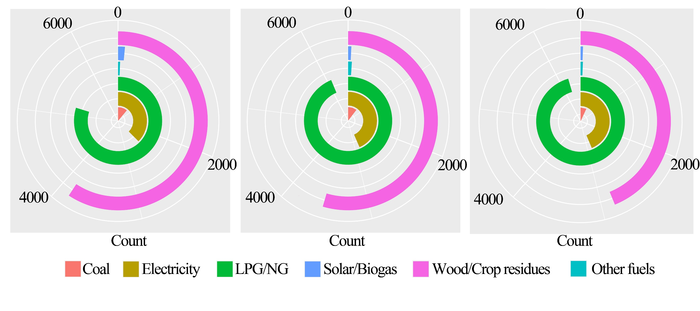
a b c
Supplementary Figure 2 | Household energy use pattern in 2013(a), 2015(b), and 2017(c). The number in the figures means the sample size of surveyed households by fuel types.

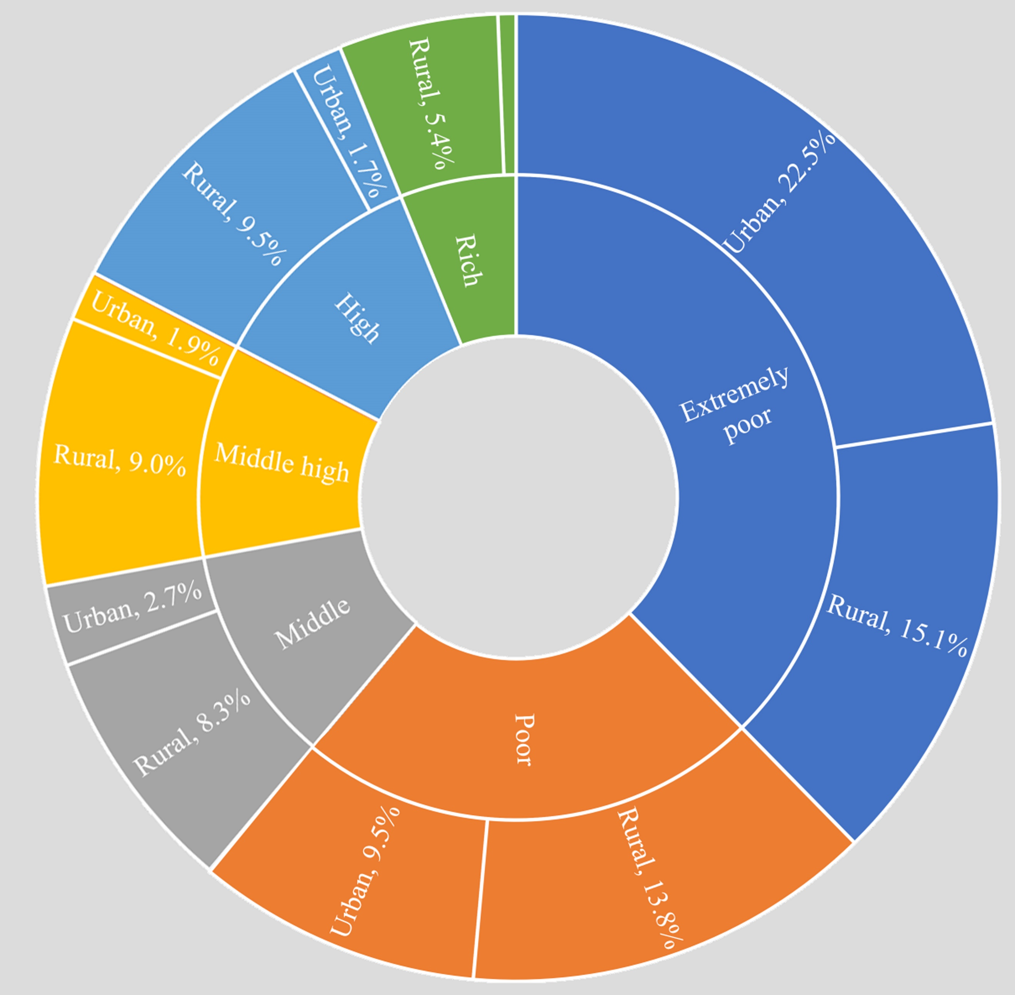
Supplementary Figure 3 | Share of households that underwent energy transition by income groups, during 2013-2017. Each income group is divided into urban- and rural subgroup, and the latter accounted for more than three fifths of the total.

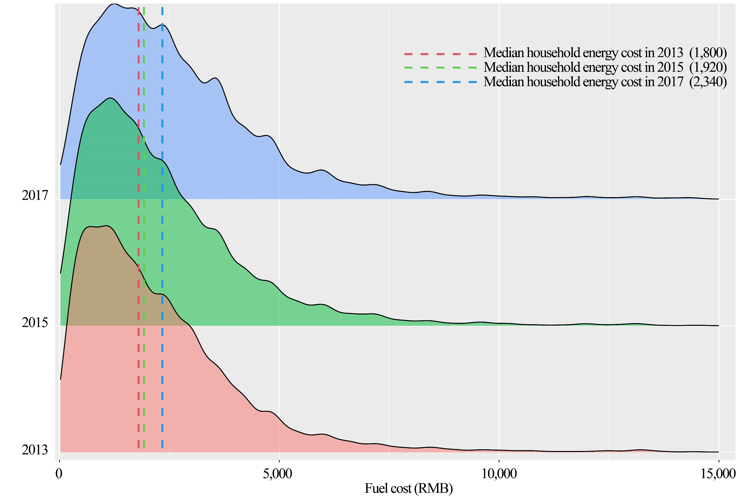
Supplementary Figure 4 | Density curves of household energy cost in 2013, 2015, and 2017.

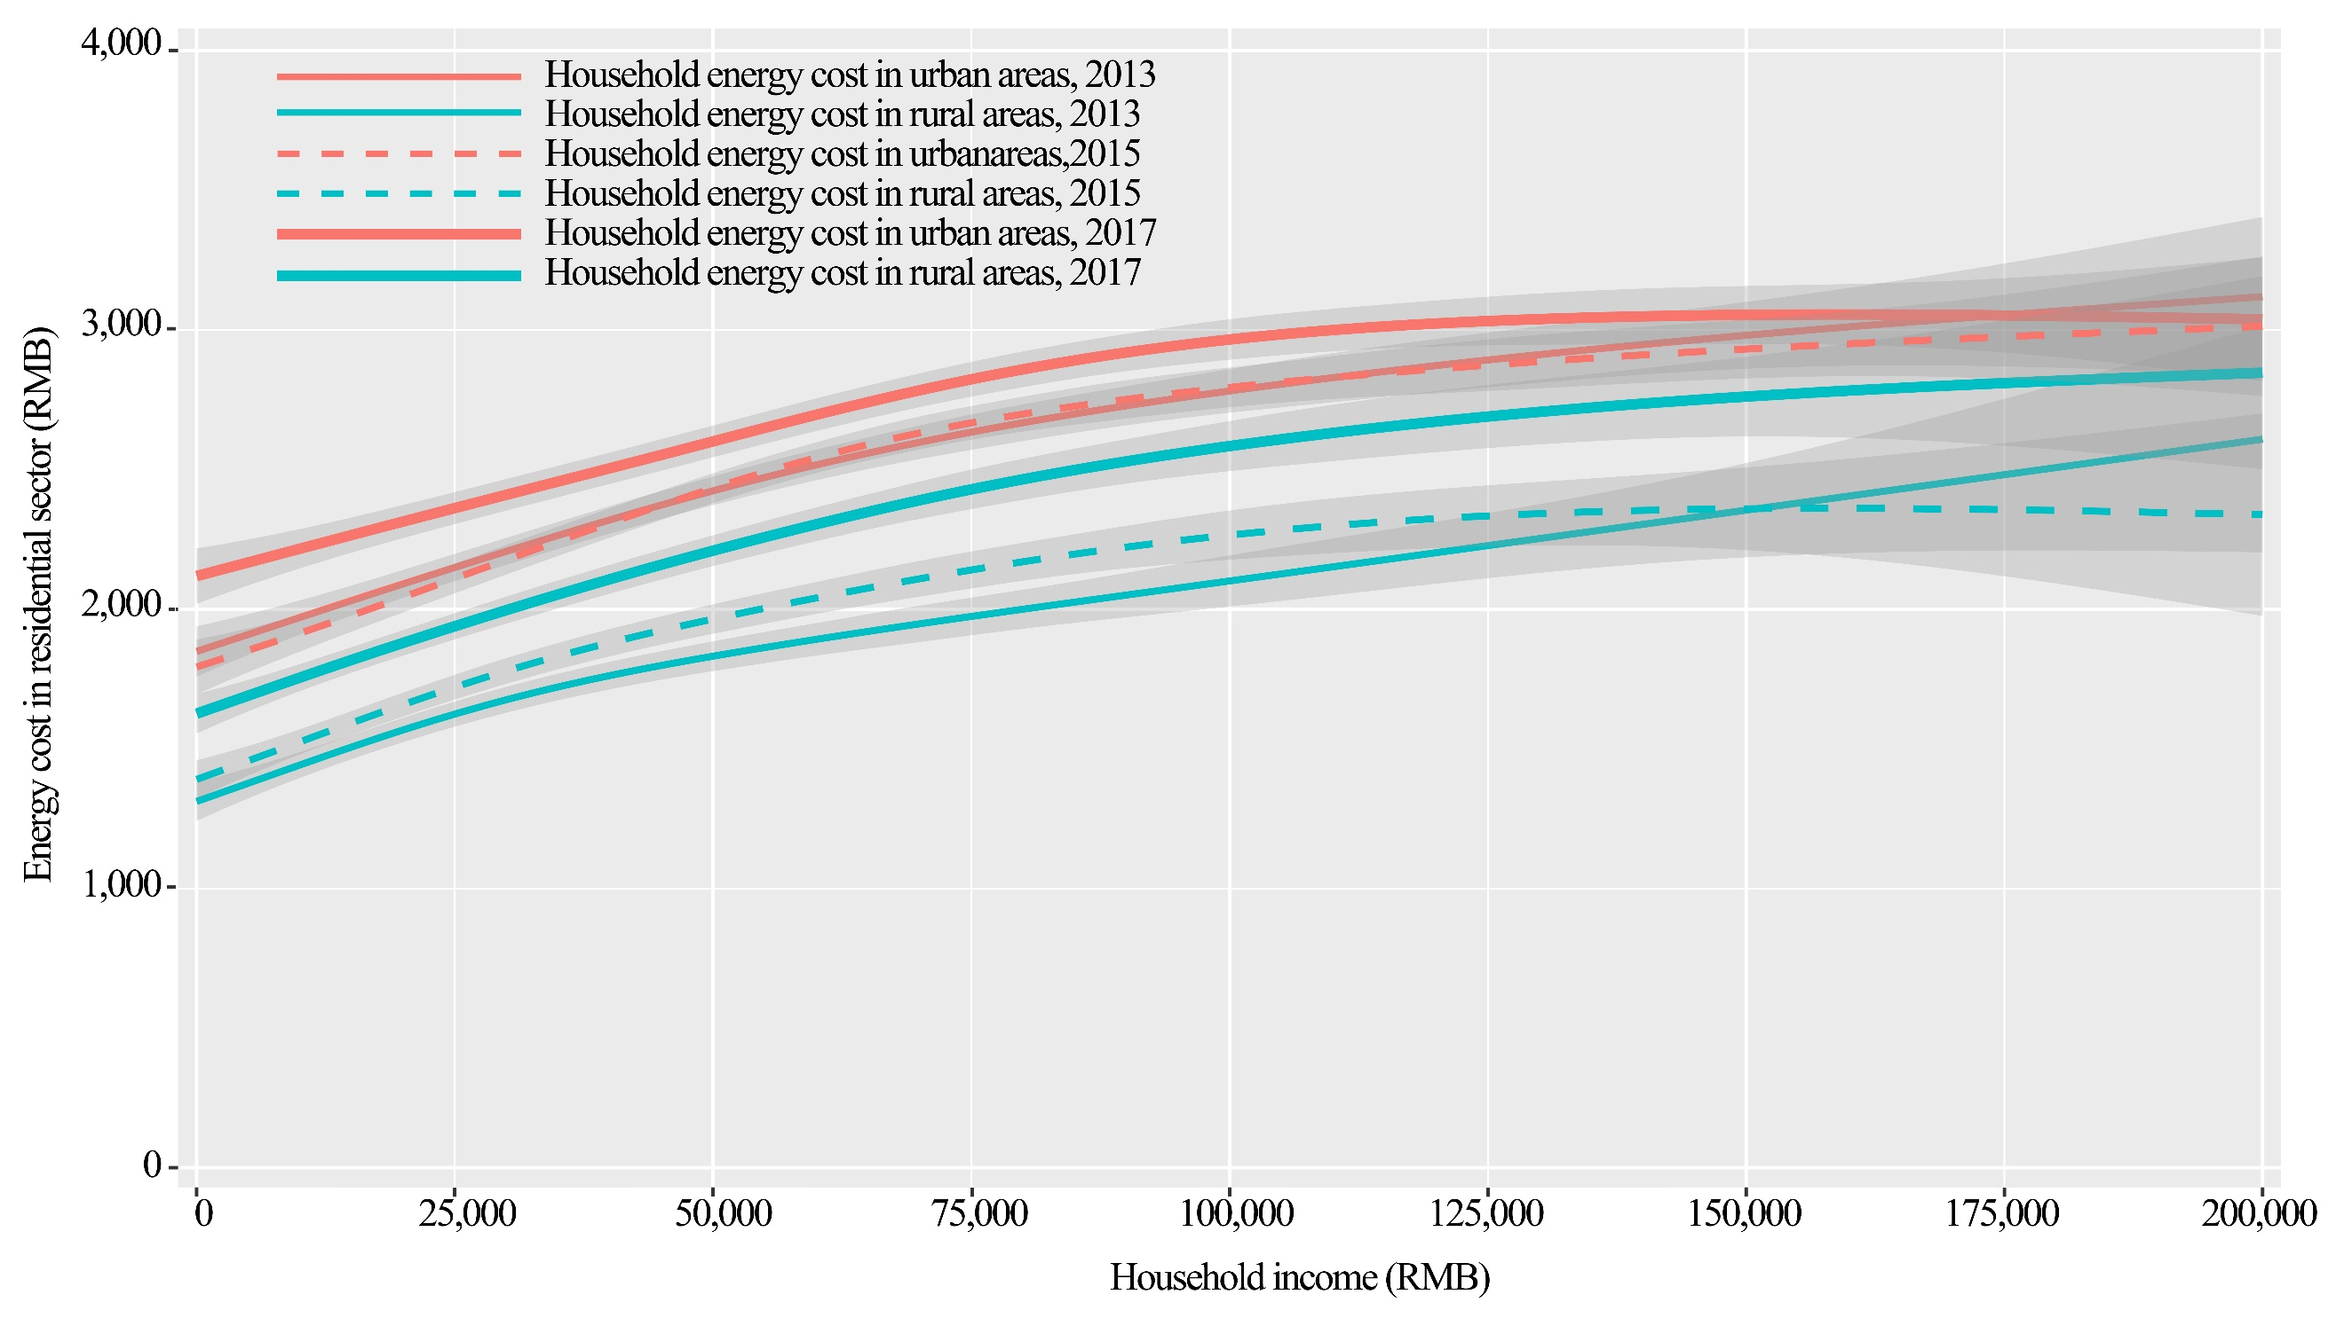
Supplementary Figure 5 | Relationship between household income and energy cost during 2013-2017.

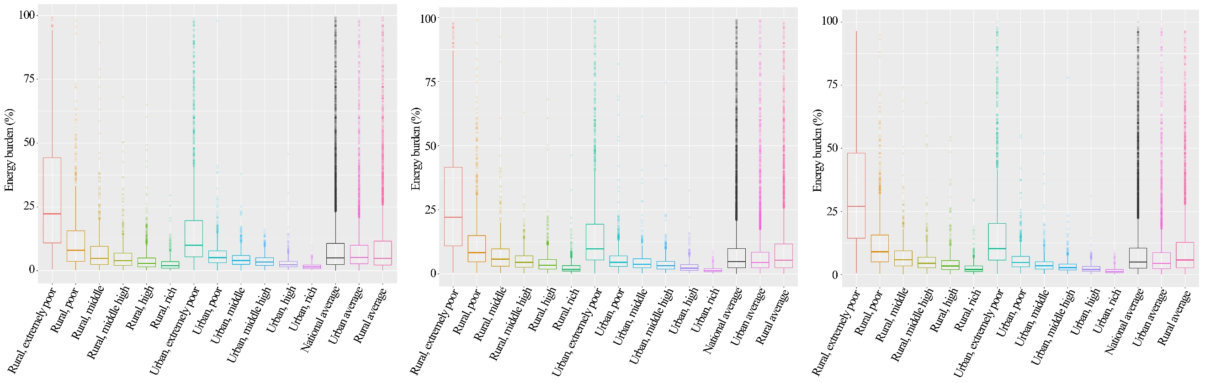
a b c
Supplementary Figure 6 | Household energy burden by income groups in 2013(A), 2015(B), and 2017(C). Each box plot shows the three-number summary of a set of data: including the first (lower) quartile, median, and third (upper) quartile. From these three figures, it can be found that the average household spent about 5% (the median) of its income on energy during 2013-2017, significantly higher than that of U.S. households (about 3.3%)⁴. In 2017, China’s urban and rural households spend 5.8% and 4.4% of their income on energy cost, respectively, higher than the U.S households ( 4.4% and 3.6%)⁵

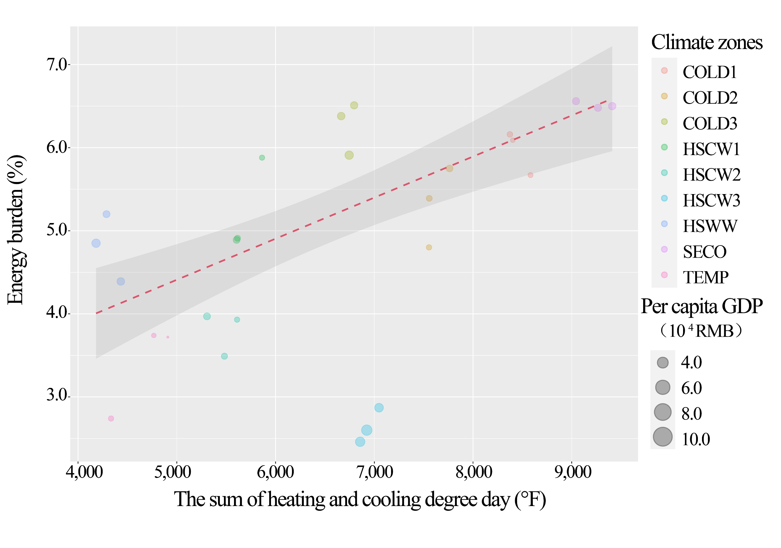
Supplementary Figure 7 | Household energy burden and the sum of HDD (Heating degree days) and CDD (Cooling degree days) at the regional scale. Regional energy burden is measured by the median for each region. In this figure, the definition of the abbreviation for each region can be found in Supplementary Table 2.

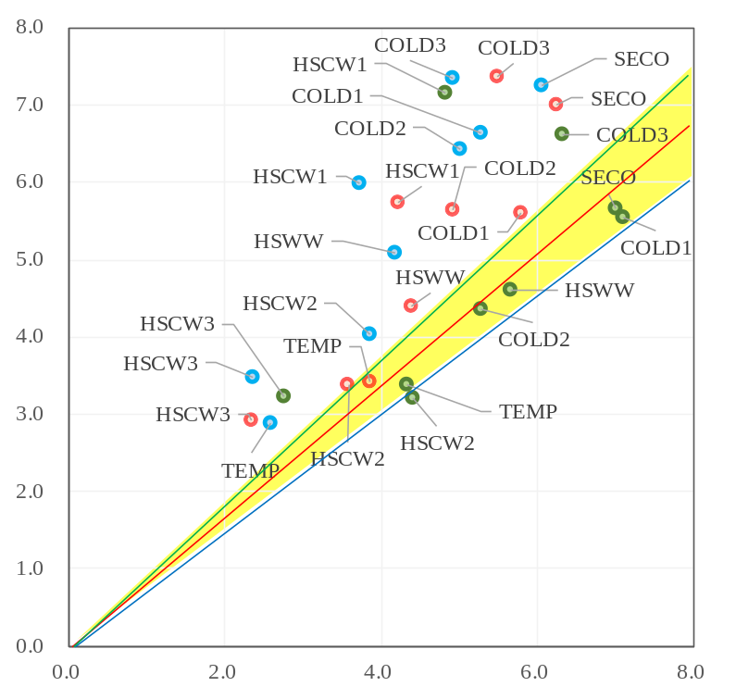
Median rural household energy burden (%)
Median urban household energy burden (%)

Supplementary Figure 8 | Household energy burden by regions. The green, red, and blue dots represent the distribution patterns in 2013, 2015, and 2017, respectively. The blue, red, and green lines represent straight lines with slopes of 0.9,1.0, and 1.1. Therefore, we define the dots in the yellow area are regions with equivalent urban and rural energy burden. Specifically, urban-rural gap widens considerably, the ratio of rural- to urban household energy burden is 1.61. Followed by COLD3 (the north with cold winter) and HSCW3 (Yangtze River Delta with hot summer and cold winter), this ratio reaches as high as 1.47. By contrast, the central with hot summer and cold winter has the smallest urban-rural disparity in energy burden, the ratio of rural- to urban household energy burden is 1.05.

Supplementary Tables
Supplementary Table 1 | Household income per capita across income groups in 2013, 2015, and 2017. (Unit: RMB)
Income group | Urban households |  |  | Rural households
Income group | 2013 | 2015 | 2017 | 2013 | 2015 | 2017
Extremely poor | ≤9895.9 | ≤12230.9 | ≤13723.1 | ≤2887.9 | ≤3085.6 | ≤3301.9
Poor | (9895.9, 17628.1] | (12230.9, 21446.2] | (13723.1, 24550.1] | (2887.9, 5965.6] | (3085.6, 7220.9] | (3301.9, 8348.6]
Middle | (17628.1,24172.9] | (21446.2, 29105.2] | (24550.1, 33781.3] | (5965.6, 8438.3] | (7220.9, 10310.6] | (8348.6, 11978.0]
Middle high | (24172.9, 32613.8] | (29105.2, 38572.4] | (33781.3, 38572.4] | (8438.3, 11816.0] | (10310.6,14537.3] | (11978.0, 16943.6]
High | (32613.8, 57762.1] | (38572.4, 65082.2] | (38572.4, 77097.2] | (11816.0,21323.7] | (14537.3, 26013.9] | (16943.6, 31299.3]
Rich | >57762.1 | >65082.2 | >77097.2 | >21323.7 | >26013.9 | >31299.3

Supplementary Table 2 | Region definition
Climate zone | Region | Provinces/municipalities included in each region
Severe cold winter (SECO) | Northeast (SECO) | Liaoning, Jilin, Heilongjiang, and Inner Mongolia
Cold winter (SECO) | Northwest (COLD1) | Gansu, Qinghai, Ningxia, and Xinjiang
Cold winter (SECO) | Central(COLD2) | Shannxi, Shanxi, and Henan
Cold winter (SECO) | North(COLD3) | Beijing, Tianjin, Hehei, and Shandong
Hot summer and cold winter (HSCW) | Southwest(HSCW1) | Sichuan, Chongqing
Hot summer and cold winter (HSCW) | Central(HSCW2) | Anhui, Hubei, Hunan and Jiangxi
Hot summer and cold winter (HSCW) | Yangtze River Delta(HSCW3) | Shanghai, Jiangsu and Zhejiang
Hot summer and warm winter  (HSWW) | Southeast(HSWW) | Guangxi, Hainan, Guangdong, and Fujian
Temperate weather (TEMP) | Southwest(TEMP) | Yunnan and Guizhou

Supplementary Table 3 | Decomposition of Gini coefficient by region.(%)
Region | In 2013 | In 2015 | In 2017
COLD1 | 2.0% | 2.2% | 2.0%
COLD2 | 2.6% | 1.9% | 2.1%
COLD3 | 1.3% | 1.5% | 1.7%
HSCW1 | 0.3% | 0.4% | 0.3%
HSCW2 | 0.6% | 0.6% | 0.7%
HSCW3 | 1.2% | 1.1% | 1.0%
HSWW | 1.4% | 1.5% | 1.9%
SECO | 2.5% | 2.3% | 2.1%
TEMP | 0.2% | 0.3% | 0.3%
Between effect | 21.6% | 16.2% | 16.5%
Overlap effect | 66.3% | 71.9% | 71.5%

Supplementary Table 4 | Panel unit root test results
Variables | Harris–Tzavalis test | Breitung test
Ln Ene_burden | -0.491***  (-88.163) | -9.445***
Ln Fam_size | -0.502  (-89.463) | -15.861***
Ln Sha_health&education | -0.486  (-87.582) | -15.400 ***
Ln Age_child | -0.489  (-88.019) | -16.239***
Ln Age_adult | -0.515  (-91.108) | -17.095***
Ln Pen_gas | -0.493  (-88.434) | -16.942***
Ln Sha_salary | -0.498  (-89.085) | -17.508***
Note: This table reports the panel unit root test results for each continuous variable using Harris–Tzavalis test and Breitung test. As shown in the second column, the number above is the rho-statistic in Harris–Tzavalis test, and the number in brackets below is its z value. In the third column, the number is the lambda-statistic in Breitung test. *** P<0.01; ** P<0.05; * P<0.1

Supplementary Table 5 | Hausman test results
Variables | FE-model |  |  |  | RE-model
Variables | Coef. | St.Err. | t-value | p-value | Coef. | St.Err. | t-value |  | p-value
Ln Fam_size | 0.212 | 0.018 | 11.93 | 0.000 | 0.174 | 0.016 | 11.21 |  | 0.000
Ln Sha_health&education | 0.046 | 0.005 | 8.37 | 0.000 | 0.061 | 0.005 | 12.73 |  | 0.000
Ln Age_child | -0.006 | 0.01 | -0.6 | 0.555 | 0.007 | 0.009 | 0.74 |  | 0.461
Ln Age_adult | -0.109 | 0.018 | -6.19 | 0.000 | -0.1 | 0.015 | -6.64 |  | 0.000
Ln Pen_gas | 0.056 | 0.007 | 8.45 | 0.000 | 0.025 | 0.006 | 4.58 |  | 0.000
Ln Sha_salary | -0.227 | 0.005 | -43.25 | 0.000 | -0.271 | 0.004 | -62.66 |  | 0.000
Constant | 2.385 | 0.077 | 30.83 | 0.000 | 2.582 | 0.067 | 38.68 |  | 0.000
R-squared  Number of obs  F-test  Prob > F  Akaike crit. (AIC)  Bayesian crit. (BIC) | 0.129  21924  361.943  0.000  51384.633  51440.600 |  |  |  | Overall r-squared  Number of obs  Chi-square  Prob > chi2  R-squared within  R-squared between |  |  | 0.177  21924  4271.081  0.000  0.127  0.248
Hausman test
Chi-square test value 304.556
P-value 0.000

Supplementary Table 6 | Robustness test results based on three regions.
Variable | entire sample | The east | The middle | The west
Ln Fam_size | 0.235***  (12.96) | 0.177***  (4.92) | 0.347***  (11.21) | 0.171***  (8.04)
Ln Sha_health&education | 0.047***  (8.28) | 0.062***  (5.89) | 0.0547***  (5.75) | 0.011***  (1.69)
Ln Age_child | -0.008  (-0.77) | -0.020  (-0.95) | 0.0196  (1.25) | 0.011  (0.59)
Ln Age_adult | -0.101***  (-6.10) | -0.146***  (-4.82) | -0.183***  (-5.38) | -0.047***  (-3.60)
Ln Pen_gas | 0.047***  (5.09) | 0.028  (1.67) | 0.052***  (3.66) | 0.066***  (4.85)
Ln Sha_salary | -0.228***  (-33.04) | -0.233***  (-22.81) | -0.259***  (-24.32) | -0.039**  (-2.99)
Tra | -0.849***  (-20.55) | -0.739***  (-10.48) | 0.147***  (3.61) | 0.181***  (5.22)
Cli | -0.097***  (-11.28) | -0.100***  (-5.76) | -0.075***  (-5.11) | -0.103***  (-10.35)
Tra_Rur | 1.067***  (26.05) | 1.004***  (14.39) | 0.040  (0.97) | 0.041  (1.41)
Tra_Urb | 1.021***  (22.98) | 0.908***  (11.77) | 0  (.) | 0  (.)
Constant | 2.456***  (30.76) | 2.949***  (20.13) | 2.556***  (17.53) | 1.297***  (12.07)
Number of objects | 21924 | 7029 | 9624 | 5271

Supplementary References:
- Harris, R.& Tzavalis, E. Inference for Unit Roots in Dynamic Panels (No. 9604), Discussion Papers. University of Exeter, Department of Economics (1996).
- Breitung, J.& Das, S. Panel unit root tests under cross-sectional dependence. Statistica Neerlandica 59, 414–433(2005).
- Breitung, J.& Meyer, W. Testing for unit roots in panel data: are wages on different bargaining levels cointegrated? Applied Economics 26, 353–361(1994).
- Drehobl, A. & Ross L. Lifting The High Energy Burden In America’s Largest Cities: How Energy Efficiency Can Improve Low Income And Underserved Communities (American Council for an Energy-Efficient Economy, Energy Efficiency for All, 2016); https://www.energyefficiencyforall.org/resources/lifting-the-high-energy-burden-in-americas-largest-cities-how-energy/.
- Ross, L., Drehobl, A. & Stickles, B. The High Cost of Energy in Rural America: Household Energy Burdens and Opportunities for Energy Efficiency (American Council for an Energy Efficient Economy, 2018).

