Group Model Building Session

A detailed internal agenda guided the session from 8:00 AM to 12:30 PM in Supplemental Table 1.
Supplemental Table 1: Group Model Building Schedule
 | Time | Activity
Part 1 | 8:00 – 8:05 | Project Overview
Part 1 | 8:05 – 8:25 | Initial Problem Framing
Part 1 | 8:25 – 8:45 | Introductions
Part 2 | 8:45 – 8:55 | Summary of Initial Problem Framing
Part 2 | 8:55 – 9:20 | Creating a Basic Stock and Flow Diagram
Part 2 | 9:20 – 9:40 | Break + Gallery Walk
Part 3 | 9:40 – 9:50 | Creating a Complex Stock and Flow Diagram
Part 3 | 9:50 – 10:45 | Creating More Complex Diagrams in Groups
Part 3 | 10:45 – 10:55 | Break
Part 3 | 10:55 – 12:10 | Group Presentations and Discussion
Part 3 | 12:10 – 12:30 | Final Problem Framing Activity

Part 1: Introduction
The session began with a brief project overview. Following this, all participants were asked to complete an initial survey, containing questions related to their role in the mental health crisis system, followed by an initial-problem framing exercise. The protocol for this exercise is aligned with that recommended by Fokkinga et al.³⁰ Each survey asked participants to identify a central workforce challenge, articulate potential causes, describe the effects of the challenge, and propose solutions (See Supplemental File 6). This design allowed for a before-and-after comparison of how participants understood the mobile crisis workforce pipeline. Later, additional demographic information was requested for participants via email.
Participant introductions followed, during which facilitators simultaneously worked in the background on two tasks: 1) creating an AI-generated synopsis of the initial-problem framing exercise, designed to help participants begin to see mobile crisis workforce issues from a system-wide perspective, and 2) creating a preliminary “stock list” based on the key problem they identified in the initial-problem framing exercise, upon which participants could build individual stock and flow diagrams.

Part 2: Individual Activity and Broadening Perspectives
The results of the AI synopsis were presented to the group. This was followed by a brief tutorial on creating a basic stock-and-flow diagram, which drew on an external healthcare workforce example for illustrative purposes. Then, participants were shown the “stock list”, and the group briefly discussed key stocks that were not present on the list that needed to be added. Participants were then given time to create their own stock-and-flow diagrams based on the stock of their choosing from the list. Variables that impacted the stocks, shown in grey in Supplemental Figure 1, were used as qualitative observations in the analysis for this study.
Next, participants were given a break and asked to look at the diagrams created by other members of the group during a “gallery walk.” Participants were also given access to results of the Program 590 monthly meeting data collection, which were preliminarily coded and sub-coded with AI assistance. This allowed participants to see variables and policies related to their stock-and-flow diagrams, further pushing them towards a system perspective during the gallery walk and complex model building activities.

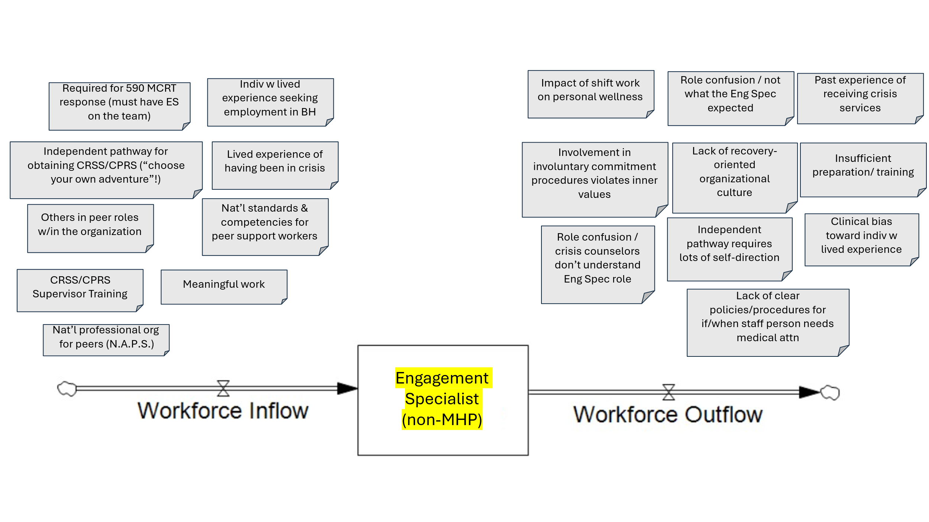
Supplemental Figure 1: A Stock and Flow Diagram Generated During Group Model Building
BH = Behavioral Health; CRSS = Certified Recovery Support Specialist; CPRS = Certified Peer Recovery Specialist; Eng Spec = Engagement Specialist; MCRT = Mobile Crisis Response Team; MHP = Mental Health Professional; NAPS = National Association of Peer Supporters

Part 3: Complexity and Discussion
The session then shifted to a tutorial on creating more complex diagrams, followed by small-group work in which participants built more detailed stock-and-flow models for either Engagement Specialists or MHPs. During this time, facilitators used Stella Architect to create diagrams live,³¹ starting with the system structure (i.e. stocks and flows), and then moving to variables and policies that may impact the system. After a brief break, facilitators from both small groups presented their respective models to the full group, and changes were made to the models based on feedback from group members. Finally, the floor was opened for discussion on key issues that became clear following the creation of the models. The morning concluded with participants repeating the problem framing activity.
Comments made during complex model building, as well as the subsequent discussion, were summarized by the first author to create additional qualitative observations used in this study.

