Supplementary Materials
Table S1. Summary of soil physicochemical properties under different nitrogen treatments (N0, N1, N2).
Soil variable | Treatment | Range | CV (%) | N0 vs N1 | N0 vs N2
Soil pH | N0 | 4.94 - 5.52 | 4.9 | ns | ns
Soil pH | N1 | 4.64 - 5.4 | 6.1 | ns | ns
Soil pH | N2 | 4.7 - 5.21 | 4 | ns | ns
Total carbon (SOC, mg/g) | N0 | 64.13 - 191.15 | 62.3 | ns | ns
Total carbon (SOC, mg/g) | N1 | 86.57 - 154.34 | 29.4 | ns | ns
Total carbon (SOC, mg/g) | N2 | 91.22 - 255.05 | 46.5 | ns | ns
Total nitrogen (TN, mg/g) | N0 | 5780.05 - 7761.68 | 10.7 | * | *
Total nitrogen (TN, mg/g) | N1 | 7067.68 - 8637.78 | 7.9 | * | *
Total nitrogen (TN, mg/g) | N2 | 8095.75 - 12747.4 | 18.7 | * | *
Total phosphorus (TP, mg/g) | N0 | 851.71 - 1696.16 | 34.3 | ns | ns
Total phosphorus (TP, mg/g) | N1 | 983.22 - 1474.04 | 17.1 | ns | ns
Total phosphorus (TP, mg/g) | N2 | 1020.22 - 1592.53 | 21.6 | ns | ns
Total potassium (TK, mg/g) | N0 | 9866.08 - 13401.89 | 11.8 | ns | ns
Total potassium (TK, mg/g) | N1 | 10648.68 - 13323.53 | 8.7 | ns | ns
Total potassium (TK, mg/g) | N2 | 7663.38 - 13511.85 | 27.2 | ns | ns
Available nitrogen (AN, mg/kg) | N0 | 522.38 - 906.94 | 22.8 | ns | ns
Available nitrogen (AN, mg/kg) | N1 | 480.51 - 796.35 | 24.1 | ns | ns
Available nitrogen (AN, mg/kg) | N2 | 515.48 - 1153.21 | 33.7 | ns | ns
Available potassium (AK, mg/kg) | N0 | 92.51 - 370.28 | 80.8 | ns | ns
Available potassium (AK, mg/kg) | N1 | 88.43 - 200.59 | 37.4 | ns | ns
Available potassium (AK, mg/kg) | N2 | 86.28 - 309.33 | 45.1 | ns | ns
Available phosphorus (AP, mg/kg) | N0 | 6.68 - 10.49 | 18.9 | ns | *
Available phosphorus (AP, mg/kg) | N1 | 4.46 - 27.56 | 77.8 | ns | *
Available phosphorus (AP, mg/kg) | N2 | 10.92 - 24.57 | 33.6 | ns | *
Soil water content (WC, %) | N0 | 87.1 - 100 | 5.8 | ns | **
Soil water content (WC, %) | N1 | 73.9 - 100 | 12.3 | ns | **
Soil water content (WC, %) | N2 | 57.2 - 76.8 | 11.7 | ns | **
Electrical conductivity (EC, ds/m) | N0 | 1.18 - 1.78 | 16.1 | ns | *
Electrical conductivity (EC, ds/m) | N1 | 1.07 - 1.29 | 9.4 | ns | *
Electrical conductivity (EC, ds/m) | N2 | 0.73 - 1.29 | 20 | ns | *
Table S2. Summary of principal component analysis (PCA) of soil physicochemical properties.
Metric | Soil PC1 | Soil PC2 | Soil PC3
Eigenvalue | 7.28 | 0.89 | 0.66
Proportion Explained (%) | 72.8 | 8.91 | 6.56
Cumulative Proportion (%) | 72.8 | 81.72 | 88.28
Loading scores
PH | 0.27 | 0.27 | -0.2
Soil Organic Carbon (SOC) | -0.36 | -0.06 | -0.07
Total Nitrogen (TN) | -0.34 | 0.3 | -0.09
Total Phosphorus (TP) | -0.34 | -0.27 | -0.13
Total Potassium (TK) | 0.34 | 0.21 | -0.06
Available Nitrogen (AN) | -0.34 | -0.27 | 0.04
Available Potassium (AK) | -0.33 | -0.3 | -0.07
Available Phosphorus (AP) | -0.29 | 0.36 | 0.36
Soil Moisture Content (WC) | 0.27 | -0.51 | -0.44
Electrical Conductivity (EC) | 0.25 | -0.4 | 0.77
Table S3. Loadings of plant functional traits on the first two principal components (PC1 and PC2) derived from PCA of six traits of Deyeuxia angustifolia. PC1 and PC2 together explained 81.72% of the total trait variation. PC1 (56.88%) represents the fast–slow resource-use gradient, mainly driven by leaf and root C:N and N:P ratios. PC2 (28.62%) reflects the aboveground–belowground allocation gradient, dominated by trade-offs between root stoichiometry and biomass allocation (AGB/BGB).
Loading scores | PC1 | PC2
Proportion Explained (%) | 56.88 | 28.62
Cumulative Proportion (%) | 56.88 | 85.50
Loading scores
LCN | 0.53 | 0.08
LNP | -0.53 | -0.33
RCN | -0.44 | 0.48
RNP | 0.38 | -0.54
AGB/BGB | -0.33 | -0.61
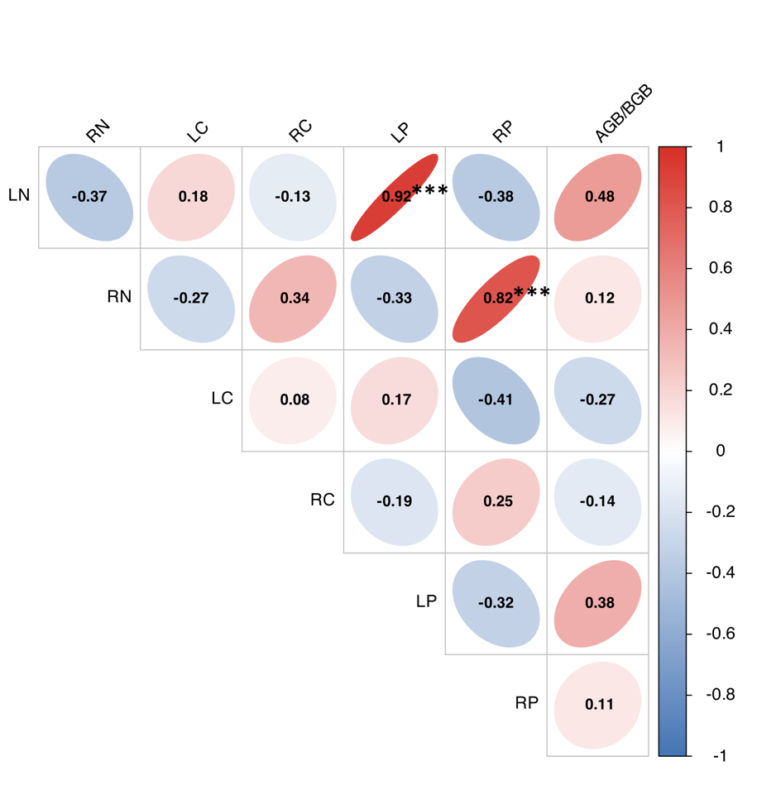
Figure S1. Trait–trait correlation structure for the dominant sedge species across all nitrogen treatments. Ellipse orientation and color represent the direction and magnitude of Pearson correlations (n = 15 samples). Leaf and root C:N:P ratios formed two partially orthogonal clusters, whereas the whole‐plant allocation ratio (AGB/BGB) showed moderate associations with both leaf N:P and rootN:P, suggesting coordinated above–belowground nutrient adjustments. 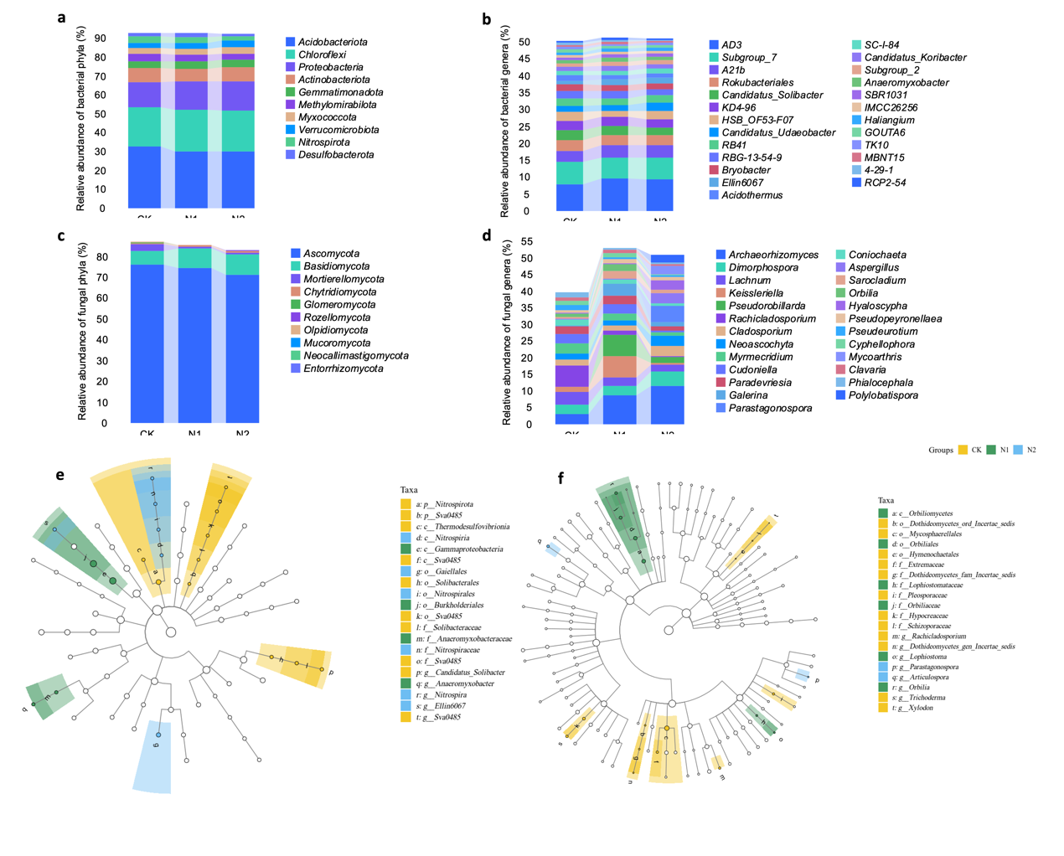
Figure S2. (a–d) Relative abundance of dominant bacterial and fungal taxa at the phylum and class levels across treatments (N0, N1, N2). Nitrogen addition altered the proportional representation of several microbial groups, particularly within Proteobacteria, Actinobacteriota, and Ascomycota, although the direction and magnitude of responses varied among lineages.(e–f) Linear discriminant analysis effect size (LEfSe) identifies differentially enriched bacterial (e) and fungal (f) taxa among treatments. Taxa highlighted in yellow, green, and blue correspond to biomarkers significantly associated with N0, N1, and N2, respectively (LDA score > 3.5). These biomarkers reflect treatment-specific shifts in microbial functional potentials and nutrient processing pathways.

Table S4. Divergent responses of bacterial communities to plant economic
traits and soil gradients
 | Overall bacteria |  |  | Generalist bacteria |  | Specialist bacteria |  | Putative N-cycling bacteria |  |  | Putative redox-related  bacteria
 | R² |  | P | R² | P | R² | P |  | R² | P | R² | P
Soil PC1 | 0.35 |  | 0.08 | 0.00 | 0.96 | 0.00 | 0.89 |  | 0.08 | 0.29 | 0.08 | 0.29
Soil PC2 | 0.08 | 0.60 |  | 0.42 | 0.01* | 0.21 | 0.06 | 0.25 |  | 0.07 | 0.25 | 0.05
Soil PC3 | 0.14 | 0.42 |  | 0.00 | 1.00 | 0.00 | 0.99 | 0.03 |  | 0.51 | 0.03 | 0.54
LN | 0.02 | 0.84 |  | 0.10 | 0.25 | 0.03 | 0.48 | 0.18 |  | 0.12 | 0.18 | 0.13
RN | 0.06 | 0.67 |  | 0.01 | 0.76 | 0.01 | 0.79 | 0.10 |  | 0.24 | 0.10 | 0.27
LC | 0.53 | 0.01* |  | 0.04 | 0.48 | 0.01 | 0.83 | 0.11 |  | 0.23 | 0.11 | 0.25
RC | 0.00 | 0.97 |  | 0.08 | 0.31 | 0.03 | 0.55 | 0.23 |  | 0.08 | 0.23 | 0.08
LP | 0.04 | 0.75 |  | 0.00 | 0.83 | 0.01 | 0.77 | 0.02 |  | 0.65 | 0.02 | 0.64
RP | 0.04 | 0.81 |  | 0.00 | 0.84 | 0.00 | 0.98 | 0.04 |  | 0.49 | 0.04 | 0.53
AGB/BGB | 0.15 | 0.36 |  | 0.00 | 0.98 | 0.00 | 0.91 | 0.04 |  | 0.45 | 0.04 | 0.47
Table S5. Divergent responses of fungal communities to plant economic
traits and soil gradients
 | Overall  fungi |  | Generalist  fungi |  | Specialist  fungi |  | Putative P-cycling  fungi
 | R² | P | R² | P | R² | P | R² | P
Soil PC1 | 0.33 | 0.10 | 0.01 | 0.74 | 0.01 | 0.76 | 0.01 | 0.79
Soil PC2 | 0.29 | 0.12 | 0.04 | 0.45 | 0.08 | 0.32 | 0.11 | 0.24
Soil PC3 | 0.13 | 0.42 | 0.03 | 0.56 | 0.02 | 0.63 | 0.13 | 0.19
LN | 0.26 | 0.14 | 0.08 | 0.30 | 0.09 | 0.28 | 0.00 | 0.96
RN | 0.20 | 0.25 | 0.01 | 0.66 | 0.07 | 0.35 | 0.01 | 0.67
LC | 0.18 | 0.30 | 0.01 | 0.74 | 0.02 | 0.67 | 0.06 | 0.37
RC | 0.04 | 0.76 | 0.07 | 0.31 | 0.04 | 0.46 | 0.35 | 0.02*
LP | 0.16 | 0.36 | 0.11 | 0.23 | 0.09 | 0.30 | 0.25 | 0.05
RP | 0.10 | 0.48 | 0.04 | 0.46 | 0.04 | 0.49 | 0.03 | 0.55
AGB/BGB | 0.49 | 0.02* | 0.13 | 0.19 | 0.25 | 0.06 | 0.17 | 0.14

Table S6. Best predictors explaining the variation in the relative abundance of specific functional groups of bacteria and fungi across nitrogen treatments.The table reports the coefficient of determination (adjusted R²) of the best-fitting model (lowest AICc), together with the regression coefficients (Estimate) and t-values for the predictors selected. Only the functional groups whose relative abundances were significantly explained by at least one predictor namely Generalist bacteria, Specialist bacteria, N-cycling bacteria, Putative redox-related bacteria, and P-cycling fungi are presented here. The relative abundance of P-cycling fungi was natural log-transformed prior to the regression analysis.
Response | Best predictors | R² | AICc
Generalist bacteria | Plant PC2 | 0.513** | -44.56
Specialist bacteria | Plant PC2 | 0.395* | -52.34
Generalist fungi | None | 0 | -72.4
Specialist fungi | None | 0 | -20.26
Putative N-cycling bacteria | Plant PC2 | 0.419** | -5.67
Putative redox-related bacteria | Plant PC2 | 0.419** | -5.67
Putative P-cycling fungi | Plant PC2 | 0.365* | 53.53
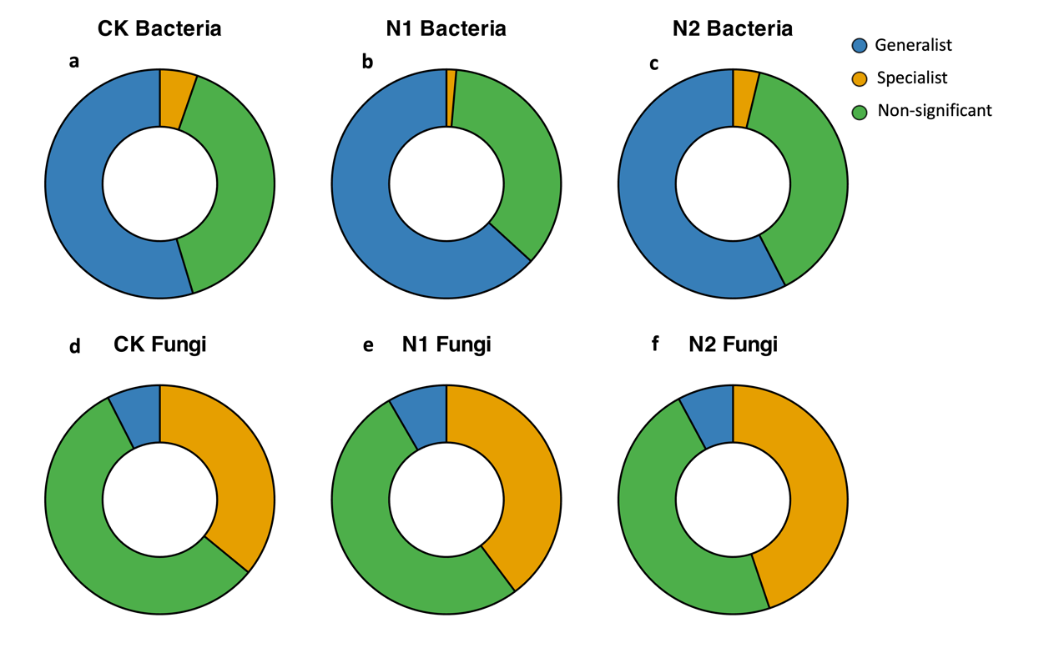
Figure S3. Distribution of habitat niche breadth for soil bacterial (a–c) and fungal (d–f) communities under different nitrogen addition treatments.The donut plots illustrate the proportions of generalists (blue), specialists (yellow), and non-significant taxa (green) N0, N1, N2 treatments. The classification is based on the Levins’ niche breadth model.

