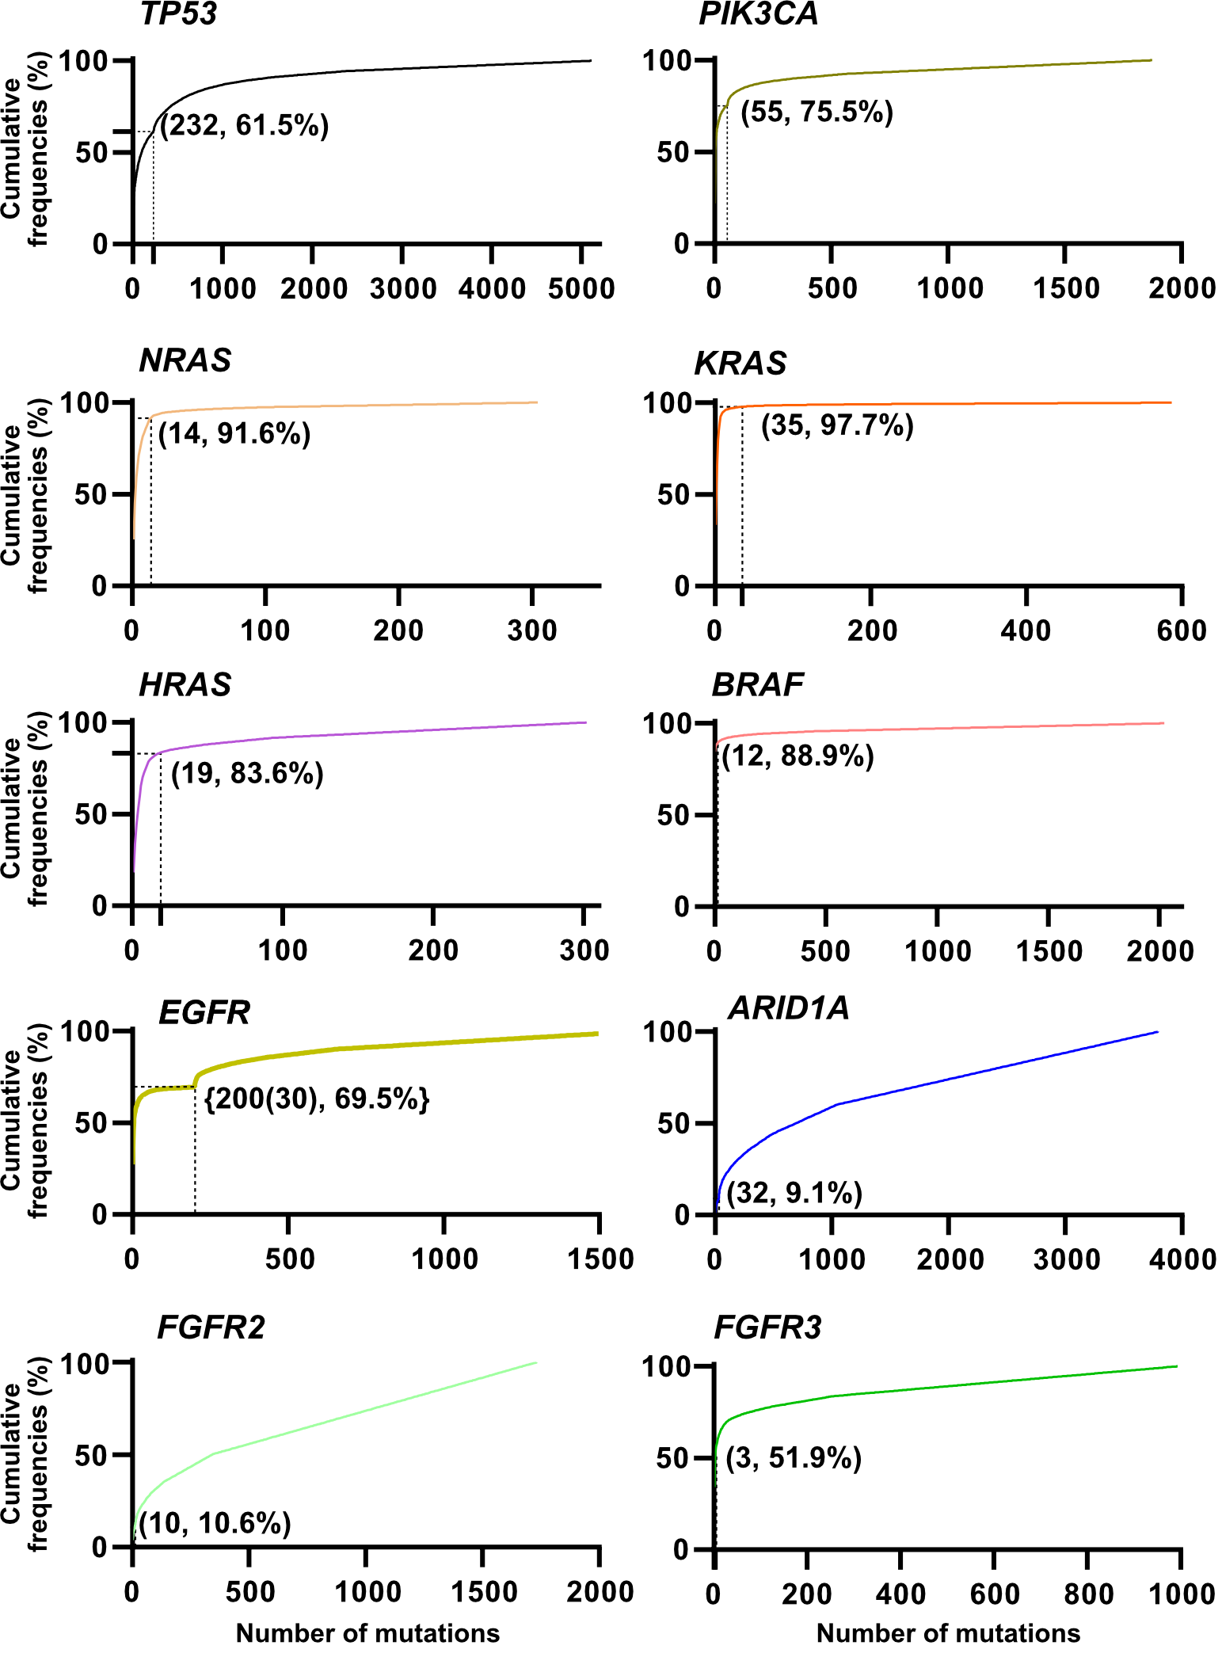

Fig. S1. Cumulative frequency of tumor-related gene mutations in the COSMIC database. COSMIC: Catalogue Of Somatic Mutations In Cancer. The values in the graph show the cover rate by OTS-1000ex 1.0.0.

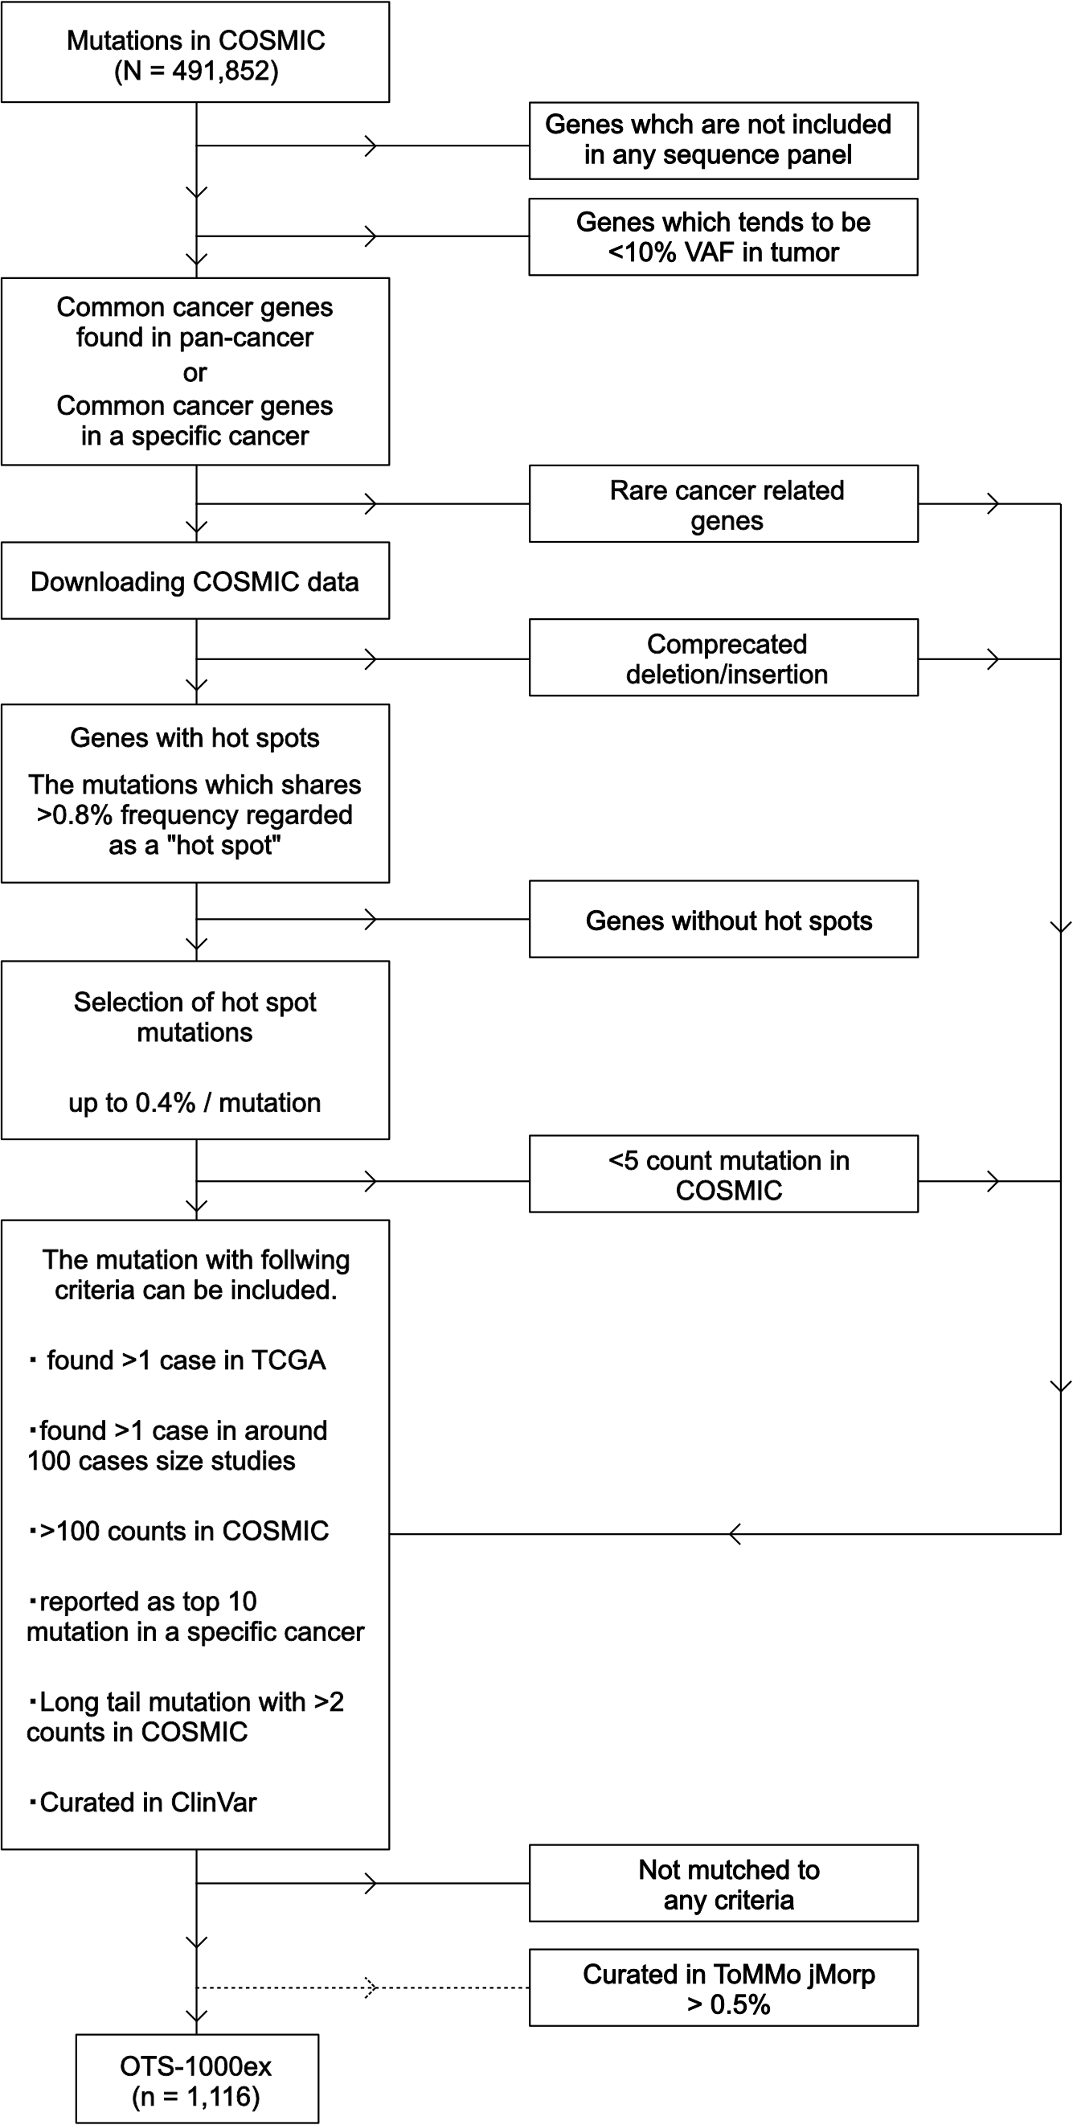

Fig. S2. Flowchart of target mutation selection for the OTS-1000ex. COSMIC: COSMIC, Catalogue Of Somatic Mutations In Cancer; jMorp, Japanese Multi Omics Reference Panel. TCGA, the Center for Cancer Genomics and Advanced Therapeutics.

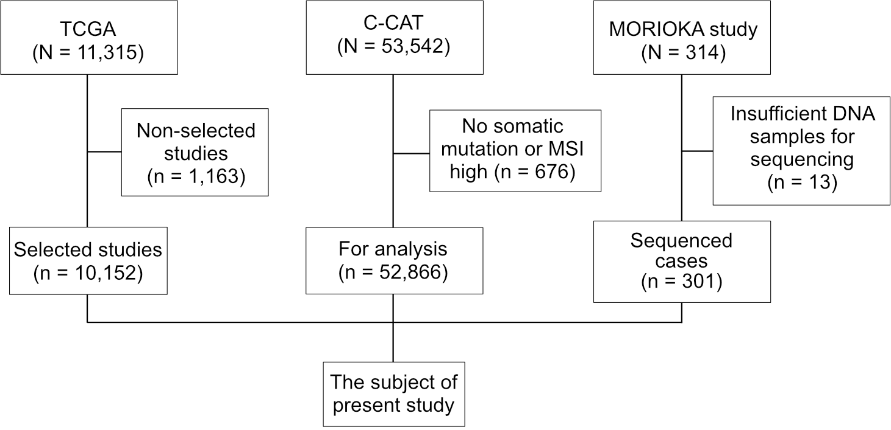

Fig. S3. Consort diagram of analyzed cases in three databases. TCGA, The Cancer Genome Atlas. The “selected studies” were based on the list of TCGA Cancers Selected for Study (https://www.cancer.gov/ccg/research/genome-sequencing/tcga/studied-cancers; Data set S2). COSMIC, Catalogue Of Somatic Mutations In Cancer; C-CAT, Center for Cancer Genomics and Advanced Therapeutics; MORIOKA study, Monitoring Recurrence of Individual tumor by serial Observation of Known gene Alterations.

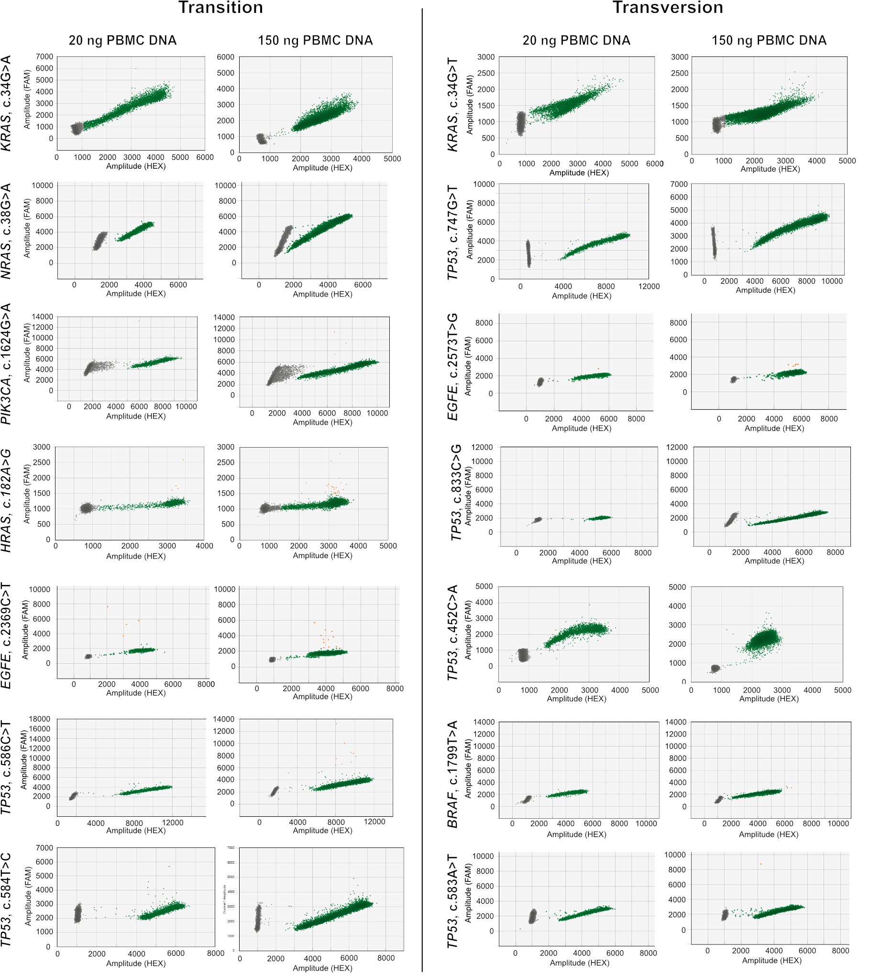

Fig. S4. DNA input and non-specific annealing of OTS-Probes. For transition mutations, KRAS_c.34G>A, NRAS_c.38G>A, NRAS_c.38G>A, PIK3CA_c.1624G>A, HRAS_c.182A>G, EGFE_c.2369C>T, TP53_c.586C>T, and TP53_c.584T>C, and for transversion mutations, KRAS_c.34G>T, TP53_c.747G>T, EGFR_c.2573T>G, TP53_c.833C>G, TP53_c.452C>A, BRAF_c.1799T>A, and TP53_c.583A>T were tested using the QX200 ddPCR system (Bio-Rad Laboratories) with 20 or 150 ng of DNA template extracted from peripheral blood mononuclear cells (PBMCs).

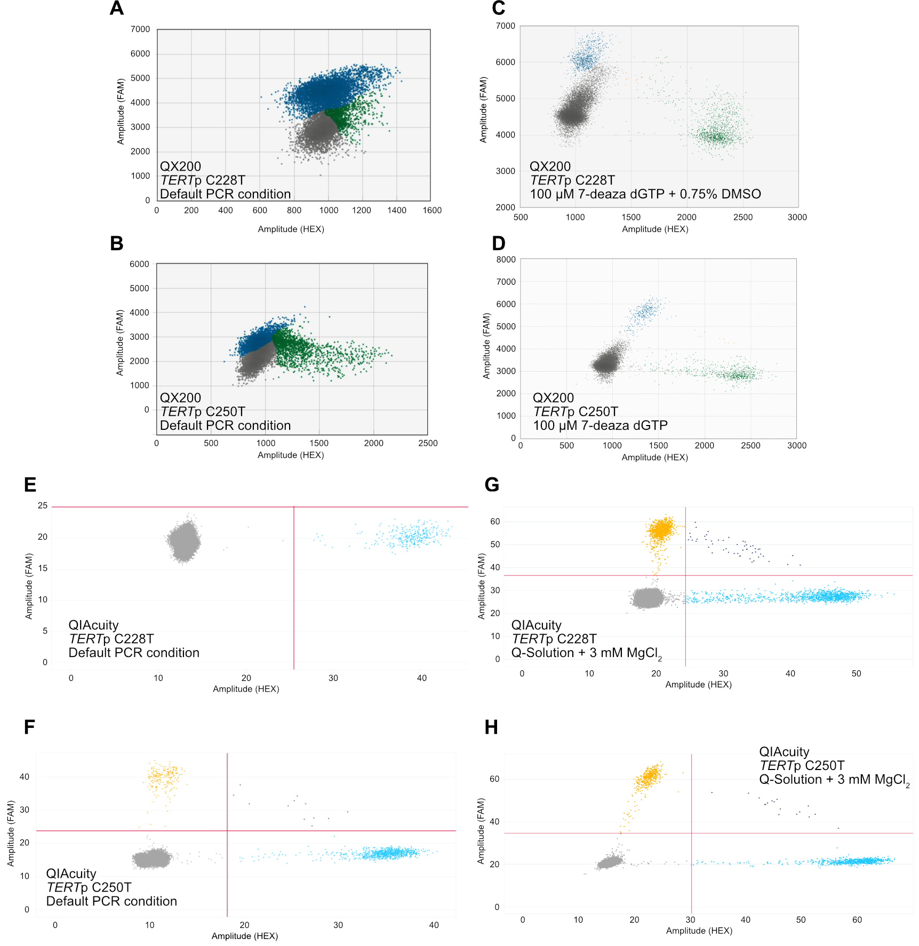

Fig. S5. Scatter plots from digital PCR (dPCR) with OTS-Probes for the TERT promoter mutations, C228T and C250T. (A) A 2D scatter plot with default PCR conditions for TERTp C228T. (B) A 2D scatter plot with default PCR conditions for TERTp C250T. (C) A 2D scatter plot of TERTp C228T supplemented with 100 μM 7-deaza dGTP and 0.75% DMSO. (D) A 2D scatter plot of TERTp C250T supplemented with 100 μM 7-deaza dGTP. (A-D) all data were produced using QX200 (Bio-Rad Laboratories). (E) A 2D scatter plot with default PCR conditions for TERTp C228T. (F) A 2D scatter plot with default PCR conditions for TERTp C250T. (G) A 2D scatter plot with Q-Solution (QIAGEN) and 3 mM MgCl₂ for TERTp C228T. (H) A 2D scatter plot with Q-Solution (QIAGEN) and 3 mM MgCl₂ for TERTp C250T. (E-H) All data were produced using QIAcuity (QIAGEN).
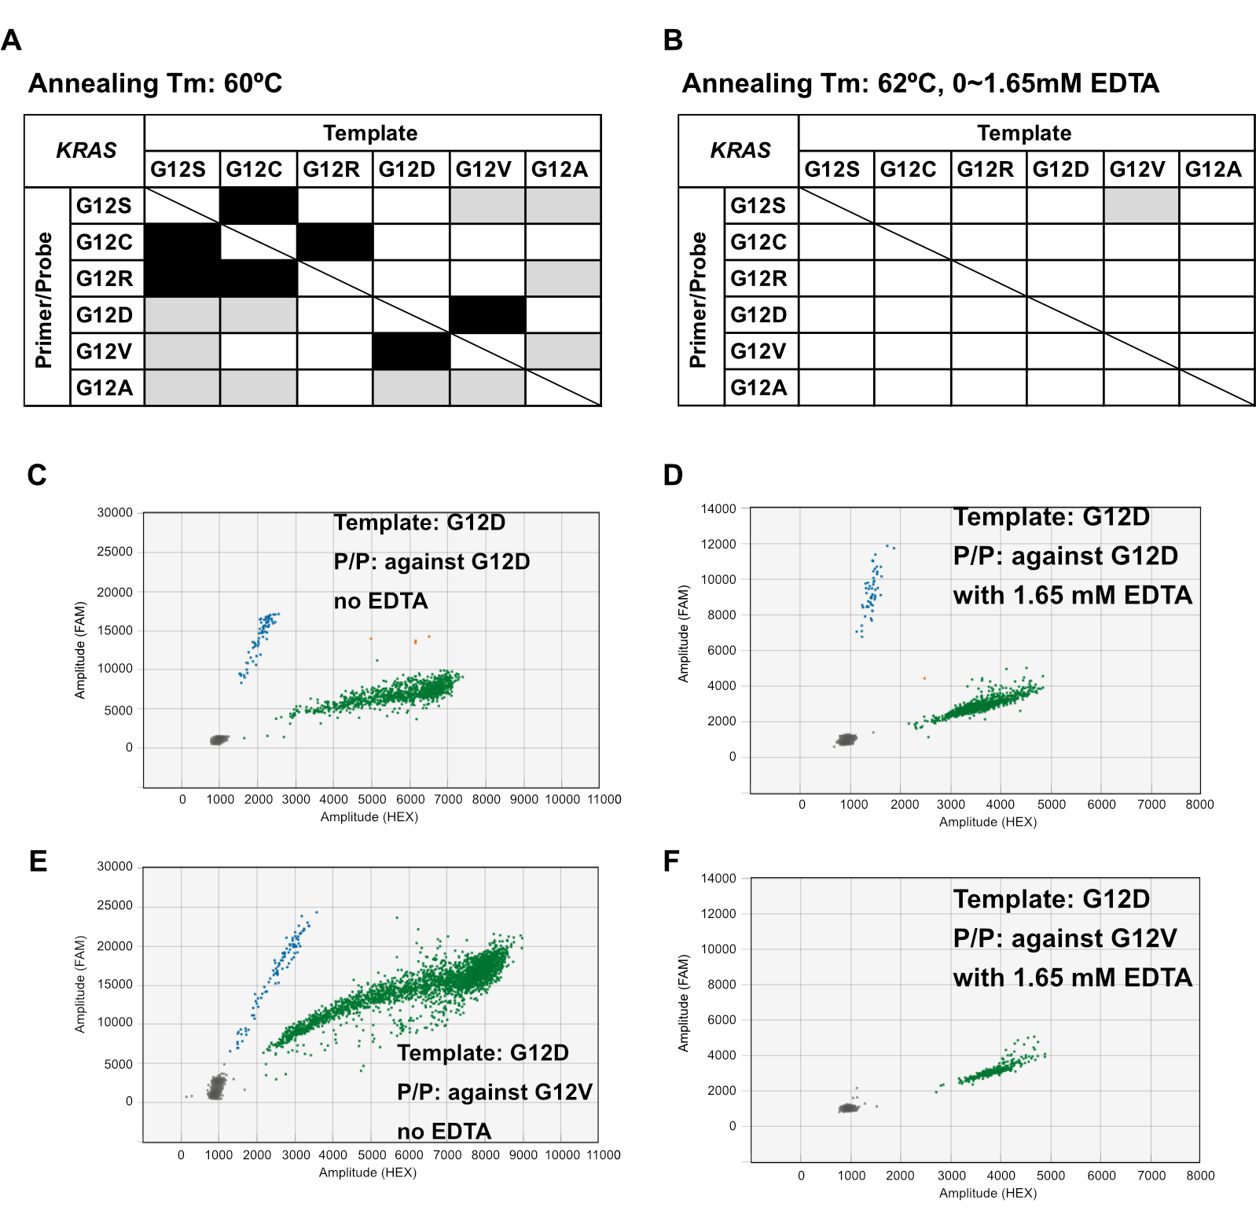

Fig. S6. Cross-validation of OTS-Probes for KRAS mutations. (A) The black blocks indicate a high rate of cross PCR (500-1000/1000) with the wrong template. The gray blocks indicate less than 1/1000 rate of cross PCR. The annealing temperature was 60°C. (B) The gray block indicates less than 1/1000 rate of cross PCR. The annealing temperature was 62°C. For KRAS G12S (c.34G>A) and G12V (c.35G>T), 1.5 mM EDTA; for G12D (c.35G>A) and G12C (c.34G>T), 1.65 mM EDTA were used as a PCR additive, and no additive was used for G12A (c.35G>C). (C) A 2D scatter plot of digital PCR (dPCR) for KRAS G12D (c.35G>A) using the KRAS G12D (c.35G>A) template without a PCR additive. (D) A 2D scatter plot of dPCR for KRAS G12D (c.35G>A) using the KRAS G12D (c.35G>A) template at 62°C of the annealing temperature with 1.65 mM EDTA. (E) A 2D scatter plot of dPCR for KRAS G12D (c.35G>T) using the template of G12V (c.35G>T). (F) 2D scatter plots of dPCR that detect KRAS G12V (c.35G>T) using the G12D (c.35G>T) template at 62°C of the annealing temperature with 1.65 mM EDTA. All templates were synthesized for specific nucleotide changes.

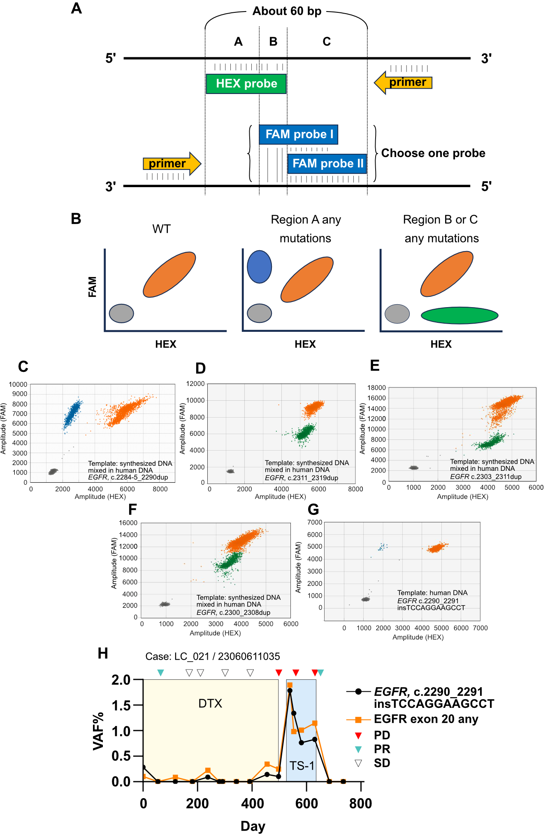

Fig. S7. The novelly designed digital PCR (dPCR) primers/probes for EGFR exon 20 mutations. (A) The concept of novel primers/probes (P/P) design that can detect any mutation in the probe annealing region. (B) The expected results of novel P/P. (C-F), The 2D scatterplots detected the following mutations: (C) EGFR, c.2284-5_2290dup, p.A763_Y764insFQEA; (D) EGFR, c.2311_2319dup, p.N771_H773dup; (E) EGFR c.2303_2311dup, p.S768_D770dup; and (F) EGFR, c.2300_2308dup, p.A767_V769dup using novel primers/probes on QX200 (Bio-Rad Laboratories). The templates were each synthesized for mutation fragments of mutant alleles and PBMC DNA was used for wild-type templates. (G) The 2D scatterplot of detected EGFR, c.2290_2291insTCCAGGAAGCCT, p.A763_764insFQEA. The template was human tumor DNA. (H) The VAF dynamics with conventional and a novelly designed OTS-Probe in a lung cancer case who had the EGFR, c.2290_2291insTCCAGGAAGCCT, p.A763_764insFQEA mutation. The red arrowheads indicate the timing of diagnostic of progression disease (PD), the blue arrowheads indicate that of partial response (PR), and the white arrowheads indicate that of stable disease (SD). DTX: Docetaxel. Those dPCR assays were performed by using QX200 (Bio-Rad Laboratories).
Footnote: In case LC_021 (23060611035), the initial sequencing of a pre-treatment blood sample did not detect the EGFR mutation. A second sequencing attempt of the tumor sample identified the EGFR mutation. Consequently, two types of probes, an OTS-Probe specific to the EGFR mutation and another OTS-Probe that detects any mutation in EGFR exon 20, were synthesized and a retrospective analysis of plasma samples was performed using dPCR.

Tables

Table S1. Detailed PCR conditions of OTS-Probes.
Primer concentration (nM) | Probe concentration (nM) | Annealing Tm (°C) | PCR additives | Number of OTS- Probes | rate (%)
900 | 250 | 60 | - | 577 | 95.8
1800 | 250 | 60 | - | 7 | 1.2
900 | 250 | 60 | 100 μM 7-deaza dGTP / Q-solution + 3 mM MgCl2 | 1 | 0.2
900 | 250 | 60 | 100 μM 7-deaza dGTP + 0.75% DMSO / Q-solution + 3 mM MgCl₂ | 1 | 0.2
900 | 250 | 58 | - | 5 | 0.8
1800 | 250 | 58 | - | 1 | 0.2
900 | 250 | 62 | - | 1 | 0.2
1800 | 250 | 62 | - | 1 | 0.2
900 | 250 | 64 | 1.5 mM EDTA | 2 | 0.3
900 | 250 | 60/62 | - | 1 | 0.2
900 | 250 | 60/62 | 1.5 mM EDTA | 3 | 0.5
900 | 250 | 60/62 | 1.65 mM EDTA | 2 | 0.3
60/62 means that 60°C for Thermo Fisher Scientific QuantStudio 3D and 62°C for other dPCR systems

Table S2. The overview of analyzed data sets.

TCGA projects |  | Case |  | C-CAT | Case |  | MORIOKA study | Case
COAD/READ | Colorectal Adenocarcinoma | 536 |  | Bowel | 8,886 |  | Colorectum | 51
PAAD | Pancreatic Ductal Adenocarcinoma | 180 |  | Pancreas | 7,397 |  | Pancreas | 6
CHOL | Cholangiocarcinoma | 51 |  | Biliary Tract | 4,335 |  | Biliary tract | 10
CHOL | Cholangiocarcinoma | 51 |  | Biliary Tract | 4,335 |  | Intrahepatic cholangiocarcinoma | 1
BRCA | Breast Ductal Carcinoma | 986 |  | Breast | 3,390 |  | Breast | 7
BRCA | Breast Lobular Carcinoma | 986 |  | Breast | 3,390 |  | Breast | 7
ESCA | Esophageal Carcinoma | 184 |  | Esophagus/Stomach | 3,245 |  | Esophagus | 22
STAD | Gastric Adenocarcinoma | 437 |  | Esophagus/Stomach | 3,245 |  | Stomach | 16
OV | Ovarian Serous Adenocarcinoma | 436 |  | Ovary/Fallopian Tube | 3,084 |  | Ovary | 13
PRAD | Prostate Adenocarcinoma | 496 |  | Prostate | 3,178 |  | Prostate | 10
LUAD | Lung Adenocarcinoma | 567 |  | Lung | 3,000 |  | Lung | 53
LUSC | Lung Squamous Cell Carcinoma | 492 |  | Lung | 3,000 |  | Lung | 53
SARC | Sarcoma | 237 |  | Soft Tissue | 2,322 |  | Bone and soft tissue | 9
- | - | - |  | Bone | 415 |  | Bone and soft tissue | 9
UCS | Uterine Carcinosarcoma | 57 |  | Uterus | 1,842 |  | Uterine | 25
UCEC | Uterine Corpus Endometrioid Carcinoma | 530 |  | Uterus | 1,842 |  | Uterine | 25
HNSC | Head and Neck Squamous Cell Carcinoma | 508 |  | Head and Neck | 1,875 |  | Head and Neck | 7
GBM | Glioblastoma Multiforme | 393 |  | CNS/Brain | 1,705 |  | Glioblastoma | 12
LGG | Lower Grade Glioma | 509 |  | CNS/Brain | 1,705 |  | Glioblastoma | 12
CESC | Cervical Carcinoma | 289 |  | Cervix | 1,491 |  | Cervix | 3
CESC | Cervical Carcinoma | 289 |  | Vulva/Vagina | 122 |  | Cervix | 3
SKCM | Skin Cutaneous Melanoma | 468 |  | Skin | 939 |  | Melanoma | 5
BLCA | Bladder Urothelial Carcinoma | 412 |  | Bladder/Urinary Tract | 843 |  | Bladder | 5
BLCA | Bladder Urothelial Carcinoma | 412 |  | Bladder/Urinary Tract | 843 |  | Urothelium epithelium | 9
THCA | Thyroid Papillary Carcinoma | 492 |  | Thyroid | 586 |  | - | -
MESO | Mesothelioma | 82 |  | Peritoneum | 390 |  | - | -
MESO | Mesothelioma | 82 |  | Pleura | 153 |  | - | -
LIHC | Hepatocellular Carcinoma | 364 |  | Liver | 480 |  | Liver | 23
THYM | Thymoma | 123 |  | Thymus | 431 |  | - | -
KICH | Kidney Chromophobe Carcinoma | 66 |  | Kidney | 430
KIRC | Kidney Clear Cell Carcinoma | 336 |  | Kidney | 430 |  | Kidney | 8
KIRP | Kidney Papillary Cell Carcinoma | 281 |  | Kidney | 430
- |  | - |  | Ampulla of Vater | 329 |  | - | -
PCPG | Paraganglioma & Pheochromocytoma | 179 |  | Peripheral Nervous System | 198 |  | - | -
ACC | Adrenocortical Carcinoma | 92 |  | Adrenal Gland | 159 |  | - | -
TGCT | Testicular Germ Cell Cancer | 145 |  | Testis | 90 |  | - | -
UVM | Uveal Melanoma | 80 |  | Eye | 83 |  | - | -
- |  | - |  | Penis | 34 |  | - | -
LAML | Acute Myeloid Leukemia | 144 |  | Lymphoid/Myeloid | 2 |  | Multiple myeloma | 2
- |  | - |  | Other | 1,432
- |  | - |  | - | - |  | Unknown | 2
- |  | - |  | - | - |  | Pediatric | 2
Total | 10,152 |  |  | 52,866 |  |  |  | 301

Table S3. VAF concordance in six different digital-PCR systems with OTS-Probes.
Mutated Gene | CDS change | AA change | COSM ID | VAF(%) by QX200 | VAF(%) by 3D | VAF(%) by |Q| | VAF(%) by QIAcuity | VAF(%) by naica | VAF(%) by Digital LightCyclar
PIK3CA | c.1633G>A | p.E545K | COSM763 | 23.46 | 26.90 | 28.64 | 26.15 | 29.04 | 23.46
PIK3CA | c.1624G>A | p.E542K | COSM760 | 2.01 | 2.51 | 2.20 | 1.87 | 2.09 | 2.01
EGFR | c.2582T>A | p.L861Q | COSM6213 | 0.23 | 0.64 | 0.64 | 0.75 | 1.49 | 0.23
KRAS | c.34G>T | p.G12C | COSM516 | 0.00 | 1.65 | 0.00 | 0.00 | - | -
KRAS | c.35G>T | p.G12V | COSM520 | 0.54 | 0.40 | 0.92 | 0.36 | - | -
KRAS | c.35G>A | p.G12D | COSM521 | 0.16 | 0.24 | 0.35 | 0.13 | 0.00 | 0.16
TP53 | c.742C>T | p.R248W | COSM10656 | 25.19 | 23.58 | 26.61 | 25.30 | 27.87 | 25.19
TP53 | c.747G>T | p.R249S | COSM10817 | 2.70 | 2.71 | 3.90 | 2.42 | 2.80 | 2.70
TP53 | c.527G>T | p.C176F | COSM10645 | 35.17 | 36.94 | 39.39 | 54.89 | 52.58 | 35.17
TP53 | c.856G>A | p.E286K | COSM10726 | 15.04 | 15.31 | 16.32 | 14.56 | 16.52 | 15.04
TP53 | c.743G>T | p.R248L | COSM6549 | 0.11 | 0.18 | 0.13 | 0.19 | - | -
TP53 | c.404G>T | p.C135F | COSM10647 | 85.14 | 86.40 | 84.63 | 85.45 | 81.50 | 85.14
TP53 | c.659A>G | p.Y220C | COSM10758 | 0.66 | 1.09 | 0.77 | 0.61 | 0.82 | 0.66
TP53 | c.524G>A | p.R175H | COSM10648 | 47.80 | 46.97 | 47.91 | 48.35 | 48.85 | 47.80
TP53 | c.743G>A | p.R248Q | COSM10662 | 1.30 | 2.27 | 1.93 | 1.76 | - | -
TP53 | c.845G>A | p.R282Q | COSM44338 | 0.00 | 0.13 | 0.02 | 0.00 | - | -
TP53 | c.614A>G | p.Y205C | COSM43947 | - | 4.55 | - | - | 4.91 | 4.55
BRAF | c.1799T>A | p.V600E | COSM476 | - | 1.08 | - | - | 0.35 | 1.08

Table S4. OTS-Select rank and success rate.
 | Clinical concordant | Clinical discordant | Success  rate (%) | Median observation duration (days) | Number of Mutations
S | 323 | 40 | 89.0 | 224 | 363
A | 63 | 12 | 84.0 | 321.5 | 75
B | 90 | 35 | 72.0 | 232.5 | 125
C | 19 | 15 | 55.9 | 225 | 34
D | 5 | 12 | 29.4 | 61 | 17
E | 1 | 11 | 8.3 | 91 | 12
All | 501 | 125 | 80.0 | 241 | 626
Clinical concordance was defined as either detection of ctDNA at least once during the observation period,
or consistently negative ctDNA results with no tumor detected by CT scan.

Dataset S1 (separate file). List of OTS-1000ex.

Dataset S2 (separate file). Analyzed TGCA cases and references.

Dataset S3 (separate file). Frequently mutated genes by organ type selected based on top-100 ranking

Dataset S4 (separate file). OTS-Select sample result.

Dataset S5 (separate file). OTS-Select gene list.

