Niche partitioning at microscale level and coexistence in two alpine vipers: Vipera berus walser and Vipera aspis aspis

Supplementary Materials

Table SM1. Number of individuals collected in Strona Valley at sampling events.

Date | V. aspis aspis | V. berus walser
28/05/2022 | 0 | 1
05/06/2022 | 1 | 0
06/06/2022 | 5 | 1
22/06/2022 | 0 | 0
25/06/2022 | 4 | 3
26/06/2022 | 2 | 8
27/06/2022 | 0 | 0
30/07/2022 | 2 | 2
01/08/2022 | 1 | 2
02/08/2022 | 2 | 3
03/08/2022 | 0 | 1
06/08/2022 | 0 | 1
07/08/2022 | 2 | 0
09/08/2022 | 0 | 1
20/08/2022 | 3 | 1
21/08/2022 | 0 | 1
22/08/2022 | 2 | 0
27/08/2022 | 1 | 1
28/08/2022 | 1 | 0
30/08/2022 | 0 | 1
31/08/2022 | 0 | 0
01/09/2022 | 0 | 0
02/09/2022 | 0 | 0
03/09/2022 | 0 | 0
04/09/2022 | 1 | 0
17/09/2022 | 0 | 1
08/05/2023 | 0 | 3
09/05/2023 | 0 | 0
10/06/2023 | 1 | 2
11/06/2023 | 1 | 0
01/07/2023 | 1 | 0
02/07/2023 | 0 | 0

Table SM2. Number of individuals collected in Chiobbia Valley at sampling events.

Date | V. aspis aspis | V. berus walser
02/06/2023 | 0 | 0
03/06/2023 | 0 | 0
24/06/2023 | 0 | 3
26/06/2023 | 0 | 0
27/06/2023 | 0 | 1
11/07/2023 | 0 | 0
15/07/2023 | 0 | 0
17/07/2023 | 0 | 0
20/07/2023 | 0 | 0
25/07/2023 | 0 | 0
27/07/2023 | 0 | 0
31/07/2023 | 0 | 3
03/08/2023 | 0 | 3
07/08/2023 | 2 | 0
09/08/2023 | 1 | 1
11/08/2023 | 1 | 0
13/08/2023 | 0 | 2
17/08/2023 | 1 | 0
20/08/2023 | 0 | 1
29/08/2023 | 0 | 1
31/08/2023 | 1 | 0
01/09/2023 | 0 | 1
07/09/2023 | 3 | 1
14/09/2023 | 0 | 0

Table SM3. Additional data from previous surveys used for fitting GAMs.

Date | Area | V. aspis aspis | V. berus walser
25/05/2014 | Strona | 2 | 0
26/06/2014 | Strona | 0 | 1
19/07/2014 | Strona | 1 | 2
24/04/2016 | Strona | 0 | 1
05/06/2016 | Strona | 0 | 1
22/04/2017 | Strona | 0 | 1
05/08/2018 | Strona | 1 | 0
01/05/2019 | Strona | 0 | 1
14/06/2019 | Strona | 1 | 0
21/09/2019 | Strona | 0 | 1
24/07/2015 | Chiobbia | 0 | 3
07/09/2018 | Chiobbia | 0 | 2
10/07/2018 | Chiobbia | 0 | 1
12/06/2019 | Chiobbia | 0 | 1
27/07/2020 | Chiobbia | 1 | 0
15/08/2020 | Chiobbia | 1 | 0
03/06/2021 | Chiobbia | 4 | 0
04/09/2021 | Chiobbia | 2 | 0

Table SM4. List of microhabitats categories collected in the field (left) and used for the maps (right).
Original categories | Merged categories
Large rock heap | Rocks
Small rock heap | Rocks
Dry stone wall | Rocks
Outcropping rocks | Rocks
Concrete walls | Rocks
Ferns | Shrubs
Alpenrose | Shrubs
Scotch Broom | Shrubs
Broad-leaved woods | Woods
Grass | Grass

Table SM5. Proportions of each microhabitat category (rocks, shrubs, grass, trees) and elevation values (in m) for sighting locations of Vipera aspis aspis (asp viper) and V. berus walser (Walser viper).

Species | Prop_{rock} | Prop_{shrub} | Prop_{grass} | Prop_{tree} | Elevstion (m)
Asp viper | 0 | 0 | 1 | 0 | 1652
Asp viper | 0,133 | 0,836 | 0,031 | 0 | 1412
Walser viper | 0 | 0,774 | 0,226 | 0 | 1725
Walser viper | 0 | 1 | 0 | 0 | 1601
Walser viper | 0,526 | 0,053 | 0,421 | 0 | 1750
Asp viper | 0,07 | 0,93 | 0 | 0 | 1368
Asp viper | 0,325 | 0 | 0,675 | 0 | 1341
Asp viper | 0 | 0,026 | 0,974 | 0 | 1664
Asp viper | 0,045 | 0,775 | 0,18 | 0 | 1412
Asp viper | 0,149 | 0 | 0,851 | 0 | 1400
Asp viper | 0,594 | 0 | 0,374 | 0,032 | 1431
Asp viper | 0,103 | 0 | 0,741 | 0,156 | 1435
Asp viper | 0,559 | 0 | 0,215 | 0,226 | 1336
Asp viper | 0,24 | 0,273 | 0,487 | 0 | 1404
Asp viper | 0,094 | 0,856 | 0,051 | 0 | 1401
Asp viper | 1 | 0 | 0 | 0 | 1349
Asp viper | 0,97 | 0,03 | 0 | 0 | 1374
Asp viper | 0,216 | 0,784 | 0 | 0 | 1641
Asp viper | 1 | 0 | 0 | 0 | 1507
Asp viper | 0 | 0 | 1 | 0 | 1349
Asp viper | 0,932 | 0 | 0,068 | 0 | 1353
Asp viper | 0 | 1 | 0 | 0 | 1515
Asp viper | 0,028 | 0 | 0,972 | 0 | 1346
Asp viper | 0 | 0 | 1 | 0 | 1406
Asp viper | 0,672 | 0,328 | 0 | 0 | 1399
Asp viper | 0,4 | 0,6 | 0 | 0 | 1399
Asp viper | 0,088 | 0,912 | 0 | 0 | 1410
Asp viper | 0 | 0,884 | 0,116 | 0 | 1746
Asp viper | 0 | 1 | 0 | 0 | 1394
Asp viper | 0,268 | 0 | 0,732 | 0 | 1329
Asp viper | 0,519 | 0,182 | 0,299 | 0 | 1412
Asp viper | 0,411 | 0 | 0,589 | 0 | 1415
Asp viper | 0 | 1 | 0 | 0 | 1494
Asp viper | 1 | 0 | 0 | 0 | 1503
Asp viper | 0 | 1 | 0 | 0 | 1408
Asp viper | 0,345 | 0,655 | 0 | 0 | 1521
Asp viper | 0 | 1 | 0 | 0 | 1394
Walser viper | 0 | 0,221 | 0,779 | 0 | 1654
Asp viper | 0 | 0 | 1 | 0 | 1348
Asp viper | 0 | 0,838 | 0,162 | 0 | 1401
Asp viper | 0,51 | 0,259 | 0,232 | 0 | 1326
Asp viper | 0,433 | 0,144 | 0,423 | 0 | 1326
Asp viper | 0,388 | 0 | 0,406 | 0,206 | 1348
Asp viper | 0,099 | 0 | 0,345 | 0,557 | 1344
Asp viper | 0 | 0 | 1 | 0 | 1391
Asp viper | 0 | 0 | 1 | 0 | 1391
Asp viper | 0,596 | 0,087 | 0,317 | 0 | 1326
Walser viper | 0,382 | 0,618 | 0 | 0 | 1374
Walser viper | 0 | 1 | 0 | 0 | 1655
Walser viper | 0 | 0,949 | 0,051 | 0 | 1659
Walser viper | 0,012 | 0,845 | 0,144 | 0 | 1758
Walser viper | 1 | 0 | 0 | 0 | 1770
Walser viper | 0,422 | 0 | 0,578 | 0 | 1783
Walser viper | 0,544 | 0,456 | 0 | 0 | 1399
Walser viper | 0,139 | 0,861 | 0 | 0 | 1396
Walser viper | 0,75 | 0,25 | 0 | 0 | 1385
Walser viper | 0,178 | 0,487 | 0,334 | 0 | 1767
Walser viper | 0 | 0,586 | 0,414 | 0 | 1751
Walser viper | 0,035 | 0 | 0,903 | 0,062 | 1508
Walser viper | 0 | 0,307 | 0,693 | 0 | 1600
Walser viper | 0,582 | 0 | 0,418 | 0 | 1635
Walser viper | 0,859 | 0 | 0,141 | 0 | 1625
Walser viper | 0 | 0,807 | 0,193 | 0 | 1764
Walser viper | 0,112 | 0 | 0,888 | 0 | 1559
Walser viper | 0 | 0,687 | 0,313 | 0 | 1907
Walser viper | 0 | 0,362 | 0,638 | 0 | 1835
Walser viper | 0 | 1 | 0 | 0 | 1935
Walser viper | 0 | 1 | 0 | 0 | 1483
Walser viper | 0 | 1 | 0 | 0 | 1659
Walser viper | 0 | 0,87 | 0,13 | 0 | 1443
Walser viper | 0 | 0,215 | 0,785 | 0 | 1443
Walser viper | 0 | 1 | 0 | 0 | 1526
Walser viper | 1 | 0 | 0 | 0 | 1519
Walser viper | 0 | 0,169 | 0,831 | 0 | 1746
Walser viper | 0,977 | 0,023 | 0 | 0 | 1676
Walser viper | 0,256 | 0 | 0,744 | 0 | 1329
Walser viper | 0 | 1 | 0 | 0 | 1430
Walser viper | 1 | 0 | 0 | 0 | 1509
Walser viper | 0,441 | 0,097 | 0,462 | 0 | 1412
Walser viper | 0 | 1 | 0 | 0 | 1750
Walser viper | 0 | 0,734 | 0,266 | 0 | 1733
Walser viper | 0 | 0,998 | 0,002 | 0 | 1744
Walser viper | 0,247 | 0,753 | 0 | 0 | 1399
Walser viper | 0 | 1 | 0 | 0 | 1692
Walser viper | 0 | 1 | 0 | 0 | 1397
Walser viper | 0 | 0,789 | 0,211 | 0 | 1773
Walser viper | 0 | 0,212 | 0,788 | 0 | 1773
Walser viper | 0 | 0,869 | 0,131 | 0 | 1733
Walser viper | 0 | 0,524 | 0,476 | 0 | 1727

Table SM6. Summary of model comparisons for Walser and Asp viper occurrence GAMs, on the basis of Likelihood Ratio Tests (LRTs) and Akaike Information Criterion (AIC). Independent variables included elevation (dem) as a linear predictor, and the coverage of rocks (per_roc), shrubs (per_shr), grass (per_gra), and trees (per_tree) as smooth terms. Model selection was based on Likelihood Ratio Tests (ΔDev = ΔDeviance; p-val = p-values) and (AIC).
Walser viper models
Predictors | ΔDev | p-val LRT | AIC
dem + per_roc + per_shr | - | - | 185.36
dem + per_roc + per_shr + per_gra | 1.22 | 0.36 | 186.22
dem + per_roc + per_shr + per_tree | -1.12 | 0.09 | 187.25
dem + per_roc + per_shr + per_gra + per_tree | 1.12 | 0.09 | 186.22

Asp viper models
Predictors | ΔDev | p-val LRT | AIC
dem + per_roc + per_shr | - | - | 152.10
dem + per_roc + per_shr + per_gra | 0.26 | 0.61 | 153.84
dem + per_roc + per_shr + per_tree | 2.31 | 0.11 | 152.90
dem + per_roc + per_shr + per_gra + per_tree | ~0 | >0.001 | 152.90

Table SM7. Pairwise Pearson correlation matrix among independent variables used in the Generalized Additive Models (GAMs) fitted for V. berus walser and V. aspis aspis.

Walser viper model
 | Altitude | Rock coverage | Shrub coverage
Altitude | 1 | -0.130 | -0.002
Proportion of rocks | -0.130 | 1 | -0.330
Proportion of shrubs | -0.002 | -0.330 | 1

Asp viper model
 | Altitude | Rock coverage | Shrub coverage
Altitude | 1 | -0.280 | 0.061
Proportion of rocks | -0.280 | 1 | -0.315
Proportion of shrubs | 0.061 | -0.315 | 1

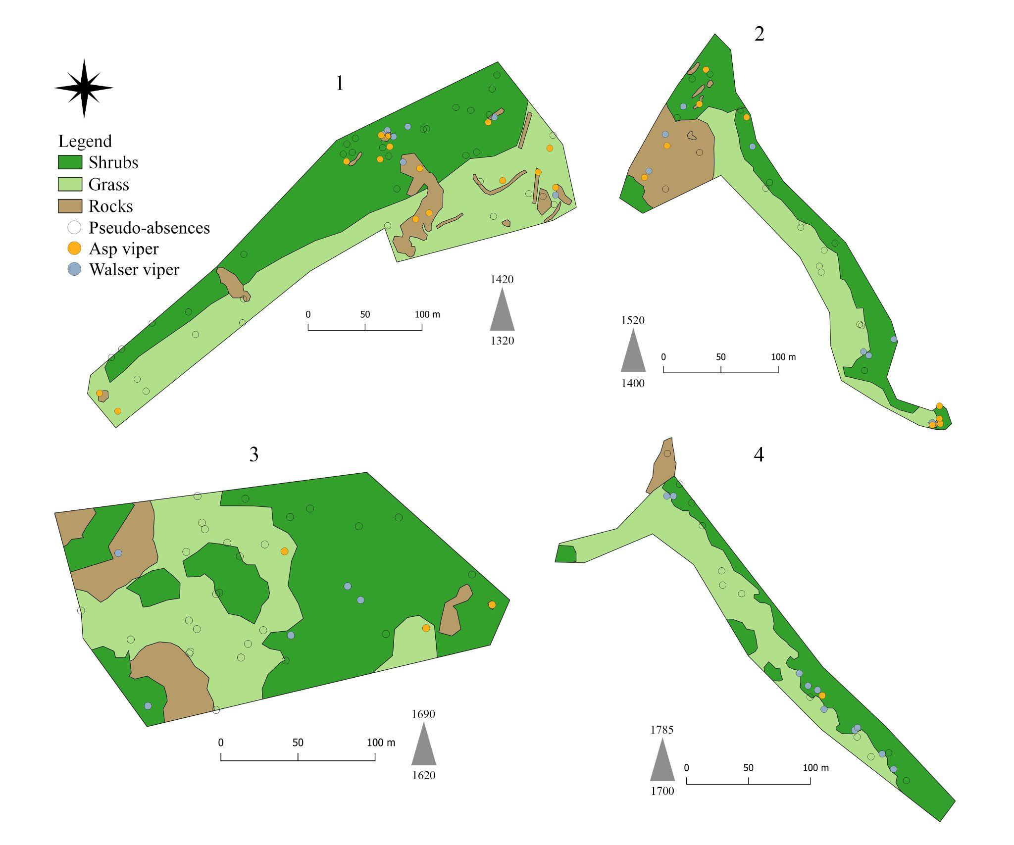

Figure SM1. The microhabitats of Strona Valley are represented, with presences and pseudo-absences. The patches are shown as separated images, the proportions are not maintained (see scales) and the relative positions are not as in reality. Gray triangles indicate the minimum and maximum altitudinal values (m a.s.l.) for each patch.

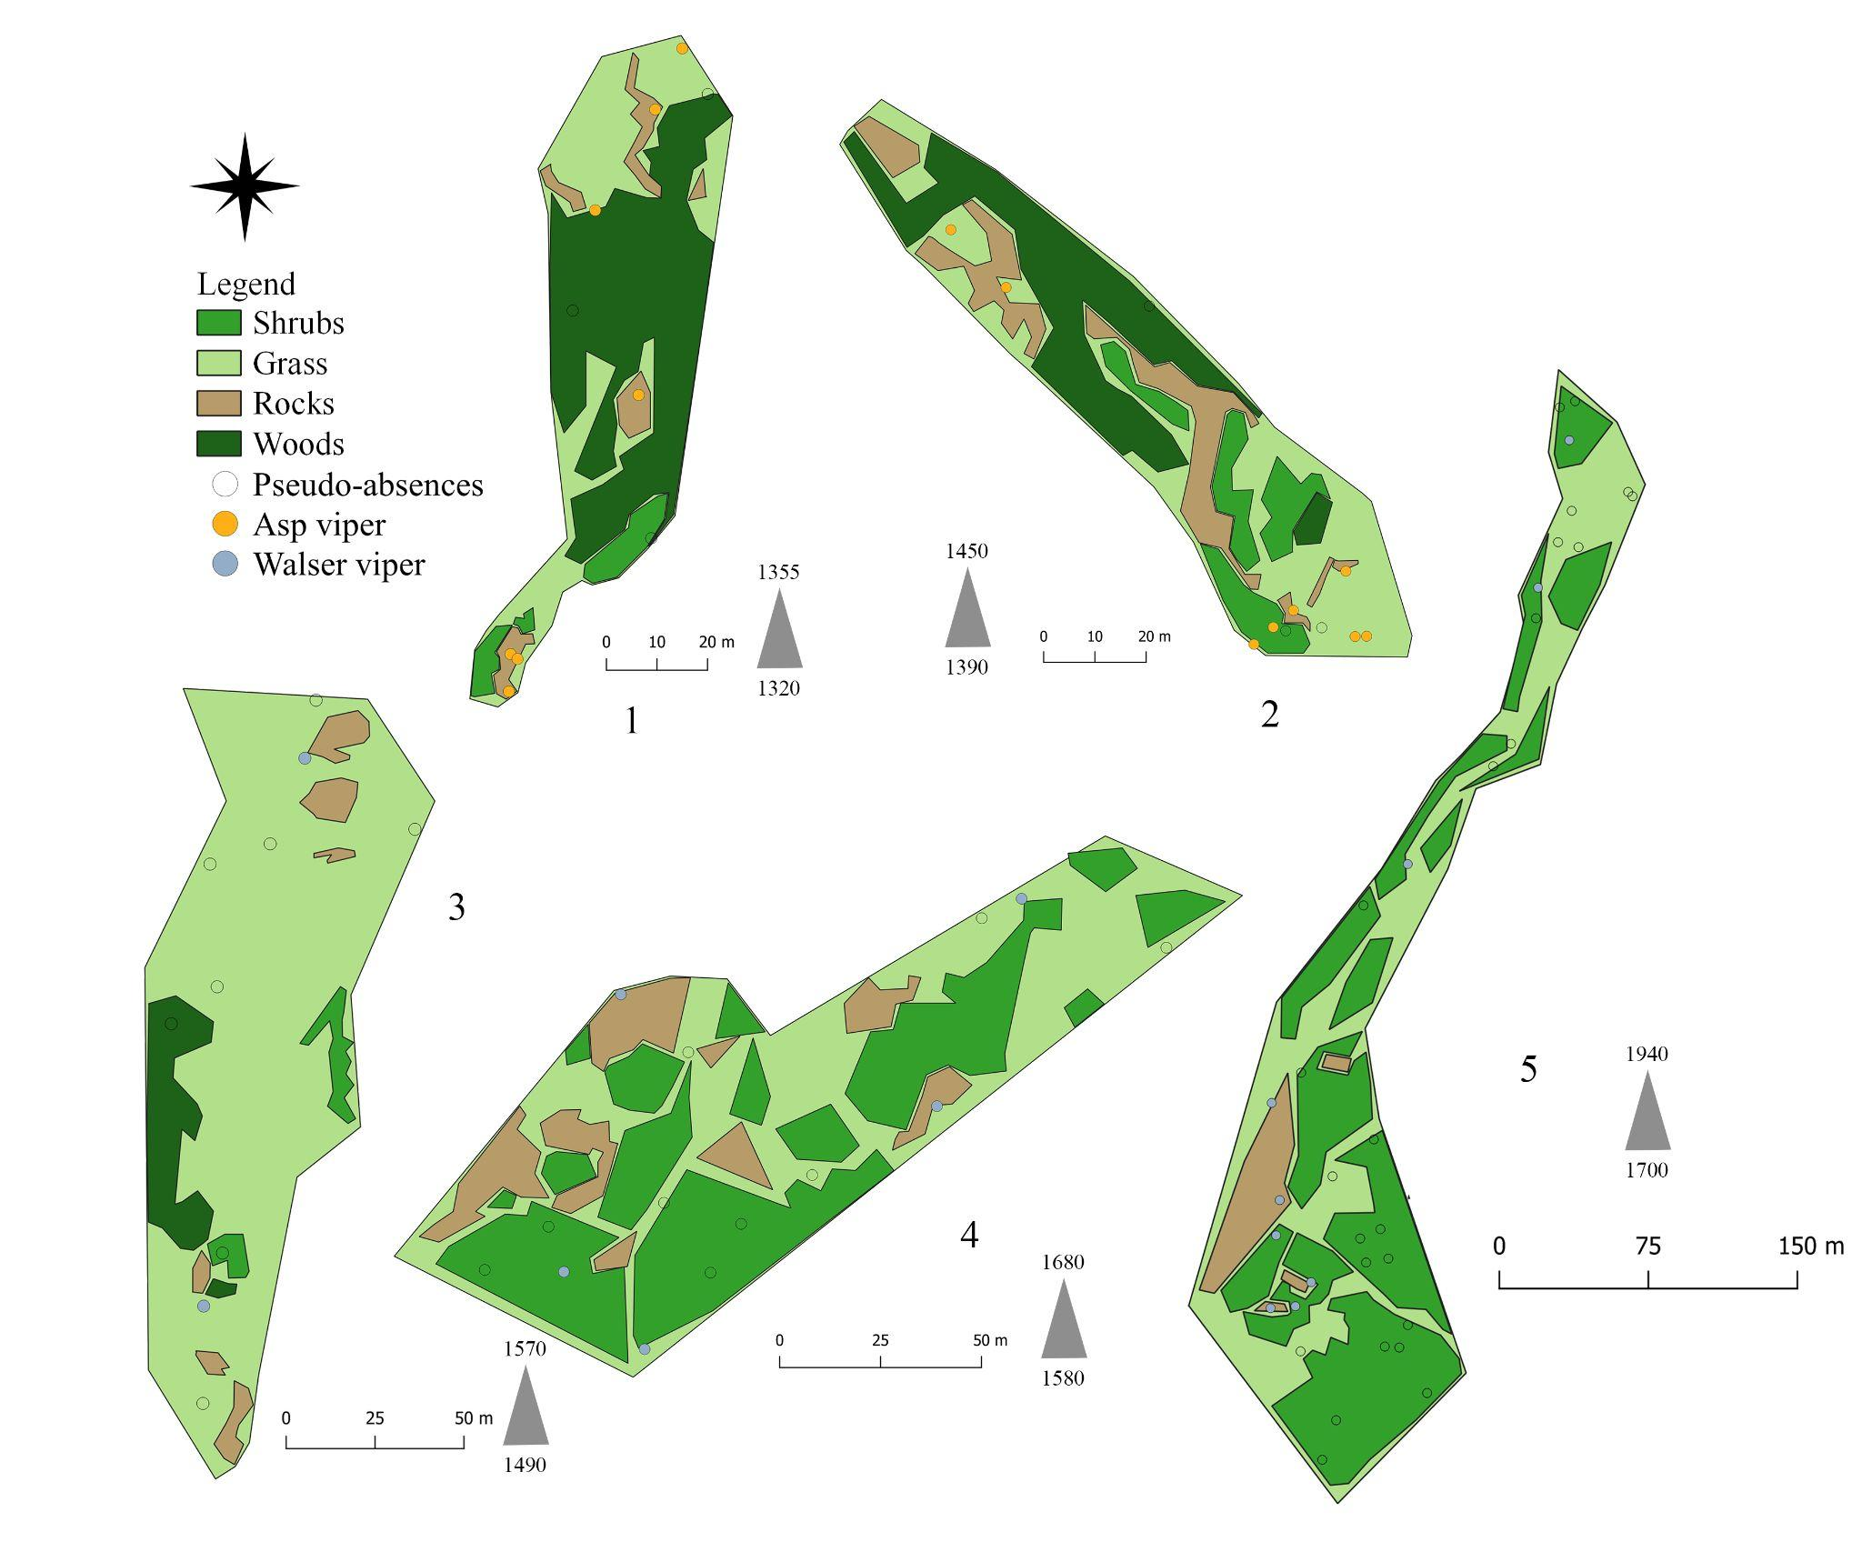
Figure SM2. The microhabitats of Chiobbia Valley are represented, with presences and pseudo-absences. The patches are shown as separated images, the proportion are not maintained (see scales) and the relative positions are not as in reality. Gray triangles indicate the minimum and maximum altitudinal values (m a.s.l.) for each patch.

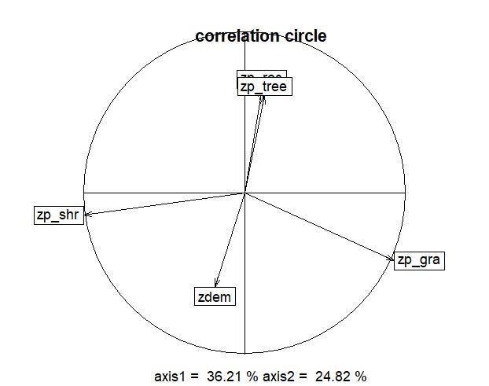

Figure SM3. Correlation circle resulting from the Principal Component Analysis. zp_shr = proportion of shrubs; zp_tree = proportion of trees; zp_roc = proportion of rocks; zp_gra = proportion of grass; zdem = Digital Elevation Model. The “z” in the names implies that all the variables have been scaled.
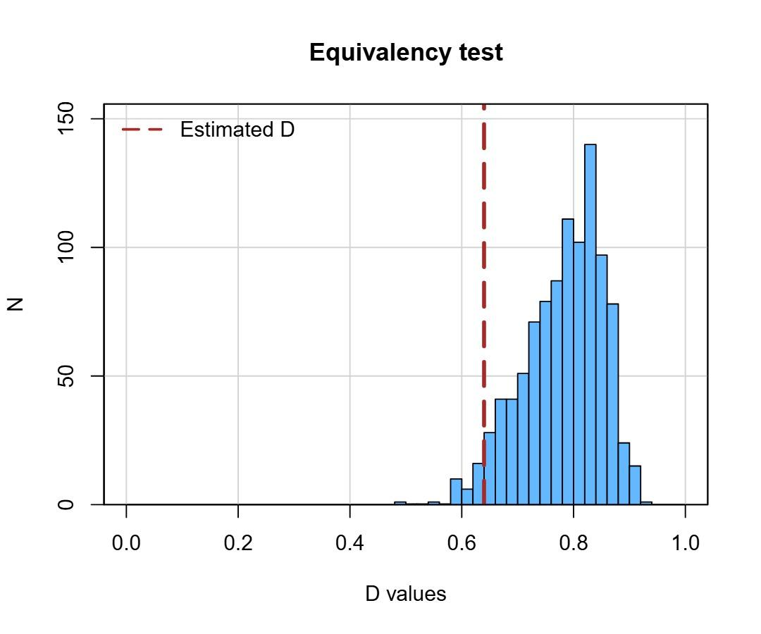
Figure SM4. Histogram of the null distribution of Schoener’s D values generated by the niche equivalency test, based on 1000 randomizations of species occurrences. The vertical dashed line indicates the observed Schoener’s D value. The histogram illustrates the range and frequency of simulated overlap values under the null hypothesis of niche equivalency.

Code for the main steps of the analysis (RStudio)
#### GAMs fitting ####
##### Walser viper ######
gam.w = gam(pres ~ dem
+ s(per_roc, k = 3)
+ s(per_shr, k = 3)
, family = "binomial"
, link = "logit"
, data = wal)
# the dataframe “wal” includes all the data associated to presences and pseudoabsences of V. berus walser
##### Asp viper ######
gam.a = gam(pres ~ dem
+ s(per_roc, k = 3)
+ s(per_shr, k = 3)
, family = "binomial"
, link = "logit"
, data = asp)
# the dataframe “asp” includes all the data associated to presences and pseudoabsences of V. aspis aspis

#### PCA-env with ecospat ####

##### PCA #####
pca.eco = dudi.pca(env, center = T, scale = T, scannf = FALSE, nf = 2)
# the dataframe “env” includes the environmental data of all the cells in the study sites
## Background scores (coordinates on PC axes)
scores.eco = pca.eco$li

###### Kernel densities on PC axes ######

####### Walser viper ######­
z1.wal = ecospat.grid.clim.dyn(scores.eco[,c(1,2)], scores.eco[,c(1,2)], sp = wal.scores[,c(1,2)], R = 100, kernel.method = "adehabitat")

####### Asp viper ######­
z1.asp = ecospat.grid.clim.dyn(scores.eco[,c(1,2)], scores.eco[,c(1,2)], sp = asp.scores[,c(1,2)], R = 100, kernel.method = "adehabitat")

#### Niche overlap ####
D.overlap = ecospat.niche.overlap(z1.wal, z1.asp, cor = T)

##### Equivalency test #####
eq.test.div = ecospat.niche.equivalency.test(z1.wal, z1.asp, rep = 1000, overlap.alternative = "lower")

#### Activity patterns ####
##### Kernel densities on vipers’ abundance per julian day #####
dens.w = density(yd.dfw, from = min(c(yd.dfw, yd.dfa)), to = max(c(yd.dfw, yd.dfa)))
dens.a = density(yd.dfa, from = min(c(yd.dfw, yd.dfa)), to = max(c(yd.dfw, yd.dfa)))
# yd.dfw and yd.dfa are vectors of julian dates, repeated for the number of vipers observed at each sampling day

