Appendix
Table 1. Sociodemographic Characteristics of Overall Sample
Demographic variable | N = 1,170
Ageª | 26 (13.25)
Firearm ownership status (“Do you own a gun?”)  Does not own a firearm (no)  Owns at least one firearm (yes)  Firearm access status (“Does anyone in your family own a gun?”)  Yes, a family member owns a gun  No, a family member does not own a gun | 933  235  590  579
Race  White only  Any BIPOC/Latinx  Latinx/Hispanic  Asian  Black/African American  Indigenous  Other race/ethnicity  Middle Eastern/North African | 935  207  101  52  41  34  28  14
Gender identity  Non-cisgender  Non-binary / genderqueer/ gender non-conforming  Trans man  Trans woman  Cisgender  Cisgender woman  Cisgender man  Other gender identity | 618  392  150  76  499  305  194  44
Sexual orientation  Queer  Bisexual  Gay  Lesbian  Asexual  Pansexual  Other sexual orientation  Heterosexual/straight | 310  258  232  216  70  39  26  16
Geographic region  Midwest  South  Northeast  West | 324  300  292  253
Firearm-related beliefs  “I would be extremely upset if someone used my gun to kill  him/herself.”  Agree  Disagree  Neutral  “The recent increase in anti-LGBTQ+ laws (e.g., “Don’t Say Gay,”  bathroom bills, etc.) in the United States has…”  Had no impact on my interest in buying a gun  Made me more interested in buying a gun  Made me less interested in buying a gun  “If I carried/when I carry a gun, I am less likely to be attacked.”  Disagree  Agree  Neutral | 1095  26  23  752  262  21  764  227  155
Depressive symptoms  None-minimal  Mild  Moderate  Moderately severe | 421  302  209  189
ª Values are mean (standard deviation).

Figure 1. Firearm ownership and access to a firearm among a sample of LGBTQ+ individuals.
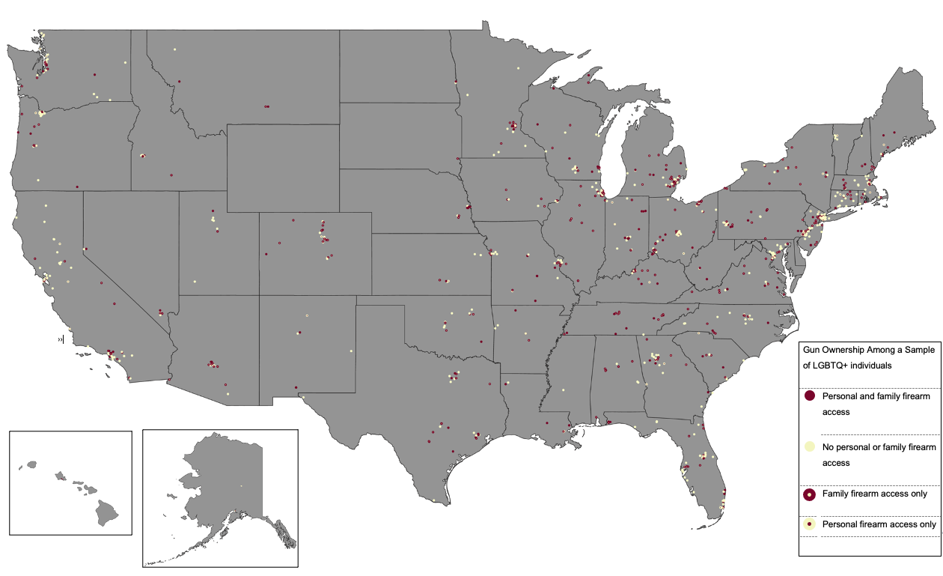

Figure 2. Intentions to purchase firearms among sample of LGBTQ+ adults.
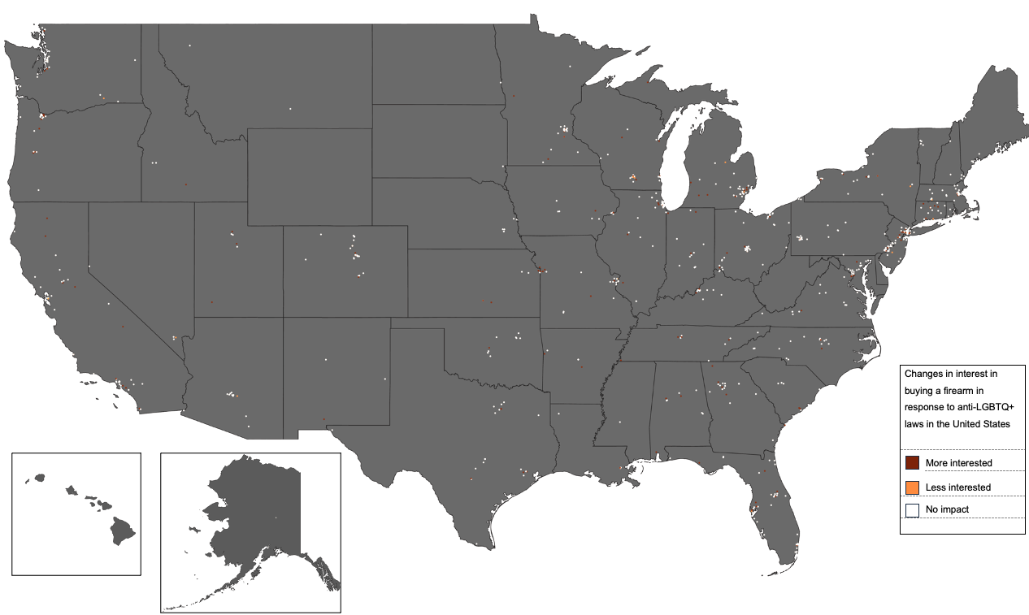

Figure 3. Suicidal ideation and rurality levels among a sample of LGBTQ+ adults, with access to a firearm (no ownership) versus firearm owners.
