Supplementary information for
Adsorption-regulated precise synthesis of atomically-dispersed bimetallic Fe-Co sites on carbon for electrocatalytic nitrogen reduction reaction
Shengbo Zhang¹, Miaomiao Han², Tongfei Shi¹, Haimin Zhang^{1*}, Yue Lin³, Xusheng Zheng⁴, Li Rong Zheng⁵, Hongjian Zhou¹, Chun Chen¹, Yunxia Zhang¹, Guozhong Wang¹, Huajie Yin¹, Guowen Meng^{1*}, Huijun Zhao^{6*}
¹Key Laboratory of Materials Physics, Centre for Environmental and Energy Nanomaterials, Anhui Key Laboratory of Nanomaterials and Nanotechnology, CAS Center for Excellence in Nanoscience, Institute of Solid State Physics, HFIPS, Chinese Academy of Sciences, Hefei 230031, China.
²School of Science, Huzhou University, Huzhou, Zhejiang 313000, China.
³Hefei National Laboratory for Physical Sciences at the Microscale, University of Science and Technology of China, Hefei 230026, China.
⁴National Synchrotron Radiation Laboratory, University of Science and Technology of China, Hefei, Anhui 230029, China.
⁵Beijing Synchrotron Radiation Facility, Institute of High Energy Physics, Chinese Academy of Sciences, 19B Yuquan Road, Beijing 100049, China.
⁶Centre for Catalysis and Clean Energy, Griffith University, Gold Coast Campus, QLD 4222, Australia.
*Correspondence: h.zhao@griffith.edu.au (H.Z.), zhanghm@issp.ac.cn (H.Z.), gwmeng@issp.ac.cn (G.M.)

Supplementary Table 1. NRR performance of the reported NRR electrocatalysts and Fe/Co-O-C-1.0.
References | Catalyst | Conditions | NH₃ Production Rate | Faradaic Efficiency (%) | Detection method
Noble Metal Electrocatalysts
1 | Pd nanoparticles | 0.1 M PBS | 4.2 μg h⁻¹ mg_{cat}⁻¹  (0.1 V vs. RHE) | 8.2 | Indophenol method
2 | Au/TiO₂ | 0.1 M HCl | 21.4 μg h⁻¹ mg_{cat}⁻¹  (-0.2 V vs. RHE) | 8.11 | Indophenol method
3 | Pd_{0.2}/Cu_{0.8} nanoclusters | 0.1 M KOH | 1.66 μg h⁻¹ mg_{cat}⁻¹  (-0.2 V vs. RHE) | 4.52 | Indophenol method
4 | Ag nanosheets | 0.1 M HCl | 2.8 μg h⁻¹ cm⁻²  (-0.6 V vs. RHE) | 4.8 | Indophenol method
5 | Ag-Au@ZIF | LiCF₃SO₃ 1% EtOH in THF | 10 pmol cm⁻² s⁻¹  (-2.9 V vs. Ag/AgCl) | 18 ± 4 | Indophenol method
6 | Au₆/Ni | 0.05 M H₂SO₄ | 7.4 μg h⁻¹ mg_{cat}⁻¹  (-0.14 V vs. RHE) | 67.8 | Indophenol method
7 | Rh-Se NCs | 0.1 M HCl | 175.6 ± 23.6 μg h⁻¹ mg_{cat}⁻¹  (-0.1 V vs. RHE) | 13.3 ± 0.4 | Indophenol method
8 | np-PdH_{0.43} | 0.1 M PBS | 20.4 μg h⁻¹ mg_{cat}⁻¹  (-0.15 V vs. RHE) | 43.6 | Indophenol method
9 | Ru/rGO | 0.05 M H₂SO₄ | 50 μg h⁻¹ mg_{cat}⁻¹  (-0.1 V vs. RHE) | 11 | Indophenol method
10 | Au₂₅-Cys-Mo | 0.1 M HCl | 34.5 μg h⁻¹ mg_{cat}⁻¹  (-0.2 V vs. RHE) | 26.5 | Indophenol method
11 | Pd/HsGDY | 0.05 M H₂SO₄ | 115.93 mg h⁻¹ g_{cat}⁻¹  (-0.25 V vs. RHE) | 44.45 | Indophenol method
Metal Free Electrocatalysts
12 | NPC-500 | 0.005 M H₂SO₄ | 22.3 μg h⁻¹ mg_{cat}⁻¹  (-0.4 V vs. RHE) | 9.58 | Indophenol method
13 | B₄C nanosheet | 0.1 M HCl | 26.57 μg h⁻¹ mg_{cat}⁻¹  (-0.75 V vs. RHE) | 15.95 | Indophenol method
14 | Fluorine-doped carbon | 0.05 M H₂SO₄ | 6.9 µg h⁻¹ cm⁻²  (-0.55 V vs. RHE) | 12.1 | Indophenol method
15 | Boron phosphide | 0.1 M HCl | 26.24 μg h⁻¹ mg_{cat}⁻¹  (-0.6 V vs. RHE) | 12.7 | Indophenol method
16 | BNS/CP | 0.1 M Na₂SO₄ | 13.22 μg h⁻¹ mg_{cat}⁻¹  (-0.8 V vs. RHE) | 4.04 | Indophenol method
17 | Eex-COF/NC | 0.1 M KOH | 12.53 μg h⁻¹ mg_{cat}⁻¹  (-0.2 V vs. RHE) | 45.43 | Indophenol method
18 | Molten LiCl-KCl | LiCl-KCl | 2.4×10⁻⁸ mol cm⁻² s⁻¹  (0.7 V vs. Li⁺/Li) | 4.2 | NH₃ ISE
19 | F-doped carbon | 0.05 M H₂SO₄ | 197.7 μg h⁻¹ mg_{cat}⁻¹  (-0.3 V vs. RHE) | 54.8  (-0.2 V vs. RHE) | Indophenol method
20 | BND₂-NC/Ti | 0.05 M H₂SO₄ +  0.2 M LiSO₄ | 19.1 µg h⁻¹ cm⁻²  (-0.7 V vs. RHE) | 21.2 | Indophenol method
21 | cRP NRs | 0.1 M Na₂SO₄ | 15.4 μg h⁻¹ mg_{cat}⁻¹  (-0.4 V vs. RHE) | 9.4  (-0.2 V vs. RHE) | Indophenol method
Transition Metal Electrocatalysts
22 | Cu/PI-300 | 0.1 M KOH | 12.4 μg cm⁻² h⁻¹  (-0.3 V vs. RHE) | 6.56 | Indophenol method
23 | Fe–Ni@C | 0.1 M Na₂SO₄ | 1.72 × 10⁻¹⁰ mol cm⁻² s⁻¹  (-0.5 V vs. RHE) | 23 | Indophenol method
24 | FeS₂-Mo_{17.3} | 0.1 M KOH | 25.15 μg h⁻¹ mg_{cat}⁻¹  (-0.2 V vs. RHE) | 14.41 | Indophenol method
25 | GDY/Co₂N | 0.1 M Na₂SO₄ | 219.72 μg h⁻¹ mg_{cat}⁻¹  (0.055 V vs. RHE) | 58.60 | Indophenol method
26 | Fe-doped W₁₈O₄₉ | 0.25 M LiClO₄ | 24.7 μg h⁻¹ mg_{cat}⁻¹  (-0.15 V vs. RHE) | 20.0 | Indophenol method
27 | Fe-ReS₂@N-CNF | 0.1 M Na₂SO₄ | 80.4 μg h⁻¹ mg_{cat}⁻¹  (-0.2 V vs. RHE) | 12.3 | Indophenol method
28 | Co_{SC}-N-C | 0.1 M KOH | 76.2 μg h⁻¹ mg_{cat}⁻¹  (-0.2 V vs. RHE) | 52.9 | Indophenol method
29 | Mo₂C | 0.1 M Na₂SO₄ | 3.36 μg cm⁻² h⁻¹  (-0.55 V vs. RHE) | 40.2 | Indophenol method
30 | MoS₂/NC-900 | 0.1 M Na₂SO₄ | 36.1 μg h⁻¹ mg_{cat}⁻¹  (-0.50 V vs. RHE) | 15.2 | Indophenol method
31 | FeWS_{x}@FeWO₄ | 1 M KOH | 30.2 μg h⁻¹ mg_{cat}⁻¹  (-0.45 V vs. RHE) | 16.4 | Indophenol method
32 | PAL-MoS₂ | 0.1 M HCl | 3405.55 μg h⁻¹ mg_{cat}⁻¹  (-0.1 V vs. RHE) | 44.36 | Indophenol method
33 | Mo-PTA@CNT | 0.1 M K₂SO₄ | 51 ± 1 μg h⁻¹ mg_{cat}⁻¹  (-0.1 V vs. RHE) | 83 ± 1 | Indophenol method
Main Group Metal Electrocatalysts
34 | PC/Sb/SbPO₄ | 0.1 M HCl | 25 μg h⁻¹ mg_{cat}⁻¹  (-0.25 V vs. RHE) | 31  (-0.15 V vs. RHE) | Indophenol method
35 | BP@SnO_{2-x} nanotube | 0.1 M Na₂SO₄ | 48.87 μg h⁻¹ mg_{cat}⁻¹  (-0.4 V vs. RHE) | 14.6 | Indophenol method
36 | Bi NS | 0.1 M Na₂SO₄ | 12.23 μg h⁻¹ mg_{cat}⁻¹  (-0.8 V vs. RHE) | 10.46 ± 1.45 | Indophenol method
37 | BiNCs | 0.5 M K₂SO₄ | 200 mmol g^{–1} h^{–1}  (-0.6 V vs. RHE) | 66 | Nessler’s reagent
38 | R-O-Bi | 0.2 M Na₂SO₄ | 5.453 μg h⁻¹ mg_{Bi}⁻¹  (-0.6 V vs. RHE) | 11.68 | Indophenol method
39 | Bi NS/CF | 0.1 M HCl | 6.89 × 10⁻¹¹ mol cm⁻² s⁻¹  (-0.5 V vs. RHE) | 10.26 | Indophenol method
40 | Al-N₂ battery | 0.05 M H₂SO₄ | 13.4 mg h⁻¹ g_{cat.}⁻¹  (-0.1 V vs. RHE) | 5 | Indophenol method
41 | Bi NPs | 0.1 M Na₂SO₄ | 3.25 ± 0.08 μg cm⁻² h⁻¹  (-0.7 V vs. RHE) | 12.11 ± 0.84  (-0.6 V vs. RHE) | Indophenol method
42 | Bi@C-900 | 0.1 M Na₂SO₄ | 4.22 ± 0.33  μg h⁻¹ mg_{cat.}⁻¹  (-0.6 V vs. RHE) | 15.10 ± 0.43  (-0.4 V vs. RHE) | Indophenol method
Single-Atom Electrocatalysts
43 | Au SAs/C₃N₄  (Au-N bond) | 0.005 M H₂SO₄ | 1305 μg h⁻¹ mg_{Au}⁻¹  (-0.2 V vs. RHE) | 11.1 | Indophenol method
44 | Ru SAs/N-C  (Ru-N bond) | 0.05 M H₂SO₄ | 120.9 μg h⁻¹ mg_{cat}⁻¹  (-0.2 V vs. RHE) | 29.6 | Indophenol method
45 | Ru@ZrO₂/NC  (Ru-N bond) | 0.1 M HCl | 3665 μg h⁻¹ mg_{Ru}⁻¹  (-0.21 V vs. RHE) | 21 | Indophenol method
46 | SA-Mo/NPC  (Mo-N bond) | 0.1 M KOH | 34.0 ± 3.6 μg h⁻¹ mg_{cat}⁻¹  (-0.3 V vs. RHE) | 14.6 ± 1.6 | Indophenol method
47 | Fe_{SA}-N-C  (Fe-N bond) | 0.1 M KOH | 7.48 μg h⁻¹ mg_{cat}⁻¹  (0 V vs. RHE) | 56.55 | Indophenol method
48 | ISAS-Fe-N-C  (Fe-N bond) | 0.1 M PBS | 62.9 ± 2.7 μg h⁻¹ mg_{cat}⁻¹  (-0.4 V vs. RHE) | 18.6 ± 0.8 | Indophenol method
49 | Mo⁰/GDY  (Mo-C bond) | 0.1 M Na₂SO₄ | 145.4 μg h⁻¹ mg_{cat}⁻¹  (-1.2 V vs. SCE) | 21 | Indophenol method
50 | NC-Cu SA  (Cu-N bond) | 0.1 M KOH | 53.3 μg h⁻¹ mg_{cat}⁻¹  (-0.35 V vs. RHE) | 13.8 | Indophenol method
50 | NC-Cu SA  (Cu-N bond) | - M HCl | 49.3 μg h⁻¹ mg_{cat}⁻¹  (-0.3 V vs. RHE) | 11.7 | Indophenol method
51 | Fe₁-N-C  (Fe-N bond) | 0.1M HCl | 1.56 × 10⁻¹¹ mol cm⁻² s⁻¹  (-0.05 V vs. RHE) | 4.51 | Indophenol method
52 | Co SA/NPC  (Co-N bond) | 0.05 M Na₂SO₄ | 0.86 μmol cm⁻² h⁻¹  (-0.2 V vs. RHE) | 10.5 | Indophenol method
53 | Ru SAs/g-C₃N₄  (Ru-N bond) | 0.5 M NaOH | 23.0 μg h⁻¹ mg_{cat}⁻¹  (-0.05 V vs. RHE) | 8.3 | Indophenol method
54 | Fe-SAs/LCC/GC  (Fe-O bond) | 0.1 M KOH | 307.7 μg h⁻¹ mg_{cat.}⁻¹  (-0.15 V vs. RHE) | 51.0 | Indophenol method
55 | Co-SAs/NC-L  (Co-N bond) | 0.005 M H₂SO₄ | 16.9 μg h⁻¹ mg_{cat}⁻¹  (-0.25 V vs. RHE) | 27.4  (-0.15 V vs. RHE) | Indophenol method
56 | Fe-SnO₂  (Fe-O bond) | 0.1 M HCl | 82.7 μg h⁻¹ mg_{cat}⁻¹  (-0.3 V vs. RHE) | 20.4 | Indophenol method
57 | SA Ru-Mo₂CT_{x}  (Ru-C(O) bond) | 0.5 M K₂SO₄ | 40.57 μg h⁻¹ mg_{cat}⁻¹  (-0.3 V vs. RHE) | 25.77 | Indophenol method
58 | Fe-MoS₂  (Fe-S bond) | 0.1 M KCl | 97.5 ± 6 μg h⁻¹ cm⁻²  (-0.2 V vs. RHE) | 31.6 ± 2 | Indophenol method
59 | MoSAs-Mo₂C/  NCNTs  (Mo-N/C bond) | 0.005 M H₂SO₄ | 16.1 μg h⁻¹ mg_{cat}⁻¹  (-0.25 V vs. RHE) | 7.1 | Indophenol method
60 | Fe-MoS₂  (Fe-S bond) | 0.5 M K₂SO₄ | 8.63 μg h⁻¹ mg_{cat}⁻¹  (-0.3 V vs. RHE) | 18.8 | Indophenol method
61 | SA-Ag/NC  (Ag-N bond) | - M HCl | 270.9 μg h⁻¹ mg_{cat}⁻¹  (-0.65 V vs. RHE) | 21.9  (-0.60 V vs. RHE) | Indophenol method
62 | Pd-GDY  (Pd-N bond) | 0.1 M Na₂SO₄ | 4.45 ± 0.3 mg h⁻¹ mg_{Pd}⁻¹  (-0.16 V vs. RHE) | 31.62 ± 1.06 | Indophenol method
63 | Mn-O₃N₁/PC  (Mn-N/O bond) | 0.1 M HCl | 66.41 ± 4.05 μg h⁻¹ mg_{cat}⁻¹  (-0.35 V vs. RHE) | 8.91 ± 0.82 | Indophenol method
64 | Ni-N_{x}-C  (Ni-N bond) | 0.1 M KOH | 81 ± 3 μg h⁻¹ cm⁻²  (-0.3 V vs. RHE) | 12.4 ± 1.5 | Indophenol method
65 | Y₁/NC  (Y-N/C bond) | 0.1 M HCl | 23.2 μg h⁻¹ cm⁻²  (-0.1 V vs. RHE) | 12.1 | Indophenol method
65 | Sc₁/NC  (Sc-N/C bond) | 0.1 M HCl | 20.4 μg h⁻¹ cm⁻²  (-0.1 V vs. RHE) | 11.2 | Indophenol method
Dual-Atom Electrocatalysts
66 | CNT@C₃N₄-  Fe&Cu  (Fe-Nand  Cu-N bond) | 0.001 M H₂SO₄ | 9.86 μg h⁻¹ mg_{cat}⁻¹  (-1.2 V vs. Ag/AgCl) | 34.0  (-0.8 V vs. Ag/AgCl) | Indophenol method
67 | PdCu/NC  (Pd-Cu bond) | 0.05 M H₂SO₄ | 69.2 ± 2.5 μg h⁻¹ mg_{cat}⁻¹  (-0.45 V vs. RHE) | 24.8 ± 0.8 | Indophenol method
This work | Fe/Co-O-C-1.0  (Fe-Co bond) | 0.1 M Na₂SO₄ | 574.8 ± 35.3 μg h⁻¹ mg_{cat}⁻¹  (-0.30 V vs. RHE) | 73.2 ± 4.6 | Indophenol method

Supplementary Table 2. Impregnated Fe³⁺/Co²⁺ contents on BC from different adsorption solutions and corresponding Fe/Co and Fe/Co SAs loaded on CBC.
[Fe³⁺]/[Co²⁺] in Adsorption Solution  (mmol L⁻¹) | Impregnated Fe³⁺/Co²⁺ in Fe³⁺-20-BC, Fe³⁺/Co²⁺-x/y-BC, Co²⁺-20-BC†  (mmol g⁻¹) | Fe/Co in Fe-20-CBC, Fe/Co-x/y-CBC, Co-20-CBC†  (mmol g⁻¹) | Fe/Co SAs in Fe-O-C, Fe/Co-O-C-r, Co-O-C†  (wt.%) | Fe/Co SAs in Fe-O-C, Fe/Co-O-C-r, Co-O-C†  (mmol g⁻¹) | Fe/Co Atomic Ratio in Fe/Co-O-C-r
20/-  15/5.0  10/10  5.0/15  1.0/19  -/20 | 0.54/-  0.42/0.13  0.31/0.20  0.24/0.25  0.12/0.30  -/0.32 | 1.65/-  1.29/0.40  0.94/0.61  0.74/0.77  0.37/0.91  -/0.99 | 0.27/-  0.22/0.08  0.18/0.13  0.15/0.16  0.1/0.19  -/0.22 | 0.0480/-  0.0391/0.0135  0.0320/0.0219  0.0266/0.0269  0.0178/0.0319  -/0.0370 | -  2.9  1.5  1.0  0.56  -
†Determined by ICP-AES.

Supplementary Table 3. BET specific surface area and average pore volume of Fe-O-C, Co-O-C, Fe/Co-O-C-r and CBC.
Samples | BET Specific Surface Area  (m² g⁻¹) | Average Pore Diameter  (nm)
Fe-O-C | 559.2 | 0.84
Co-O-C | 416.7 | 0.59
Fe/Co-O-C-2.9 | 463.5 | 0.70
Fe/Co-O-C-1.5 | 522.0 | 0.88
Fe/Co-O-C-1.0 | 490.0 | 0.71
Fe/Co-O-C-0.56 | 368.4 | 0.61
CBC | 497.3 | 0.89

Supplementary Table 4. EXAFS fitting results of Fe/Co-O-C-1.0.
Sample | Edge | Scattering Pair | CN | R (Å) | σ²(10⁻³Å²) | ΔE₀ (eV)
As-synthesised Fe/Co-O-C-1.0 | Fe | Fe-O | 2.80 | 2.00 | 4.13 | 6.62
As-synthesised Fe/Co-O-C-1.0 | Fe | Fe-Co | 1.00 | 2.13 | 4.22 | 9.55
As-synthesised Fe/Co-O-C-1.0 | Co | Co-O | 2.80 | 2.05 | 6.63 | -3.84
As-synthesised Fe/Co-O-C-1.0 | Co | Co-Fe | 0.80 | 2.11 | 7.03 | -8.12
Fe/Co-O-C-1.0  after10 NRR cycles | Fe | Fe-O | 3.00 | 1.96 | 8.80 | -7.79
Fe/Co-O-C-1.0  after10 NRR cycles | Fe | Fe-Co | 1.00 | 2.10 | 6.29 | 2.47
Fe/Co-O-C-1.0  after10 NRR cycles | Co | Co-C | 2.00 | 1.99 | 4.33 | -9.90
Fe/Co-O-C-1.0  after10 NRR cycles | Co | Co-O | 1.00 | 2.11 | 4.16 | 6.53
Fe/Co-O-C-1.0  after10 NRR cycles | Co | Co-Fe | 1.00 | 2.04 | 5.64 | -8.9
CN: Coordination number; R: Interatomic distance (the bond length between central atoms and surrounding coordination atoms); σ²: Debye-Waller factor (a measure of thermal and static disorder in absorber-scatter distances); ΔE₀: Edge-energy shift (the difference between the zero kinetic energy value of the sample and that of the theoretical model).

Supplementary Table 5. Loaded Fe, Co and bimetallic Fe-Co SAs on CBC.
Sample | Fe SAs†  (μmol g⁻¹) | Co SAs†  (μmolg⁻¹) | Total  Fe/Co SAs†  (μmol g⁻¹) | Assumed Bimetallic  Fe-Co Loading  (μmol g⁻¹) | Bimetallic Fe-Co Loading Density*  (nmol cm⁻²)
Fe-O-C  Fe/Co-O-C-2.8  Fe/Co-O-C-1.5  Fe/Co-O-C-1  Fe/Co-O-C-0.56  Co-O-C | 47.95  39.07  31.96  26.61  17.75  - | -  13.45  21.85  26.89  31.93  37.0 | -  52.52  53.81  53.5  49.68  - | -  13.45  21.85  26.61  17.75  - | -  6.72  10.93  13.31  8.87  -
†Determined by ICP-AES.
*The bimetallic loading densities (D) were calculated according to:
D (μmol cm⁻²) = (N × S) × ω/M ×10³
where, N is the loaded electrocatalyst on working electrode (0.5 mg cm⁻²), S is the geometric surface area of working electrode (π × 1.5² = 0.07065 cm²), ω is the assumed Fe or Co loadings (μmol g⁻¹), M is the atomic mass of Fe (55.8 g mol⁻¹) or Co (58.9 g mol⁻¹).

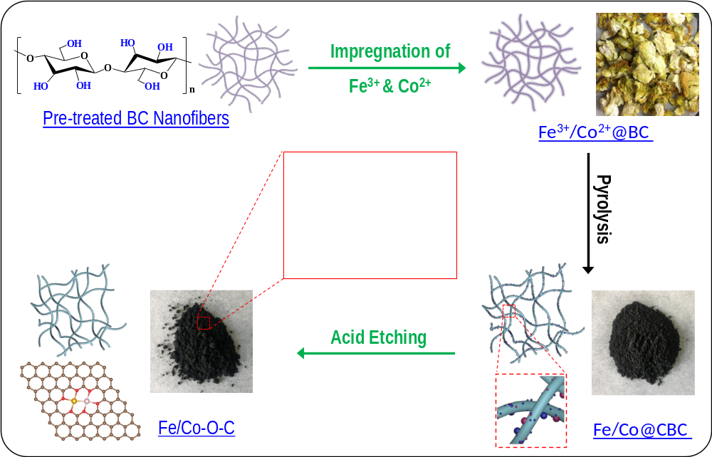
Supplementary Figure 1. Schematic diagram illustrating synthetic procedure of Fe/Co-O-C.

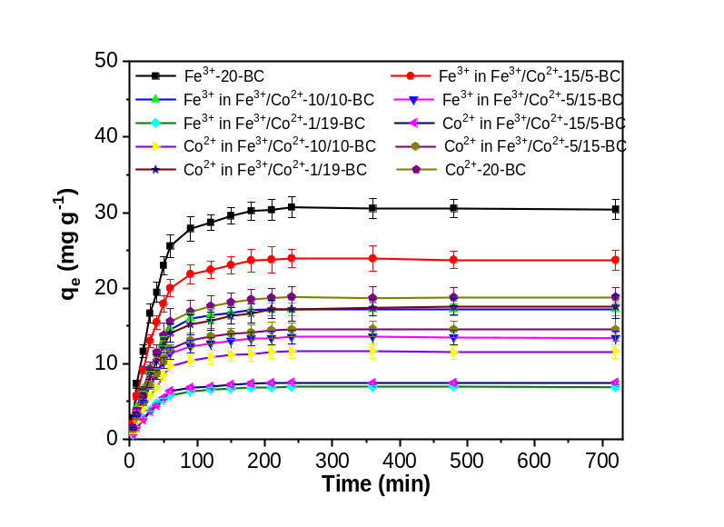
Supplementary Figure 2. Adsorption of Fe³⁺, Co²⁺ and Fe³⁺/Co²⁺on BC at 25 °C. Adsorption solutions were prepared by dissolving appropriate amounts of Co(SO₄)₃·7H₂O and Fe₂(SO₄)₃·10H₂O in deionised water. The adsorption solutions for Fe³⁺-20-BC and Co²⁺-20-BC contain 20 mmol L⁻¹ of Fe³⁺ or Co²⁺, respectively. The adsorption solutions for Fe³⁺/Co²⁺-x/y-BC (x/y: [Fe³⁺]/[Co²⁺] ratios in adsorption solutions) contain a total Fe³⁺ and Co²⁺ concentration of 20 mmol L⁻¹ with different x/y values of 15/5, 10/10, 5/15 and 1/19. Adsorption solution volume: 400 mL; Amount of BC: 1.0 g; q_{e}: Impregnated Fe³⁺/Co²⁺ amount on BC under equilibrium condition determined by ICP-AES.

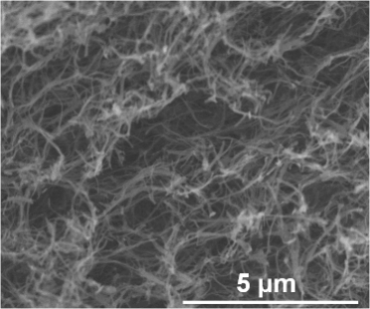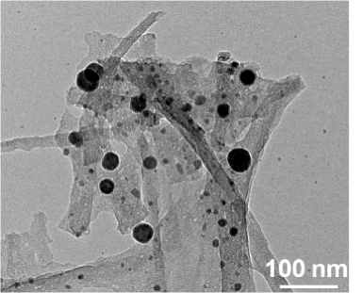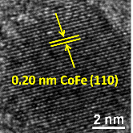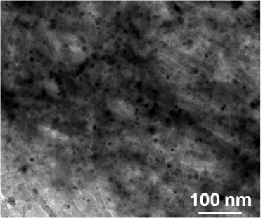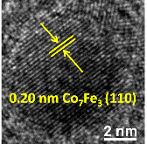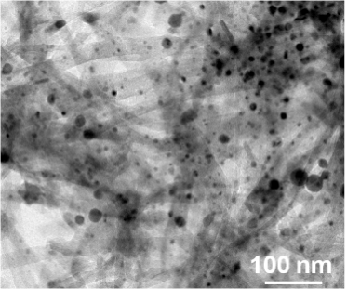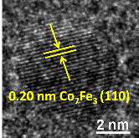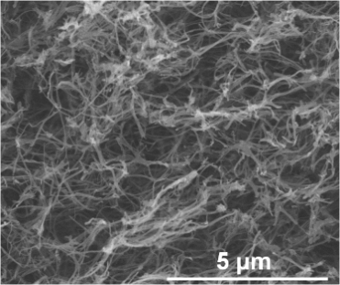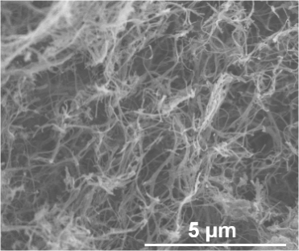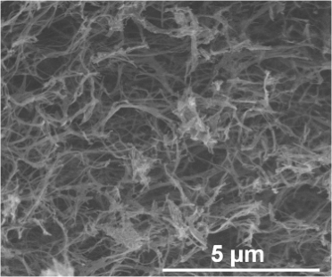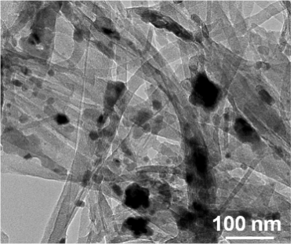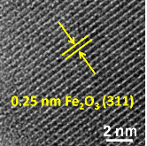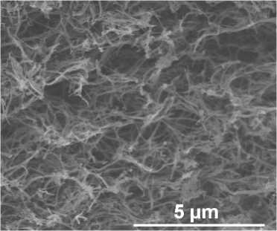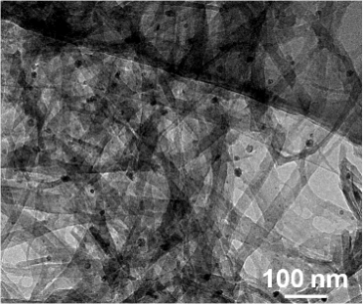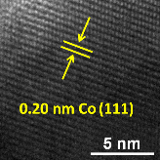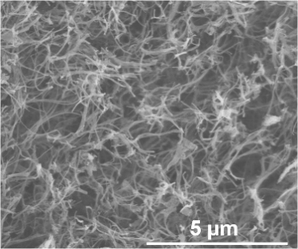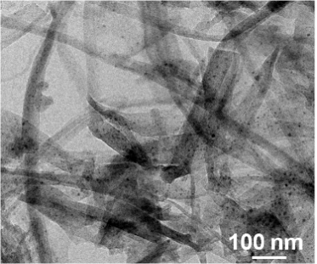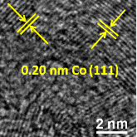
e
f
j
h
g

k
a
b
c

d
i
l
Supplementary Figure 3. SEM images and TEM images (Inset: HRTEM images) of (a, b) Fe-20-CBC, (c, d) Co-20-CBC, (e, f) Fe/Co-15/5-CBC, (g, h) Fe/Co-10/10-CBC, (i, j) Fe/Co-5/15-CBC and (k, l) Fe/Co-1/19-CBC.
a
b
d
c
e
f
Supplementary Figure 4. XRD patterns of (a) Fe-20-CBC and Fe-O-C, (b) Co-20-CBC and Co-O-C, (c) Fe/Co-15/5-CBC and Fe-O-C-2.9, (d) Fe/Co-10/10-CBC and Fe-O-C-1.5, (e) Fe/Co-5/15-CBC and Fe-O-C-1.0, (f) Fe/Co-1/19-CBC and Fe-O-C-0.56.
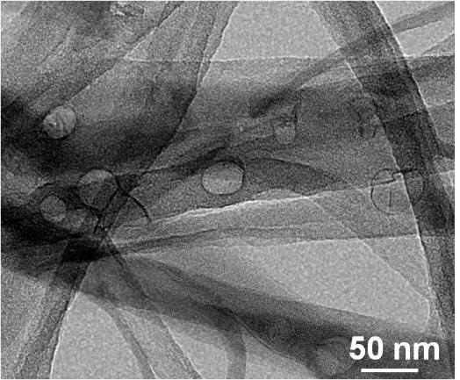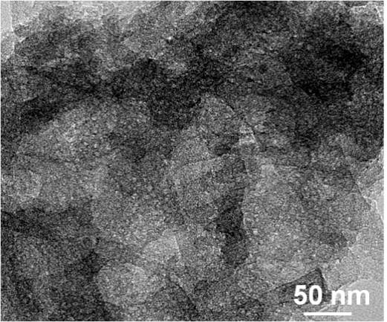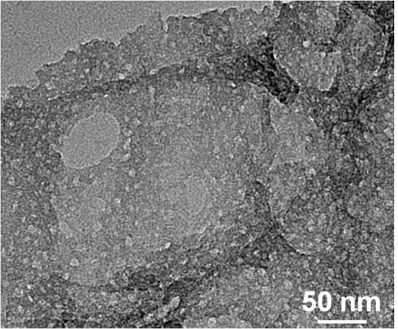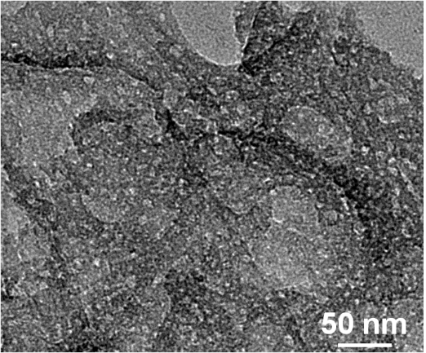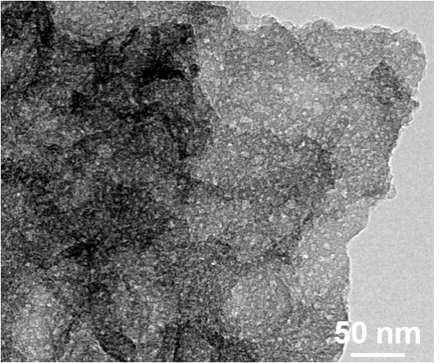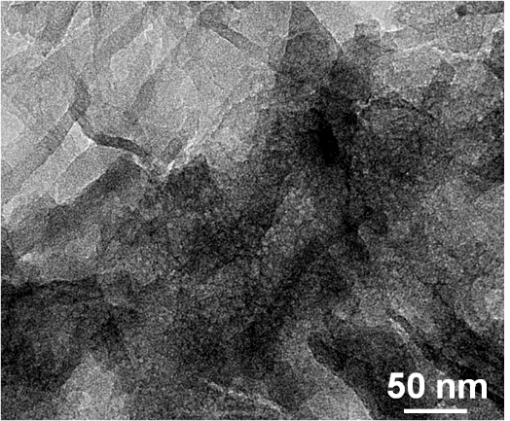
a
b
c
d
e
f
Supplementary Figure 5. TEM images of (a) Fe-O-C, (b) Co-O-C, (c) Co-O-C-2.9, (d) Fe/Co-O-C-1.5, (e) Fe/Co-O-C-1.0 and (f) Fe/Co-O-C-0.56 derived respectively from the acid-etched Fe-20-CBC, Co-20-CBC, Fe/Co-15/5-CBC, Fe/Co-10/10-CBC, Fe/Co-5/15-CBC and Fe/Co-1/19-CBC.

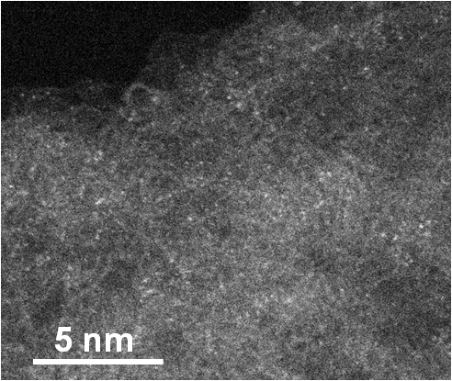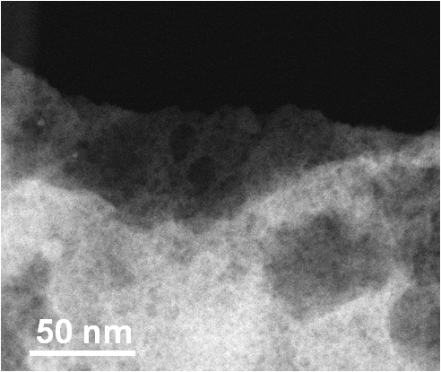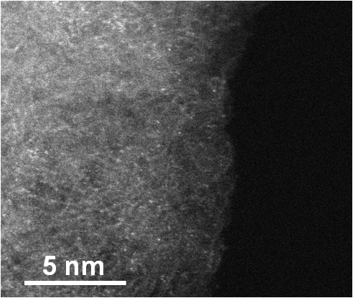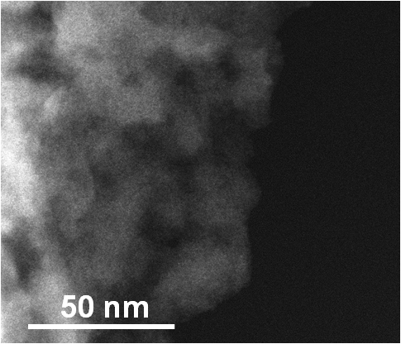
a
b
Supplementary Figure 6. HAADF-STEM images of (a) Fe-O-C and (b) Co-O-C derived respectively from the acid-etched Fe-20-CBC and Co-20-CBC.

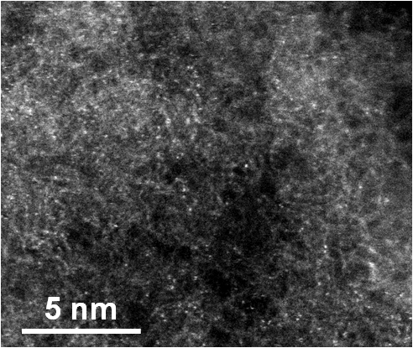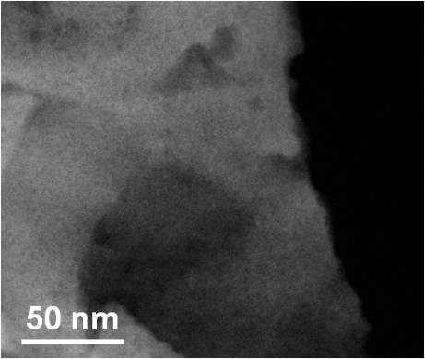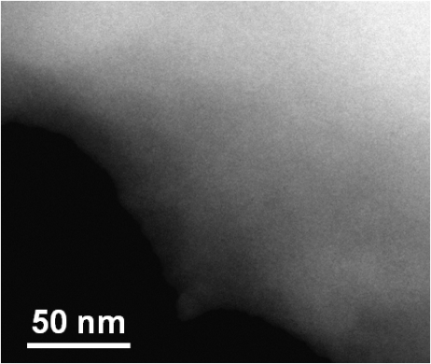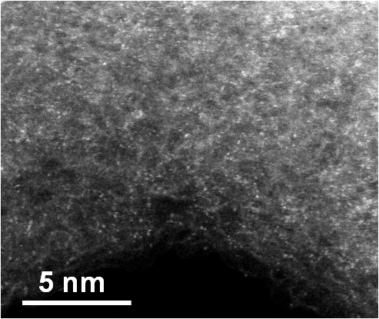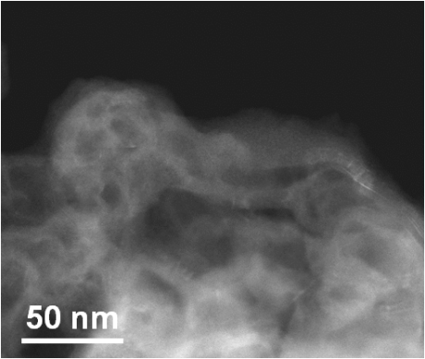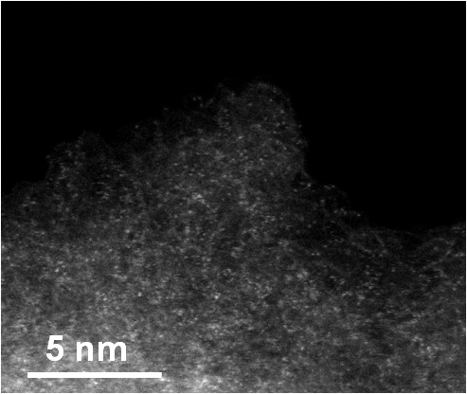
a
b
c
Supplementary Figure 7. HAADF-STEM images of (a) Fe/Co-O-C-0.56, (b) Fe/Co-O-C-1.5 and (c) Fe/Co-O-C-2.9 derived respectively from the acid-etched Fe/Co-1/19-CBC, Fe/Co-10/10-CBC and Fe/Co-15/5-CBC.

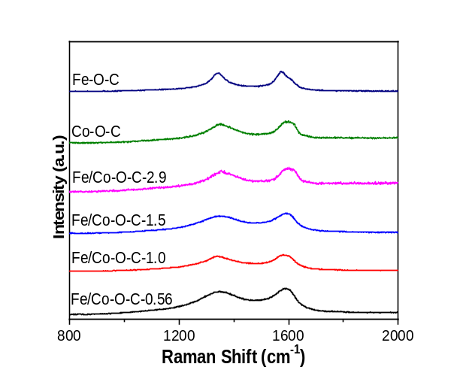
Supplementary Figure 8. Raman spectra of Fe-O-C, Co-O-C, Fe/Co-O-C-2.9, Fe/Co-O-C-1.5, Fe/Co-O-C-1.0 and Fe/Co-O-C-0.56.

a
b
Supplementary Figure 9. (a) N₂ adsorption-desorption isotherms and (b) Corresponding pore size distribution curves of Fe-O-C, Co-O-C, Fe/Co-O-C-2.9, Fe/Co-O-C-1.5, Fe/Co-O-C-1.0 and Fe/Co-O-C-0.56.

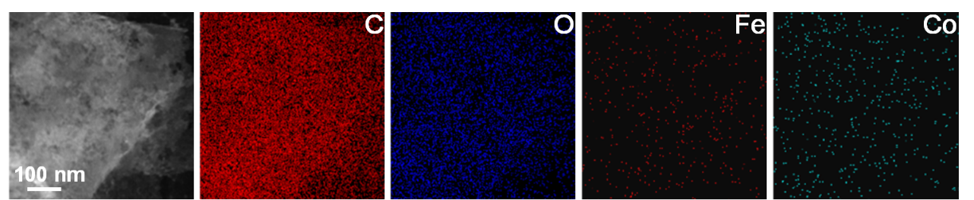

Supplementary Figure 10. HAADF-STEM image of Fe/Co-O-C-1.0 and corresponding elemental mapping images.

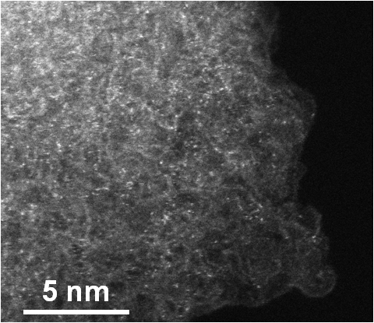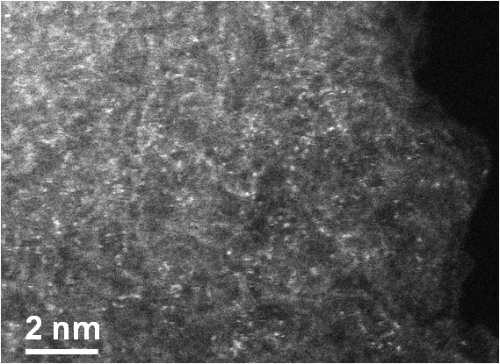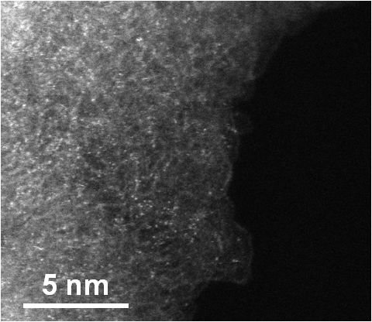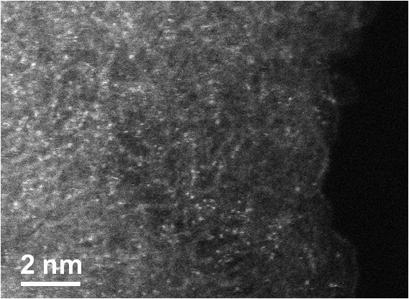
a
b
Supplementary Figure 11. HAADF-STEM images obtained from different locations of a Fe/Co-O-C-1.0 sample.

c
d
a
b
Supplementary Figure 12. (a) Survey XPS spectrum and high-resolution XPS spectra of (b) O 1s, (c) C 1s and (d) Co 2p and Fe 2p of Fe/Co-O-C-1.0.

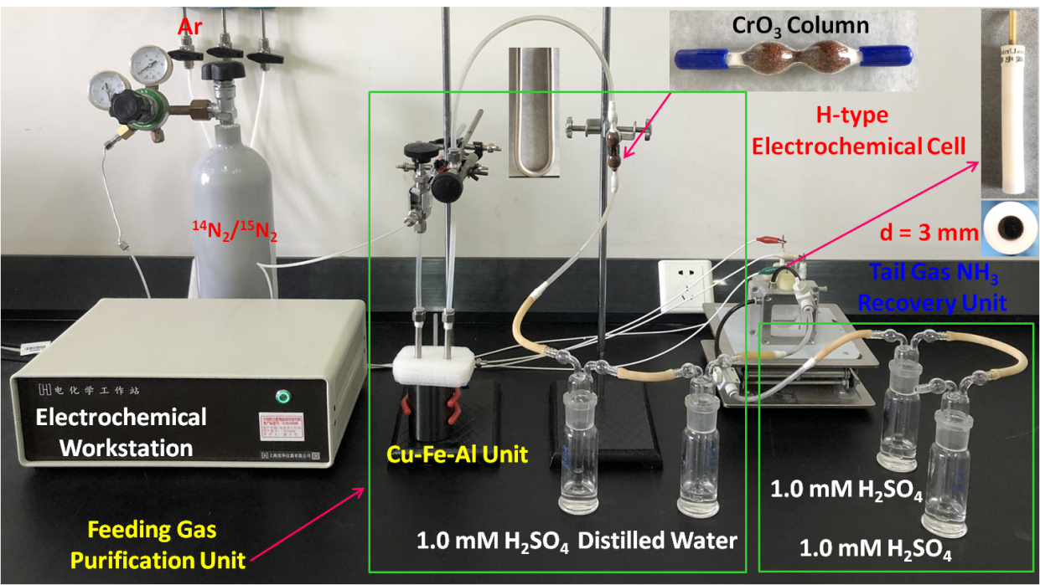
Supplementary Figure 13. Photograph of electrochemical experimental setup.

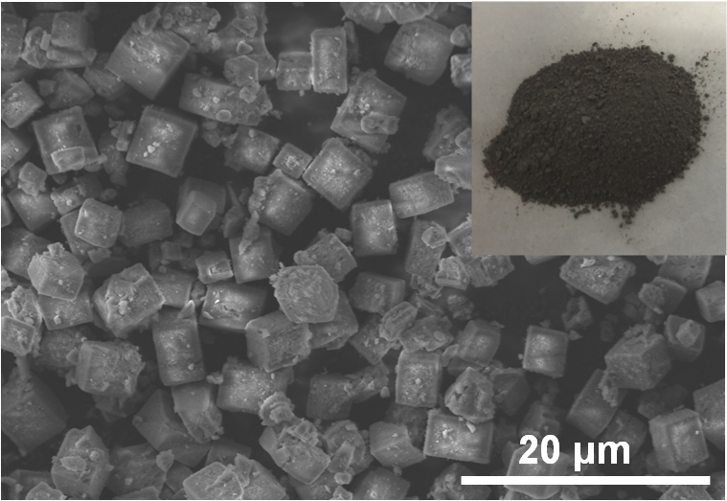
Supplementary Figure 14. SEM image and photograph (inset) of the synthesised Cu-Fe-Al catalyst.

b
a
Supplementary Figure 15. (a) UV-Vis absorption spectra obtained from solutions with different NH₄⁺-N concentrations (0, 0.05, 0.10, 0.25, 0.50, 1.0 and 2.0 μg mL⁻¹) incubated for 1 h at room temperature. (b) Calibration curve used to determine NH₄⁺-N concentrations.

a
b
Supplementary Figure 16. (a) UV-Vis absorption spectra obtained from solutions with different N₂H₄ concentrations (0, 0.05, 0.10, 0.25, 0.50, 1.0 and 2.0 μg mL⁻¹) incubated for 20 min at room temperature. (b) Calibration curve used to determine N₂H₄ concentrations.

b
a
Supplementary Figure 17. (a) Time-dependent current density curves of Fe/Co-O-C-1.0 catalysed NRR at different potentials in N₂-saturated 0.1 M Na₂SO₄ electrolyte over a 2 h period. (b) UV-Vis absorption spectra of the corresponding samples recorded in accordance with the indophenol blue method.

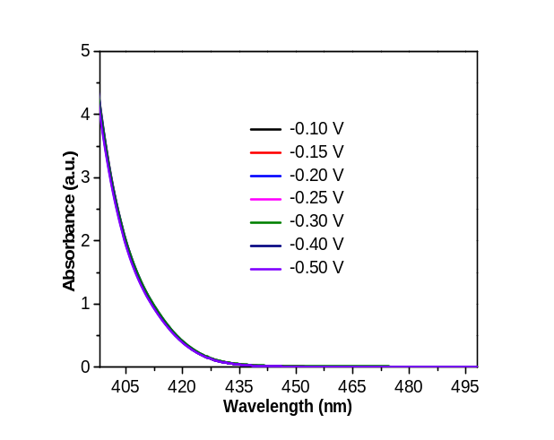
Supplementary Figure 18. UV-Vis absorption spectra of samples resulted from Fe/Co-O-C-1.0 catalysed NRR at different potentials in N₂-saturated 0.1 M Na₂SO₄ for 2 h recorded in accordance with Watt and Chrisp method.

d
e
c
b
a
f
Supplementary Figure 19. (a) ¹H NMR spectra of ¹⁴NH₄⁺ standards and (b) The corresponding ¹⁴NH₄⁺ calibration curve. (c) ¹H NMR spectra of ¹⁵NH₄⁺ standards and (d) The corresponding ¹⁵NH₄⁺ calibration curve. (e) ¹H NMR spectra of ¹⁴NH₄⁺ and ¹⁵NH₄⁺ standards (75 μg mL⁻¹), and the resultant samples from Fe/Co-O-C-1.0 catalysed NRR using ¹⁴N₂ and ¹⁵N₂ feeding gases, respectively. (f) Yielded ¹⁴NH₄⁺ and ¹⁵NH₄⁺ concentrations in the resultant sample solutions determined by the indophenol blue and ¹H NMR methods.

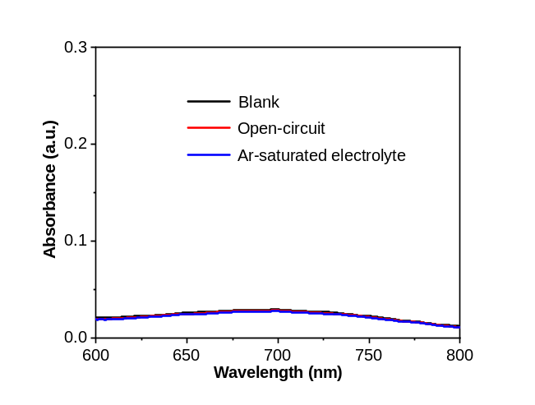
Supplementary Figure 20. UV-Vis absorption spectra of samples after 2 h NRR in N₂-saturated 0.1 M Na₂SO₄ solution at -0.30 V applied potential without Fe/Co-O-C-1.0 (blank), N₂-saturated 0.1 M Na₂SO₄ solution with Fe/Co-O-C-1.0 under open-circuit condition (open-circuit), and Ar-saturated 0.1 M Na₂SO₄ solution with Fe/Co-O-C-1.0 at -0.30 V (Ar-saturated electrolyte). The spectra were recorded in accordance with the indophenol blue method.

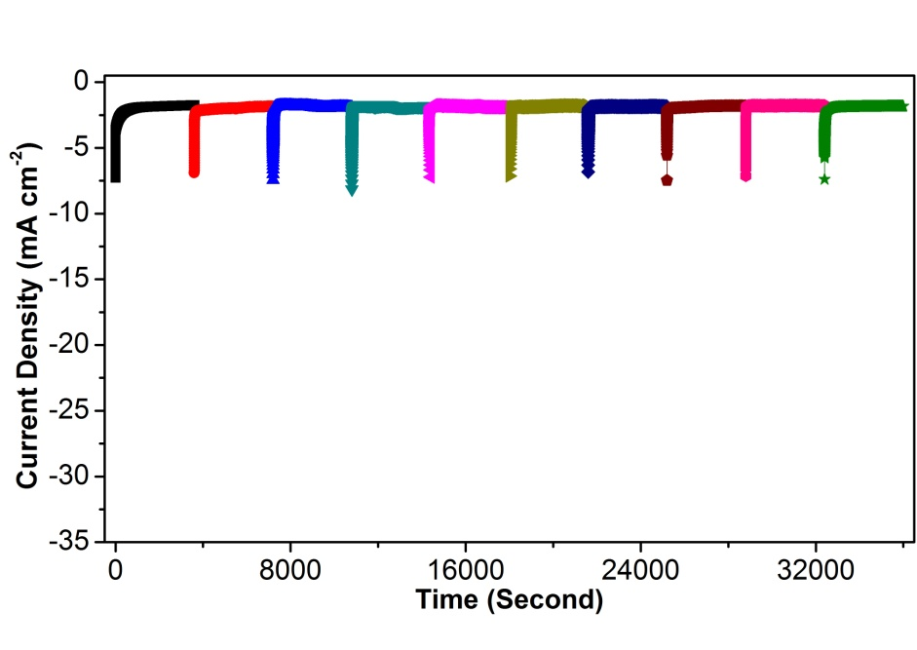
a
b
Supplementary Figure 21. (a) Cycling stability test of Fe/Co-O-C-1.0 in N₂-saturated 0.1 M Na₂SO₄ electrolyte at -0.30 V (vs. RHE) for 10 cycles with 1 h NRR period per cycle. (b) Corresponding R_{NH3} and FE of each testing cycle.

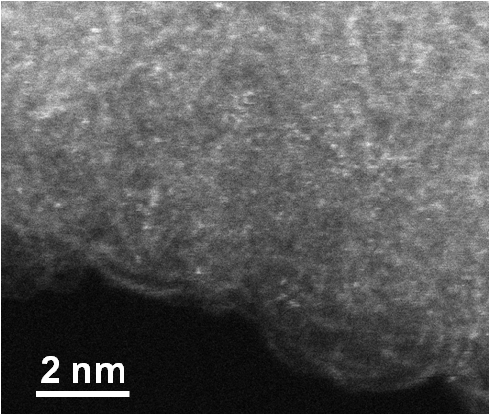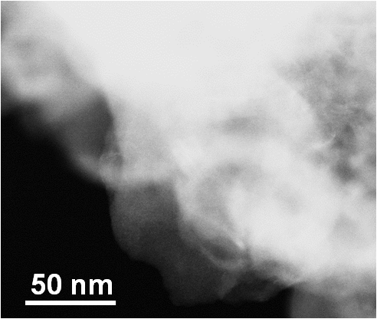
b
a
Supplementary Figure 22. (a) Low- and (b) High-magnification aberration-corrected HAADF-STEM images of Fe/Co-O-C-1.0 after 72 h stability test.

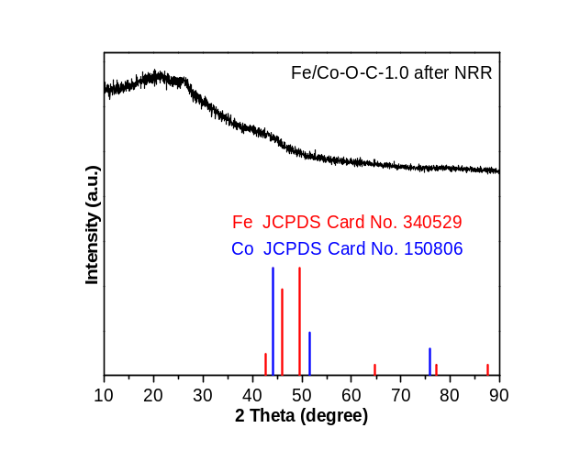
Supplementary Figure 23. XRD patterns of Fe/Co-O-C-1.0 after 72 h stability test.

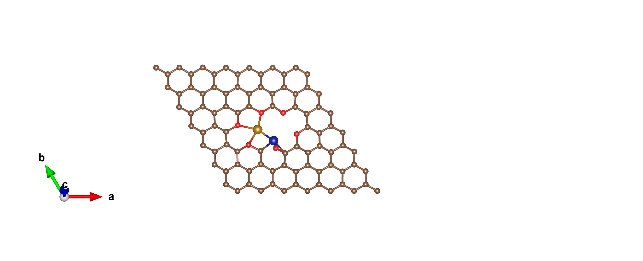
e
f
a
b
c
d
Supplementary Figure 24. Fe K edge (a) XANES spectra and (b) k³-weighted FT-EXAFS spectra of Fe/Co-O-C-1.0 after 10 NRR cycles, and Fe foil (Noting that the spectrum is transformed by 0.7), Fe₂O₃. Co K edge (c) XANES spectra and (d) k³-weighted FT-EXAFS spectra of Fe/Co-O-C-1.0 after 10 NRR cycles, Co foil (Noting that the spectrum is transformed by 0.7), Co₃O₄. (e, f) Fe K edge and Co K edge EXAFS fitting curves of [(O-C₂)₃Fe-Co(O-C)C₂] configuration for Fe/Co-O-C-1.0 at R space and k space, respectively. Inset in (e) is the possible bimetallic Fe-Co coordination configurationin Fe/Co-O-C-1.0 after 10 NRR cycles (Brown: C, red: O, orange: Fe, blue: Co).
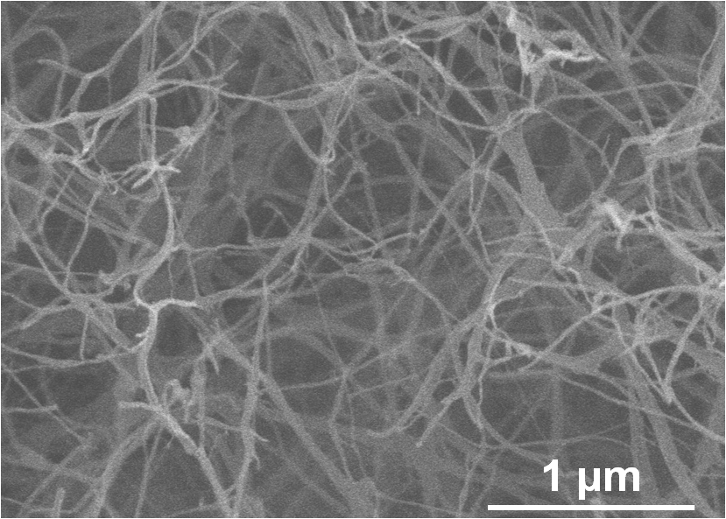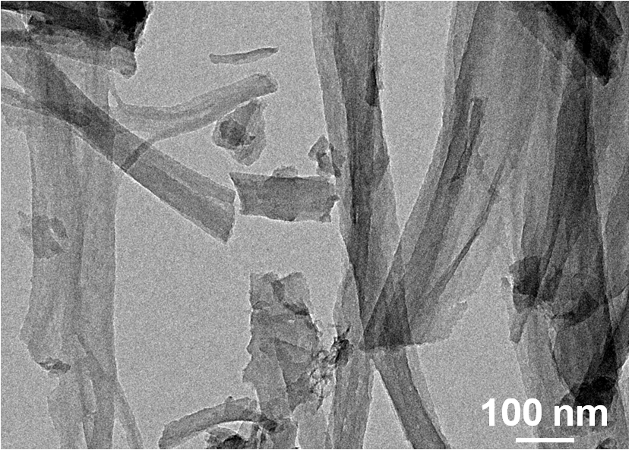
e
f
g
h
a
b
d
c
Supplementary Figure 25. (a) SEM image, (b) TEM image, (c) XRD patterns, (d) Survey XPS spectrum, (e) High-resolution O 1s, (f) High-resolution C 1s spectra, (g) N₂ adsorption-desorption isotherm and (h) Corresponding pore size distribution curve of CBC.
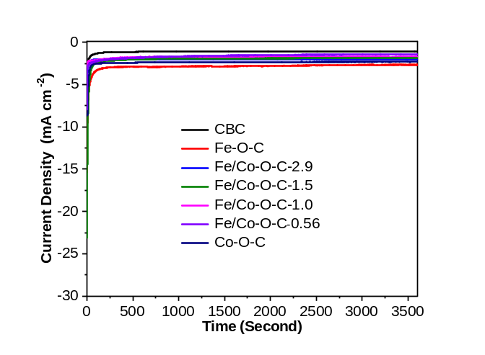
Supplementary Figure 26. Chronoamperometric responses of CBC, Fe-O-C, Fe/Co-O-C-2.9, Fe/Co-O-C-1.5, Fe/Co-O-C-1.0, Fe/Co-O-C-0.56 and Co-O-C catalysts at -0.30 V (vs. RHE) for 1 h reaction period in N₂-saturated 0.1 M Na₂SO₄ electrolyte.

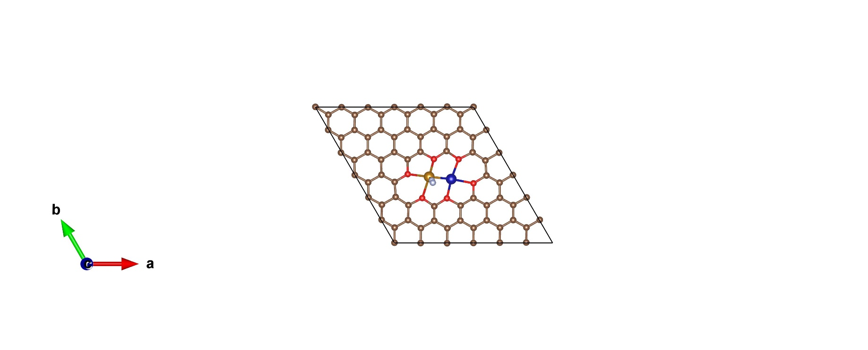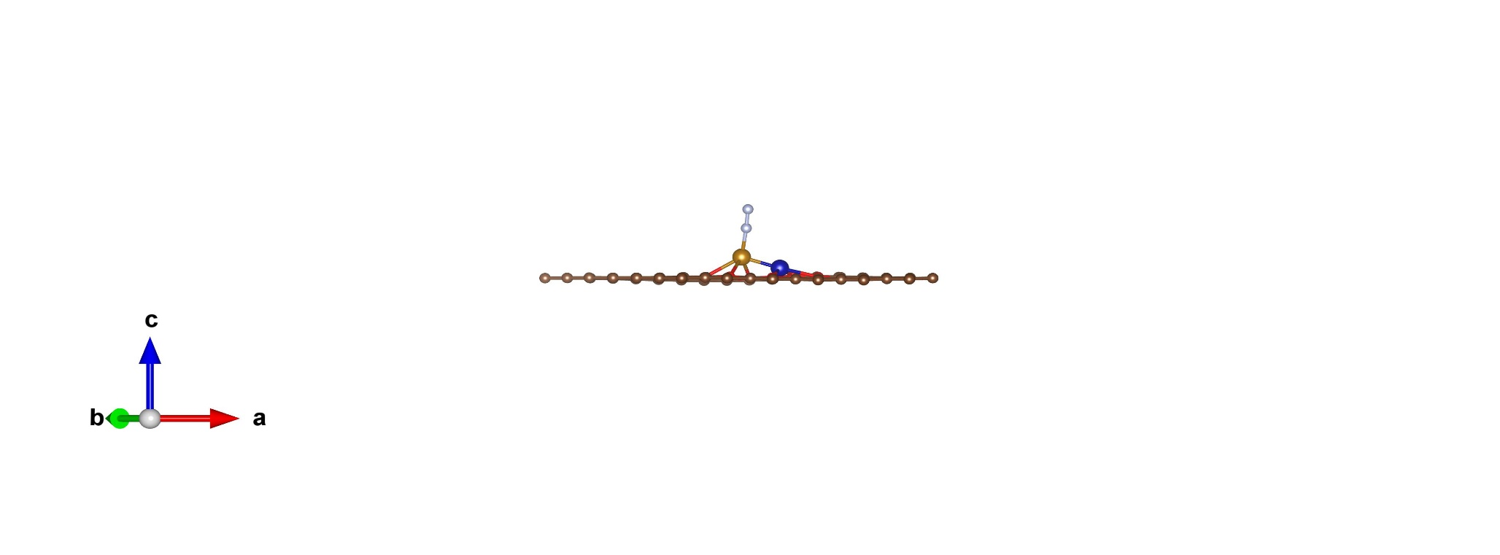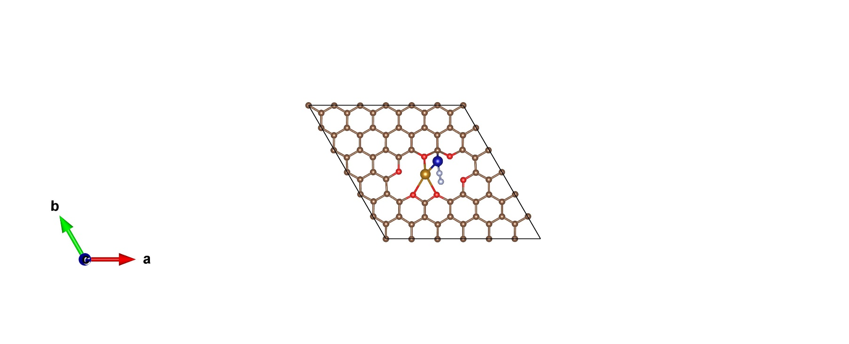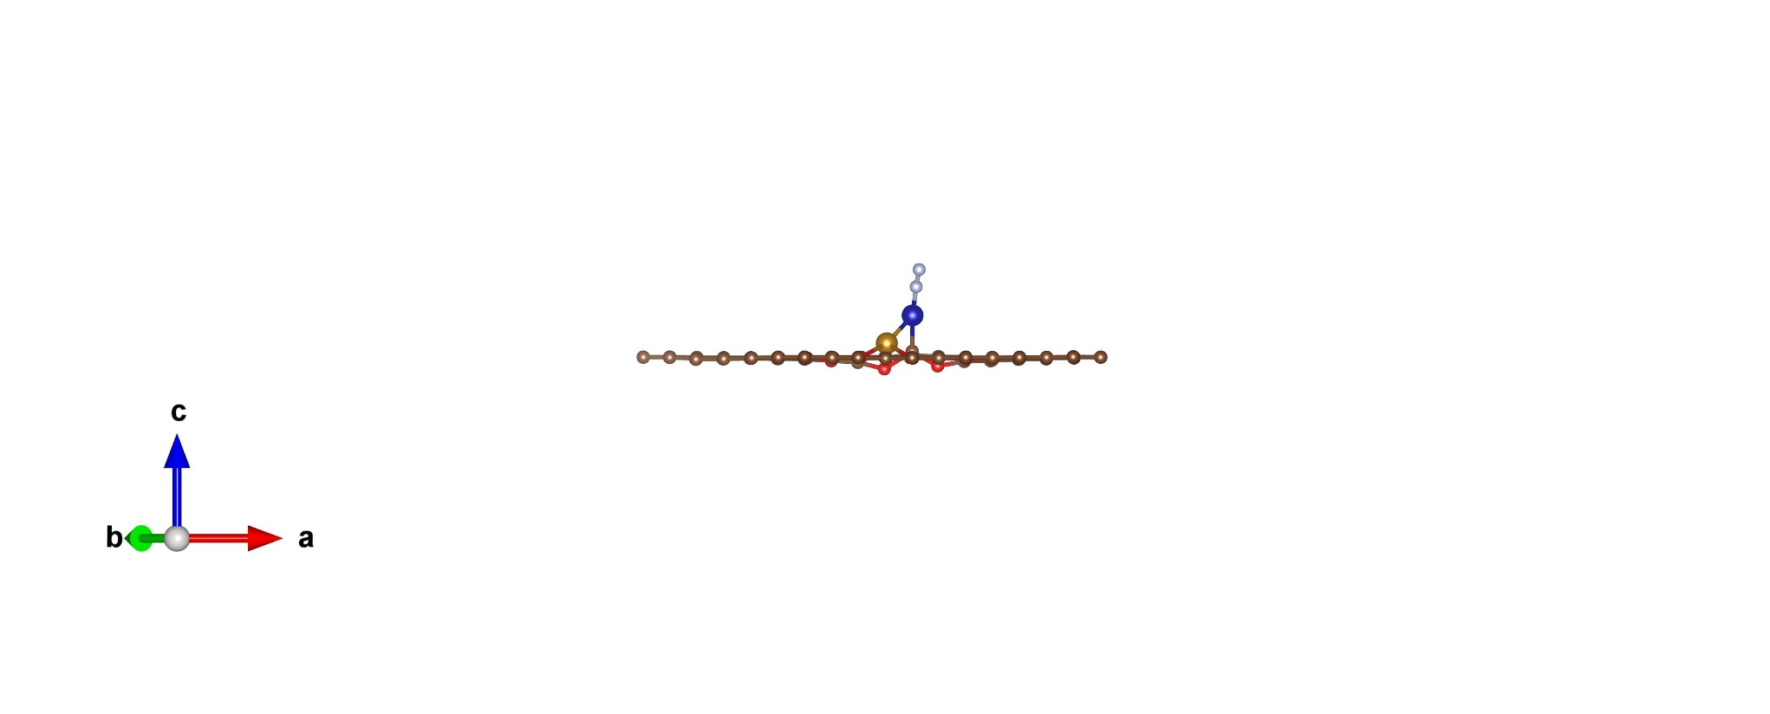
a
Top View
Side View
b
Top View
Side View
Supplementary Figure 27. DFT optimised end-on N₂ adsorption configurations on (a) Fe and (b) Co sites in [(O-C₂)₃Fe-Co(O-C₂)₃].

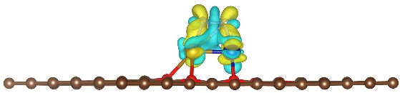
Supplementary Figure 28. DFT calculated Charge density differences (δρ=ρA+B−ρA−ρB) of side-on N₂ adsorption on [(O-C₂)₃Fe-Co(O-C₂)₃]. Yellow and cyan stand respectively for the electron accumulation and depletion. The isosurface value is 0.005 e/a₀⁻³, where a₀ is the Bohr radius.

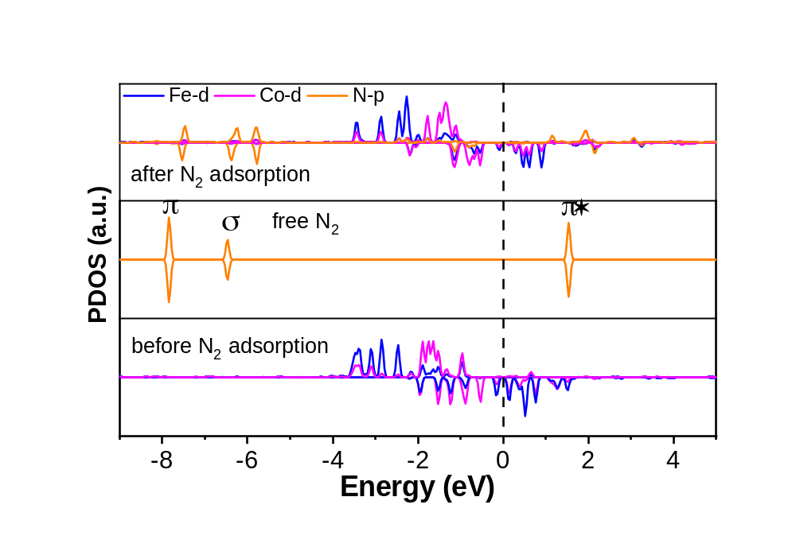
Supplementary Figure 29. Calculated PDOS for graphene with [(O-C₂)₃Fe-Co(O-C₂)₃] before and after side-on N₂ adsorption.

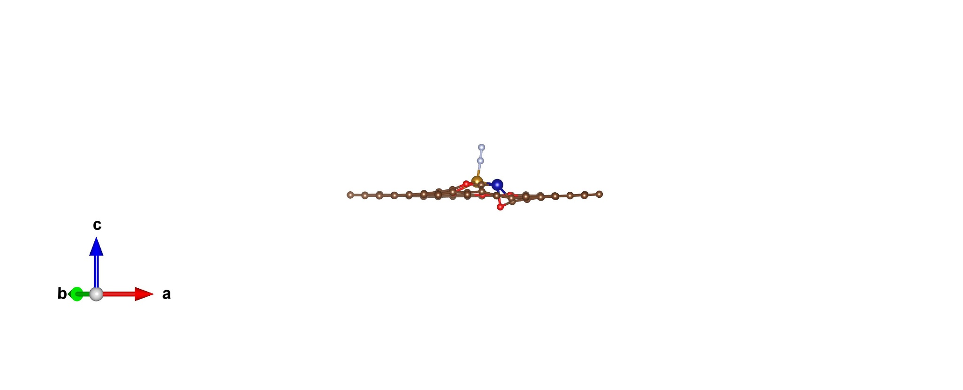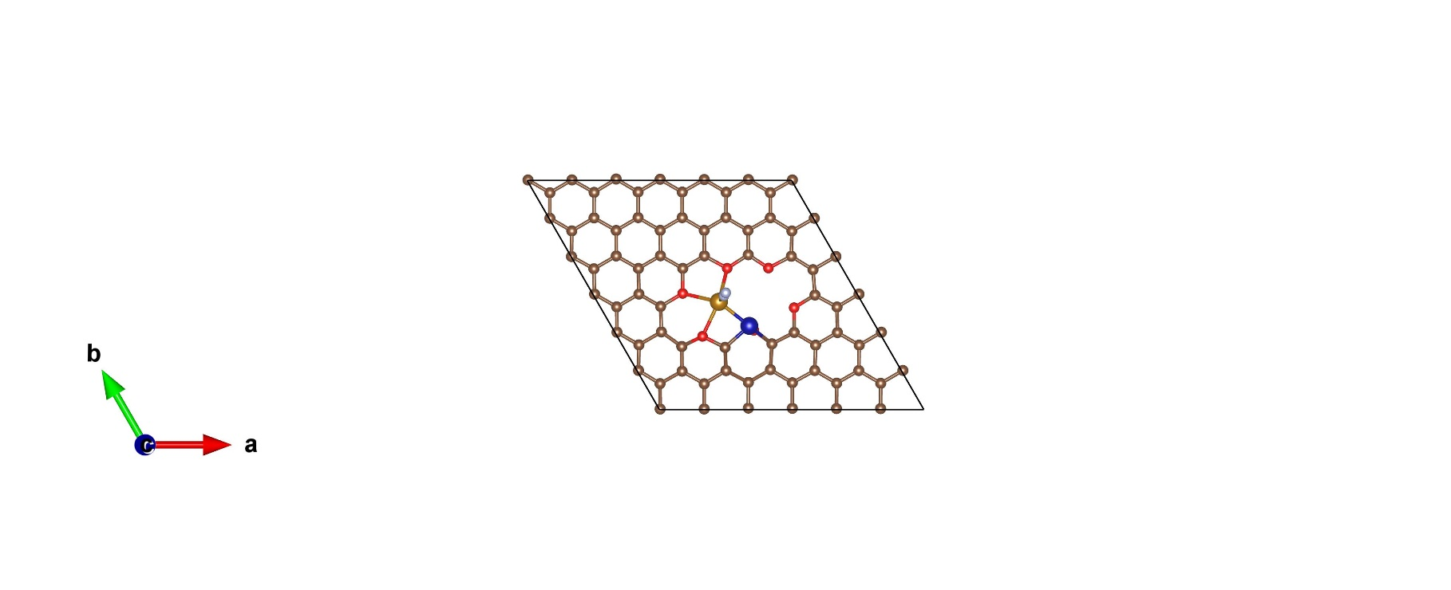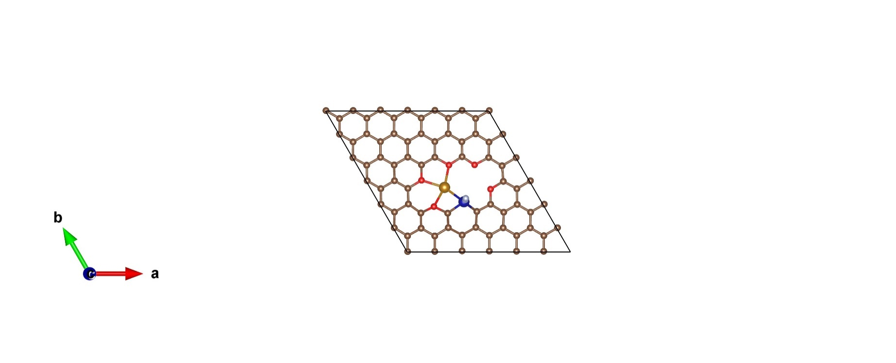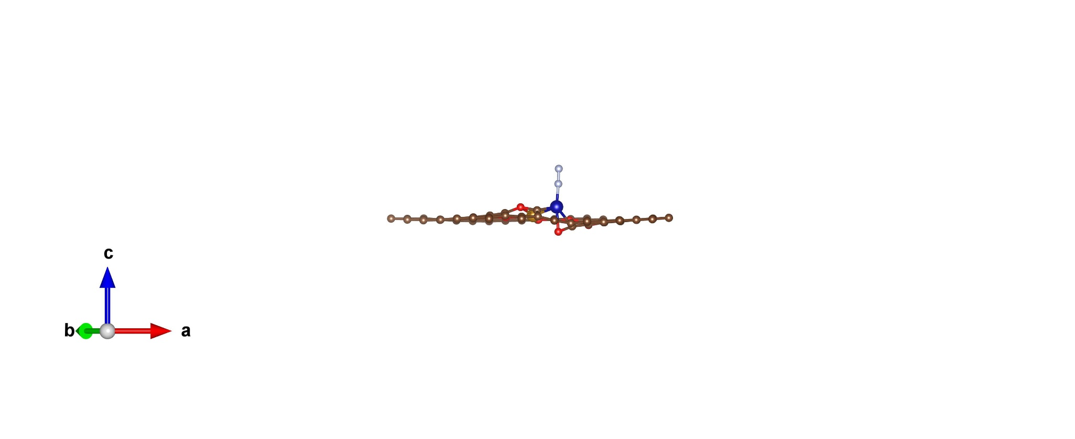
a
Top View
Side View
b
Top View
Side View
Supplementary Figure 30. DFT optimised end-on N₂ adsorption configurations on (a) Fe and (b) Co sites in [(O-C₂)₃Fe-Co(O-C)C₂].

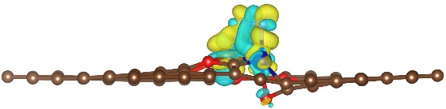
Supplementary Figure 31. DFT calculated Charge density differences (δρ=ρA+B−ρA−ρB) of side-on N₂ adsorption on [(O-C₂)₃Fe-Co(O-C)C₂]. Yellow and cyan stand respectively for the electron accumulation and depletion. The isosurface value is 0.005 e/a₀⁻³, where a₀ is the Bohr radius.

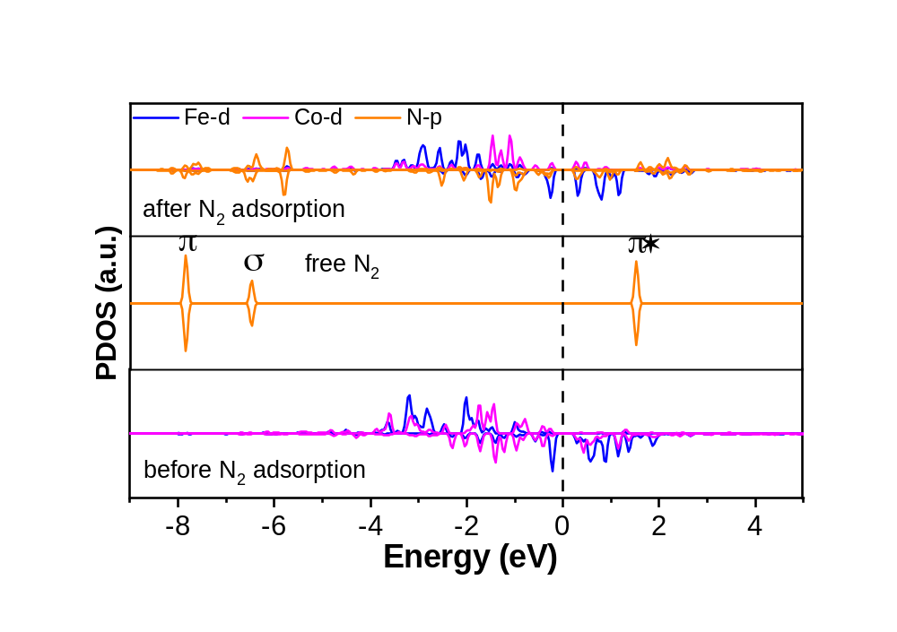
Supplementary Figure 32. Calculated PDOS for graphene with [(O-C₂)₃Fe-Co(O-C)C₂] before and after side-on N₂ adsorption.

Supplementary References
- Wang, J., et al. Ambient ammonia synthesis via palladiumcatalyzed electrohydrogenation of dinitrogen at low overpotential. Nat. Commun. 9, 1795–1801 (2018).
- Shi, M. –M., et al. Au subnanoclusters on TiO₂ toward highly efficient and selective electrocatalyst for N₂ conversion to NH₃ at ambient conditions. Adv. Mater. 29, 1606550 (2017).
- Shi, M. –M., et al. Anchoring PdCu amorphous nanocluster on graphene for electrochemical reduction of N₂ to NH₃ under ambient conditions in aqueous solution. Adv. Energy Mater. 8, 1800124 (2018).
- Huang H, et al. Ag nanosheets for efficient electrocatalytic N₂ fixation to NH₃ under ambient conditions. Chem. Commun. 54, 11427-11430 (2018).
- Lee HK, et al. Favoring the unfavored: selective electrochemical nitrogen fixation using a reticular chemistry approach. Sci. Adv. 4, eaar3208 (2018).
- Xue Z-H, et al. Electrochemical reduction of N₂ into NH₃ by donor–acceptor couples of Ni and Au nanoparticles with a 67.8% faradaic efficiency. J. Am. Chem. Soc. 141, 14976-14980 (2019).
- Yang C, et al. A generalized surface chalcogenation strategy for boosting the electrochemical N₂ fixation of metal nanocrystals. Adv. Mater. 32, 2001267 (2020).
- Xu W, et al. Nanoporous palladium hydride for electrocatalytic N₂ reduction under ambient conditions. Angew. Chem. Int. Ed. 59, 3511-3516 (2020).
- Ahmed MI, et al. Metal–sulfur linkages achieved by organic tethering of ruthenium nanocrystals for enhanced electrochemical nitrogen reduction. Angew. Chem. Int. Ed. 59, 21465-21469 (2020).
- Tan Y, et al. Fabrication of an Au₂₅-Cys-Mo electrocatalyst for efficient nitrogen reduction to ammonia under ambient conditions. Small 17, 2100372 (2021).
- Guo Y, et al. Regulating nitrogenous adsorption and desorption on Pd clusters by the acetylene linkages of hydrogen substituted graphdiyne for efficient electrocatalytic ammonia synthesis. Nano Energy 86, 106099 (2021).
- Zhao C, et al. Ambient electrosynthesis of ammonia on a biomass-derived nitrogen-doped porous carbon electrocatalyst: contribution of pyridinic nitrogen. ACS Energy Lett. 4, 377-383 (2019).
- Qiu W, et al. High-performance artificial nitrogen fixation at ambient conditions using a metal-free electrocatalyst. Nat. Commun. 9, 3485 (2018).
- Yuan D, et al. Electron distribution tuning of fluorine-doped carbon for ammonia electrosynthesis. J. Mater. Chem. A 7, 16979-16983 (2019).
- Zhu X, et al. Ambient electrohydrogenation of N₂ for NH₃ synthesis on non-metal boron phosphide nanoparticles: the critical role of P in boosting the catalytic activity. J. Mater. Chem. A 7, 16117-16121 (2019).
- Zhang X, et al. Boron nanosheet: An elemental two-dimensional (2D) material for ambient electrocatalytic N₂-to-NH₃ fixation in neutral media. ACS Catal. 9, 4609-4615 (2019).
- Liu S, et al. Facilitating nitrogen accessibility to boron-rich covalent organic frameworks via electrochemical excitation for efficient nitrogen fixation. Nat. Commun. 10, 3898 (2019).
- McPherson IJ, et al. The feasibility of electrochemical ammonia synthesis in molten LiCl-KCl eutectics. Angew. Chem. Int. Ed. 58, 17433-17441 (2019).
- Liu Y, et al. A highly efficient metal-free electrocatalyst of F-doped porous carbon toward N₂ electroreduction. Adv. Mater. 32, 1907690 (2020).
- Liu B, et al. Nanostructured and boron-doped diamond as an electrocatalyst for nitrogen fixation. ACS Energy Lett. 5, 2590-2596 (2020).
- Liu Q, et al. Crystalline red phosphorus nanoribbons: large-scale synthesis and electrochemical nitrogen fixation. Angew. Chem. Int. Ed. 59, 14383-14387 (2020).
- Lin Y-X, et al. Boosting selective nitrogen reduction to ammonia on electron-deficient copper nanoparticles. Nat. Commun. 10, 4380 (2019).
- Liu Y-T, et al. Promoted electrocatalytic nitrogen fixation in Fe-Ni layered double hydroxide arrays coupled to carbon nanofibers: the role of phosphorus doping. Angew. Chem. Int. Ed. 59, 13623-13627 (2020).
- Wang H-B, et al. Bionic design of a Mo(IV)-doped FeS₂ catalyst for electroreduction of dinitrogen to ammonia. ACS Catal. 10, 4914-4921 (2020).
- Fang Y, et al. Graphdiyne interface engineering: highly active and selective ammonia synthesis. Angew. Chem. Int. Ed. 59, 13021-13027 (2020).
- Tong Y, et al. Vacancy engineering of iron-doped W₁₈O₄₉ nanoreactors for low-barrier electrochemical nitrogen reduction. Angew. Chem. Int. Ed. 59, 7356-7361 (2020).
- Lai F, et al. Refining energy levels in ReS₂ nanosheets by low-valent transition-metal doping for dual-boosted electrochemical ammonia/hydrogen production. Adv. Funct. Mater. 30, 1907376 (2020).
- Liu S, et al. Altering the rate-determining step over cobalt single clusters leading to highly efficient ammonia synthesis. Natl Sci. Rev. https://doi.org/10.1093/nsr/nwaa136 (2021).
- Ba K, et al. Single faceted two-dimensional Mo₂C electrocatalyst for highly efficient nitrogen fixation. ACS Catal. 10, 7864-7870 (2020).
- Lv X-W, et al. Identifying the dominant role of pyridinic-N–Mo bonding in synergistic electrocatalysis for ambient nitrogen reduction. ACS Nano 15, 12109-12118 (2021).
- Zhao Y, et al. Identification of M-NH₂-NH₂ intermediate and rate determining step for nitrogen reduction with bioinspired sulfur-bonded FeW catalyst. Angew. Chem. Int. Ed. https://doi.org/10.1002/anie.202104918 (2021).
- Chen J, et al. The activation of porous atomic layered MoS₂ basal-plane to induce adjacent Mo atom pairs promoting high efficiency electrochemical N₂ fixation. Appl. Catal. B: Environ. 285, 119810 (2021).
- Liao W, et al. Interfacial engineering promoting electrosynthesis of ammonia over Mo/phosphotungstic acid with high performance. Adv. Funct. Mater. 31, 2009151 (2021).
- Liu X, et al. Antimony-based composites loaded on phosphorus-doped carbon for boosting faradaic efficiency of the electrochemical nitrogen reduction reaction. Angew. Chem. Int. Ed. 58, 13329-13334 (2019).
- Liu Y-T, et al. Stable confinement of black phosphorus quantum dots on black tin oxide nanotubes: a robust, double-active electrocatalyst toward efficient nitrogen fixation. Angew. Chem. Int. Ed. 131, 16591-16595 (2019).
- Li L, et al. Two-dimensional mosaic bismuth nanosheets for highly selective ambient electrocatalytic nitrogen reduction. ACS Catal. 9, 2902-2908 (2019).
- Hao Y-C, et al. Promoting nitrogen electroreduction to ammonia with bismuth nanocrystals and potassium cations in water. Nat. Catal. 2, 448-456 (2019).
- Wang Y, et al. Generating defect-rich bismuth for enhancing the rate of nitrogen electroreduction to ammonia. Angew Chem Int Ed. 58, 9464-9469 (2019).
- Zhang R, et al. Electrocatalytic N₂-to-NH₃ conversion with high faradaic efficiency enabled using a Bi nanosheet array. Chem. Commun. 55, 5263-5266 (2019).
- Guo Y, et al. A rechargeable Al–N₂ battery for energy storage and highly efficient N₂ fixation. Energy Environ.Sci. 13, 2888-2895 (2020).
- Yao D, et al. In situ fragmented bismuth nanoparticles for electrocatalytic nitrogen reduction. Adv. Energy Mater. 10, 2001289 (2020).
- Wan Y, et al. Oxidation state modulation of bismuth for efficient electrocatalytic nitrogen reduction to ammonia. Adv. Funct. Mater. 31, 2100300 (2021).
- Wang X, et al. Atomically dispersed Au₁ catalyst towards efficient electrochemical synthesis of ammonia. Sci. Bull. 63, 1246-1253 (2018).
- Geng Z, et al. Achieving a record-high yield rate of 120.9 for N₂ electrochemical reduction over Ru single-atom catalysts. Adv. Mater. 30, 1803498 (2018).
- Tao H, et al. Nitrogen fixation by Ru single-atom electrocatalytic reduction. Chem 5, 204-214 (2019).
- Han L, et al. Atomically dispersed molybdenum catalysts for efficient ambient nitrogen fixation. Angew. Chem. Int. Ed. 131, 2343-2347 (2019).
- Wang M, et al. Over 56.55% Faradaic efficiency of ambient ammonia synthesis enabled by positively shifting the reaction potential. Nat. Commun. 10, 341 (2019).
- Lü F, et al. Nitrogen-coordinated single Fe sites for efficient electrocatalytic N₂ fixation in neutral media. Nano Energy 61, 420-427 (2019).
- Hui L, et al. Highly efficient and selective generation of ammonia and hydrogen on a graphdiyne-based catalyst. J. Am. Chem. Soc. 141, 10677-10683 (2019).
- Zang W, et al. Copper single atoms anchored in porous nitrogen-doped carbon as efficient pH-universal catalysts for the nitrogen reduction reaction. ACS Catal. 9, 10166-10173 (2019).
- Zhang R, et al. Single-atom catalysts templated by metal–organic frameworks for electrochemical nitrogen reduction. J. Mater. Chem. A 7, 26371-26377 (2019).
- Liu Y, et al. Electrochemical reduction of N₂ to ammonia on Co single atom embedded N-doped porous carbon under ambient conditions. J. Mater. Chem. A 7, 26358-26363 (2019).
- Yu B, et al. Tuning the catalytic preference of ruthenium catalysts for nitrogen reduction by atomic dispersion. Adv. Funct. Mater. 30, 1905665 (2020).
- Zhang S, et al. Electrocatalytically active Fe-(O-C₂)₄ single-atom sites for efficient reduction of nitrogen to ammonia. Angew. Chem. Int. Ed. 59, 13423-13429 (2020).
- Zhang S, et al. Laser irradiation in liquid to release cobalt single-atom sites for efficient electrocatalytic N₂ reduction. ACS Appl. Energy Mater. 3, 6079-6086 (2020).
- Zhang L, et al. A janus Fe-SnO₂ catalyst that enables bifunctional electrochemical nitrogen fixation. Angew. Chem. Int. Ed. 59, 10888-10893 (2020).
- Peng W, et al. Spontaneous atomic ruthenium doping in Mo₂CT_{X} MXene defects enhances electrocatalytic activity for the nitrogen reduction reaction. Adv. Energy Mater. 10, 2001364 (2020).
- Li J, et al. Accelerated dinitrogen electroreduction to ammonia via interfacial polarization triggered by single-atom protrusions. Chem 6, 885-901 (2020).
- Ma Y, et al. Synergizing Mo single atoms and Mo₂C nanoparticles on CNTs synchronizes selectivity and activity of electrocatalytic N₂ reduction to ammonia. Adv. Mater. 32, 2002177 (2020).
- Su H, et al. Single atoms of iron on MoS₂ nanosheets for N₂ electroreduction into ammonia. Angew. Chem. Int. Ed. 59, 20411-20416 (2020).
- Chen Y, et al. Highly productive electrosynthesis of ammonia by admolecule-targeting single Ag sites. ACS Nano 14, 6938-6946 (2020).
- Yu H, et al. Graphdiyne based metal atomic catalysts for synthesizing ammonia. Natl Sci. Rev. https://doi.org/10.1093/nsr/nwaa213 (2020).
- Han L, et al. Local modulation of single-atomic Mn sites for enhanced ambient ammonia electrosynthesis. ACS Catal. 11, 509-516 (2021).
- Mukherjee S, et al. Atomically dispersed single Ni site catalysts for nitrogen reduction toward electrochemical ammonia synthesis using N₂ and H₂O. Small Methods 4, 1900821 (2020).
- Liu J, et al. Rare earth single-atom catalysts for nitrogen and carbon dioxide reduction. ACS Nano 14, 1093-1101 (2020).
- Wang X, et al. Confined Fe–Cu clusters as sub-nanometer reactors for efficiently regulating the electrochemical nitrogen reduction reaction. Adv. Mater. 32, 2004382 (2020).
- Han L, et al. Modulating single-atom palladium sites with copper for enhanced ambient ammonia electrosynthesis. Angew. Chem. Int. Ed. 60, 345-350 (2021).

