Dual Cation Cross-Linked Alginate-Kaolin Hydrogel Beads: A Sustainable and Powerful Toolkit for Enhancing Wastewater Remediation
Meriem Fizir ^{a,b*}, Khawla Boussibeur ^{a,b}, Amina Richa ª, Sami Touil ª, Liu Wei ^{c*}, Houda Douba ^{b,d}, Dilmi Asma ^{b}, Souad Cherifi ^{a,b}, Houria Rezala ^{b}, Meryem Briki^{e-f}, Jiawei Shi^{g*}.
ªLaboratory of Precision Agriculture, Environment and Sustainable Development, Khemis Miliana University, Algeria.
^{b}Laboratoire de Valorisation des Substances Naturelles, University of Khemis Miliana, Algeria
^{c}Zhejiang Pharmaceutical University, Ningbo 315500, Zhejiang, China.
^{d}Laboratory Physical Chemistry of Materials Interfaces Applied to the Environment, University of Saad Dahlab Blida 1, Algeria
e Petrochemical Synthesis Laboratory, Faculty of Hydrocarbons and Chemistry.University​ of M'Hamed Bougara Boumerdes, Algeria
f Hydrocarbon Technologies Laboratory, Faculty of Hydrocarbons and Chemistry.University​ of M'Hamed Bougara Boumerdes, Algeria
g College of Food Science and Technology, Zhejiang Pharmaceutical University, Ningbo 315500, Zhejiang, China

Email of the corresponding authors: liuwei_fj1992@163.com/meriem.fizir@univ-dbkm.dz/shijw@sina.cn

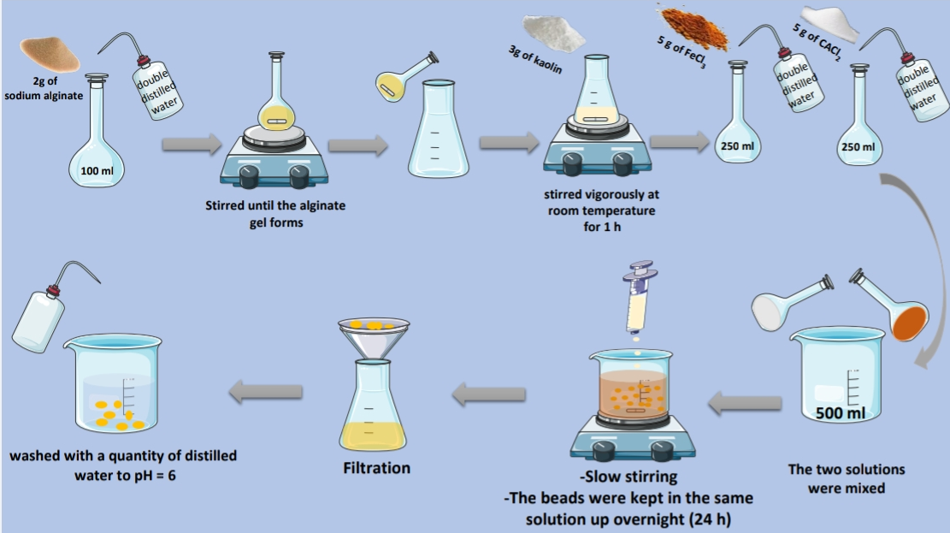
Fig.S1 Synthesis steps of Fe/Ca cross-linked Alg@K composites.
Table 1 List of kinetic adsorption models[1][2] .
Model | Non-linear equation | Parameters
Pseudo-first-order (PFO) | $$Q_{t }= Q_{e}[1 -\exp{(-k_{1}}t)]$$ | Q_{e} and Q_{t} are the chlortetracycline hydrochloride adsorption capacities (mg/g) at equilibrium and at time t, respectively.  K₁ (1/min) is the first-order kinetic rate constant.  K₂ (g/mg.min) is the pseudo-second-order kinetic rate constant.  K_{id} (mg/g.min^{1/2}) is the Weber–Morris intraparticle diffusion rate constant, and C (mg/g) is a constant corresponding to the thickness of the boundary layer in the Weber–Morris intraparticle diffusion kinetic model.
Pseudo-second-order (PSO) | $$Q_{t} = \frac{k_{2}Q_{e}^{2}t}{1+Q_{e}k_{2}t}$$
Weber–Morris intraparticle diffusion | $${\text{Q}}_{\text{t}}\text{=}{\text{K}}_{\text{id}}\text{t}\text{1/2 }\text{+ C}$$

Table 2 List of isotherm adsorption models[2].
Model | Non-linear equation | Parameters
Langmuir | $$Q_{e}= \frac{K_{L}Q_{max}C_{e}}{1 + K_{L}C_{e}}$$ | Q_{e} (mg/g) and C_{e} (mg/L) are the chlortetracycline hydrochloride adsorption capacity and equilibrium concentration, respectively.  Q_{max} (mg/g) is the Langmuir maximum adsorption capacity of the adsorbent. K_{L} (L/mg) is the Langmuir constant.  K_{F} (mg/g)/(L/mg)^{1/n} is the Freundlich constant, and n (dimensionless) is the Freundlich intensity parameter.
Freundlich | $$Q_{e}= K_{F}C_{e}^{1/n}$$

Table 3 The characteristics of the real wastewaters.
 | units | Oued Chlef  (surface water) | Saidal (pharmaceutical wastewater)
pH | - | 7.89 | 9.20
Conductivity | μS/cm | 2031 | 562
Temperature | ºC | 24.2 | 24.2
COD | mg O₂/L | 124 | 292,8
CTC | mg/L | ND | ND
^{*ND: not detected}

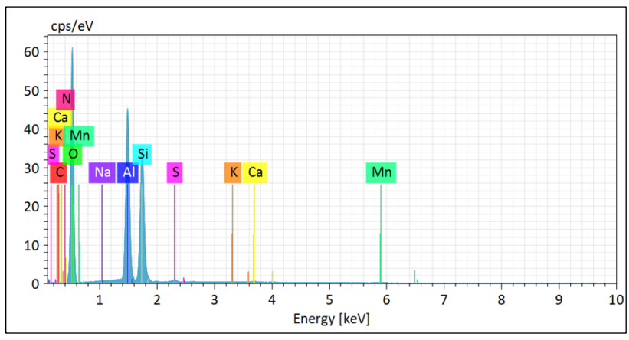
Fig.S2 Chemical composition of kaolin.

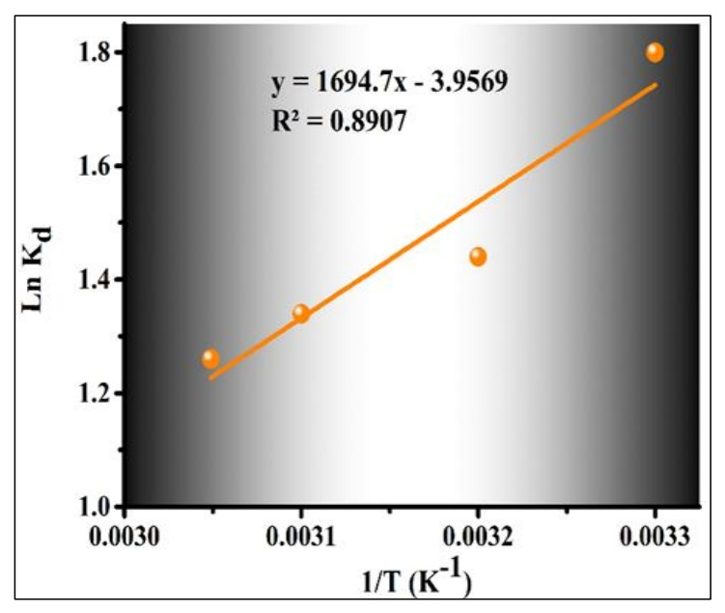
Fig.S3 Plot of LnK_{d} vs 1/T for the estimation of the thermodynamic parameters for the adsorption of CTC on Fe/Ca-Alg@K-3 beads.
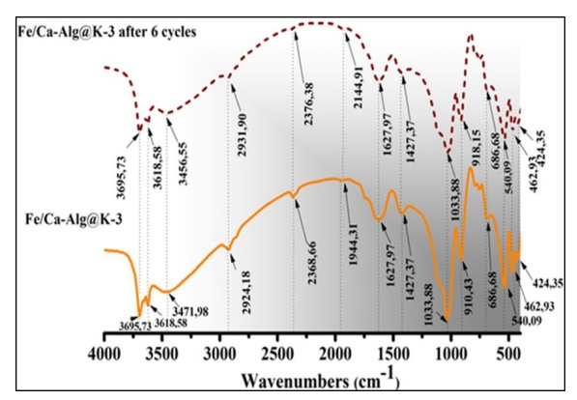
Fig.S4 FTIR spectra of as-synthesized Fe/Ca-Alg@K-3 beads and regenerated Fe/Ca-Alg@K-3 beads after 6 cycles.
Text S1

Chemical Oxygen Demand test (COD)
Chemical Oxygen Demand (COD) is a crucial parameter in water treatment and environmental monitoring. It represents the mass concentration of oxygen equivalent to the amount of dichromate consumed by the organic and suspended matter when treated with potassium dichromate (K₂Cr₂O₇) under specific conditions. The reaction occurs during boiling at 370°C in an acidic medium with the presence of a catalyst (HgSO₄/H₂SO₄).
The principle of COD test is based on the fact that nearly all organic compounds can be fully oxidized to carbon dioxide using a strong oxidizing agent under acidic conditions. The excess of potassium dichromate is determined using the Mohr salt method (ammonium iron sulfate). It is expressed in milligrams of oxygen per liter (mg L) and is given by the following expression:
$COD= \frac{8000c(V_{1}- V_{2})}{V_{0}}$(Eq.1)
With:
c: Concentration of the solution of iron (III) sulfate and ammonium.
V₀: Volume in milliliters, of the testwd portion before delution.
V₁: Volume in millilitres of the iron (II) ammonium sulfate solution used for blank test.
V₂: Volume in millilitres of the iron (II) ammonium sulfate solution used for the
determination.
8000: The molecular weight in milligrams per liter of ½ O₂

Reagents

- Concentrated sulfuric acid: (d = 1.84 g/ml).
- Potassium dichromate: reference standard solution (0.04mol/L), containing a mercury (II) salt.
- Dissolve 80 g of mercury sulfate (HgSO₄) in 800 mL of water. Carefully add 100 ml of sulfuric acid, allow to cool and dissolve 11.768 g of precisely weighed potassium dichromate, previously dried at 105 °C for two hours, in the solution.
- Transfer the solution quantitatively into a volumetric flask and dilute to 1000 mL. The solution is stable for at least one month.
- Iron (II) ammonium sulfate hexahydrate: (Mohr's salt), standard solution [(NH₄) 2Fe (SO₄)₂.6H₂O] ≈ 0.12 mol/L.
Preparation
- Dissolve 47 g of iron (II) sulfate and ammonium hexahydrate in water. Add 20 mL of sulfuric acid, cool and dilute to 1000 mL.
The concentration, c, expressed in moles per liter of the iron (II) sulfate solution and of ammonium hexahydrate is given by the following formula:
$c= \frac{10 ×0.040 ×6}{V}=\frac{2.4}{V}$(Eq.2)
With V is the volume, in milliliters, of iron(II) sulfate and ammonium solution consumed. 10 is the volume of potassium dichromate solution in mL 0.02 is the concentration of the potassium dichromate solution in mol/L,6 is the factor: 1 mole of dichromate is equivalent to 6 moles of iron(II) sulfate and ammonium hexahydrate.

- Sulfuric acid-silver sulfate
- Add 10 g of silver sulfate to 35 mL of water. Add, per portion, 965 mL of sulfuric acid
(d = 1.84 g/L) and leave for 1 or 2 days to dissolution. Dissolution is favored by agitation.

- Potassium hydrogen phthalate: reference standard solution [KC₈H₅O₄] ≈ 2.0824 mmol/L.
Dissolve 0.425 g of potassium hydrogen phthalate previously dried at 105 °C for 2h in deionized water and dilute to 1000 mL in a volumetric flask. This solution to prepared daily has a theoretical COD value of 500 mg O₂/L.

- Ferroin indicator solution
Dissolve 0.7 g of iron(II) sulfate FeSO₄.7H₂O or 1 g of iron(II) ammonium sulfate hexahydrate (NH₄)2Fe(SO₄)2.6H₂O in water. Add 1.50 g of 1,10-phenanthroline monohydrate C₁₂H₈N₈.H₂O and shake until dissolved. Dilute to 100mL. This solution remains stable for several months if stored in the dark.

Operatory mode
• Transfer 10 mL of the sample for analysis (diluted, if necessary) into the vial of the reflux apparatus.
• Add 5 mL of potassium dichromate solution and some boiling regulators to the test portion and mix carefully.
• Slowly add 15 ml of sulfuric acid-silver sulfate by carefully shaking the tube.
• If the mixture immediately turns from yellow to light green, you must start again by diluting the sample.
• Place the tube in the heating block, connect the condenser to the tube and heat to 370°C for 2h.
• To ensure complete oxidation of organic matter, an excess of potassium dichromate must be present.
• After oxidation, the excess dichromate is titrated with ferrous ammonium sulfate (FAS) until all excess oxidizing agent has been reduced to Cr³⁺.
• The ferroin indicator changes color during this titration, allowing accurate determination of the excess dichromate.
Note: Perform two blank tests in parallel with the determination, following the same method but replacing the test portion with 10 mL of deionized water [4].

References
[1]Wang, G., Yue, X., Zhang, S., Geng, Q., Zheng, J., Xu, X., . . . Jia, Y. (2022). La (III) loaded Fe (III) cross–linked chitosan composites for efficient removal of phosphate from wastewater: Performance and mechanisms. Journal of cleaner production, 379, 134833.
[2]Wang, J., & Guo, X. (2022). Rethinking of the intraparticle diffusion adsorption kinetics model: Interpretation, solving methods and applications. Chemosphere, 309, 136732.
[3] Xu, X., Wang, B., Tang, H., Jin, Z., Mao, Y., & Huang, T. (2020). Removal of phosphate from wastewater by modified bentonite entrapped in Ca-alginate beads. Journal of environmental management, 260, 110130.
[4] MESROUK, H., Caractérisation physico-chimique et étude de l’évolution spatio-temporelle de quelques polluants organiques dans les points de rejets d’eaux usées de la région de Ouargla, et contribution à la mise en place d’un protocole de leur traitement. Universite Kasdi Merbah Ouargla.

