Supplementary Materials for

European Heatwaves Aggravated by Recent Summer Arctic Changes

El Noh, Joowan Kim*, Yu Kosaka, Sang-Wook Yeh, Seok-Woo Son, Baek-Min Kim, Dim Coumou, Kai Kornhuber, Sang-Yoon Jun, Woosok Moon, Masato Mori, and Jeong-Hun Kim

Corresponding author: joowan.k@gmail.com

The file includes:

Method
Figs. S1 to S15

Method
Surface radiation (energy) budget

To identify the thermodynamic processes responsible for Arctic surface warming trends, we applied a surface energy budget decomposition approach. The surface energy budget can be expressed as:

F_{DLR} + F_{SW} + F_{LH} + F_{SH} + F_{LB} = εσT_{S}⁴ (1)

where F_{DLR} is the downward longwave radiation at the surface, F_{SW} represents the net shortwave radiation, F_{LH} is the surface latent heat flux, F_{SH} is the surface sensible heat flux, ε denotes the emissivity (ε = 1), σ is the Stefan-Boltzmann constant, T_{S} represents the surface temperature, and F_{LB} represents heat transfer at the lateral boundaries. All downward fluxes were defined as positive.
The surface temperature trend can be obtained through Taylor expansion of the upward longwave flux term to first order. The reconstructed surface temperature trend is:

ΔT_{S} = (ΔF_{DLR} + ΔF_{SW} + ΔF_{LH} + ΔF_{SH} + ΔF_{LB}) / (4εσT_{S}³) (2)

where ΔT_{S} is the linear trend of surface temperature, ΔF_{i} represents the linear trend of each energy flux component, and T_{S} is the climatological surface temperature.
Daily surface temperature and energy flux components were obtained from the ERA5 reanalysis dataset. The analysis focused on three key Arctic regions: the western Greenland(70°-80°N, 30°W-70°W), Norwegian Sea (65°-80°N, 30°W-30°E), and the Barents-Kara Sea (70°-85°N, 20°E-90°E) for the period 2010–2024. All variables were detrended by removing their long-term linear trends for 1979–2024 while preserving the regional-mean trends of interest.

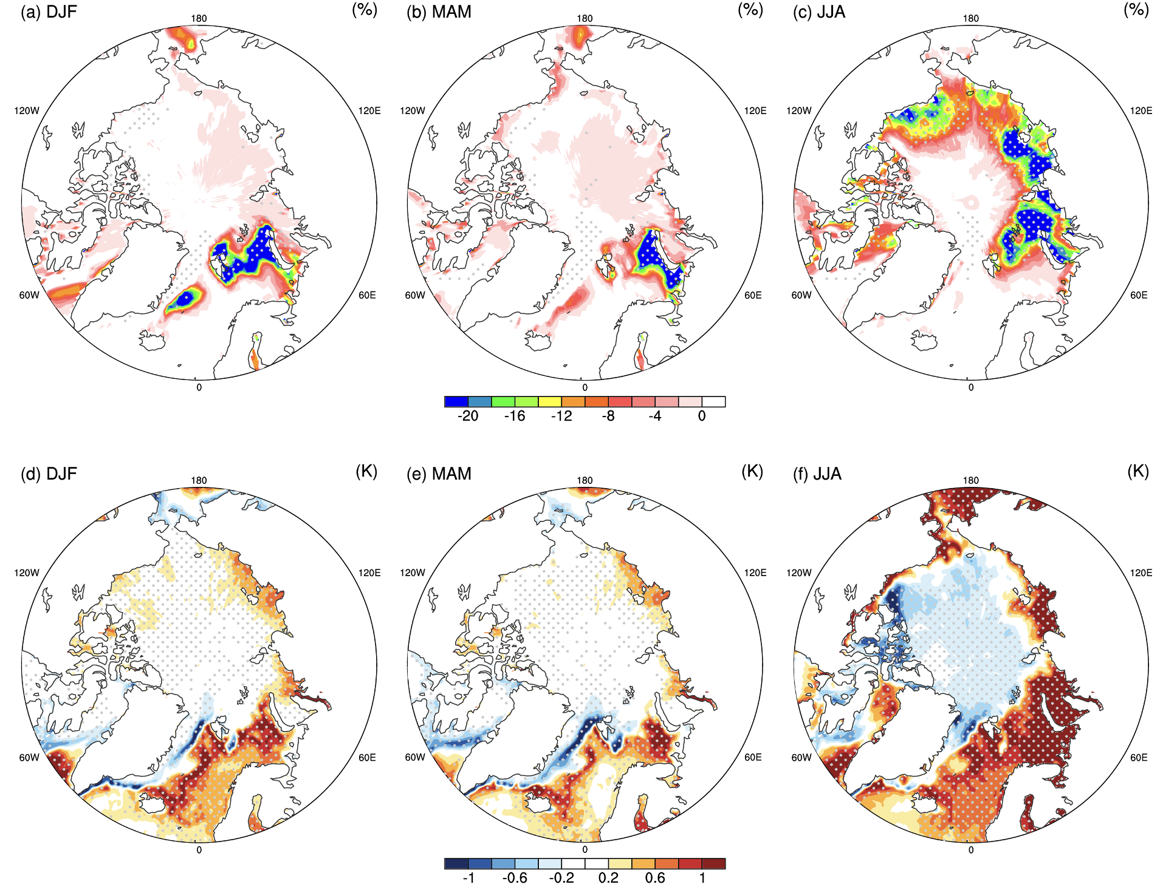

Supplementary Fig. 1. Seasonal differences in sea ice concentration and sea surface temperature
Differences between 2010–2024 and 1979–2009 periods for (a-c) sea ice concentration (%) and (d-f) sea surface temperature (K) during (a, d) winter (DJF), (b, e) spring (MAM), and (c, f) summer (JJA). Dotted areas denote statistically significant at the p = 0.05 level.

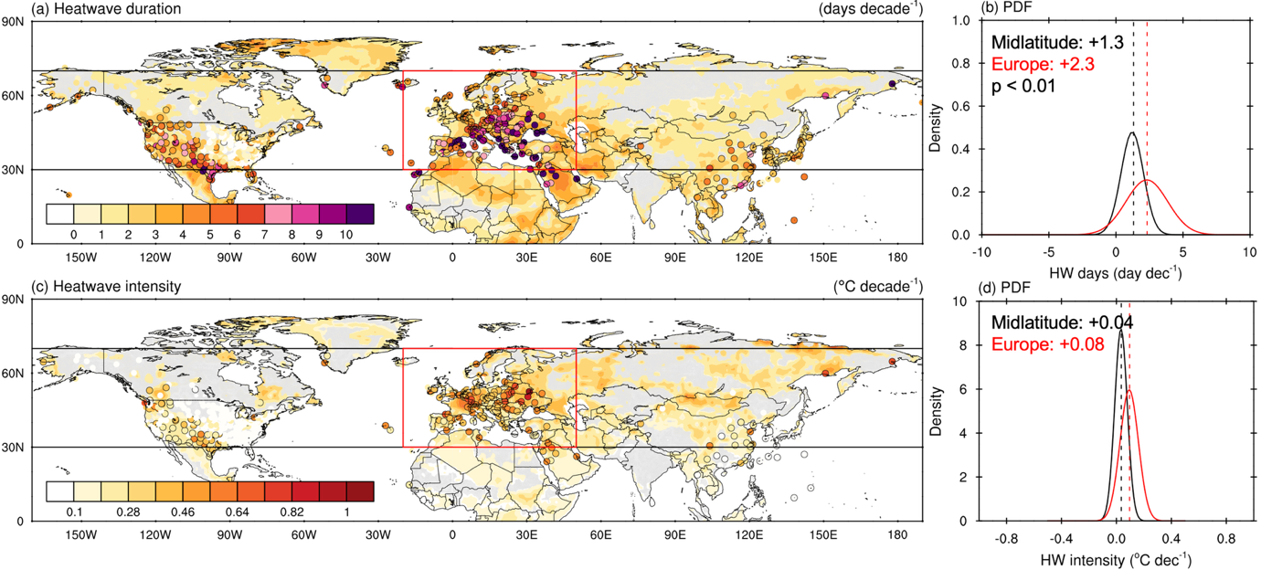

Supplementary Fig. 2. Trends of European summer heatwaves duration and intensity
Spatial distribution of decadal trends of heatwave (a) duration (days decade⁻¹) and (c) intensity (℃ decade⁻¹) from 1979 to 2024 during boreal summer (June–August). Shading represent trends derived from ERA5 reanalysis, with gray hatching indicating regions where trends are not statistically significant at the p = 0.05 level. Colored dots indicate trends from HadISD observation stations, with the black outlines denoting statistical significance at the p = 0.05 level. (b, d) Probability distribution function of decadal trend of heatwave (b) duration and (d) intensity of all observation stations for Europe (in red, as the region included in red box of (a, c)) and the midlatitudes excluding Europe (in black).

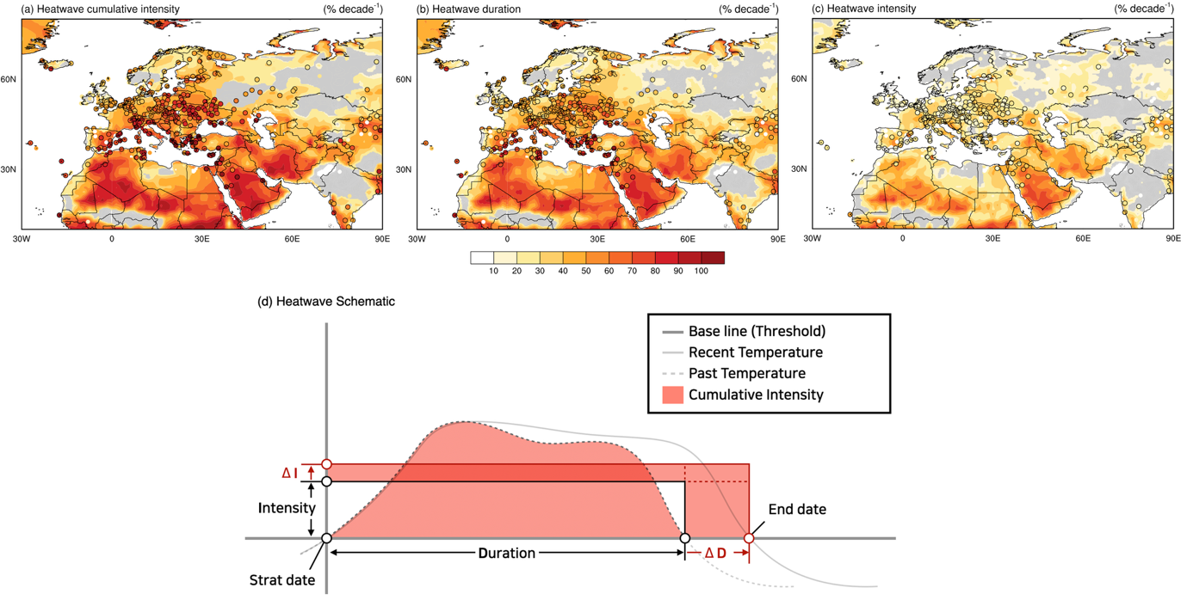

Supplementary Fig. 3. Escalating European heatwave characteristics and their decomposition
Spatial distribution of decadal trends from 1979 to 2024 in (a) heatwave cumulative intensity (% decade⁻¹), (b) heatwave duration (% decade⁻¹), and (c) heatwave intensity (% decade⁻¹) during boreal summer (June–August). Shading represents trends derived from ERA5 reanalysis, with grey shading indicating regions where trends are not statistically significant at the p = 0.05 level. Colored dots indicate trends from HadISD observation stations, with the black circles denoting statistical significance at the p = 0.05 level. (d) Schematic diagram illustrating changes in European heatwave characteristics based on observation station data across Europe.

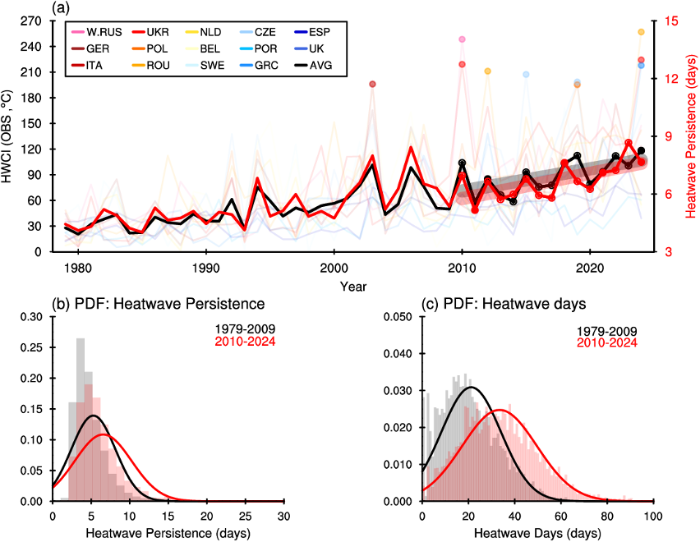

Supplementary Fig 4. European heatwave cumulative intensity changes
(a) Time series of summer heatwave cumulative intensity for 14 European countries (colored lines) from 1979 to 2024, with the 10 highest cumulative intensity (colored dots). The thick black marked line shows the multi-country average. The thick red marked line represents the heatwave persistence. (b, c) Probability density function distributions of the heatwave persistence and heatwave days, respectively. Background histograms show the observed frequency distributions, with kernel density estimates (KDE) curves (gray: 1979–2009, red: 2010–2024).

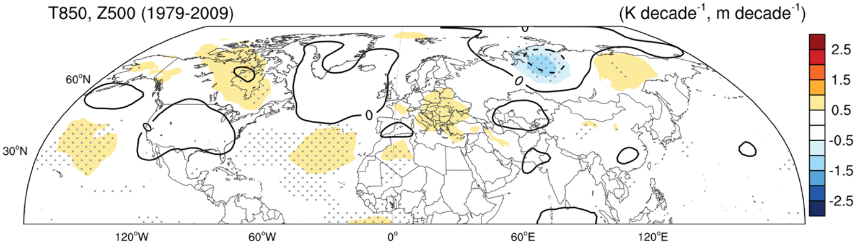

Supplementary Fig. 5. Summer climate changes (1979-2009)
Spatial distributions of decadal trends during boreal summer (June–August) in 850-hPa temperature (shading, K decade⁻¹) and 500-hPa geopotential height (contour, m decade⁻¹) for 1979-2009. Gray stippling denotes regions with statistically significant trends at p < 0.05.
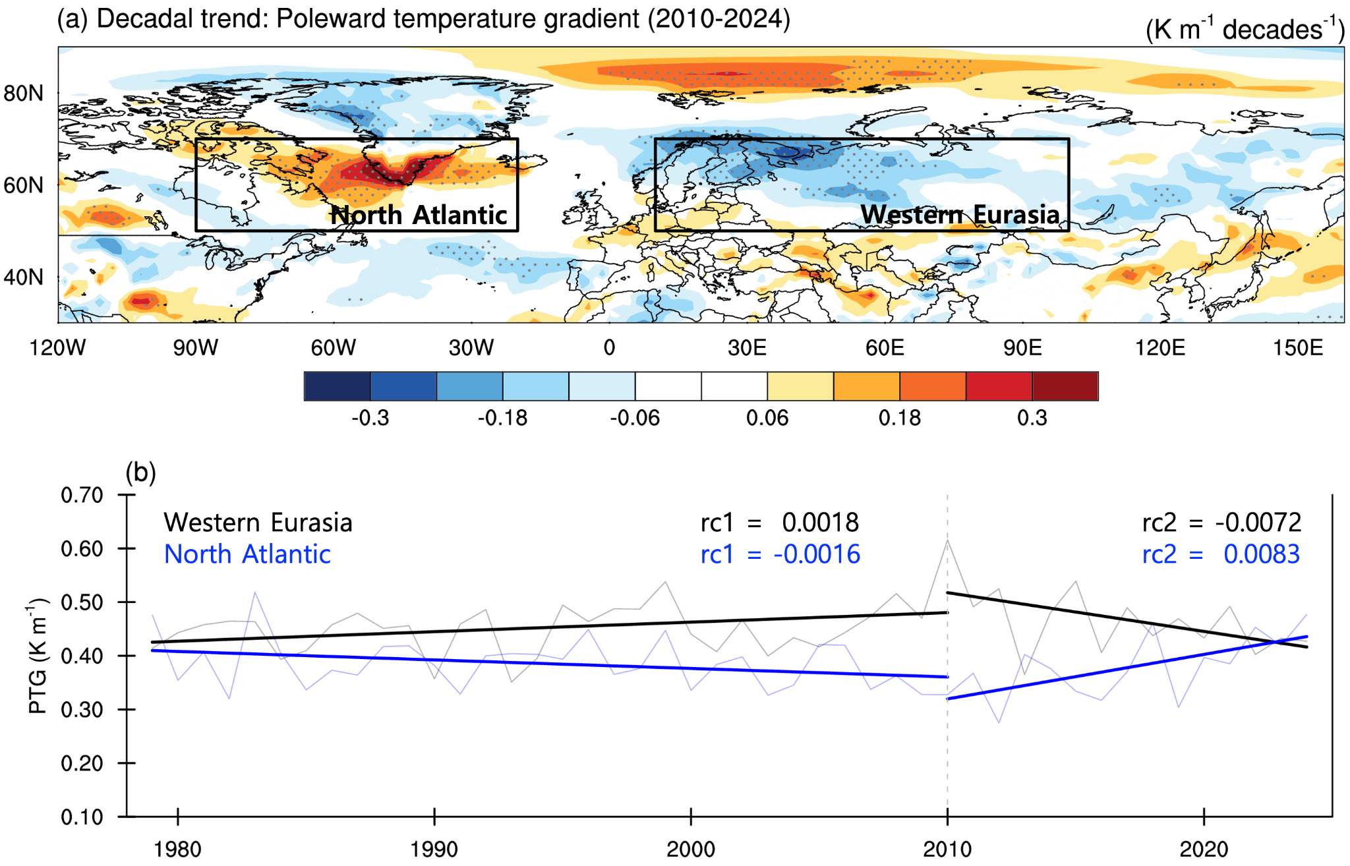

Supplementary Fig. 6. Poleward temperature gradient trend during recent Arctic warming
(a) Spatial pattern of decadal trend in poleward temperature gradient (PTG) from 2010 to 2024. black stippling denotes regions with statistically significant trends at p < 0.05. (b) Time series of 850-hPa poleward temperature gradient averaged over the North Atlantic region [50°-70°N, 20°-90°W] and the western Eurasia [50°-70°N, 10°E-100°E], respectively. The linear regression coefficients show trends for 1979–2009 (rc1) and 2010–2024 (rc2) periods, revealing contrasting regional responses to Arctic amplification.

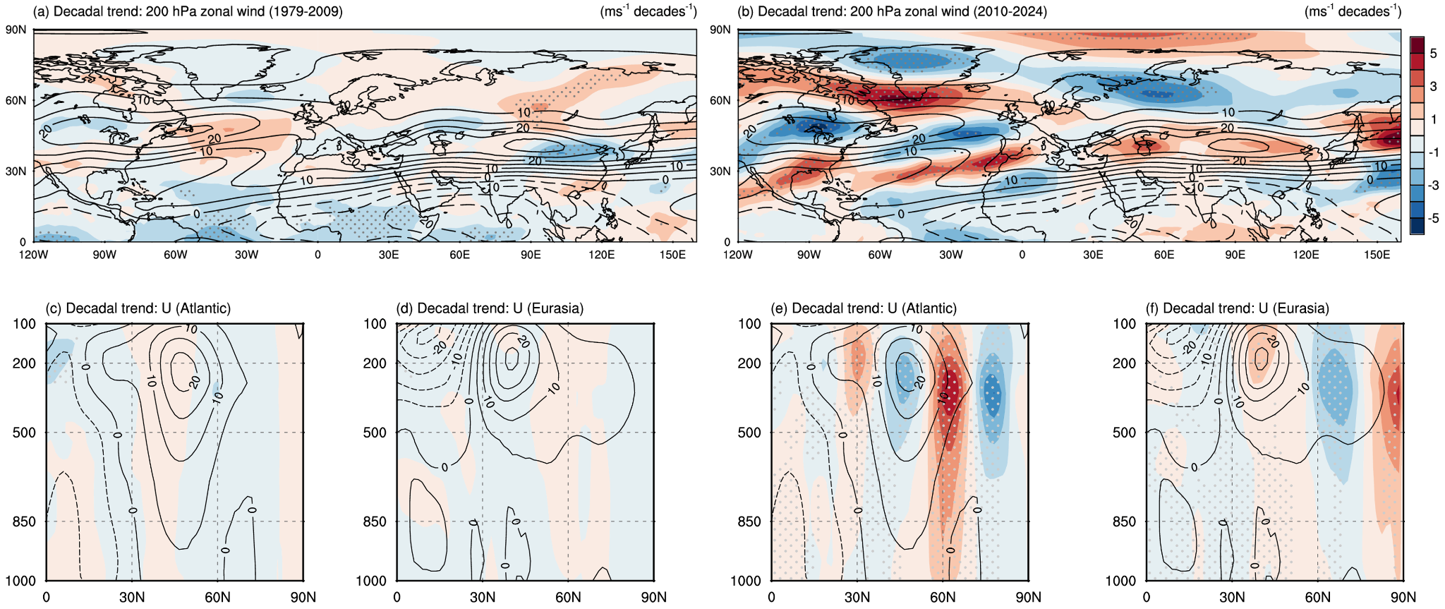

Supplementary Fig. 7. Jet stream change in response to Arctic warming
Spatial distributions of decadal trends during boreal summer (June–August) in 200-hPa zonal wind (shading, ms⁻¹ decade⁻¹) for (a) 1979–2009 and (b) 2010–2024, with climatology (black contour, ms⁻¹). Gray stippling denotes regions with statistically significant trends at p < 0.05. Lower panels show meridional cross-sections of zonal wind trends for Atlantic [20°-90°W] and Eurasia [0°-100°E] sectors during (c, d) 1979–2009 and (d, f) 2010–2024 periods, respectively.

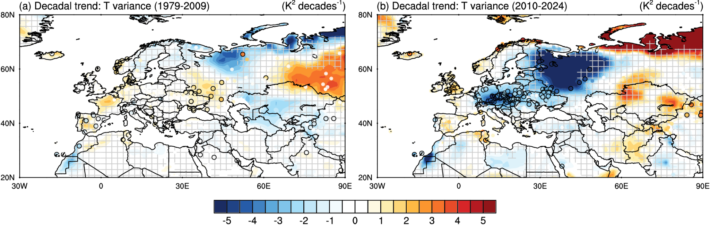

Supplementary Fig. 8. Decadal trend of the daily weather variability
Spatial distributions of decadal trends during boreal summer (June–August) in daily surface temperature variance (shading, K² decade⁻¹) for (a) 1979–2009 and (b) 2010–2024. Shading represents trends derived from ERA5 reanalysis, with grey hatching indicating regions where trends are not statistically significant at p = 0.05. Colored dots indicate trends from HadISD observation stations, with the black circles denoting statistical significance at the 95% level.

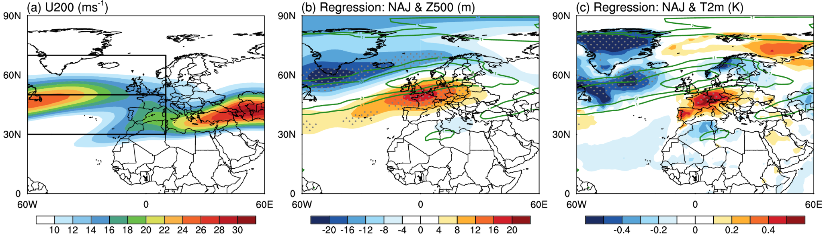

Supplementary Fig. 9. North Atlantic circulation related to Jet stream changes
Spatial distributions and temporal evolution of the North Atlantic jet stream during boreal summer (June-August) for 1979–2024. (a) Climatological 200-hPa zonal wind (ms⁻¹) showing the Atlantic jet structure. (b, c) Regression coefficients between Atlantic jet latitude with 200 hPa zonal wind (ms⁻¹, green thick lines), (b) 500 hPa geopotential height (m, shading), and (c) 2m temperature anomalies (K, shading), respectively. Stippling in (c, d) denotes regions with statistically significant correlations at p < 0.05. The North Atlantic Jet (NAJ) identified by the differences between standardized detrended 200-hPa zonal wind anomalies in the northern box (50°–70°N, 60°W–10°E) and those in the southern box (30°–50°N, 60°W–10°E).

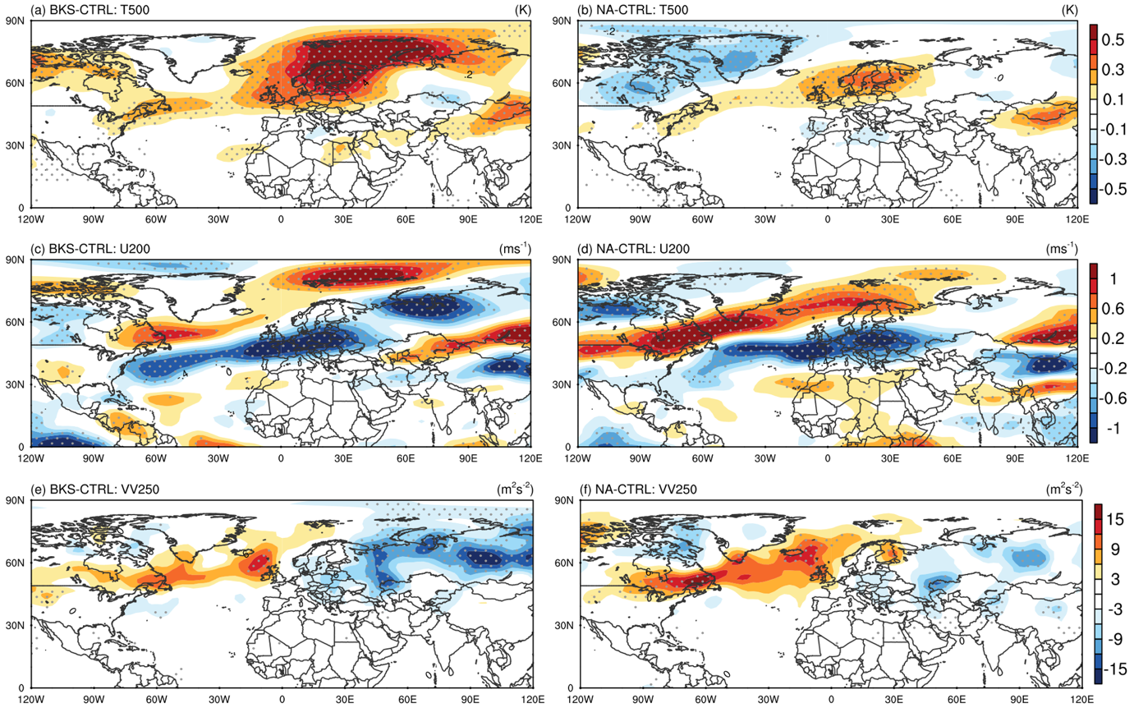

Supplementary Fig. 10. Atmospheric response to regional climate changes
Ensemble mean (50 members) differences between sensitivity experiments and control run for (a, b) 500-hPa temperature (K), (c, d) 200-hPa zonal wind (m s⁻¹), and (e, f) 250-hPa meridional wind variance (m² s⁻²) from (a, c, e) Barents-Kara Sea warming experiment (BKS-CTRL) and (b, d, f) North Atlantic dipole experiment (NA-CTRL). Dotted areas indicate regions where differences are statistically significant at p < 0.05.

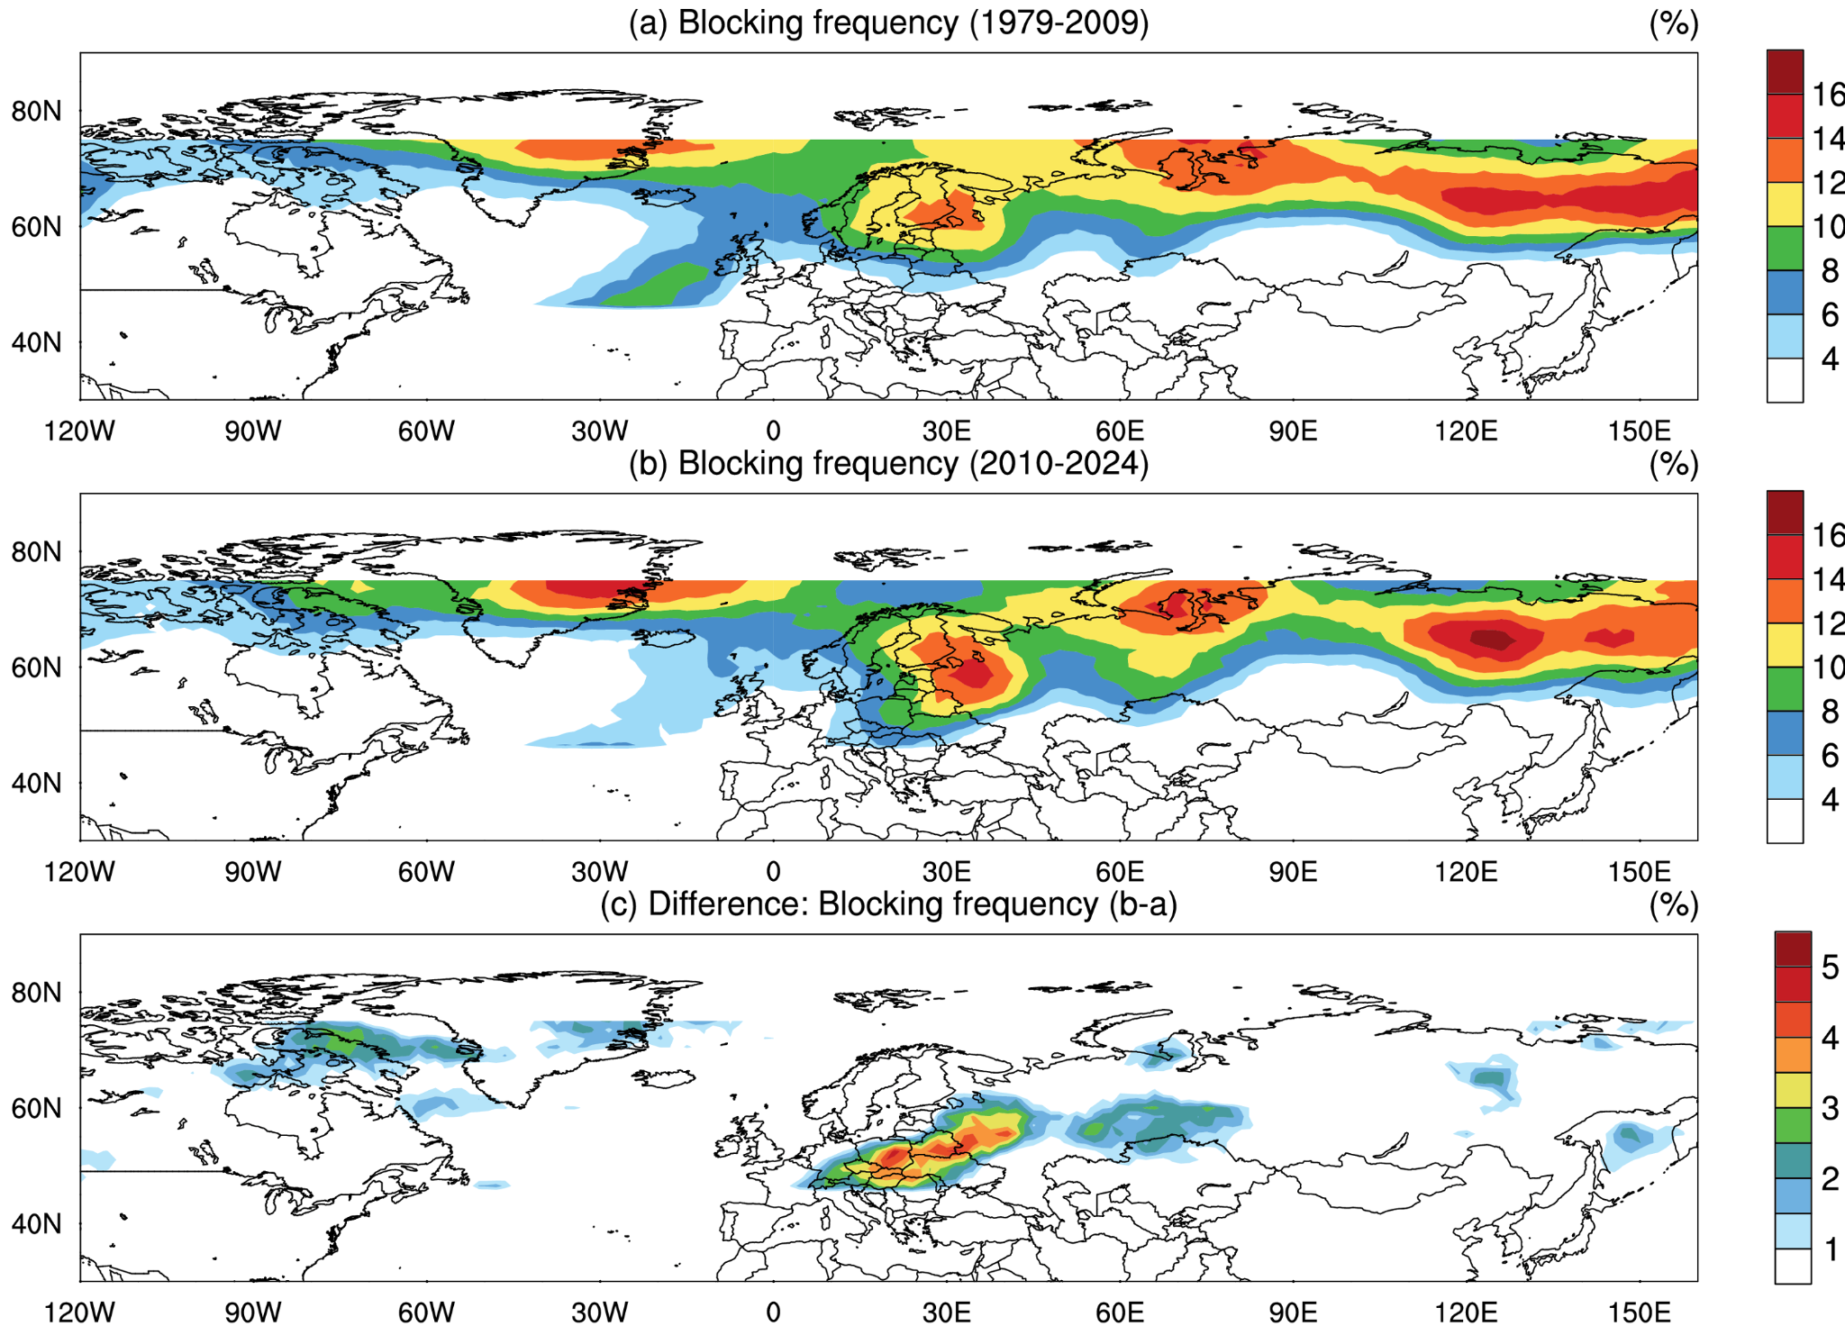

Supplementary Fig. 11. Blocking frequency changes
Spatial distributions of the blocking frequency (%) during boreal summer (June–August) for (a) 1979–2009, (b) 2010–2024, and (c) difference between two periods. Blocking events are identified using the Tibaldi and Molteni (1990)⁶¹ gradient reversal method, which detects instantaneous blocking based on meridional geopotential height gradients at 500 hPa. The instantaneous blocking frequency represents the percentage of days when blocking conditions are met at each grid point, without requiring temporal persistence criteria.

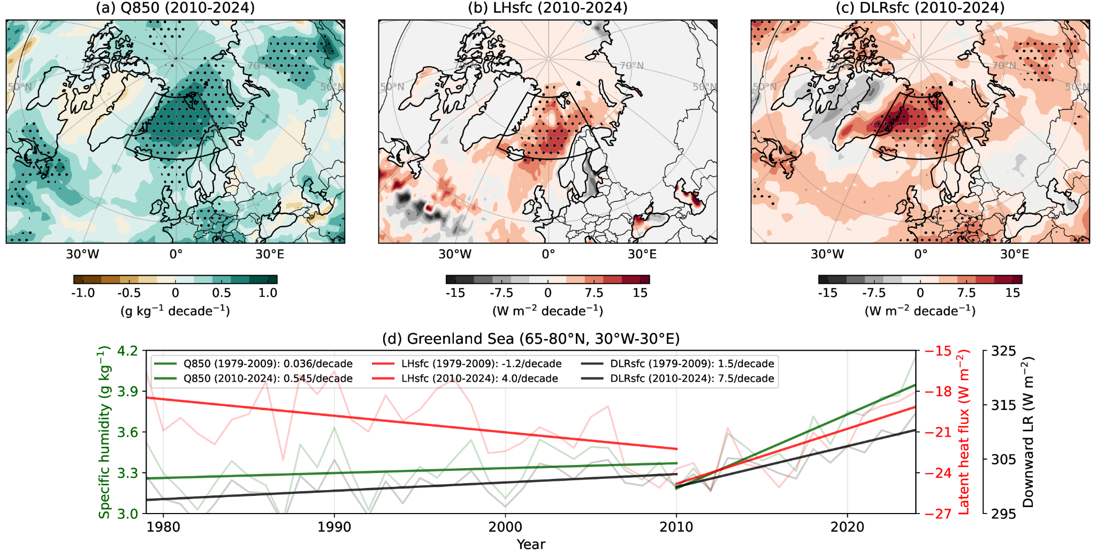

Supplementary Fig 12. Recent Norwegian Sea warming
Spatial distributions of decadal trends during boreal summer (June–August) from 2010 to 2024 in (a) 850-hPa specific humidity (g kg⁻¹ decade⁻¹), (b) latent heat flux (Wm⁻² decade⁻¹) and (c) downward longwave radiation (Wm⁻² decade⁻¹). Gray stippling denotes regions with statistically significant trends at p < 0.05. (d) Time series of 850-hPa specific humidity (green line, left axis), surface latent heat flux (red line, right axis), and downward longwave radiation (black line, right axis) averaged over the Greenland Sea (black box regions [65°-80°N, 30°W-30°E] shown in upper panel). Translucent lines indicate annual values; thick lines denote segmented linear trends, highlighting changes in slope across different periods.

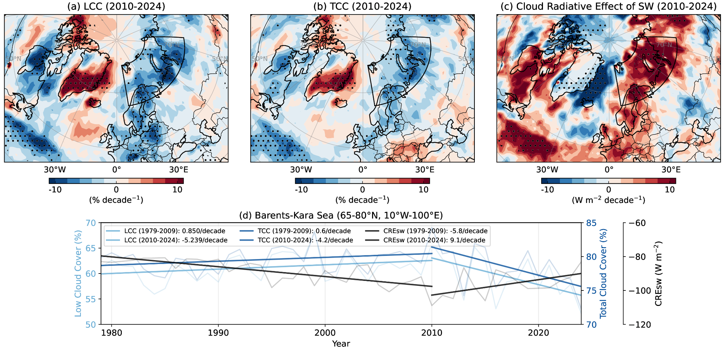

Supplementary Fig. 13. Recent Barents-Kara Sea warming
Spatial distributions of decadal trends during boreal summer (June–August) from 2010 to 2024 in (a) Low cloud cover (LCC, % decade⁻¹), (b) total cloud cover (TCC, % decade⁻¹) and (c) cloud radiative effect of shortwave radiation (Wm⁻² decade⁻¹). Black stippling denotes regions with statistically significant trends at p < 0.05. (d) Time series of LCC (sky blue line, left axis), TCC (deep blue line, right axis), and cloud radiative effect of shortwave radiation (black line, right axis) averaged over the Barents-Kara Sea (black box regions [65°-80°N, 10°-100°E] shown in upper panel). Translucent lines indicate annual values; thick lines denote segmented linear trends, highlighting changes in slope across different periods.

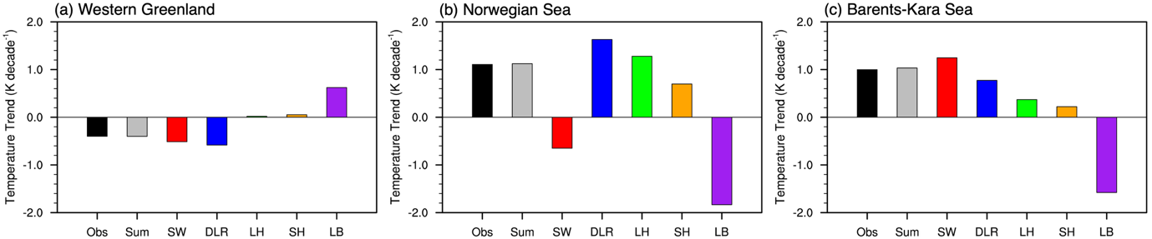

Supplementary Fig. 14. The surface energy budget over the Arctic regions
Surface temperature trend over (a) western Greenland, (b) Norwegian Sea, and (b) Barents-Kara Sea from 2010 to 2024. The black bar indicates the observed (ERA5) trend and the gray bar represents the reconstructed temperature trend derived from the surface energy budget. Individual energy budget components include: shortwave radiation (SW, red), downward longwave radiation (DLR, blue), latent heat flux (LH, green), sensible heat flux (SH, orange), and heat transfer at the lateral boundary (LB, purple).

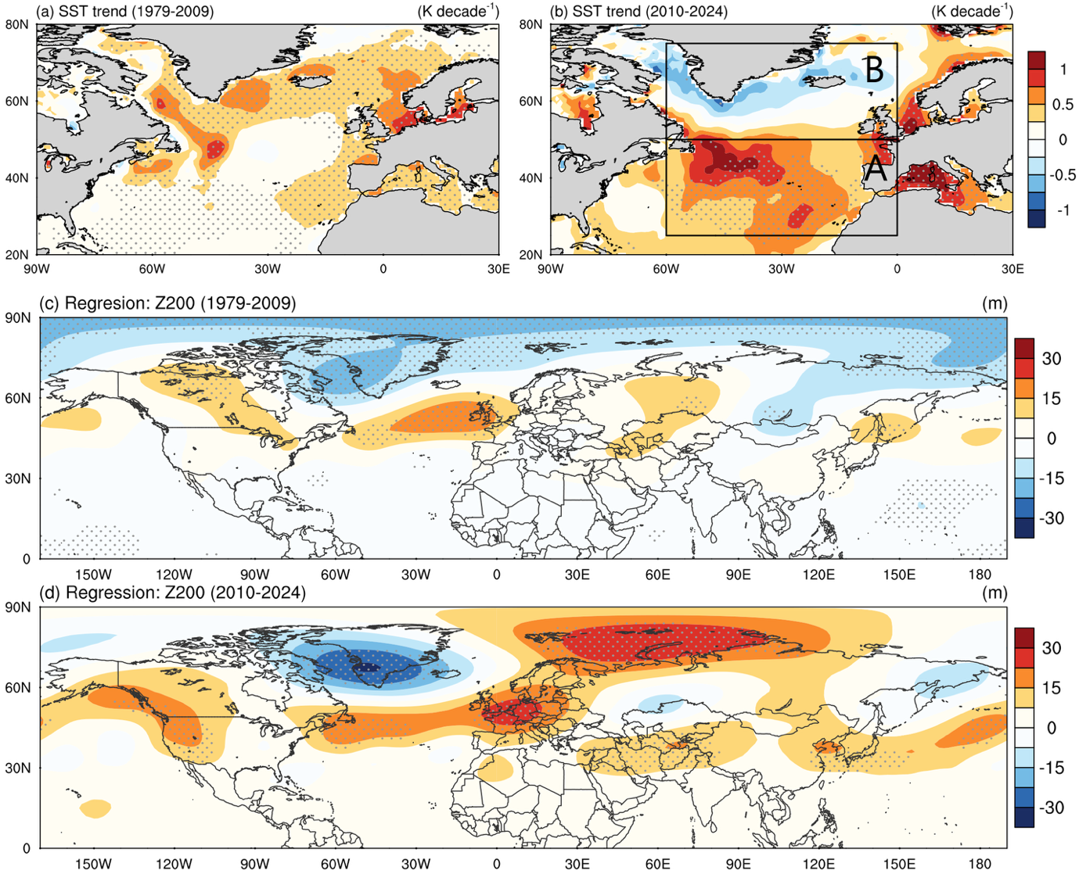

Supplementary Fig. 15. SST trends and associated atmospheric circulation patterns
(a, b) Decadal trends in sea surface temperature (K decade⁻¹) for (a) 1979-2009 and (b) 2010-2024. Gray dots indicate regions where trends are statistically significant at p < 0.05. (c, d) Regression of 200-hPa geopotential height (m) onto the normalized North Atlantic SST dipole index for (c) 1979-2009 and (d) 2010-2024. The SST dipole index is calculated as the standardized difference between area-averaged SST in region A (warm trend region) and region B (cold trend region) shown in panel (b). Dotted areas indicate regions where regression coefficients are statistically significant at p < 0.05.

