Supplementary Information
Degradation of Graphene Oxide-Silver Nanoparticles by Hypochlorite: Impacts on Physicochemical Properties, Antimicrobial Activity and Ecotoxicity
Theodoro da Rosa Salles^{1,2}, Gabrielle Aguiar Dantas^{1,3}, Gabriela Helena da Silva¹, Joice Janeri Gomes¹, Aline Maria Zigiotto de Medeiros¹, Carlos Alberto Ospina¹, Cleyton Alexandre Biffe¹, Roberto Christ Vianna Santos³, Diego Stéfani Teodoro Martinez^{1,2*}
¹Brazilian Nanotechnology National Laboratory (LNNano), Brazilian Center for Research in Energy and Materials (CNPEM), Campinas, São Paulo, Brazil.
²School of Technology, University of Campinas (UNICAMP), Limeira, São Paulo, Brazil.
³Department of Microbiology and Parasitology, Federal University of Santa Maria (UFSM), Santa Maria, Rio Grande do Sul, Brazil.
Corresponding author: diego.martinez@lnnano.cnpem.br
Figure = 9
Tables = 4

Methods
Synthesis of Graphene Oxide (GO)
First, 5.0 g of graphite flakes (Sigma-Aldrich, Lot#MKBW0432V) and 3.75 g of NaNO₃ were added to a beaker containing 370 mL of H₂SO₄ in an ice bath, and stirred vigorously with a magnetic stirrer for 20 min. Sequentially, 7.5 g of KMnO₄ were slowly added to the reaction mixture in three portions at 45-min intervals, followed by stirring at room temperature for 72 h. At this period, 300 mL of ultrapure water was added slowly, and the mixture was heated at 95 ºC and stirred for 60 min. The temperature was then reduced to 60 ºC, and 15 mL of H₂O₂ (30%) was added to reduce the residual manganese ions. The mixture was stirred overnight, resulting in a bright yellow solution. For purification, the reaction mixture was centrifuged (4000 rpm, 30 min) and washed with 1.0 L of an aqueous solution containing 3% H₂SO₄ and 0.5% H₂O₂ to remove oxidizing agents and inorganic impurities. The product was further washed twice with ultrapure water by centrifugation (4000 rpm, 30 min). Finally, the material was dialyzed (cut-off: 14,000 kDa) against distilled water for 8 days. The GO dispersion was freeze-dried for 40 h, and the resulting powder was stored in a sealed container at room temperature.
Characterization of nanomaterials
FourierTransform Infrared Spectroscopy (FTIR)
Spectroscopic analyses were performed using a high-performance Agilent FTIR Cary 600 spectrometer, equipped with a DLATGS (Deuterated L-Alanine Doped Triglycine Sulphate) detector and operating in transmission mode. Measurements were conducted within the spectral range of 4000-800 cm⁻¹, with a spectral resolution of 16 cm^{-1.} Sample preparation involved KBr pellets.
Raman spectroscopy
The Raman was made in the equipment Raman XploRA Plus (Horiba, Japan) in circular laser of 532 nm, 50x objective, 10% filter, 200 slit and 500 hole, 5 accumulations and acquisition time of 10 sec. For the calculation of the I_{D}/I_{G}, an average of 3 spectra was made, and deconvolution was done using Origin software.
UV-Visible spectroscopy (UV-Vis)
The absorbance of GO, GO-AgNPs and degradation by-products was measured using UV-vis spectroscopy (Multiskan GO, Thermo Scientific, UK). The curves were performed from 200 to 800 nm.
X-ray photoelectron spectroscopy technique (XPS)
A dispersion of 1 mg mL⁻¹ of GO and GO-AgNPs in ultrapure water was sonicated. For the aliquots collected during the degradation (1 day, 5 days and 10 days), the samples were used after the dialyze. Then, 5.0 µL of this dispersion was placed in the center of a silicon substrate. Subsequently, it was allowed to dry in a clean or local environment. Manufacturer: Themo, Model: K-alpha; total acquisition time: 2min 23,3 secs; Number of Scans: 15; Source Gun Type: Al K Alpha; Spot size: 400 µm; Lens Mode: Standard; Analyser Mode: CAE: Pass Energy 50.0 eV; Energy Step Size: 0.100 eV; Number of Energy Steps: 191. The collected results were analyzed and deconvoluted using the open-source software KherveFitting v1.65.
Electrophoretic light scattering (ELS)
The surface charge of all samples (i.e., GO, GO-AgNPs, 1D, 5D, and 10D) was measured in a Zetasizer Nano ZS (Model ZEN3600, Malvern). The dispersions were prepared in ultrapure water at 30 mg C L⁻¹.
Atomic force microscopy (AFM)
he shape, surface properties and thickness of the graphene sheets were evaluated through topographic images from atomic force microscopy (AFM). The analysis was conducted at room temperature and low humidity (<10%) using a Multimode 8 microscope equipped with a Nanoscope V controller. The images were acquired in PeakForce Tapping mode (Bruker) using a ScanAsyst-Air probe (Bruker) with a nominal spring constant of 0.4N/m and a nominal tip radius of 2nm. The images were treated using Gwyddion software.
Transmission Electron Microscopy (TEM) and Energy Dispersive X-ray Spectroscopy (EDS)
To evaluate the sample evolution as a function of the degradation time, transmission electron microscopy (TEM) was employed. For this analysis, the samples dispersed in water were dripped onto TEM copper grids (Lacey carbon without ultrathin carbon membrane), and analyzed using a JEOL JEM-2100F microscope operated at 200 kV in scanning mode (STEM). Images were collected using high angle annular dark field (HAADF) detector, with spot size 0.7 nm and camera length 8 cm. Chemical mapping was obtained by energy dispersive X-ray spectroscopy (EDS), using a X-Max 80 detector (SDD 80 mm² - Oxford Instruments, energy range: 40 keV, energy channels: 2048) coupled to JEM-2100F microscope. EDS data was processed in AZtec software (Oxford Instruments).
Total organic carbon (TOC)
The concentration of organic carbon was measured as carbon-equivalent (i.e. dissolved carbon). The equipment used was Sierves Innovox (GE Analytical Instruments).
X-ray diffraction (XRD)
The high-resolution X-ray diffraction (XRD) patterns (XDR6000, Shimadzu) of dry samples (GO and GO-AgNPs) were measured using Cu Kα1 radiation (λ: 1.5406 Å) at 40 kV in the range of 2θ = 10–90°.
Inductively Coupled Plasma Optical Emission Spectroscopy (ICP-OES)
For the sample decomposition, 1.0 mL of each sample (GO-AgNPs, 1D, 5D and 10D), 300 µL of sub-boiling distilled nitric acid (65%), 500 µL of Merck H₂O₂ (30%), and 5 mL of deionized water (Purelab, ELGA) were added to a Teflon vessel for an Ethos Easy microwave digestion system equipped with a MAXI44 rotor (Milestone). A heating ramp up to 180 °C was applied for 15 minutes, followed by a 30-minute hold at 180 °C with a power of 1800 W. The digested solution was quantitatively transferred and diluted with deionized water in a polypropylene tube, resulting in a final residual acidity of 2%. The determination of total Ag was performed by ICP-OES using an Optima 8000 DV spectrometer (PerkinElmer, Waltham, MA) equipped with a Meinhard K1 nebulizer and a cyclonic spray chamber. The plasma flow rate was 12 L/min, the nebulizer flow rate was 0.65 L/min, auxiliary gas flow rate was 0.5 L/min, Axial observation view and Ag(I) emission line was 328.0368 nm.
Results
Incubation of GO-AgNPs with NaClO
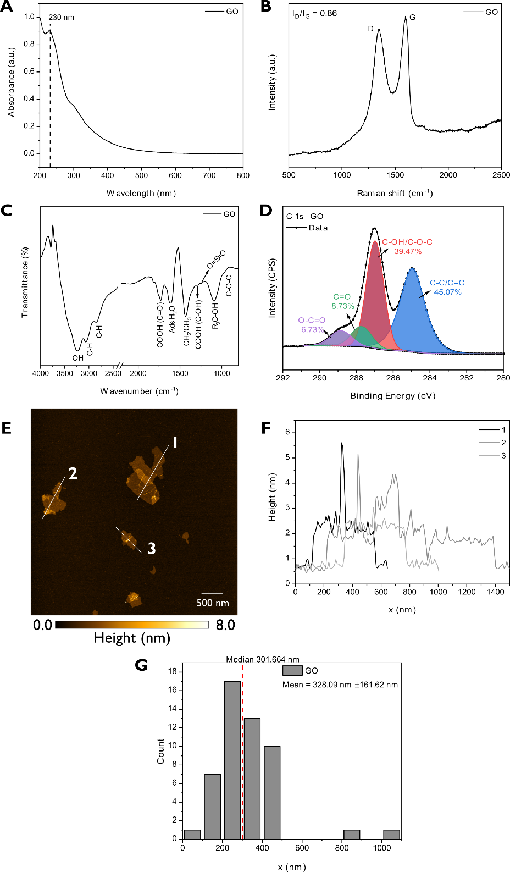
Figure S1. GO characterization: (A) UV-vis (200 – 800 nm), (B) Raman spectrum (500 – 2500 cm⁻¹), (C) Fourier transform infrared spectroscopy (FTIR, 4000 – 800 cm⁻¹), (D) C 1s XPS high resolution, (E) AFM image (scale bar 500 nm), (F) Height measurement for the regions marked on the AFM image and (G) Histogram of lateral size distribution.
Figure S2. X-ray diffraction (XRD) of GO-AgNPs (2θ = 10 – 90º).
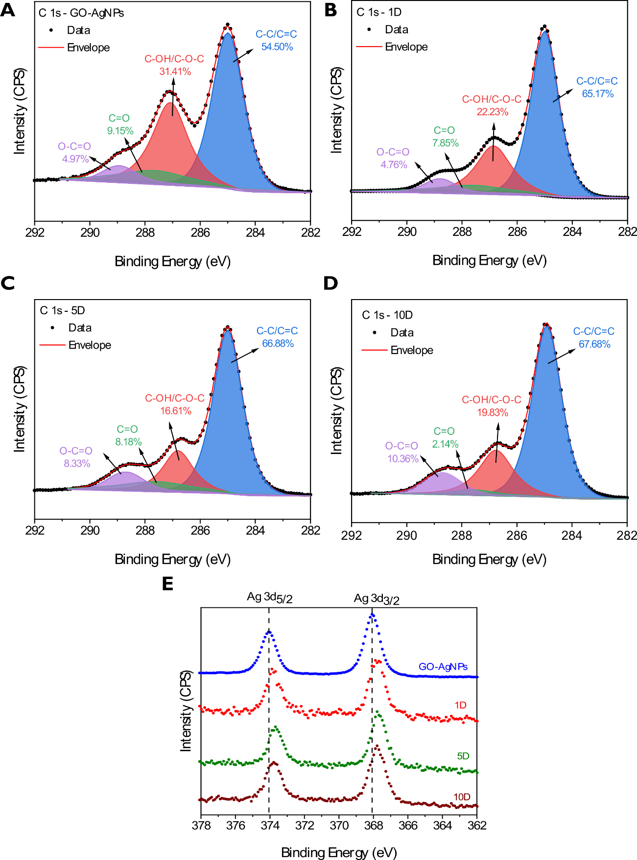
Figure S3. C1s XPS high resolution for (A) GO-AgNPs, (B) 1D, (C) 5D, (D) 10D and (E) Ag3d for all samples.

Table S1 – Deconvolution peaks used in C 1s high resolution.
Peak | Position (eV)
C-C/C=C | 285.0
C-OH/C-O-C | 286.8
C=O | 287.6
O-C=O | 288.7
Table S2 – XPS survey results for all samples
Sample | C (%) | O (%) | N (%) | Ag (%)
GO | 65.18 | 31.40 | 3.42 | -
GO-AgNPs | 66.75 | 30.78 | - | 2.47
1D | 72.48 | 27.12 | - | 0.40
5D | 71.49 | 28.25 | - | 0.26
10D | 71.34 | 28.49 | - | 0.17

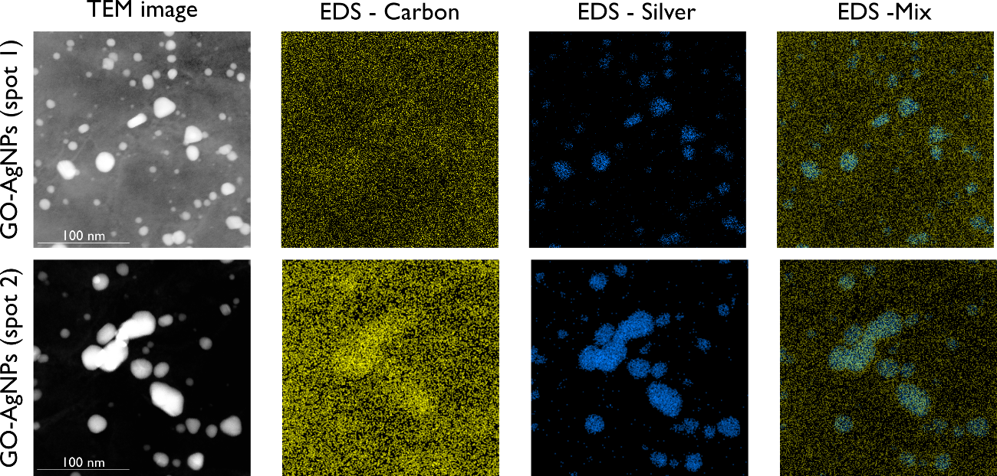
Figure S4. EDS characterization of GO-AgNPs sample with two different spots. From left to right: TEM image, EDS image for caron, EDS image for silver, and EDS image color mix (C and Ag).

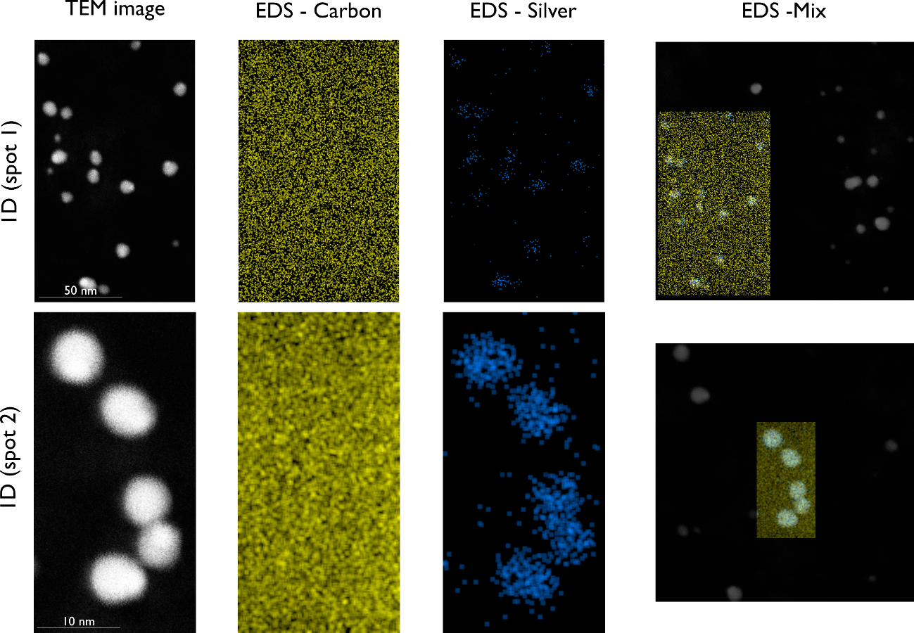
Figure S5. EDS characterization of 1D sample with two different spots. From left to right: TEM image, EDS image for caron, EDS image for silver, and EDS image color mix (C and Ag).
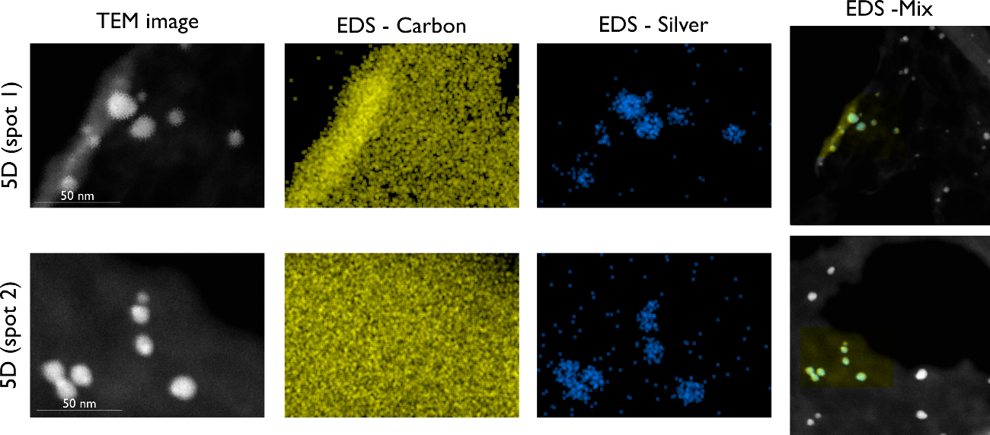
Figure S6. EDS characterization of 5D sample with two different spots. From left to right: TEM image, EDS image for caron, EDS image for silver, and EDS image color mix (C and Ag).
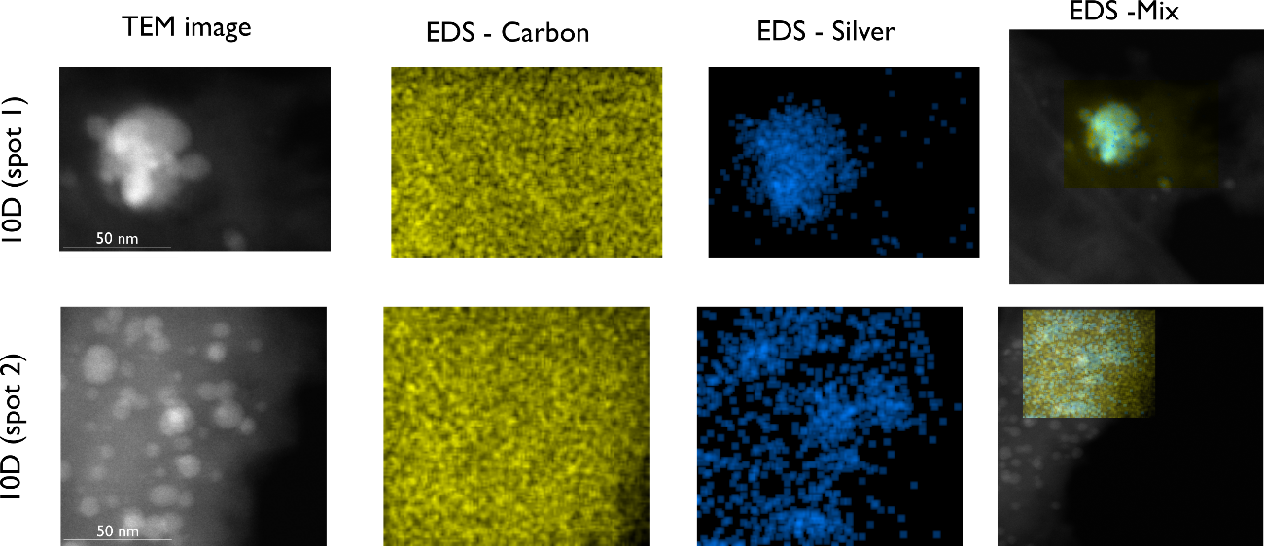
Figure S7. EDS characterization of 10D sample with two different spots. From left to right: TEM image, EDS image for caron, EDS image for silver, and EDS image color mix (C and Ag).
Table S3 – Zeta potential (ζ) measured for all samples.
Sample | Ζ (mV)
GO-AgNPs | -56.51 ± 1.04
1D | -34.63 ± 1.68
5D | -31.74 ± 1.63
10D | -24.09 ± 0.28
Colloidal stability
Table S4 – Total organic carbon (TOC) and silver (ICP-OES) concentrations of GO-AgNPs, 1D, 5D, and 10D samples
Sample | TOC (mg C L⁻¹) | Ag (mg L⁻¹)
GO-AgNPs | 157.7 ± 2.01 | 43.1 ± 4.23
1D | 81.35 ± 1.13 | 10.52 ± 0.35
5D | 74.14 ± 2.67 | 11.77 ± 0.24
10D | 61.39 ± 1.14 | 7.09 ± 0.23

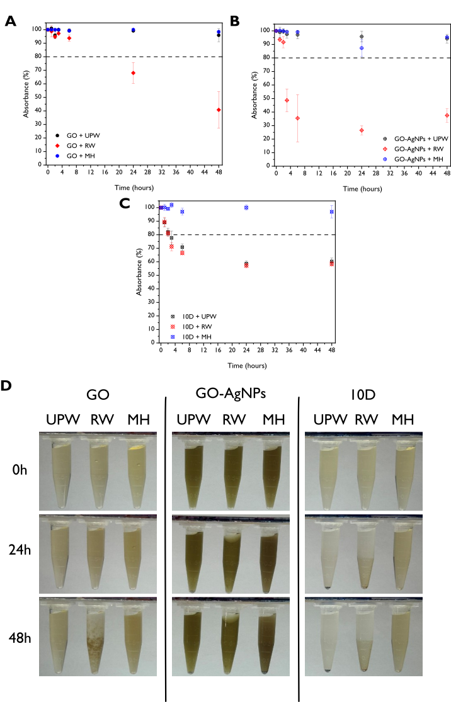
Figure S8. Colloidal stability of samples in UPW, RW and MH mediums for 48 hours monitored by UV-Vis spectrophotometer: (A) GO, (B) GO-AgNPs and (C) 10D; (D) Digital pictures in 0h, 24h and 48h.

Ecotoxicity assessment
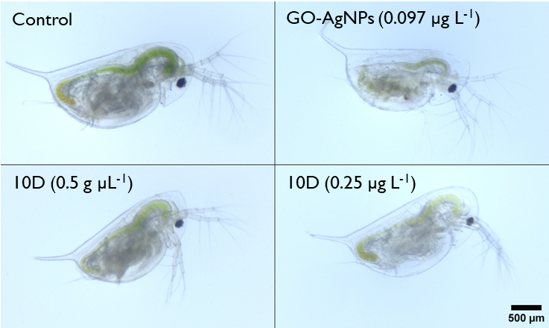
Figure S9 – Bright field images for control, GO-AgNPs, and 10D samples. The concentrations are indicated in the images (scale bar = 500 µm).

