SUPPLEMENTARY MATERIALS
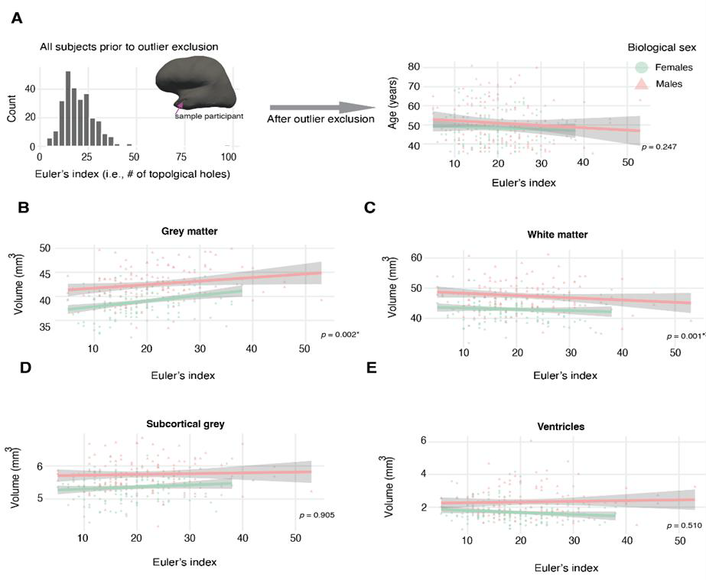
Figure S1. Euler’s index distribution across participants and its association with age and cerebrum tissues.
(A) Inflated brain reconstruction from a sample participant, signalling with the pink arrow a topological hole. The histogram reflects the distribution of Euler’s Index (EI) across our sample. After excluding outliers, we present the relationship between age and EI. (B-D) Associations between (B) grey matter (p<0.05), (C) white matter (p<0.05), (D) subcortical grey matter volumes, and (E) ventricles with EI using GAMs. Points are colored by biological sex. Axes are scaled in units of 10,000 mm3 (10 ml).

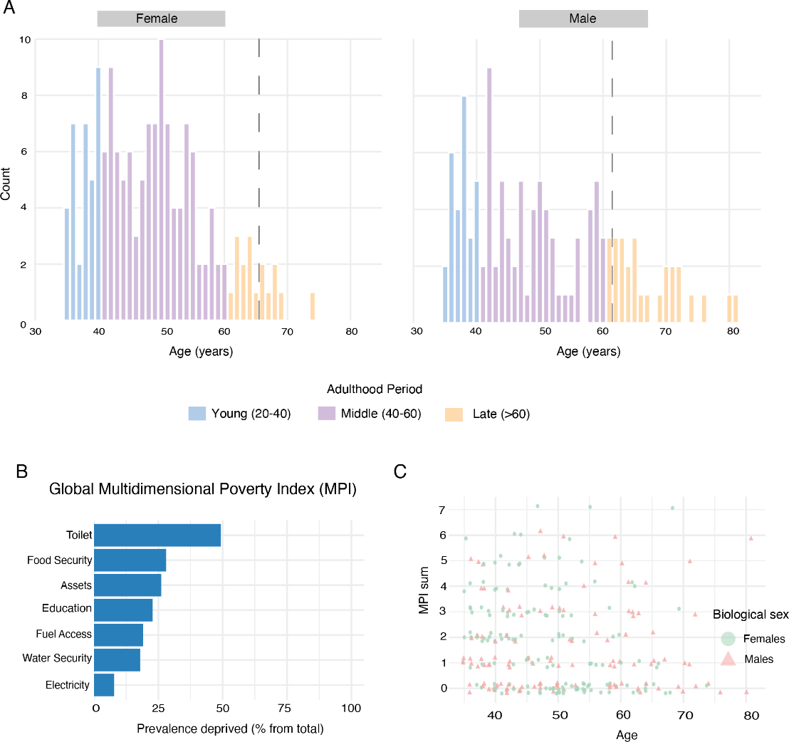
Figure S2. Age distribution and multidimensional poverty exposure. (A) Age distributions are shown for biological females (left) and males (right), coloured by age groups77. The grey dashed lines represent the life expectancy per sex in Kenya. (B) Prevalence of multidimensional poverty index (MPI) indicators in the sample. (C) Distribution of participants exposed to various degrees of deprivation across ages. Points are colored by biological sex

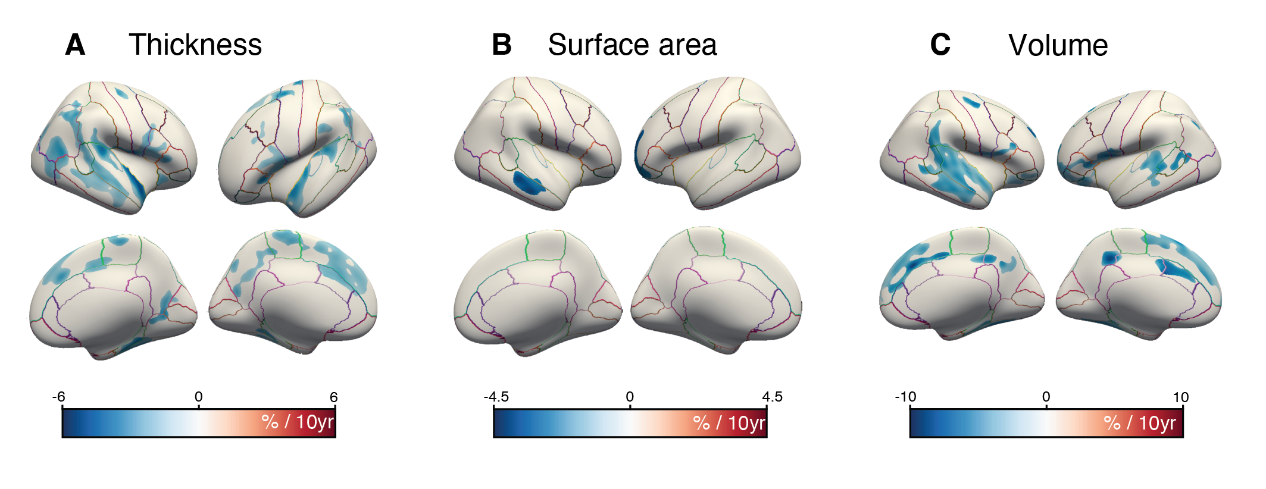
Figure S3. Regionalised cortical atrophy rates. Vertex-wise age effects are shown as percentage change per decade for (a) cortical thickness, (b) surface area, and (c) volume. Effects that survived cluster-based permutation testing corrections (Fig. 2) are displayed.
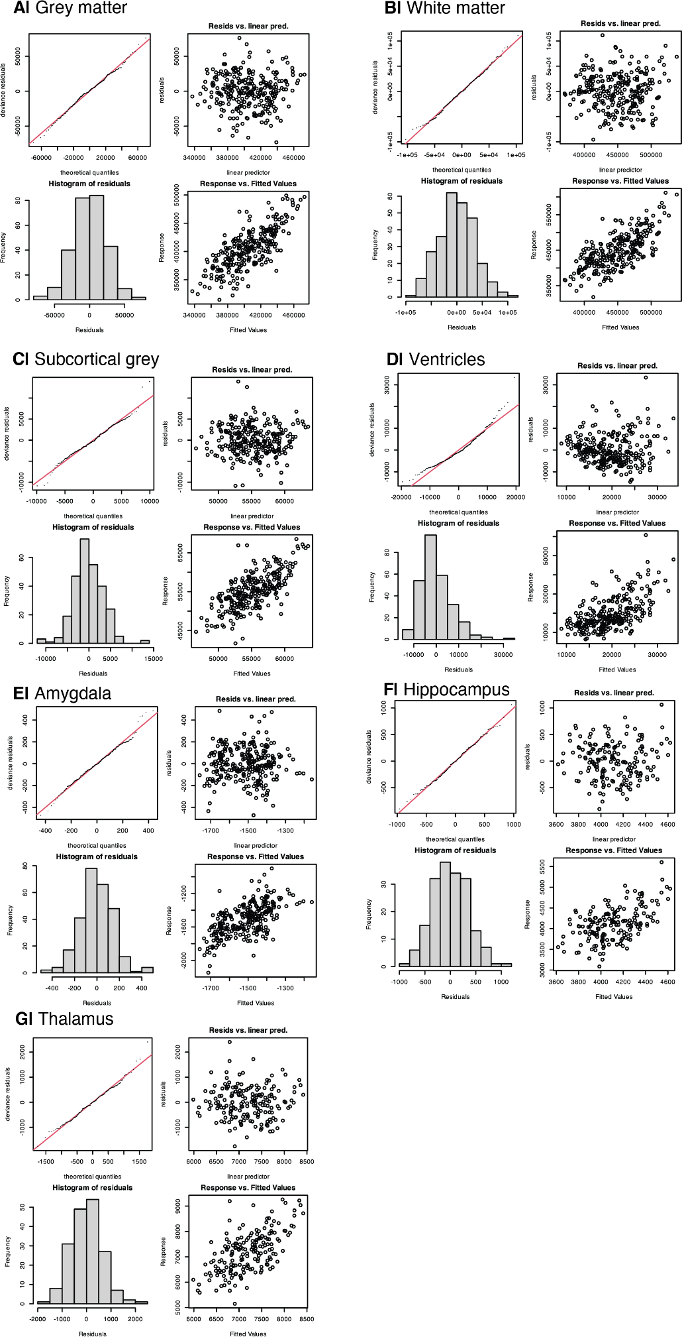
Figure S4. Model fit diagnostics Q-Q plots. Visual inspection indicates that model residuals for cerebrum tissues are normally distributed, further supporting the adequacy of the fitted distributions.

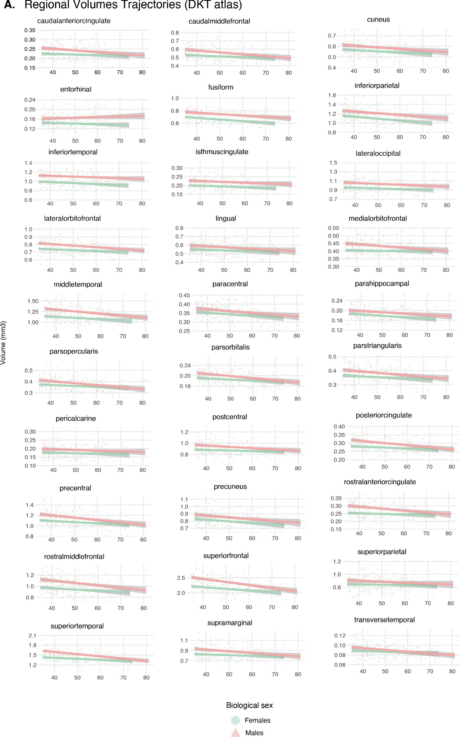

Figure S5. Model fits for regional brain volumes. (A) Bilateral raw regional volumes for 31 Desikan–Killiany (DK) cortical regions (Desikan et al., 2006) are shown across age. Axes are scaled in units of 10,000 mm3 (10 ml)

Supplementary Tables

Table S1. Summary statistics of significant clusters from Figure 2 for (A) thickness, (B) surface area, and (C) volume of significant clusters. From left to right, columns correspond to the peak statistic value within that cluster, the vertex identity where the maximum was located, cluster size in millimetres, standard space (MNI) coordinates, cluster-wise p-value after corrections, number of vertices in the cluster, and DKT region of the cluster.

  - Thickness
lh | Max | Vertex Max | Size(mm^2) | MNIX | MNIY | MNIZ | CWP | # Vertices | DKT region
 | -6.8952 | 76872 | 3140.33 | -22.2 | -9.6 | 50.8 | 0.002 | 5941 | precentral
 | -8.7055 | 98535 | 1488.34 | -35.2 | 10.3 | 13.2 | 0.002 | 3516 | parsopercularis
 | -6.0295 | 42598 | 1100.78 | -51.1 | -55.2 | 24.9 | 0.002 | 2468 | inferiorparietal
 | -8.6377 | 26214 | 944 | -41.8 | -9.9 | -16.3 | 0.002 | 2001 | superiortemporal
 | -5.1729 | 33896 | 676.57 | -11 | -56.6 | 31.7 | 0.002 | 1490 | precuneus
 | -8.5282 | 155352 | 620.67 | -32.6 | -30.2 | 12.9 | 0.002 | 1526 | transversetemporal
 | -5.7535 | 151861 | 561.91 | -5.6 | -35.3 | 60.3 | 0.002 | 1369 | paracentral
 | -4.5426 | 25553 | 537.02 | -26.2 | -45.6 | -6.2 | 0.002 | 1108 | lingual
 | -5.9626 | 94833 | 246.12 | -14.7 | -30.9 | 57.4 | 0.00798 | 624 | precentral
 | -4.8663 | 156064 | 226.85 | -58.6 | -26.7 | 27 | 0.01196 | 509 | supramarginal
 | -3.6294 | 80446 | 197.31 | -45.1 | 26 | 30.6 | 0.02188 | 308 | rostralmiddlefrontal
 | -5.6897 | 42671 | 186.05 | -6.6 | -71.9 | 39.6 | 0.02583 | 360 | precuneus
 | -4.391 | 156990 | 176.21 | -52.4 | -60.6 | 8.7 | 0.03371 | 288 | middletemporal

rh | Max | Vertex Max | Size(mm^2) | MNIX | MNIY | MNIZ | CWP | # Vertices | DKT region
 | -13.8111 | 66217 | 3624.24 | 46.9 | -4.4 | -16.7 | 0.002 | 7847 | superiortemporal
 | -7.8083 | 8432 | 3481.02 | 49.6 | -49.7 | 40.2 | 0.002 | 7488 | inferiorparietal
 | -8.7658 | 27858 | 1390.83 | 44.2 | -56.8 | 9.4 | 0.002 | 2486 | inferiorparietal
 | -7.5119 | 26376 | 1373.56 | 10.4 | 26.1 | 35.6 | 0.002 | 2662 | superiorfrontal
 | -7.7629 | 90202 | 972.82 | 36.7 | -30.4 | -22.4 | 0.002 | 1946 | fusiform
 | -5.7338 | 86548 | 715.93 | 23.9 | -66.5 | 2.1 | 0.002 | 1401 | lingual
 | -6.4896 | 157812 | 598.01 | 31.8 | -72.6 | 18 | 0.002 | 1069 | inferiorparietal
 | -6.1164 | 150535 | 286.99 | 11.5 | -3.4 | 44 | 0.00798 | 789 | superiorfrontal
 | -5.2898 | 150273 | 286.05 | 6.7 | -25.6 | 61 | 0.00798 | 674 | paracentral
 | -6.1299 | 23446 | 274.99 | 40 | -13 | 60 | 0.00997 | 631 | precentral
 | -5.919 | 4860 | 175 | 29.7 | 26.2 | -6.5 | 0.0396 | 398 | lateralorbitofrontal

  - Surface area
lh | Max | Vertex Max | Size(mm^2) | MNIX | MNIY | MNIZ | CWP | # Vertices | DKT region
 | -4.4296 | 121681 | 1648.86 | -23.9 | 48.5 | 9.5 | 0.002 | 2455 | rostralmiddlefrontal

rh | Max | Vertex Max | Size(mm^2) | MNIX | MNIY | MNIZ | CWP | # Vertices | DKT region
 | -4.7906 | 79980 | 717.8 | 60 | -31.3 | -9.9 | 0.01792 | 1281 | middletemporal

  - Volume
lh | Max | Vertex Max | Size(mm^2) | MNIX | MNIY | MNIZ | CWP | # Vertices | DKT region
 | -10.2597 | 99359 | 3331.34 | -44.6 | 7.4 | 5.4 | 0.002 | 6517 | parsopercularis

 | -9.1102 | 100381 | 2745.79 | -8.4 | 17.9 | 61.6 | 0.002 | 4765 | superiorfrontal
 | -5.8815 | 125763 | 1087.65 | -62.8 | -30.2 | 7.4 | 0.004 | 2463 | superiortemporal
 | -8.4861 | 10156 | 859.8 | -31.9 | -37.8 | -21 | 0.004 | 1621 | fusiform
 | -7.1816 | 99568 | 468.25 | -5.2 | 9.8 | 33.4 | 0.00599 | 1089 | caudalanteriorcingulate
 | -9.4321 | 62051 | 418.43 | -13 | -43.2 | 38 | 0.00997 | 898 | precuneus
 | -4.3321 | 33639 | 359.37 | -46.6 | -48.3 | 7.7 | 0.00997 | 743 | bankssts
 | -5.8362 | 74208 | 230.37 | -37.7 | -70.6 | 44.9 | 0.03568 | 398 | inferiorparietal

rh | Max | Vertex Max | Size(mm^2) | MNIX | MNIY | MNIZ | CWP | # Vertices | DKT region
 | -7.2368 | 23611 | 5196.29 | 48.1 | -5.7 | -14.1 | 0.002 | 11142 | superiortemporal
 | -10.1336 | 14514 | 2707.29 | 10.4 | 43.6 | 43.8 | 0.002 | 5094 | superiorfrontal
 | -5.0439 | 143803 | 836.81 | 30.2 | -52.3 | -13.2 | 0.002 | 1627 | fusiform
 | -6.3971 | 27010 | 804.59 | 43.1 | -3.2 | 17.1 | 0.002 | 1655 | postcentral
 | -6.1335 | 65374 | 386.2 | 40.1 | -11.4 | 58.1 | 0.01792 | 879 | precentral
 | -5.3309 | 60928 | 366.24 | 15 | 29.6 | -19.4 | 0.01792 | 776 | lateralorbitofrontal
 | -5.2979 | 61162 | 309.25 | 5.9 | -39.1 | 41.3 | 0.02583 | 768 | precuneus
 | -4.4884 | 54600 | 309.21 | 12 | -54 | 32.8 | 0.02583 | 720 | precuneus
 | -5.4795 | 27179 | 291.46 | 30.8 | 26.3 | -7.8 | 0.0278 | 543 | lateralorbitofrontal
 | -4.3155 | 83959 | 257.3 | 46 | 34.4 | -13.4 | 0.03568 | 375 | parsorbitalis

Table S2. General Additive Models (GAMs) results for cerebrum tissues. For GAMs that fit age as a linear covariate, we present standardised beta coefficients (SDs of the unit outcome) with their corresponding standard errors, t-statistics, and FDR-corrected p-values for age. Modelling of tissues with a penalised regression spline for age (k=6) was characterised with effective degrees of freedom (EDF), differences in BIC and AIC metrics across models (non-linear minus linear), F-statistic, and FDR-corrected p-values for the approximate significance of the smooth term.

 | Linear GAM |  |  | Non-linear GAM
Region | β (SE) | t-stat | p-valFDR | edf | F | ΔBIC | ΔAIC | p-valFDR | Best model-fit
GMW | -0.035 (0.004) | -8.64 | <0.001 | 1.01 | 72.88 | 0.02 | 0.01 | <0.001 | Linear
sGMV | -0.040 (0.004) | -9.11 | <0.001 | 2.27 | 31.17 | 3.85 | -2.17 | <0.001 | Linear
WMV | -0.019 (0.004) | -4.38 | <0.001 | 2.05 | 8.70 | 4.00 | -0.61 | <0.001 | Linear
Ventricles | 0.035 (0.004) | 7.05 | <0.001 | 2.07 | 18.79 | 3.77 | -2.68 | <0.001 | Linear
Thalamus | -0.037 (0.005) | -7.85 | <0.001 | 1.09 | 53.41 | 0.01 | 0.00 | <0.001 | Linear
Amygdala | -0.028 (0.005) | -5.54 | <0.001 | 3.21 | 14.23 | -8.68 | -18.07 | <0.001 | Non-linear
Hippocampus | -0.026 (0.005) | -4.95 | <0.001 | 2.53 | 10.59 | 2.02 | -5.31 | <0.001 | Linear

Table S3. Rates of change in cerebrum tissues yearly and per decade. For each tissue, we present percentage changes per decade, with 95% CI. Changes per decade were standardised by mean intracranial volume.

Region | % Δ decade (95% CI)
GMW | -3.11 (-3.82 to -2.406)
sGMV | -3.40 (-4.13 to -2.67)
WMV | -2.07 (-3.00 to -1.15)
Ventricles | 14.86 (10.73 to 18.99)
Thalamus | -4.02 (-5.02 to -3.01)
Amygdala | -3.50 (-4.73 to -2.26)
Hippocampus | -2.57 (-3.59 to -1.55)

