Synergistic Effect of Samarium Promotion on the Performance and Stability of Ni/KIT-6 for Dry Reforming of Methane
Catalyst Characterization S1

Nitrogen physisorption. Nitrogen adsorption/desorption measurements were carried out at 77 K on a Micromeritics TriStar II 3020. All samples were degassed identically (150 °C, 12 h, high vacuum) to remove physisorbed water. Degas conditions and analysis settings were kept constant across the series. Specific surface area was calculated by the BET method, and pore volume and pore-size distribution were obtained. X-ray diffraction. Powder XRD patterns were recorded on a Rigaku MiniFlex 600 using Cu Kα radiation (λ = 0.15406 nm) over 2θ = 10-80°. H₂-TPR. Temperature-programmed reduction was performed on a Micromeritics AutoChem II 2920. Approximately 70 mg of the sample was pre-treated in helium at 200 °C, cooled, and then heated to 900 °C in 10% H₂/Ar to assess reducible species. Raman spectroscopy. Spent catalysts were analyzed on a JASCO Raman instrument with a 532 nm laser to characterize carbon deposits.

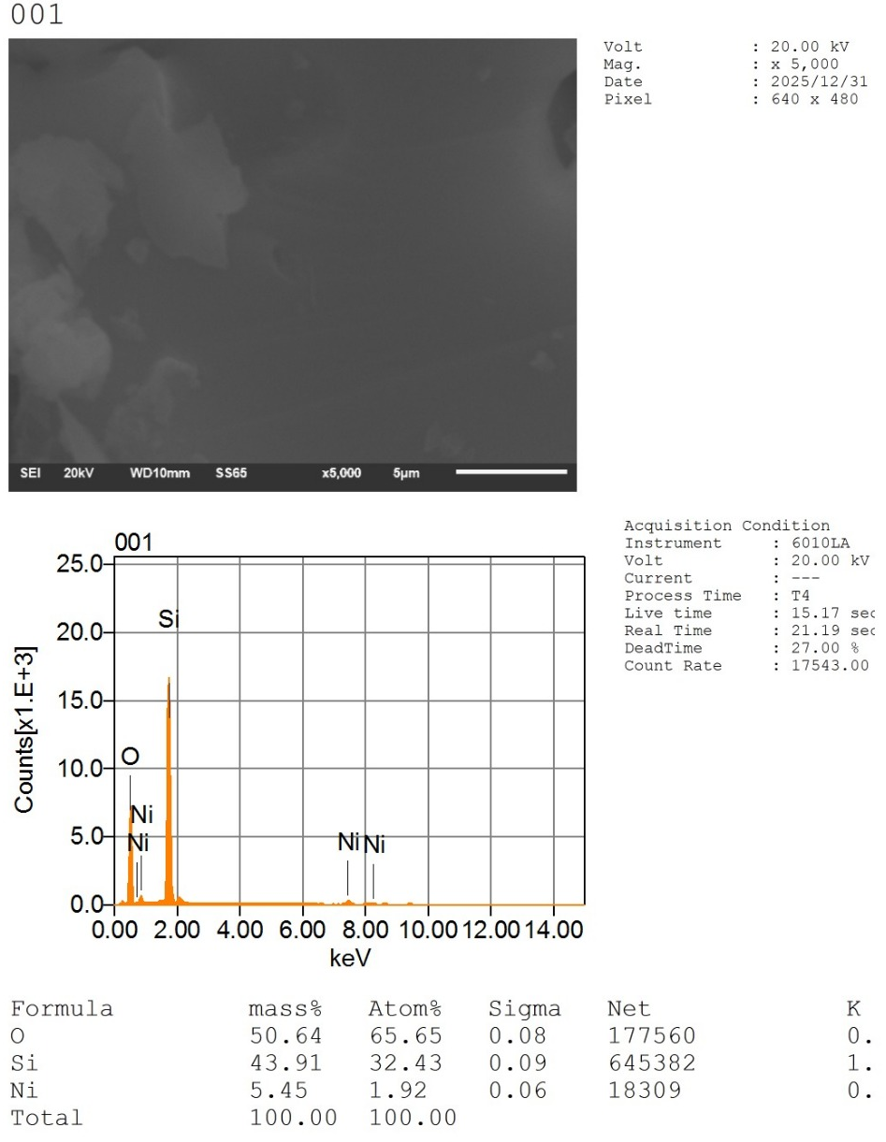
Figure S1 SEM-EDX of 5Ni-KIT-6
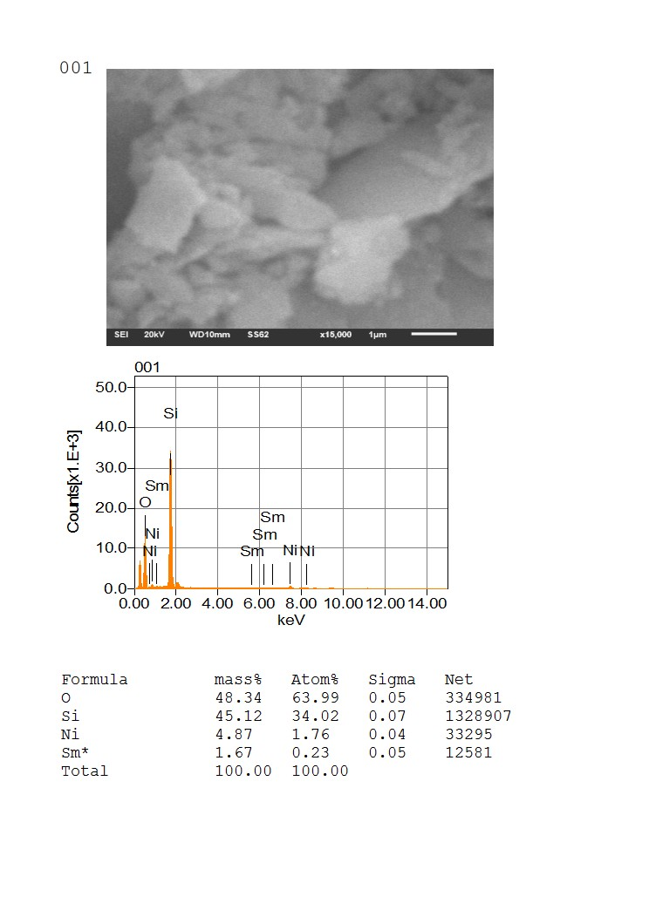
Figure S2 SEM-EDX of 5Ni+1.5Sm-KIT-6

Figure S3 XPS spectra of Sm 3d for Ni-Sm supported on KIT-6 catalysts with varying Sm content.

