Supplementary materials:

Figure S1. ¹H NMR spectrum of lovastatin in C₃D₆O at 300 K, * - solvent signals.

Figure S2. ¹³C NMR spectrum of lovastatin in C₃D₆O at 300 K, * - solvent signals.
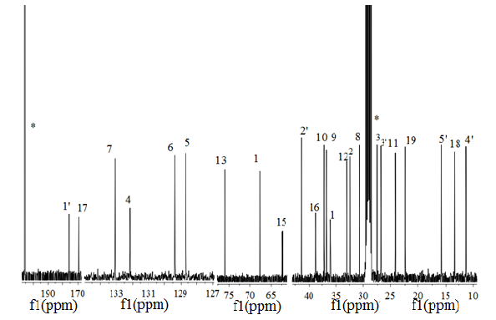

Figure S3 –Radial distribution function (RDF) functions for lovastatin CH-15 and CH₂-16 H atoms and Zn²⁺ (red), Mn²⁺ (orange), and Ni²⁺ (blue) ions obtained from the simulation results.

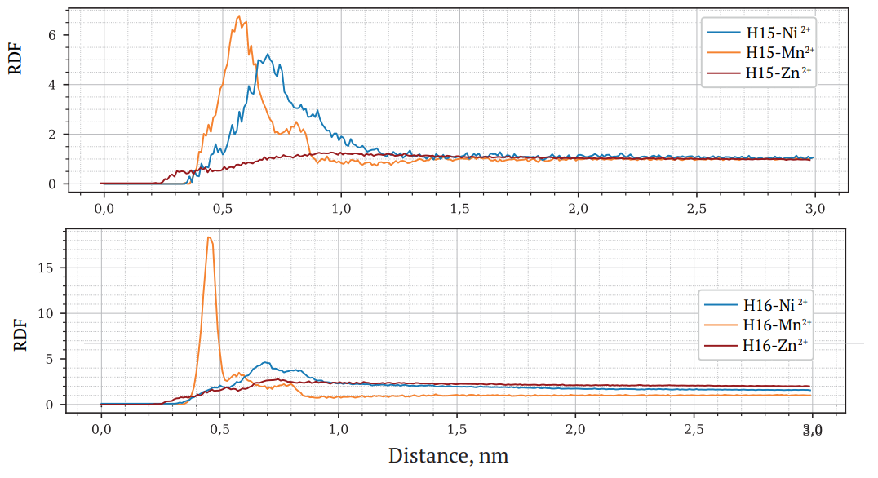

Table S1. Chemical shifts in the ¹H, ¹³C NMR spectrum of lovastatin in C₃D₆O at 300 K
Chemical group | δ ¹H, ppm | δ ¹³C, ppm
CH-1 | 5.36 | 67.68
CH₂-2 | 1.96 | 32.44
CH-3 | 2.43 | 27.60
CH-4 | 5.53 | 132.16
C-5 | - | 128.64
CH-6 | 6.00 | 129.37
CH-7 | 5.81 | 133.09
CH-8 | 2.42 | 30.75
CH-9 | 1.73 | 36.76
CH-10 | 2.36 | 37.18
CH₂-11 | 1.53; 1.40 | 24.16
CH₂-12 | 1.82 | 33.11
CH-13 | 4.62 | 77.30
CH₂-14 | 1.94; 1.75 | 36.08; 36.13
CH-15 | 4.32 | 62.21
CH₂-16 | 2.66; 2.5 | 38.61; 38.66
C-17 | - | 169.48
CH₃-18 | 0.9 | 13.36
CH₃-19 | 1.07 | 22.45
C-1’ | - | 175.69
CH-2’ | 2.35 | 41.31
CH₂-3’ | 1.67; 1.46 | 26.81
CH₃-4’ | 0.87 | 11.28
CH₃-5’ | 1.09 | 15.80

Table S2. Chemical shifts and changes in the chemical shifts in the ¹H, ¹³C NMR spectrum of lovastatin with Mn²⁺ ions at statin:ion ratios 1:0 (a), 50:1 (b), 5:1 (c) in C₃D₆O at 300 K (the chemical shift change is highlighted).
Number of atom | a: |  | b: | c:
Number of atom | δ ¹H,  ppm | δ¹³C,  ppm | δ ¹H,  ppm | δ ¹H,  ppm | δ¹³C,  ppm
1 | 5.36 | 67.68 | 5.36 | 5.36 | 64.12
2 | 1.96 | 32.44 | 1.96 | 1.96 | 28.28
3 | 2.43 | 27.60 | 2.43 | 2.43 | 23.41
4 | 5.53 | 132.16 | 5.53 | 5.53 | 127.92
5 | - | 128.64 | - | - | 124.44
6 | 6.00 | 129.37 | 6.00 | 6.00 | 125.38
7 | 5.81 | 133.09 | 5.81 | 5.81 | 129.13
8 | 2.42 | 30.75 | 2.42 | 2.42 | 26.60
9 | 1.73 | 36.76 | 1.73 | 1.73 | 32.67
10 | 2.36 | 37.18 | 2.36 | 2.36 | 33.01
11 | 1.53;1.40 | 24.16 | 1.53;1.40 | 1.53; 1.40 | 19.82
12 | 1.82 | 33.11 | 1.82 | 1.82 | 28.76
13 | 4.62 | 75.93 | 4.62 | 4.64 | 72.56
14 | 1.94(b);  1.75(a) | 36.13(b);  36.08(a) | 1.94;  1.75 | 1.94;  1.75 | 31.46
15 | 4.32 | 62.21 | 4.32 | 4.31 | -
16 | 2.66 (b);  2.50 (a) | 38.61 (b);  38.66 (a) | 2.67  2.51 | 2.70  2.55 | 34.20
17 | - | 169.48 | - | - | -
18 | 0.90 | 13.36 | 0.90 | 0.90 | 9.29
19 | 1.07 | 22.45 | 1.07 | 1.07 | 18.38
1’ | - | 175.69 | - | - | -
2’ | 2.35 | 41.31 | 2.35 | 2.35 | 37.45
3’ | 1.67;1.46 | 26.81 | 1.67;1.46 | 1.67;1.46 | 22.67
4’ | 0.87 | 11.28 | 0.87 | 0.87 | 7.24
5’ | 1.09 | 15.80 | 1.09 | 1.09 | 11.76

Table S3. Chemical shifts and changes in the chemical shifts in the ¹H, ¹³C NMR spectrum of lovastatin with Ni²⁺ ions at statin:ion ratios 1:0 (a), 50:1 (b), 5:1 (c) in C₃D₆O at 300 K (the chemical shift change is highlighted).
Number of atom | a: |  | b: | c:
Number of atom | δ ¹H,  ppm | δ¹³C,  ppm | δ ¹H,  ppm | δ ¹H,  ppm | δ¹³C,  ppm
1 | 5.36 | 67.68 | 5.36 | 5.36 | 65.05
2 | 1.96 | 32.44 | 1.96 | 1.96 | 29.36
3 | 2.43 | 27.60 | 2.43 | 2.43 | 24.48
4 | 5.53 | 132.16 | 5.53 | 5.53 | 129.00
5 | - | 128.64 | - | - | 125.51
6 | 6.00 | 129.37 | 6.00 | 6.00 | 126.40
7 | 5.81 | 133.09 | 5.81 | 5.81 | 130.19
8 | 2.42 | 30.75 | 2.42 | 2.42 | 27.67
9 | 1.73 | 36.76 | 1.73 | 1.73 | 33.72
10 | 2.36 | 37.18 | 2.36 | 2.36 | 34.08
11 | 1.53;1.40 | 24.16 | 1.53;1.40 | 1.53; 1.40 | 20.93
12 | 1.82 | 33.11 | 1.82 | 1.82 | 29.86
13 | 4.62 | 75.93 | 4.62 | 4.63 | 73.45
14 | 1.94(b);  1.75(a) | 36.13(b);  36.08(a) | 1.94;  1.75 | 1.94;  1.75 | 32.63
15 | 4.32 | 62.21 | 4.31 | 4.31 | 58.92
16 | 2.66 (b);  2.50 (a) | 38.61 (b);  38.66 (a) | 2.67  2.51 | 2.70  2.54 | 35.33
17 | - | 169.48 | - | - | -
18 | 0.90 | 13.36 | 0.90 | 0.90 | 10.35
19 | 1.07 | 22.45 | 1.07 | 1.07 | 19.46
1’ | - | 175.69 | - | - | -
2’ | 2.35 | 41.31 | 2.35 | 2.35 | 38.43
3’ | 1.67;1.46 | 26.81 | 1.67;1.46 | 1.67;1.46 | 23.72
4’ | 0.87 | 11.28 | 0.87 | 0.87 | 8.27
5’ | 1.09 | 15.80 | 1.09 | 1.09 | 12.81

Table S4. Self-diffusion coefficients of lovastatin, water, and acetone at different ratios of statin: Zn²⁺, Mn²⁺, Ni²⁺ion at a temperature of 300 K.

Statin:ion ratio | D_{statin}, m²/s | D_{H2O}, m²/s | D_{C3H6O}, m²/s
pure statin | 1.28*10⁻⁹ | 4.5*10⁻⁹ | 3.8*10⁻⁹
50:1 Zn²⁺ | 1.28*10⁻⁹ | 4.5*10⁻⁹ | 3.8*10⁻⁹
5:1 Mn2+ | 1.6*10⁻¹⁰ | - | 1.80*10⁻⁹
5:1 Ni²⁺ | 5.4*10⁻¹⁰ | - | 1.8*10⁻⁹

Table S5. ¹H-¹³C NOESY distances (r) and cross-relaxation rates (σ) for lovastatin in C₃D₆O at 300 K in the absence and presence of metal ions (Mn²⁺, Ni²⁺) determined from 2D NOESY NMR experiments. The distance between nonequivalent protons of the CH₂-11 group (*11a-11b, 2.49 Å) was used as an internal reference for distance calibration.
Statin:ion ratio | Group of atoms | r, Å | σ, 1/s
Pure statin | 3-4 | 3,58 | 0,019
 | 3-18 | 3,31 | 0,031
 | 9-15 | 3,24 | 0,035
 | *11a-11b | 2,49 | 0,017
5:1 Mn²⁺ | 3-4 | 3,72 | 0,031
 | 3-18 | 3,65 | 0,035
 | 9-15 | 4,19 | 0,025
 | *11a-11b | 2,49 | 0,018
5:1 Ni²⁺ | 3-4 | 2,86 | 0,035
 | 3-18 | 3,01 | 0,026
 | 9-15 | 3,13 | 0,020
 | *11a-11b | 2,49 | 0,079

