Supplementary Figure S1. Original western blot images corresponding to Fig. 6A,C

Figure 6A.
Western blot analysis confirming efficient knockdown of TUBB4B in HK1 cells transfected with TUBB4B-specific siRNAs compared with control cells.
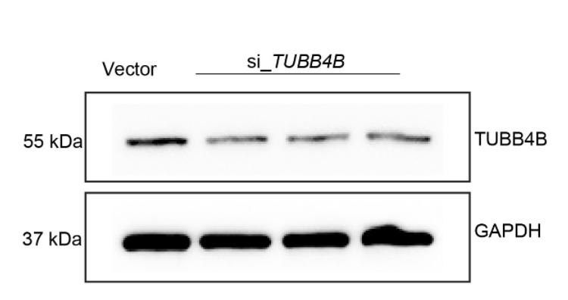
TUBB4B
55 KDa
40 KDa
GAPDH
Figure 6C.
Western blot of TUBB4B, FLAG, PCNA, and β-ACTIN in HK1 cells transduced with TUBB4B-overexpressing lentiviral vectors.
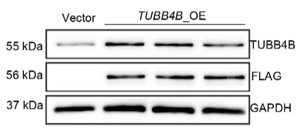

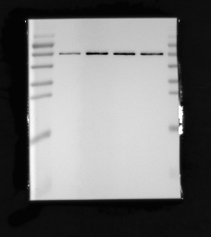
TUBB4B
55 KDa

FLAG
55 KDa

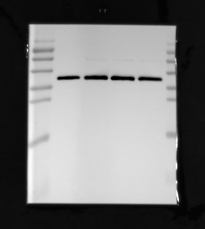
40 KDa
GAPDH
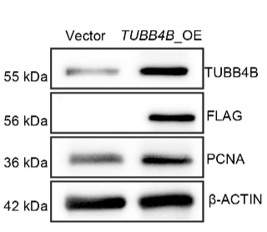

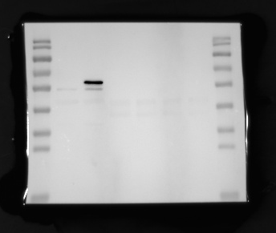
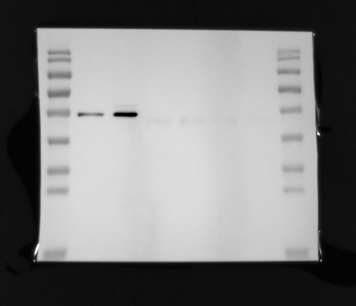
55 KDa
55 KDa
FLAG
TUBB4B

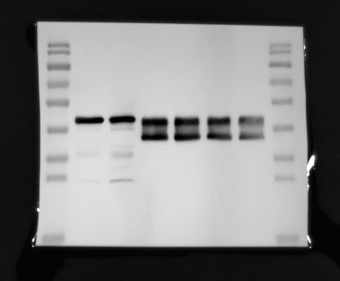
40 KDa
35 KDa
β-ACTIN

PCNA

