Supplementary
¹H-NMR spectra of compound 2
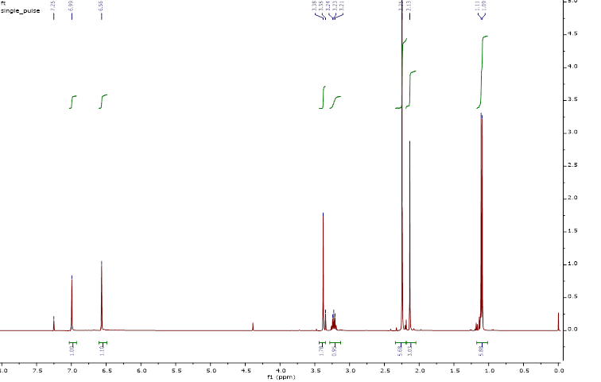
Fig.S1: ¹H-NMR spectra of compound 2
Fig.S2: ¹³C NMR spectra of compound 2
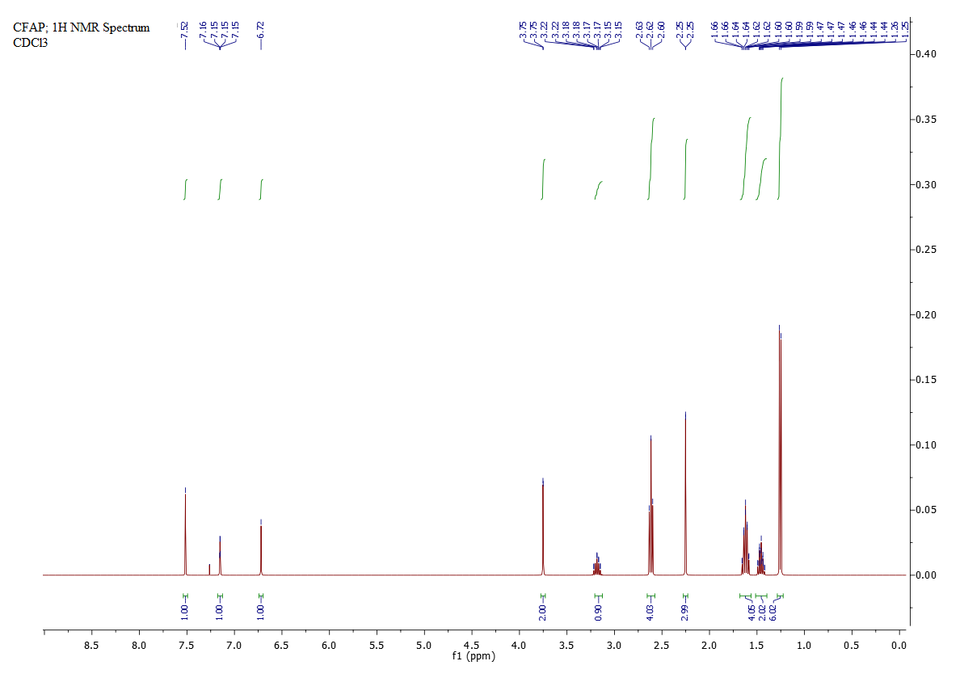
Fig.S3: ¹H- NMR spectra of compound 3
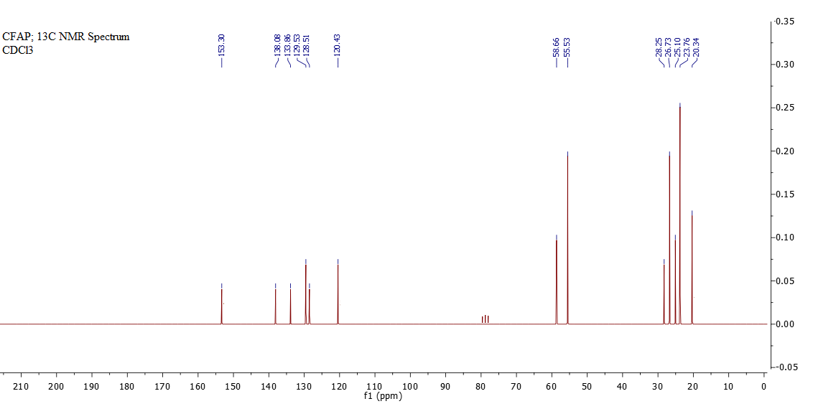
Fig.S4: ¹H- NMR spectra of compound 3

