A Miniature Sorbent-Coated Capillary Device for Efficient Breath Volatile Organic Compound Capture and Analysis

Supplementary Materials

Abbi Abdel-Rehim^{1,*}, Mohamed Abdel-Rehim²

¹Department of Chemical Engineering and Biotechnology, University of Cambridge, Cambridge, UK.
²Department of Applied Physics, Royal Institute of Technology, Stockholm, Sweden.
*Corresponding author: aar52@cam.ac.uk

SEM images:
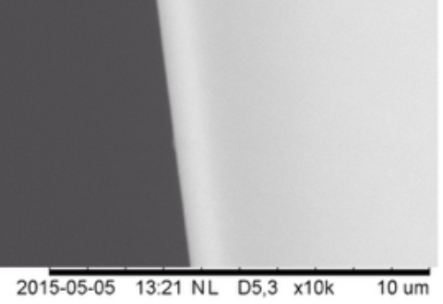

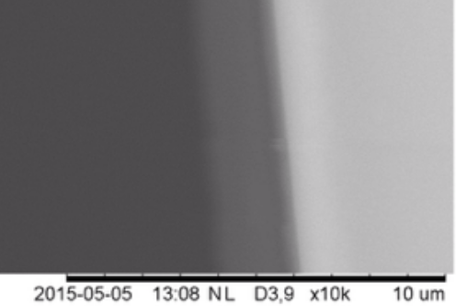

Spectra:
