Supplementary Information

Supplementary Results for RQ1
This section provides per-SDG detail and supplementary diagnostics for RQ1. Its purpose is to clarify why the main text interprets LLM scores as a conservative semantic-intensity signal rather than directly treating them as rule labels or probability outputs.

S1.1 Per-SDG Ranking Metrics and Baseline Adjustment
Table S1A reports the full ranking results for all 17 SDGs under Aurora and Elsevier, including positive-set size, positive rate, raw AUPRC, ROC-AUC, and baseline-adjusted gain. It provides per-goal evidence for the main-text judgment that raw AUPRC should be interpreted alongside the prevalence baseline.
Table S1A. Per-SDG ranking metrics and prevalence-adjusted AUPRC gain.
SDG | Support A | Prev A | AUPRC A | ROC-AUC A | Lift A | Support E | Prev E | AUPRC E | ROC-AUC E | Lift E
SDG1 | 1120315 | 0.633 | 0.681 | 0.567 | 0.047 | 1136305 | 0.642 | 0.696 | 0.577 | 0.054
SDG2 | 1205477 | 0.681 | 0.711 | 0.546 | 0.029 | 1162611 | 0.657 | 0.700 | 0.561 | 0.043
SDG3 | 1442158 | 0.815 | 0.863 | 0.620 | 0.047 | 1165391 | 0.659 | 0.743 | 0.625 | 0.084
SDG4 | 987692 | 0.558 | 0.648 | 0.595 | 0.089 | 1587790 | 0.897 | 0.913 | 0.565 | 0.016
SDG5 | 962385 | 0.544 | 0.588 | 0.549 | 0.044 | 1453930 | 0.822 | 0.836 | 0.538 | 0.014
SDG6 | 1344071 | 0.760 | 0.777 | 0.535 | 0.018 | 1078846 | 0.610 | 0.651 | 0.552 | 0.041
SDG7 | 1035185 | 0.585 | 0.635 | 0.560 | 0.050 | 1543630 | 0.873 | 0.889 | 0.561 | 0.016
SDG8 | 1418335 | 0.802 | 0.853 | 0.620 | 0.051 | 1179647 | 0.667 | 0.772 | 0.654 | 0.105
SDG9 | 1385706 | 0.783 | 0.831 | 0.623 | 0.048 | 1237733 | 0.700 | 0.773 | 0.642 | 0.073
SDG10 | 1291169 | 0.730 | 0.779 | 0.594 | 0.049 | 503666 | 0.285 | 0.375 | 0.614 | 0.091
SDG11 | 1281442 | 0.724 | 0.774 | 0.582 | 0.049 | 1423605 | 0.805 | 0.852 | 0.613 | 0.047
SDG12 | 1230264 | 0.695 | 0.763 | 0.610 | 0.068 | 1219917 | 0.690 | 0.753 | 0.600 | 0.063
SDG13 | 1294343 | 0.732 | 0.763 | 0.553 | 0.032 | 734592 | 0.415 | 0.511 | 0.585 | 0.096
SDG14 | 1165693 | 0.659 | 0.683 | 0.535 | 0.024 | 1366417 | 0.772 | 0.789 | 0.536 | 0.017
SDG15 | 1393147 | 0.787 | 0.819 | 0.570 | 0.031 | 1100155 | 0.622 | 0.694 | 0.596 | 0.072
SDG16 | 1411555 | 0.798 | 0.845 | 0.615 | 0.048 | 345926 | 0.196 | 0.502 | 0.800 | 0.306
SDG17 | 1580461 | 0.893 | 0.908 | 0.564 | 0.014 | 1713679 | 0.969 | 0.973 | 0.567 | 0.004

S1.2 Score-Bin Distribution and the Gradient in Empirical Hit Rates
Figure 1B already shows that the overall score-bin gradient remains monotonically increasing under both rule-based systems. What deserves more emphasis here is that this gradient does not push score 0 toward the status of a rule-based negative. On the contrary, a score of 0 still corresponds to a relatively high observed positive rate under both Aurora and Elsevier, suggesting that low LLM scores are better understood as indicating a lack of dominant focus rather than an absence of relevance.
Per-SDG heterogeneity supports the same interpretation. For a high-baseline goal such as SDG17, high hit rates may persist across all score bins without necessarily producing high gain; by contrast, for a goal with clearer separation, such as SDG16 under Elsevier, the higher-score range can generate a stronger discrimination signal.

S1.3 Rank Correlation with Rule-Evidence Strength
Table S1B reports the Spearman rank correlation between LLM scores and normalized hit intensity within the rule-positive subsample. Its purpose is not to test a linear relationship, but to assess whether the model adjusts its scores in line with the strength of rule-based evidence.
Table S1B. Per-SDG Spearman correlations between LLM scores and normalized rule-hit intensity.
SDG | Spearman A | Aurora Positive Count | Spearman E | Elsevier Positive Count
SDG1 | 0.263 | 1120315 | 0.236 | 1136305
SDG2 | 0.181 | 1205477 | 0.333 | 1162611
SDG3 | 0.305 | 1442158 | 0.208 | 1165391
SDG4 | 0.406 | 987692 | 0.352 | 1587790
SDG5 | 0.227 | 962385 | 0.254 | 1453930
SDG6 | 0.168 | 1344071 | 0.278 | 1078846
SDG7 | 0.286 | 1035185 | 0.354 | 1543630
SDG8 | 0.352 | 1418335 | 0.423 | 1179647
SDG9 | 0.193 | 1385706 | 0.182 | 1237733
SDG10 | 0.345 | 1291169 | 0.168 | 503666
SDG11 | 0.256 | 1281442 | 0.355 | 1423605
SDG12 | 0.268 | 1230264 | 0.238 | 1219917
SDG13 | 0.148 | 1294343 | 0.184 | 734592
SDG14 | 0.191 | 1165693 | 0.246 | 1366417
SDG15 | 0.320 | 1393147 | 0.403 | 1100155
SDG16 | 0.390 | 1411555 | 0.311 | 345926
SDG17 | 0.308 | 1580461 | 0.347 | 1713679
MEAN | 0.271 |  | 0.287

S1.4 Pseudo-Calibration Diagnostics and Interpretive Boundaries
Tables S1C and S1D temporarily treat the 0-4 scale as pseudo-probabilities via a linear mapping, solely to illustrate why the scores should not be interpreted directly as probability forecasts. They support the main-text judgment that an ordered score scale is not equivalent to a well-calibrated score scale.
Table S1C. Overall pseudo-calibration diagnostics for the LLM score scale.
Metric | vs Aurora | vs Elsevier
Brier Score | 0.595 | 0.556
ECE | 0.612 | 0.563
Mean per-SDG ECE | 0.612 | 0.566
Observed positive rate at score 0 | 0.674 | 0.625
Observed positive rate at score 4 | 0.947 | 0.899
Table S1D. Per-SDG expected calibration error under the pseudo-probability interpretation.
SDG | ECE A | ECE E
SDG1 | 0.585 | 0.594
SDG2 | 0.629 | 0.602
SDG3 | 0.604 | 0.469
SDG4 | 0.462 | 0.800
SDG5 | 0.505 | 0.782
SDG6 | 0.718 | 0.567
SDG7 | 0.518 | 0.799
SDG8 | 0.639 | 0.504
SDG9 | 0.475 | 0.403
SDG10 | 0.621 | 0.216
SDG11 | 0.593 | 0.671
SDG12 | 0.594 | 0.588
SDG13 | 0.658 | 0.344
SDG14 | 0.624 | 0.736
SDG15 | 0.706 | 0.541
SDG16 | 0.635 | 0.092
SDG17 | 0.833 | 0.908
MEAN | 0.612 | 0.566

Supplementary Results for RQ2
This section supplements RQ2 with per-SDG heterogeneity, threshold sensitivity, and stratified document-level overlap in order to show more precisely where thresholding losses occur and which settings affect them.

S2.1 Per-SDG Heterogeneity after Binarization
Figure S2A and Table S2A report the full label-level classification metrics for each SDG. The overall pattern from the main text holds for almost all goals: the LLM generally maintains very high precision relative to both rule-based systems, but recall remains broadly constrained, so per-SDG F1 is usually far below the Aurora-Elsevier baseline.
What this set of results emphasizes is not which SDGs perform best on their own, but that the intensity of thresholding loss is not uniform across goals. SDG17 is especially revealing: in RQ1, it shows a strong ranking signal, but after binarization, its F1 falls to only about 0.058/0.054, indicating a clear nonlinear compression between continuous scores and hard-threshold decisions.
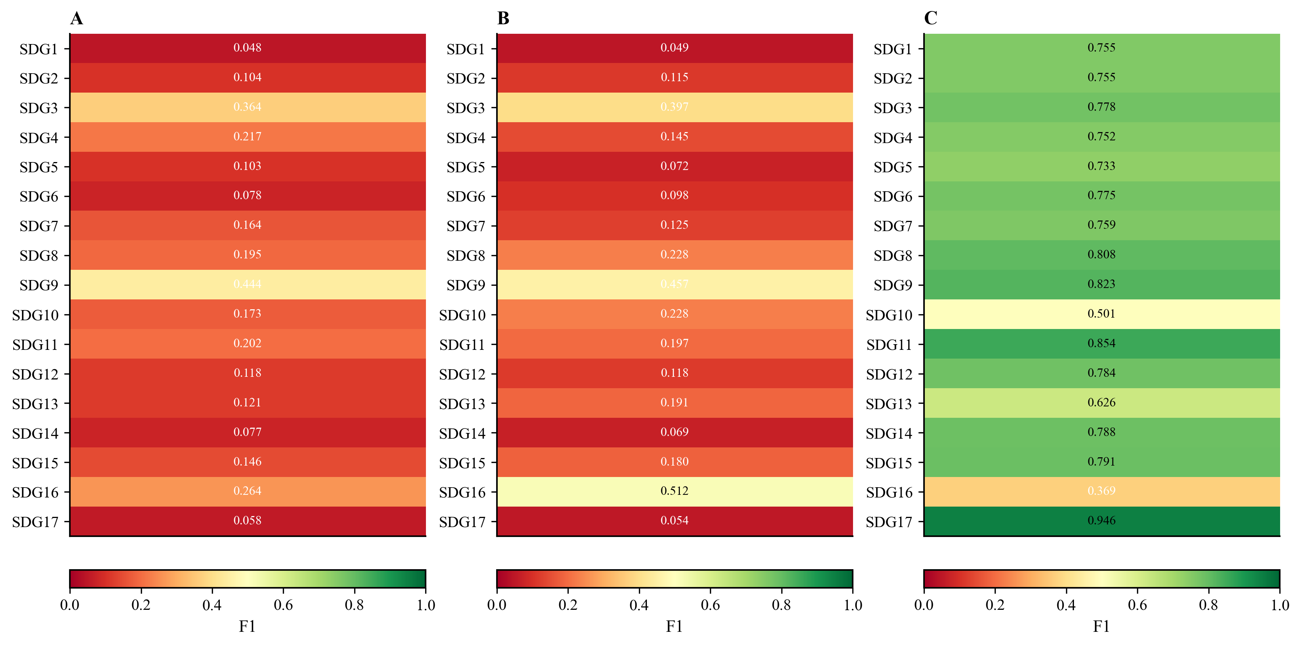
Figure S2A. Per-SDG F1 heatmap for decision-level alignment. Panel A reports LLM vs Aurora; Panel B reports LLM vs Elsevier; Panel C reports Aurora vs Elsevier.

Table S2A. Full per-SDG classification metrics at the main threshold.
SDG | Aurora support | Precision (L,A) | Recall (L,A) | F1 (L,A) | Elsevier support | Precision (L,E) | Recall (L,E) | F1 (L,E) | F1 (A,E) | LLM positive count
SDG1 | 1,120,315 | 0.9677 | 0.0248 | 0.0483 | 1,136,305 | 0.9858 | 0.0249 | 0.0485 | 0.7552 | 28,665
SDG2 | 1,205,477 | 0.9227 | 0.0553 | 0.1044 | 1,162,611 | 0.9802 | 0.0609 | 0.1148 | 0.7553 | 72,287
SDG3 | 1,442,158 | 0.9524 | 0.2248 | 0.3638 | 1,165,391 | 0.8775 | 0.2563 | 0.3968 | 0.7777 | 340,454
SDG4 | 987,692 | 0.9677 | 0.1222 | 0.2170 | 1,587,790 | 0.9956 | 0.0782 | 0.1450 | 0.7518 | 124,708
SDG5 | 962,385 | 0.9496 | 0.0544 | 0.1029 | 1,453,930 | 0.9908 | 0.0375 | 0.0724 | 0.7333 | 55,100
SDG6 | 1,344,071 | 0.9645 | 0.0407 | 0.0781 | 1,078,846 | 0.9813 | 0.0516 | 0.0980 | 0.7750 | 56,713
SDG7 | 1,035,185 | 0.9008 | 0.0902 | 0.1639 | 1,543,630 | 0.9965 | 0.0669 | 0.1254 | 0.7590 | 103,622
SDG8 | 1,418,335 | 0.9666 | 0.1083 | 0.1948 | 1,179,647 | 0.9621 | 0.1296 | 0.2285 | 0.8077 | 158,937
SDG9 | 1,385,706 | 0.8643 | 0.2985 | 0.4438 | 1,237,733 | 0.8194 | 0.3169 | 0.4570 | 0.8233 | 478,613
SDG10 | 1,291,169 | 0.9221 | 0.0952 | 0.1726 | 503,666 | 0.5438 | 0.1439 | 0.2276 | 0.5008 | 133,289
SDG11 | 1,281,442 | 0.9150 | 0.1138 | 0.2025 | 1,423,605 | 0.9788 | 0.1096 | 0.1972 | 0.8538 | 159,430
SDG12 | 1,230,264 | 0.9683 | 0.0630 | 0.1182 | 1,219,917 | 0.9600 | 0.0630 | 0.1182 | 0.7837 | 79,992
SDG13 | 1,294,343 | 0.9558 | 0.0644 | 0.1207 | 734,592 | 0.9015 | 0.1070 | 0.1914 | 0.6255 | 87,216
SDG14 | 1,165,693 | 0.9493 | 0.0399 | 0.0765 | 1,366,417 | 0.9940 | 0.0356 | 0.0688 | 0.7883 | 48,971
SDG15 | 1,393,147 | 0.9813 | 0.0789 | 0.1461 | 1,100,155 | 0.9739 | 0.0992 | 0.1800 | 0.7911 | 112,033
SDG16 | 1,411,555 | 0.9461 | 0.1535 | 0.2641 | 345,926 | 0.6430 | 0.4257 | 0.5122 | 0.3690 | 229,013
SDG17 | 1,580,461 | 0.9922 | 0.0300 | 0.0583 | 1,713,679 | 0.9992 | 0.0279 | 0.0542 | 0.9464 | 47,815

S2.2 Threshold-Sensitivity Analysis
Figure S2B and Table S2D directly test whether this compression is driven by the choice of threshold. The answer is yes: when the threshold is lowered from 3 to 1, macro F1 increases from 0.169/0.190 to 0.366/0.375, and mean Jaccard rises from 0.097/0.093 to 0.230/0.217; conversely, when the threshold is raised to 4, all indicators decline further.
The main-text choice of score >= 3 is therefore not an arbitrarily selected failure case, but a substantive test of the conservative decision rule of retaining only high-confidence positives.
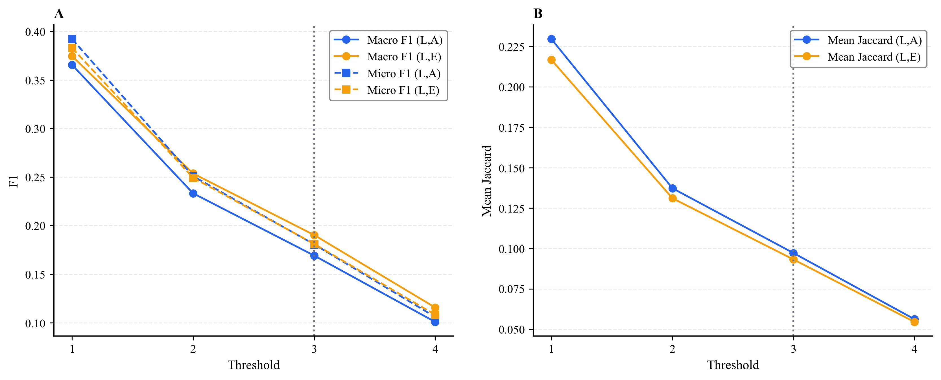
Figure S2B. Sensitivity of decision-level alignment to the binarization threshold. Panel A reports macro and micro F1 across thresholds; Panel B reports mean document-level Jaccard across thresholds.
Table S2D. Threshold sensitivity of decision-level alignment metrics.
Threshold | Macro F1 (L,A) | Macro F1 (L,E) | Micro F1 (L,A) | Micro F1 (L,E) | Macro Precision (L,A) | Macro Recall (L,A) | Macro Precision (L,E) | Macro Recall (L,E) | Mean Jaccard (L,A) | Mean Jaccard (L,E)
1 | 0.3655 | 0.3746 | 0.3922 | 0.3830 | 0.8879 | 0.2454 | 0.8536 | 0.2821 | 0.2296 | 0.2167
2 | 0.2333 | 0.2537 | 0.2509 | 0.2493 | 0.9314 | 0.1413 | 0.8994 | 0.1701 | 0.1373 | 0.1311
3 | 0.1692 | 0.1903 | 0.1808 | 0.1812 | 0.9463 | 0.0975 | 0.9167 | 0.1197 | 0.0972 | 0.0932
4 | 0.1008 | 0.1157 | 0.1060 | 0.1082 | 0.9601 | 0.0552 | 0.9313 | 0.0666 | 0.0562 | 0.0545

S2.3 Document-Level Overlap Stratified by Year and Field
Tables S2B and S2C supplement the document-level Jaccard results with year- and field-level stratification. Over time, overlap between the LLM and the rule-based systems increases only slowly, and the median remains near 0.0833 for a long period; across fields, Jaccard is relatively higher in Political science, Environmental science, Geography, and Business, and lowest in Philosophy, Physics, Mathematics, and Art.
Table S2B. Year-wise document-level Jaccard overlap.
Year | Mean Jaccard (L,A) | Median Jaccard (L,A) | Mean Jaccard (L,E) | Median Jaccard (L,E) | Mean Jaccard (A,E) | Median Jaccard (A,E)
2015 | 0.0938 | 0.0769 | 0.0891 | 0.0833 | 0.5515 | 0.5625
2016 | 0.0949 | 0.0833 | 0.0901 | 0.0833 | 0.5547 | 0.5625
2017 | 0.0959 | 0.0833 | 0.0911 | 0.0833 | 0.5596 | 0.5714
2018 | 0.0965 | 0.0833 | 0.0923 | 0.0833 | 0.5655 | 0.5714
2019 | 0.0966 | 0.0833 | 0.0922 | 0.0833 | 0.5706 | 0.5882
2020 | 0.0978 | 0.0833 | 0.0936 | 0.0833 | 0.5806 | 0.5882
2021 | 0.0976 | 0.0833 | 0.0942 | 0.0833 | 0.5840 | 0.5882
2022 | 0.0985 | 0.0833 | 0.0952 | 0.0833 | 0.5969 | 0.6154
2023 | 0.0981 | 0.0833 | 0.0957 | 0.0833 | 0.6054 | 0.6250
2024 | 0.1018 | 0.0833 | 0.0984 | 0.0909 | 0.6174 | 0.6471
Table S2C. Field-wise document-level Jaccard overlap.
Field | Mean Jaccard (L,A) | Median Jaccard (L,A) | Mean Jaccard (L,E) | Median Jaccard (L,E) | Mean Jaccard (A,E) | Median Jaccard (A,E)
Political science | 0.1382 | 0.1250 | 0.1162 | 0.1176 | 0.6941 | 0.7273
Environmental science | 0.1364 | 0.1250 | 0.1372 | 0.1333 | 0.6981 | 0.7333
Geography | 0.1304 | 0.1176 | 0.1237 | 0.1176 | 0.6954 | 0.7333
Business | 0.1294 | 0.1250 | 0.1244 | 0.1250 | 0.7665 | 0.8125
Sociology | 0.1243 | 0.1176 | 0.1020 | 0.0909 | 0.5990 | 0.6154
Engineering | 0.1198 | 0.1176 | 0.1345 | 0.1333 | 0.5741 | 0.5882
Economics | 0.1184 | 0.1176 | 0.1097 | 0.1111 | 0.7230 | 0.7647
Materials science | 0.0968 | 0.0909 | 0.1068 | 0.1000 | 0.5079 | 0.5294
Medicine | 0.0934 | 0.0769 | 0.0822 | 0.0769 | 0.5959 | 0.6250
Psychology | 0.0917 | 0.0769 | 0.0924 | 0.0833 | 0.5958 | 0.6000
Computer science | 0.0897 | 0.0769 | 0.0979 | 0.0909 | 0.5604 | 0.5714
History | 0.0881 | 0.0769 | 0.0681 | 0.0667 | 0.4791 | 0.4706
Biology | 0.0863 | 0.0714 | 0.0814 | 0.0769 | 0.5888 | 0.6000
Chemistry | 0.0849 | 0.0714 | 0.0811 | 0.0769 | 0.5346 | 0.5625
Geology | 0.0770 | 0.0714 | 0.0762 | 0.0769 | 0.5287 | 0.5333
Art | 0.0662 | 0.0000 | 0.0587 | 0.0000 | 0.4352 | 0.4286
Mathematics | 0.0445 | 0.0000 | 0.0457 | 0.0000 | 0.4279 | 0.4167
Physics | 0.0390 | 0.0000 | 0.0426 | 0.0000 | 0.4035 | 0.4000
Philosophy | 0.0360 | 0.0000 | 0.0277 | 0.0000 | 0.3653 | 0.3333

Supplementary Results for RQ3
This section supplements RQ3 with the full aggregate metrics, structural profiles, and sources of heterogeneity in order to support the main-text interpretation that the LLM preserves relative structure while compressing absolute scale.

S3.1 Full Summary Metrics across Aggregation Levels
Table S3A summarizes coverage, label density, MAE, RMSE, and JSD across the three aggregation levels of year, field, and country. It provides the numerical basis for the overall judgment presented in Figure 3 of the main text.
Table S3A. Full aggregate-level summary metrics across year, field, and country.
Level | coverage_llm | coverage_aurora | coverage_elsevier | density_llm | density_aurora | density_elsevier | mae_la | mae_le | mae_ae | rmse_la | rmse_le | rmse_ae | jsd_la | jsd_le | jsd_ae
Year | 0.8228 | 1.0 | 1.0 | 1.3091 | 12.1772 | 11.2756 | 0.6393 | 0.5863 | 0.1924 | 0.6459 | 0.6264 | 0.25 | 0.2916 | 0.3645 | 0.1696
Field | 0.7974 | 1.0 | 1.0 | 1.2598 | 11.965 | 11.071 | 0.6302 | 0.5792 | 0.2055 | 0.6455 | 0.6275 | 0.2619 | 0.5405 | 0.562 | 0.1943
Country | 0.8246 | 1.0 | 1.0 | 1.3236 | 12.2343 | 11.3477 | 0.6418 | 0.5897 | 0.192 | 0.6492 | 0.6303 | 0.2492 | 0.3239 | 0.3884 | 0.1702

S3.2 Differences in Overall SDG Profiles
Figure S3A shows the SDG frequency distribution of the three methods across the full sample. In line with the aggregate indicators in the main text, it most directly displays the concentration of LLM labels and the compression of the absolute scale.
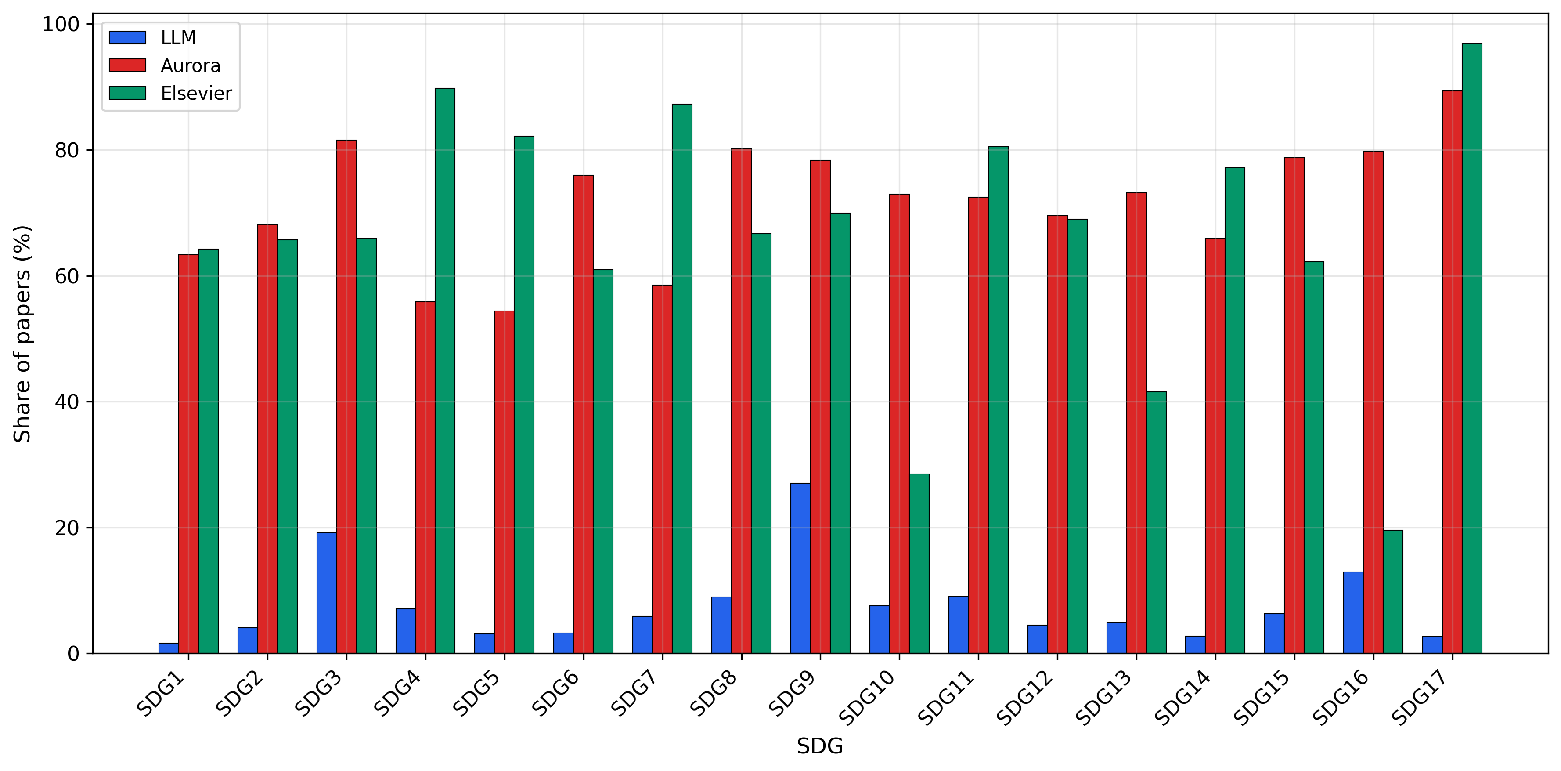
Figure S3A. Overall SDG frequency distribution across the three systems.

S3.3 Additional Temporal Diagnostics
Figure S3B further shows the temporal evolution of coverage and label density. It indicates that LLM outputs are not static, but expand slowly over 2015-2024, while still remaining substantially below Aurora and Elsevier even at the end of the period.
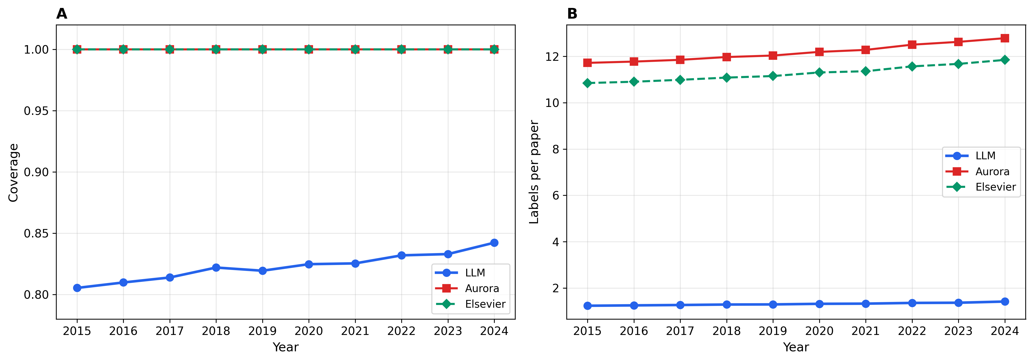
Figure S3B. Year-wise coverage and label density trends. Panel A reports coverage over time; Panel B reports label density over time.

S3.4 Field-Level Heterogeneity
Figure S3C and Table S3B report the full field-level heterogeneity. Geography, Business, and Economics are closer to Aurora in compositional structure, whereas Medicine, Physics, and Materials science show the largest deviations.
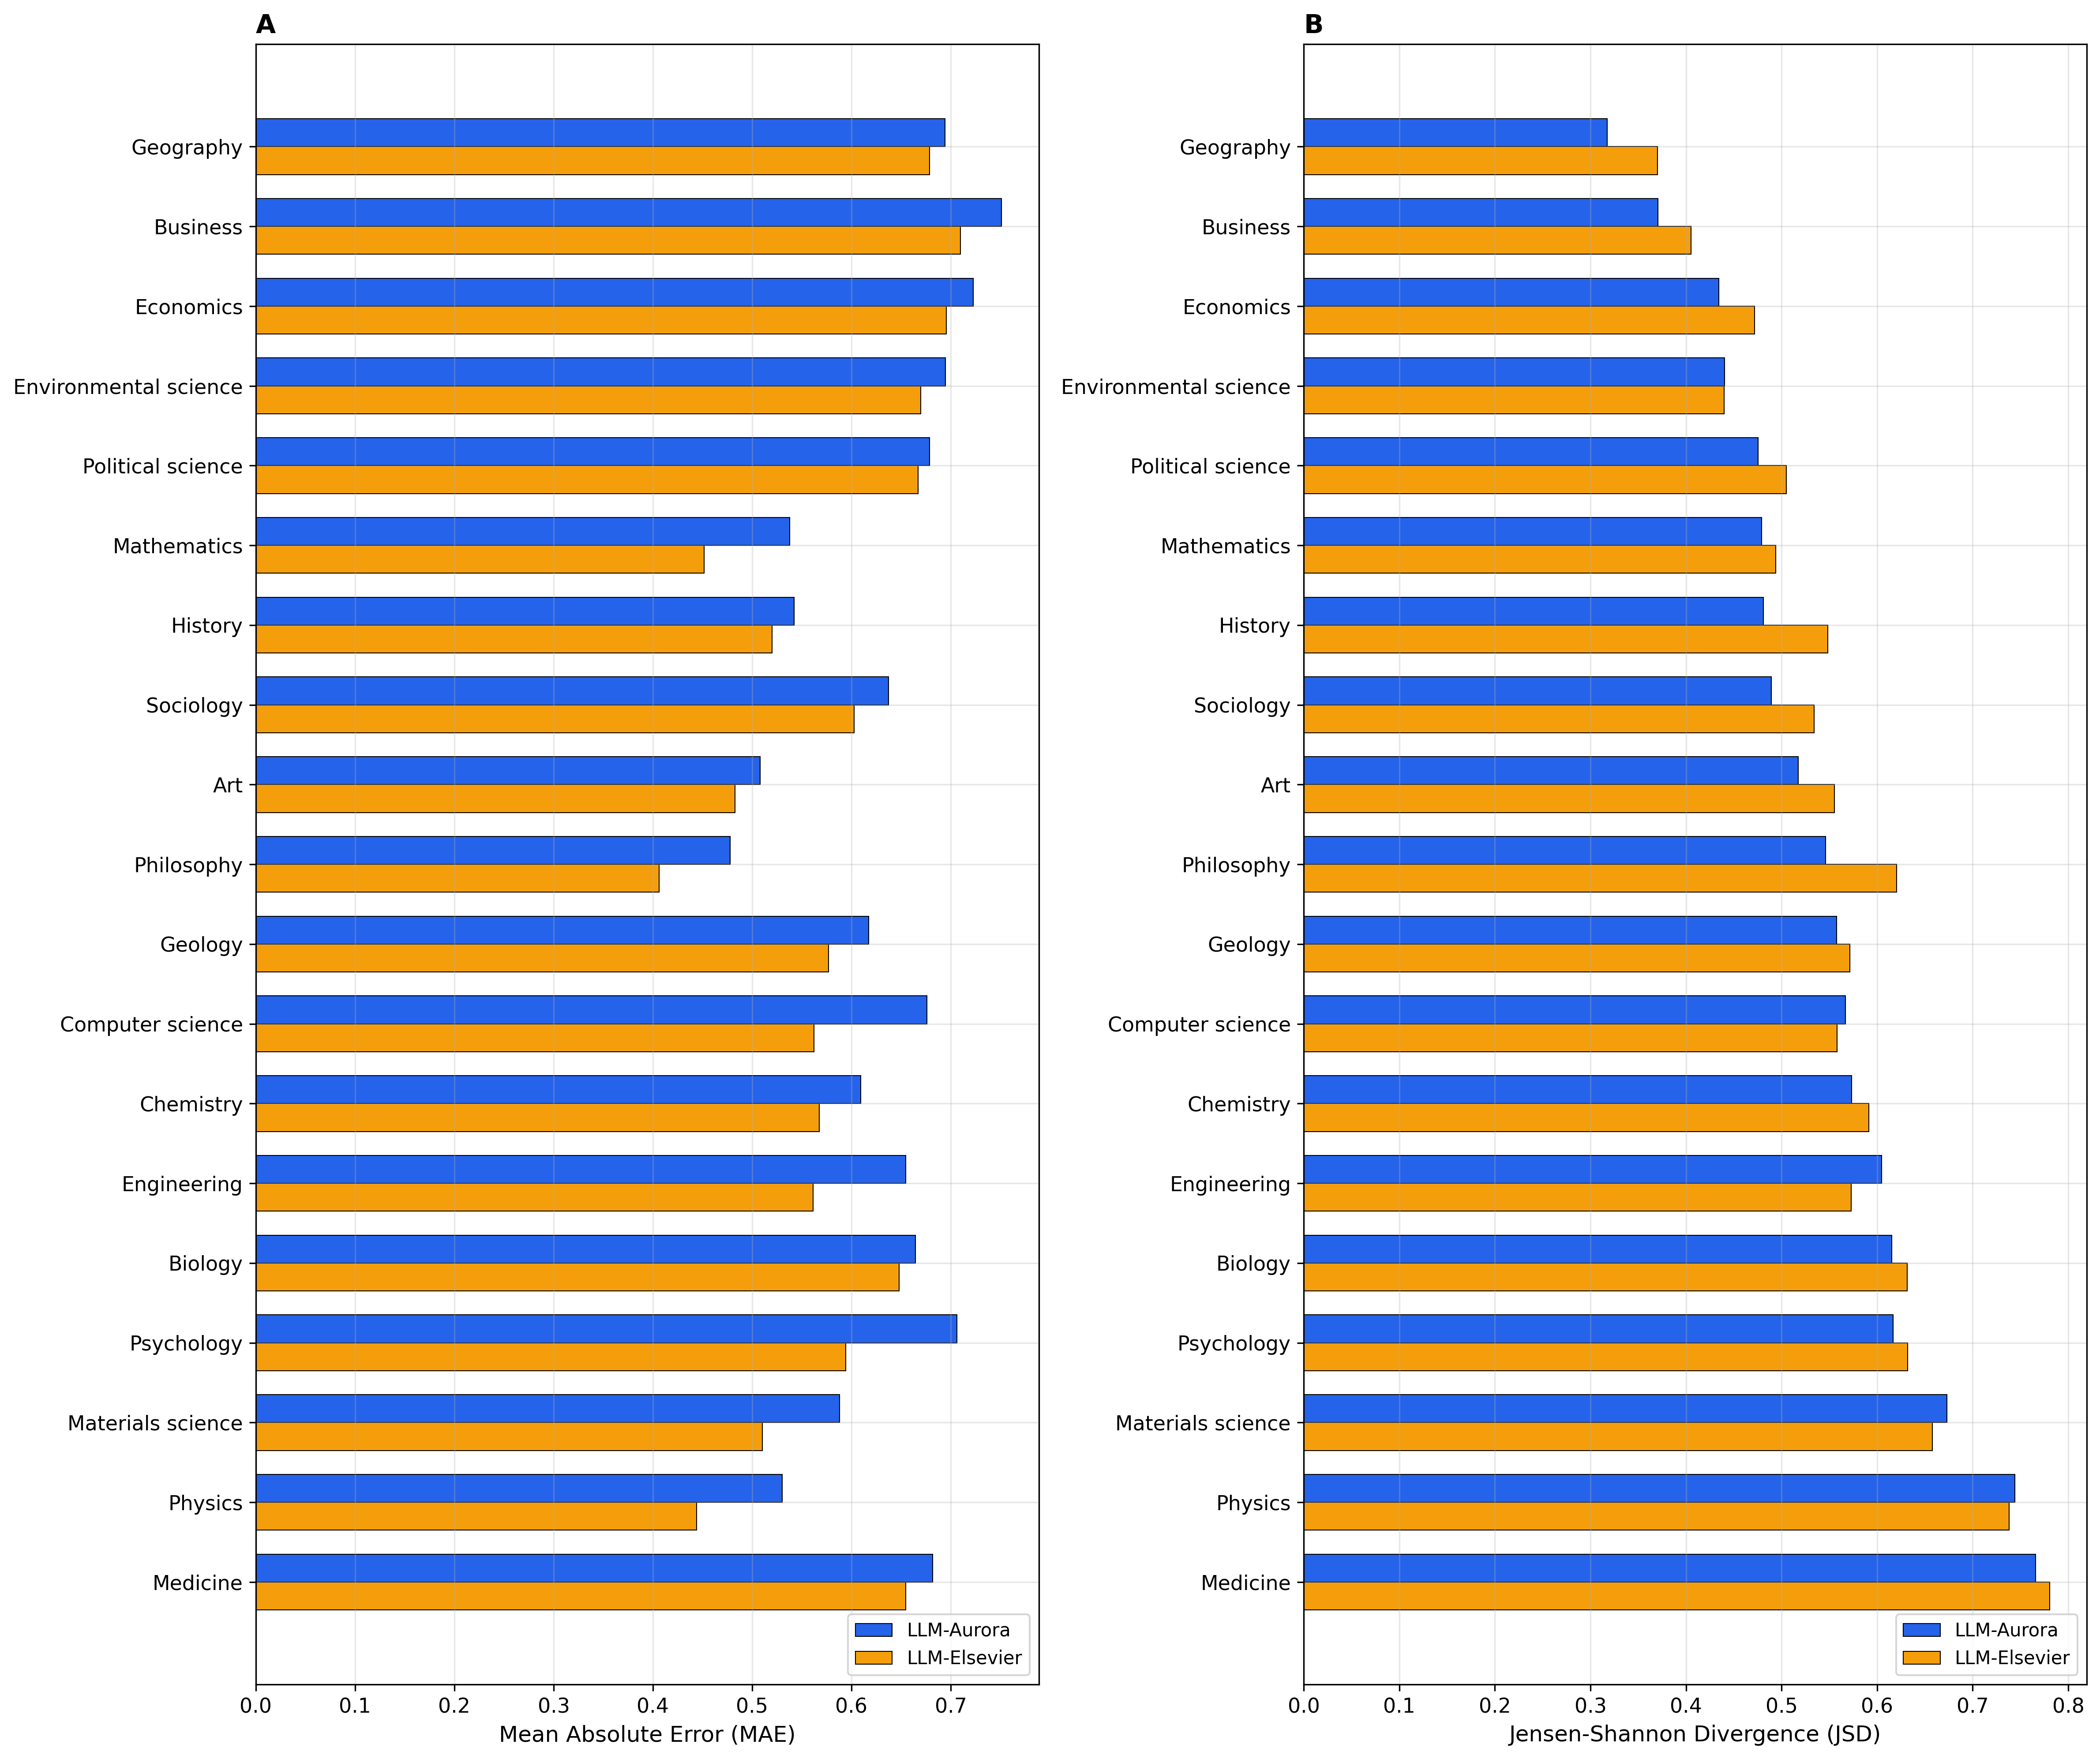
Figure S3C. Field-level comparison of prevalence mismatch and composition divergence. Panel A reports prevalence mismatch (MAE); Panel B reports composition divergence (JSD).

Table S3B. Most and least aligned fields by LLM-Aurora composition distance.
Group | Field | Coverage LLM | Density LLM | JSD L-A | JSD L-E
Most aligned | Geography | 0.9627 | 1.7722 | 0.3176 | 0.3704
Most aligned | Business | 0.9341 | 1.9818 | 0.3705 | 0.4053
Most aligned | Economics | 0.8794 | 1.7247 | 0.4344 | 0.4719
Most aligned | Environmental science | 0.9721 | 1.9533 | 0.4405 | 0.4397
Most aligned | Political science | 0.9835 | 1.8891 | 0.4757 | 0.5049
Least aligned | Medicine | 0.9902 | 1.1122 | 0.7657 | 0.7804
Least aligned | Physics | 0.4673 | 0.5288 | 0.7442 | 0.738
Least aligned | Materials science | 0.9061 | 1.3061 | 0.6732 | 0.6579
Least aligned | Psychology | 0.8955 | 1.2637 | 0.6166 | 0.6319
Least aligned | Biology | 0.8793 | 1.0208 | 0.6153 | 0.6316

S3.5 Country-Level Heterogeneity
Figure S3D and Table S3C show that country-level differences are milder than field-level differences, but are not random fluctuations. Groups such as South Africa, Other, and Nigeria are closer to Aurora, whereas Taiwan, Japan, Korea, China, and Iran show larger deviations.
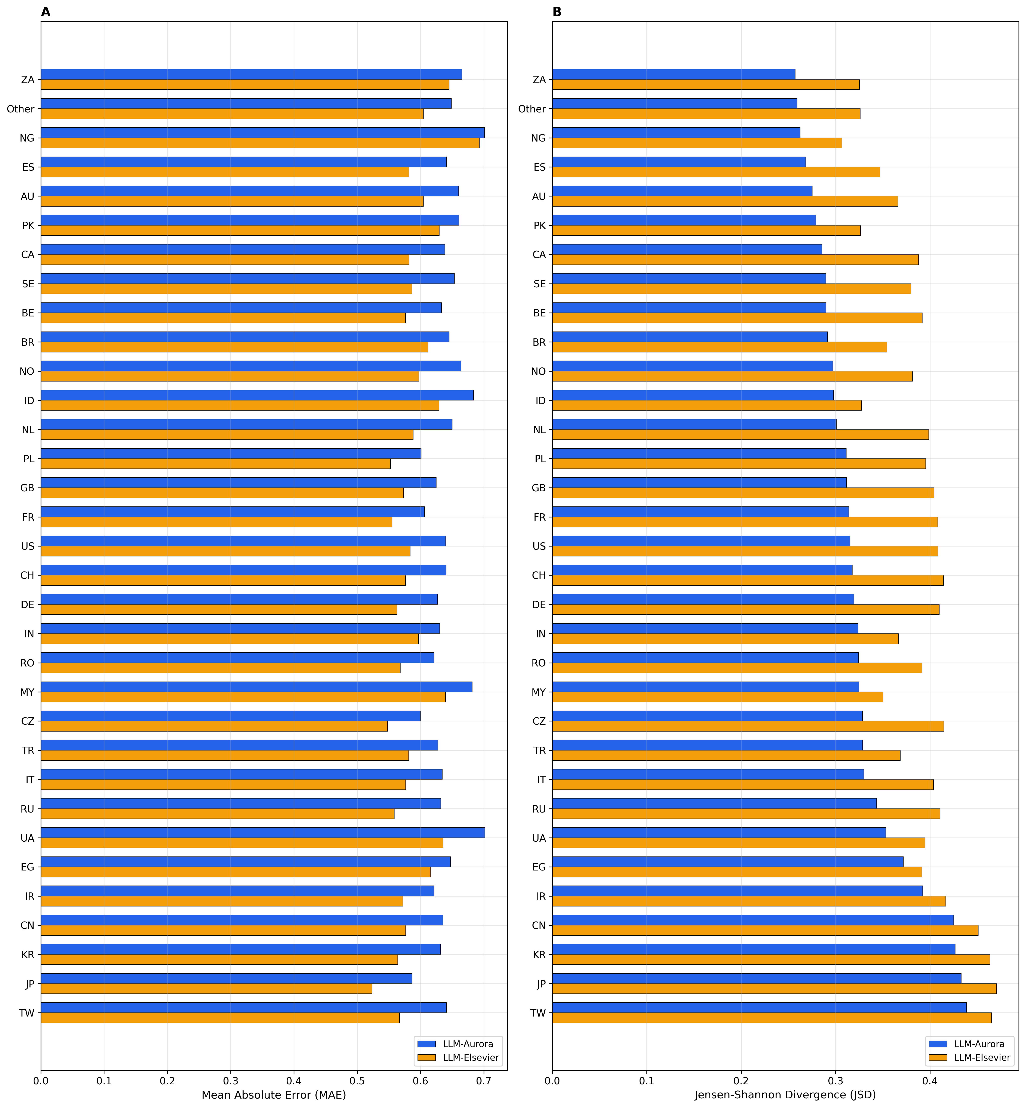
Figure S3D. Country-level comparison of prevalence mismatch and composition divergence. Panel A reports prevalence mismatch (MAE); Panel B reports composition divergence (JSD).

Table S3C. Most and least aligned countries by LLM-Aurora composition distance.
Group | Country | Coverage LLM | Density LLM | JSD L-A | JSD L-E
Most aligned | ZA | 0.8576 | 1.6263 | 0.2572 | 0.3253
Most aligned | Other | 0.8346 | 1.3847 | 0.2593 | 0.326
Most aligned | NG | 0.9158 | 1.6408 | 0.2624 | 0.3067
Most aligned | ES | 0.7996 | 1.2893 | 0.2684 | 0.347
Most aligned | AU | 0.8479 | 1.4454 | 0.2753 | 0.366
Least aligned | TW | 0.8512 | 1.2002 | 0.4386 | 0.4653
Least aligned | JP | 0.7755 | 1.0904 | 0.433 | 0.4704
Least aligned | KR | 0.8715 | 1.2715 | 0.4267 | 0.4634
Least aligned | CN | 0.8448 | 1.2431 | 0.4251 | 0.4511
Least aligned | IR | 0.8404 | 1.24 | 0.3922 | 0.4168

S3.6 Which SDGs Drive Macro-Level Heterogeneity
Figure S3E directly ranks the variance of LLM prevalence at the country level. The results show that macro-level heterogeneity is concentrated mainly in a small number of highly salient goals, especially SDG9, SDG16, and SDG3, rather than being evenly dispersed across all 17 SDGs.
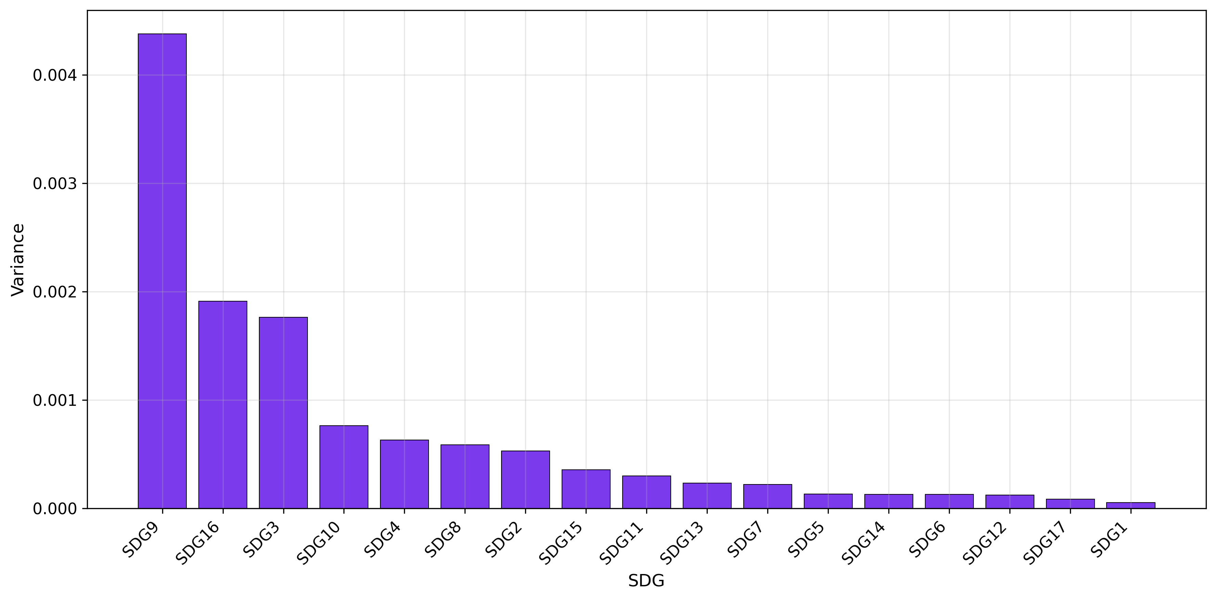
Figure S3E. SDGs driving cross-country heterogeneity in LLM aggregate prevalence.

Supplementary Results for RQ4
This section supplements the main-text RQ4 results with robustness checks for behavior classification, full regression results, relative-preference distributions across fields and countries, and model diagnostics.

S4.1 Robustness of Behavior Classification
Figure S4A and Table S4F show that after changing the behavior metric (F1 vs Jaccard) or the width of the middle interval ($δ$= 0.05 vs 0.10), middle still remains the overwhelmingly dominant category.
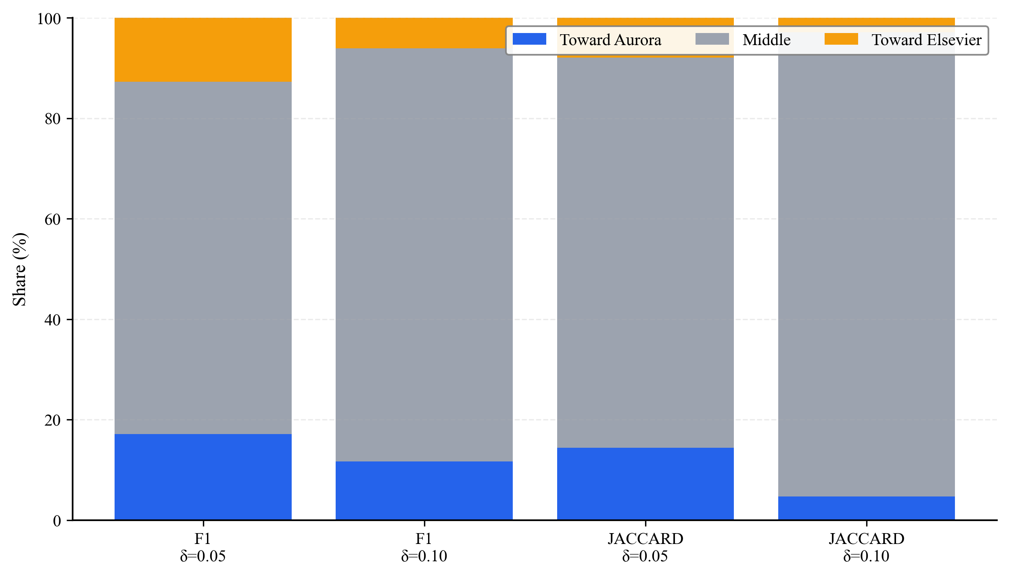
Figure S4A. Sensitivity of behavior classification to the metric and delta threshold. Each stacked bar reports the shares of toward Aurora, middle, and toward Elsevier under one metric-threshold specification.

Table S4F. Sensitivity of behavior shares to the metric and delta threshold.
Metric | Delta threshold | Toward Aurora share | Middle share | Toward Elsevier share | Sample size
f1 | 0.05 | 0.1713 | 0.7009 | 0.1277 | 1769169
f1 | 0.1 | 0.1170 | 0.8223 | 0.0607 | 1769169
jaccard | 0.05 | 0.1440 | 0.7765 | 0.0795 | 1769169
jaccard | 0.1 | 0.0474 | 0.9240 | 0.0286 | 1769169

S4.2 Full Regression Results and Robustness Checks
Table S4A reports the complete main effects from the joint F1 model, Table S4B reports the full field interactions, and Table S4C compares the robustness of key coefficients under the joint Jaccard model. Together, these three results point to the same conclusion: rule disagreement (d_{JS}) is consistently the strongest negative factor, whereas LLM SDG count is consistently the strongest positive factor.
Table S4A. Complete main effects from the joint F1 model.
Variable | Coefficient | SE | 95% CI lower | 95% CI upper | p-value | Sig.
const | -1.9522 | 0.0053 | -1.9626 | -1.9417 | 0.0000 | ***
Elsevier reference indicator (D_{m}) | -0.0312 | 0.0069 | -0.0448 | -0.0176 | 0.0000 | ***
Publication year (centered) | -0.0004 | 0.0001 | -0.0007 | -0.0001 | 0.0086 | **
Log abstract length (centered) | -0.0528 | 0.0011 | -0.0550 | -0.0506 | 0.0000 | ***
LLM score entropy (centered) | 0.0169 | 0.0007 | 0.0155 | 0.0184 | 0.0000 | ***
LLM SDG count (centered) | 0.6900 | 0.0008 | 0.6884 | 0.6915 | 0.0000 | ***
Rule disagreement (d_{JS}, centered) | -0.4221 | 0.0057 | -0.4333 | -0.4108 | 0.0000 | ***
Reference SDG count (centered) | -0.0521 | 0.0003 | -0.0527 | -0.0515 | 0.0000 | ***
level0_concept_id_Biology | 0.3562 | 0.0050 | 0.3465 | 0.3660 | 0.0000 | ***
level0_concept_id_Business | 0.0771 | 0.0049 | 0.0675 | 0.0867 | 0.0000 | ***
level0_concept_id_Chemistry | 0.2077 | 0.0050 | 0.1978 | 0.2176 | 0.0000 | ***
level0_concept_id_Computer science | 0.2677 | 0.0049 | 0.2581 | 0.2773 | 0.0000 | ***
level0_concept_id_Economics | 0.1166 | 0.0049 | 0.1070 | 0.1262 | 0.0000 | ***
level0_concept_id_Engineering | 0.2827 | 0.0049 | 0.2731 | 0.2922 | 0.0000 | ***
level0_concept_id_Environmental science | 0.2328 | 0.0048 | 0.2233 | 0.2422 | 0.0000 | ***
level0_concept_id_Geography | 0.2422 | 0.0050 | 0.2325 | 0.2519 | 0.0000 | ***
level0_concept_id_Geology | 0.1425 | 0.0050 | 0.1326 | 0.1523 | 0.0000 | ***
level0_concept_id_History | 0.0565 | 0.0054 | 0.0460 | 0.0669 | 0.0000 | ***
level0_concept_id_Materials science | 0.2632 | 0.0050 | 0.2535 | 0.2730 | 0.0000 | ***
level0_concept_id_Mathematics | -0.2231 | 0.0057 | -0.2343 | -0.2119 | 0.0000 | ***
level0_concept_id_Medicine | 0.4060 | 0.0049 | 0.3965 | 0.4155 | 0.0000 | ***
level0_concept_id_Philosophy | -0.5041 | 0.0091 | -0.5218 | -0.4863 | 0.0000 | ***
level0_concept_id_Physics | -0.2550 | 0.0060 | -0.2668 | -0.2433 | 0.0000 | ***
level0_concept_id_Political science | 0.1494 | 0.0049 | 0.1398 | 0.1591 | 0.0000 | ***
level0_concept_id_Psychology | 0.2731 | 0.0049 | 0.2635 | 0.2827 | 0.0000 | ***
level0_concept_id_Sociology | 0.1522 | 0.0049 | 0.1425 | 0.1618 | 0.0000 | ***
country_group_BE | -0.0035 | 0.0061 | -0.0154 | 0.0085 | 0.5703
country_group_BR | 0.0529 | 0.0038 | 0.0455 | 0.0604 | 0.0000 | ***
country_group_CA | -0.0138 | 0.0038 | -0.0212 | -0.0064 | 0.0003 | ***
country_group_CH | -0.0049 | 0.0055 | -0.0156 | 0.0058 | 0.3703
country_group_CN | 0.0495 | 0.0029 | 0.0438 | 0.0551 | 0.0000 | ***
country_group_CZ | 0.0298 | 0.0064 | 0.0173 | 0.0423 | 0.0000 | ***
country_group_DE | -0.0186 | 0.0036 | -0.0256 | -0.0116 | 0.0000 | ***
country_group_EG | 0.0718 | 0.0048 | 0.0623 | 0.0812 | 0.0000 | ***
country_group_ES | 0.0184 | 0.0039 | 0.0107 | 0.0261 | 0.0000 | ***
country_group_FR | -0.0450 | 0.0045 | -0.0538 | -0.0361 | 0.0000 | ***
country_group_GB | -0.0084 | 0.0032 | -0.0147 | -0.0020 | 0.0100 | **
country_group_ID | 0.1032 | 0.0032 | 0.0969 | 0.1095 | 0.0000 | ***
country_group_IN | 0.0602 | 0.0032 | 0.0539 | 0.0666 | 0.0000 | ***
country_group_IR | 0.0796 | 0.0043 | 0.0712 | 0.0879 | 0.0000 | ***
country_group_IT | 0.0170 | 0.0036 | 0.0099 | 0.0242 | 0.0000 | ***
country_group_JP | 0.0025 | 0.0039 | -0.0051 | 0.0101 | 0.5171
country_group_KR | 0.0668 | 0.0039 | 0.0591 | 0.0745 | 0.0000 | ***
country_group_MY | 0.0802 | 0.0041 | 0.0721 | 0.0883 | 0.0000 | ***
country_group_NG | 0.0403 | 0.0043 | 0.0319 | 0.0487 | 0.0000 | ***
country_group_NL | -0.0081 | 0.0044 | -0.0168 | 0.0006 | 0.0675 | .
country_group_NO | 0.0189 | 0.0053 | 0.0085 | 0.0294 | 0.0004 | ***
country_group_Other | 0.0307 | 0.0028 | 0.0251 | 0.0362 | 0.0000 | ***
country_group_PK | 0.0329 | 0.0050 | 0.0232 | 0.0426 | 0.0000 | ***
country_group_PL | 0.0317 | 0.0041 | 0.0236 | 0.0397 | 0.0000 | ***
country_group_RO | 0.0310 | 0.0058 | 0.0196 | 0.0423 | 0.0000 | ***
country_group_RU | 0.0106 | 0.0035 | 0.0037 | 0.0176 | 0.0026 | **
country_group_SE | 0.0033 | 0.0049 | -0.0062 | 0.0129 | 0.4930
country_group_TR | 0.0843 | 0.0041 | 0.0763 | 0.0924 | 0.0000 | ***
country_group_TW | 0.0719 | 0.0052 | 0.0617 | 0.0822 | 0.0000 | ***
country_group_UA | -0.0003 | 0.0047 | -0.0095 | 0.0089 | 0.9515
country_group_US | -0.0022 | 0.0028 | -0.0077 | 0.0034 | 0.4436
country_group_Unknown | 0.0611 | 0.0047 | 0.0519 | 0.0704 | 0.0000 | ***
country_group_ZA | -0.0114 | 0.0046 | -0.0203 | -0.0024 | 0.0131 | *
Table S4B. Complete field interactions from the joint F1 model.
Variable | Coefficient | SE | 95% CI lower | 95% CI upper | p-value | Sig.
Physics × D_{m} | 0.1292 | 0.0078 | 0.1140 | 0.1444 | 0.0000 | ***
Materials science × D_{m} | 0.1235 | 0.0067 | 0.1104 | 0.1367 | 0.0000 | ***
Engineering × D_{m} | 0.1126 | 0.0065 | 0.0998 | 0.1254 | 0.0000 | ***
Mathematics × D_{m} | 0.0559 | 0.0070 | 0.0422 | 0.0697 | 0.0000 | ***
Computer science × D_{m} | 0.0526 | 0.0065 | 0.0398 | 0.0654 | 0.0000 | ***
Geology × D_{m} | 0.0184 | 0.0066 | 0.0054 | 0.0313 | 0.0056 | **
Environmental science × D_{m} | 0.0095 | 0.0063 | -0.0028 | 0.0219 | 0.1316
Chemistry × D_{m} | -0.0051 | 0.0067 | -0.0182 | 0.0080 | 0.4444
Biology × D_{m} | -0.0102 | 0.0065 | -0.0229 | 0.0026 | 0.1184
Psychology × D_{m} | -0.0419 | 0.0065 | -0.0545 | -0.0292 | 0.0000 | ***
Geography × D_{m} | -0.0490 | 0.0064 | -0.0615 | -0.0366 | 0.0000 | ***
Business × D_{m} | -0.0915 | 0.0063 | -0.1040 | -0.0791 | 0.0000 | ***
Economics × D_{m} | -0.1008 | 0.0064 | -0.1133 | -0.0884 | 0.0000 | ***
Medicine × D_{m} | -0.1151 | 0.0065 | -0.1279 | -0.1023 | 0.0000 | ***
Philosophy × D_{m} | -0.1632 | 0.0110 | -0.1847 | -0.1417 | 0.0000 | ***
History × D_{m} | -0.1836 | 0.0072 | -0.1977 | -0.1695 | 0.0000 | ***
Sociology × D_{m} | -0.2009 | 0.0066 | -0.2138 | -0.1880 | 0.0000 | ***
Political science × D_{m} | -0.2056 | 0.0065 | -0.2184 | -0.1927 | 0.0000 | ***
Table S4C. Robustness of key coefficients across joint F1 and joint Jaccard models.
Model | Variable | Coefficient | SE | Sig.
Joint F1 | Elsevier reference indicator (D_{m}) | -0.0312 | 0.0069 | ***
Joint Jaccard | Elsevier reference indicator (D_{m}) | -0.0346 | 0.0078 | ***
Joint F1 | Rule disagreement (d_{JS}, centered) | -0.4221 | 0.0057 | ***
Joint Jaccard | Rule disagreement (d_{JS}, centered) | -0.4817 | 0.0072 | ***
Joint F1 | LLM SDG count (centered) | 0.6900 | 0.0008 | ***
Joint Jaccard | LLM SDG count (centered) | 0.6340 | 0.0009 | ***
Joint F1 | LLM score entropy (centered) | 0.0169 | 0.0007 | ***
Joint Jaccard | LLM score entropy (centered) | 0.0291 | 0.0008 | ***
Joint F1 | Log abstract length (centered) | -0.0528 | 0.0011 | ***
Joint Jaccard | Log abstract length (centered) | -0.0692 | 0.0012 | ***
Joint F1 | Publication year (centered) | -0.0004 | 0.0001 | **
Joint Jaccard | Publication year (centered) | -0.0001 | 0.0001
Joint F1 | Reference SDG count (centered) | -0.0521 | 0.0003 | ***
Joint Jaccard | Reference SDG count (centered) | -0.0640 | 0.0004 | ***

S4.3 Relative Preference across Fields and Countries
Figure S4B and Table S4D express relative preference as the model-implied mean predicted difference (${\hat{y}}^{A}$ minus ${\hat{y}}^{E}$). The results are consistent with the main-text observations: Political science, Sociology, and History lie closer to Aurora, whereas Engineering, Materials science, and Computer science lie closer to Elsevier.
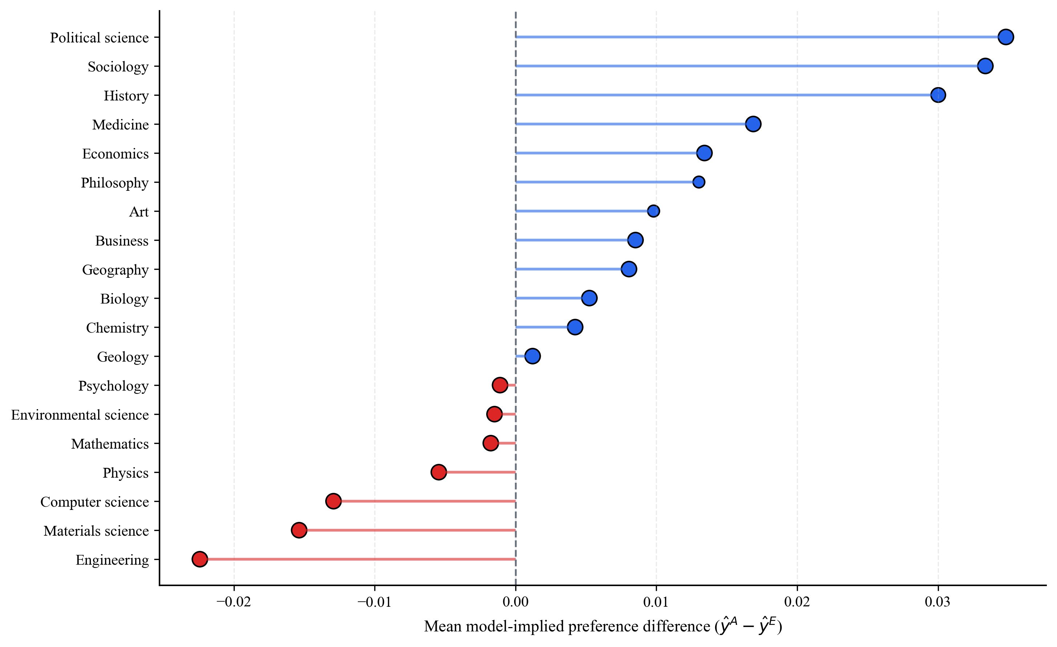
Figure S4B. Model-implied relative preference by field. Positive values indicate a model-implied shift toward Aurora; negative values indicate a shift toward Elsevier.

Table S4D. Model-implied relative preference by field.
Field | Mean delta_hat | Median delta_hat | Prefer Aurora % | Neutral % | Prefer Elsevier % | Sample size
Political science | 0.0348 | 0.0293 | 24.05 | 75.95 | 0.00 | 99988
Sociology | 0.0334 | 0.0267 | 23.99 | 76.01 | 0.00 | 99986
History | 0.0300 | 0.0238 | 19.91 | 80.09 | 0.00 | 87125
Medicine | 0.0169 | 0.0103 | 12.50 | 87.49 | 0.01 | 99994
Economics | 0.0134 | 0.0086 | 6.35 | 93.64 | 0.01 | 99999
Philosophy | 0.0130 | 0.0109 | 1.94 | 98.06 | 0.00 | 40305
Art | 0.0098 | 0.0063 | 4.79 | 95.17 | 0.04 | 42110
Business | 0.0085 | 0.0047 | 3.68 | 96.32 | 0.01 | 99994
Geography | 0.0081 | 0.0026 | 6.70 | 93.26 | 0.04 | 99993
Biology | 0.0052 | -0.0000 | 6.12 | 93.79 | 0.10 | 99992
Chemistry | 0.0042 | -0.0003 | 5.20 | 94.53 | 0.27 | 99999
Geology | 0.0012 | -0.0015 | 2.72 | 96.94 | 0.33 | 99987
Psychology | -0.0011 | -0.0053 | 3.32 | 96.39 | 0.29 | 99985
Environmental science | -0.0015 | -0.0061 | 3.97 | 95.48 | 0.55 | 99998
Mathematics | -0.0018 | -0.0021 | 0.26 | 99.57 | 0.17 | 99728
Physics | -0.0054 | -0.0051 | 0.10 | 99.54 | 0.36 | 99997
Computer science | -0.0129 | -0.0163 | 1.56 | 95.33 | 3.11 | 99993
Materials science | -0.0154 | -0.0178 | 1.76 | 88.93 | 9.31 | 99998
Engineering | -0.0224 | -0.0270 | 1.78 | 83.58 | 14.64 | 99998
Table S4E. Country-level extremes in model-implied relative preference.
Group | Country | Mean delta_hat | Median delta_hat | Prefer Aurora % | Neutral % | Prefer Elsevier % | Sample size
Top Aurora-leaning | GB | 0.0157 | 0.0105 | 12.19 | 87.26 | 0.55 | 97792
Top Aurora-leaning | ZA | 0.0138 | 0.0093 | 10.29 | 89.00 | 0.70 | 17312
Top Aurora-leaning | AU | 0.0131 | 0.0079 | 10.94 | 88.53 | 0.54 | 39809
Top Aurora-leaning | CA | 0.0130 | 0.0075 | 11.09 | 88.19 | 0.73 | 42367
Top Aurora-leaning | NL | 0.0127 | 0.0084 | 10.05 | 89.43 | 0.51 | 22736
Top Aurora-leaning | US | 0.0127 | 0.0076 | 10.55 | 88.90 | 0.55 | 303823
Top Aurora-leaning | BE | 0.0116 | 0.0075 | 9.27 | 90.07 | 0.66 | 10124
Top Aurora-leaning | PL | 0.0100 | 0.0072 | 8.17 | 90.78 | 1.05 | 31499
Top Aurora-leaning | SE | 0.0073 | 0.0034 | 7.74 | 91.01 | 1.25 | 15887
Top Aurora-leaning | NG | 0.0071 | 0.0040 | 5.33 | 93.81 | 0.85 | 15505
Top Elsevier-leaning | TW | -0.0053 | -0.0062 | 3.38 | 92.02 | 4.60 | 12733
Top Elsevier-leaning | KR | -0.0034 | -0.0050 | 4.32 | 91.18 | 4.50 | 30579
Top Elsevier-leaning | CN | -0.0029 | -0.0044 | 3.58 | 93.45 | 2.97 | 242477
Top Elsevier-leaning | JP | -0.0024 | -0.0039 | 4.26 | 92.02 | 3.72 | 47383
Top Elsevier-leaning | IR | -0.0011 | -0.0035 | 5.63 | 90.82 | 3.55 | 25436
Top Elsevier-leaning | ID | -0.0007 | -0.0023 | 3.59 | 94.25 | 2.16 | 62486
Top Elsevier-leaning | MY | -0.0000 | -0.0011 | 4.50 | 92.47 | 3.04 | 18572
Top Elsevier-leaning | IT | 0.0016 | -0.0008 | 4.92 | 93.10 | 1.98 | 45317
Top Elsevier-leaning | EG | 0.0021 | -0.0006 | 5.47 | 92.21 | 2.32 | 13401
Top Elsevier-leaning | Unknown | 0.0029 | 0.0005 | 6.16 | 91.25 | 2.59 | 16384

S4.4 Model Diagnostics
Table S4G and Table S4H suggest that the RQ4 joint model does not suffer from serious multicollinearity. Pairwise correlations among the main covariates remain low overall, and the VIF results also stay within a diagnostically acceptable range. This means that although some dependence is expected given the fixed effects, interaction terms, and stacked design, the specification does not exhibit the kind of redundancy that would render the main coefficients unstable or hard to interpret.
Table S4G. Correlation matrix for the RQ4 joint model.
Variable | 1 | 2 | 3 | 4 | 5 | 6 | 7
D_{m} | 1.000 | — | — | — | — | — | —
publication_year_c | 8.80E-16 | 1.000 | — | — | — | — | —
log_abstract_len_c | -6.60E-16 | 0.1029 | 1.000 | — | — | — | —
llm_entropy_c | 6.43E-16 | 0.0670 | 0.1762 | 1.000 | — | — | —
llm_sdg_count_c | 6.14E-16 | 0.0533 | 0.1552 | 0.0639 | 1.000 | — | —
d_js_c | 4.36E-15 | -0.0921 | -0.0409 | -0.0529 | -0.0502 | 1.000 | —
sdg_count_ref_c | -7.59E-09 | 0.0882 | 0.0503 | 0.0491 | 0.0450 | -0.0809 | 1.000

Table S4H. Highest-VIF terms in the RQ4 joint model.
Feature | VIF | Severity
Dm | 3.8348 | acceptable
country_group_US x D_{m} | 3.6279 | acceptable
country_group_Other x D_{m} | 3.5804 | acceptable
country_group_CN x D_{m} | 3.5597 | acceptable
country_group_US | 3.5512 | acceptable
country_group_CN | 3.5508 | acceptable
country_group_Other | 3.5434 | acceptable
sdg_count_ref_c x D_{m} | 3.5248 | acceptable
sdg_count_ref_c | 3.5099 | acceptable
level0_concept_id_Business x D_{m} | 3.4935 | acceptable

