Supplementary Table 1. In vitro dissolution and in vivo relative bioavailability parameters of various development tablets (FDA 2019; FDA 2019)
Tablet | Dissolution at 20min (Mean, %) | T_{max}  (Mean, h) | C_{max} GMR  (90% CI) | AUC_{inf} GMR  (90% CI) | Dissolution profile
Tablet A | 32.8 | 4.00 | 57.23  [53.29, 61.46] | 93.65  [91.18, 96.19] | 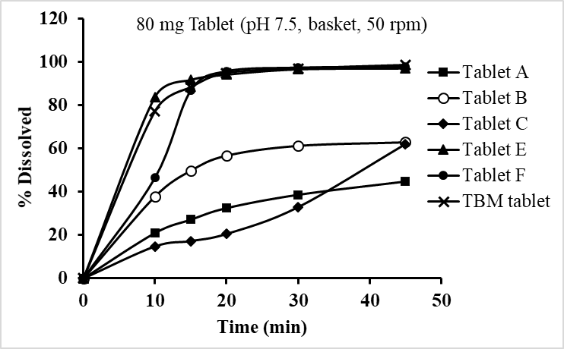
Tablet B | 55.9 | 1.00 | 53.60  [48.49, 59.24] | 98.43  [87.43, 110.82]
Tablet C | 20.3 | 1.25 | 81.55  [72.91, 91.23] | 110.12  [96.44, 125.73]
Tablet E | 94.4 | 2.52 | 81.34  [73.29, 90.27] | 92.44  [80.85, 105.69]
Tablet F | 96.2 | 2.00 | 83.19  [72.39, 95.60] | 98.66  [85.40, 113.99]
TBM tablet | 94.5 | 2.00 | 71.82  [66.75, 77.28] | 101.17  [96.77, 105.77]
Notes: GMR: geometric mean ratio; CI: confidence interval; TBM: to-be-marketed.

Supplementary Table 2. Single-dose and simulated multiple-dose data of the TBM tablet versus capsule (FDA 2019)
 |  |  | C_{max} (μg/mL) Geometric means
Regimen | Food condition | Tablet  (Test) |  | Capsule  (Reference) | Ratio (%)  (Test/Reference) |  | 90% CI for ratio  (%)
Single-dose | Fasted | 3.39 (n= 29) |  | 4.71 (n= 27) | 71.82 |  | 66.75 ~ 77.28
Single-dose | Fed | 2.68 (n= 28) |  | 2.97 (n= 28) | 90.01 |  | 79.94 ~ 101.36
Multiple-dose | Fasted | 12.09 (n= 29) |  | 13.29 (n= 27) | 90.94 |  | 87.06 ~ 95.00
Multiple-dose | Fed | 12.43 (n= 28) |  | 13.47 (n= 28) | 92.30 |  | 83.92 ~ 101.51
 |  |  | AUC (μg· h/mL) Geometric means
Regimen | Food condition | Tablet  (Test) |  | Capsule  (Reference) | Ratio (%)  (Test/Reference) |  | 90% CI for ratio  (%)
Single-dose | Fasted | 235 (n= 29) |  | 232 (n= 27) | 101.17 |  | 96.77 ~ 105.77
Single-dose | Fed | 259 (n= 28) |  | 276 (n= 28) | 93.75 |  | 85.25 ~ 103.11
Multiple-dose | Fasted | 235 (n= 29) |  | 232 (n= 27) | 101.19 |  | 96.75 ~ 105.83
Multiple-dose | Fed | 259 (n= 28) |  | 276 (n= 28) | 93.70 |  | 85.13 ~ 103.12

Supplementary Table 3. Statistical comparison of single-dose food-effect of the TBM tablet versus capsule (FDA 2019)
Pharmacokinetic parameters | Geometric means |  | Ratio (%)  (Fed/Fasted) | 90% CI for Ratio (%)
Pharmacokinetic parameters | TBM tablet-Fed | TBM tablet-Fasted | Ratio (%)  (Fed/Fasted) | Lower | Upper
N | 28 | 28 | — | — | —
T_{max} (h) | 3.00 [0.50 ~ 8.03] | 2.00 [0.50 ~ 6.02] | — | — | —
C_{max} (μg/mL) | 2.68 | 3.38 | 79.18 | 68.58 | 91.43
AUC_{0-72h} (μg· h/mL) | 102 | 102 | 99.24 | 88.91 | 110.76
AUC_{last} (μg· h/mL) | 250 | 225 | 111.01 | 96.78 | 127.33
AUC_{inf} (μg· h/mL) | 259 | 234 | 110.64 | 96.59 | 126.74
Pharmacokinetic parameters | Geometric means |  | Ratio (%)  (Fed/Fasted) | 90% CI for Ratio (%)
Pharmacokinetic parameters | Capsule-Fed | Capsule-Fasted | Ratio (%)  (Fed/Fasted) | Lower | Upper
N | 28 | 27 | — | — | —
T_{max} (h) | 3.00 | 2.00 | — | — | —
C_{max} (μg/mL) | 2.97 | 4.70 | 63.34 | 56.76 | 70.69
AUC_{0-72h} (μg· h/mL) | 106 | 104 | 102.63 | 94.79 | 111.12
AUC_{last} (μg· h/mL) | 267 | 220 | 121.44 | 108.15 | 136.36
AUC_{inf} (μg· h/mL) | 276 | 226 | 122.08 | 108.35 | 137.54

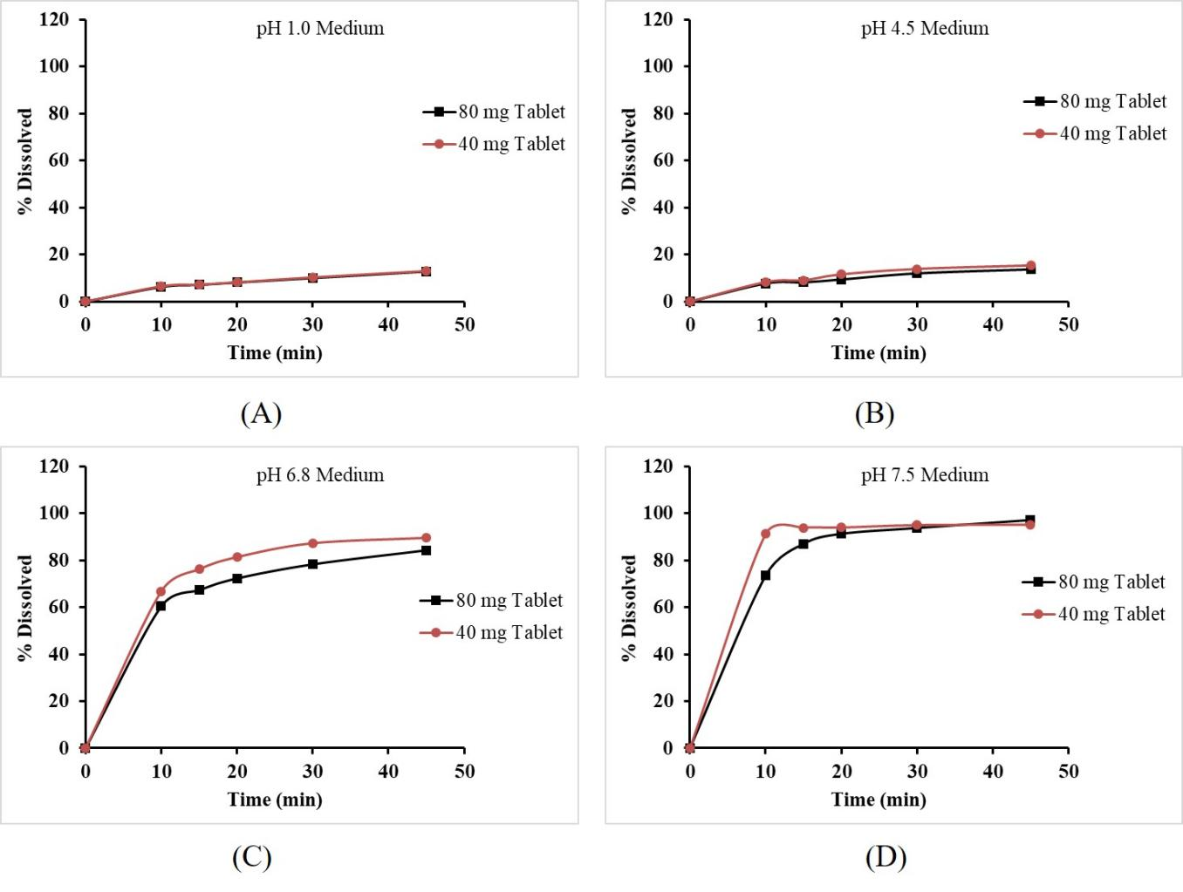
Supplementary Fig. 1. Dissolution profiles of enzalutamide tablet 80 mg and 40 mg in various medium (FDA 2019)

References
FDA. 2019. Multiple-discipline review for XTANDI® tablet. https://www.accessdata.fda.gov/drugsatfda_docs/nda/2020/213674Orig1s000 MultidisciplineR.pdf
FDA.2019. Product quality review for XTANDI® tablet. https:// www. accessdata.fda.gov/drugsatfda_docs/nda/2020/213674Orig1s000ChemR.pdf.

