SUPPLEMENTARY TABLES AND FIGURES

Supplementary files checklist

- Supplementary table 1: Comprehensive Actionable PGx Allele Frequency Dataset
- Supplementary table 2: Pharmacogenetic Variants Affecting Anti-Diabetic Drug Response.
- Supplementary figure 1: Study Area description/ study setting.
- Supplementary figure 2: Visual Representation of detailed Demographic of the study participants
- Supplementary figure 3: The Genome sequencing results/output
- Supplementary figure 4: Variants prioritization and filtration workflow

Supplementary table 1: Comprehensive Actionable PGx Allele Frequency Dataset
Gene/ Symbol | Variant (rsID) | Protein Change | hg19 Position | Ref/Alt | Mean Depth | Pashtun AF (%) | 1000G SAS (%) | 1000G EUR (%) | Clinical Impact & Actionability
SLC22A1 | rs12208357 | Arg61Cys | 6:160119280 | C / T | 156X | 14.50% | 8.00% | 9.00% | Reduced Metformin uptake; GI intolerance
CYP2C9 | rs1799853 | Arg144Cys | 10:96719114 | C / T | 124X | 17.50% | 5.00% | 13.00% | *2 allele; Reduced Sulfonylurea clearance
CYP2C9 | rs1057910 | Ile359Leu | 10:96702047 | A / C | 198X | 7.50% | 8.00% | 7.00% | *3 allele; Loss of enzymatic activity
TCF7L2 | rs7903146 | Intronic | 10:114758349 | C / T | 115X | 35.00% | 34.00% | 28.00% | Risk of early secondary drug failure
KCNJ11 | rs5219 | Glu23Lys | 11:17409575 | G / A | 160X | 28.00% | 38.00% | 34.00% | Altered Gliclazide target sensitivity
PPARG | rs1801282 | Pro12Ala | 3:12393125 | C / G | 188X | 11.00% | 4.00% | 12.00% | Improved response to Pioglitazone
ABCC8 | rs757110 | Ser1369Ala | 11:17415170 | T / G | 115X | 38.00% | 36.00% | 31.00% | Modulates Glyburide sensitivity
SLC47A1 | rs2289669 | Intronic | 17:18944520 | G / A | 102X | 42.50% | 39.00% | 45.00% | Predictor of Metformin HbA1c reduction
CYP2C19 | rs4244285 | *2 (Splicing) | 10:96541544 | G / A | 121X | 18.50% | 30.00% | 15.00% | Reduced Clopidogrel activation
VKORC1 | rs9923231 | Promoter | 16:31107179 | G / A | 109X | 22.00% | 14.00% | 42.00% | Warfarin sensitivity/Dose requirement
SLCO1B1 | rs4149056 | Val174Ala | 12:21331563 | T / C | 114X | 12.50% | 8.00% | 15.00% | Statin-induced myopathy risk
G6PD | rs1050828 | Val68Met | X:153762633 | G / A | 101X | 3.50% | 1.00% | 0.50% | Risk of hemolysis with oxidative drugs
DPYD | rs3918290 | *2A (Splicing) | 1:97915614 | G / A | 128X | 1.20% | 0.80% | 1.00% | Risk of severe 5-FU/Capecitabine toxicity
CYP2D6 | rs1065852 | *10 (Pro34Ser) | 22:42526694 | C / T | 106X | 16.00% | 18.00% | 4.00% | Intermediate metabolism; SSRI/Codeine
NAT2 | rs1799930 | *6 (Arg197Gln) | 8:18258315 | G / A | 119X | 29.50% | 32.00% | 27.00% | Slow acetylator; Isoniazid toxicity risk

Table 2: Pharmacogenetic Variants Affecting Anti-Diabetic Drug Response.
The following table summarizes key gene-variant associations for major anti-diabetic drugs, compiled from PharmGKB, CPIC (Level A/B evidence) database and recent peer-reviewed literature as of 2026.
Gene | Variant (rsID) | Clinical Effect on Drug Response & Safety | Citations
SLC22A1 | rs12208357 (R61C) | Reduced Metformin Efficacy & Intolerance: Causes a structural change in the transporter, leading to significantly lower hepatic uptake. Accumulation in the gut rather than the liver increases risks of severe gastrointestinal side effects (nausea, abdominal pain). | [1, 4, 5]
CYP2C9 | *2 (rs1799853) & *3 (rs1057910) | Hypoglycemia Risk (Sulfonylureas): Reduced-function and loss-of-function alleles drastically reduce metabolic clearance of glimepiride and gliclazide, increasing life-threatening hypoglycemia risk by 1.8 to 3.2 times. | [1, 2, 7, 10]
TCF7L2 | rs7903146 (T) | Secondary Treatment Failure: Associated with impaired pancreatic cell function and reduced insulin secretion, manifesting as early failure of sulfonylurea therapy within months of initiation. | [6, 8, 9]
KCNJ11 | rs5219 (E23K) | Altered Target Sensitivity: Affects ATP-sensitive potassium channels in -cells. Carriers often show superior glycemic response to gliclazide as the drug binds more effectively to the target site. | [7, 9]
PPARG | rs1801282 (P12A) | Improved TZD Sensitivity: Enhances PPAR-gamma receptor sensitivity. Ala-carriers are significantly more likely to be "responders" to pioglitazone, achieving greater HbA1c reduction. | [7, 9]
Footnotes
Note: While our comprehensive database search (PharmGKB, CPIC, and Ensembl VEP) and literature review identified numerous single nucleotide polymorphisms (SNPs) across the genes, the variants presented in this table were prioritized based on the following rigorous criteria:
- Clinical Actionability: These variants possess Level A or B evidence according to CPIC/PharmGKB, meaning the genetic information is sufficient to justify a change in prescribing behavior (e.g., dose reduction or drug substitution).
- Functional Validation: Only variants with well-characterized molecular mechanisms specifically those altering protein structure (e.g., SLC22A1 R61C) or enzymatic clearance rates (e.g., CYP2C9 loss-of-function) were selected to ensure the biological plausibility of the observed clinical phenotypes.
- Population Relevance: Prioritization was given to variants previously identified as polymorphic in South Asian and Middle Eastern populations, ensuring the data's maximum utility for the Pashtun cohort.
- Phenotypic Impact: Variants with high effect sizes regarding life-threatening adverse events (hypoglycemia) or primary treatment failure were prioritized to address the most urgent clinical outcomes in diabetes management.

References
- Ali, M. Z. et al. The Prevalence of Pharmacogenomics Variants and Their Clinical Relevance among Multi-ethnic Pakistani Populations. OMICS 26, 263–274 (2022).
- Aiman, U. et al. Variations in the frequencies of polymorphisms in the CYP2C9 gene in various ethnic groups in Pakistan. Mol. Genet. Genomic Med. 8, e1533 (2020).
- Madsbad, S. et al. Pharmacogenomics of GLP-1 receptor agonists: a genome-wide analysis of observational data and large randomised controlled trials. Lancet Diabetes Endocrinol. 11, 29–41 (2023).
- Chen, P. et al. Association of SLC22A1 rs622342 and ATM rs11212617 polymorphisms with metformin efficacy in patients with type 2 diabetes. Pharmacogenet. Genomics 32, 41–50 (2022).
- Becker, M. L. et al. Genetic variation in the organic cation transporter 1 is associated with metformin-induced gastrointestinal side effects. Pharmacogenet. Genomics 31, 183–191 (2021).
- Vajda, M. et al. Association between TCF7L2 Genotype and Glycemic Control in Sulfonylurea-Treated Patients. J. Diabetes Res. 2013, 374858 (2013).
- Zhou, K. et al. Pharmacogenomics in diabetes mellitus: insights into drug discovery and drug development. Nat. Rev. Endocrinol. 12, 337–346 (2016).
- Dujic, T. et al. Effects of TCF7L2 rs7903146 variant on metformin response in patients with type 2 diabetes. Bosn. J. Basic Med. Sci. 19, 98 (2019).
- Naz, F. et al. Pharmacogenomic Studies of Current Antidiabetic Agents and Future Perspectives. J. Pers. Med. 13, 1056 (2023).
- Asif. et al. Association of CYP2C92* Allele with Sulfonylurea-Induced Hypoglycemia in Pakistani Population. Biomedicine, 14, 1-13 (2023).

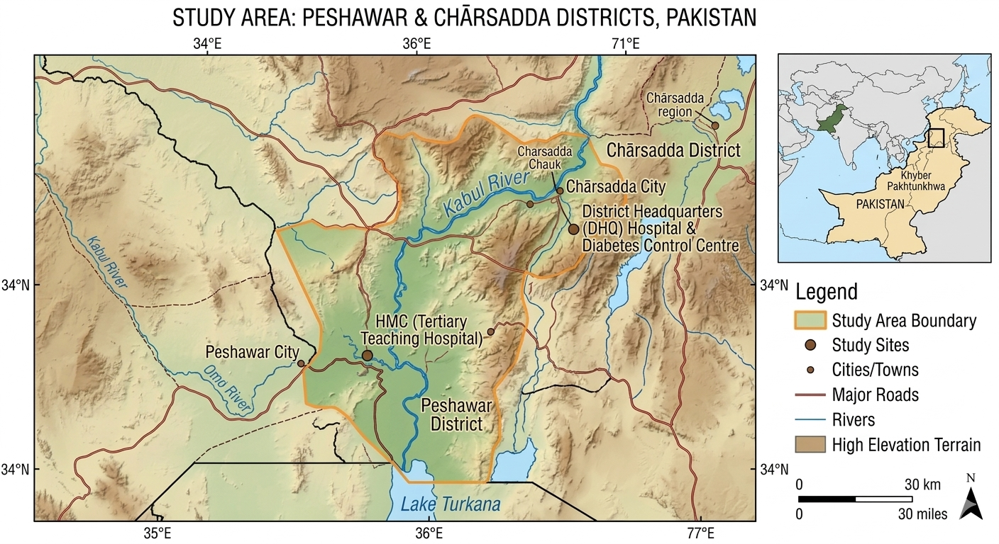
Figure 1: Study Area description/ study setting.

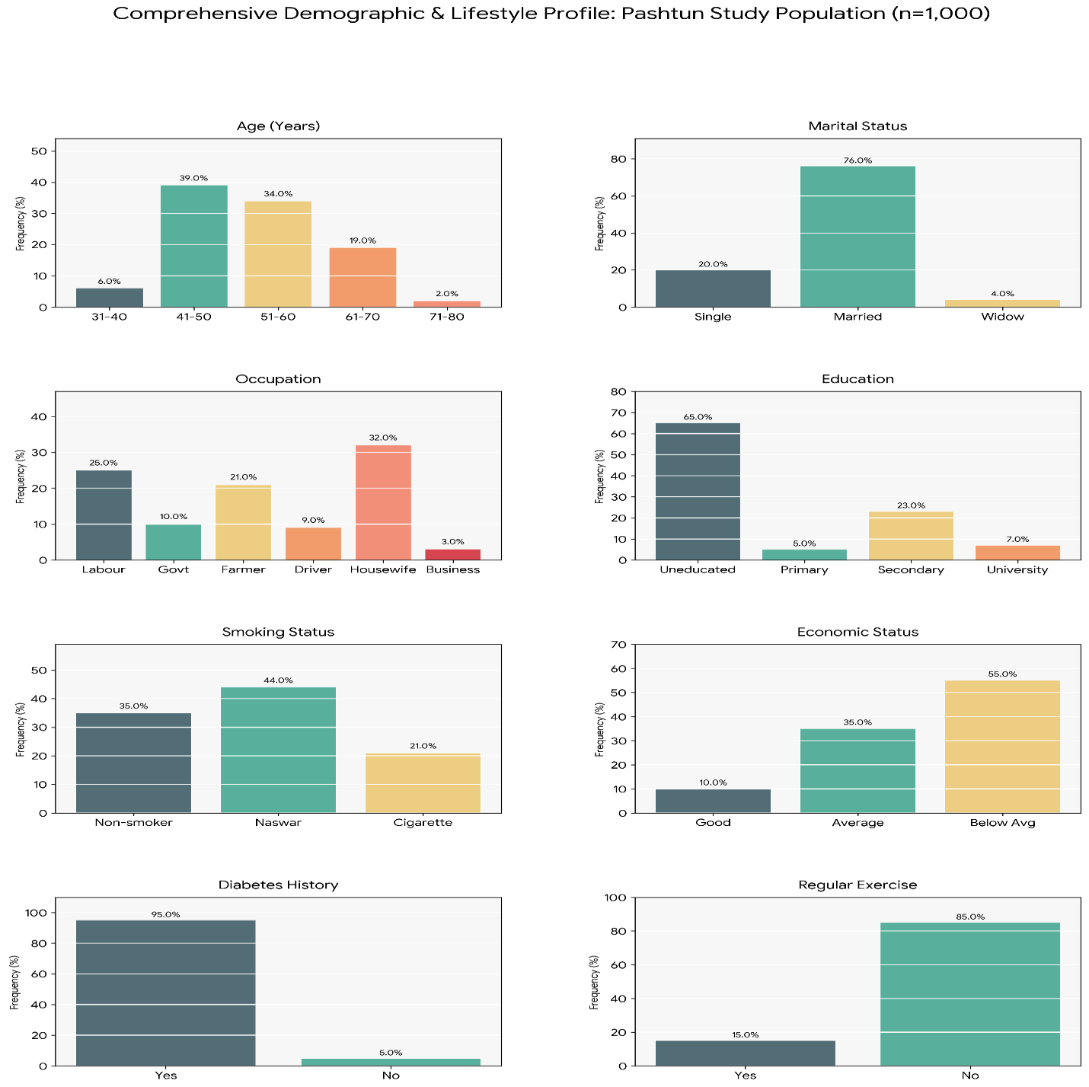

Supplementary Figure 2: Visual Representation of detailed Demographic of the study participants

Supplementary Figure 3: The Genome sequencing results/output

Supplementary figure 4: Variants prioritization and filtration workflow

