Supplementary information

S1. Demographic information & daily post practice
Table S1 summarises the descriptive characteristics of the analytical sample (N = 1,001). To maintain comparability with official population statistics, both the present analysis and the national benchmark figures exclude individuals younger than 18 years (Statistics Poland, 2024). The mean participant age is 44.28 years, indicating a predominantly working-age cohort. Relative to the 2024 population distribution, respondents aged 18–24 are slightly over-represented (10.7% vs 8.1%). The sample also includes higher shares of adults aged 25–34 (19.3% vs 14.6%) and 35–44 (22.7% vs 19.8%), while the 45–54 group closely matches the national profile (18.5% vs 18.0%). Participants aged 55–64 are somewhat over-represented (18.7% vs 14.4%), whereas those aged 65+ are substantially under-represented (10.2% vs 25.1%). Gender composition mirrors the national distribution almost exactly (48.4% female; 51.6% male). Household size is heterogeneous, with two-person households most common (30.9%), followed by households of more than three persons (30.2%) and three-person households (26.0%); 13.0% of respondents live alone. Most participants reside in urban areas (599 of 1,001), and housing is split between purpose-built flats (46.1% up to five storeys; 15.9% six storeys or more) and houses (38.0%). Overall, the sample aligns well with national gender patterns but is weighted toward working-age adults and urban, multi-unit residential settings—contexts in which drone delivery and bystander interactions are likely to be most salient.

Table S1. Demographic characteristics
 | Full sample (n=1001) | Poland census 2024
Age
18-24 | 10.70% | 8.13%
25-34 | 19.30% | 14.59%
35-44 | 22.70% | 19.77%
45-54 | 18.50% | 17.98%  14.40%
55-64 | 18.70%
65+ | 10.20% | 25.13%
Mean | 44.28
Gender
Female | 48.40% | 48.45%
Male | 51.60% | 51.55%
Household size
1 | 13.00%
2 | 30.90%
3 | 26.00%
More than 3 | 30.20%
Area
Urban | 599
Rural | 402
Dwelling type
Purpose built flat (up to 5 storeys high) | 46.10%
Purpose built flat (6 storeys and more) | 15.90%
House | 38%

Patterns of daily postal practices provide contextual insight into participants’ familiarity with parcel logistics and potential readiness for emerging delivery services (as shown in Table S2). A majority live within 0.5 km of a post office, with an additional 27.4% within 1 km, indicating good accessibility to postal infrastructure. Deliveries most frequently occur to participants’ homes (58.9%), followed by pick-up points such as post offices (33.9%) and retail collection sites (13.0%), while only 9.3% receive/post deliveries at work. Postal usage is regular but moderate: 58.7% receive parcels one or two times per month, 15.0% three to five times, and 3.1% six or more times, while 23.2% report no recent deliveries. Roughly 22.3% hold a postal or delivery subscription service. Most respondents spend less than 250 zł per month on postal or courier services (91.4%), with only 7.5% spending between 251 zł and 500 zł and 1.0% exceeding 500 zł. Drone awareness is high, with 83.7% of respondents indicating prior awareness of such technology. These patterns highlight that the sample is accustomed to conventional delivery systems, which provides a relevant behavioural baseline for evaluating attitudes toward drone-enabled delivery scenarios.

Table S2. Daily post practice information
Daily post practice | Percentage
Distance to post office
Less than 0.5 km | 41.50%
0.5-1 km | 27.40%
1-2 km | 13.00%
2-3 km | 6.20%
3-5 km | 4.60%
More than 5 km | 7.40%
Post location
Home | 58.90%
Work | 9.30%
Pick up point - post office | 33.90%
Collect from store | 13.00%
Other | 11.50%
Post & delivery frequency
Never | 23.20%
1-2 times per month | 58.70%
3-5 times per month | 15%
6+ times per month | 3.10%
Post & delivery subscription
Yes | 22.30%
No | 77.70%
Post/delivery costs (per month)
Less than 250 zł | 91.40%
Between 251 and 500 zł | 7.50%
More than 500 zł | 1%

S2. Variable coding/recoding
This section documents how questionnaire fields were harmonised and recoded into the model matrix used in the multinomial logit estimation. Table S3 shows the main attributes used in this research and how they were coded/recoded.

Table S3. Variable coding and recoding
Attribute (what respondents saw) | Before recoding — available levels | After recoding | Dummies & baseline used in estimation
Quietness (5-icon scale) | Five icons indicating relative loudness (ordered) | Unchanged
Operator licensing | 1. Licensed; 2. NOT licensed | Unchanged | Dummy: 1 = NOT licensed, 0 = licensed; base = licensed
Drone registration | 1. Registered; 2. NOT registered | Unchanged | Dummy: 1 = NOT registered, 0 = registered; base = registered
On-board camera | 1. Camera present; 2. No camera | Unchanged | Dummy: 1 = NO camera, 0 = camera present; base = camera present
Built context (noise-sensitive) | 1. Hospital, 2. Home, 3. Business/Office area, 4. Shopping area | 1,2= noise-sensitive spaces (1)  3,4 Non-sensitive area (2)" | Dummy: 1 = noise-sensitive(homes/hospitals), 0 = other; base = other
Delivery point (private) | 1. Building - window, 2. Building - doorstep, 3. Building - communal space (i.e. garden), 4.Private terrace, 5. open public space | New: 1,2,4 = private spaces (1)  3,5 = public spaces (2) | Dummy: 1 = private (doorstep/terrace/window), 0 = public/communal; base = public/communal
Parcel type | Asymmetry:  Bystander side: 1. Medicines, 2. food delivery, 3. clothes, 4. mail, 5. surveillance, 6. Illegal things, 7. Organic material  Recipient side:  1. Medicines, 2. food delivery, 3. clothes, 4. mail, 5. Illegal things | New: 1,7=medicine(1);  2=food (2);  3,4,5,6=others (3) | Two dummies; base = Other
Delivery cost (recipient only) | Free, 10, 20, 30, 40, 50 zł | Divided by 5 → 0, 2, 4, 6, 8, 10 units | Continuous; 1 unit = 5 zł; set to 0 for bystander tasks
Delivery time (recipient only) | 20min–48h (10 levels) | Continuous (minutes) | Continuous; set to 0 for bystander tasks
Topography (bystander only) | 1. Over city, 2. Over village, 3. Rural area | Two dummies; baseline = over city | Village = 1 if over village; Rural = 1 if rural area; set to 0 for recipient tasks

Two parallel choice tasks were administered to the same individuals, once under a recipient viewpoint and once under a bystander viewpoint. We stacked both tasks and flagged the active viewpoint with a binary role indicator. For each task, two drone alternatives (A, B) and one opt-out (Neither) were available.
Table S3 above summarises the coding for each attribute. All binary indicators use one-sided 'undesirable-state' coding (e.g., 1 = not licensed, 1 = no camera), so that the reported odds ratios for the desirable state (e.g., licensed vs not) are obtained by exponentiating the negative of the estimated coefficient. Parcel type uses two dummies (medical, food) with other content as the baseline.
The noise attribute is analysed as an ordered noisiness score where one unit corresponds to one icon step nosier (higher value = nosier). Recipient-only attributes (delivery cost and delivery time) were set to zero for bystander tasks so that role-gating operates correctly in the pooled model. Delivery cost was scaled in 5 zł units (i.e., one unit in the model corresponds to 5 Polish złoty). Bystander-only topography was recoded into two dummy variables (over village, rural area; baseline = over city) and set to zero for recipient tasks.
The role is coded as 1 for bystander tasks and 0 for recipient tasks. Role-specific parameters are implemented as recipient baselines plus bystander shifts; combined effects for the bystander viewpoint are the sum of the baseline and the shift. The opt-out alternative includes an intercept for recipients and an additive bystander shift. In Results, contrasts such as 'licensed vs not licensed' and 'camera present vs no camera' are obtained by negating the corresponding design-state coefficient before exponentiation, so that odds ratios above 1 consistently indicate higher acceptability of the more desirable state. We note that our recoding simplifies several design dimensions to maintain interpretability. For example, collapsing built context to 'noise-sensitive places vs nonsensitive' may mask finer heterogeneity within each class, and the five-level parcel categorisation is reduced to three groups (medical, food, other).

S3. Model fit comparison
We compared the role-interaction model (22 parameters) to the pooled main-effects model without role interactions (13 parameters). Both models include all attributes: shared attributes (noise, camera, licensing, registration, parcel type, and context interactions), recipient-only cost and time, and bystander-only topography. The main-effects model pools both roles with common slopes for shared attributes, whereas the interaction model adds bystander-shift parameters that allow shared-attribute slopes to differ by role.
As shown in Table S4, the improvement in log-likelihood is ΔLL = 58.43 (−12,899.95 vs −12,958.38). The likelihood-ratio statistic is LR = 2 × ΔLL = 116.86 on 9 degrees of freedom (p < 0.001), indicating that allowing attribute slopes to vary by viewpoint and context adds material explanatory power. Information criteria also favour the interaction model: AIC decreases by 98.86 (25,843.9 vs 25,942.8) and BIC decreases by 31.60 (26,008.3 vs 26,039.9), both supporting the more flexible specification despite its higher dimensionality. Pseudo-ρ² against equal shares rises from 0.0936 to 0.0977.

Table S4. Model indices comparison
Model indices | Without role interaction | With role interaction
LL(start) | -12982.45 | -12949.30
LL at equal shares, LL(0) | -14296.24 | -14296.24
LL at observed shares, LL(C) | -13689.64 | -13689.64
LL(final) | -12958.38 | -12899.95
Rho-squared vs equal shares | 0.0936 | 0.0977
Adj.Rho-squared vs equal shares | 0.0927 | 0.0961
Rho-squared vs observed shares | 0.0534 | 0.0577
Adj.Rho-squared vs observed shares | 0.0526 | 0.0562
AIC | 25942.77 | 25843.91
BIC | 26039.93 | 26008.33

We note that ρ² values in multinomial logit models applied to stated-choice data are typically lower than R² values in linear regression. Values in the range of 0.05–0.15 are common in discrete-choice experiments with large choice sets and repeated tasks, and the improvement from main-effects to interaction model is the relevant diagnostic rather than the absolute level (Ben-Akiva and Lerman, 1985). Together, these indices justify using the role-dependent specification as the primary model.

S4. Odds ratio by encounter role
To complement the role-gap odds ratios reported in the main text (which express the ratio of bystander to recipient odds), we present here the underlying odds ratios separately for each role. These allow the reader to see the absolute direction and magnitude of each attribute effect under the recipient and bystander viewpoints independently, before taking their ratio.
Table S5 and Fig. S1 report odds ratios and 95% delta-method confidence intervals for six attribute contrasts, computed from the full-sample pooled interaction model. Contrasts are oriented toward the desirable or more salient state: for noise, the OR corresponds to one step noisier (OR < 1 indicates noisier operations reduce acceptability); for camera, the OR corresponds to camera present versus no camera; for safeguards, the OR corresponds to licensed versus not licensed and registered versus not registered (OR > 1 indicates the desirable state increases acceptability).
Table S5. Odds ratios by encounter role
Attribute contrast | Recipient odds ratio | 95% CI | Bystander Odds ratio | 95% CI
Noise – nonsensitive | 0.917 | [0.889, 0.945] | 0.862 | [0.833, 0.892]
Noise – sensitive | 0.901 | [0.876, 0.927] | 0.892 | [0.863, 0.922]
Camera present vs No - public | 0.908 | [0.832, 0.991] | 1.264 | [1.111, 1.439]
Camera present vs No - private | 0.951 | [0.881, 1.028] | 0.705 | [0.639, 0.778]
Licensed vs Not | 1.350 | [1.268, 1.436] | 1.537 | [1.429, 1.653]
Registered vs Not | 1.539 | [1.438, 1.647] | 1.604 | [1.490, 1.727]
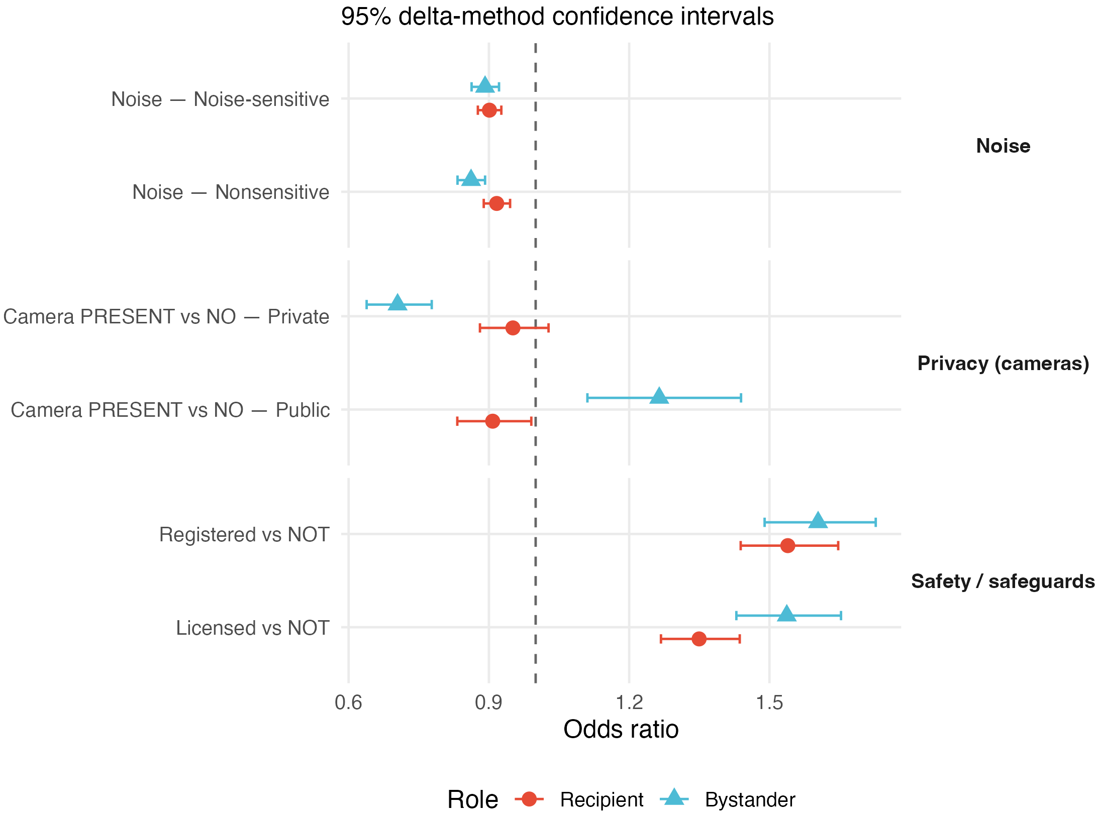Fig. S1 Odds ratio by encounter role

Three patterns are evident. First, noise reduces acceptability under both roles, but more strongly for bystanders in nonsensitive settings than for recipients. In noise-sensitive settings the two roles converge, consistent with recipients becoming more noise-averse when the context signals that quiet matters. Second, camera effects are strikingly role- and context-dependent. Recipients show weak camera sensitivity (ORs close to unity in both settings), whereas bystanders show a camera premium at public delivery points but a camera penalty at private delivery points. Third, both roles value licensing and registration, with bystanders placing modestly greater weight on both safeguards. These patterns provide the attribute-level detail underlying the role-gap ratios in the main text.

S5. Urban-rural robustness: odds ratios by role and area
To assess whether the role-dependent patterns vary by settlement type, we re-estimated the full interaction model separately for urban (n = 599) and rural (n = 402) respondents. This section reports the odds ratios separately for each role within each subsample — that is, the absolute attribute effects under the recipient and bystander viewpoints in urban and rural areas independently. These complement the role-gap ratios in the main text (Table 2), which express the ratio of bystander to recipient odds within each model. Because separate estimation by area does not constrain the error scale to be equal across subsamples [39], we interpret cross-area comparisons as pattern-replication checks rather than formal magnitude tests.
From each subsample we derived odds ratios for six attribute contrasts: one step noisier in nonsensitive and noise-sensitive settings; camera present vs no camera at public and private delivery points; and licensed vs not and registered vs not, for both recipient and bystander viewpoints. Table S6 reports the estimates and 95% delta-method confidence intervals. Fig. S2 visualises the same results.

Table S6. Odds ratios by encounter role and area
Attribute contrast | Role | Urban OR | 95% CI | Rural OR | 95% CI
Noise – nonsensitive | Recipient | 0.910 | [0.874, 0.948] | 0.924 | [0.884, 0.973]
Noise – nonsensitive | Bystander | 0.863 | [0.826, 0.903] | 0.859 | [0.814, 0.905]
Noise – sensitive | Recipient | 0.909 | [0.876, 0.944] | 0.891 | [0.854, 0.929]
Noise – sensitive | Bystander | 0.879 | [0.842, 0.917] | 0.911 | [0.865, 0.961]
Camera present vs No - public | Recipient | 0.828 | [0.738, 0.929] | 1.029 | [0.903, 1.174]
Camera present vs No - public | Bystander | 1.255 | [1.059, 1.486] | 1.283 | [1.049, 1.570]
Camera present vs No - private | Recipient | 0.984 | [0.890, 1.088] | 0.914 | [0.809, 1.032]
Camera present vs No - private | Bystander | 0.717 | [0.634, 0.811] | 0.687 | [0.582, 0.810]
Licensed vs Not | Recipient | 1.330 | [1.223, 1.446] | 1.352 | [1.231, 1.485]
Licensed vs Not | Bystander | 1.572 | [1.428, 1.730] | 1.490 | [1.333, 1.665]
Registered vs Not | Recipient | 1.557 | [1.427, 1.698] | 1.524 | [1.369, 1.696]
Registered vs Not | Bystander | 1.543 | [1.403, 1.698] | 1.707 | [1.518, 1.919]

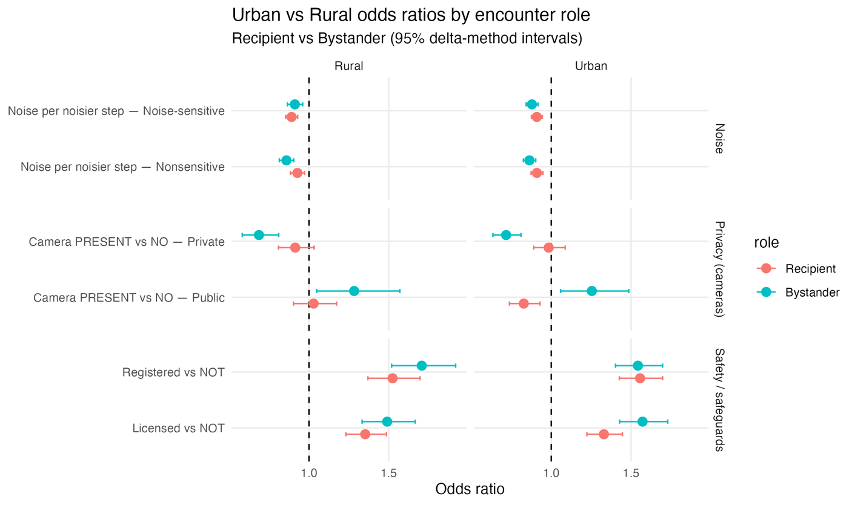
Fig. S2 Odds ratio by role and area

The table and figure allow readers to trace the source of the role-gap ratios reported in the main text. For instance, the smaller camera role-gap in rural versus urban public delivery points arises primarily from a shift in recipient sensitivity: urban recipients show a significant camera penalty, while rural recipients are camera-neutral. Bystander camera premiums are similar in both areas. For safeguards, rural bystanders place notably higher weight on registration than urban bystanders, although both exceed the respective recipient values. These decompositions confirm that the qualitative role-dependent patterns are robust across settlement types, while revealing that area-level variation in the role-gap is sometimes driven by recipient-side shifts rather than bystander-side changes.

S6. Mixed logit robustness check

To assess whether the primary MNL results depend on the assumption of homogeneous preferences, we estimated a mixed logit (MXL) version of the pooled role model. The MXL allows the recipient-baseline coefficients on all four core shared attributes (noise, camera, licensing, and registration) to vary across individuals as normally distributed random coefficients. Bystander shifts, context interactions, and parcel type parameters are kept fixed. The model was estimated in Apollo using maximum simulated likelihood with 500 Halton draws and panel likelihood across repeated tasks, and it converged with a negative definite Hessian. Table S7 presents the MNL and MXL estimates side by side for direct comparison. The MXL column includes the estimated standard deviations (SD) for the four randomised coefficients.

Table S7. MNL and MXL coefficient estimates comparison
Parameter | MNL estimate | MNL Rob.Se | MXL Estimate | MXL Rob.SE | Sig.
Recipient baselines (means)
Noise (recipient) | -0.087 | 0.016 | -0.114 | 0.021 | ***
Not licensed (recipient) | -0.300 | 0.032 | -0.498 | 0.045 | ***
Not registered (recipient) | -0.431 | 0.035 | -0.656 | 0.051 | ***
No Camera (recipient) | 0.096 | 0.044 | 0.078 | 0.057
Medical parcel (recipient) | 0.515 | 0.053 | 0.718 | 0.066 | ***
Food parcel (recipient) | 0.291 | 0.043 | 0.407 | 0.056 | ***
Bystander shifts
Noise shift | -0.062 | 0.022 | -0.135 | 0.028 | ***
Not licensed shift | -0.130 | 0.044 | -0.106 | 0.056 | *
Not registered shift | -0.041 | 0.046 | 0.008 | 0.060
No Camera shift | -0.331 | 0.079 | -0.538 | 0.099 | ***
Medical parcel shift | -0.228 | 0.080 | -0.403 | 0.096 | ***
Food parcel shift | 0.110 | 0.066 | 0.179 | 0.086 | **
Context interaction
Noise × sensitive (recipient) | -0.017 | 0.014 | -0.050 | 0.018 | ***
Noise × sensitive shift (bystander) | 0.051 | 0.021 | 0.136 | 0.028 | ***
No camera × private (recipient) | -0.047 | 0.054 | -0.209 | 0.069 | ***
No camera × private shift (bystander) | 0.631 | 0.089 | 0.981 | 0.113 | ***
Opt-out ASC
ASC Neither (recipient) | -1.328 | 0.072 | -1.267 | 0.074 | ***
ASC Neither shift (bystander) | 0.100 | 0.075 | -0.557 | 0.089 | ***
Standard deviations (MXL only)
SD Noise (recipient) | — | — | 0.473 | 0.020 | ***
SD No camera (recipient) | — | — | 0.660 | 0.050 | ***
SD Not licensed (recipient) | — | — | 0.867 | 0.045 | ***
SD Not registered (recipient) | — | — | 0.843 | 0.045 | ***
Notes:
1. Recipient is the baseline; bystander coefficients equal (recipient baseline + bystander shift).
2. MXL randomises recipient baselines for noise, camera, licensing, and registration with normal distributions; all other parameters are fixed.
3. * p < 0.10, ** p < 0.05, *** p < 0.01 (robust t-ratios).
Three features of the MXL results are worth noting. First, all four standard deviations are large and highly significant (robust t-ratios between 13.3 and 24.0), confirming substantial unobserved heterogeneity in how individuals value noise, camera, licensing, and registration. The heterogeneity is especially pronounced for licensing (SD = 0.87) and registration (SD = 0.84), suggesting that respondents are divided about the value of institutional safeguards — some place very high weight on them while others are relatively indifferent.
Second, the key role-dependent patterns from the primary MNL are preserved in the MXL. The bystander noise shift remains strongly negative (−0.135, p < 0.001), the bystander camera shift remains strongly negative (−0.538, p < 0.001), and the camera × private bystander interaction remains the largest effect in the model (0.981, p < 0.001). The overall story is unchanged.
Third, two differences between the MNL and MXL are worth noting. The bystander shift for licensing is smaller and not statistically significant at the 5% level in the MXL (−0.106, robust t = −1.91), compared to a significant effect in the MNL (−0.130, robust t = −2.99). This suggests that once individual-level heterogeneity in licensing preferences is accounted for, the average role difference in licensing valuation becomes less distinct. Additionally, the bystander ASC shift changes sign, likely reflecting absorption of heterogeneity by the random coefficients. Neither difference undermines the paper's central findings about noise, camera, and safeguard reweighting by role.

S7. Recipient side willingness to pay

To translate recipient preferences into monetary terms, we estimated a recipient-only multinomial logit model using only the recipient task. This model includes the same shared attributes as the primary pooled model (noise, camera, licensing, registration, parcel type, and context interactions) plus delivery cost. Delivery cost is coded in units of 5 Polish złoty (PLN), so the cost coefficient β_cost captures the utility change per 5 zł increment. Delivery time was excluded from the parsimonious WTP specification because our objective was to express operational externalities, privacy cues, and governance safeguards in money terms rather than to estimate a full service-attribute demand model. Willingness to pay for attribute k is computed as:
$${WTP}_{k}=-(\frac{β_{k}}{β_{cost}})×5$$
where the factor of 5 converts the ratio from cost units to złoty (1 złoty = around 0.22 Euro in 2020). Ninety-five per cent confidence intervals are obtained via the delta method. To assess whether WTP differs by settlement type, we re-estimated the same model separately for urban (n = 599) and rural (n = 402) recipients. Table S8 reports the WTP model coefficient estimates, while Table S9 and Fig. S3 present the resulting WTP values in złoty for eight attribute contrasts across the three samples.
Table S8. Recipient-only WTP model estimates
Parameter | Estimate | Rob.SE | Rob.t | Sig.
ASC neither | -1.265 | 0.071 | -17.82 | ***
Noise | -0.076 | 0.016 | -4.80 | ***
Notlicense | -0.306 | 0.032 | -9.58 | ***
Not registered | -0.436 | 0.035 | -12.62 | ***
No camera | 0.105 | 0.044 | 2.35 | **
Noise x sensitive | -0.022 | 0.014 | -1.58
No camera x private | -0.057 | 0.054 | -1.04
Medical parcel | 0.496 | 0.053 | 9.36 | ***
Food parcel | 0.272 | 0.043 | 6.36 | ***
Delivery cost (per 5 złoty) | -0.089 | 0.006 | -14.66 | ***
Notes:
LL(final) = −7,135.3; AIC = 14,290.5; 10 estimated parameters. 3. * p < 0.10, ** p < 0.05, *** p < 0.01 (robust t-ratios).
Table S9. Recipient willingness to pay by area
Attribute contrast | Sample | WTP | 95% CI
Noise per noisier step – nonsensitive | Full sample | -4.26 | [-5.95, -2.58]
 | Urban | -4.24 | [-6.39, -2.09]
 | Rural | -4.28 | [-7.02, -1.53]
Noise per noisier step – Noise-sensitive | Full sample | -5.52 | [-7.17, -3.88]
 | Urban | -4.60 | [-6.64, -2.55]
 | Rural | -6.87 | [-9.68, -4.06]
Camera present vs No – Public | Full sample | -5.88 | [-10.60, -1.15]
 | Urban | -10.55 | [-16.62, -4.48]
 | Rural | 0.90 | [-6.75, 8.59]
Camera present vs No – Private | Full sample | -2.68 | [-6.99, 1.63]
 | Urban | -0.48 | [-6.01, 5.05]
 | Rural | -5.57 | [-12.77, 1.63]
Licensed vs Not | Full sample | 17.17 | [13.35, 20.98]
 | Urban | 15.69 | [11.02, 20.36]
 | Rural | 18.36 | [11.77, 24.94]
Registered vs Not | Full sample | 24.48 | [19.94, 29.01]
 | Urban | 24.56 | [18.79, 30.34]
 | Rural | 24.69 | [17.22, 32.15]
Medical vs other parcel | Full sample | 27.82 | [21.29, 34.36]
 | Urban | 30.01 | [21.45, 38.58]
 | Rural | 25.94 | [15.36, 36.52]
Food vs other parcel | Full sample | 15.30 | [10.11, 20.48]
 | Urban | 14.09 | [7.71, 20.47]
 | Rural | 17.18 | [8.22, 26.14]
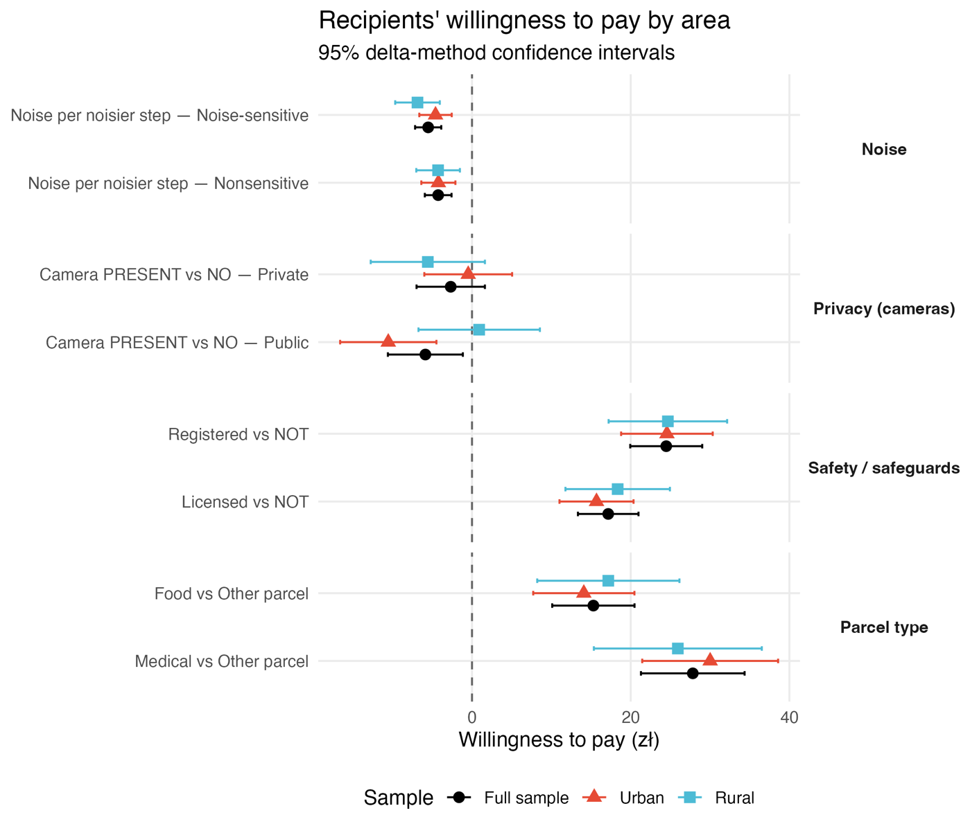
Fig. S3 Recipients’ willingness to pay by area
Recipients place the largest positive WTP on institutional safeguards. Drone registration commands the highest premium (full sample: 24.5 zł, approximately €5.50 at the time of the survey), followed by operator licensing (17.2 zł). These values are consistent across urban and rural subsamples, with overlapping confidence intervals. Medical parcels also command a substantial premium, suggesting that recipients value drone delivery most when the payload is health-related.
Noise carries a consistent negative valuation. Recipients would require a discount of roughly 4–5 zł per step increase in noisiness in nonsensitive settings, rising to 5–7 zł in noise-sensitive settings. The rural subsample shows a somewhat larger penalty in noise-sensitive locations (−6.87 zł vs −4.60 zł for urban), though confidence intervals overlap.
Camera valuations are the least stable across areas and contexts. In the full sample, camera presence carries a modest negative WTP at public delivery points (−5.88 zł, CI just excluding zero) and a smaller, non-significant effect at private points (−2.68 zł, CI spanning zero). The urban–rural split reveals marked divergence: urban recipients show a clear negative valuation for cameras at public points (−10.55 zł), while the rural estimate is small, positive, and non-significant (0.90 zł, CI [−6.75, 8.56]). This mirrors the urban–rural divergence in camera ORs observed in the pooled role model (Supplementary Information S5) and is consistent with the interpretation that camera sensitivity is shaped by the everyday context in which drone encounters occur.
These WTP values should be interpreted as indicative magnitudes rather than precise point forecasts, given the stated-preference setting and the sensitivity of WTP ratios to model specification. The key insight is the relative ordering: institutional safeguards are valued most highly, noise carries a moderate and consistent cost, and camera valuations are context-dependent and less precisely estimated.

References:
Statistics Poland (2024) Structure of the population. Statistics Poland. Available at: https://stat.gov.pl/en/topics/population/population/structure-of-the-population,7,1.html (Accessed 6 November 2025).

