Supporting Information

One-Step Electrodeposition of a Nanoflower-like FeOOH/Ti₃C₂T_{x} Composite for Enhanced Supercapacitor Performance

Shisen Bo†, Ruifeng Liu†, Fang Lei†, Mei Wang†, Tantan Liu†, Yu-Ting Liu‡,* and Ying Li†,*
†School of Materials Science and Engineering, North University of China, Taiyuan 030051, China
‡Shanxi Key Laboratory of Carbon Materials, Institute of Coal Chemistry, Chinese Academy of Sciences, Taiyuan 030001, China
*Corresponding author(s). E-mail(s): liyingmt@nuc.edu.cn; liuyuting@sxicc.ac.cn;
† These authors contributed equally to this work.

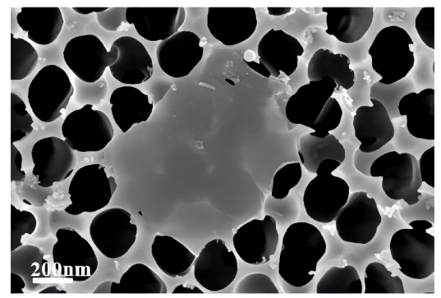
Fig. S1 SEM image of Ti₃C₂T_{x} on AAO.

Fig. S2 CV curves of F-1200 (a), FT-800 (b) and FT-1600 (c) at different scan rates.

Fig. S3 GCD curves of F-1200 (a), FT-800 (b) and FT-1600 (c) at different current densities.

Fig. S4 Peak current vs. scan rate with linear fitting.

Fig. S5 SEM images of MC.

Fig. S6 (a) CV curves and (b) GCD curves of the MC cathode; (c) areal specific capacitance of the FT-1200//MC ASC at various current densities; (d) photograph of an LED light bulb successfully powered by the ASC.

