Supplementary Material - Methods
Setting
In the Reggio Emilia province (Northern Italy, 532,000 inhabitants), Local Health Authority (LHA) hospital care is provided by six hospitals, with five emergency departments (ED) and one imaging department with centralized image reading. During the first pandemic wave, which lasted in Italy until May 2020, patients in the Reggio Emilia province with severe COVID-19 pneumonia were hospitalized primarily in the two main hospitals.
Methods for CRP and D-dimer measurement
CRP was measured in serum or plasma using the automated Siemens Immunoturbidimetric “wide range CRP” method on ADVIA-1800 analyzers (Siemenes Healthineers, Erlangen, Germany); D-dimer concentrations were measured on citrated plasma samples with Siemens “Innovance D-dimer” (reported in fibrinogen equivalent units) on Sysmex CS-5100 coagulometers (Sysmex Corporation, Kobe, Japan).
Methods for computing CRP descriptors
CRP peak: the highest value in (mg/dl) registered during the disease course
CRP integral: the area under the curve in terms of mg/dl*day observed during the disease course. Computationally it is the $\sum_{1}^{n}{CRPn}$ , where n is the day of disease from symptom onset and the CRP_{n} is the value of CRP registered on the n^{th} day.
If more than one CRP value was registered in one day, the average was considered. If for one or more days there was no CRP measured, the value was estimated by interpolation using the closest known values; for the days between symptom onset and the first measurement, a triangle was estimated interpolating the values from symptom onset and the first value assuming CRP=0 at day one of symptom onset; the course of inflammation ended when CRP reached a value of <1 mg/dl. For patients having the last measurement (usually at discharge) higher than 3 mg/dl we estimated the right tail of the curve using the average descending slope of the observed complete curves (ie, those with last observed value <1 mg/dl) with a similar CRP value (+/- 1) at the same day from symptom onset (or at the closest time). Curves ending with a value between 1 and 3 mg/dl were not completed through an estimate of the right tail. Indeed, the change in total values would be negligible, increasing the percentage of estimated data.
CRP velocity: the peak value divided by the number of days from symptom onset to the day of peak value (mg/dl/days).
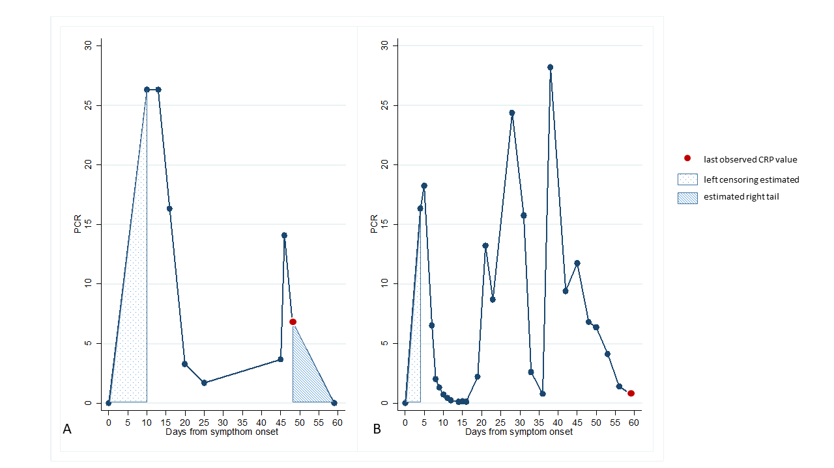
Supplementary Figure 1. Example case of an estimated right tail (A) obtained by adding the observed time to CRP decrease in a complete curve (B). The shaded area below the drawn line is the estimated area.

Methods for follow-up CT scan acquisition parameters
Follow-up CT scans were performed using a 128-slice scanner (Somatom Definition Edge, Siemens Healthineers), without contrast media injection, with the patient in supine position during end-inspiration. Scanning parameters were tube voltage 120 KV, automatic tube current modulation, collimation width 0.625 or 1.25 mm, acquisition slice thickness 2.5 mm, and interval 1.25 mm. Images were reconstructed with a high-resolution algorithm at slice thickness 1.0/1.25 mm.

Methods for mediation analysis
Using the method provided by VanderWeele (13), we fitted natural effect models to estimate the natural direct (NDE) and natural indirect (NIE) effects of CRP peak on CT abnormalities at 2-3 months and CRP integral at 6-7 months on odds ratio (OR) scales. We also report the proportion of the mediation effect of each measure of disease severity estimated using logarithm of OR (14).
${P(x)}_{OR}=log{(NIE(x)}_{OR})/log⁡({TE}_{OR})$
where TE is the total effect.

Supplementary Table 1. Patients’ pre-existing clinical conditions, as well as baseline laboratory and CT characteristics at the first hospital admission for COVID-19.

 | Median (IQR) | min | max | Missing (n)
 | N=259
Comorbidities, n (%)
yes | 207 (79.9)
no | 52 (20.1)
Hypertension, n (%) | 152 (58.7)
Diabetes, n (%) | 55 (21.2)
Cancer, n (%) | 27 (10.4)
Overweight/obesity, n (%) | 59 (22.8)
Chronic kidney failure, n (%) | 9 (3.5)
Liver diseases, n (%) | 6 (2.3)
Dyslipidemia, n (%) | 51 (19.7)
Asthma, n (%) | 9 (3.5)
Arrythmias, n (%) | 13 (5.0)
COPD, n (%) | 9 (3.5)
Cerebrovascular diseases, n (%) | 12 (4.6)
Cardiovascular diseases, n (%) | 43 (16.6)
Peripheral vascular diseases, n (%) | 18 (7.0)
Other, n (%) | 33 (12.7)
CT parenchymal extension, n (%)
<20% | 21 (8.1)
20-40% | 58 (22.4)
40-60% | 136 (52.5)
>60% | 44 (17.0)
CRP (mg/dL) | 8.80 (4.40-15.56) | 0.03 | 36.3 | 26
pH | 7.46 (7.44-7.49) | 3.40 | 7.61 | 40
PaO2 (mmHg) | 64.8 (57.4-73.4) | 27 | 709 | 34
PaCO2 (mmHg) | 34.2 (31.4-37.1) | 23.4 | 93.2 | 35
PaO2/FiO2 (mmHg) | 291 (233-321) | 31 | 681 | 63
White blood cell count (*10⁹/L) | 5.9 (4.5-7.8) | 1.5 | 18.5 | 6
Neutrophil count (*10⁹/L) | 4.3 (3.1-6.3) | 0.6 | 983.5 | 29
Lymphocyte count (*10⁹/L) | 0.94 (0.67-1.24) | 0.13 | 55 | 29
D-dimer (ng/mL) | 770 (457-1523) | 171 | 35000 | 168
LDH (U/L) | 580 (392-734) | 105 | 1585 | 61
IQR, interquartile range; COPD, chronic obstructive pulmonary disease; CT, computed tomography; CRP, C-reactive protein; PaO2, arterial partial pressure of oxygen; PaCO2, arterial partial pressure of carbon dioxide; FIO2, inspiratory fraction of oxygen; LDH, lactate dehydrogenase.

Supplementary Figure 2
A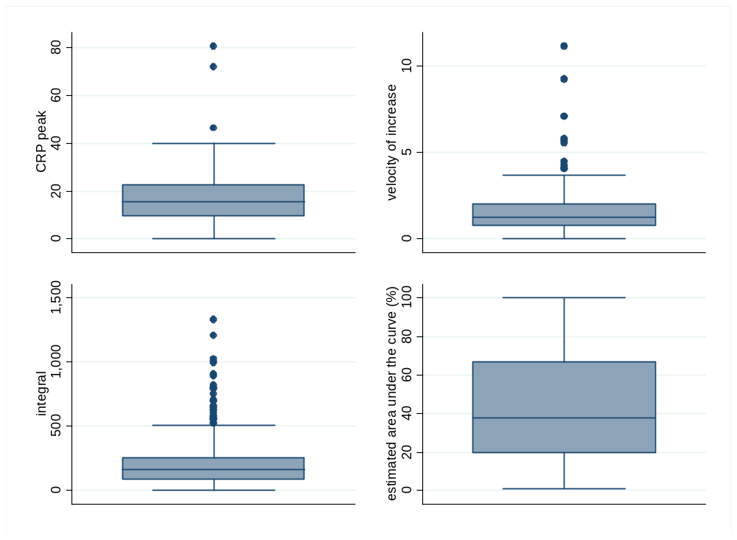

B 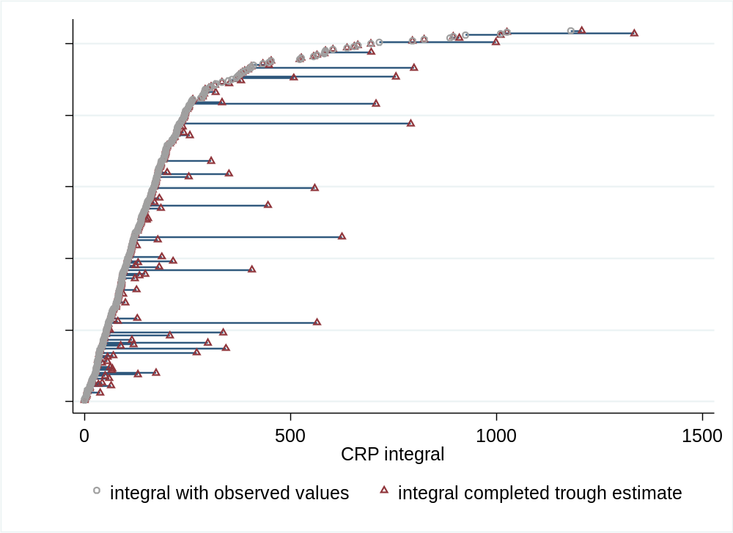

Supplementary Figure 2. Distribution of CRP descriptors (peak, velocity of increase, and integral) and percentage of the curve which was estimated by means of imputation (A). The right tail of the curve was not estimated in 186 (71.8%) patients. In fact, a complete CRP curve (ending value <1 mg/dl) was available in 130 patients, and 56 other patients had an ending value between 1 and 3 mg/dl, which was approximated to 0. Panel B shows integral values with and without adding the right tail.

Supplementary Table 2. Spearman’ correlation between the three CRP curve descriptors

 | Velocity | Peak | Integral
Velocity | 1
Peak | 0.7855 | 1
Integral | 0.5384 | 0.8244 | 1

Supplementary Figure 3

Supplementary Figure 3. Axial (A, B, C) and coronal (D, E, F) CT images showing bilateral consolidations with predominant peripheral distribution at baseline (A, D) and residual abnormalities at 2-3 months (B, E) and 6-7 months (C, F) characterized by subtle ground-glass opacities and peripheral bands becoming progressively less apparent, suggestive of OP sequelae.

Supplementary Figure 4
Supplementary Figure 4. Disease evolution pattern consistent with fibrotic abnormalities (NSIP pattern). Axial (A-B-C) and sagittal (D-E-F) CT images showing patchy ground glass opacities at baseline (A-D), subtle residual ground-glass opacities, and appearance of subpleural reticulation and traction bronchiectasis in upper lobes at 2-3 months (C-D) and at 6-7 months (E-F).

Supplementary Figure 5
Supplementary Figure 5. Axial and sagittal CT images representing changes typical of post-ventilatory damage, characterized by cicatricial emphysema, parenchymal bands, and traction bronchiectasis in the anterior portions of upper lobes.

Supplementary Table 3. Logistic models adjusted for age and sex, including different combinations of CRP curve descriptors (peak, velocity, integral) to predict persistent CT lung abnormalities at 2-3 and 6-7 months.

 | CT lung abnormalities at 2-3 months |  |  |  | CT lung abnormalities at 6-7 months
 | N=259 |  |  |  | N=241
 | OR (95% CI) | R² | AIC | AUROC | OR (95% CI) | R² | AIC | AUROC
 |  | 0.138 | 243.2 | 0.752 |  | 0.120 | 296.0 | 0.723
Peak std | 1.79 (1.23-2.62) |  |  |  | 1.72 (1.27-2.34)
Age | 1.07 (1.04-1.10) |  |  |  | 1.07 (1.04-1.10)
Sex Male | 1 |  |  |  | 1
Female | 0.80 (0.40-1.59) |  |  |  | 0.90 (0.49-1.66)
 |  | 0.109 | 251.3 | 0.726 |  | 0.103 | 301.4 | 0.710
Velocity std | 1.29 (0.94-1.77) |  |  |  | 1.68 (1.16-2.42)
Age | 1.07 (1.04-1.10) |  |  |  | 1.06 (1.04-1.09)
Sex Male | 1 |  |  |  | 1
Female | 0.82 (0.41-1.64) |  |  |  | 0.93 (0.51-1.70)
 |  | 0.134 | 244.4 | 0.757 |  | 0.141 | 289.0 | 0.748
Integral std | 1.64 (1.18-2.29) |  |  |  | 2.24 (1.53-3.28)
Age | 1.07 (1.04-1.10) |  |  |  | 1.06 (1.03-1.09)
Sex Male | 1 |  |  |  | 1
Female | 0.85 (0.42-1.71) |  |  |  | 0.94 (0.51-1.75)
 |  | 0.140 | 244.7 | 0.751 |  | 0.121 | 297.7 | 0.722
Peak std | 2.01 (1.21-3.33) |  |  |  | 1.60 (1.07-2.38)
Velocity std | 0.87 (0.59-1.29) |  |  |  | 1.14 (0.72-1.81)
Age | 1.07 (1.04-1.11) |  |  |  | 1.07 (1.04-1.10)
Sex Male | 1 |  |  |  | 1
Female | 0.76 (0.38-1.54) |  |  |  | 0.91 (0.50-1.68)
 |  | 0.142 | 244.3 | 0.759 |  | 0.142 | 290.8 | 0.746
Peak std | 1.46 (0.84-2.53) |  |  |  | 1.11 (0.73-1.69)
Integral std | 1.26 (0.78-2.04) |  |  |  | 2.02 (1.18-3.47)
Age | 1.07 (1.04-1.10) |  |  |  | 1.06(1.04-1.09)
Sex Male | 1 |  |  |  | 1
Female | 0.83 (0.41-1.68) |  |  |  | 0.94(0.50-1.74)
 |  | 0.137 | 245.6 | 0.756 |  | 0.141 | 290.9 | 0.747
Velocity std | 0.81 (0.51-1.29) |  |  |  | 1.11 (0.70-1.75)
Integral std | 1.90 (1.19-3.04) |  |  |  | 2.13 (1.38-3.31)
Age | 1.07 (1.04-1.10) |  |  |  | 1.6 (1.03-1.09)
Sex Male | 1 |  |  |  | 1
Female | 0.82 (0.41-1.67) |  |  |  | 0.94 (0.51-1.75)
The following variables were included for building the models with a backward strategy: CRP peak, CRP integral, CRP velocity, age, sex. Smoke, asthma, and COPD were also tested but did not improve the models’ performance. Pseudo R², Akaike information criterion (AIC), and area under ROC curve (AUROC) are reported for each model. For standardized variables we report OR for one standard deviation increase of the variable; for age we report the OR for one year increase.

Supplementary Table 4. Sensitivity analyses reporting the models previously selected in the whole population and after excluding patients with CT post-ventilatory damage (n=7) and active smokers (n=4).

 | CT lung abnormalities at 2-3 months |  |  |  | CT lung abnormalities at 6-7 months
 | N | OR (95% CI) | p | AUC | N | OR (95% CI) | p | AUC
Whole population
 | 259 |  |  | 0.752 | 241 |  |  | 0.748
Peak std |  | 1.79 (1.23-2.62) | 0.003
Integral std |  |  |  |  |  | 2.24 (1.53-3.28) | <0.001
Age |  | 1.07 (1.04-1.10) | <0.001 |  |  | 1.06 (1.03-1.09) | <0.001
Sex M |  | 1 |  |  |  | 1
F |  | 0.80 (0.40-1.59) | 0.52 |  |  | 0.94 (0.51-1.75) | 0.84
Excluding patients with CT post-ventilatory changes
 | 252 |  |  | 0.747 | 234 |  |  | 0.740
Peak std |  | 1.74 (1.19-2.55) | 0.004
Integral std |  |  |  |  |  | 2.10 (1.42-3.09) | <0.001
Age |  | 1.07 (1.04-1.10) | <0.001 |  |  | 1.06 (1.03-1.09) | <0.001
Sex M |  | 1 |  |  |  | 1
F |  | 0.79 (0.40-1.59) | 0.52 |  |  | 0.92 (0.49-1.72) | 0.79
Excluding active smokers
 | 255 |  |  | 0.765 | 237 |  |  | 0.755
Peak std |  | 1.88 (1.27-2.78) | 0.002
Integral std |  |  |  |  |  | 2.33 (1.57-3.46) | <0.001
Age |  | 1.08 (1.05-1.11) | <0.001 |  |  | 1.07 (1.04-1.10) | <0.001
Sex M |  | 1 |  |  |  | 1
F |  | 0.79 (0.39-1.59) | 0.50 |  |  | 0.91 (0.49-1.71) | 0.78

OR, odds ratio; CI, confidence interval; AUC, area under the ROC curve.

