Supplementary Information for
Macroscopic and controlled levitation by photoelectric conversion

Dalei Wang, Changsong Zhan, Chenjun Chu, Mingtong Li, Haochen Huang, Hao Yang, Lei Liu, Xinjian Fan, Zhen Hou, Zijun Ye, Jun Zhong, Tao Cheng, Wenqi Hu, Jiwei Jiang, Hui Zhang, Bin Dong, Metin Sitti

Corresponding authors: msitti@ku.edu.tr, bdong@suda.edu.cn, huizhang@suda.edu.cn, jwjiang@suda.edu.cn, mingtong@is.mpg.de

The PDF includes:

Supplementary Figs. 1 to 23
Supplementary Tables 1 to 3

Other Supplementary Materials for this manuscript include the following:

Supplementary Videos 1 to 22

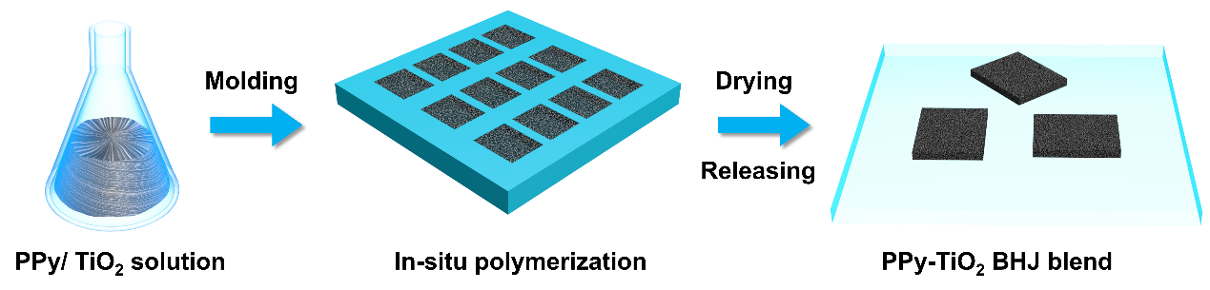

Supplementary Fig. 1. The fabrication process of the PPy/TiO₂ BHJ blend.

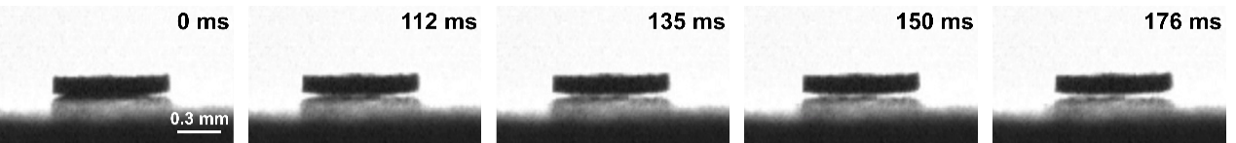
Supplementary Fig. 2. Time-lapse high-speed camera images illustrating the levitation process of the PPy-TiO₂ BHJ blend.

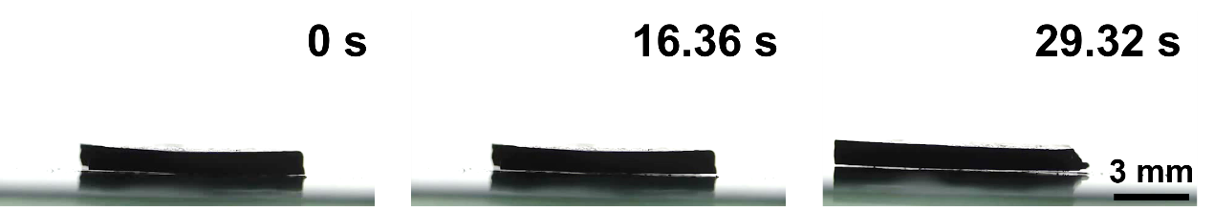
Supplementary Fig. 3. The time-lapse images show the levitation of the PPy-TiO₂ BHJ blend with dimensions at 1 cm × 1 cm × 1 mm.

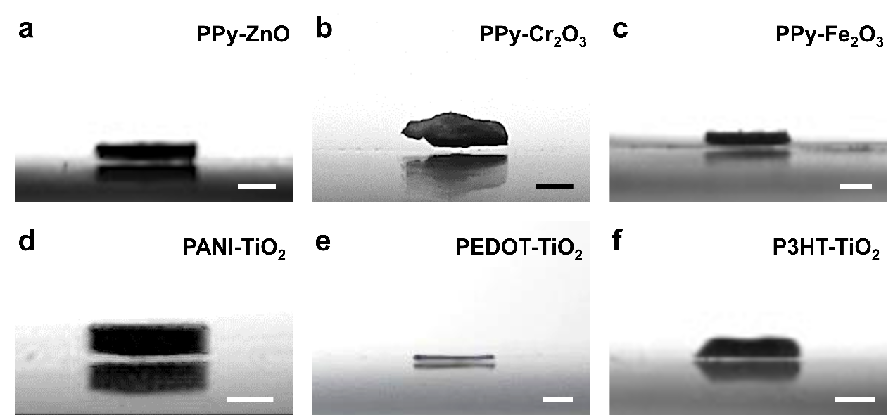
Supplementary Fig. 4. The images show the stable levitation behavior of different donor-acceptor combinations including (a) PPy-ZnO, (b) PPy-Cr₂O₃, (c) PPy-Fe₂O₃, (d) PANI-TiO₂, (e) PEDOT-TiO₂, and (f) P3HT-TiO₂. Scale bars represent 0.3 mm.

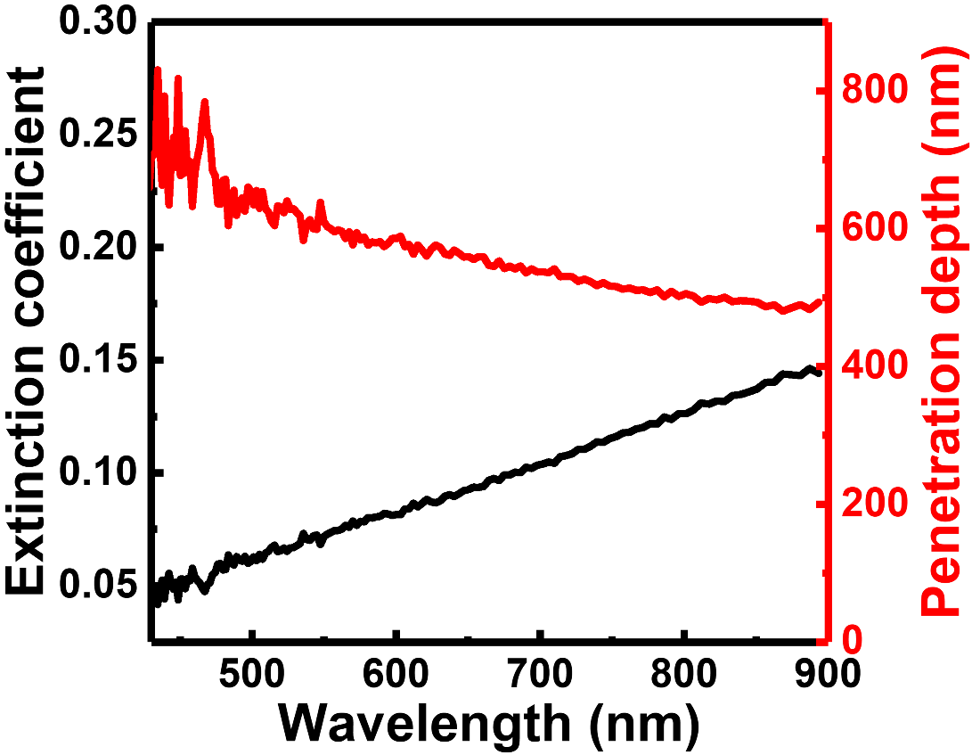
Supplementary Fig. 5. The light extinction coefficient (black line) and penetration depth (red line) inside the PPy-TiO₂ BHJ blend.

To determine the light penetration depth in the PPy-TiO₂ BHJ blend, we measure the extinction coefficient (k) of the blend at different wavelengths using spectroscopic ellipsometry (model: Unisel Plus). The attenuation of light intensity within the material follows the Beer-Lambert law: I(z) = I₀e ^ (-αz), where α is the absorption coefficient, z is the propagation depth, and I(z) is the light intensity at depth z. The optical penetration depth (δ) is typically defined as the depth at which the light intensity decays to 1/e of its initial value, given by: δ = 1/α. The extinction coefficient (k) is related to the absorption coefficient (α) through: α = 4πk/λ. Accordingly, the optical penetration depth is estimated to vary from 450 to 800 nm, depending on the incident wavelength.

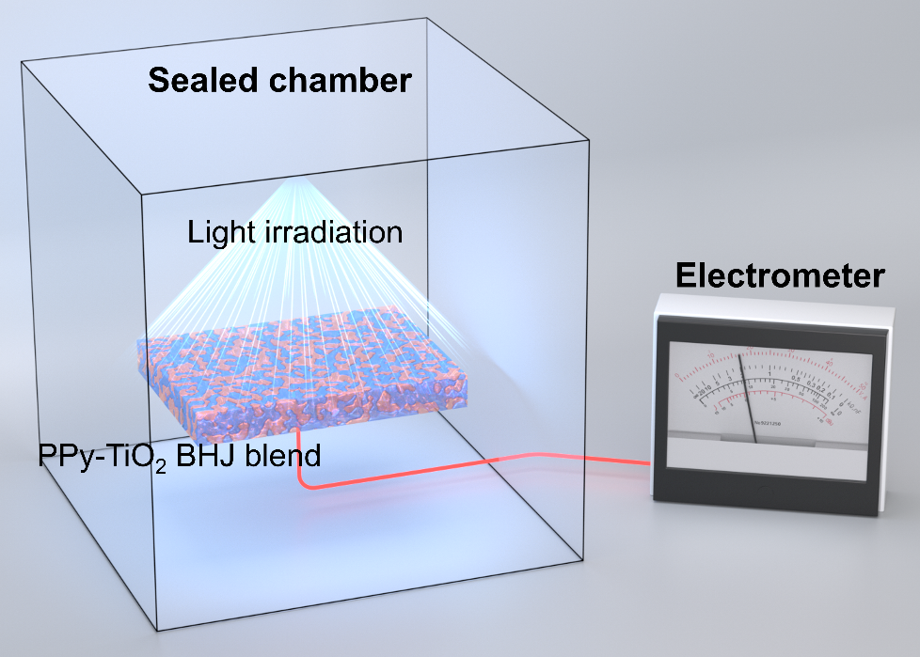
Supplementary Fig. 6. Schematic illustration of the photocurrent measurement setup. Note, light irradiates the top surface of the PPy-TiO2 BHJ blend, while the electrometer contacts the bottom.

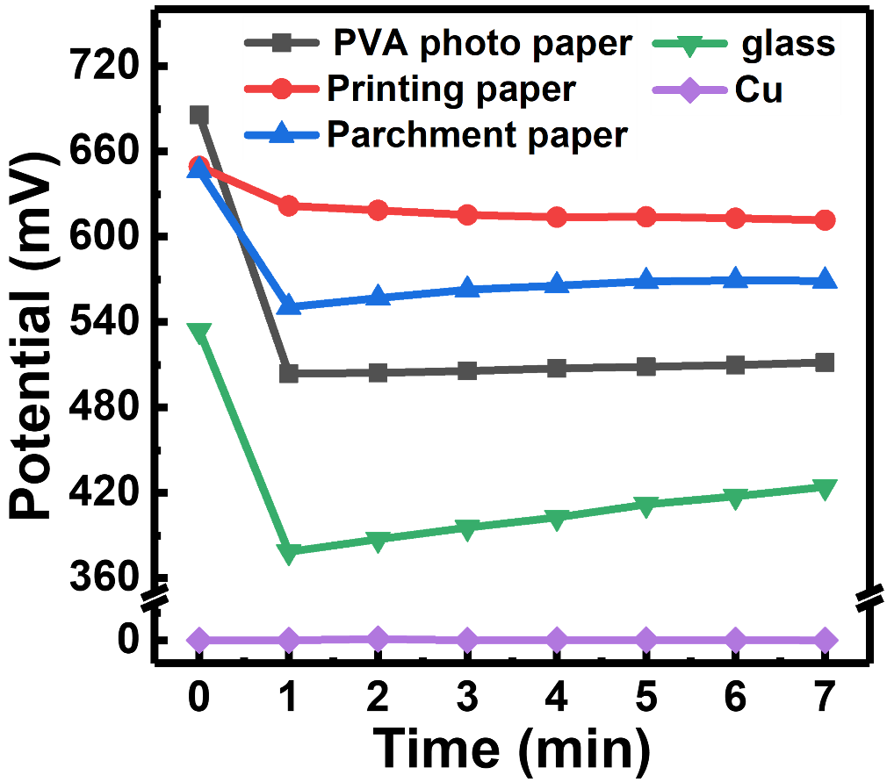
Supplementary Fig. 7. Electron residency of different substrate after contact electrification with the PPy-TiO₂ BHJ blend.

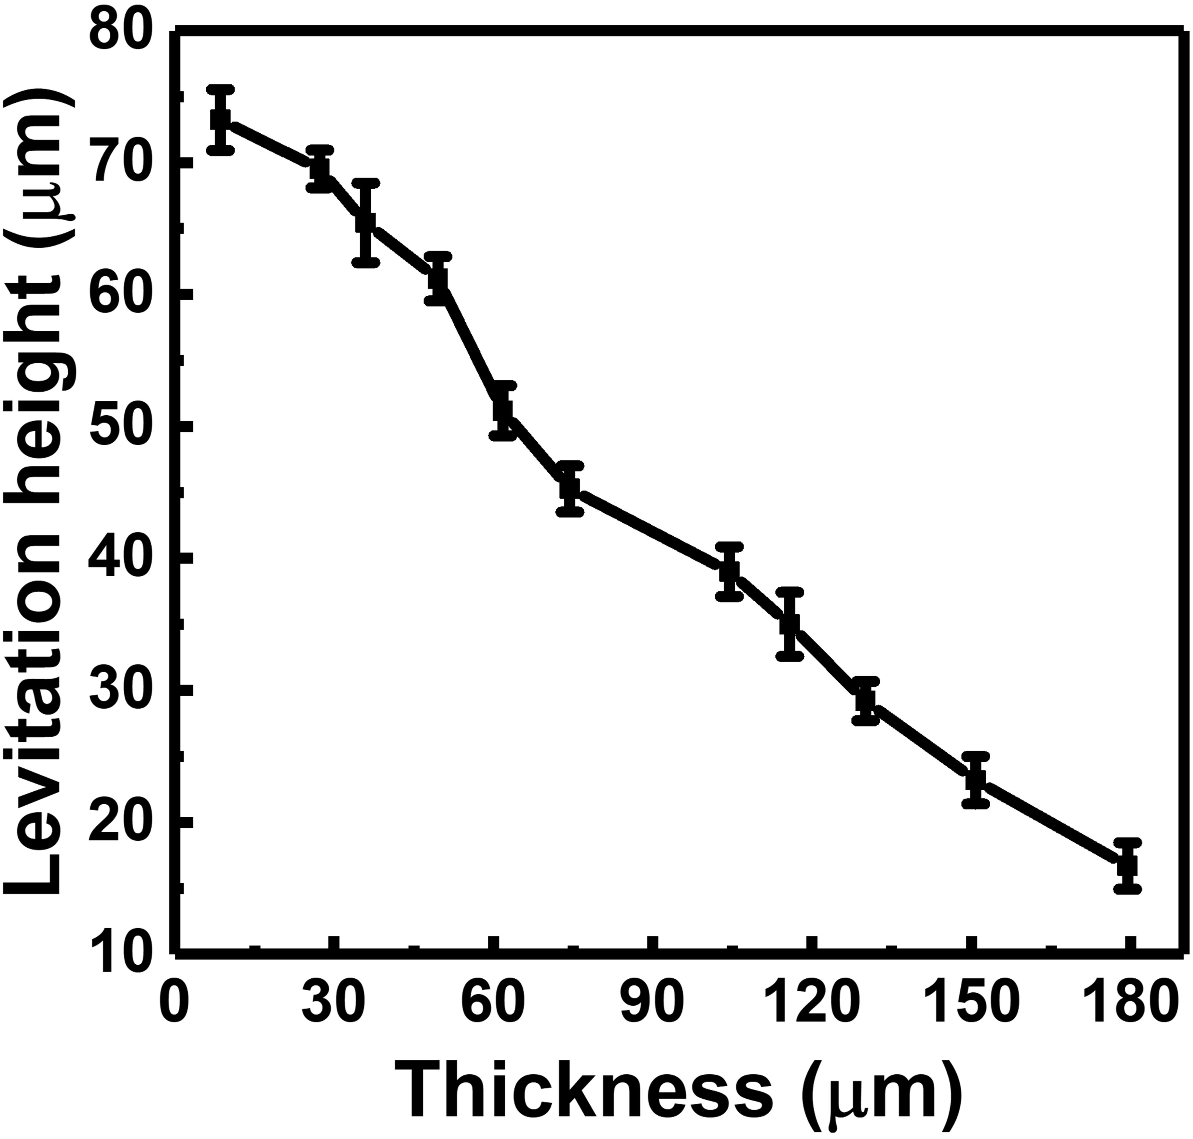
Supplementary Fig. 8. The levitation height of the PPy-TiO₂ BHJ blend with different thickness under the white light irradiation (1.0 W/cm²).

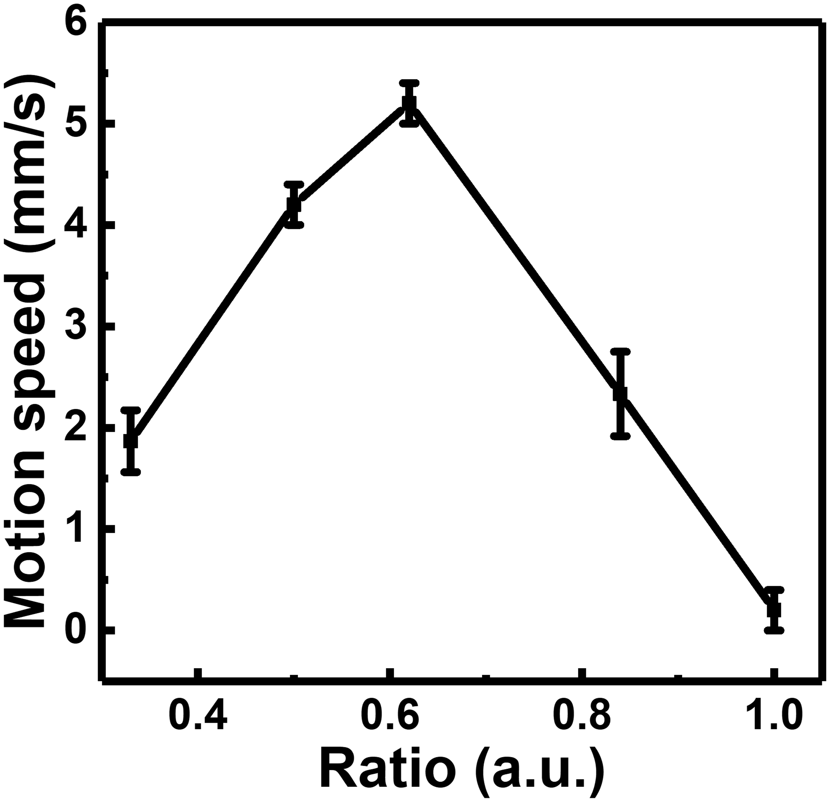
Supplementary Fig. 9. The motion speed of the PPy-TiO₂ BHJ blend with different thickness ratio of left and right sides.

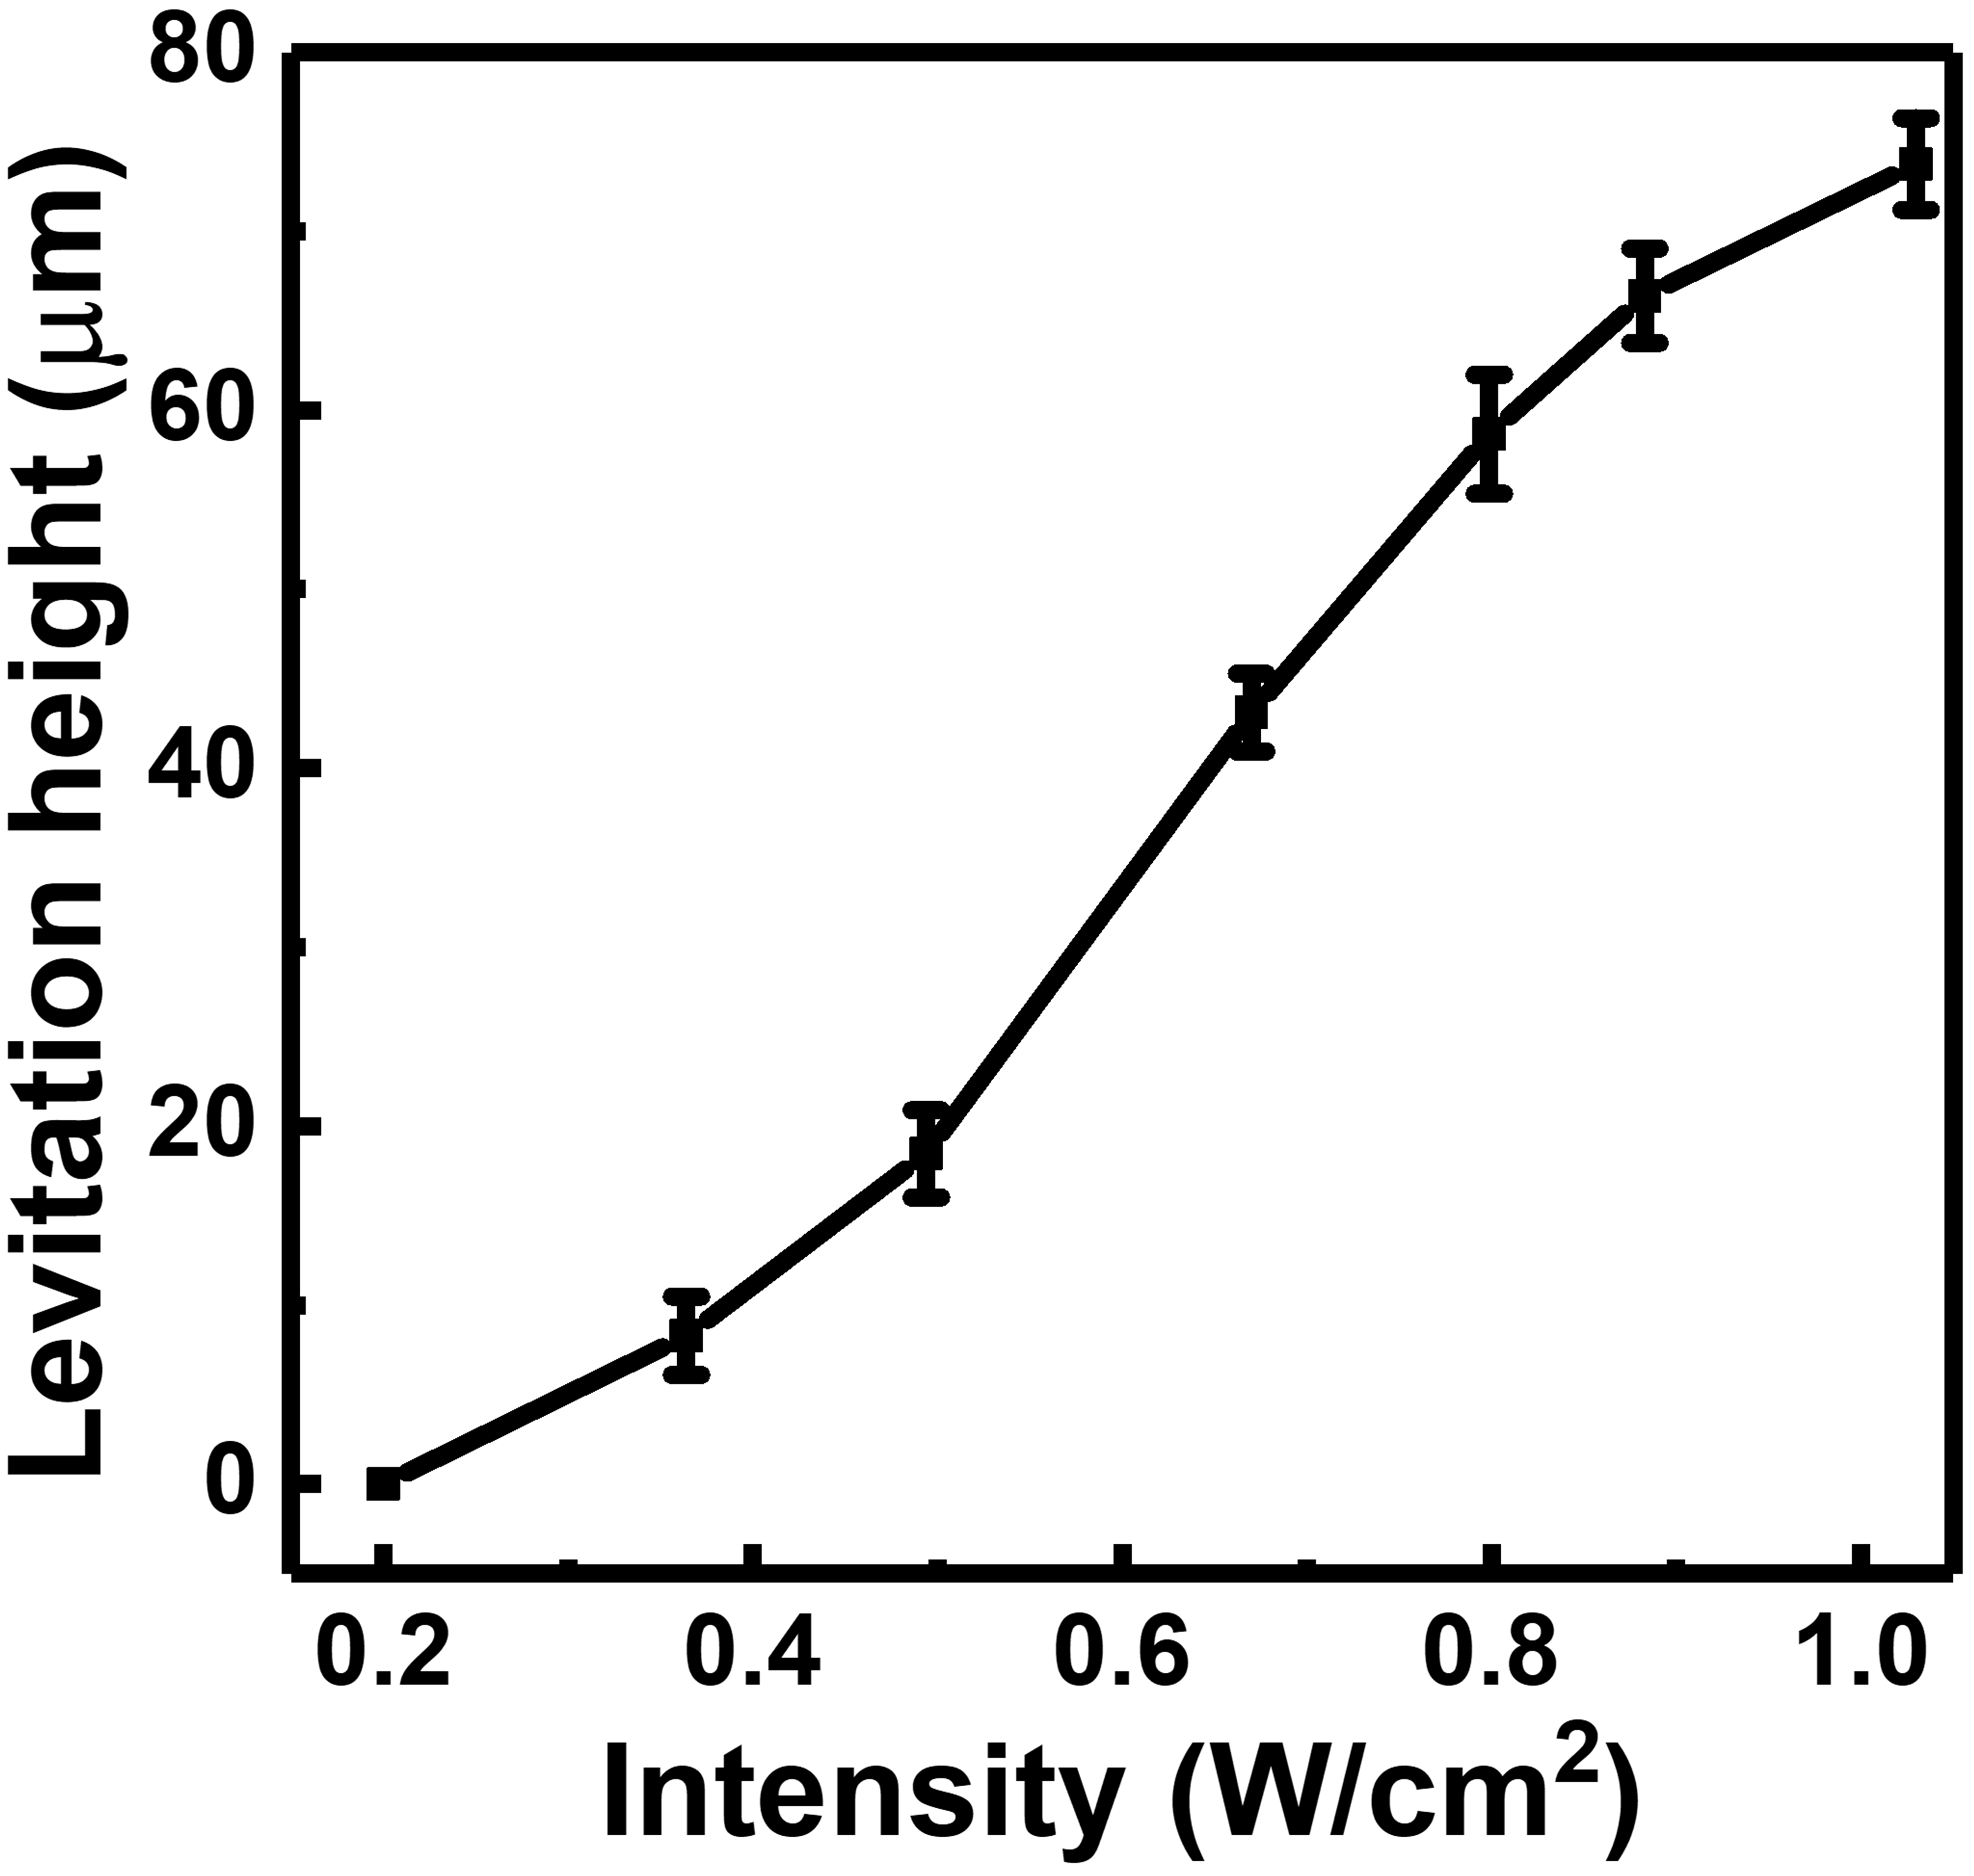
Supplementary Fig. 10. The levitation height of the PPy-TiO₂ BHJ blend with different white light irradiating intensity.

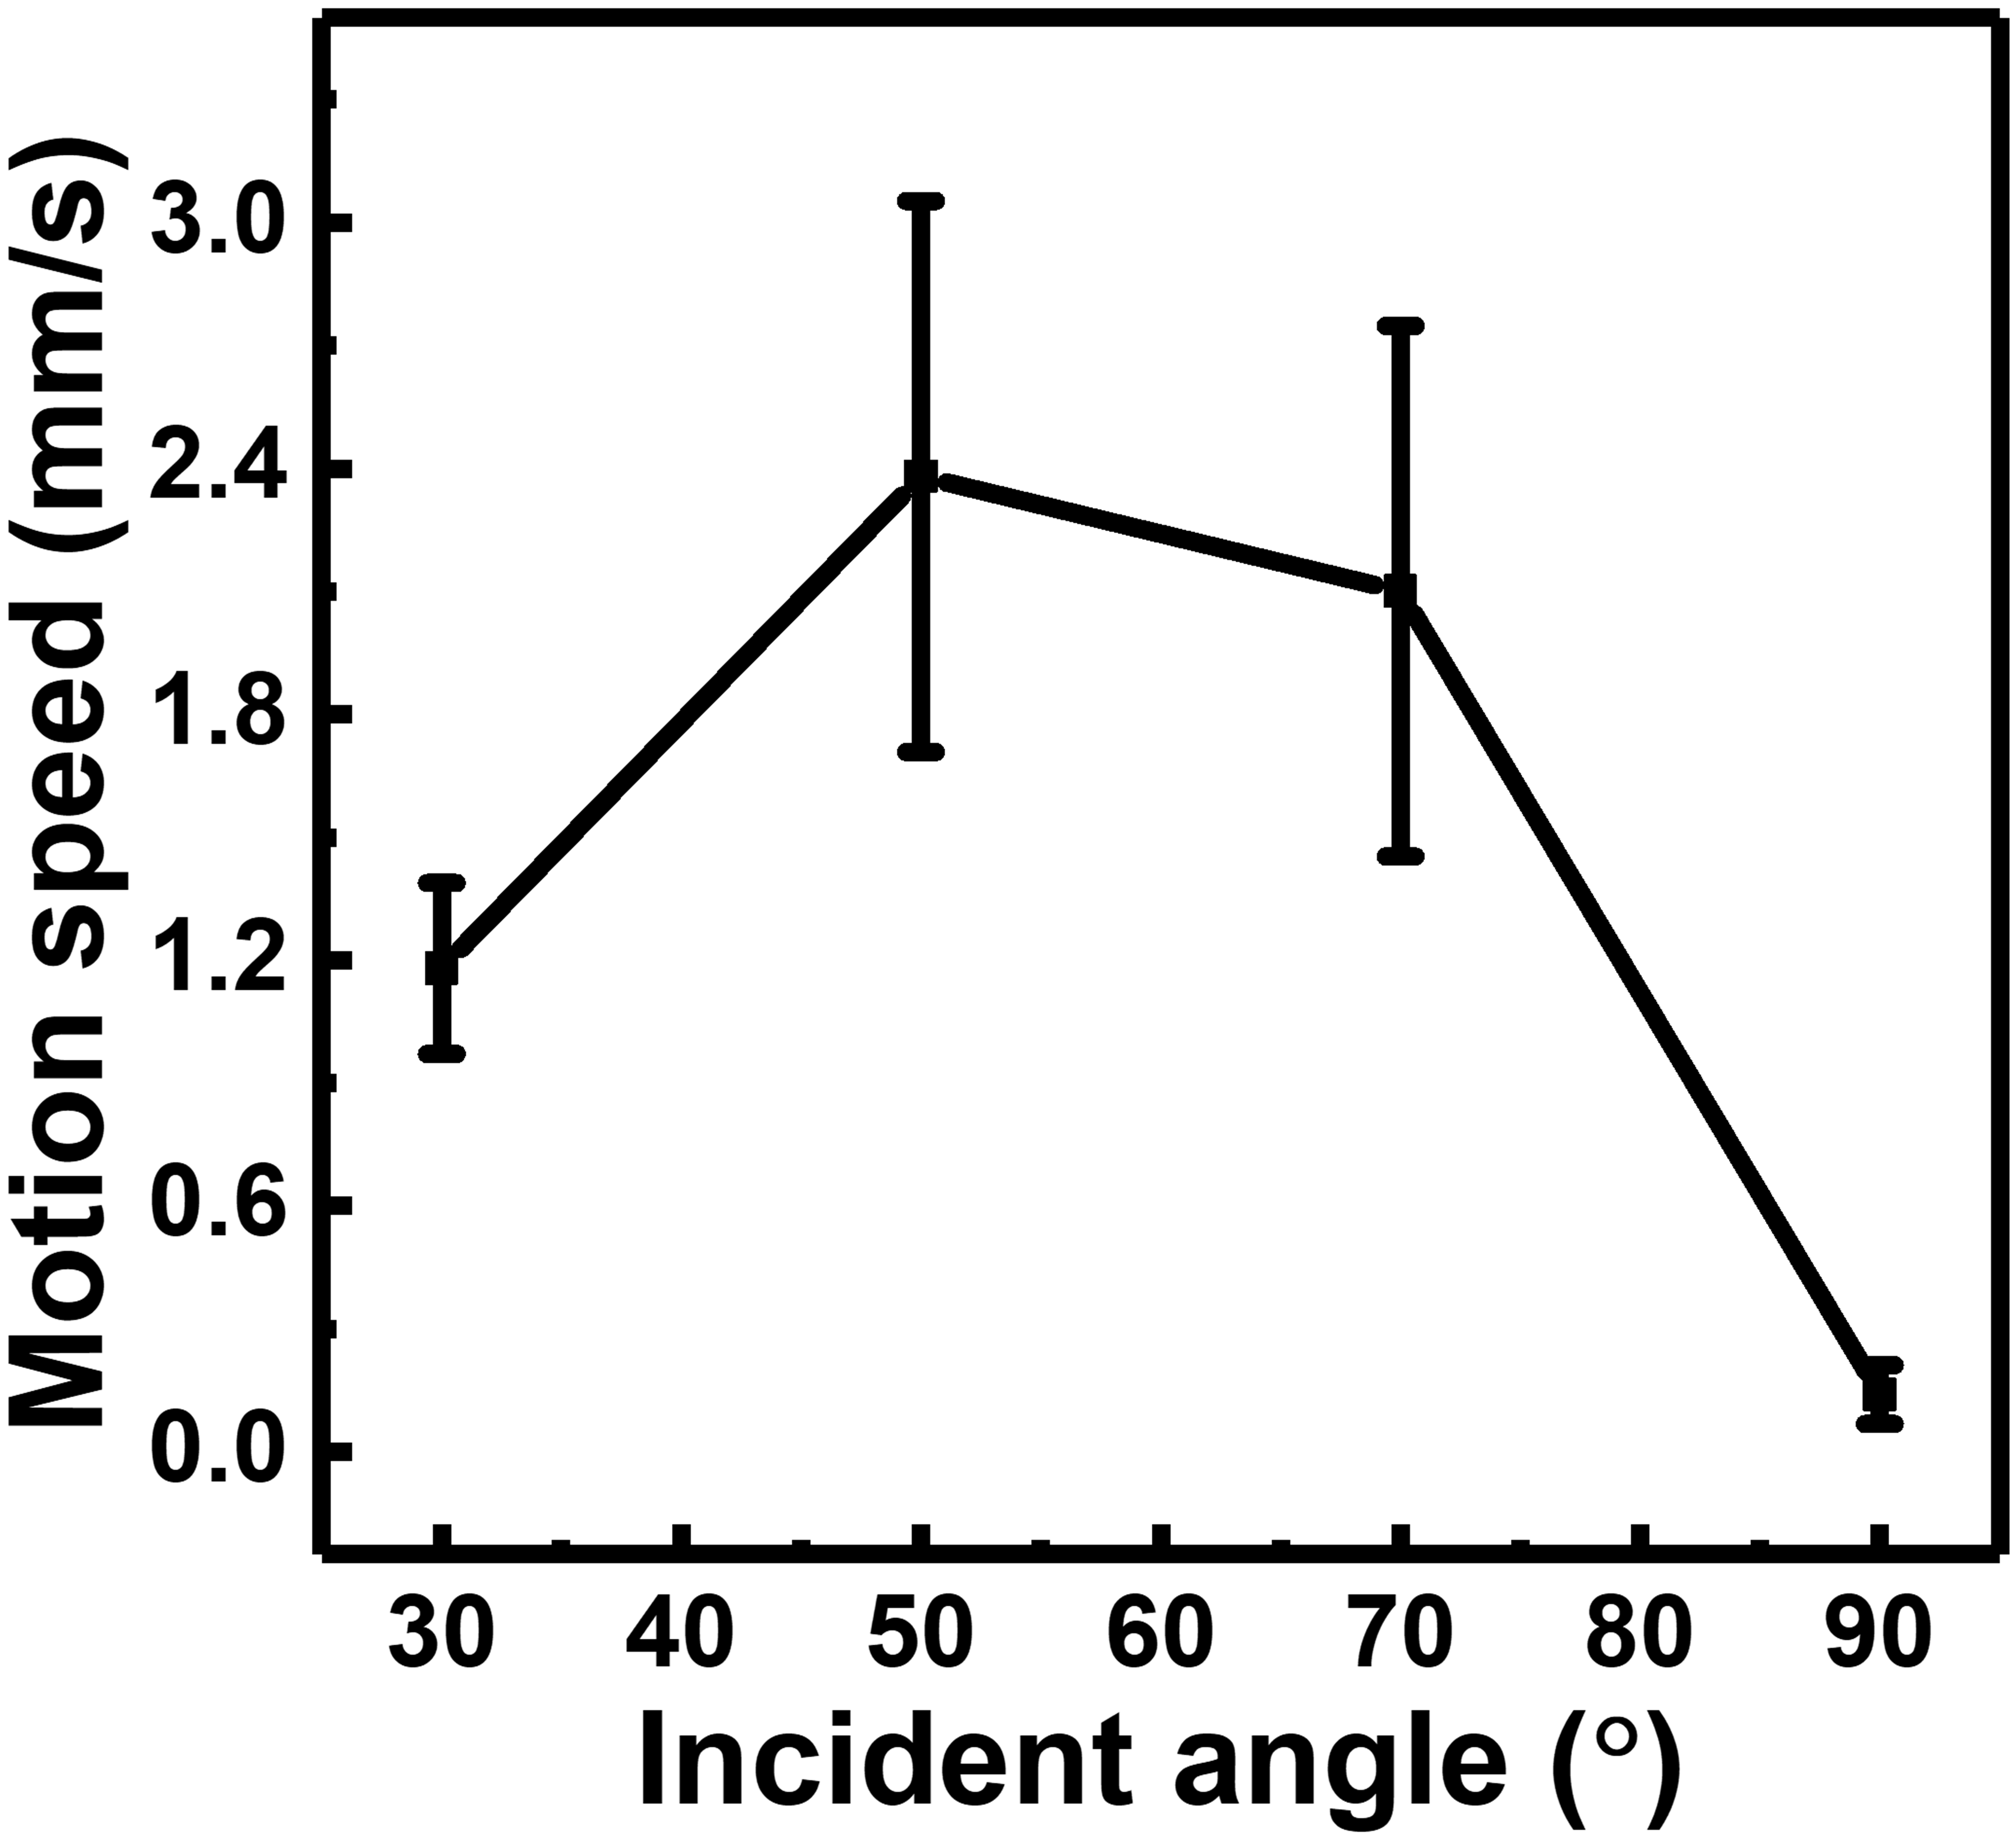
Supplementary Fig. 11. The propulsion velocity of the PPy-TiO₂ BHJ blend under the titled light with different incident angle.

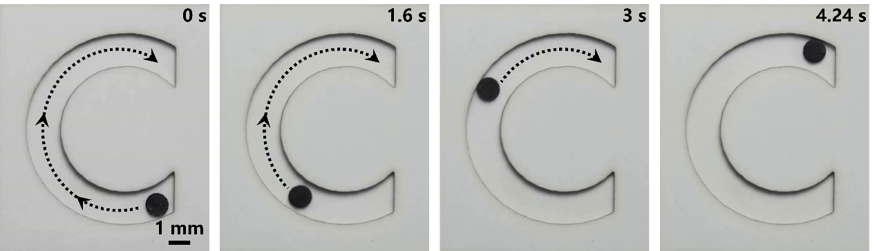
Supplementary Fig. 12. Time-lapse images showing the motion of a circular PPy-TiO₂ BHJ blend confined within C-shaped, following the corresponding C-shaped trajectories under tilted light irradiation.

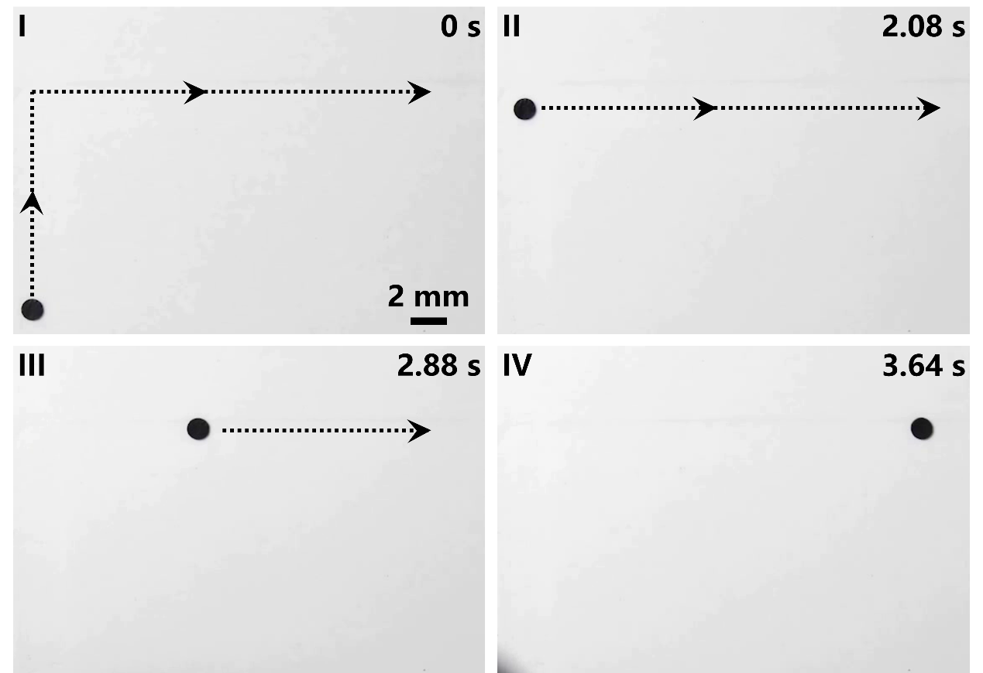
Supplementary Fig. 13. Time-lapse images showing the motion of a circular PPy-TiO₂ BHJ blend confined within L-shaped, following the corresponding L-shaped trajectories under tilted light irradiation.

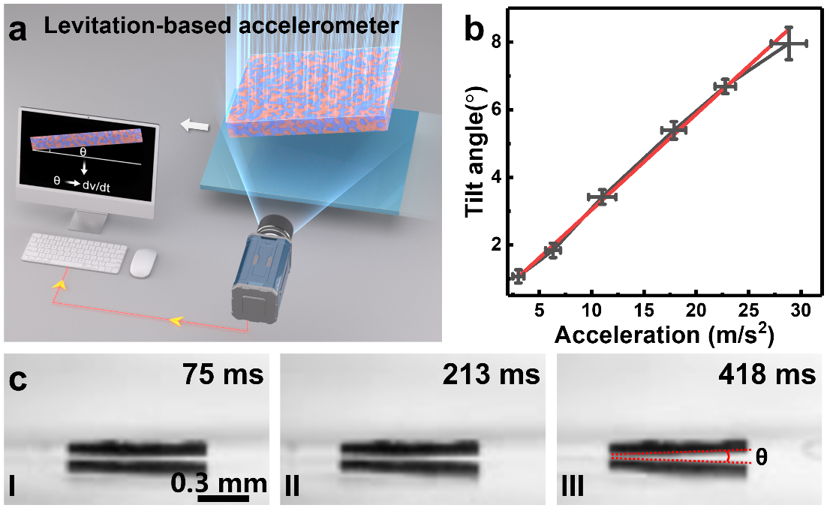
Supplementary Fig. 14. (a) Schematic illustration of the levitation-based accelerometer demonstration. When the base undergoes acceleration, the levitated PPy-TiO₂ BHJ blend tilts in the direction of motion, forming a tilt angle relative to the horizontal plane. The magnitude of this tilt angle exhibits a linear dependence on the applied acceleration. (b) Measured tilt angles under different applied accelerations. The black symbols represent experimental data, and the red curve shows the linear fit. (c) Optical images showing the tilting process of the levitated object during base acceleration.

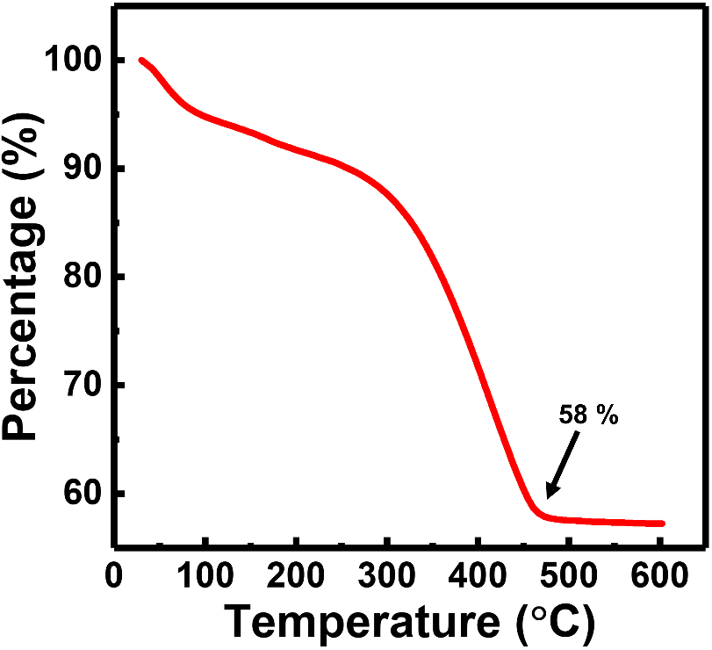
Supplementary Fig. 15. The TGA of the PPy-TiO₂ BHJ blend.

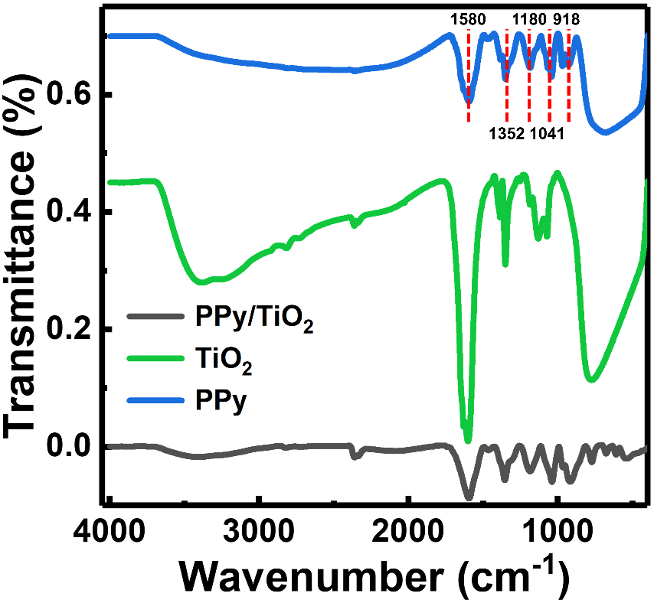
Supplementary Fig. 16. The FTIR spectra of the PPy-TiO₂ BHJ blend, TiO₂ and PPy.

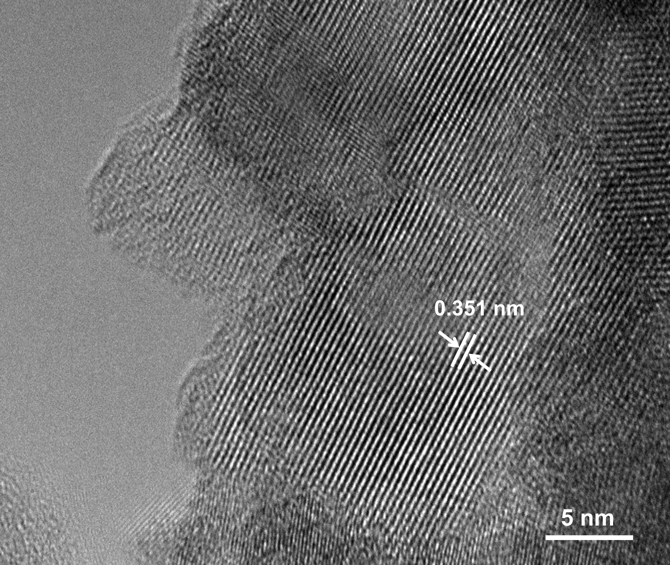
Supplementary Fig. 17. The TEM image of the TiO₂ on the PPy.

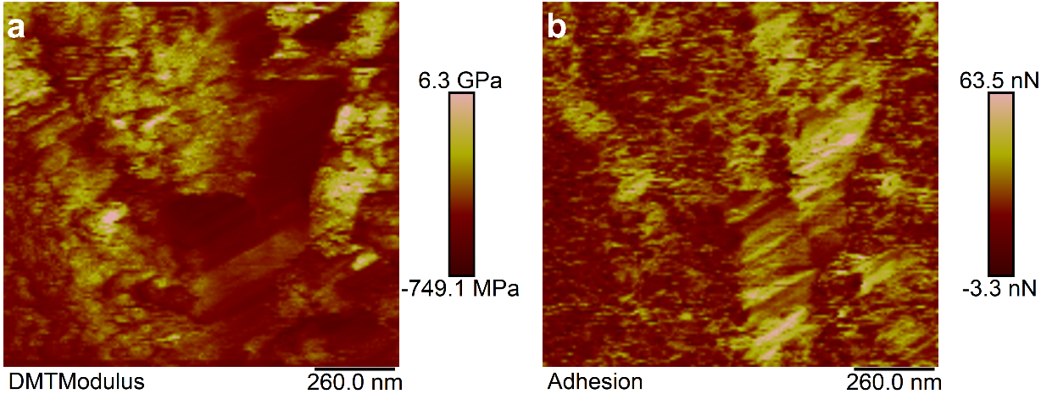
Supplementary Fig. 18. The DMTmodulus and adhesion of the PPy-TiO₂ BHJ blend measured by AFM.

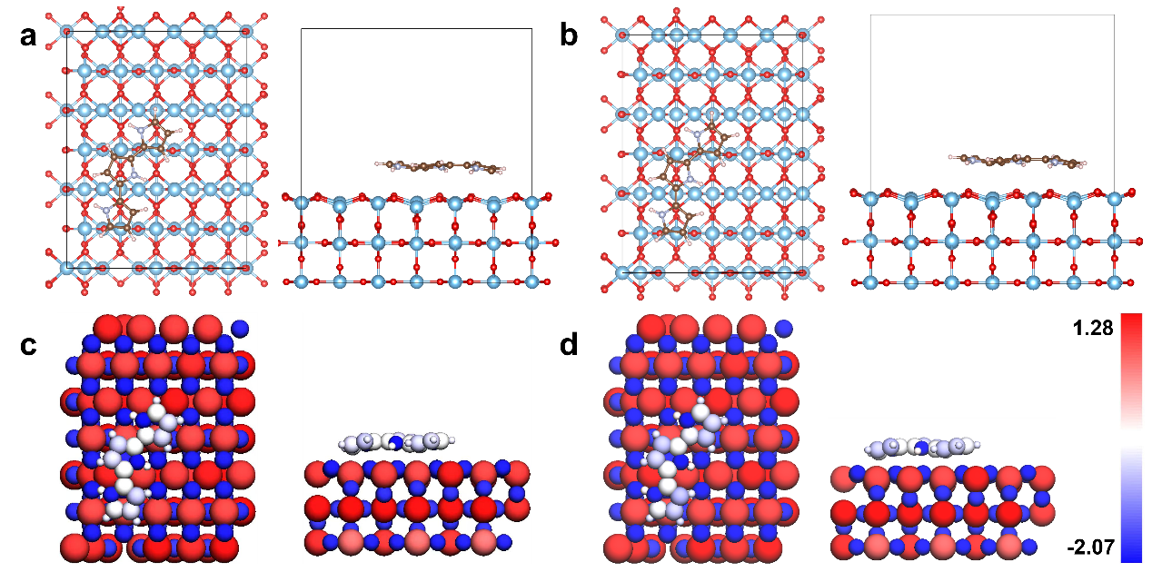
Supplementary Fig. 19. Schematic of the top view and front view of PPy-TiO₂ DFT models a) electrical neutrality and b) one electron deficiency. Bader charge distribution of PPy-TiO₂ for c) electrical neutrality and d) one electron deficiency.

All density functional theory (DFT) calculations were performed using the Vienna Ab initio Simulation Package (VASP). The exchange–correlation interactions were described within the generalized gradient approximation (GGA) using the Perdew-Burke-Ernzerhof (PBE) functional, and the interactions between core and valence electrons were treated using the projector-augmented wave (PAW) method. Long-range dispersion interactions were accounted for by the DFT-D3 method with Becke–Johnson damping.
A plane-wave energy cutoff of 400 eV was employed, and all calculations were spin-polarized. For surface slab models with large supercells, the Brillouin zone was sampled using a Monkhorst–Pack k-point mesh of 1×1×1. To properly describe the localized d electrons of Ti, the Dudarev implementation of the DFT+U method was applied to the Ti 3d orbitals with an effective Hubbard parameter U_{eff} = 4.2 eV, while no U correction was applied to other elements. Periodic slab models were constructed with several atomic layers, in which the bottom layers were fixed to mimic the bulk structure, while the remaining atoms were fully relaxed.
Geometry optimizations were carried out using the conjugate-gradient algorithm until the total energy change was less than 1×10⁻⁵ eV and the residual forces on each atom were below 0.01 eV·Å⁻¹. Harmonic vibrational frequency calculations were performed on the optimized structures using the finite-difference method to confirm that the obtained structures correspond to true minima and to obtain zero-point energy (ZPE) and thermal corrections at 298.15 K. The Gibbs free energy change was evaluated according to ΔG = ΔE + ΔZPE − TΔS, where ΔE is the DFT electronic energy difference, ΔZPE and TΔS are the zero-point energy and entropic contributions, respectively. Solvation effects were included by performing single-point calculations using an implicit solvation model, in which the dielectric constant was set to 78.4 to represent water and the ionic response of the solvent was considered with a Debye screening length of 3.0 Å. No further geometry relaxation was performed in the solvation step, and the solvation-corrected electronic energies were combined with gas-phase geometries and vibrational corrections to obtain the final Gibbs free energies in solution.

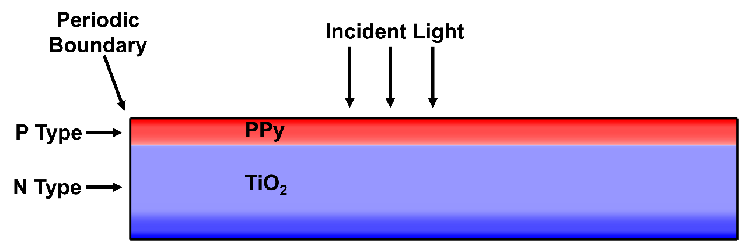
Supplementary Fig. 20. Schematic illustration of simplified 2D FEM PPy-TiO₂ model.

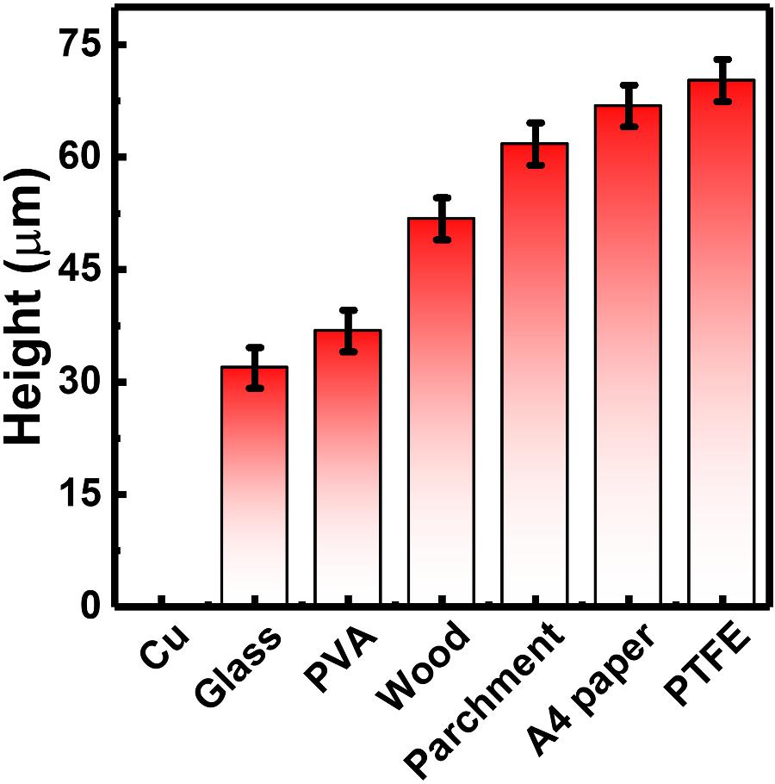
Supplementary Fig. 21. The levitation height of the PPy-TiO₂ BHJ blend on the different substrate under the same intensity white light irradiation (1.0 W/cm²).

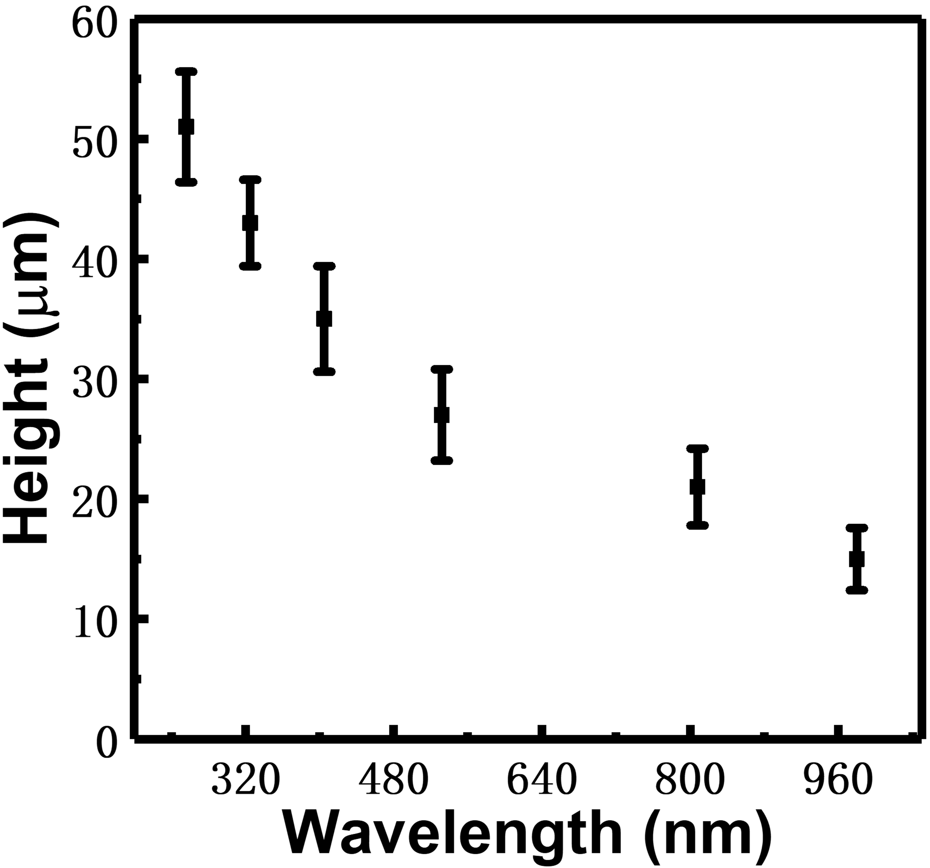
Supplementary Fig. 22. The levitation height of the PPy-TiO₂ BHJ blend under different wavelength light irradiation.

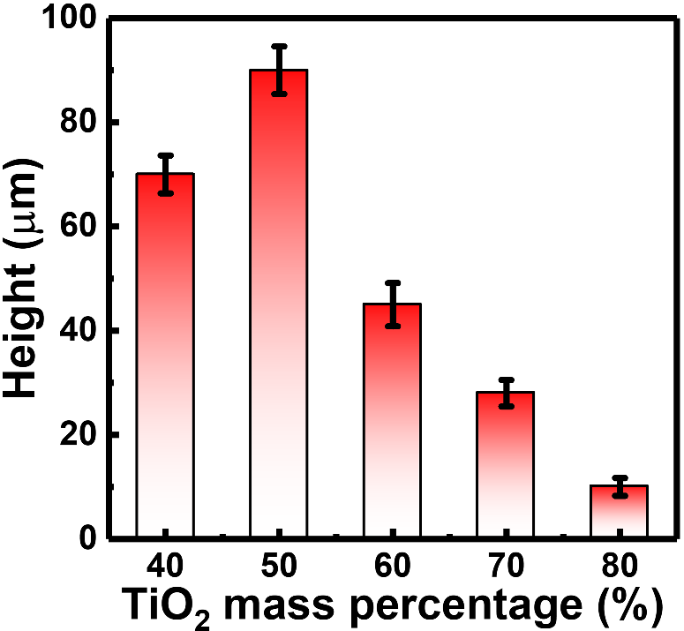
Supplementary Fig. 23. The levitation height of the PPy-TiO₂ BHJ blend with different mass percentage of TiO₂ under the white light irradiation (1.0 W/cm²).

Supplementary Table 1. Bader charge information for non-excited model including average initial, variation, and final value of Bader charge.
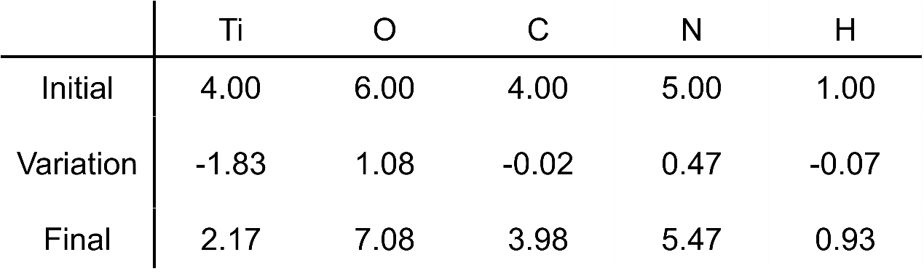

Supplementary Table 2. Bader charge information for one-electron-deficiency model including average initial, variation, and final value of Bader charge.
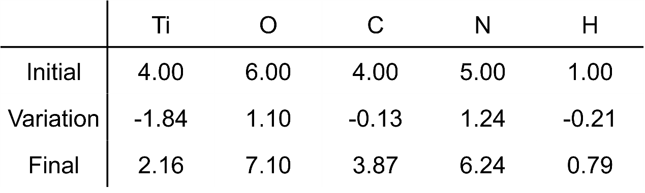

Supplementary Table 3. TiO₂, PPy, and total Bader charge information including initial state, non-excited model and one-electron deficiency model.
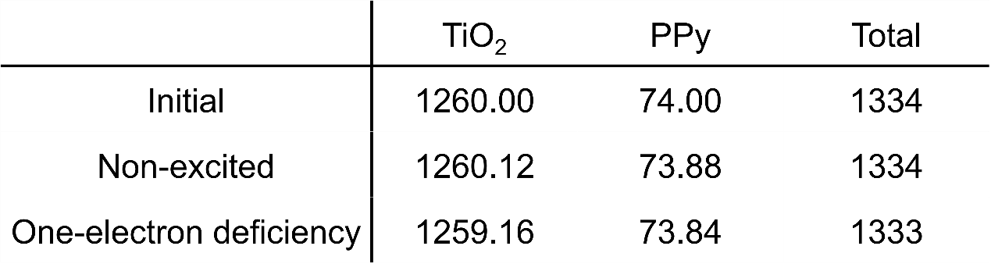

Supplementary Video 1. White-light-driven levitation of the PPy-TiO₂ BHJ blend.
Supplementary Video 2. High-speed video of stable levitation in the PPy-TiO₂ BHJ blend.
Supplementary Video 3. 7-min stable levitation of the PPy-TiO₂ BHJ blend under continuous irradiation.
Supplementary Video 4. Light-induced levitation of a macroscopic PPy-TiO₂ BHJ blend.
Supplementary Video 5. Rightward levitation and propulsion of a laterally tapered structure under vertical irradiation.
Supplementary Video 6. Leftward levitation and propulsion of a laterally tapered structure under vertical irradiation.
Supplementary Video 7. Tilt light-induced directional levitation and propulsion of the PPy-TiO₂ BHJ blend.
Supplementary Video 8. Sun-light driven stable levitation of the PPy-TiO₂ BHJ blend.
Supplementary Video 9. Vertical sun-light driven levitation and propulsion of the PPy-TiO₂ BHJ blend.
Supplementary Video 10. Tilt sun-light driven levitation and propulsion of the PPy-TiO₂ BHJ blend.
Supplementary Video 11. Locomotion of the PPy-TiO₂ BHJ blend confined in C-shaped groove.
Supplementary Video 12. Locomotion of the PPy-TiO₂ BHJ blend confined in S-shaped groove.
Supplementary Video 13. Locomotion of a cyclic PPy-TiO₂ BHJ blend confined in C-shaped groove.
Supplementary Video 14. Locomotion of a cyclic PPy-TiO₂ BHJ blend confined in L-shaped groove.
Supplementary Video 15. Simultaneous tilt light-driven coverage of four PPy-TiO₂ BHJ blends on Au substrates.
Supplementary Video 16. White-light-induced levitation for noise-sensing demonstration.
Supplementary Video 17. Levitation-based accelerometer demonstration.
Supplementary Video 18. Turn-on of the assembled LED device.
Supplementary Video 19. Rightward levitation and propulsion of a commercial LED chip.
Supplementary Video 20. Leftward levitation and propulsion of a commercial LED chip.
Supplementary Video 21. Tilt-light-driven placement of a commercial LED chip into a missing site.
Supplementary Video 22. Light-driven transfer of a PPy-TiO₂ BHJ blend between platforms.

