e-Appendix

e-Methods S1. FDA terminology and definitions related to SaMD

- Device: An FDA “device” is defined as a distinct entity based on the combination of manufacturer name, device trade name, and primary product code. Types of radiological software-enabled devices are described in e-Table S1.
- Submission: A submission is the application package sent to FDA from a device manufacturer (e.g., a 510(k)); submissions sharing all three identifiers, manufacturer name, device trade name, and primary product code, are grouped under the same device.
- Types of FDA reviews:
510(k): A 510(k) is a premarket submission made to FDA to demonstrate that the device to be marketed is as safe and effective, that is, substantially equivalent, to a legally marketed device (section 513(i)(1)(A) FD&C Act). Submitters must compare their device to one or more similar legally marketed devices and make and support their substantial equivalence claims [Link].

De novo (DEN): The De Novo request provides a marketing pathway to classify novel medical devices for which general controls alone, or general and special controls, provide reasonable assurance of safety and effectiveness for the intended use, but for which there is no legally marketed predicate device. De Novo classification is a risk-based classification process [Link].

Premarket approval (PMA): Premarket approval (PMA) is the most stringent type of FDA process of scientific and regulatory review to evaluate the safety and effectiveness of Class III medical devices. Class III devices are those that support or sustain human life, are of substantial importance in preventing impairment of human health, or which present a potential, unreasonable risk of illness or injury. Due to the level of risk associated with Class III devices, FDA has determined that general and special controls alone are insufficient to assure the safety and effectiveness of Class III devices. Therefore, these devices require a premarket approval (PMA) application under section 515 of the FD&C Act in order to obtain marketing approval [Link].

Breakthrough device program: Devices subject to premarket approval applications (PMAs), 510(k) or De Novo classification are eligible for Breakthrough Device designation if the device meets both of the following criteria [Link], e-Table S2.

- Public summary:
510(k) Application summary: A summary of the information on which the vendor/submitter and FDA based the substantial equivalence claim.
De Novo Decision summary: FDA’s decision letter is intended to present an objective and balanced summary of the scientific evidence that served as the basis for FDA’s decision to grant a De Novo request.
- Cleared vs approved vs authorized:
Cleared = 510(k) substantially equivalent order;
Granted= through the De Novo regulatory approval
approved = PMA approval based on sufficient valid scientific evidence of safety/effectiveness;
authorized = Emergency Use Authorization (EUA) to use unapproved products/uses during emergencies when criteria are met.
- Drift: Performance deviations/degradation over time; Drift can be defined as (i) technical (data/model shift), (ii) clinical (use/population/workflow shift), (iii) operational (integration/uptime/process factors), aligned to FDA’s lifecycle monitoring emphasis.
- Transparency: The degree to which appropriate information about an ML-enabled device (intended use, development, performance, and, when available, logic/explainability) is clearly communicated to relevant audiences.
- Human-in-the-loop : Human-in-the-loop in the context of automated device class refers to device designs requiring clinician review of AI outputs before clinical action is taken, as opposed to fully autonomous systems

e-Table S1. Types of Radiology Software-enabled devices

Type of device | FDA Definition | Product  Code(s) | Classification
Image management & processing | To provide automated radiological image processing and analysis tools. Software implementing artificial intelligence including nonadaptive machine learning algorithms trained with clinical and/or artificial data. In these devices, the algorithm training data typically impacts device performance. Adaptive AI algorithms are not within scope of this product code. | LLZ,  QIH  [Link] | 21 CFR 892.2050
Image acquisition and guidance | A radiological acquisition and/or optimization guidance system is a device that is intended to aid in the acquisition and/or optimization of images and/or diagnostic signals. The device interfaces with the acquisition system, analyzes its output, and provides guidance and/or feedback to the operator for improving image and/or signal quality. | QJU  [Link] | 21 CFR 892.2100
Image detection-adjunct devices (CADe) | CADe devices are computerized systems that incorporate pattern recognition and data analysis capabilities (i.e., combine values, measurements, or features extracted from the patient radiological data) and are intended to identify, mark, highlight, or in any other manner direct attention to portions of an image, or aspects of radiology device data, that may reveal abnormalities during interpretation of patient radiology images or patient radiology device data by the intended user (i.e., a physician or other health care professional), referred to as the “clinician”. | NWE, OEB, OMJ  [Link] | 21 CFR 892.2050
Image detection- diagnostic devices (CADx) | CADx devices are computerized systems intended to provide information beyond identifying, marking, highlighting, or in any other manner directing attention to portions of an image, or aspects of radiology device data, that may reveal abnormalities during interpretation of patient radiology images or patient radiology device data by the clinician. CADx devices include those that are intended to provide an assessment of disease or other conditions in terms of the likelihood of the presence or absence of disease, or are intended to specify disease type (i.e., specific diagnosis or differential diagnosis), severity, stage, or intervention recommended. | POK  [Link] | 21 CFR 892.2060
Image detection adjunct-diagnostic combined (CADe/x) | CADe/x devices are computerized systems intended to provide information beyond identifying, directing attention, that may reveal abnormalities during interpretation of patient radiology images by the clinician and also intended to provide an assessment of disease or other conditions in terms of the likelihood of the presence or absence of disease, or are intended to specify disease type (i.e., specific diagnosis or differential diagnosis), severity, stage, or intervention recommended. | QBS,  QDQ  [Link] | 21 CFR 892.2090
Image detection triage and notification devices (CADt) | Computer-triage devices are computerized systems intended to, in any way, reduce or eliminate any aspect of clinical care currently provided by a clinician, such as a device for which the output indicates that a subset of patients (i.e., one or more patients in the target population) are normal and therefore do not require interpretation of their radiological data by a clinician. | QAS, QFM  [Link] | 21 CFR 892.2080

e-Table S2. Criteria defined for the Breakthrough Device Program

Criteria | Description
First Criterion | The device provides for more effective treatment or diagnosis of life-threatening or irreversibly debilitating human disease or conditions
Second Criterion | The device also meets at least one of the following:  - Represents Breakthrough Technology  - No Approved or Cleared Alternatives Exist  - Offers Significant Advantages over Existing Approved or Cleared Alternatives  - Device Availability is in the Best Interest of Patients

e-Methods S2. Data sources and search strategy
Device identification and descriptive analyses were based on the FDA AI/ML-enabled medical device list accessed in April 2026 [Link]. Records were filtered to Radiology as the lead panel and restricted to final decision dates between 2015 and 2025.
Devices were categorized as Software as a Medical Device (SaMD)/AI, Hardware, or Other using product-code lists and device-name keyword matching (regular expressions for AI terms [e.g., “artificial intelligence,” “machine learning,” “deep learning”] and hardware indicators [e.g., “CT,” “MRI,” “ultrasound”]). A device was defined as a distinct entity based on the combination of manufacturer name, device trade name, and primary product code; submissions sharing all three identifiers were grouped under the same device, with the most recent submission retained as the canonical record for device-level sequential analyses. Submission-level analyses retained all records including multiple submissions from the same device. Multiple submissions from the same device were identified and consolidated to derive unique device counts. Device-count with PRISMA-ScR flow is described in e-Table S1.
Full database-specific query strings and filters are summarized in e-Table S2. Extracted charted fields using a standardized template is described in e-Table S3.

e-Table S3. PRISMA-ScR flow (device identification from FDA list)
Counts below reflect device records (submission numbers) extracted from the FDA AI/ML-enabled device list.
Step | Records (n) | Notes / exclusions
Records identified from FDA AI/ML-enabled device list (2015-2025) | 1394 | Total AI/ML devices list
Records excluded | 314 | Non-Radiology lead panels
Radiology AI/ML-enabled submissions included in analysis | 1080 | Total Radiology submissions including multiple submissions
Radiology AI/ML-enabled unique devices included in analysis | 870 | Multiple submissions from the same device consolidated to derive unique device counts
Radiology single submissions | 740 | Excluded devices with multiple submissions

e-Table S4. Data sources and reproducible query framework
Data source | Purpose | Reproducible query / filters (summary) | Key outputs captured
FDA AI/ML-enabled medical device list | Primary sampling frame for AI/ML-enabled devices | Filter: Panel (lead) = Radiology; Final decision date = 2015-01-01 to 2025-12-31; Accessed 2026-04-01  Note: A few devices that are arguably AI/ML but likely cleared as SaMD algorithm rather than "AI/ML-based SaMD" per FDA's specific definition, did not appear in the FDA AI/ML list. | Submission number, device name, company, panel, primary product code, date of final decision
FDA Non AI/ML-enabled medical device list From FDA 510(k), De Novo and PMA database | Primary sampling frame for non- AI/ML-enabled devices | Filter: Panel (lead) = Radiology; Final decision date = 2015-01-01 to 2025-12-31; Accessed 2026-04-01  Filters: Traditional hardware (CT, MRI, Ultrasound)  Exclusion: Software-enabled”, “Software-as-a-medical-device (SaMD), Artificial Intelligence, Machine Learning, Deep Learning | Submission number, device name, company, panel, primary product code, date of final decision
FDA 510(k) database (public) | Confirm regulatory records; retrieve 510(k) application summary when available | Lookup by submission number or device/manufacturer | 510(k) application summary; intended use; indications; labeling; update history (if described)
FDA De Novo database (public) | Confirm De Novo records and retrieve decision summary when applicable | Lookup by De Novo number or device/manufacturer | De Novo decision summary; intended use; special controls (if listed)
FDA PMA database (public) | Confirm PMA approvals for included tools when applicable | Lookup by PMA number or device/manufacturer | PMA summary/statement; labeling; post-approval study requirements (if applicable)

e-Table S5. Device-level data charting template (fields and definitions)
Field | Definition | CSV / entry
Submission number | Unique FDA submission identifier (e.g., K-number, DEN, PMA). | Submission Number
Device name | Commercial device name as listed by FDA. | Device
Manufacturer | Company name as listed by FDA. | Company
Lead panel | FDA lead review panel. | Panel (lead)
Primary product code | FDA product code (when listed). | Primary Product Code
Date of final decision | FDA final decision date for the submission. | Date of Final Decision
Year of clearance/decision | Derived from date of final decision. | Year
Sequential updates evidence | Evidence of iterative updates (e.g., sequential submissions, release notes). | Dataset- multiple submissions
PCCP utilization tier | PCCP-explicit / no public PCCP evidence | PCCP-devices
Core performance metrics reported | AUROC, sensitivity, specificity, PPV/NPV, calibration, etc. | PCCP-devices
Monitoring / trigger thresholds described | Whether thresholds/metrics triggering change are publicly described. | PCCP-devices

Note: Several charted fields (e.g., PCCP tier, performance metrics and core monitoring triggers) required manual abstraction from Individual 510(k) application and De Novo decision summaries. Trade names are used solely for identification based on public FDA documents and do not imply endorsement or comparative judgment.

e-Methods S3. Screening, adjudication, and agreement reporting
PCCP identification showed greater initial variability (31 vs 39 candidate devices) and was finalized by K-number–level adjudication of FDA 510(k) application and De Novo Decision summaries (final n=34).
Initial PCCP identification using the FDA AI/ML device database revealed discrepancies with individual 510(k) application and De Novo decision summaries. Surprisingly, Nine of the PCCP authorized devices had “No” in PCCP authorized tab in the 510k premarket notification despite the application summary authorized for the PCCP (K243065, K241350, K241561, K240417, K241891, K243250, DEN190040, K201992, DEN220063). Notably, Two of the devices were cleared for PCCP inadvertently from FDA (ex. K233692, K231837), later corrected with revision letters. To ensure accuracy, all devices flagged as potential PCCP candidates underwent manual review of the official De Novo decision and 510(k) application summaries. Final PCCP status was determined hierarchically: (1) explicit PCCP description in De Novo Decision and 510(k) application summary, (2) database classification. One device (K234009) was confirmed PCCP-cleared per 510(k) application summary but lacked PCCP description in the summary- later included in the subsequent summary K252103.
We identified Seven radiology AI devices (K251408, K242467, DEN230023, DEN190040, DEN220040, K212616, K231094) in our cohort with FDA Breakthrough Device marketing authorization, including 2 within the PCCP subset (e-Table S4 below); because Breakthrough designation is administered through a separate FDA program, it was verified against the FDA Breakthrough Devices list rather than individual 510(k) summaries, where it was not consistently stated.

e-Table S6. Breakthrough Devices within FDA AI/ML-enabled list

Submission Number | Trade Name | Manufacturer | Decision Date
DEN190040  (PCCP-cleared) | Caption Guidance | Bay Labs, Inc. | February 7, 2020
K212616 | Koios DS | Koios Medical, Inc. | December 16, 2021
K231094 | Annalise Enterprise CTB Triage-OH | Annalise-AI Pty Ltd | August 15, 2023
DEN220040  (PCCP-cleared) | Fibresolve | Imvaria, Inc | January 12, 2024
DEN230023 | Rho | 16 Bit Inc | April 9, 2024
K242467 | IQ-UIP | Imbio, Inc. | December 19, 2024
K251408 | OsteoSight™ Hip (v1) | Naitive Technologies Ltd | September 2, 2025

e-Methods S4: Development and operationalization of the PCCP documentation completeness rubric (0–8 points, 4 domains)
The rubric was developed to assess the completeness and transparency of PCCP-related information in publicly available FDA summaries, not the full internal quality of sponsor submissions. It was derived from the FDA’s final PCCP guidance, which defines three core components: Description of Modifications, Modification Protocol, and Impact Assessment, and emphasizes that public-facing documents should provide sufficient transparency on planned modifications, validation methods, performance requirements, and user communication.
Because the FDA guidance is written for full marketing submissions, whereas this study evaluated only public summaries, we operationalized the guidance into four observable domains: PCCP specificity; data and validation transparency; real-world/local evaluation; and post-market monitoring/update procedures. This framework was intended as a pragmatic transparency tool, not a replacement for the FDA’s three official PCCP components. Domain 1 reflects modification description and overall specificity; Domains 2 and 3 reflect data, representativeness, and validation elements of the Modification Protocol; and Domain 4 reflects update procedures, monitoring, and parts of the Impact Assessment. Undocumented elements were scored as absent. The rubric therefore evaluates publicly visible lifecycle transparency, not the scientific adequacy of the PCCP itself.

e-Table S7. Mapping of rubric domains to FDA PCCP guidance

Rubric domain | Operational definition used in this study | FDA PCCP component covered | FDA guidance mapping [4]
Domain 1. PCCP specificity | Whether the public summary clearly described the planned modifications, the associated validation methodology, and the anticipated impact/risk-control approach, with sufficient specificity to understand what changes were authorized | Description of Modifications + Impact Assessment | FDA states that a PCCP should include a Description of Modifications, Modification Protocol, and Impact Assessment, and recommends that planned modifications be specific, verifiable, and linked to performance evaluation activities (Section V.A, pp. 10-11; Section VI.B, pp. 21-22).
Domain 2. Data and validation transparency | Whether the public summary reported characteristics of training/tuning/test data, population representation, study design, performance metrics, and acceptance criteria | Modification Protocol | FDA recommends that the Modification Protocol describe data management practices and performance evaluation methods, including representativeness of intended use populations, sequestered test data, study design, performance metrics, and predefined acceptance criteria (Section VII.B.1 and VII.B.3, pp. 25-30).
Domain 3. Real-world/local evaluation | Whether the public summary described testing in local or intended-use environments, multi-site or heterogeneous data sources, and evidence that reflected current clinical populations or workflows | Modification Protocol | FDA recommends that data be representative of intended use populations and environments, including identifiable subpopulations, and that older data be complemented or replaced by newer data so performance remains representative of the current patient population and standard of care (Section VII.B.1, pp. 25-28).
Domain 4. Post-market monitoring and update procedures | Whether the public summary described how updates would be deployed (automatic vs manual), communicated to users, versioned/labeled, and monitored after implementation, including surveillance or drift-related triggers when available | Modification Protocol + Impact Assessment | FDA’s update procedures section states that manufacturers should describe whether changes will be implemented automatically or manually, how users will be informed, and their post-market surveillance plans and procedures, which may include real-world monitoring and notification requirements if the device does not function as intended. The guidance also notes that retraining practices may identify triggers such as when new data reach a certain size or when drift in data is observed over time (Section VII.B.4, pp. 27-28).

e-Table S8. The methodology framework for scoring the documentation of 510k application and De Novo decision summaries

Total score: 0-8 points
Rule: If an element is not described in publicly available FDA summaries, score 0 for that element.
Domain | Basis of Evaluation | Scoring Criteria
Domain 1: PCCP Documentation Specificity | Based on the quality of PCCP documentation.  Specific: The PCCP details planned device modifications, the associated methodology to develop, validate, and implement those modifications, and an assessment of the impact of those modifications.  Generic: describe broad concepts without planned modifications or defined validation criteria or impact assessment. Lack of benefit-risk analysis and risk-mitigation strategies.  Ex. Acorn 3D software (K234009) does not define or mention PCCP plan- scored as Zero  Ex. BoneMRI (K233030) does not detail rigorous methodology for modifications or mention an assessment of impact and no benefit-risk analysis or risk-mitigation strategies laid out- scored as One | 2 pts: Specific  1 pt: Generic  0 pts: Not defined / not described
Domain 2: Data + Validation Transparency | Based on data collected transparently (detailed reporting of demographics and site/scanner distribution)+ quality of studies conducted (independent test set, metrics and well-defined ground truth methods included).  Ex.Clarify DL (K241350) does mention the site of clinical testing but does not document the metrics and ground truth methods- scored as one | 2 pts: Both are "yes"  1 pt: One is "yes"  0 pts: Neither described / yes
Domain 3: Local Evaluation + Real world evidence | Based on testing in clinical health systems (dataset from intended-use environment / practice-representative evaluation) + real-world evidence (used retrospective data acquired from multiple sites dealing with real-world cases and techniques).  Ex. InferOperate Suit (K250237) does not mention the retrospective real world evaluation of the dataset- scored as one | 2 pts: Both are "yes"  1 pt: One is "yes"  0 pts: Neither described / yes
Domain 4: Post-Market Monitoring and update Plan | Based on post-market continuous monitoring mentioned + Real-time update mechanism present  Ex. Mammoscreen BD (K241561) mentions monitoring of the clinical sites post market and mentions real-time alerts for any deviations of the modifications- scored as two | 2 pts: Both are "yes"  1 pt: One is "yes"  0 pts: Neither described / yes

e-Methods S5. Statistical analysis of Inter-rater reliability for rubric scoring
Inter-rater reliability of PCCP documentation quality scoring between two independent reviewers was assessed using three complimentary approaches:
1. two one-sided tests (TOST) with pre-specified bounds of ±1 point on the 8-point rubric;
2. absolute agreement via Bland–Altman analysis to characterize the magnitude and distribution of score differences; and
3. reliability via Intraclass correlation coefficient (ICC) (using two-way mixed-effects for absolute agreement, single measurement), with thresholds of ICC >0.75 and mean bias not statistically different from zero prespecified as acceptable.
Agreement was excellent across all approaches: TOST confirmed the mean difference (0.29) fell within the equivalence margin (p < 0.001); Bland–Altman analysis revealed minimal systematic bias (mean bias 0.29; p = 0.057; 95% LoA: −1.41 to 2.00); and ICC confirmed excellent reliability (ICC = 0.93; 95% CI: 0.87–0.96; p < 0.001), supporting consistent scoring with minimal clinically meaningful disagreement.

e-Table S9. Inter-rater reliability results using TOST, Bland Altman Analysis and ICC

Method | Statistic | Value
Equivalence (TOST) | Mean difference (Obs1 − Obs2) | 0.29
Equivalence (TOST) | SD of differences | 0.87
Equivalence (TOST) | Equivalence bounds | −1 to +1
Equivalence (TOST) | p‑value (lower bound test) | < 0.001
Equivalence (TOST) | p‑value (upper bound test) | < 0.001
Bland–Altman | Mean bias | 0.29
Bland–Altman | SD of bias | 0.87
Bland–Altman | 95% lower limit of agreement | −1.41
Bland–Altman | 95% upper limit of agreement | 2
Bland–Altman | p‑value (bias ≠ 0) | 0.057
Intraclass Correlation Coefficient (ICC) | ICC estimate | 0.93
Intraclass Correlation Coefficient (ICC) | 95% CI | 0.87 to 0.96
Intraclass Correlation Coefficient (ICC) | p‑value (ICC = 0) | < 0.001

e-Table S10- Specialty wise PCCP adoption for AI/ML and non-AI/ML devices from 2020-2025.

 | Total (%) | AI/ML (%) | Non-AI/ML (%)
Radiology | 37 (21.8) | 34 | 3
Cardiology | 39 (22.9) | 9 | 30
Neurology | 11 (6.5) | 6 | 5
Anesthesiology | 4 (2.4) | 4 | 0
Others | 79 (46.5) | 2 | 77
Total PCCP devices during study period | 170 (1.0) | 55 (5.7) | 115 (0.7)
Total devices cleared within study period | 16,527 (100) | 961 (100) | 15566 (100)

e-Table S11- Domain-specific scores for each PCCP device.

Device | Submission number | PCCP Specificity | Data collected transparently | Quality of studies conducted | Local testing done | Real-world evidence | Post-market continuous monitoring | Real-time update mechanism present
Caption Guidance | DEN190040 | not defined | no | yes | no | no | no | no
Caption Guidance | K201992 | not defined | no | yes | no | no | no | no
Caption Interpretation Automated Ejection Fraction Software | DEN220063 | specific | yes | yes | yes | yes | no | no
BoneMRI | K233030 | generic | yes | yes | yes | yes | no | no
Clarius OB AI | K233955 | specific | yes | yes | yes | yes | no | no
Acorn 3D Software (AC-SEG-4009); Acorn 3DP Model (AC-101-XX) | K234009 | not defined | no | no | no | no | no | no
AI Platform 2.0 (AIP002) | K240953 | specific | yes | yes | yes | no | no | no
AiMIFY (1.x) | K240290 | specific | yes | yes | yes | yes | no | no
Overjet Charting Assist | K241684 | generic | yes | no | no | no | no | no
FETOLY-HEART | K241380 | specific | yes | yes | yes | yes | no | no
MammoScreen BD | K241561 | specific | yes | yes | yes | yes | yes | yes
ProFound Detection V4.0 | K240417 | generic | yes | yes | yes | yes | no | no
Clarify DL | K241350 | generic | yes | no | no | no | no | no
ScreenDx ILD | K241891 | specific | yes | yes | yes | yes | no | no
Cardiac Guidance | K243065 | specific | no | yes | no | no | no | no
SubtleHD | K243250 | specific | yes | yes | yes | yes | no | no
syngo Dynamics (Version VA41D) | K242551 | generic | yes | yes | yes | no | no | no
HeartFocus (V.1.1.1) | K242807 | specific | yes | yes | yes | no | no | no
Clarius Prostate AI | K243853 | specific | yes | yes | yes | no | no | no
BrightHeart View Classifier | K243684 | specific | yes | yes | yes | yes | no | no
Clarius Median Nerve AI | K250226 | specific | yes | yes | no | yes | no | no
BrightHeart View Classifier | K251456 | specific | yes | yes | yes | yes | yes | no
MammoScreen 4 | K243679 | specific | yes | yes | yes | yes | no | no
HeartFlow Analysis | K250902 | specific | yes | yes | yes | no | no | no
MammoScreen BD | K243685 | specific | yes | yes | yes | yes | no | no
VELMENI | K250753 | specific | yes | yes | yes | yes | yes | no
MuscleView 2. | K251682 | specific | yes | yes | yes | yes | no | no
FETOLY | K251368 | specific | yes | yes | yes | yes | no | no
InferOperate Suit | K250237 | specific | yes | yes | yes | no | no | no
Axial3D Insight | K250369 | specific | yes | yes | yes | no | no | no
Fibresolve | K252041 | specific | yes | yes | yes | yes | no | no
a2z-Unified-Triage | K252366 | specific | yes | yes | yes | yes | no | no
UltraSight Guidance | K251416 | specific | yes | yes | yes | yes | no | no
PVAD IQ Software | K252235 | specific | yes | yes | yes | no | no | no

* This device was noted as PCCP-cleared in the FDA decision summary but lacked publicly available PCCP documentation in the 510(k) summary, precluding quality assessment. This case was excluded from documentation scoring but retained in the overall PCCP count.

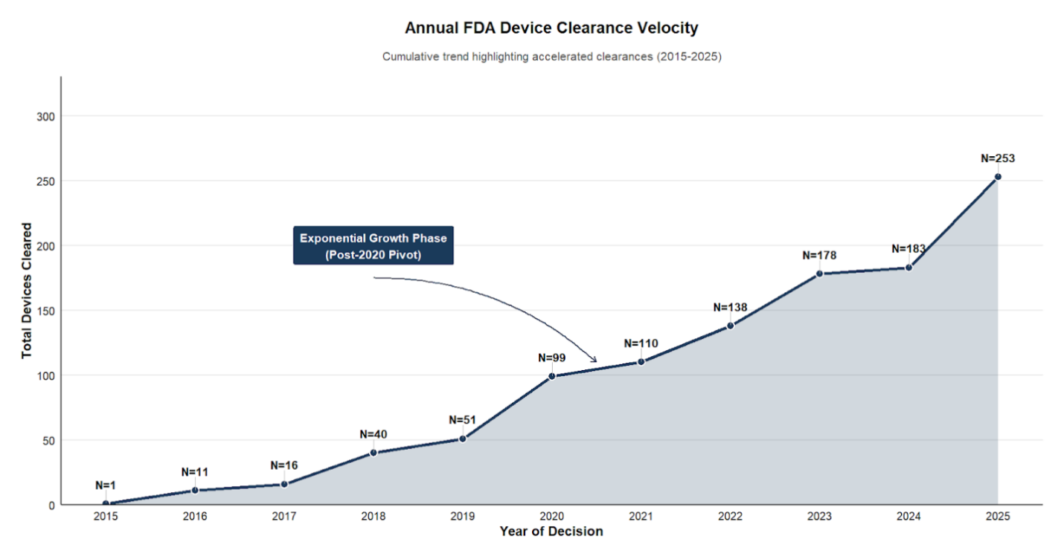
e-Figure S1. Cumulative FDA Clearance Trend for AI/ML-Enabled Radiology Devices (2015--2025). An area chart illustrating the cumulative count of annual FDA clearances for AI/ML-enabled radiology devices from 2015 to 2025. The figure displays a steadily rising trend, with total cumulative clearances increasing from N=1 in 2015 to N=253 in 2025. A distinct acceleration is visible after 2020 (N=99), designated as an 'Exponential Growth Phase' with annual cumulative counts of 110, 138, 178, 183, and 253 through 2025.

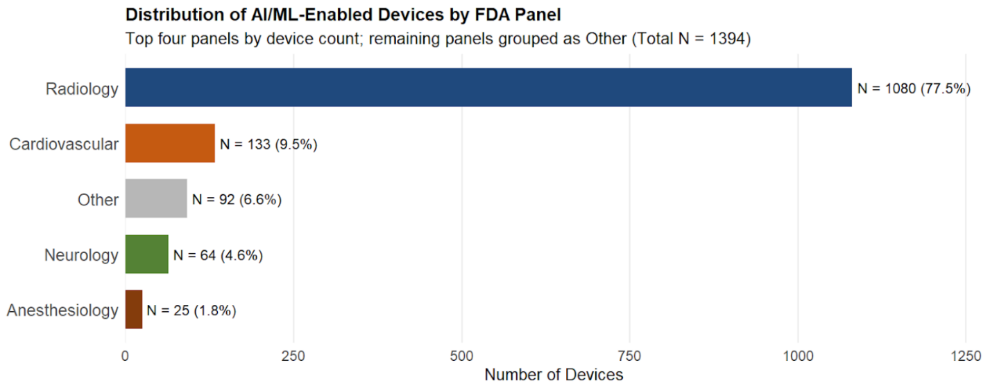
e-Figure S2. Distribution of FDA-Cleared AI/ML-Enabled Medical Devices by Specialty Panel (2015–2025). A horizontal bar chart illustrating the distribution of total AI/ML-enabled device clearances (N=1,394) categorized by FDA medical specialty panels over the study period. The chart highlights the top four panels by device count, with all other remaining panels aggregated into an 'Other' category. Radiology dominates the clearance landscape, accounting for 77.5% (N=1,080) of all AI/ML-enabled submissions. This is followed distantly by Cardiovascular devices at 9.5% (N=133), Neurology at 4.6% (N=64), and Anesthesiology at 1.8% (N=25). The aggregated 'Other' category comprises 6.6% (N=92) of total clearances.

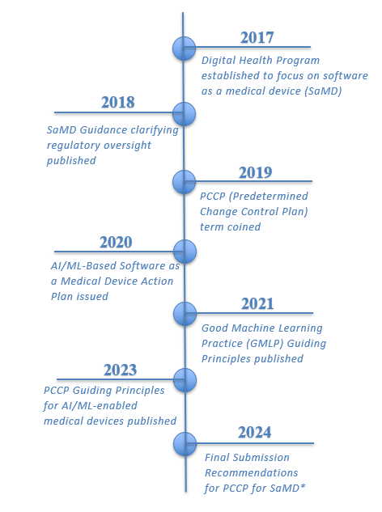
e-Figure S3. Evolution of the FDA’s Approach to Software as a Medical Device (SaMD) and Predetermined Change Control Plans (2017–2024). A chronological timeline detailing key regulatory milestones in the FDA's oversight of AI/ML-enabled devices. The timeline traces the progression from the establishment of the Digital Health Program in 2017 to the introduction of the PCCP concept in 2019, followed by foundational action plans and guiding principles (2020–2023). The timeline culminates with the publication of the Final Submission Recommendations for PCCPs in 2024.

* The 2024 guidance was administratively re-issued in August 2025. This re-issuance updated the legal basis for the AI definition from the revoked Executive Order 14110 to the permanent statutory definition under the National AI Initiative Act (15 U.S.C. 9401(3)), without altering the structural PCCP framework.

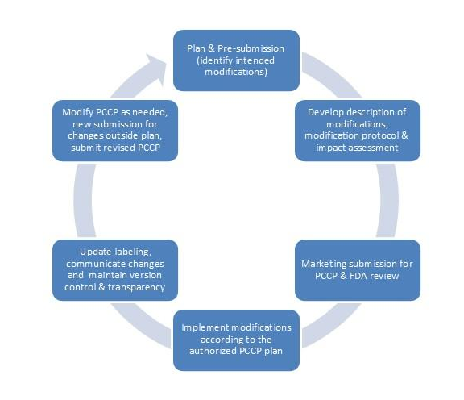
e-Figure S4. Key Phases of the Predetermined Change Control Plan (PCCP) Lifecycle. A cyclic flow diagram illustrating the operational stages of a PCCP as outlined in the final FDA guidelines. The lifecycle begins with the pre-submission identification of intended modifications, followed by the development of specific modification protocols and impact assessments. Subsequent phases include the formal marketing submission and FDA review, the real-world implementation of authorized modifications, and crucial post-market steps involving labeling updates, communication, and version control. The cycle dictates a revised submission if future modifications fall outside the authorized plan.

