Supplementary Document
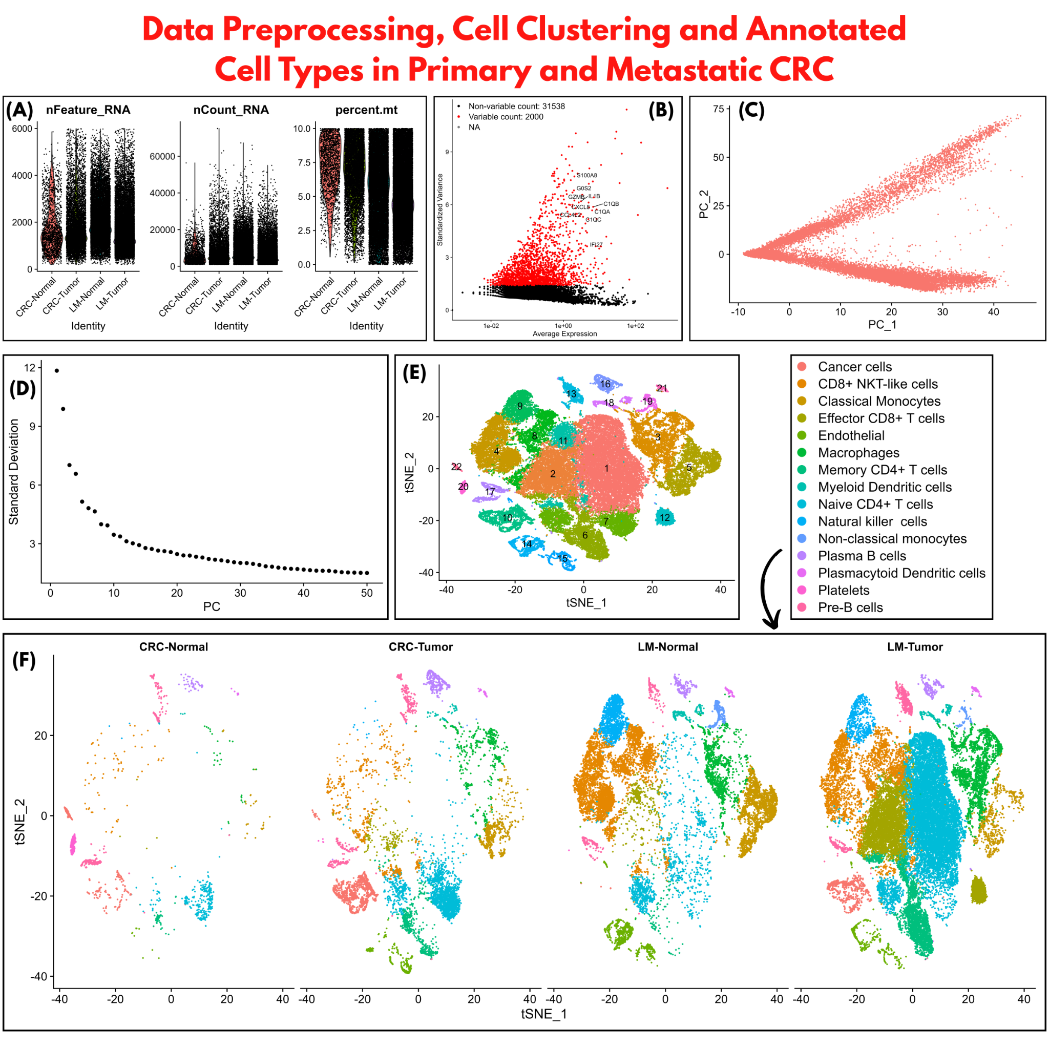
Figure S1. Data preprocessing, cell clusters and annotated cell types of CRC dataset; (A) Data filtration violin plots showing nFeature_RNA, nCount_RNA, and percent.mt filtered reads in CRC-Tumor, CRC-Normal, LM-Tumor, and LM-Normal conditions; (B) HVFs plot showing 2000 HVFs and 31538 non-variable features; (C) PCA plot showing major variance in the dataset across PC_1 and PC_2. The distinct bifurcated pattern indicate the presence of two major states such as normal and diseased; (D) Elbow plot showing standard deviation of the dataset across 50 PCs, indicating major standard deviation in the first 20 PCs; (E) tSNE plot of cell clusters showing a total 22 cell clusters; (F) Annotated cell types showing 15 cell types in CRC-Tumor, CRC-Normal, LM-Tumor, and LM-Normal conditions
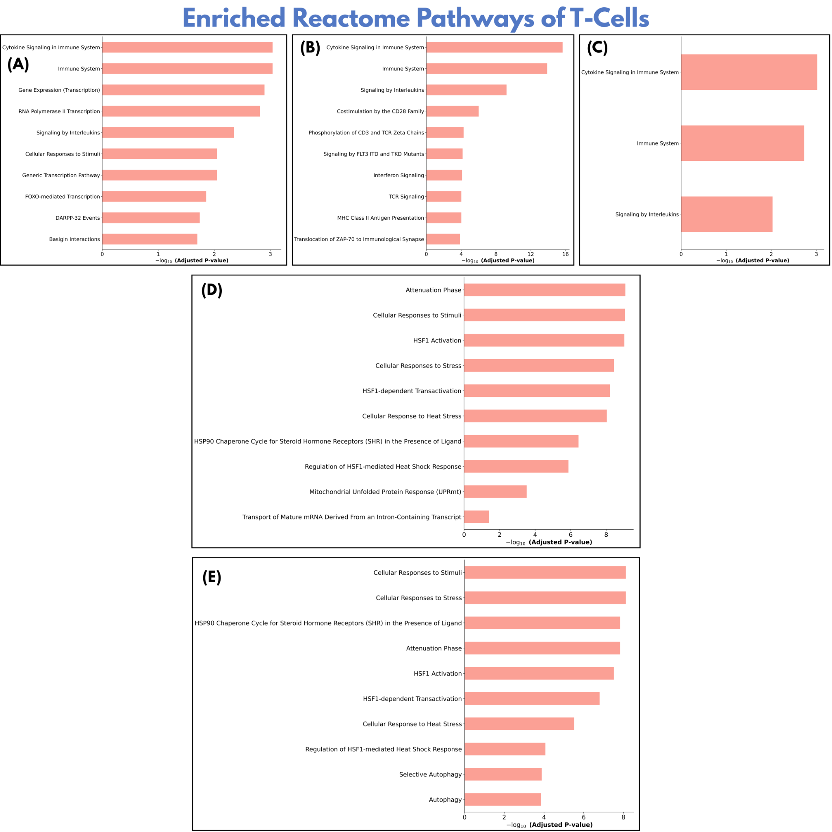
Figure S2. Enriched Reactome pathways of T-cells DEGs; (A) Reactome pathways of CD8⁺ NKT-like cells (CRC-Tumor vs CRC-Normal), including "Cytokine Signaling in Immune System", "Immune System", "Gene Expression (Transcription)", "RNA Polymerase II Transcription", "Signaling by Interleukins", "Cellular Responses to Stimuli", "Generic Transcription Pathway", "FOXO-mediated Transcription", "DARPP-32 Events", and "Basigin Interactions" to be top significant pathways; (B) Reactome pathways of memory CD4⁺ T-cells (CRC-Tumor vs CRC-Normal), including "Cytokine Signaling in Immune System", "Immune System", "Signaling by Interleukins", "Costimulation by the CD28 Family", "Phosphorylation of CD3 and TCR Zeta Chains", "Signaling by FLT3 ITD and TKD Mutants", "Interferon Signaling", "MHC Class II Antigen Presentation", "TCR Signaling", and "Translocation of ZAP-70 to Immunological Synapse" to be top significant pathways; (C) Reactome pathways of naive CD4⁺ T-cells (CRC-Tumor vs CRC-Normal), including "Cytokine Signaling in Immune System", "Immune System", and "Signaling by Interleukins" to be top significant pathways; (D) Reactome pathways of memory CD4⁺ T-cells (LM-Tumor vs LM-Normal), including "Attenuation Phase", "Cellular Responses to Stimuli", "HSF1 Activation", "Cellular Responses to Stress", "HSF1-dependent Transactivation", "Cellular Response to Heat Stress", "HSP90 Chaperone Cycle for Steroid Hormone Receptors (SHR) in the Presence of Ligand", "Regulation of HSF1-mediated Heat Shock Response", "Mitochondrial Unfolded Protein Response (UPRmt)", and "Transport of Mature mRNA Derived From an Intron-Containing Transcript" to be top significant pathways; (E) Reactome pathways of naive CD4⁺ T-cells (LM-Tumor vs LM-Normal), including "Cellular Responses to Stimuli", "Cellular Responses to Stress", "HSP90 Chaperone Cycle for Steroid Hormone Receptors (SHR) in the Presence of Ligand", "Attenuation Phase", "HSF1 Activation", "HSF1-dependent Transactivation", "Cellular Response to Heat Stress", "Regulation of HSF1-mediated Heat Shock Response", "Selective Autophagy", and "Autophagy" to be top significant pathways
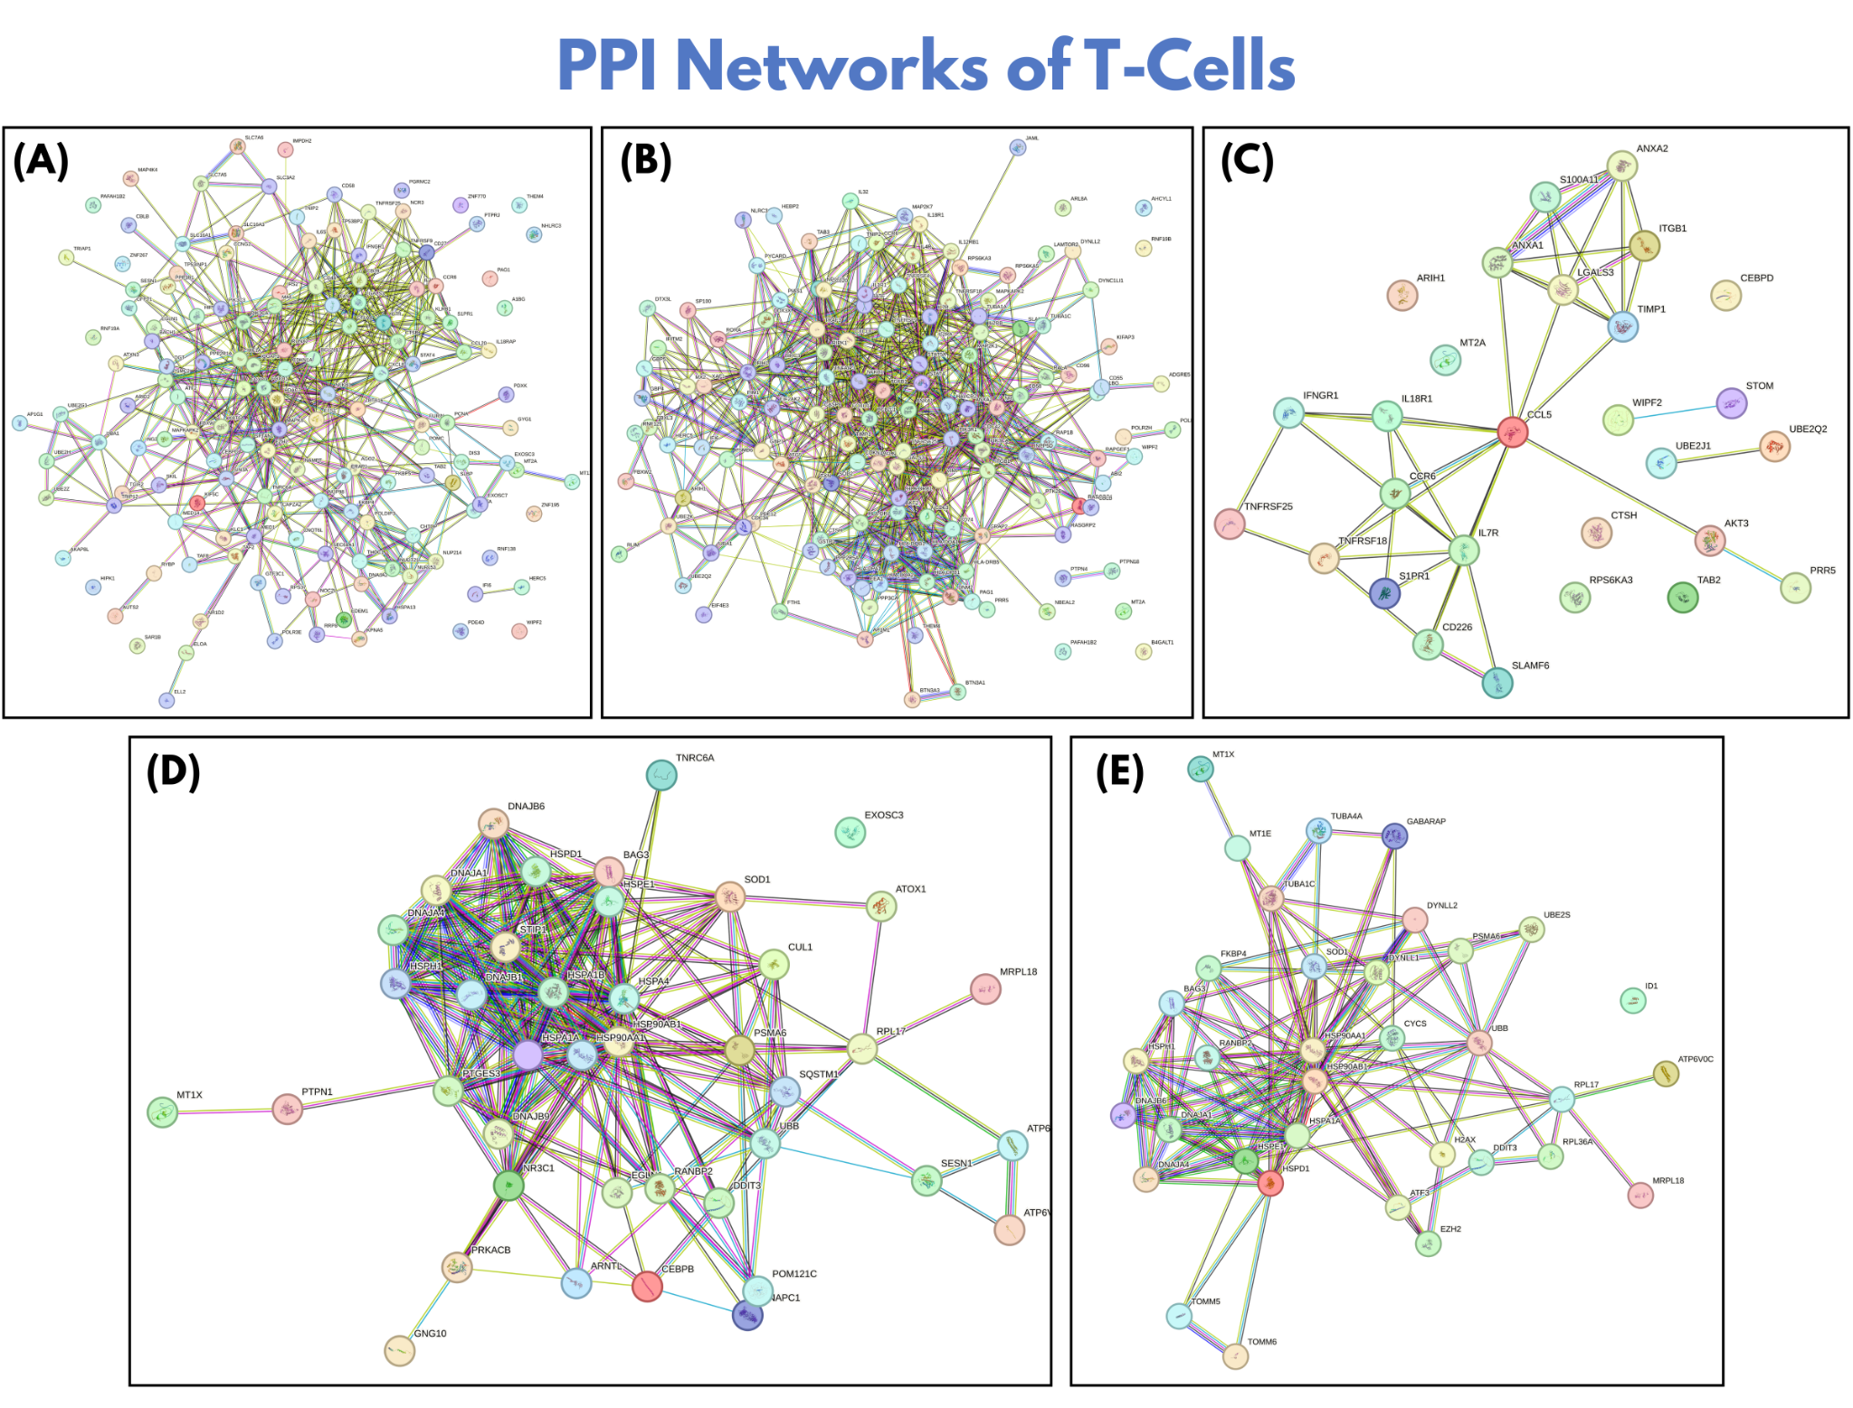
Figure S3. PPI networks of T-cells in primary CRC and LM-CRC; (A) PPI network of CD8⁺ NKT-like cells (CRC-Tumor vs CRC-Normal), showing a network of 132 proteins interacting with each other; (B) PPI network of memory CD4⁺ T-cells (CRC-Tumor vs CRC-Normal), exhibiting a network of 135 interacting proteins; (C) PPI network of naive CD4⁺ T-cells (CRC-Tumor cs CRC-Normal), exhibiting a network of 22 interacting proteins; (D) PPI network of memory CD4⁺ T-cells (LM-Tumor vs LM-Normal), exhibiting a network of 40 interacting proteins; (E) PPI network of naive CD4⁺ T-cells, exhibiting a network of 34 interacting proteins

