Appendix
Appendix A. Safety Attitude Measures
All items were rated on a seven‑point Likert scale ranging from 1 = Strongly Disagree to 7 = Strongly Agree. Items marked with an asterisk (*) assess traditional safety attitude, whereas all remaining items measure social‑related safety attitude. Items labeled (R) were reverse‑coded prior to analysis.
- Social influence is crucial in shaping safety behaviour patterns at construction sites.
- Persisting conventions at construction sites, even if not formally written down, may influence workers' compliance with safety protocols.
- Observing coworkers’ safety habits influences one’s individual safety decisions.
- *Training on physical hazards can effectively lower accident rates at construction sites.
- Workers are more likely to follow safety protocols when others around them do so.
- A strong safety climate at construction sites reduces the likelihood of accidents.
- Supervisors’ pressure has minimal influence on individual workers’ safety behaviours. (R)
- *Detecting potential hazards is a major part of site planning for managers and safety officers.
- Safety decisions at construction sites are personal decisions independent of group dynamics. (R)

Appendix B. Bystander Behavioral Intention Items (measured at T_Final)
Participants rated each item on a seven‑point Likert scale ranging from 1 = Very Unlikely to 7 = Very Likely. Items are labeled by subscale: (AC) = Active Constructive, (PC) = Passive Constructive, (AD) = Active Destructive, and (PD) = Passive Destructive.
- I would tell my boss to stop pointing out to Allen that way. (AC)
- I would keep my feelings about the situation to myself. (PD)
- I would make it clear to my boss that I will report his actions. (AC)
- If Allen shares his experiences about the situation, I would acknowledge his feelings. (PC)
- I would play along with what my boss is doing. (AD)
- I would encourage Allen to keep what is going on to himself. (AD)
- I would offer comfort to Allen. (PC)
- I would alert the Labour Department of my boss' actions. (AC)
- I would keep a low profile. (PD)
- I would encourage Allen to alert the Labour Department. (AC)
- I would show my boss that I am on his side. (AD)
- I would listen to Allen if he wanted to talk about the situation. (PC)
- I would report the situation to the Labour Department. (AC)
- I would try to make Allen feel better. (PC)
- I would let Allen know that I agree with how my boss is treating him. (AD)
- I would help Allen with reporting his experiences to the Labour Department. (AC)
- I would take actions that reinforce my boss' actions towards Allen. (AD)
- I would remove myself from the situation. (PD)
- I would try to offer Allen emotional support. (PC)
- I would empathise with Allen’s experiences. (PC)
- I would put my attention elsewhere when my boss is pointing out the issue. (PD)
- I would make my boss aware that I agree with him. (AD)

Appendix C. Perceived Interpersonal Distance and Social Presence (measured at T_Final)
- Inclusion of Others in the Self (IOS) scale
- Please indicate which picture best describe your relationship with Jackie (your character) (IOS1)
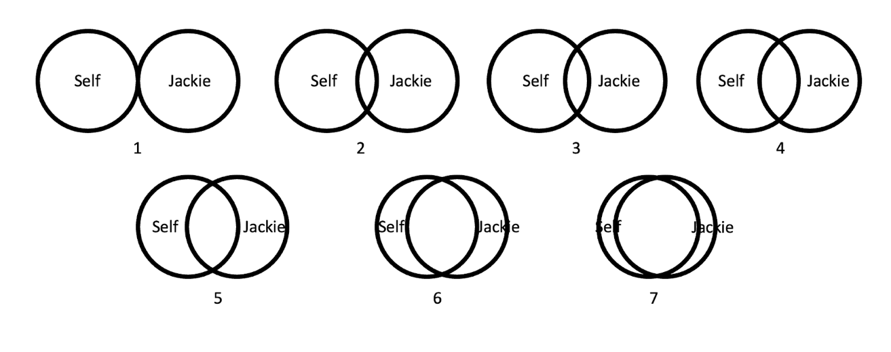
- Please indicate which picture best describe your relationship with Allen (IOS2)
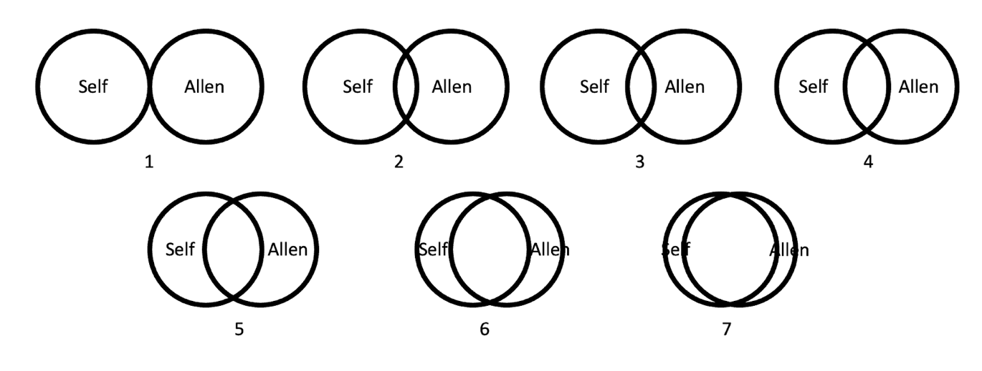
- Virtual Reality Experience Questionnaire for IMR_SoP
Participants rated each item on a seven-point Likert scale ranging from 1 = Not at All to 7 = Very Much.
- Did you feel that the virtual character (your boss) was talking to you and addressing you personally?
- Did you feel at any time the desire to remind the accident victim (Allen) to be cautious about safety?
- In scene 1 (right after lunch), did you feel at any time the desire to help the accident victim (Allen)?
- In scene 2 (when the accident happened), did you feel at any time the desire to help the accident victim (Allen)?
- Three-item Attention Check
- Was Allen sitting on your left or right? (Left or Right)
- What happened to Allen in the end? (Allen continued working or Allen experienced an accident)
- Did you witness the accident in the VR scenario? (Yes or No)

