Fig.S1. The Secondary structure prediction of COL10A1 in cobia (A), zebrafish (B), and mouse (C). The tertiary structure prediction of COL10A1 in cobia (D), zebrafish (E), and mouse (F)
Helix: Alpha helix, Turn: Beta turn, Sheet: Extended strand, coil: Random coil.

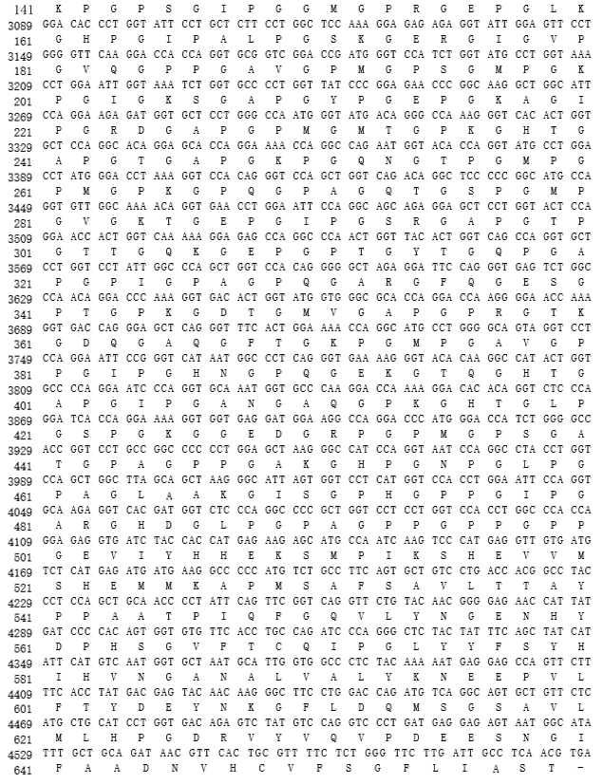
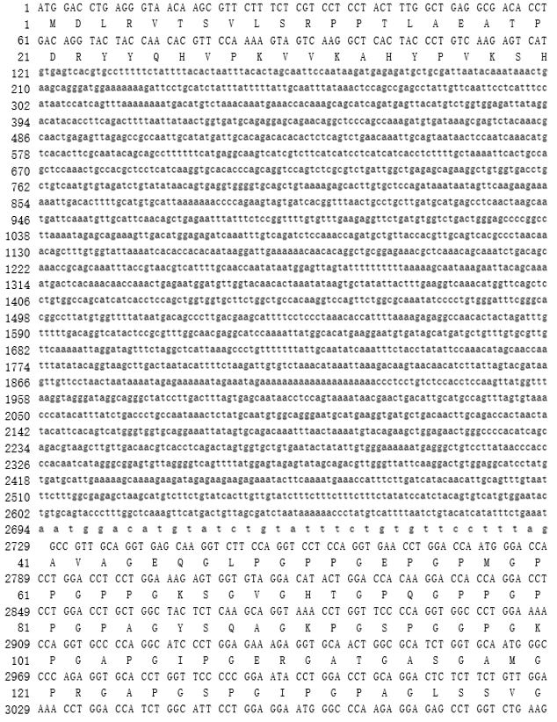

Fig.S2. The full-length sequence of the col10a1 gene and the amino acid sequence it encodes
Lowercase letters represent intron regions, while uppercase letters represent exon regions and the amino acid sequences they encode.

