Supplymentary figure

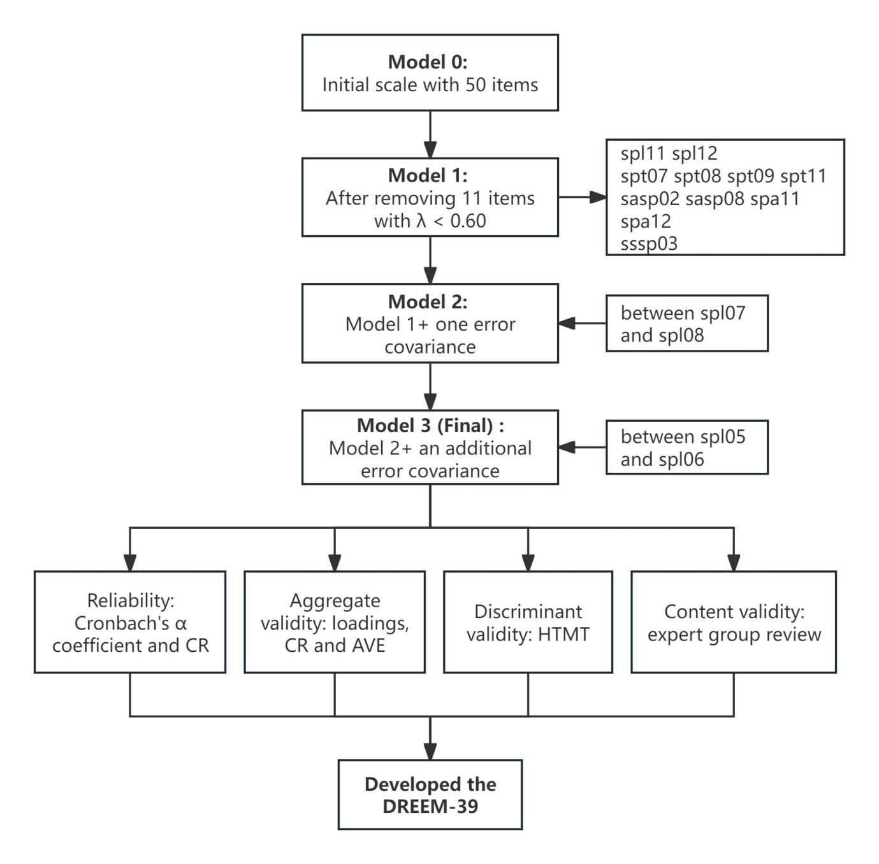
Figure S1. Development process of DREEM-39.

Supplymentary tables

Table S1. Stepwise Revision and CFA Fitting Indicators of the Scale.
Model phase | Revised content | No. of items | χ² (df ) | CFI | TLI | RMSEA [90% CI] | SRMR
Model 0 | initial 5-dimension model | 50 | 4299.676(1165)*** | 0.670 | 0.653 | 0.110 [0.106, 0.113] | 0.103
Model 1 | After removing 11 items with λ < 0.60 | 39 | 1759.019(692)*** | 0.852 | 0.842 | 0.083 [0.078, 0.088] | 0.068
Model 2 | Model 1 + one correlated error | 39 | 1711.455(691)*** | 0.859 | 0.849 | 0.081 [0.076, 0.086] | 0.070
Model 3 | Model 2 + an additional correlated error | 39 | 1686.090(690)*** | 0.862 | 0.852 | 0.080 [0.075, 0.085] | 0.069
Model 2: allowing one error covariance between spl07 (“The teaching is often stimulating”) and spl08 (“The teaching time is put to good use”). Model 3: allowing an additional error covariance between spl05 (“The teaching is sufficiently concerned to develop my competence”) and spl06 (“I am clear about the learning objectives of the course”).
Abbreviations: λ, standardization factor loading; CFI, comparative fit index; TLI, Tucker-Lewis index; RMSEA, root mean square error of approximation; CI, confidence interval; SRMR, standardized root mean square residual.
*** All χ² values are statistically significant (p < 0.001).

Table S2. Standardized Factor Loadings, Error Variances and Average Score of Each Item of the DREEM-39.
Dimension | Items | Content | Standardized Loading | Error Variance | Mean score  (SD)
Students’ Perceptions of Learning (SPL) | spl01 | I am encouraged to participate in class. | 0.70 | 0.50 | 3.80 (0.44)
Students’ Perceptions of Learning (SPL) | spl02 | The teaching is sufficiently concerned to develop my confidence. | 0.84 | 0.29 | 3.64 (0.68)
Students’ Perceptions of Learning (SPL) | spl03 | The teaching encourages me to be an active learner. | 0.91 | 0.16 | 3.69 (0.57)
Students’ Perceptions of Learning (SPL) | spl04 | The teaching is well focused. | 0.84 | 0.30 | 3.73 (0.61)
Students’ Perceptions of Learning (SPL) | spl05 | The teaching is sufficiently concerned to develop my competence. | 0.88 | 0.23 | 3.71 (0.61)
Students’ Perceptions of Learning (SPL) | spl06 | I am clear about the learning objectives of the course. | 0.79 | 0.37 | 3.71 (0.61)
Students’ Perceptions of Learning (SPL) | spl07 | The teaching is often stimulating. | 0.83 | 0.31 | 3.54 (0.76)
Students’ Perceptions of Learning (SPL) | spl08 | The teaching time is put to good use. | 0.75 | 0.44 | 3.68 (0.55)
Students’ Perceptions of Learning (SPL) | spl09 | The teaching is student centred. | 0.67 | 0.54 | 3.76 (0.48)
Students’ Perceptions of Learning (SPL) | spl10 | Long-term learning is emphasized over short term. | 0.65 | 0.58 | 3.76 (0.54)
Students’ Perceptions of Teachers (SPT) | spt01 | The teachers are good at providing feedback to students. | 0.72 | 0.48 | 3.78 (0.46)
Students’ Perceptions of Teachers (SPT) | spt02 | The teachers have good communications skills with patients. | 0.80 | 0.36 | 3.85 (0.38)
Students’ Perceptions of Teachers (SPT) | spt03 | The teachers are knowledgeable. | 0.84 | 0.30 | 3.89 (0.33)
Students’ Perceptions of Teachers (SPT) | spt04 | The teachers give clear examples. | 0.87 | 0.24 | 3.87 (0.35)
Students’ Perceptions of Teachers (SPT) | spt05 | The teachers are well prepared for their classes. | 0.80 | 0.36 | 3.86 (0.36)
Students’ Perceptions of Teachers (SPT) | spt06 | The teachers provide constructive criticism here. | 0.67 | 0.55 | 3.77 (0.51)
Students’ Perceptions of Teachers (SPT) | spt10 | The teachers are patient with patients. | 0.56 | 0.69 | 3.76 (0.60)
Students’ Academic Self-Perceptions (SASP) | sasp01 | I am able to memorize all I need. | 0.68 | 0.54 | 3.21 (0.69)
Students’ Academic Self-Perceptions (SASP) | sasp03 | I feel I am being well prepared for my profession. | 0.71 | 0.50 | 3.23 (0.82)
Students’ Academic Self-Perceptions (SASP) | sasp04 | Last year’s work has been a good preparation for this year’s work. | 0.77 | 0.42 | 3.27 (0.83)
Students’ Academic Self-Perceptions (SASP) | sasp05 | My problem-solving skills are being well developed here. | 0.91 | 0.18 | 3.50 (0.63)
Students’ Academic Self-Perceptions (SASP) | sasp06 | I am confident about passing this year. | 0.64 | 0.59 | 3.13 (0.91)
Students’ Academic Self-Perceptions (SASP) | sasp07 | I have learned a lot about empathy in my profession. | 0.86 | 0.27 | 3.57 (0.64)
Students’ Perceptions of Atmosphere (SPA) | spa01 | The atmosphere is relaxed during lectures. | 0.78 | 0.39 | 3.65 (0.57)
Students’ Perceptions of Atmosphere (SPA) | spa02 | I feel able to ask the questions I want. | 0.75 | 0.44 | 3.57 (0.59)
Students’ Perceptions of Atmosphere (SPA) | spa03 | I feel comfortable in class socially. | 0.90 | 0.19 | 3.64 (0.62)
Students’ Perceptions of Atmosphere (SPA) | spa04 | There are opportunities for me to develop interpersonal skills. | 0.85 | 0.27 | 3.67 (0.58)
Students’ Perceptions of Atmosphere (SPA) | spa05 | The atmosphere is relaxed during seminars/tutorials. | 0.86 | 0.27 | 3.69 (0.50)
Students’ Perceptions of Atmosphere (SPA) | spa06 | The enjoyment outweighs the stress of studying medicine. | 0.74 | 0.45 | 3.46 (0.79)
Students’ Perceptions of Atmosphere (SPA) | spa07 | The atmosphere motivates me as a learner. | 0.87 | 0.24 | 3.58 (0.68)
Students’ Perceptions of Atmosphere (SPA) | spa08 | I am able to concentrate well. | 0.84 | 0.29 | 3.61 (0.60)
Students’ Perceptions of Atmosphere (SPA) | spa09 | The atmosphere is relaxed during the ward teaching. | 0.78 | 0.39 | 3.77 (0.45)
Students’ Perceptions of Atmosphere (SPA) | spa10 | This school is well timetabled. | 0.62 | 0.62 | 3.65 (0.52)
Students’ Social Self-Perceptions (SSSP) | sssp01 | I have good friends in this school. | 0.65 | 0.58 | 3.65 (0.56)
Students’ Social Self-Perceptions (SSSP) | sssp02 | There is a good support system for students who get stressed. | 0.61 | 0.63 | 3.26 (0.90)
Students’ Social Self-Perceptions (SSSP) | sssp04 | I am rarely bored on this course. | 0.57 | 0.67 | 3.28 (0.94)
Students’ Social Self-Perceptions (SSSP) | sssp05 | My accommodation is pleasant. | 0.70 | 0.52 | 3.22 (0.97)
Students’ Social Self-Perceptions (SSSP) | sssp06 | My social life is good. | 0.86 | 0.27 | 3.26 (0.91)
Students’ Social Self-Perceptions (SSSP) | sssp07 | I seldom feel lonely. | 0.68 | 0.54 | 3.20 (0.92)

Table S3. Items Deleted of the Chinese DREEM in This Study.
Dimension | Item | Content | Standardized factor loading | Theoretical reasons for deletion
SPL | spl11 | The teaching is too teacher-centred. | 0.066 | This item reflects the characteristics of traditional lecture class.
SPL | spl12 | The teaching over-emphasizes factual learning. | 0.054 | The discrimination of this item decreases under the current ability oriented teaching mode.
SPT | spt07 | The teachers ridicule the students. | 0.350 | These items all reflect extreme or rare negative behaviors of teachers and students.
SPT | spt08 | The teachers get angry in class. | 0.320
SPT | spt09 | The teachers are authoritarian. | 0.293
SPT | spt11 | The students irritate the teachers. | 0.365
SASP | sasp02 | Much of what I have to learn seems relevant to a career in medicine. | 0.389 | It is difficult for lower grade students to judge this correlation
SASP | sasp08 | Learning strategies which worked for me before continue to work for me now. | 0.456 | This item measures the continuity of the learning method and has a weak correlation with the current dimension.
SPA | spa11 | I find the experience disappointing. | 0.295 | The expression of this item is too broad in the Chinese context.
SPA | spa12 | Cheating is a problem in this school. | 0.111 | This item is inconsistent with the teaching mode of this course.
SSSP | sssp03 | I am too tired to enjoy this course. | 0.449 | This item reflects academic burnout more directly than the core connotation of social self perceptions.

