Supporting Information for
Biophysical Controls on Climate Responses to Tree-Cover Change Across Land-Use Types
Jyoti Sharma¹ and Pankaj Kumar¹
¹Department of Earth and Environmental Sciences, Indian Institute of Science Education and Research Bhopal, Madhya Pradesh, India - 462066
Corresponding author: Pankaj Kumar (kumarp@iiserb.ac.in)

Contents of this file
Tables S1 to S5
Figures S1 to S4

Table S1. Description of satellite-derived datasets used in this study.
Category | Dataset | Abbreviation | Time -period | Temporal Resolution | Spatial Resolution
Tree Cover | Tree Cover Percentage (MOD44B.061) | TC | 2001-2022 | Yearly | 250 m
Land Use/Land Cover | Land Use/Land Cover (MCQ12Q1.061) | LULC | 2001-2020 | Yearly | 500 m
Main Variable | Land Surface Temperature (Daytime) | LST Day | 2003-2022 | 8 Days | 1 km
Biogeophyical  Factors | Albedo (MCD43A3) | Albedo | 2003-2022 | Daily | 500 m
Biogeophyical  Factors | Latent Heat (MYD16A2GF.061) | LE | 2003-2022 | 8 Days | 500 m
Biogeophyical  Factors | Evapotranpiration (MYD16A2GF.061) | ET | 2003-2022 | 8 Days | 500 m
Biogeochemical  Factors | GPP (MYD17A2HGF.061) |  | 2003-2021 | 8 Days | 500 m
Biogeochemical  Factors | NPP (MYD17A3HGF.061) |  | 2003-2022 | Yearly | 500 m

Table S2: Sensitivity analysis of methodological parameters.
Category | Sensitivity Analysis
Window Size (km × km) | 3×5, 4×6, 3×7, 2×4
Overlap (rows × cols) | 2×3 (for 3×5, 4×6, 3×7), 1×2 (for 2×4)
Tree Cover Threshold (%) | ±0.3, ±0.5, ±1, ±2
Elevation Difference (m) | ±50, ±100, ±200, ±500
Sensitivity tests were performed by varying window size, overlap, tree-cover thresholds, and elevation constraints to assess the robustness of the moving-window framework and the stability of derived temperature responses.

Table S3: Optimized XGBoost hyperparameters for predicting LST responses to tree-cover change
LULC | Tree Cover | Box | colsample_bytree | Learning Rate | max_depth | n_estimators | reg_alpha | reg_lambda | subsample
Forest | Gain | 1 | 0.730 | 0.02 | 10 | 1000 | 0 | 0 | 0.790
Forest | Gain | 2 | 0.6 | 0.049 | 10 | 1000 | 0 | 0 | 0.805
Forest | Gain | 3 | 0.6 | 0.042 | 10 | 951 | 0 | 0 | 0.843
Forest | Gain | 4 | 0.6 | 0.030 | 10 | 821 | 0 | 0 | 0.6
Savanna | Gain | 1 | 1 | 0.02 | 10 | 920 | 0 | 0 | 0.6
Savanna | Gain | 2 | 0.6 | 0.022 | 10 | 1000 | 0 | 0 | 0.791
Savanna | Gain | 3 | 0.6 | 0.053 | 10 | 1000 | 0 | 0 | 0.830
Savanna | Gain | 4 | 0.6 | 0.040 | 10 | 1000 | 0 | 0 | 0.834
Shrub | Gain | 0 | 0.6 | 0.041 | 8 | 1000 | 0 | 0 | 0.6
Forest | Loss | 1 | 0.67 | 0.042 | 10 | 1000 | 0 | 0 | 1
Forest | Loss | 2 | 0.65 | 0.037 | 10 | 1000 | 0 | 0 | 0.821
Forest | Loss | 3 | 0.6 | 0.049 | 10 | 1000 | 0 | 0 | 0.898
Forest | Loss | 4 | 1 | 0.02 | 10 | 1000 | 0 | 0 | 0.767
Savanna | Loss | 1 | 0.6 | 0.02 | 10 | 1000 | 0 | 2.7 | 1
Savanna | Loss | 2 | 0.6 | 0.024 | 10 | 891 | 0 | 0 | 0.776
Savanna | Loss | 3 | 0.6 | 0.038 | 10 | 1000 | 0 | 0 | 0.800
Savanna | Loss | 4 | 0.6 | 0.02 | 10 | 400 | 0 | 0 | 0.834
Best-performing XGBoost model settings for each land-cover class (forest, savanna, and shrubland), tree-cover change category (gain and loss), and study region (Box 0-4). Hyperparameters were selected through model tuning to maximize predictive skill and provide robust estimates of the relative importance of biogeophysical and biogeochemical drivers controlling ΔLST.

Table S4: Predictive performance of XGBoost models for LST responses to tree-cover change.
Box | LULC | Tree Cover | Total_samples | Best_iteration | Best_CV_R2 | Test_R2 | RMSE | MAE
1 | Forest | Gain | 4345 | 990 | 0.61 | 0.70 | 0.20 | 0.09
2 | Forest | Gain | 22685 | 999 | 0.50 | 0.61 | 0.20 | 0.10
3 | Forest | Gain | 14365 | 942 | 0.53 | 0.66 | 0.19 | 0.09
4 | Forest | Gain | 7285 | 807 | 0.58 | 0.66 | 0.22 | 0.11
1 | Savanna | Gain | 6255 | 911 | 0.42 | 0.51 | 0.29 | 0.14
2 | Savanna | Gain | 7577 | 998 | 0.53 | 0.60 | 0.20 | 0.10
3 | Savanna | Gain | 18692 | 997 | 0.53 | 0.61 | 0.22 | 0.11
4 | Savanna | Gain | 7733 | 739 | 0.55 | 0.64 | 0.24 | 0.11
0 | Shrub | Gain | 4479 | 800 | 0.71 | 0.72 | 0.40 | 0.20
1 | Forest | Loss | 4763 | 624 | 0.52 | 0.65 | 0.22 | 0.10
2 | Forest | Loss | 17262 | 999 | 0.51 | 0.61 | 0.20 | 0.10
3 | Forest | Loss | 28427 | 996 | 0.50 | 0.59 | 0.22 | 0.11
4 | Forest | Loss | 6792 | 995 | 0.55 | 0.65 | 0.20 | 0.10
1 | Savanna | Loss | 1945 | 999 | 0.44 | 0.50 | 0.31 | 0.14
2 | Savanna | Loss | 7965 | 890 | 0.53 | 0.62 | 0.21 | 0.11
3 | Savanna | Loss | 22695 | 999 | 0.53 | 0.61 | 0.22 | 0.12
4 | Savanna | Loss | 1235 | 396 | 0.57 | 0.61 | 0.25 | 0.12
Performance metrics of the optimized XGBoost models for each land-cover class, tree-cover change category, and study region. Reported values include total sample size, best iteration, best cross-validated coefficient of determination (Best CV $R^{2}$), test $R^{2}$, root mean square error (RMSE), and mean absolute error (MAE), summarizing the predictive skill of the models in capturing $Δ$LST responses to tree-cover gain and loss.

Table S5: Median and mean daytime land surface temperature responses to tree-cover gain and loss.
Box | Landcover | Gain N | ΔLST (Gain) |  | Loss N | ΔLST (Loss)
Box | Landcover | Gain N | Median | Mean ± SE | Loss N | Median | Mean ± SE
Box0 | Shrub | 21424 | -0.7206 | -0.781 ± 0.006 | - | - | -
Box1 | Forest | 4497 | -0.0067 | -0.005 ± 0.006 | 5098 | 0.0086 | 0.019 ± 0.006
Box1 | Savanna | 6323 | -0.0403 | -0.060 ± 0.005 | 1995 | 0.0253 | 0.013 ± 0.010
Box2 | Forest | 103146 | -0.0395 | -0.051 ± 0.001 | 122597 | 0.0383 | 0.039 ± 0.001
Box2 | Savanna | 9643 | -0.0668 | -0.079 ± 0.003 | 9784 | 0.0667 | 0.088 ± 0.004
Box3 | Forest | 24911 | -0.0008 | -0.008 ± 0.002 | 37531 | 0.0222 | 0.032 ± 0.002
Box3 | Savanna | 24727 | -0.0544 | -0.065 ± 0.002 | 24657 | 0.0674 | 0.076 ± 0.002
Box4 | Forest | 10678 | -0.0536 | -0.068 ± 0.004 | 16297 | 0.0397 | 0.048 ± 0.003
Box4 | Savanna | 28542 | -0.0876 | -0.094 ± 0.002 | 14422 | 0.0841 | 0.089 ± 0.003
Summary statistics of $Δ$LST associated with tree-cover gain and loss across land-cover classes and study regions. For each box and land-cover type, the table reports sample size ($N$), median $Δ$LST, and mean $±$standard error (SE), highlighting the contrasting cooling and warming responses linked to tree-cover change.

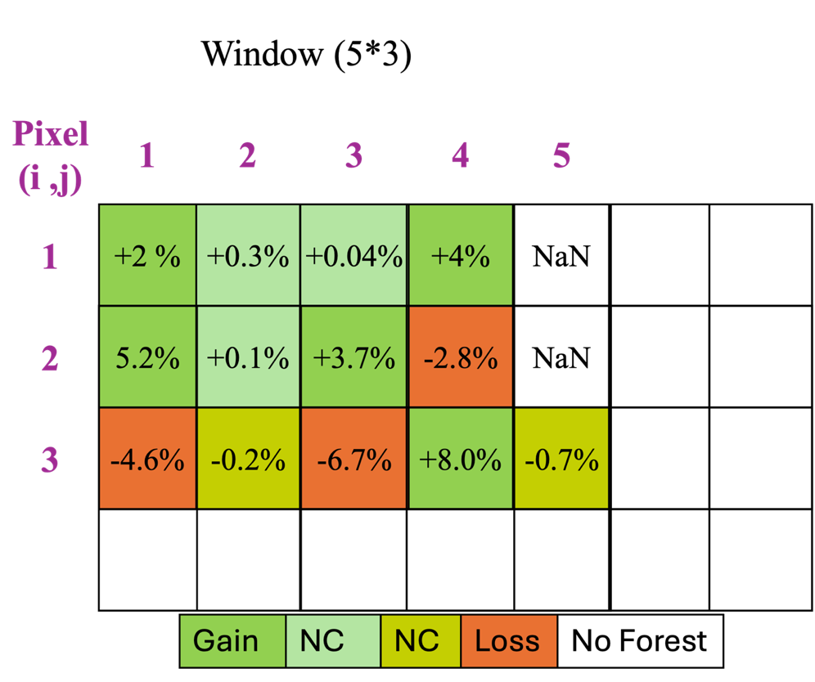
Figure S1: Schematic of the moving-window framework for isolating tree-cover-driven temperature signals.
Conceptual illustration of the moving-window methodology used to quantify the impact of tree-cover gain and loss on land surface temperature (LST). Within each moving window, pixels are classified into gain, loss, and no-change categories, and LST differences are computed relative to no-change pixels to minimize background climate effects. This approach enables robust attribution of temperature responses to tree-cover dynamics under comparable environmental conditions.

a 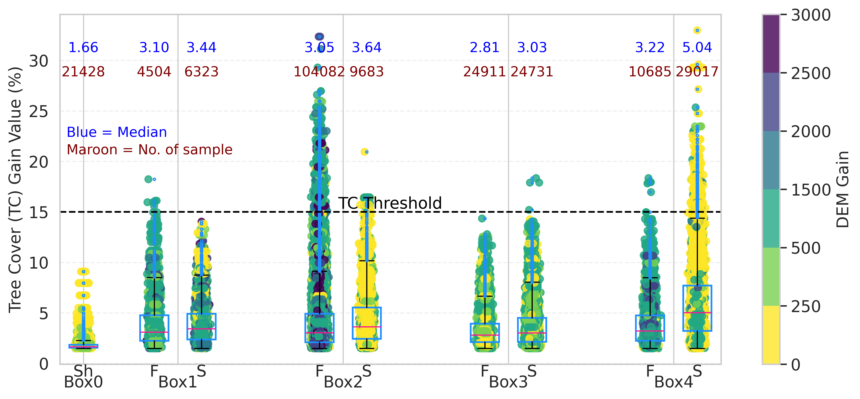
b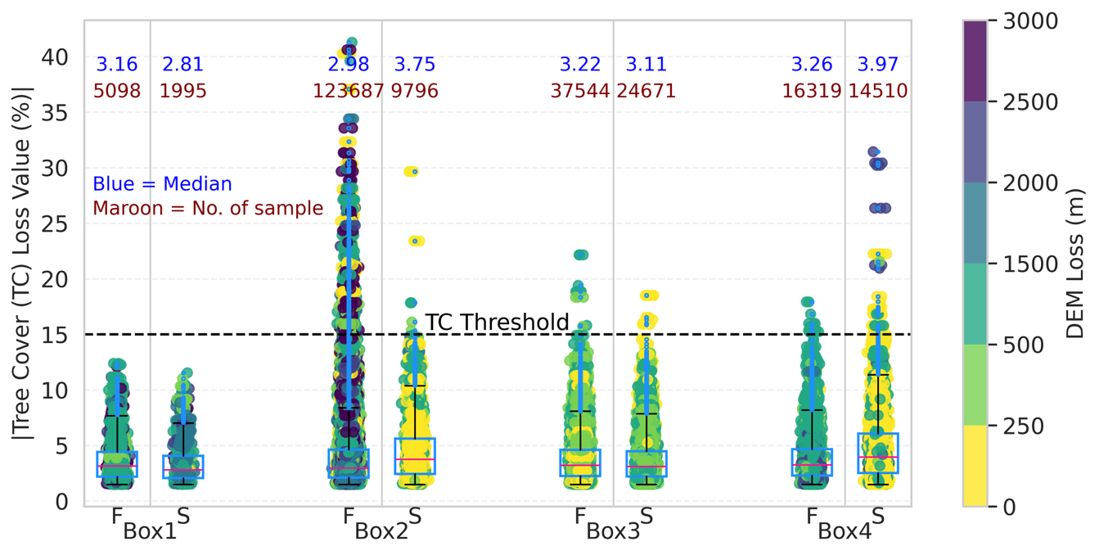
Figure S2: Threshold-based filtering for robust estimation of mean and median values.
(a) Tree-cover gain (%) and (b) tree-cover loss (%) distributions used to define thresholds for outlier removal across regions (Boxes 0-4). Extreme values beyond the defined threshold are excluded prior to calculating mean and median statistics. Blue markers indicate median values, maroon markers denote sample size, and colours represent elevation (m). This filtering ensures that summary metrics reflect the central tendency of the data and are not biased by outliers.

a 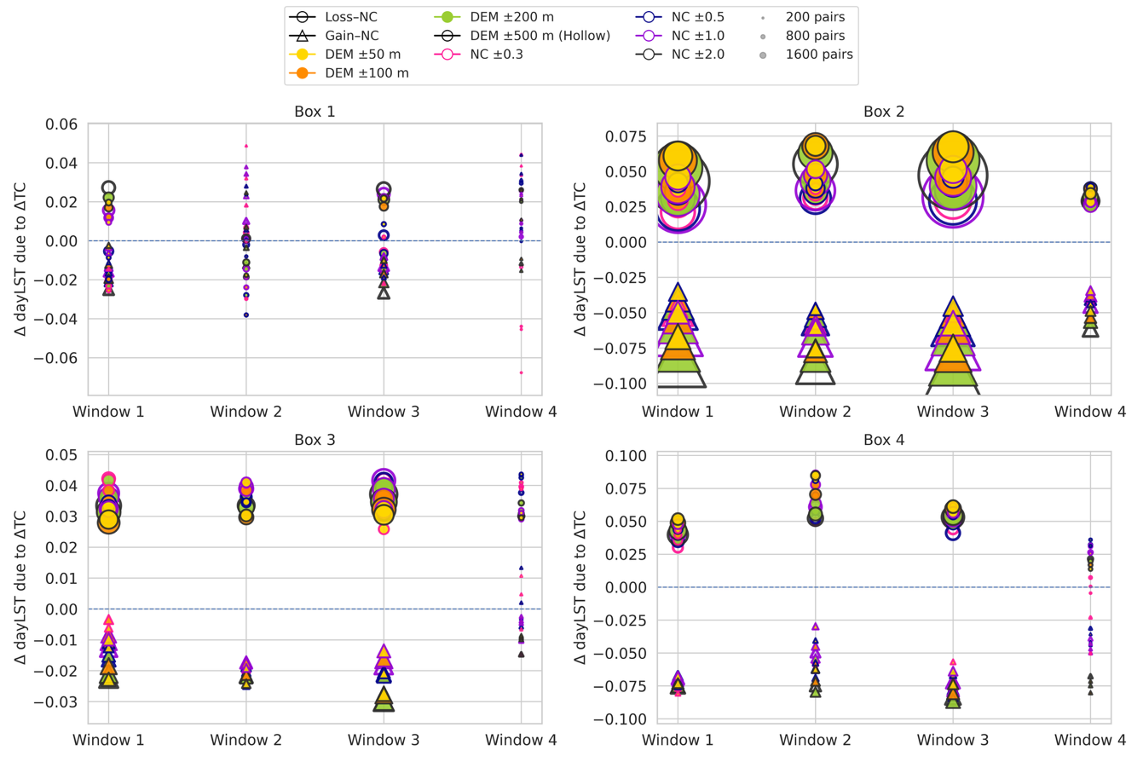
b 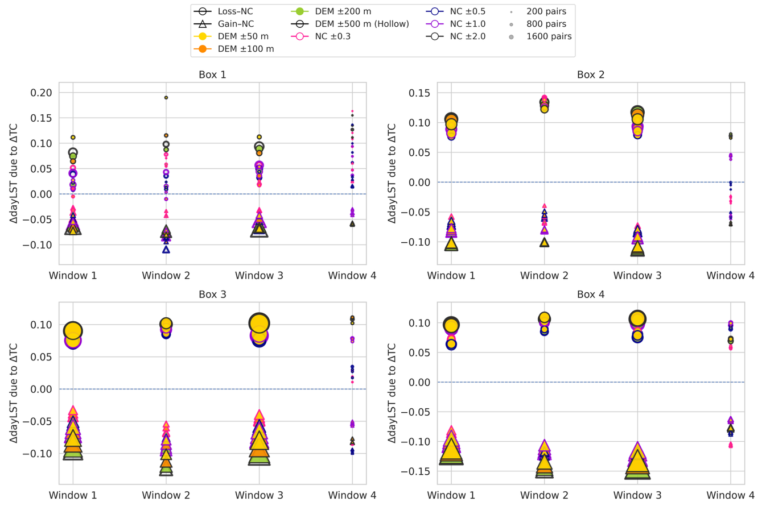
c 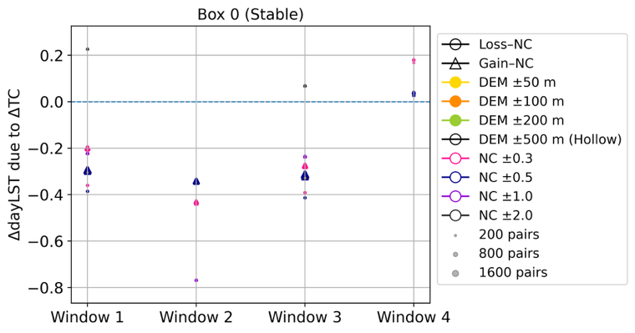 | d 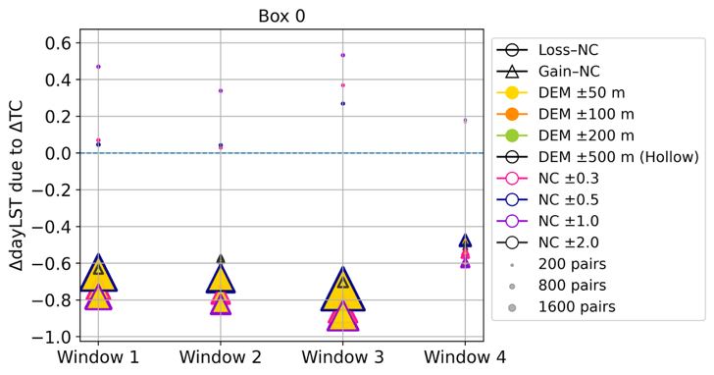
Figure S3: Sensitivity of LST responses to tree-cover change across land-cover classes.
(a-d) Sensitivity analysis of ΔLST responses under varying methodological parameters for (a) stable forest, (b) stable savanna, (c) stable shrubland, and (d) shrubland including both stable and non-stable pixels. Results demonstrate the robustness of the estimated temperature responses to changes in window size, overlap, tree-cover thresholds, and elevation constraints.

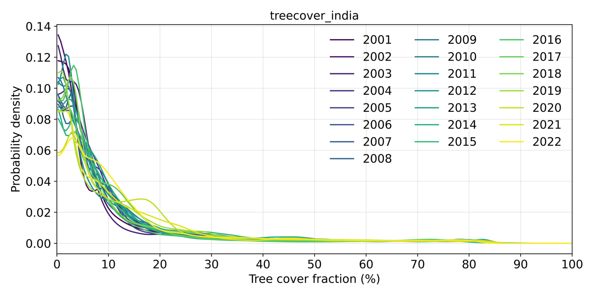
Figure S4: Year-wise kernel density distribution of tree-cover fraction.
Kernel density estimates (KDE) showing the distribution of tree-cover fraction (%) across India for each year from 2001 to 2022. The curves illustrate temporal shifts in the distribution of vegetation density, highlighting changes in the proportion of low, moderate, and high tree-cover areas over time.

