Supporting information
High performance core-shell Fe₂O₃@N-C anode materials
derived from iron concentrate leachate for lithium ion batteries
Yihao Peng^{a,b,1}, Yu Song^{a,b,1}, Li Wang^{c}, Hui Zhang^{d}, Yin Li^{a,b,e*}, Yaochun Yao^{a,b}
(a The National Engineering Laboratory for Vacuum Metallurgy, Kunming University of Science and Technology, Kunming 650093, Yunnan Province, China;
b Engineering Laboratory for Advanced Battery and Materials of Yunnan Province, Kunming University of Science and Technology, Kunming 650093, Yunnan Province, China;
c Hebei Normal University for Nationalities Chengde 067002, Hebei Province, China;
d Material and Architecture College, Guizhou Normal University, Guiyang 550025, China;
e Postdoctoral Programme of Shandong Humon Smelting Co. Ltd., Yantai 3264110, Shandong Province, China)
¹ These authors contribute equally.

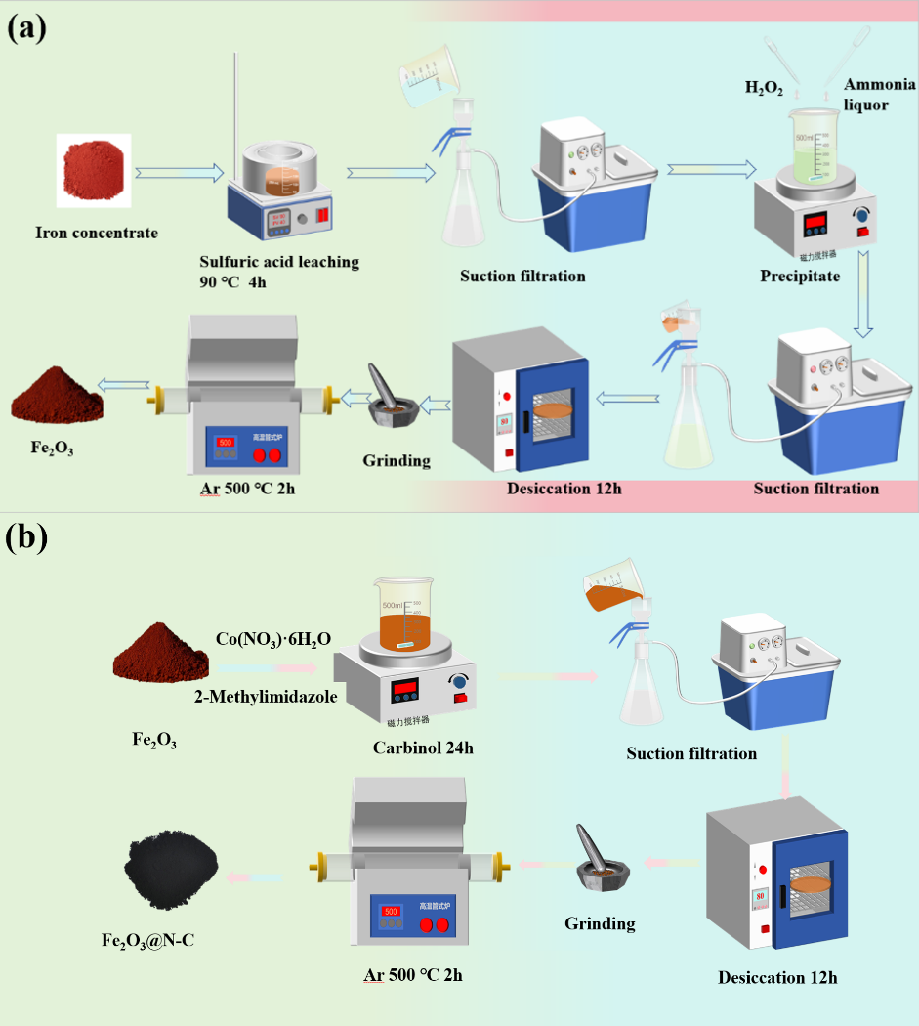
Fig. S1. (a) Flowchart of iron oxide preparation via iron ore concentrate leaching, and (b) the synthesis process of Fe₂O₃@N-C
Table S1 The main components of iron concentrate before and after leaching determined by ICP-OES.
Solutions | Constituents and content
Solutions | Al | Co | Cr | Mn | Ti | K | Na | Ca | Mg | Fe
Before leaching (wt. %) | 0.17 | 0.031 | 0.01 | 0.038 | 0.10 | 0.11 | 0.084 | 0.13 | 0.12 | 65.87
After leaching (g/L) | 0.007 | 0.42 | 0.5 | 0.38 | 0.03 | 0.001 | 0.004 | 0.007 | 0.002 | 53.367

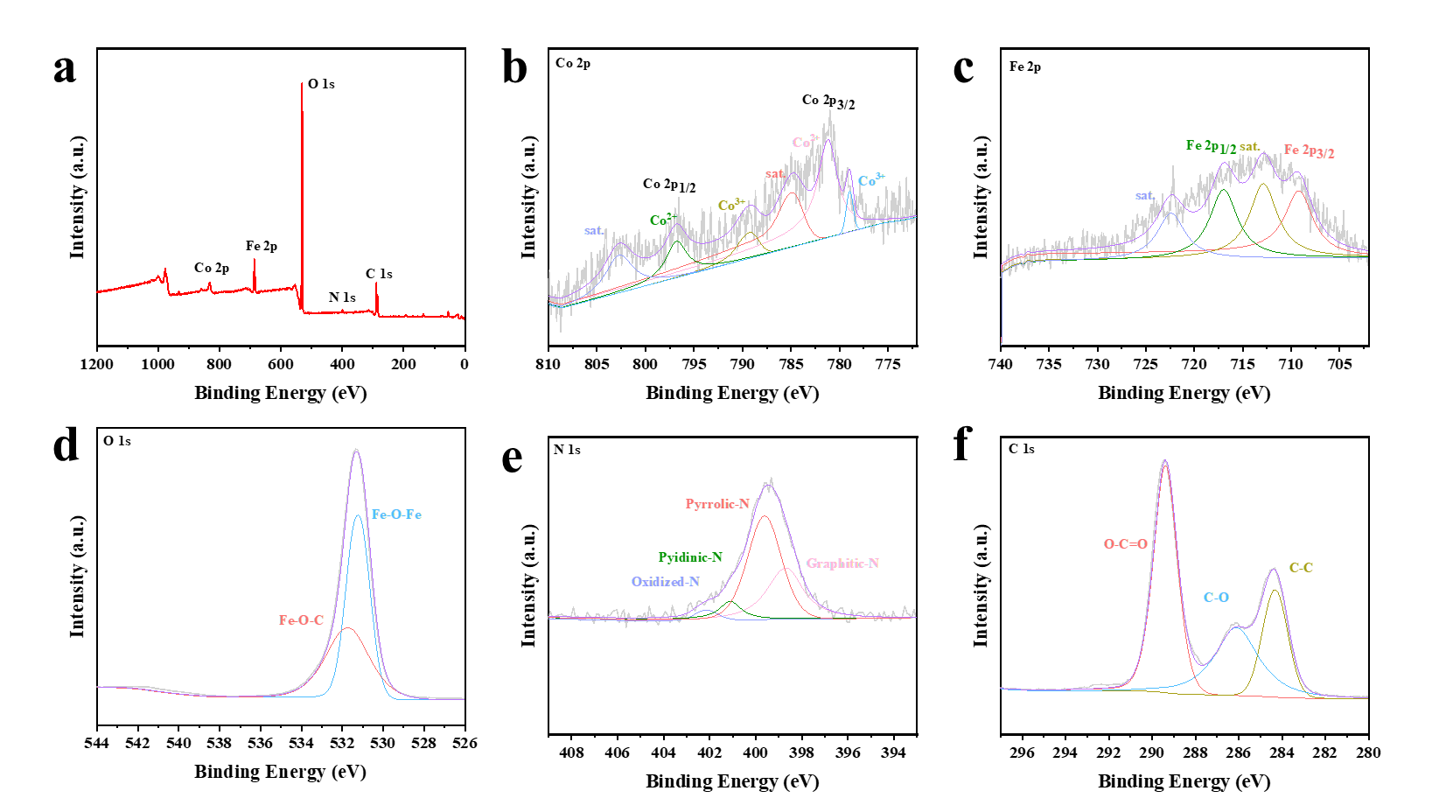
Fig. S2. XPS analysis of Fe₂O₃@N-C electrodes after 100 cycles at 1 A g⁻¹ current density; (a) complete survey spectrum, (b) Co 2p, (c) Fe 2p, (d) O 1s, (e) N 1s and (f) C 1s.
To investigate the stability of Fe₂O₃@N-C electrodes, XPS analysis was performed after 100 cycles at 1 A g⁻¹ (Fig. S2). The survey scan (Fig. S2a) confirms retention of all constituent elements (Fe, Co, N, O, C) with no observable elemental loss, indicating excellent structural stability. Detailed spectral analysis reveals: Co 2p spectrum (Fig. S2b) shows characteristic peaks at 779.96 eV (Co⁰), 781.20 eV (Co²⁺), and 784.93 eV (Co³⁺), with satellite peaks at 789.25 and 802.73 eV[S1]. The decreased peak intensities suggest partial material detachment due to volumetric expansion during cycling[S2]. Fe 2p spectrum (Fig. S2c) displays main peaks at 709.20 eV (Fe 2p_{3/2}) and 716.98 eV (Fe 2p_{1/2}), with satellite peaks at 712.86 and 722.40 eV, consistent with Fe³⁺ oxidation state. O 1s spectrum (Fig. S2d) exhibits two dominant peaks at 529.52 eV (Fe-O-Fe) and 531.32 eV (Fe-O-C), confirming maintained chemical bonding. N 1s spectrum (Fig. S2e) resolves four components: 398.64 eV (graphitic N), 399.62 eV (pyridinic N), 401.11 eV (pyrrolic N), and 402.13 eV (oxidized N), demonstrating nitrogen configuration stability[S3]. C 1s spectrum (Fig. S2 f) shows increased O-C=O peak intensity (289.38 eV) attributable to electrolyte decomposition (1M LiPF₆ in EC/DMC/EMC 1:1:1 v/v), while maintaining C-C (284.32 eV) and C-O (286.1 eV) bonds[S4].

[S1] X. Wan, R. Wu, J. Deng, Y. Nie, S. Chen, W. Ding, X. Huang, Z. Wei, A metal–organic framework derived 3D hierarchical Co/N-doped carbon nanotube/nanoparticle composite as an active electrocatalyst for oxygen reduction in alkaline electrolyte†, Journal of Materials Chemistry A, (2018).
[S2] M. Wang, F. Xi, S. Li, W. Ma, X. Wan, Z. Tong, B. Luo, ZIF-67-derived porous nitrogen-doped carbon shell encapsulates photovoltaic silicon cutting waste as anode in high-performance lithium-ion batteries, Journal of Electroanalytical Chemistry, (2023).
[S3] D. Jin, X. Yang, Y. Ou, M. Rao, Y. Zhong, G. Zhou, D. Ye, Y. Qiu, Y. Wu, W. Li, Thermal pyrolysis of Si@ZIF-67 into Si@N-doped CNTs towards highly stable lithium storage, Science Bulletin, (2019).
[S4] K. Zhang, H. Mao, X. Gu, C. Song, J. Yang, Y. Qian, ZIF-Derived Cobalt-Containing N-Doped Carbon-Coated SiOx Nanoparticles for Superior Lithium Storage, ACS Applied Materials & Interfaces, (2020).

Based on GITT curves, the lithium ion diffusion coefficient (D_{Li+}) can be estimated by the following formula [S6, S7]:
$DLi+=\frac{4}{πτ}{\left(\frac{m_{B}V_{M}}{M_{B}S}\right)}^{2}({\frac{{∆E}_{S}}{∆E_{τ}}}^{2})$( τ＜＜L²/D) (Eq.S1)
where t is the duration time of the constant current pulse (S), m_{B}, M_{B}, and V_{M} are the mass loading (g), molecular weight (g mol⁻¹), molar volume (cm⁻³ mol⁻¹) of the active material; S denotes the surface area of the electrode; ΔE_{S} and ΔE_{τ} represent the change in the steady-state voltage at a plateau and the total change in cell voltage during pulse time, respectively. d the total change in cell
voltage during pulse time, respectively. Fig. S3b compares the D_{Li+} values during the 3rd and 4th cycles. It can be seen that the D_{Li+} values range from 10⁻¹² to 10⁻⁹ cm² s⁻¹.
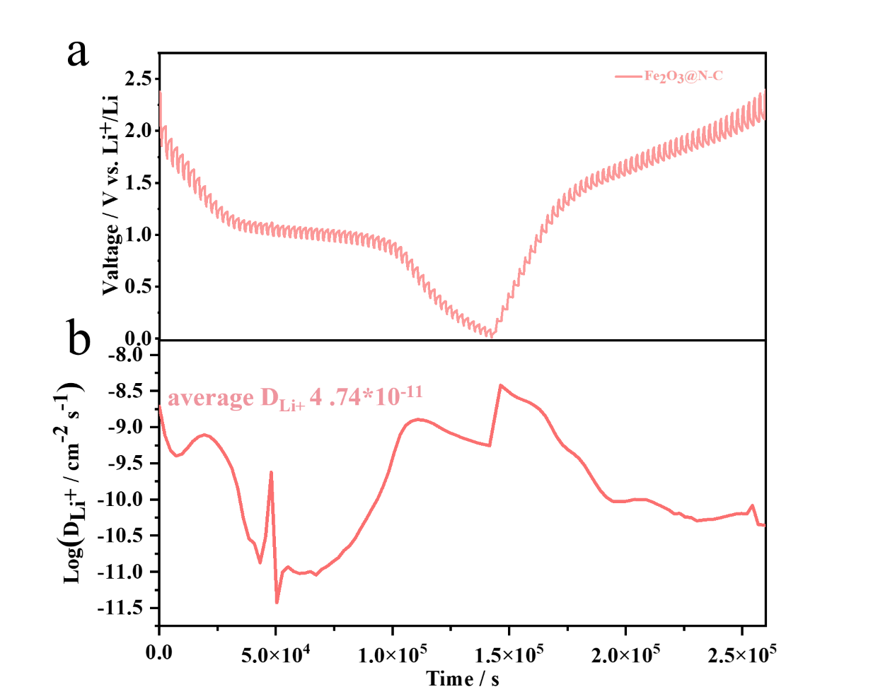
Fig. S3. (a) GITT curves and (b) the corresponding Li⁺ diffusion coefficients (D_{Li}⁺) of the Fe₂O₃@N-C electrode

[S5] C. Hong, Q. Leng, J. Zhu, S. Zheng, H. He, Y. Li, R. Liu, J. Wan, Y. Yang, Revealing the correlation between structural evolution and Liþ diffusion kinetics of nickel-rich cathode materials in Li-ion batteries, J. Mater. Chem. 8 (2020) 8540-8547
[S6] X.H. Rui, N. Ding, J. Liu, C. Li, C.H. Chen, Analysis of the chemical diffusion coefficient of lithium ions in Li3V2(PO4)3 cathode material, Electrochim. Acta. 55 (2010) 2384-2390.

