Supplemental document
Quantifying human and environmental viral load relationships amidst mitigation strategies in a controlled chamber with participants having COVID-19

Authors:
Hooman Parhizkar^{1,2}, Leslie Dietz ^{1,3}, Andreas Olsen-Martinez ^{1,3}, Patrick F. Horve ^{1,3}, Liliana Barnatan³, Dale Northcutt ^{1,2}, Kevin G. Van Den Wymelenberg ^{1,2,3}

Affiliations:
1 - Institute for Health and the Built Environment, University of Oregon, Portland, OR, 97209
2 - Energy Studies in Buildings Laboratory, University of Oregon, Eugene, OR, 97403
3 - Biology and the Built Environment Center, University of Oregon, Eugene, OR, 97403

Corresponding Author: Kevin G. Van Den Wymelenberg, kevinvdw@uoregon.edu, (541) 346-5647, Biology and the Built Environment Center, University of Oregon, Eugene, OR, 97403, Energy Studies in Buildings Laboratory, University of Oregon, Eugene, OR, 97403, Institute for Health and the Built Environment, University of Oregon, Portland, OR, 97209

Supplemental figure 1 The correlation of both near field (1.2 m) and far field (3.5 m) aerosol viral loads (RNA) with corresponding human nasal samples during routine trials

Supplemental figure 2 - Difference between number of particles of difference sizes (0.3 µm-25 µm) for routine trials; a) 0.3 µm – 1 µm, b) 1 µm -2.5 µm, c) 2.5 µm -3 µm, d) 3 µm -5 µm, e) 5 µm -10 µm, f) 10 µm -25 µm
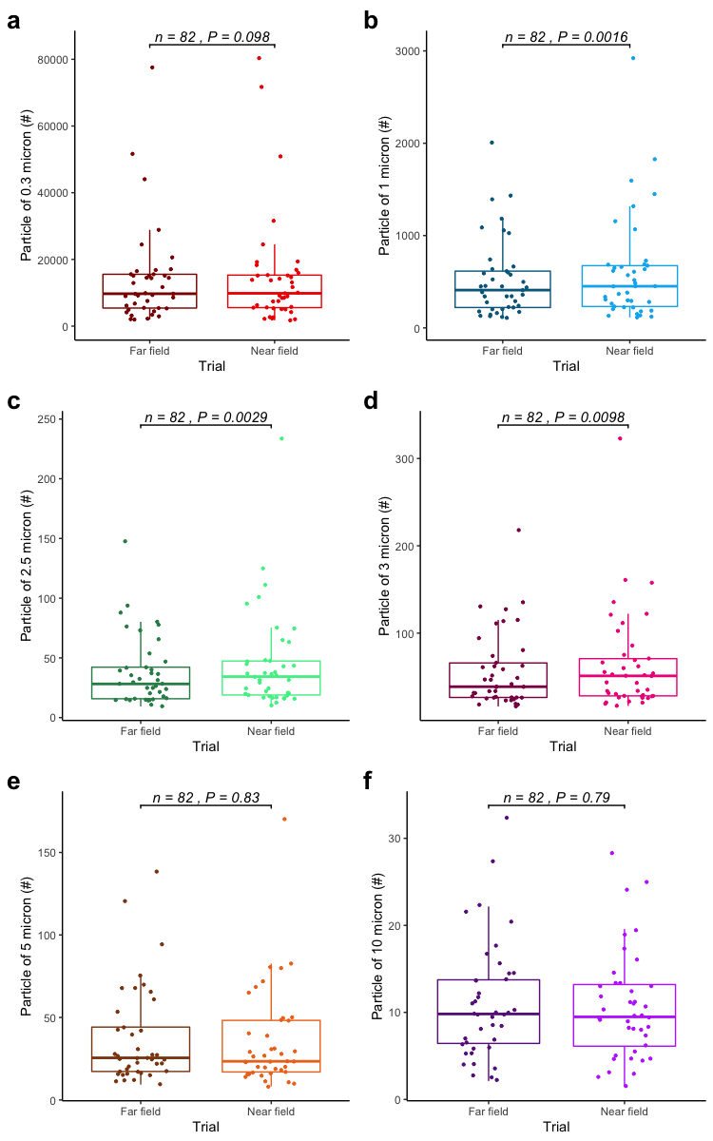

Supplemental figure 3 Correlation between aerosol particles of difference sizes (0.3-25) and average CO₂ concentration for routine trials at ~0 ACH; a) 0.3 µm -1 µm, b) 1 µm -2.5 µm, c) 2.5 µm -3 µm, d) 3 µm -5 µm, e) 5 µm -10 µm, f) 10 µm -25 µm
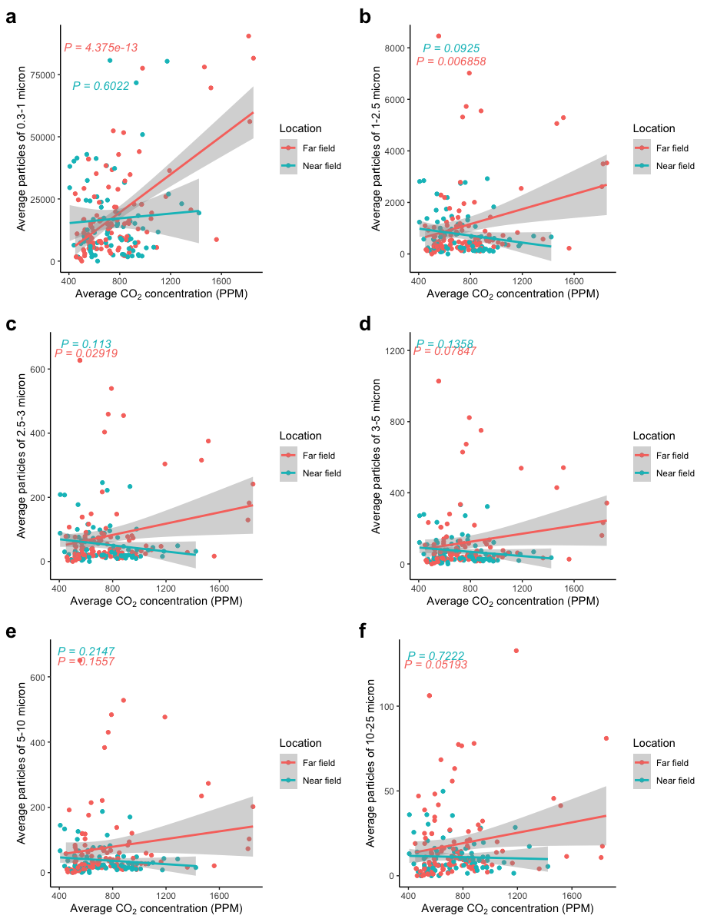
Supplemental figure 4 Comparison of surface viral load for three high touched surfaces
Supplemental figure 5 Comparison of surface viral load for settling plates in near and far field
Supplemental figure 6 Correlation between aerosol and paired nasal vial load for higher expiratory rials

Sitting quietly and speaking trials

In addition to routine trials lasting one hour, we conducted a series of shorter trials (using Setup 2 with six participants) whereby participants were sitting silently for 30 minutes in one trial and then were speaking on a conference call or online meetings for 30 minutes. The mean difference of aerosol viral load for speaking trials was 1.957143 C_{T} and 0.242857 C_{T} lower than for silent trials in near field and far field aerosols, respectively; however, these results were not statistically significant (P = 0.09164 for far field and P = 0.5608 for near field). We hypothesize that the mean difference observed may be associated with higher concentrations of bioaerosols emitted during speaking trials, but the small sample size is a limitation.
Supplemental figure 7 Comparison of aerosol C_{T} for sitting-speaking and sitting-quietly trials in near field and far field

Physical activity and aerosol viral load
Human exhaled breath is the major source of viral pathogens^{1–3}. Few measurements are available documenting the relationship between physical activity, viral shedding rate, and aerosol viral loads in realistic environments. Here we investigated this relationship by measuring room aerosol viral load and CO₂ concentrations during the following trials: coughing, speaking, sitting, standing, sitting silently, sitting while speaking, and walking on a treadmill.
CO₂ is frequently used as a surrogate for human exhaled breath⁴. Models of disease transmission use CO₂ as an indicator of air exchange rate within a space^{5,6} . However, here we monitored CO₂ with the aim of characterizing the degree of physical activity. Therefore, all physical activity trials were conducted at ~0 ACH and ambient conditions. Supplemental figure 3a shows the significant correlation between aerosol C_{T} value and average CO₂ concentration and Supplemental figure 3b shows the relative difference in average CO₂ concentrations across physical activity trials. Among physical activity trials, we observed an increase in room aerosol viral load equivalent to -1 C_{T} to be associated with an average CO₂ concentration increase of 400 PPM (P = 0.0484). Moreover, increased CO₂ concentration as the result of increased physical activity level was associated with increased number of particles of 0.3-1, 1-2.5, and 2.5-3 micron (Supplemental figure 4). Our study provides evidence that the level of physical activity is significantly correlated with the rate of viral shedding in indoor environments.
Supplemental figure 8 Physical activity correlations, a ) paired C_{T} values and corresponding average concentration affected by only physical activity (~0 ACH), b) Average CO₂ of different physical activities. CO₂

Supplemental figure 9 Comparison of aerosol C_{T} for ventilation trials of under ~4.5 ACH and above ~9 ACH in near field and far field
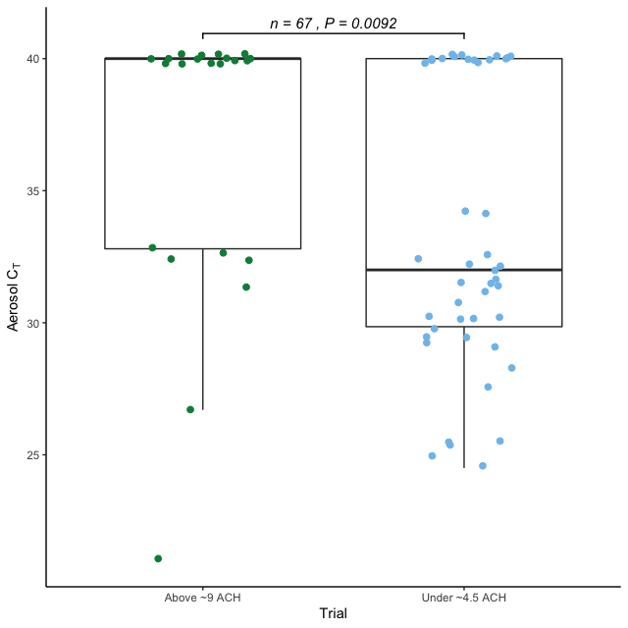
Supplemental figure 10 The impact of removal mechanism on high touched surface viral load

Supplemental figure 11 Number and type of samples collected for each participant
Supplemental figure 12 Number and proportion positive of nasal and saliva samples for each participant

-
Supplemental table 1 Demographic data of the study participants
Biological sex | Percent(n)
Male | 36(4)
Female | 63(7)
Ethnicity Percent(n)
White | 72(8)
Hispanic/Latino/Spanish | 27(3)
Native Hawaiian / Pacific Islander | -
Black / African American | 18(2)
Multiple | 36(4)
Asian | 9(1)

Supplemental table 2 The mean difference of removal mechanism trials and their paired control trials with ~ 0 ACH
Observation | ~3 & 4.5 ACH~Control | ~9ACH~Control | Filtration~Control
Near field C_{T} | 1.1409(P = 0.25) | 2.5766(P = 0.07) | 5.1462(P = 0.03)
Far field C_{T} | 0.5125(P = 0.39) | 0.8233(P = 0.32) | 1.3351(P = 0.23)
Near field CO₂ | -332.90 (P = 1.12e-08) | -398.46 (P = 1.11e-06) | 87.41 (P = 0.37)
Far field CO₂ | -320.08 (P = 1.4e-06) | -369.62 (P = 2.39e-05) | 103.27 (P = 0.09)

Appendix A: Rainbow passage⁷
When the sunlight strikes raindrops in the air, they act as a prism and form a rainbow. The rainbow is a division of white light into many beautiful colors. These take the shape of a long round arch, with its path high above, and its two ends apparently beyond the horizon. There is , according to legend, a boiling pot of gold at one end. People look, but no one ever finds it. When a man looks for something beyond his reach, his friends say he is looking for the pot of gold at the end of the rainbow.

Reference

1. Tellier, R. Aerosol transmission of influenza A virus: a review of new studies. J. R. Soc. Interface 6 Suppl 6, S783-90 (2009).
2. Gralton, J., Tovey, E., McLaws, M.-L. & Rawlinson, W. D. The role of particle size in aerosolised pathogen transmission: a review. J. Infect. 62, 1–13 (2011).
3. Tang, J. W. Investigating the airborne transmission pathway - different approaches with the same objectives. Indoor Air 25, 119–124 (2015).
4. Yang, L. et al. Carbon dioxide generation rates of different age and gender under various activity levels. Build. Environ. 186, 107317 (2020).
5. Rudnick, S. N. & Milton, D. K. Risk of indoor airborne infection transmission estimated from carbon dioxide concentration. Indoor Air 13, 237–245 (2003).
6. Blocken, B. et al. Ventilation and air cleaning to limit aerosol particle concentrations in a gym during the COVID-19 pandemic. Build. Environ. 193, 107659 (2021).
7. https://www.cdc.gov/niosh/npptl/stps/pdfs/RCT-APR-0067-508.pdf.

