Supplementary Information

Extension of the phenotypic spectrum of BMP1-related disorders through a novel homozygous variant identified in a fetus with intrauterine growth retardation

Le Guillou Horn et al.

S1. Supplementary Fig. 1: Minigene construction and analysis
S2. Supplementary Table 1: Primer list
S3. Supplementary Materials: original full-length blot or gel
S3.1 Original uncropped gel corresponding to Fig. 2.D1
S3.2 Original uncropped gel corresponding to Fig. 2.D2
S3.3 Original uncropped gel corresponding to Fig. 2.E
S3.4 Original uncropped gel/blot corresponding to Fig. 3.A
S3.5 Original uncropped gel/blot corresponding to Fig. 3.B
S3.6 Original uncropped gel/blot corresponding to Fig. 4.E
S3.7 Original uncropped gel/blot corresponding to Fig.4.C
S3.8 Original uncropped gel/blot corresponding to Fig. 4.D

pSpliceExpress
ccdB
CmR
AttP1
AttP2
AttB1
AttB2
AttB1
AttB2
Forward primer
Reverse primer
Exon 6
IVS5
IVS6
Exon 2
Exon 3
IVS2
(5’ part)
IVS2
(3’ part)
AttL1
AttL2
Exon 3
IVS2
(3’ part)
Exon 2
Exon 3
Rat Insulin exon
Human BMP1/mTLD exon 6
E2F
E3R
and / or
E2F
E3R
E2F
E3R
261 bp
367 bp (WT)
870 bp
Step 1 : amplification (PCR) of BMP1 exon 6 and its flanking intronic region from foetus genomic DNA
Step 2 : molecular cloning into pSpliceExpress (minigene generation)
recombinase
Step 3 : minigene analysis : cells transfections followed by RT-PCR
106 bp
Exon 2

S1. Supplementary Figure 1: Minigene construction and analysis
S2. Supplementary Table 1: Primers used in this study
PRIMER IDENTIFICATION | SEQUENCE PRIMERS (5’-3’)
BMP1EX6EP_Forward | GGGGACAAGTTTGTACAAAAAAGCAGGCTCCATGTTCCCTTGAGTCCTCCATT
BMP1EX6EP_Reverse | GGGGACCACTTTGTACAAGAAAGCTGGGTTGTGCCTGTCATCCTAGCTACTCAGTA
BMP1EX6SA_Forward | CATTCCCTGCCCTGGAAAGT
BMP1EX6SA_Reverse | AGGCAGGAGGAGAATAGCCT
BMP1EX6INT_Forward | GGCAGGAGTATAACTTCCTGA
BMP1EX6INT_Reverse | GAATGTGTTCCGAGCGTAA
BMP1EX5-6-7_Forward | GCCCCCAGGCCATCTCCAT
BMP1EX5-6-7_Reverse | TGCGGGCTTGGGCAATGT

BMP1EX6EXP = Minigene’s primers
BMP1EX6SA = Miniprep’s primer sequences
BMP1EX6INT = Nested PCR primers from RT-PCR
BMP1EX5-6-7 = RT-PCR primers from primary cell culture

S3.1 Original uncropped gel corresponding to Fig. 2D1
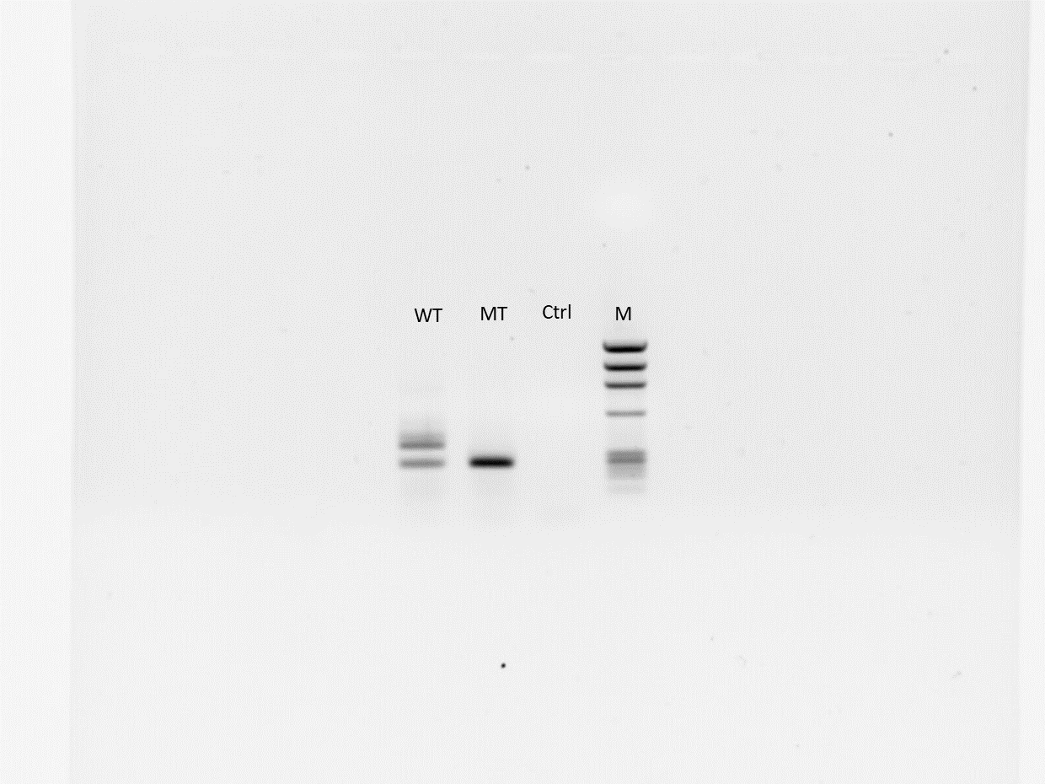
Caption: Migration of the PCR product amplified using forward and reverse primers targeting the rat insulin exons, demonstrated successful insertion of BMP1 exon 6 between exons 2 and 3 of the rat insulin gene and an apparent BMP1 exon 6 skipping in mutated minigene construction
The region displayed in the main figure is derived from this original image.
WT: Wild Type; MT: proband’s foetus mutation BMP1: c.835A>G ; M: Marker

S3.2 Original uncropped gel corresponding to Fig. 2.D2
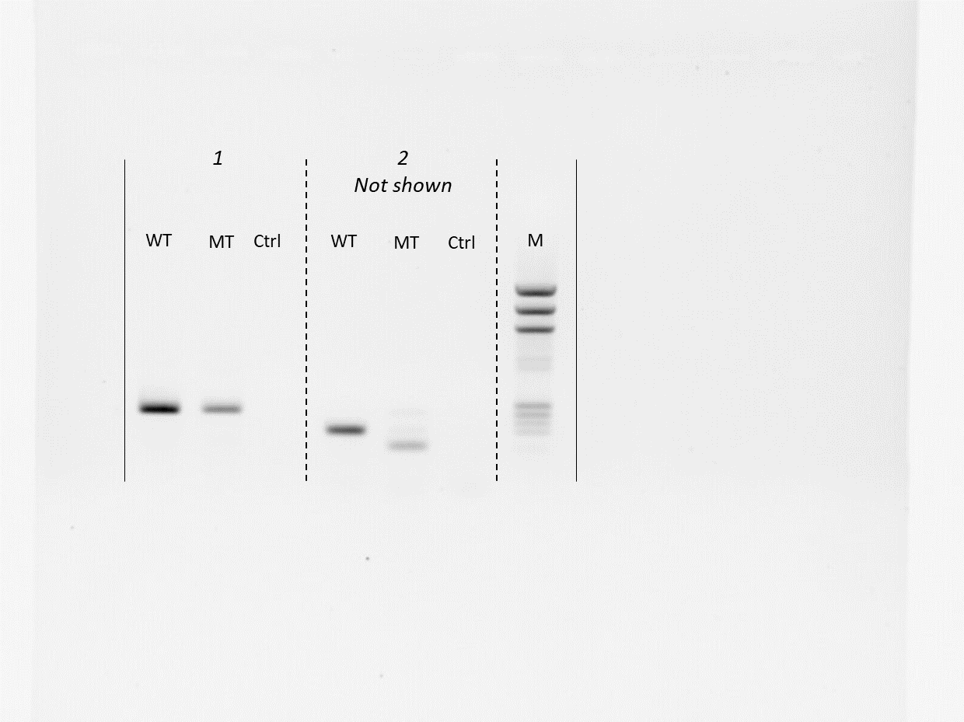
Caption: A primary amplification was performed using primers within the rat insulin exons, followed by a nested PCR using primers specific to the inserted BMP1 exon 6, confirming the correct integration and presence of the exon within the minigene. The original gel image contains two sets of three lanes (WT, MT, and Ctrl) generated with different primer pairs. The lanes corresponding to the assay shown in the main figure are identified as set 1 and were used for Fig. 2D2. The intervening lanes, corresponding to a different nested PCR assay, are visible in the original gel but were not included in the main figure.
WT: Wild Type; MT: proband’s foetus mutation BMP1: c.835A>G ; M: Marker
S3.3 Original uncropped gel corresponding to Fig.2.E
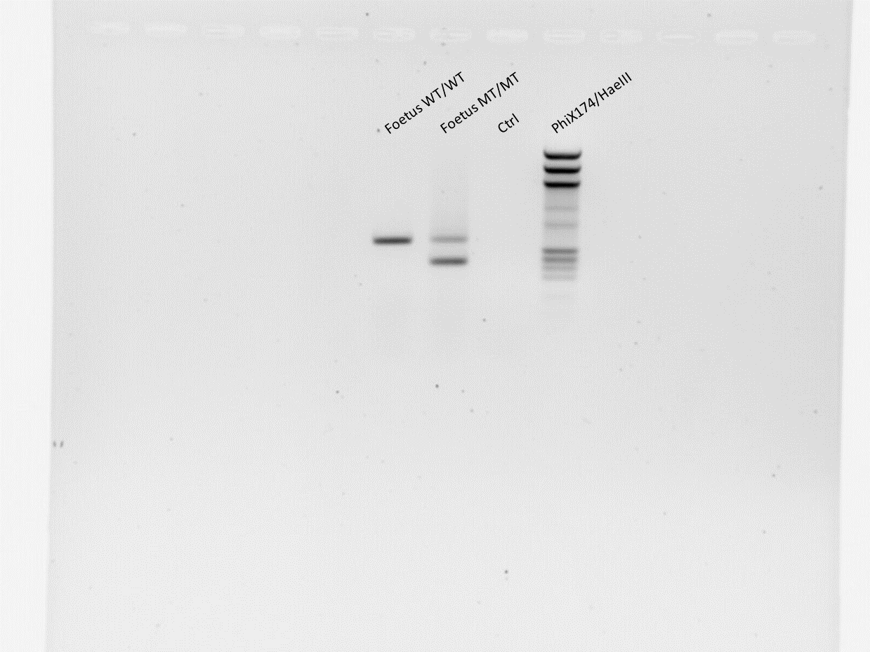
Caption: RT-PCR was performed using primers located in BMP1 exons 5 and 7. The migration pattern demonstrates the presence of a transcript construct lacking exon 6, indicating aberrant splicing (exon 6 skipping)
The region displayed in the main figure is derived from this original image.

S3.4 Original uncropped gel/blot corresponding to Fig.3.A:
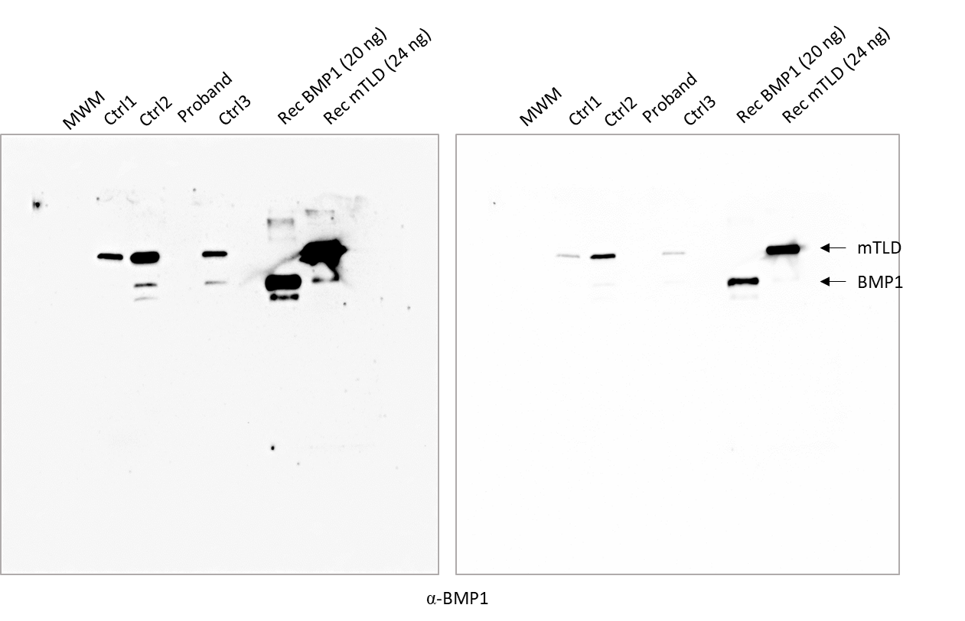
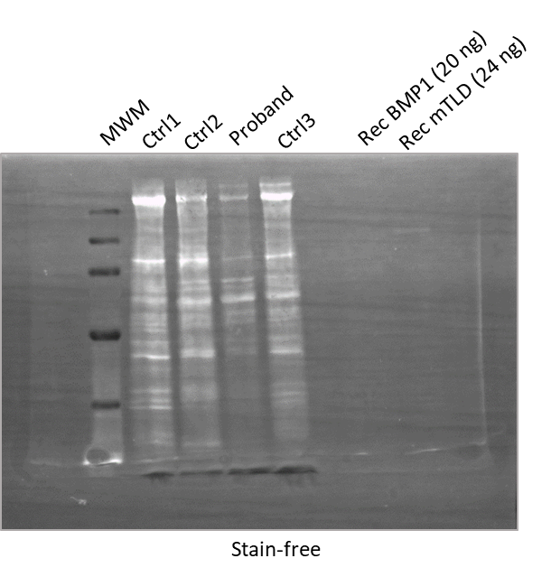
Caption: Uncropped western blot images of the detection of BMP1 and mTLD in the supernatant of proband’s foetus-derived cells and control cells (17 µg total protein/lane) or of recombinant BMP1 and mTLD (amounts as indicated). Proteins were detected with the MAB1927 antibody (10 % acrylamide gel; reducing conditions). Images were acquired in two different modes (super sensitivity on the left and high sensitivity on the right).
The bottom image shows the stain-free detection of total proteins on the same membrane prior to saturation and antibody addition.
S3.5 Original uncropped gel/blot corresponding to Fig.3 blot:
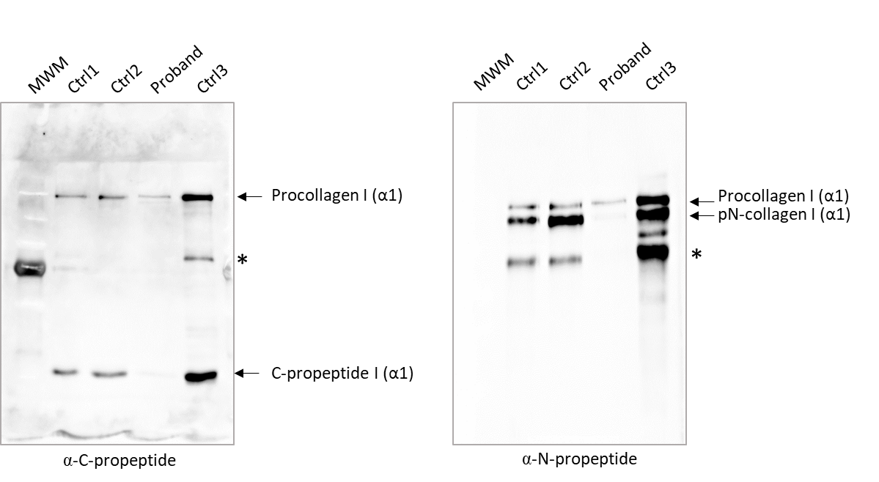
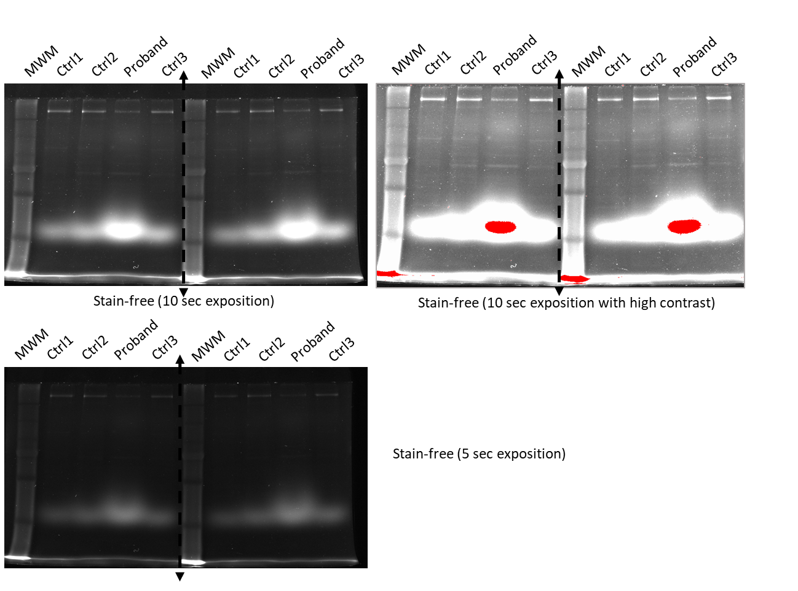
Caption: Uncropped Western blot images of the detection of procollagen I and BTP-dependent cleavage products (0.5 µg/ total protein/lane) in the foetal cell supernatants (10 % acrylamide gel; reducing conditions). *: other procollagen cleavage products.
The bottom image shows the stain-free detection of total proteins on the same membrane prior to saturation and antibody addition.
S3.6 Original uncropped gel/blot corresponding to Fig.4.A and Figure 4.E
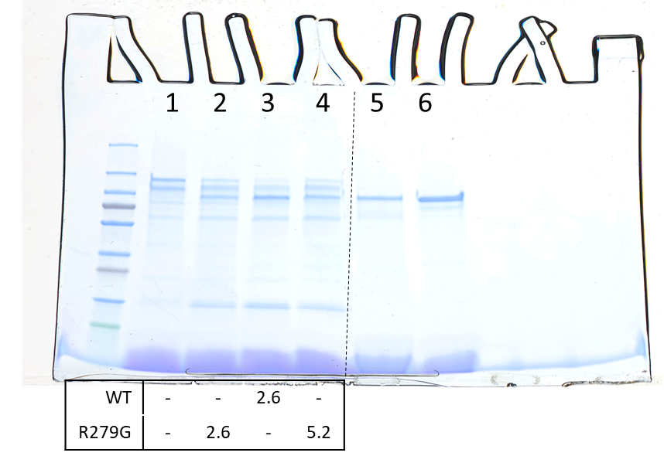
Caption: Uncropped image of gel shown in figure 4A and 4E
Lanes 1 to 4 = figure 4E : SDS-PAGE analysis of the cleavage of chordin (363 nM) by WT-FLAG BMP1 and Arg279Gly-FLAG (concentrations in µg/ml as indicated below the gel) after 1 h (4-20 % acrylamide gradient gel; reducing conditions).

Lanes 5-6 = figure 4A: SDS-PAGE analysis of 1 µg of WT-FLAG BMP1 (lane 6) and its Arg279Gly-FLAG (lane 5) mutant after production in 293-EBNA cells and purification (4-20 % acrylamide; reducing conditions)

Protein ladder: page ruler plus (Thermo Scientific)

S3.7 Original uncropped gel/blot corresponding to Fig.4.C:
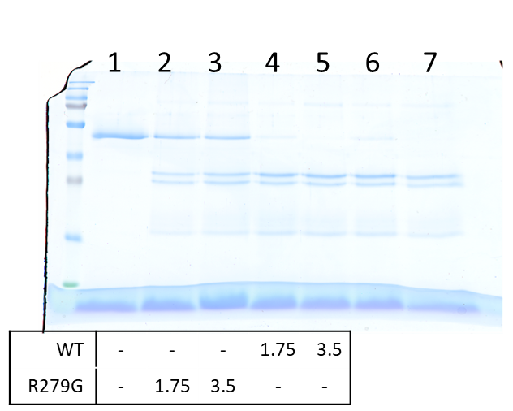
Caption: Uncropped image of gel shown in figure 4C
Lanes 1 to 5 = figure 4C: SDS-PAGE analysis of the cleavage of mini-procollagen I (350 nM) by WT-FLAG BMP1 and Arg279Gly-FLAG (concentrations in µg/ml as indicated below the gel) after 1 h (15 % acrylamide; reducing conditions).
Lanes 6 and 7 = replicate of 4-5 with another batch of WT-FLAG BMP1, this was not included in the paper because it was considered to provide no additional information
Protein ladder: page ruler plus (Thermo Scientific)

S3.8 Original uncropped gel/blot corresponding to Fig. 4.D:
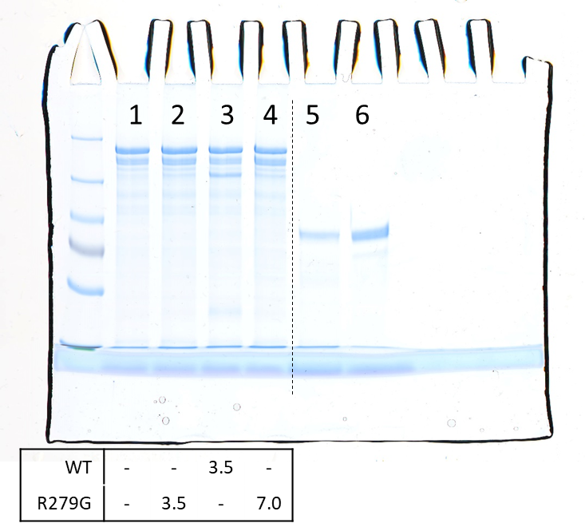
Caption: Uncropped image of gel shown in figure 4.D
Lanes 1 to 4 = figure 4D : SDS-PAGE analysis of the cleavage of TSP1 (513 nM) by WT-FLAG BMP1 and Arg279Gly-FLAG (concentrations in µg/ml as indicated below the gel) after 1 h (8 % acrylamide; reducing conditions).
Lanes 5 and 6 = not shown, 1 µg of Arg279Gly-FLAG (lane 5) and WT-FLAG BMP1 (lane 6)
Protein ladder: page ruler plus (Thermo Scientific)

