Supplementary Material
Supplementary Figures
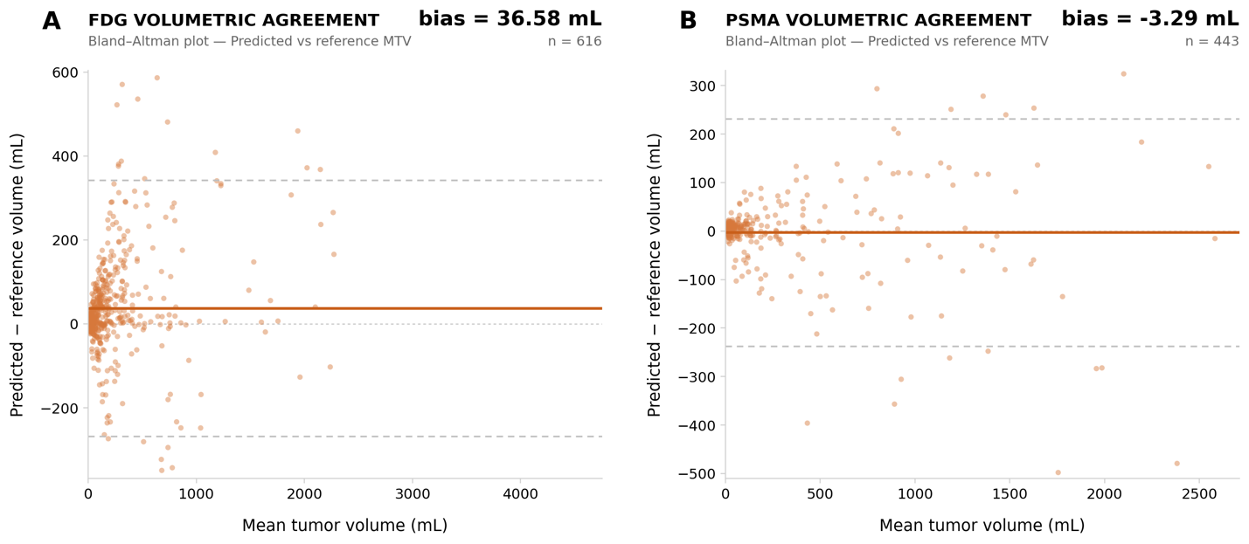Supplementary Figure S1. Bland–Altman analysis of volumetric agreement for LION on FDG and PSMA holdout cohorts. (A) [¹⁸F]FDG holdout cases and (B) PSMA-targeted holdout cases, showing the difference between predicted and reference tumor volume plotted against their mean. Solid lines indicate mean bias, and dashed lines indicate 95% limits of agreement. Mean volumetric bias was +36.58 mL for [¹⁸F]FDG and −3.29 mL for PSMA-targeted tracers.

Supplementary Tables
Supplementary Table S1. CLAIM guidelines.
Section / Topic | No. | Item | Page / Line | No | NA
TITLE / ABSTRACT
 | 1 | Identification as a study of AI methodology, specifying the category of technology used (e.g., deep learning) | Page 1
ABSTRACT
 | 2 | Summary of study design, methods, results, and conclusions | Page 4
INTRODUCTION
 | 3 | Scientific and/or clinical background, including the intended use and role of the AI approach | Page 5
 | 4 | Study aims, objectives, and hypotheses | Page 6
METHODS
Study Design | 5 | Prospective or retrospective study | Page 7 / Line 3
Study Design | 6 | Study goal | Page 6
Data | 7 | Data sources | Page 7
Data | 8 | Inclusion and exclusion criteria |  |  | X
Data | 9 | Data pre-processing | Page 7-8
Data | 10 | Selection of data subsets |  |  | X
Data | 11 | De-identification methods |  |  | X
Data | 12 | How missing data were handled |  |  | X
Data | 13 | Image acquisition protocol |  | X
Reference Standard | 14 | Definition of method(s) used to obtain reference standard | Supplementary methods
Reference Standard | 15 | Rationale for choosing the reference standard | Page 14 line 18
Reference Standard | 16 | Source of reference standard annotations | Supplementary methods
Reference Standard | 17 | Annotation of test set | Supplementary methods
Reference Standard | 18 | Measures of inter- and intra-rater variability of features described by the annotators |  | X
Data Partitions | 19 | How data were assigned to partitions | Page 7/ Table 1/2
Data Partitions | 20 | Level at which partitions are disjoint | Page 7 / Line 15
Testing Data | 21 | Intended sample size | Page 7
Model | 22 | Detailed description of model | Page 7-8 and Supplementary methods
Model  Training | 23 | Software libraries, frameworks, and packages | Page 7-8
Training  Evaluation | 26 | Method of selecting the final model | Page 8
 | 27 | Ensembling techniques |  |  | X
 | 28 | Metrics of model performance | Page 8
Evaluation  RESULTS | 29 | Statistical measures of significance and uncertainty |  |  | X
 | 30 | Robustness or sensitivity analysis |  |  | X
 | 31 | Methods for explainability or interpretability | Page 8-9
 | 32 | Evaluation on internal data | Page 8-9
 | 33 | Testing on external data | Page 8-9
 | 34 | Clinical trial registration |  |  | X
RESULTS
Data | 35 | Numbers of patients or examinations included and excluded |  |  | X
 | 36 | Demographic and clinical characteristics of cases in each partition | Table 1 and Table 2
Model performance | 37 | Performance metrics and measures of statistical uncertainty | Page 11-13
 | 38 | Estimates of diagnostic performance and their precision |  |  | X
 | 39 | Failure analysis of incorrect results | Page 11-12
DISCUSSION
 | 40 | Study limitations | Page 15
 | 41 | Implications for practice, including intended use and/or clinical role |  |  | X
OTHER INFORMATION
 | 42 | Provide a reference to the full study protocol or to additional technical details | Supplementary methods
 | 43 | Statement about the availability of software, trained model, and/or data | Page 9
 | 44 | Sources of funding and other support; role of funders | Acknowledgements

Supplementary Table S2. Holdout dataset usages. Summary of how each holdout cohort was used across analyses, including tracer type, whether the reference standard was defined using an SUV threshold, and whether the cohort was included in open-source model benchmarking.

Cohort | Tracer | Ground truth threshold | Used in the comparison with open-source models
AP-mixed | [¹⁸F]FDG | No | No
LMU-LC | [¹⁸F]FDG | No | Yes
Lym-JNM | [¹⁸F]FDG | SUV > 4 | Yes
Lym-UCD | [¹⁸F]FDG | No | Yes
AutoPET | PSMA-targeted | No | No
Turku | PSMA-targeted | No | Yes
UC Davis | PSMA-targeted | No | Yes
Innsbruck | PSMA-targeted | No | Yes

Supplementary Table S3. Effect of organ-context on holdout performance. Per-cohort and overall median Dice, lesion-level sensitivity, and positive predictive value (PPV) for baseline tumor-only models and organ-context (multiclass) models on [¹⁸F]FDG and PSMA-targeted holdout datasets. The bold numbers show the best performing model

Tracer | Holdout Cohort | Baseline Median Dice | Baseline Median Sensitivity | Baseline Median PPV | Organ context Dice | Organ Context Sensitivity | Organ Context PPV
[¹⁸F]FDG | AP-Mixed | 0.61 | 0.70 | 0.60 | 0.71 | 0.73 | 0.80
[¹⁸F]FDG | LMU-LC | 0.60 | 1.00 | 0.50 | 0.70 | 1.00 | 0.69
[¹⁸F]FDG | Lym-JNM | 0.98 | 1.00 | 0.54 | 0.99 | 1.00 | 0.60
[¹⁸F]FDG | Lym-UCD | 0.55 | 0.55 | 0.41 | 0.64 | 0.50 | 0.67
[18F]FDG Overall |  | 0.62 | 0.86 | 0.50 | 0.71 | 0.86 | 0.67
PSMA-targeted | UCD | 0.84 | 0.81 | 0.87 | 0.87 | 0.85 | 0.94
PSMA-targeted | AutoPET | 0.60 | 0.83 | 0.75 | 0.66 | 0.90 | 0.86
PSMA-targeted | Turku | 0.49 | 1.00 | 0.50 | 0.55 | 1.00 | 0.67
PSMA-targeted | Innsbruck | 0.76 | 0.96 | 0.67 | 0.86 | 1.00 | 0.86
PSMA Overall |  | 0.75 | 0.88 | 0.79 | 0.83 | 0.93 | 0.91
Supplementary Table S4. Per-Cohort Segmentation Performance. Median and mean Dice similarity coefficient (DSC), lesion-level sensitivity, and positive predictive value (PPV) are reported for each [¹⁸F]FDG and PSMA-targeted holdout cohort, along with overall pooled performance across all [¹⁸F]FDG (n = 616) and PSMA-targeted (n = 443) test scans. Cohorts span multiple cancer types and scanner platforms.

Tracer | Holdout Cohort | Number of test scans | Median Dice | Mean Dice | Lesion Sensitivity | PPV
[¹⁸F]FDG | AP-Mixed | 52 | 0.71 | 0.66 | 0.73 | 0.80
[¹⁸F]FDG | LMU-LC | 369 | 0.70 | 0.65 | 1.00 | 0.69
[¹⁸F]FDG | Lym-JNM | 58 | 0.99 | 0.96 | 1.00 | 0.60
[¹⁸F]FDG | Lym-UCD | 137 | 0.64 | 0.55 | 0.50 | 0.67
FDG Overall |  | 616 | 0.71 | 0.66 | 0.86 | 0.67
PSMA-targeted | UCD | 173 | 0.87 | 0.82 | 0.85 | 0.94
PSMA-targeted | AutoPET | 50 | 0.66 | 0.58 | 0.90 | 0.86
PSMA-targeted | Turku | 50 | 0.55 | 0.51 | 1.00 | 0.67
PSMA-targeted | Innsbruck | 170 | 0.86 | 0.78 | 1.00 | 0.86
PSMA Overall |  | 273 | 0.81 | 0.74 | 0.93 | 0.91

Supplementary Table S5. Open-Source Model Comparison. Median Dice similarity coefficient (DSC), lesion-level sensitivity, and positive predictive value (PPV) are reported for LION and publicly available comparator models evaluated on the same test scans. Input modalities reflect each model’s required inference data (PET-only vs PET+CT). Comparisons were restricted to common-patient subsets after excluding AutoPET cohorts to prevent potential data leakage, yielding 564 [¹⁸F]FDG and 393 PSMA-targeted cases.

Tracer | Model | Input | Number of test scans | Median Dice | Lesion Sensitivity | PPV
[¹⁸F]FDG | LION | PET-only | 564 | 0.71 | 0.89 | 0.67
[¹⁸F]FDG | LesionTracer | PET+CT | 564 | 0.68 | 0.89 | 0.78
[¹⁸F]FDG | Champalimaud | PET | 564 | 0.62 | 0.86 | 0.50
[¹⁸F]FDG | TMTVNet | PET+CT | 564 | 0.47 | 0.88 | 0.50
PSMA-targeted | LION | PET-only | 393 | 0.85 | 0.93 | 0.92
PSMA-targeted | LesionTracer | PET+CT | 393 | 0.73 | 0.80 | 0.87
Supplementary Methods
Tumor segmentation annotation
All tumor masks, with the exception of AutoPET data and Lym-JNM were created by board-certified nuclear medicine physicians or hybrid imaging expert radiologists on paired PET/CT. Readers were instructed to delineate PET-positive malignant tumor uptake based on their clinical expertise, using the CT component only for anatomical localization as needed. No fixed SUV thresholds or prescribed segmentation tool were required, and both lesion definition and delineation approach were left to the reader. All annotations were reviewed by a senior physician. More information on the AutoPET and Lym-JNM annotations can be found in (27,29,30).
Prepreprocessing
CT-derived organ labels from MOOSE were resampled to PET space and combined with tumor masks to form multiclass targets, with tumor labels taking priority in overlapping regions. PET images and corresponding labels were then resampled to 3 × 3 × 3 mm prior to training (linear interpolation for PET; nearest-neighbor for labels).
LION model training
Separate nnU-Net v2 models were trained for FDG and PSMA using tracer-specific auxiliary organ classes (see Organ Context Inclusion). Both models were trained for 1,000 epochs with batch size 2 and patch size [160, 128, 112] and z-score normalization; the FDG model used nnUNetTrainerDA5, whereas the PSMA model used the default nnUNetTrainer.

