SUPPLEMENTARY MATERIAL

A. B.
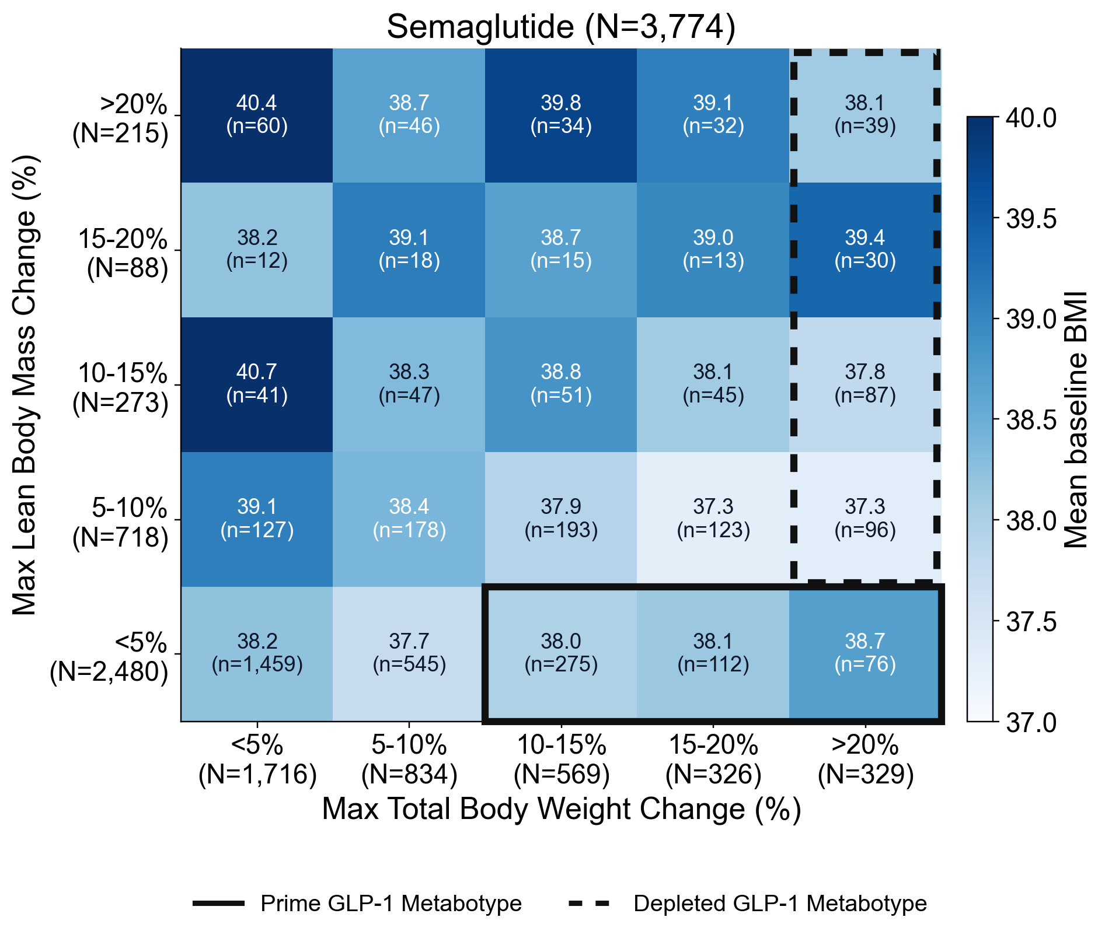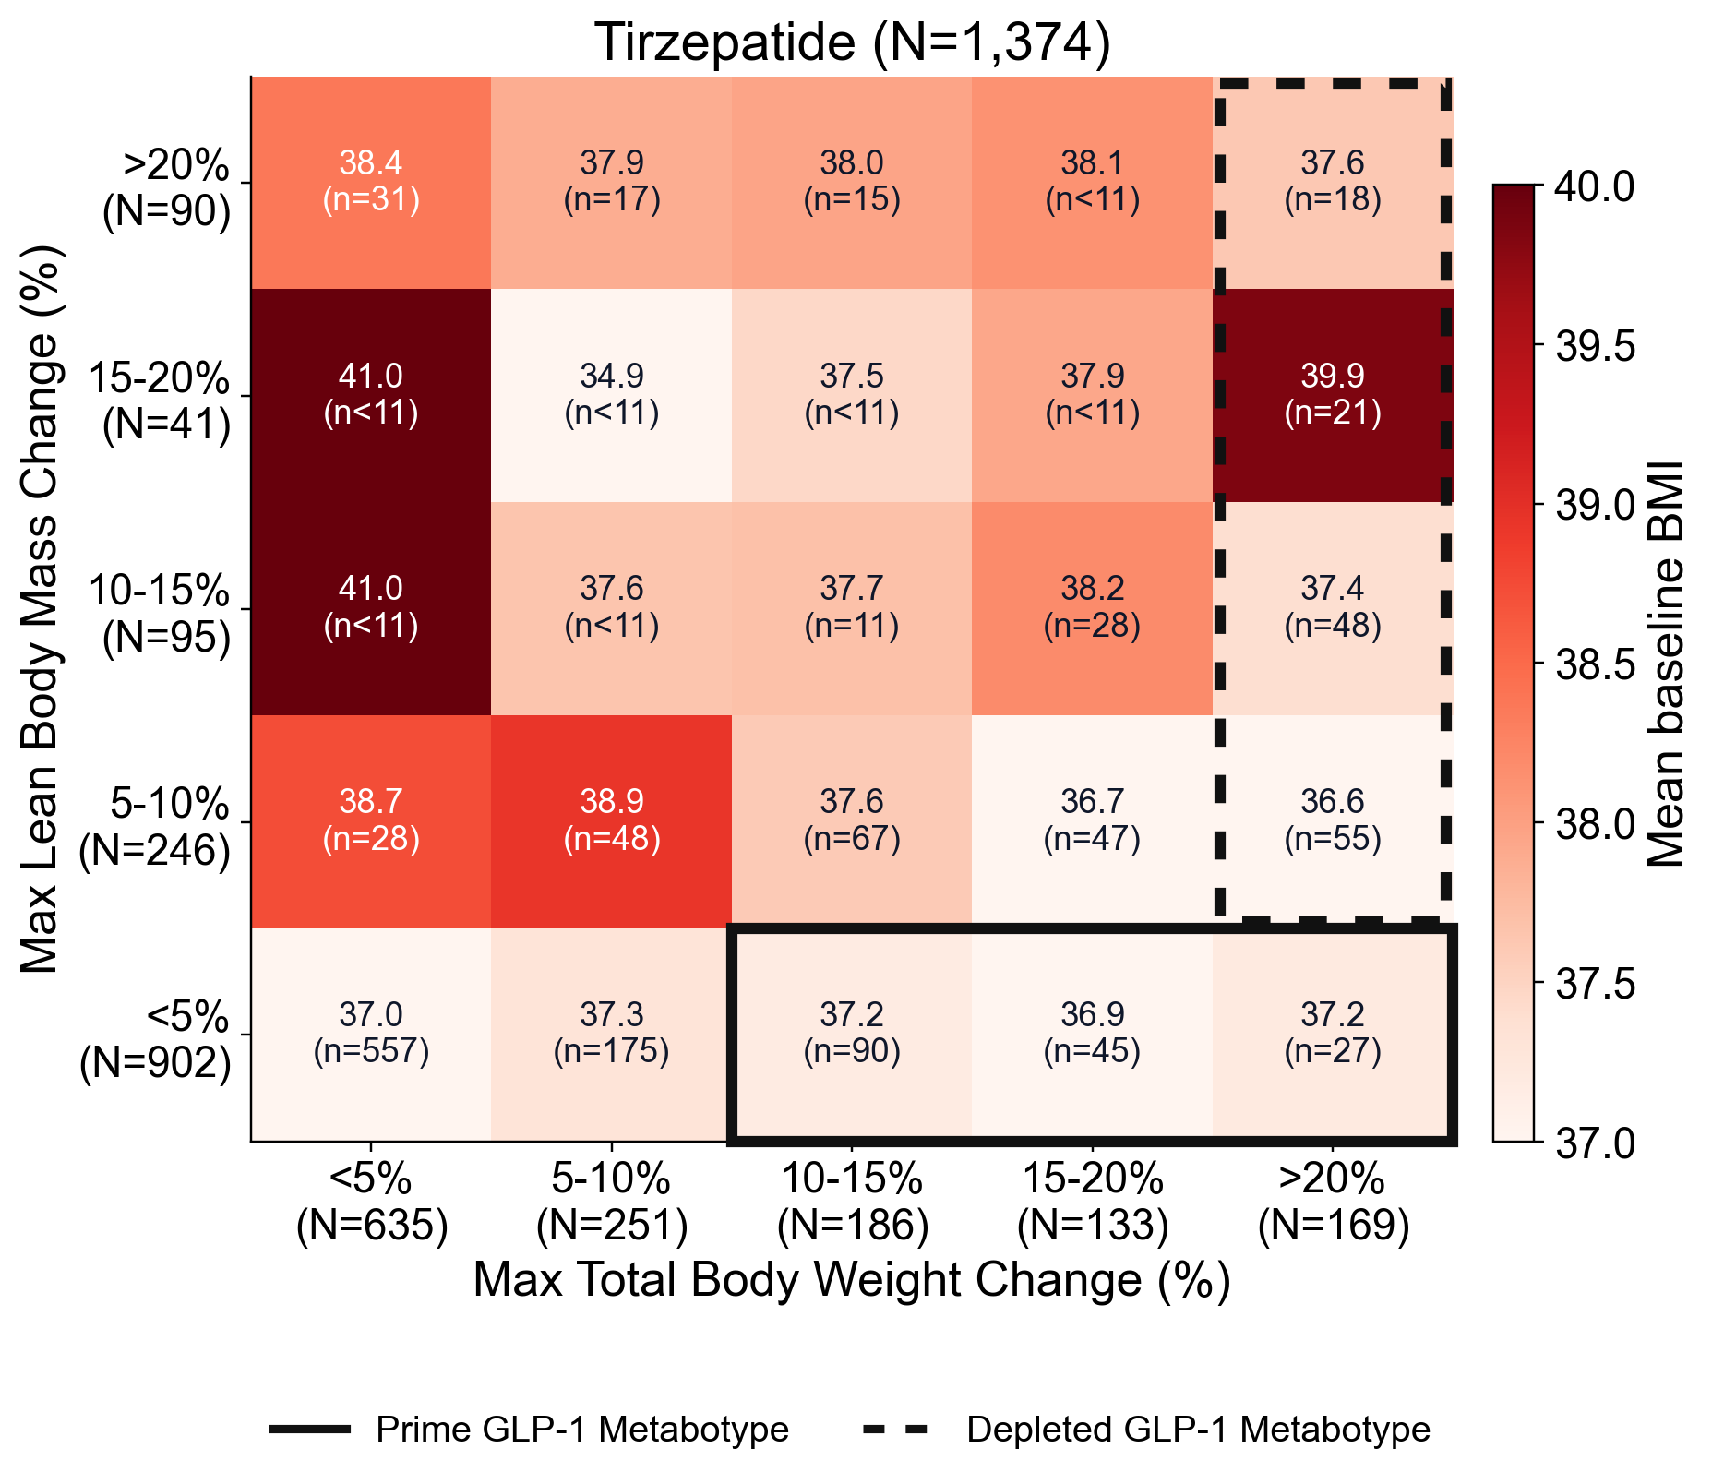
Fig S1. Mean baseline BMI across GLP-1 receptor agonist response strata for semaglutide and tirzepatide. Heatmap of mean baseline BMI across patient response strata defined by maximum % total body weight change (x-axis: <5%, 5–10%, 10–15%, 15–20%, >20% loss) and maximum % lean body mass change (y-axis: <5%, 5–10%, 10–15%, 15–20%, >20% loss) for (A) semaglutide (N=3,774) and (B) tirzepatide (N=1,374). Each tile displays the mean baseline BMI and patient count. Tile color intensity reflects mean BMI magnitude. The solid box denotes the Prime GLP-1 Metabotype (≥10% total body weight loss with <5% lean body mass loss), and the dashed box denotes the Depletive GLP-1 Metabotype (>20% total body weight loss with ≥5% lean body mass loss).

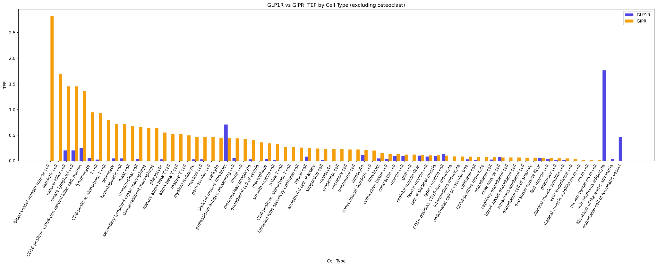
Fig. S2. The Target Engagement Potential (TEP, see methods) of GIPR (orange bars) and GLP1R (blue bars) are compiled across the musculature tissue from single cell RNA-seq data sets, including all cell types expressing either of these genes significantly.

Supplementary Methods

Large Language Model-Based Extraction of Body Composition and Functional Outcomes

Clinical note extraction was performed using GPT-OSS-20B on NVIDIA A100 40GB GPUs. For both body-composition and functional-outcome extraction, model generation used a temperature of 0.6 and a maximum output length of 8,192 tokens.

Body composition extraction

Candidate notes for body-composition extraction were identified using the following exact screening terms:

- fat %
- body fat percent
- percent body fat
- % fat
- lean body mass
- muscle mass
- fat mass
- basal metabolic rate
- bmr
- tanita
- fat free mass

System prompt

You are a clinical information extraction system. Extract body composition measurements from clinical notes and return valid JSON only.

User prompt

Note: “<YYYY-MM-DD>” and “<note text>” are replaced with structured note date and full note text respectively, at inference time

Extract body-composition measurements from this clinical note.

<<<NOTE_FRAGMENT_START>>>
Structured note date: <YYYY-MM-DD>

Clinical note: <note text>
<<<NOTE_FRAGMENT_END>>>

Use the structured note date as the temporal anchor. If the note clearly refers to a prior or future measurement, attribute the measurement to that other time as best as possible. Do not assume every value is from the note date. If a precise date is unavailable, use the best approximate temporal information present in the note.

Return ONLY a JSON array. Each item in the array must represent one measurement timepoint/event and use this schema:
[
{
"measurement_date": "YYYY-MM-DD or null",
"measurement_date_text": "verbatim or normalized temporal phrase",
"date_precision": "exact|month|year|relative|note_date|unknown",
"date_relation_to_note": "same_day|before_note|after_note|unknown",
"measurement_source": "canonical lowercase comma-separated source list or null",
"body_weight": {"value": number, "unit": string} or null,
"fat_percent": {"value": number, "unit": "%"} or null,
"lean_body_mass": {"value": number, "unit": string} or null,
"basal_metabolic_rate": {"value": number, "unit": "kcal"} or null,
"evidence_text": "short supporting excerpt"
}
]

Rules:
- Include only measurements actually stated or strongly implied in the note.
- Extract only measurements that are actually attributed to the patient, whether current or historical.
- Do not extract values that are suggestions, goals, targets, recommendations, educational examples, template text, or hypothetical/future-only values.
- Do not extract changes, differences, gains, losses, or percentages of change in these metrics; extract only absolute measurement values. For example, "15% decrease in lean mass" should not be extracted as a lean_body_mass value.
- If multiple metrics belong to the same timepoint, place them in the same JSON object.
- If the note contains multiple distinct timepoints, return multiple JSON objects.
- If the note states the measurement source or device, extract it as measurement_source using canonical lowercase labels.
- If more than one source applies to the same timepoint, return a comma-separated lowercase list such as "tanita, scale".
- Obvious examples include: "dexa", "tanita", "inbody", "bod pod", "bioimpedance", "skinfold", "scale". Use null if the source is not stated.
- Interpret "ffm" and "fat free mass" as lean body mass when the note is using them as equivalent body-composition metrics.
- Preserve the units stated in the note. Do not convert units.
- Prefer "kg" for body_weight and lean_body_mass when the note provides kilograms explicitly.
- For fat_percent, always use unit "%".
- For basal_metabolic_rate, always use unit "kcal".
- If none of Basal Metabolic Rate, Fat %, Lean Body Mass, or Body weight are present, return [].
- Output must be valid JSON with no markdown fences and no extra commentary.

Example structured output

[
{
"measurement_date": "2024-09-22",
"measurement_date_text": "current visit",
"date_precision": "exact",
"date_relation_to_note": "same_day",
"measurement_source": "tanita",
"body_weight": {"value": 78.7, "unit": "kg"},
"fat_percent": {"value": 39.8, "unit": "%"},
"lean_body_mass": {"value": 47.4, "unit": "kg"},
"basal_metabolic_rate": {"value": 1441, "unit": "kcal"},
"evidence_text": "Tanita assessment performed at the current visit showed weight 78.7 kg, body fat 39.8%, lean body mass 47.4 kg, and basal metabolic rate 1441 kcal."
}
]

2. Functional outcome extraction

Candidate notes for functional-outcome extraction were identified using the following exact screening terms:

- fall
- falls
- fracture
- physical therapy
- occupational therapy
- pt evaluation
- ot evaluation
- walker
- rollator
- cane
- wheelchair
- crutches
- mobility aid
- assistive device
- weakness
- decondition
- frail
- exercise tolerance
- endurance
- functional status

System prompt

You are a clinical information extraction system. Extract functional-status and physical-performance data from clinical notes and return valid JSON only.

User prompt

Note: “<YYYY-MM-DD>” and “<note text>” are replaced with structured note date and full note text respectively, at inference time

Extract functional metrics from this clinical note.

<<<NOTE_FRAGMENT_START>>>
Structured note date: <YYYY-MM-DD>

Clinical note: <note text>
<<<NOTE_FRAGMENT_END>>>

Use the structured treatment start date and structured note date as temporal anchors. If the note clearly refers to a prior or future functional assessment, attribute that assessment to the best available date. Do not assume every metric occurred on the note date. If a precise date is unavailable, use the best approximate temporal information present in the note.

Return ONLY a JSON array. Each item in the array must represent one functional-assessment event/timepoint and use this schema:
[
{
"assessment_date": "YYYY-MM-DD or null",
"assessment_date_text": "verbatim or normalized temporal phrase",
"date_precision": "exact|month|year|relative|note_date|unknown",
"date_relation_to_note": "same_day|before_note|after_note|unknown",
"falls": {"status": "present|absent|unknown", "count": number or null, "timeframe_text": string or null} or null,
"fracture": {"status": "present|absent|unknown", "site": string or null, "timeframe_text": string or null} or null,
"pt_ot_assessment": {"status": "present|absent|unknown", "discipline": "pt|ot|pt,ot|unknown", "summary": string or null} or null,
"mobility_aid_use": {"status": "present|absent|unknown", "device": string or null} or null,
"weakness_signal": {"status": "present|absent|unknown", "summary": string or null} or null,
"exercise_tolerance_signal": {"status": "reduced|normal|improved|unknown", "summary": string or null} or null,
"evidence_text": "short supporting excerpt"
}
]

Rules:
- Extract only patient-attributed functional information, whether current or historical.
- Include qualitative findings when clearly documented.
- Do not extract goals, recommendations, hypothetical plans, educational examples, template placeholders, or unrelated family history.
- If multiple metrics belong to the same assessment timepoint, place them in the same JSON object.
- If a note contains multiple distinct functional-assessment timepoints, return multiple JSON objects.
- Use "unknown" for qualitative statuses only when the note mentions the domain but does not make the polarity clear.
- For falls and fractures, mark "present" only when the patient is described as having a history/event; mark "absent" only when the note explicitly denies them.
- For PT/OT, extract formal therapy or therapist assessments/evaluations only.
- For mobility aid use, include devices such as cane, walker, wheelchair, rollator, crutches, prosthesis, or other assistive ambulation aids.
- For weakness_signal, capture clinician-described weakness, frailty, deconditioning, sarcopenia-like weakness, or similar functional weakness signals.
- For exercise_tolerance_signal, use "reduced" for poor/decreased/limited exercise tolerance, exertional limitation, poor endurance, or low stamina; use "normal" or "improved" only when the note clearly states that.
- If none of the requested metrics/signals are present, return [].
- Output must be valid JSON with no markdown fences and no extra commentary.

Example structured output

[
{
"assessment_date": "2024-06-10",
"assessment_date_text": "today",
"date_precision": "note_date",
"date_relation_to_note": "same_day",
"falls": {"status": "absent", "count": null, "timeframe_text": null},
"fracture": null,
"pt_ot_assessment": {"status": "present", "discipline": "pt", "summary": "physical therapy evaluation completed"},
"mobility_aid_use": {"status": "present", "device": "cane"},
"weakness_signal": {"status": "present", "summary": "generalized weakness with deconditioning"},
"exercise_tolerance_signal": {"status": "reduced", "summary": "poor exercise tolerance and limited endurance"},
"evidence_text": "Physical therapy evaluation completed today. Patient ambulates with a cane, reports generalized weakness and deconditioning, and has poor exercise tolerance with limited endurance. Denies recent falls."
}
]

3. General considerations

For both extraction tasks, prompts required valid JSON output only and explicitly instructed the model not to extract template text, hypothetical recommendations, educational examples, or values not attributable to the patient. Temporal anchoring language was included to distinguish current, historical, and future-referenced observations. Supporting evidence excerpts were retained with each extracted record to facilitate manual review and downstream quality assurance.

