Electronic Supplementary Material

Title: Glomus chinense and Dominikia gansuensis, two new Glomeraceae species of arbuscular mycorrhizal fungi from high altitude in the Tibetan Plateau

Fengxia Yu¹ • Bruno Tomio Goto² • Franco Magurno³ • Janusz Błaszkowski⁴ • Jian Wang⁵ • Wenxia Ma¹ • Huyuan Feng¹ • Yongjun Liu^{1,6}

¹ School of Life Sciences, Lanzhou University, Lanzhou, 730000, China
² Departamento de Botânica e Zoologia, Universidade Federal do Rio Grande do Norte, Campus Universitário, Natal, RN 59072-970, Brazil
³ Institute of Biology, Biotechnology and Environmental Protection, Faculty of Natural Sciences, University of Silesia in Katowice, Jagiellońska 28, 40-032 Katowice, Poland
⁴ Laboratory of Plant Protection, Department of Shaping of Environment, West Pomeranian University of Technology in Szczecin, Słowackiego 17, PL–71434 Szczecin, Poland
⁵ Institute of Land Engineering and Technology, Shaanxi Provincial Land Engineering Construction Group Co., Ltd, Xi'an, 710075, China
⁶ Center for Grassland Microbiome, State Key Laboratory of Grassland Agro-ecosystems, Lanzhou University, Lanzhou, 730000, China

Corresponding author
Yongjun Liu
E-mail: yjliu@lzu.edu.cn

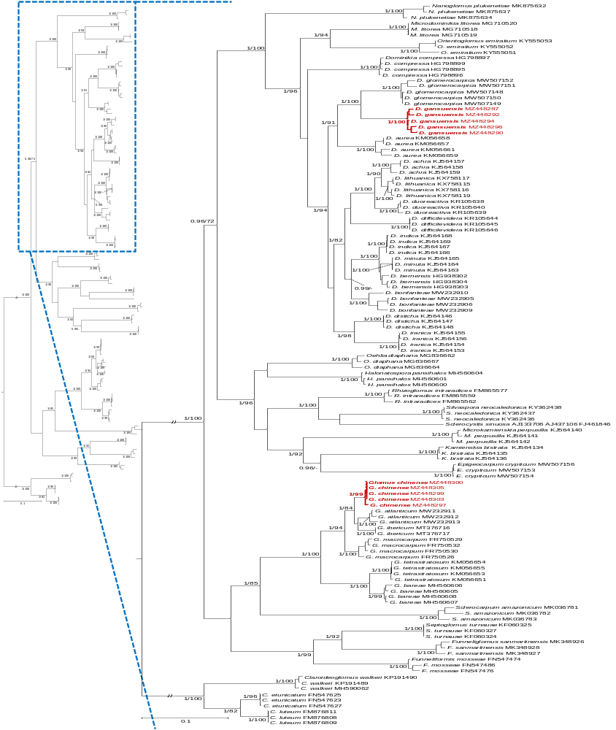

Fig. S1 Bayesian phylogenetic tree inferred from the representative 18S-ITS-28S sequences of Glomus chinense and Dominikia gansuensis obtained in this study (in bold and red), and other 33 species in the Glomeraceae. Three species in the Claroideoglomeraceae serve as outgroup. Sequences are labeled with their GenBank accession numbers. The Bayesian posterior probabilities ≥ 0.95 and ML bootstrap values ≥ 70% are shown near the branches, respectively. Bar indicates 0.1 expected change per site per branch. Some branches are shortened to 30% in length to improve visibility (indicated by //).

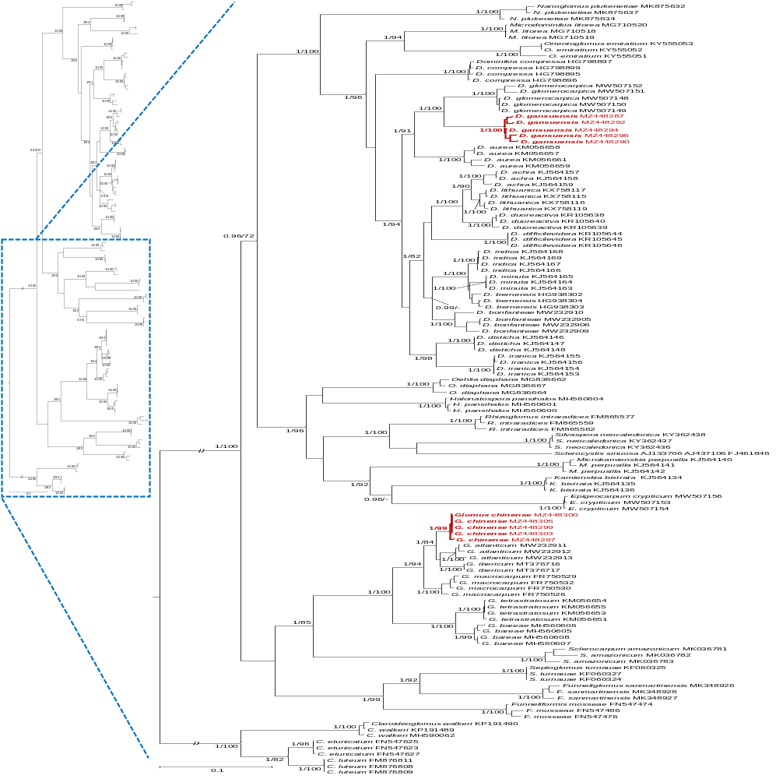

Fig. S1 (continued)

