Supplementary Martials
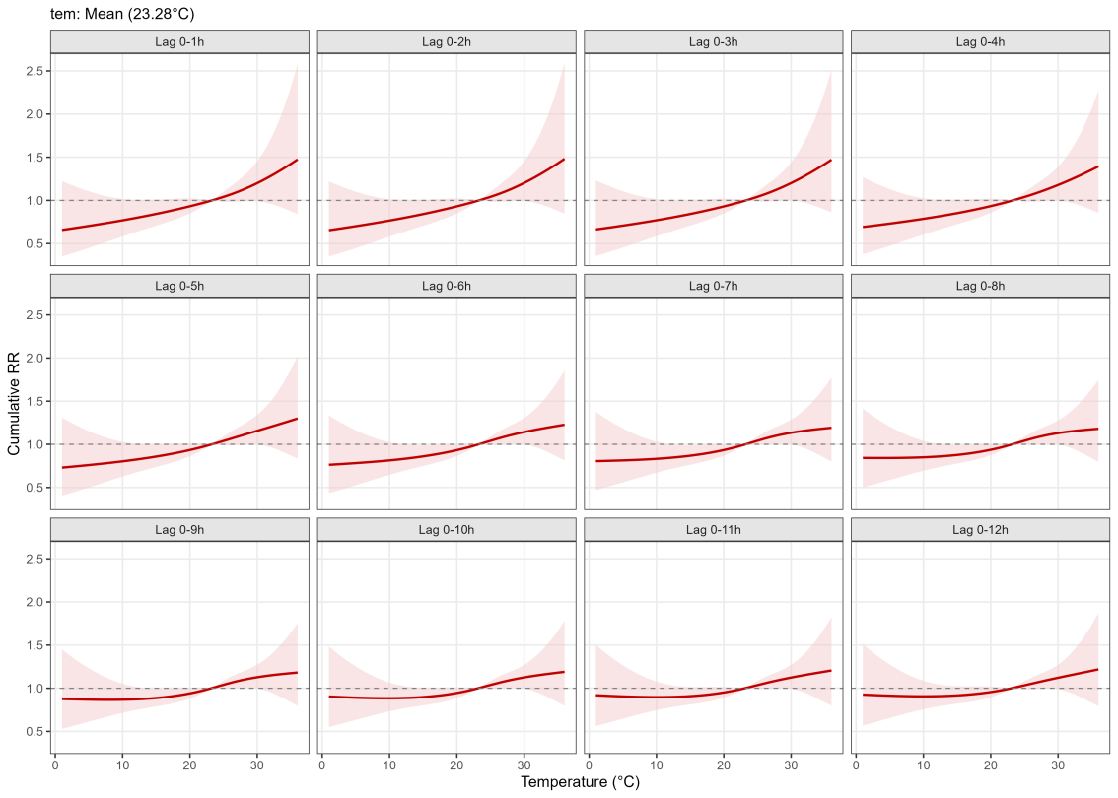
Fig. S1 Cumulative exposure-response relationship between temperature and electric bicycle accident risk: Sensitivity analysis based on the baseline model with 3 degrees of freedom for temperature.
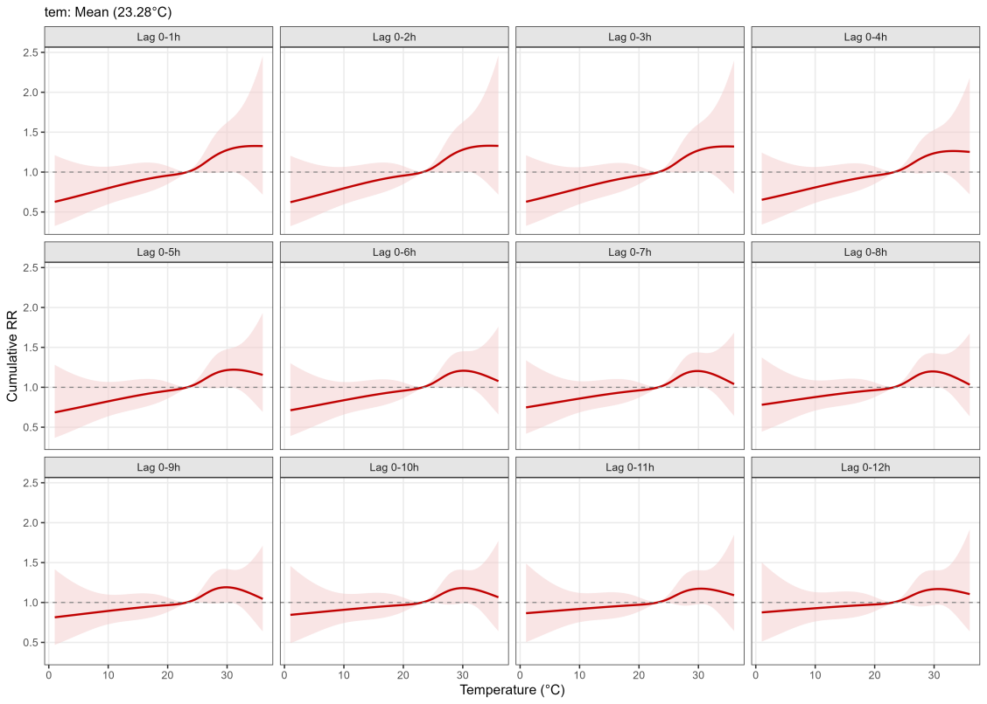
Fig. S2 Association between temperature and electric bicycle accident risk: Sensitivity analysis varying the degrees of freedom for temperature natural cubic spline to 4.
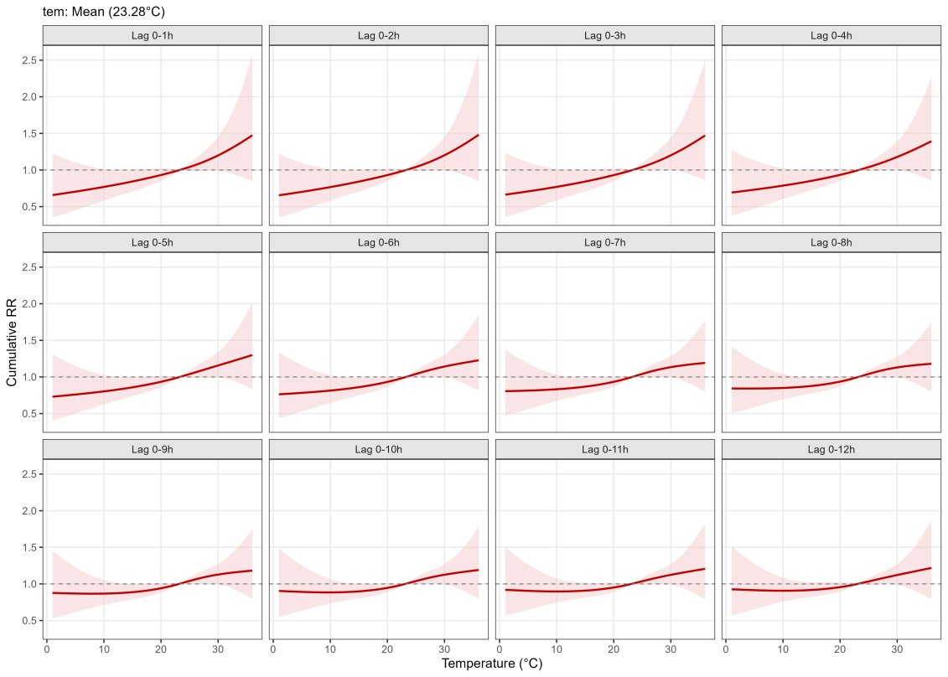
Fig. S3 Temperature effects under adjusted air quality control: Sensitivity analysis with 3 degrees of freedom for PM2.5.

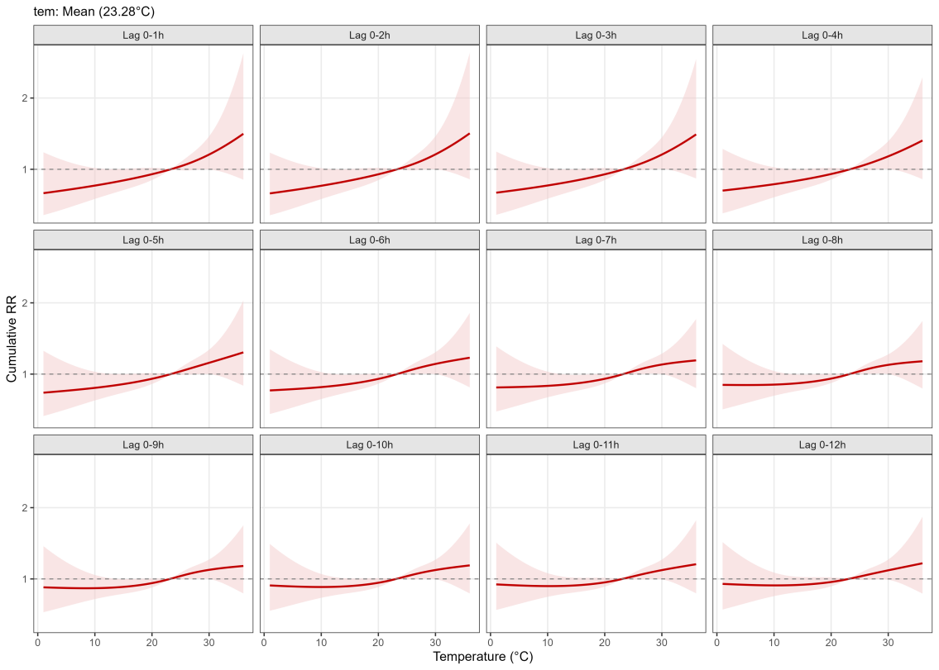
Fig. S4 Temperature effects under adjusted air quality control: Sensitivity analysis with 4 degrees of freedom for PM2.5.
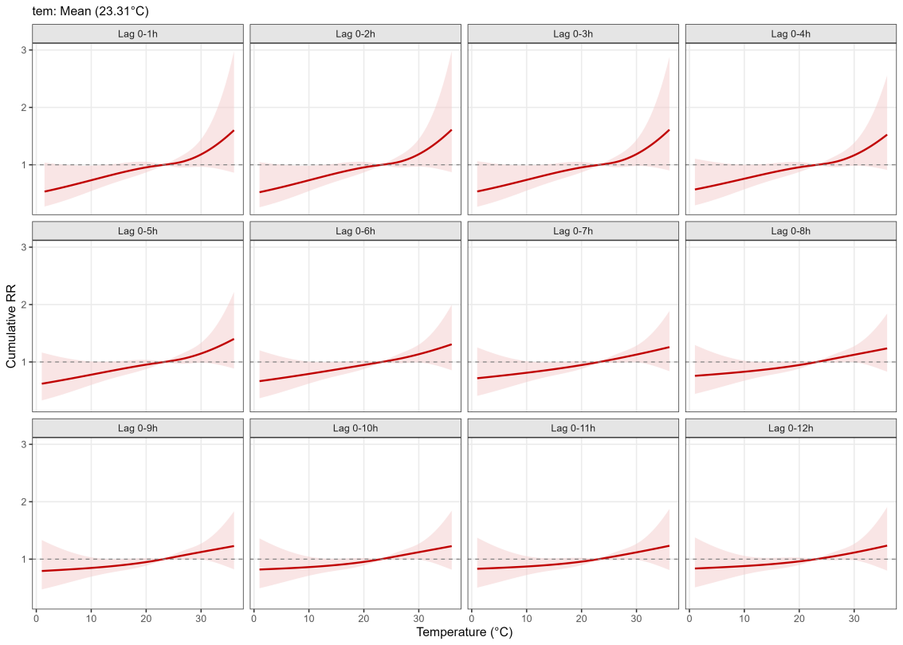
Fig. S5 Exposure-response relationship excluding extreme temperatures: Sensitivity analysis based on data truncated at the 1st and 99th percentiles of temperature.

