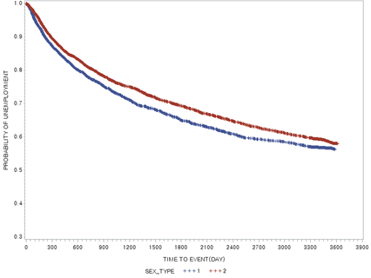 | 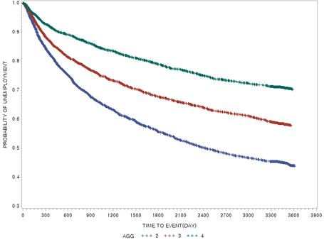
(a) Sex (log-rank p<0.0001) | (b) Age group (log-rank p<0.0001)
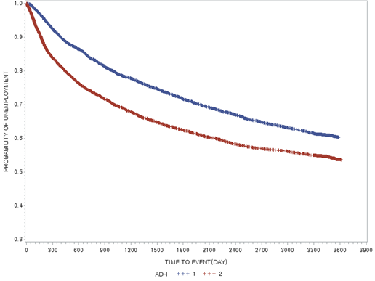 | 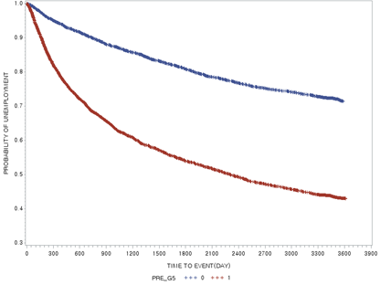
(c) Adherence (log-rank p<0.0001) | (d) Job experience (log-rank p<0.0001)
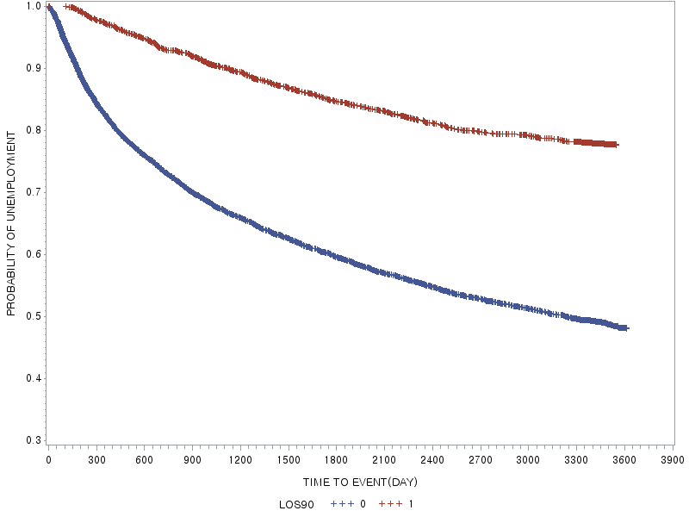 | 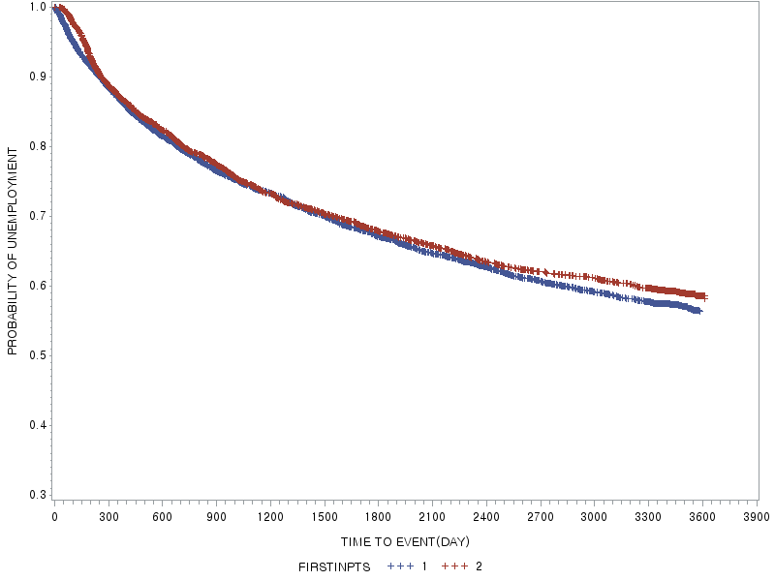
(e) Length of hospital stay (cut-off 90 days) (log-rank p<0.0001) | (f) Hospitalization at first episode (log-rank, p=0.136)
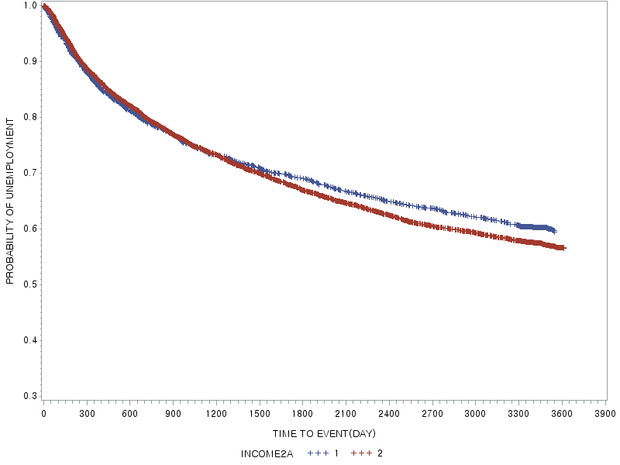
(g) Income level (log-rank p=0.1136)

Supplementary Figure 1. Kaplan-Meier curves and log-rank tests

Supplementary Table 1. List of psychoactive medications co-prescribed in the study population, classified according to ATC codes
ATC Code | Descriptions
N02BF | Gabapentinoids
N03 | Antiepileptics
N03A | Antiepileptics
N04 | Anti-Parkinson Drugs
N04A | Anticholinergic Agents
N04B | Dopaminergic Agents
N04C | Other Antiparkinson Drugs
N05 | Psycholeptics
N05A | Antipsychotics
N05B | Anxiolytics
N05C | Hypnotics and Sedatives
N06 | Psychoanaleptics
N06A | Antidepressants
N06BA | Centrally acting sympathomimetics
ATC, Anatomical Therapeutic Classification
Source: https://atcddd.fhi.no/atc_ddd_index/

Supplementary Table 2. List of antipsychotics prescribed in the study population, classified according to ATC codes, DDD, subclass, and LAI
ATC | API | DDD | Subclass | LAI
N05AA01 | chlorpromazine | 300.0 | typical | 0
N05AA02 | Levomepromazine | 300.0 | typical | 0
N05AB03 | Perphenazine | 30.0 | typical | 0
N05AD01 | Haloperidol | 8.0 | typical | 0
N05AD01 | Haloperidol | 3.3 | typical | 1
N05AD06 | Bromperidol | 10.0 | typical | 0
N05AE02 | Molindone | 50.0 | typical | 0
N05AE04 | ziprasidone | 80.0 | atypical | 0
N05AF03 | chlorprothixene | 300.0 | typical | 0
N05AF04 | thiothixene | 30.0 | typical | 0
N05AG02 | Pimozide | 4.0 | typical | 0
N05AH02 | clozapine | 300.0 | atypical | 0
N05AH03 | Olanzapine | 10.0 | atypical | 0
N05AH04 | Quetiapine | 400.0 | atypical | 0
N05AL01 | sulpiride | 800.0 | atypical | 0
N05AL05 | Amisulpride | 400.0 | atypical | 0
N05AL07 | levosulpiride | 400.0 | typical | 0
N05AL | nemonapride | 36.0 | typical | 0
N05AN01 | lithium | 240.0 | Lithium | 0
N05AX08 | Risperidone | 5.0 | atypical | 0
N05AX08 | Risperidone | 2.7 | atypical | 1
N05AX11 | zotepin | 200.0 | atypical | 0
N05AX12 | Aripiprazole | 15.0 | atypical | 0
N05AX12 | Aripiprazole | 15.0 | atypical | 1
N05AX13 | Paliperidone | 6.0 | atypical | 0
N05AX13 | Paliperidone | 2.5 | atypical | 1
N05AX | Blonanserin | 16.0 | atypical | 0
DDD, defined daily dose; LAI, Long-acting injection
Supplementary Table 3. List of psychoactive drugs co-prescribed in the study population, classified according to ATC codes
Items | ATC | Active pharmaceutical ingredient
Antiepileptics (N03A) | N02BF01 | Gabapentine
Antiepileptics (N03A) | N02BF02 | Pregabalin
Antiepileptics (N03A) | N03AA02 | Phenobarbital
Antiepileptics (N03A) | N03AA03 | Primidone
Antiepileptics (N03A) | N03AB02 | Phenytoin
Antiepileptics (N03A) | N03AB03 | diphenylhydantoin
Antiepileptics (N03A) | N03AB05 | Fosphenytoin
Antiepileptics (N03A) | N03AD01 | Ethosuximide
Antiepileptics (N03A) | N03AE01 | Clonazepam
Antiepileptics (N03A) | N03AF01 | Carbamazepine
Antiepileptics (N03A) | N03AF02 | Oxcarbazepine
Antiepileptics (N03A) | N03AF03 | Rufinamide
Antiepileptics (N03A) | N03AF04 | Eslicarbazepine
Antiepileptics (N03A) | N03AG01 | sodium valproate
Antiepileptics (N03A) | N03AG04 | Vigabatrin
Antiepileptics (N03A) | N03AGX | divalproex
Antiepileptics (N03A) | N03AX09 | Lamotrigine
Antiepileptics (N03A) | N03AX11 | Topiramate
Antiepileptics (N03A) | N03AX14 | Levetiracetam
Antiepileptics (N03A) | N03AX15 | zonisamide
Antiepileptics (N03A) | N03AX17 | stiripentol
Antiepileptics (N03A) | N03AX18 | Lacosamide
Antiepileptics (N03A) | N03AX22 | Perampanel
Antiepileptics (N03A) | N03AX24 | Cannabidiol
Antidepressants (N06A) | N06AA02 | Imipramine
Antidepressants (N06A) | N06AA04 | Clomipramine
Antidepressants (N06A) | N06AA09 | Amitriptyline
Antidepressants (N06A) | N06AA10 | Nortryptiline
Antidepressants (N06A) | N06AA12 | doxepin
Antidepressants (N06A) | N06AA17 | Amoxapine
Antidepressants (N06A) | N06AB03 | Fluoxetine
Antidepressants (N06A) | N06AB04 | Citalopram
Antidepressants (N06A) | N06AB05 | Paroxetine
Antidepressants (N06A) | N06AB06 | Sertraline
Antidepressants (N06A) | N06AB08 | Fluvoxamine
Antidepressants (N06A) | N06AB10 | Escitalopram
Antidepressants (N06A) | N06AG02 | Moclobemide
Antidepressants (N06A) | N06AX02 | tryptophan
Antidepressants (N06A) | N06AX05 | Trazodone
Antidepressants (N06A) | N06AX11 | Mirtazapine
Antidepressants (N06A) | N06AX12 | Bupropion
Antidepressants (N06A) | N06AX14 | Sodium tianeptine
Antidepressants (N06A) | N06AX16 | Venlafaxine
Antidepressants (N06A) | N06AX17 | Milnacipran
Antidepressants (N06A) | N06AX21 | Duloxetine
Antidepressants (N06A) | N06AX23 | Desvenlafaxine
Antidepressants (N06A) | N06AX26 | Vortioxetine
Antidepressants (N06A) | N06AX | S-Adenosyl-L-Methionine
Antiparkinson drugs (N04) | N04AA01 | trihexyphenidyl
Antiparkinson drugs (N04) | N04AA02 | Biperiden
Antiparkinson drugs (N04) | N04AB02 | Orphenadrine
Antiparkinson drugs (N04) | N04AC01 | Benztropine
Antiparkinson drugs (N04) | N04BA02 | Carbidopa+levodopa
Antiparkinson drugs (N04) | N04BA02 | Benserazide+levodopa
Antiparkinson drugs (N04) | N04BA03 | Carbidopa+entecapone+levodopa
Antiparkinson drugs (N04) | N04BB01 | Amantadine
Antiparkinson drugs (N04) | N04BC03 | dihydroergocryptine mesylate
Antiparkinson drugs (N04) | N04BC04 | Ropinirole
Antiparkinson drugs (N04) | N04BC05 | Pramipexole
Antiparkinson drugs (N04) | N04BC06 | cabergoline
Antiparkinson drugs (N04) | N04BD01 | Selegiline
Antiparkinson drugs (N04) | N04BD02 | Rasagiline
Antiparkinson drugs (N04) | N04BD03 | Safinamide
Antiparkinson drugs (N04) | N04BX02 | Entacapone
Anxiolytic (N05B) | N04BX04 | Opicapone
Anxiolytic (N05B) | N05BA02 | Chlordiazepoxide
Anxiolytic (N05B) | N05BA05 | clorazepate dipotassium
Anxiolytic (N05B) | N05BA06 | Lorazepam
Anxiolytic (N05B) | N05BA08 | Bromazepam
Anxiolytic (N05B) | N05BA09 | Clobazam
Anxiolytic (N05B) | N05BA12 | Alprazolam
Anxiolytic (N05B) | N05BA18 | ethyl loflazepate
Anxiolytic (N05B) | N05BA19 | etizolam
Anxiolytic (N05B) | N05BA21 | Clotiazepam
Anxiolytic (N05B) | N05BA23 | Tofisopam
Anxiolytic (N05B) | N05BA25 | mexazolam
Anxiolytic (N05B) | N05BB01 | Hydroxyzine
Anxiolytic (N05B) | N05BE01 | Buspirone
Psychostimulants-Centrally acting sympathomimetics  (N06BA) | N06BA04 | Methylphenidate
Psychostimulants-Centrally acting sympathomimetics  (N06BA) | N06BA07 | Modafinil
Psychostimulants-Centrally acting sympathomimetics  (N06BA) | N06BA13 | Armodafinil
Hypnotics & Sedatives (N05C) | N05CA19 | Thiopental
Hypnotics & Sedatives (N05C) | N05CC01 | Chloral Hydrate
Hypnotics & Sedatives (N05C) | N05CD01 | Flurazepam
Hypnotics & Sedatives (N05C) | N05CD03 | Flunitrazepam
Hypnotics & Sedatives (N05C) | N05CD05 | Triazolam
Hypnotics & Sedatives (N05C) | N05CD08 | Midazolam
Hypnotics & Sedatives (N05C) | N05CF02 | Zolpidem
Hypnotics & Sedatives (N05C) | N05CF03 | Zaleplon
Hypnotics & Sedatives (N05C) | N05CM | Doxylamine
ATC, Anatomical Therapeutic Classification
Source: https://atcddd.fhi.no/atc_ddd_index/

Supplementary Table 4. Adjusted hazard ratios for job acquisition from Cox proportional hazard analysis: Sex-stratified model
 | Male |  |  | Female
 | AHR (95% CI) | p |  | AHR (95% CI) | p
Adherence to Antipsychotics
Low | 1 (reference) |  |  | 1 (reference)
High | 1.29 (1.13, 1.46) | 0.0001 |  | 1.07 (0.96, 1.20) | NS
Age group
25-34 years | 1 (reference) |  |  | 1 (reference)
35~44 years | 0.61 (0.54, 0.69) | <0.001 |  | 0.77 (0.68, 0.87) | <0.001
45~54 years | 0.51 (0.44, 0.59) | <0.001 |  | 0.54 (0.47, 0.62) | <0.001
Income
Underprivileged | 1 (reference) |  |  | 1 (reference)
Others | 1.08 (0.95, 1.24) | NS |  | 0.96 (0.84, 1.08) | NS
Job experience
None | 1 (reference) |  |  | 1 (reference)
Yes | 2.55 (2.25, 2.90) | <0.001 |  | 2.42 (2.17, 2.70) | <0.001
First intervention
Ambulatory | 1 (reference) |  |  | 1 (reference)
Hospitalized | 0.77 (0.68, 0.87) | <0.001 |  | 0.81 (0.72, 0.90) | <0.001
Length of hospital stay
<90 days | 1 (reference) |  |  | 1 (reference)
>=90 days | 0.26 (0.22, 0.31) | <0.001 |  | 0.36 (0.31, 0.42) | <0.001
Dose intensity of antipsychotics
Low | 1 (reference) |  |  | 1 (reference)
Moderate | 1.14 (0.98, 1.32) | NS |  | 1.24 (1.08, 1.43) | 0.003
High | 0.98 (0.81, 1.18) | NS |  | 1.05 (0.86, 1.27) | NS
AHR, Adjusted Hazard Ratio

Supplementary Table 5. Adjusted hazard ratios for job acquisition from Cox proportional hazard analysis: Age-group-stratified model
 | Aged 25-34 years |  |  | Aged 35-44 years |  |  | Aged 45-54 years
 | HR (95% CI) | p |  | HR (95% CI) | p |  | HR (95% CI) | p
Adherence to antipsychotics
High (vs. Low) | 1.30 (1.14, 1.48) | <0.001 |  | 1.08 (0.93, 1.25) | NS |  | 1.04 (0.87, 1.24) | NS
Sex
Female (vs. Male) | 0.85 (0.76, 0.96) | 0.008 |  | 1.09 (0.95, 1.24) | NS |  | 0.96 (0.81, 1.14) | NS
Income
Others (vs. the underprivileged) | 0.93 (0.81, 1.07) | NS |  | 1.20 (1.03, 1.41) | 0.0238 |  | 0.86 (0.71,1.05) | NS
Job experience
Yes (vs. None) | 2.02 (1.79, 2.29) | <0.001 |  | 2.77 (2.40, 3.20) | <0.001 |  | 2.99 (2.53, 3.54) | <0.001
First intervention
Hospitalized (vs. Ambulatory) | 0.79 (0.70, 0.89) | <0.001 |  | 0.89 (0.75, 0.99) | 0.0374 |  | 0.69 (0.58, 0.83) | <0.001
Length of hospital stay
≥90days (vs.< 90days) | 0.33 (0.28, 0.39) | <0.001 |  | 0.33 (0.27, 0.40) | <0.001 |  | 0.23 (0.18, 0.29) | <0.001
Antipsychotics dose intensity
Moderate (vs. Low) | 1.25 (1.07, 1.45) | 0.003 |  | 1.11 (0.93, 1.33) | NS |  | 1.25 (0.99, 1.59) | 0.063
High (vs. Low) | 0.87 (0.71, 1.07) | NS |  | 1.07 (0.85, 1.35) | NS |  | 1.35 (0.99, 1.84) | 0.058

Supplementary Table 6. Adjusted hazard ratios for job acquisition from Cox proportional hazard analysis: Income-stratified model
 | Underprivileged group |  |  | Others
 | HR (95% CI) | p |  | HR (95% CI) | p
Adherence to antipsychotics
High (vs. Low) | 1.13 (0.94, 1.36) | NS |  | 1.18 (1.07, 1.30) | 0.0009
Sex
Female (vs. Male) | 0.85 (0.76, 0.96) | NS |  | 0.92 (0.84, 1.00) | 0.0518
Age group
35~44 years (vs. 25-34 years) | 0.58 (0.48, 0.70) | <0.001 |  | 0.73 (0.66, 0.80) | <0.001
45~54 years (vs. 25-34 years) | 0.57 (0.46, 0.70) | <0.001 |  | 0.51 (0.46. 0.57) | <0.001
Job experience
Yes (vs. None) | 2.25 (1.88, 2.68) | <0.001 |  | 2.52 (2.30, 2.77) | <0.001
First intervention
Hospitalized (vs. Ambulatory) | 0.71 (0.59, 0.84) | <0.001 |  | 0.82 (0.75, 0.91) | <0.001
Length of hospital stay
≥90days (vs.< 90days) | 0.21 (0.17, 0.27) | <0.001 |  | 0.34 (0.30, 0.39) | <0.001
Antipsychotics dose intensity
Moderate (vs. Low) | 1.14 (0.91, 1.42) | NS |  | 1.21 (1.08, 1.36) | 0.0014
High (vs. Low) | 1.13 (0.85, 1.49) | NS |  | 0.99 (0.85, 1.16) | NS

Supplementary Table 7. Adjusted hazard ratios for job acquisition from Cox proportional hazard analysis: Dose-intensity-stratified model
 | Low Dose Group |  |  | Moderate Dose Group |  |  | High Dose Group
 | HR (95% CI) | p |  | HR (95% CI) | p |  | HR (95% CI) | p
Adherence to AP
High (vs. Low) | 1.15 (1.04, 1.27) | 0.005 |  | 1.24 (0.99,1.55) | 0.065 |  | 1.26 (0.84, 1.89) | NS
Sex
Female (vs. Male) | 0.93 (0.85, 1.02) | NS |  | 0.97 (0.83, 1.15) | NS |  | 0.97 (0.79, 1.23) | NS
Age group
35~44 years (vs. 25-34 years) | 0.71 (0.64, 0.79) | <0.001 |  | 0.60 (0.50, 0.72) | <0.001 |  | 0.79 (0.66, 1.12) | NS
45~54 years (vs. 25-34 years) | 0.51 (0.45, 0.57) | <0.001 |  | 0.48 (0.38, 0.60) | <0.001 |  | 0.72 (0.54, 1.03) | 0.075
Income
Others (vs. the underprivileged) | 0.98 (0.88, 1.09) | NS |  | 1.12 (0.91, 1.36) | NS |  | 0.94(0.72, 1.24) | NS
Job experience
Yes (vs. None) | 2.35 (2.13, 2.59) | <0.001 |  | 2.63 (2.19, 3.15) | <0.001 |  | 2.73 (2.12, 3.53) | <0.001
First intervention
Hospitalized (vs. Ambulatory) | 0.90 (0.81, 1.00) | 0.043 |  | 0.65 (0.55, 0.78) | <0.001 |  | 0.60 (0.46, 0.77) | <0.001
Length of hospital stay
≥90days (vs.< 90days) | 0.31 (0.27, 0.36) | <0.001 |  | 0.33 (0.27, 0.41) | <0.001 |  | 0.27(0.20, 0.37) | <0.001

