Interface Synergistic Regulation-Driven Green Construction of Ternary Composite Carbon Films
Zerui Chenª, Zexi Linª, Hao Zhongª, Shaozhong Zengª, Shuzhang Niuª, Zeguo Tangª, Dongju Fu^{a*}, Peigang Hanª, Xiao Yu^{a*}, and Yan-Bing He^{b*}
ª College of New Materials and New Energies, Shenzhen Technology University, Shenzhen, 518118 P. R. China
^{b} Shenzhen All-Solid-State Lithium Battery Electrolyte Engineering Research Center, Institute of Materials Research (IMR), Tsinghua Shenzhen International Graduate School, Tsinghua University, Shenzhen, 518055 P. R. China

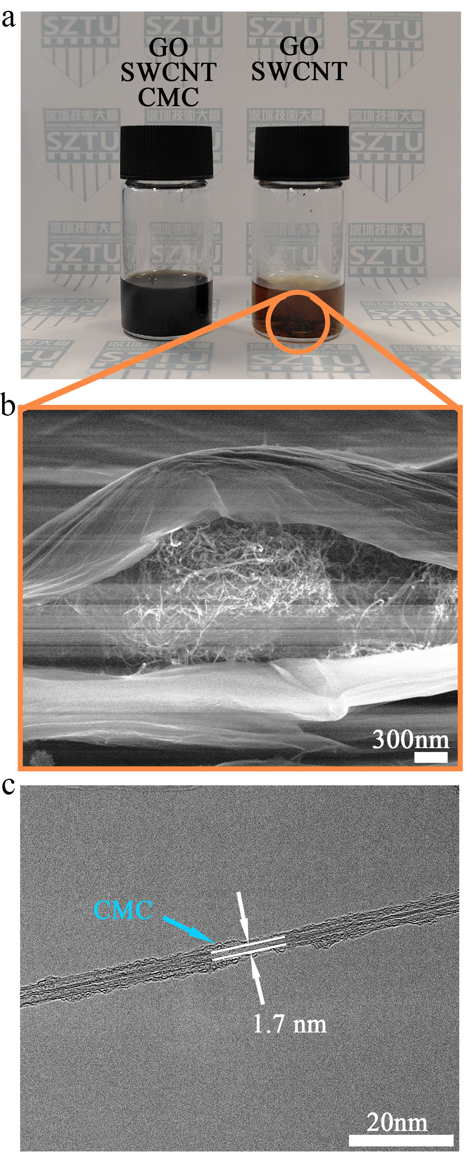
Supplementary Figure 1. Influence of CMC for solution stability. (a) optical photo of aqueous dispersion of GO and CM-SWCNTs with and without CMC and (b) the SEM graph of TCF without adding CMC. (c) The TEM graph CM-SWCNT.

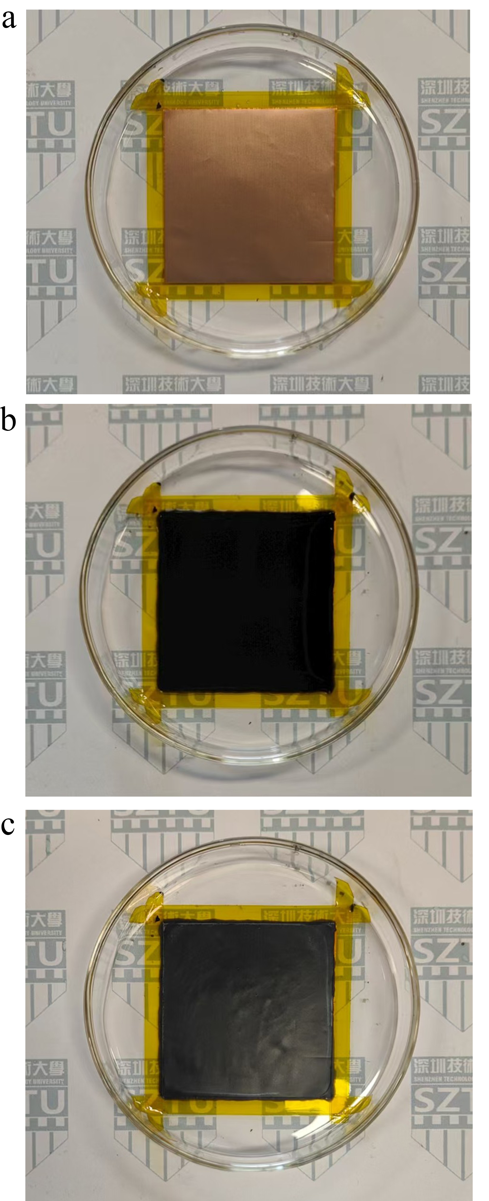
Supplementary Figure 2. The optical photo of TCF. (a) HCl-treated Copper foil, (b) RGO@CM-SWCNT@GO gel, and (c) RGO@CM-SWCNT@GO TCFs.

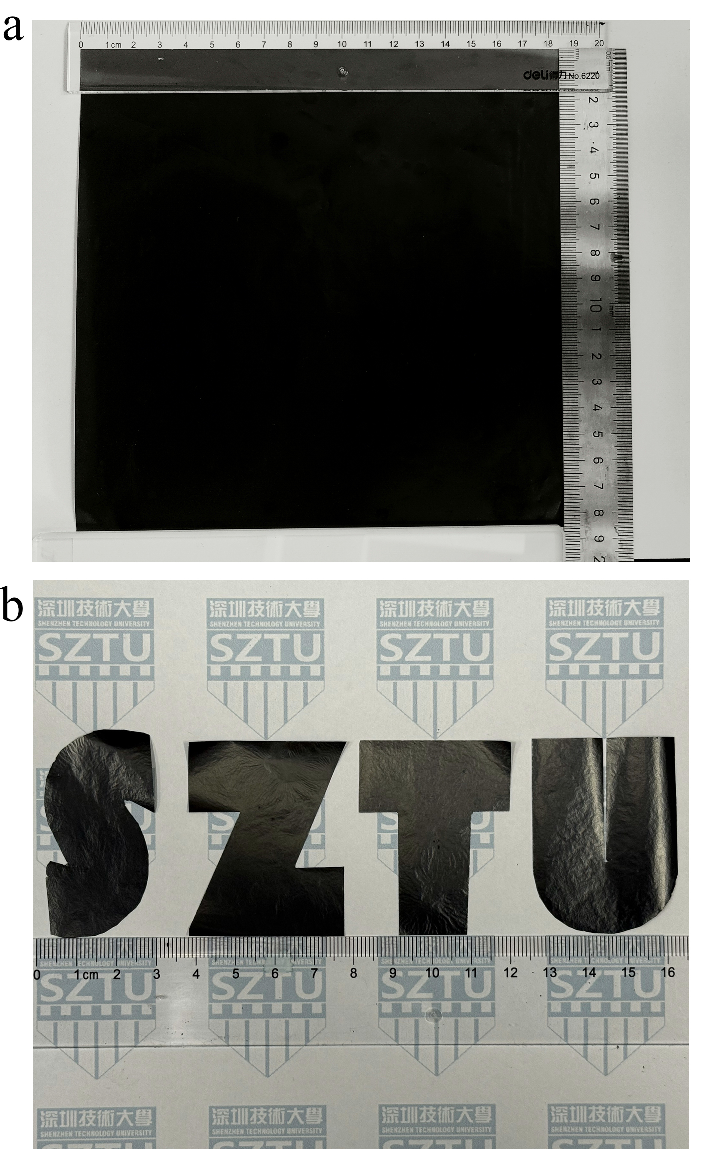
Supplementary Figure 3. The potential of TCF toward large-scale preparation and customization. (a) 1-32%-4h TCF with 18.5×18.5 cm² area, and (b) the ‘SZTU’ shape 1-32%-4h TCF.

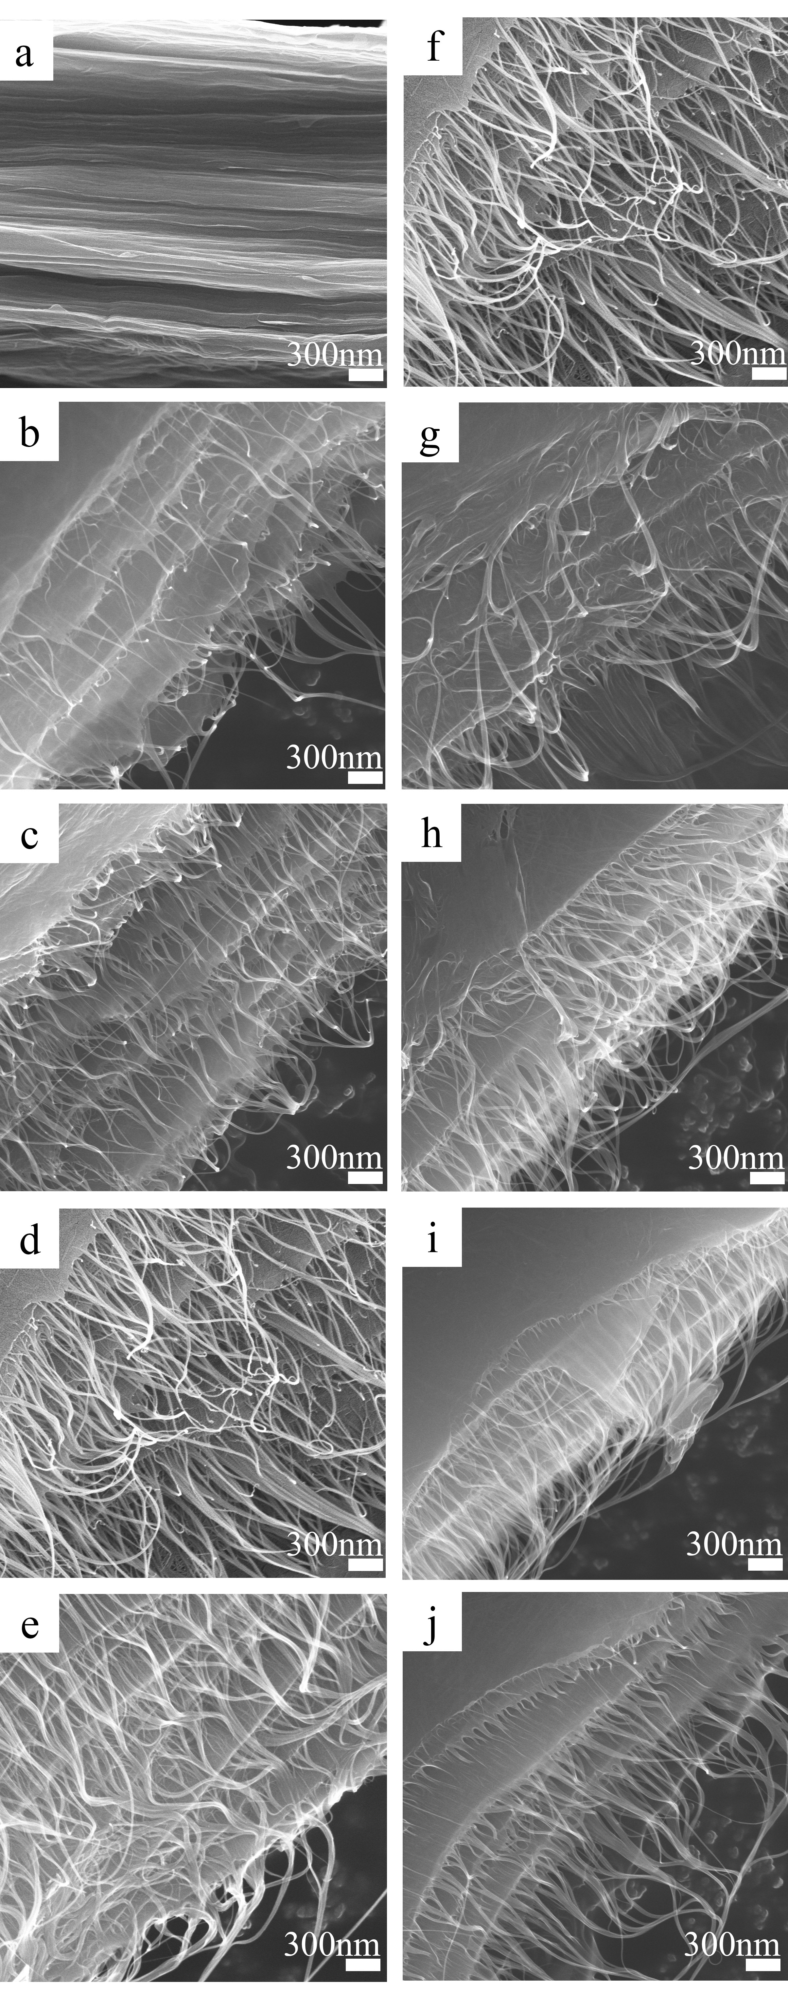
Supplementary Figure 4. SEM images of TCFs. (a) 1-0%-4h, (b) 1-8%-4h, (c) 1-16%-4h, (d) 1-32%-4h, (e) 1-48%-4h, (f) 1-32%-4h, (g) 1-32%-8h, (h) 1-32%-16h, (i) 1-32%-24h, (j) 1-32%-48h. The scale bar is 300 nm.
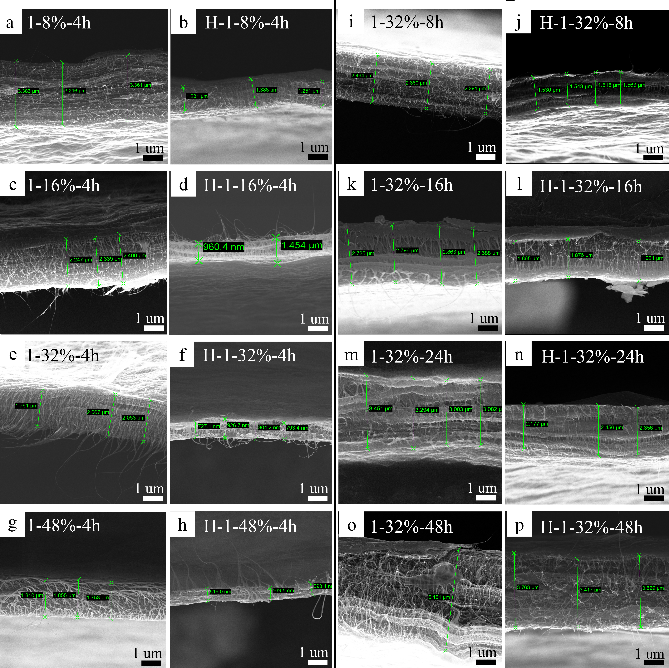
Supplementary Figure 5. Cross-section SEM graphs of TCFs. Cross-section SEM graphs of TCFs before and after calcination. (a) 1-8%-4h, (b) H-1-8%-4h, (c) 1-16%-4h, (d) H-1-16%-4h, (e) 1-32%-4h, (f) H-1-32%-4h, (g) 1-48%-4h, (h) H-1-48%-4h, (i) 1-32%-8h, (j) H-1-32%-8h, (k) 1-32%-16h, (l) H-1-32%-16h, (m) 1-32%-24h, (n) H-1-32%-24h, (o) 1-32%-48h, (p) H-1-32%-24. The scale bar is 1 μm.

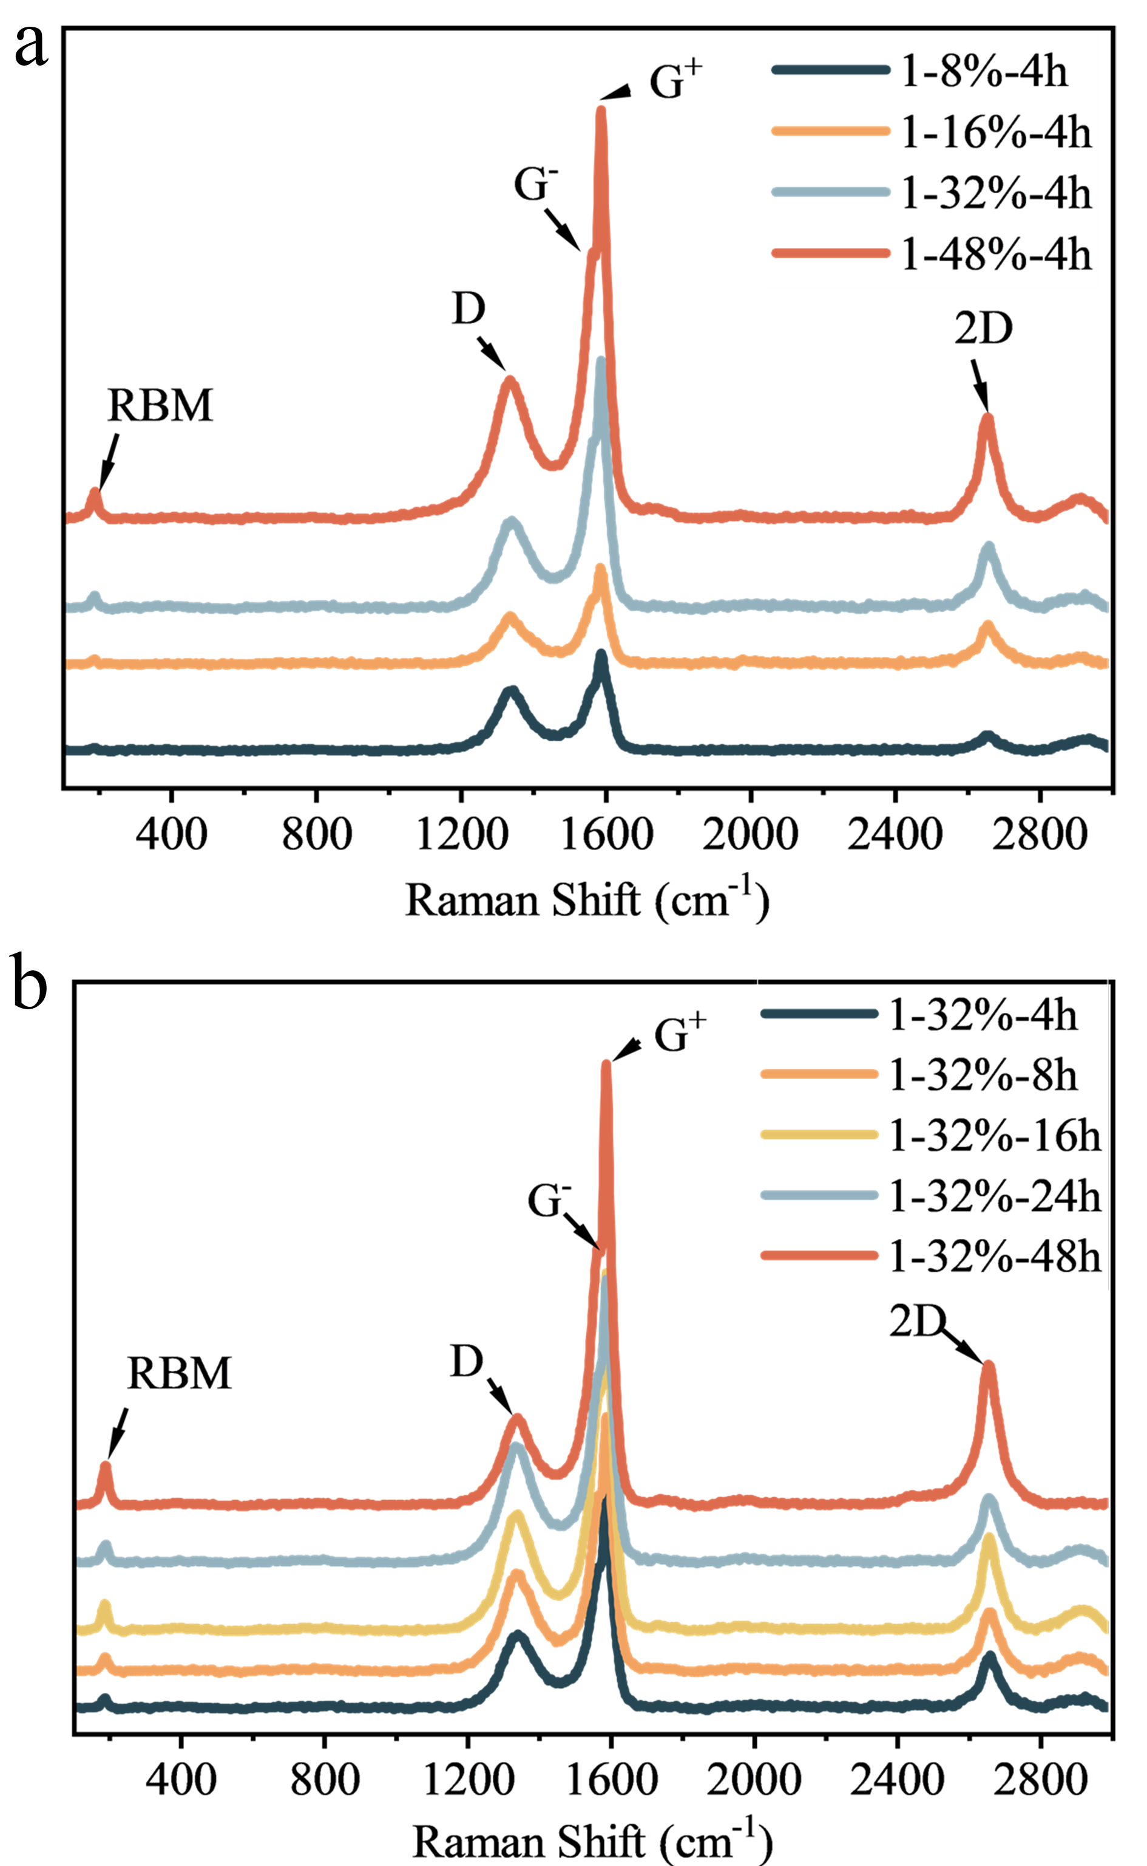
Supplementary Figure 6. The Raman spectrum of TCFs. (a) and (b) showing TCF prepared with different SWCNT concentration and different incubation time, respectively.

Supplementary Figure 7. The XRD patterns of TCF. (a) TCFs prepared with different incubation time. The inset shows the peak shift of GO (001) and the corresponding interlayer spacing change.

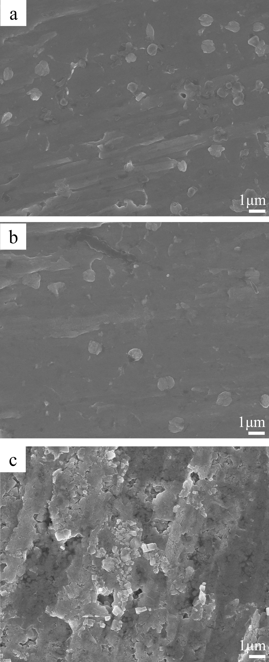
Supplementary Figure 8. The top view SEM graph of copper foil. (a) HCl-treated copper foil, (b) copper foil incubated in pure water, and (c) copper foil incubated in GO/and Copper foil.

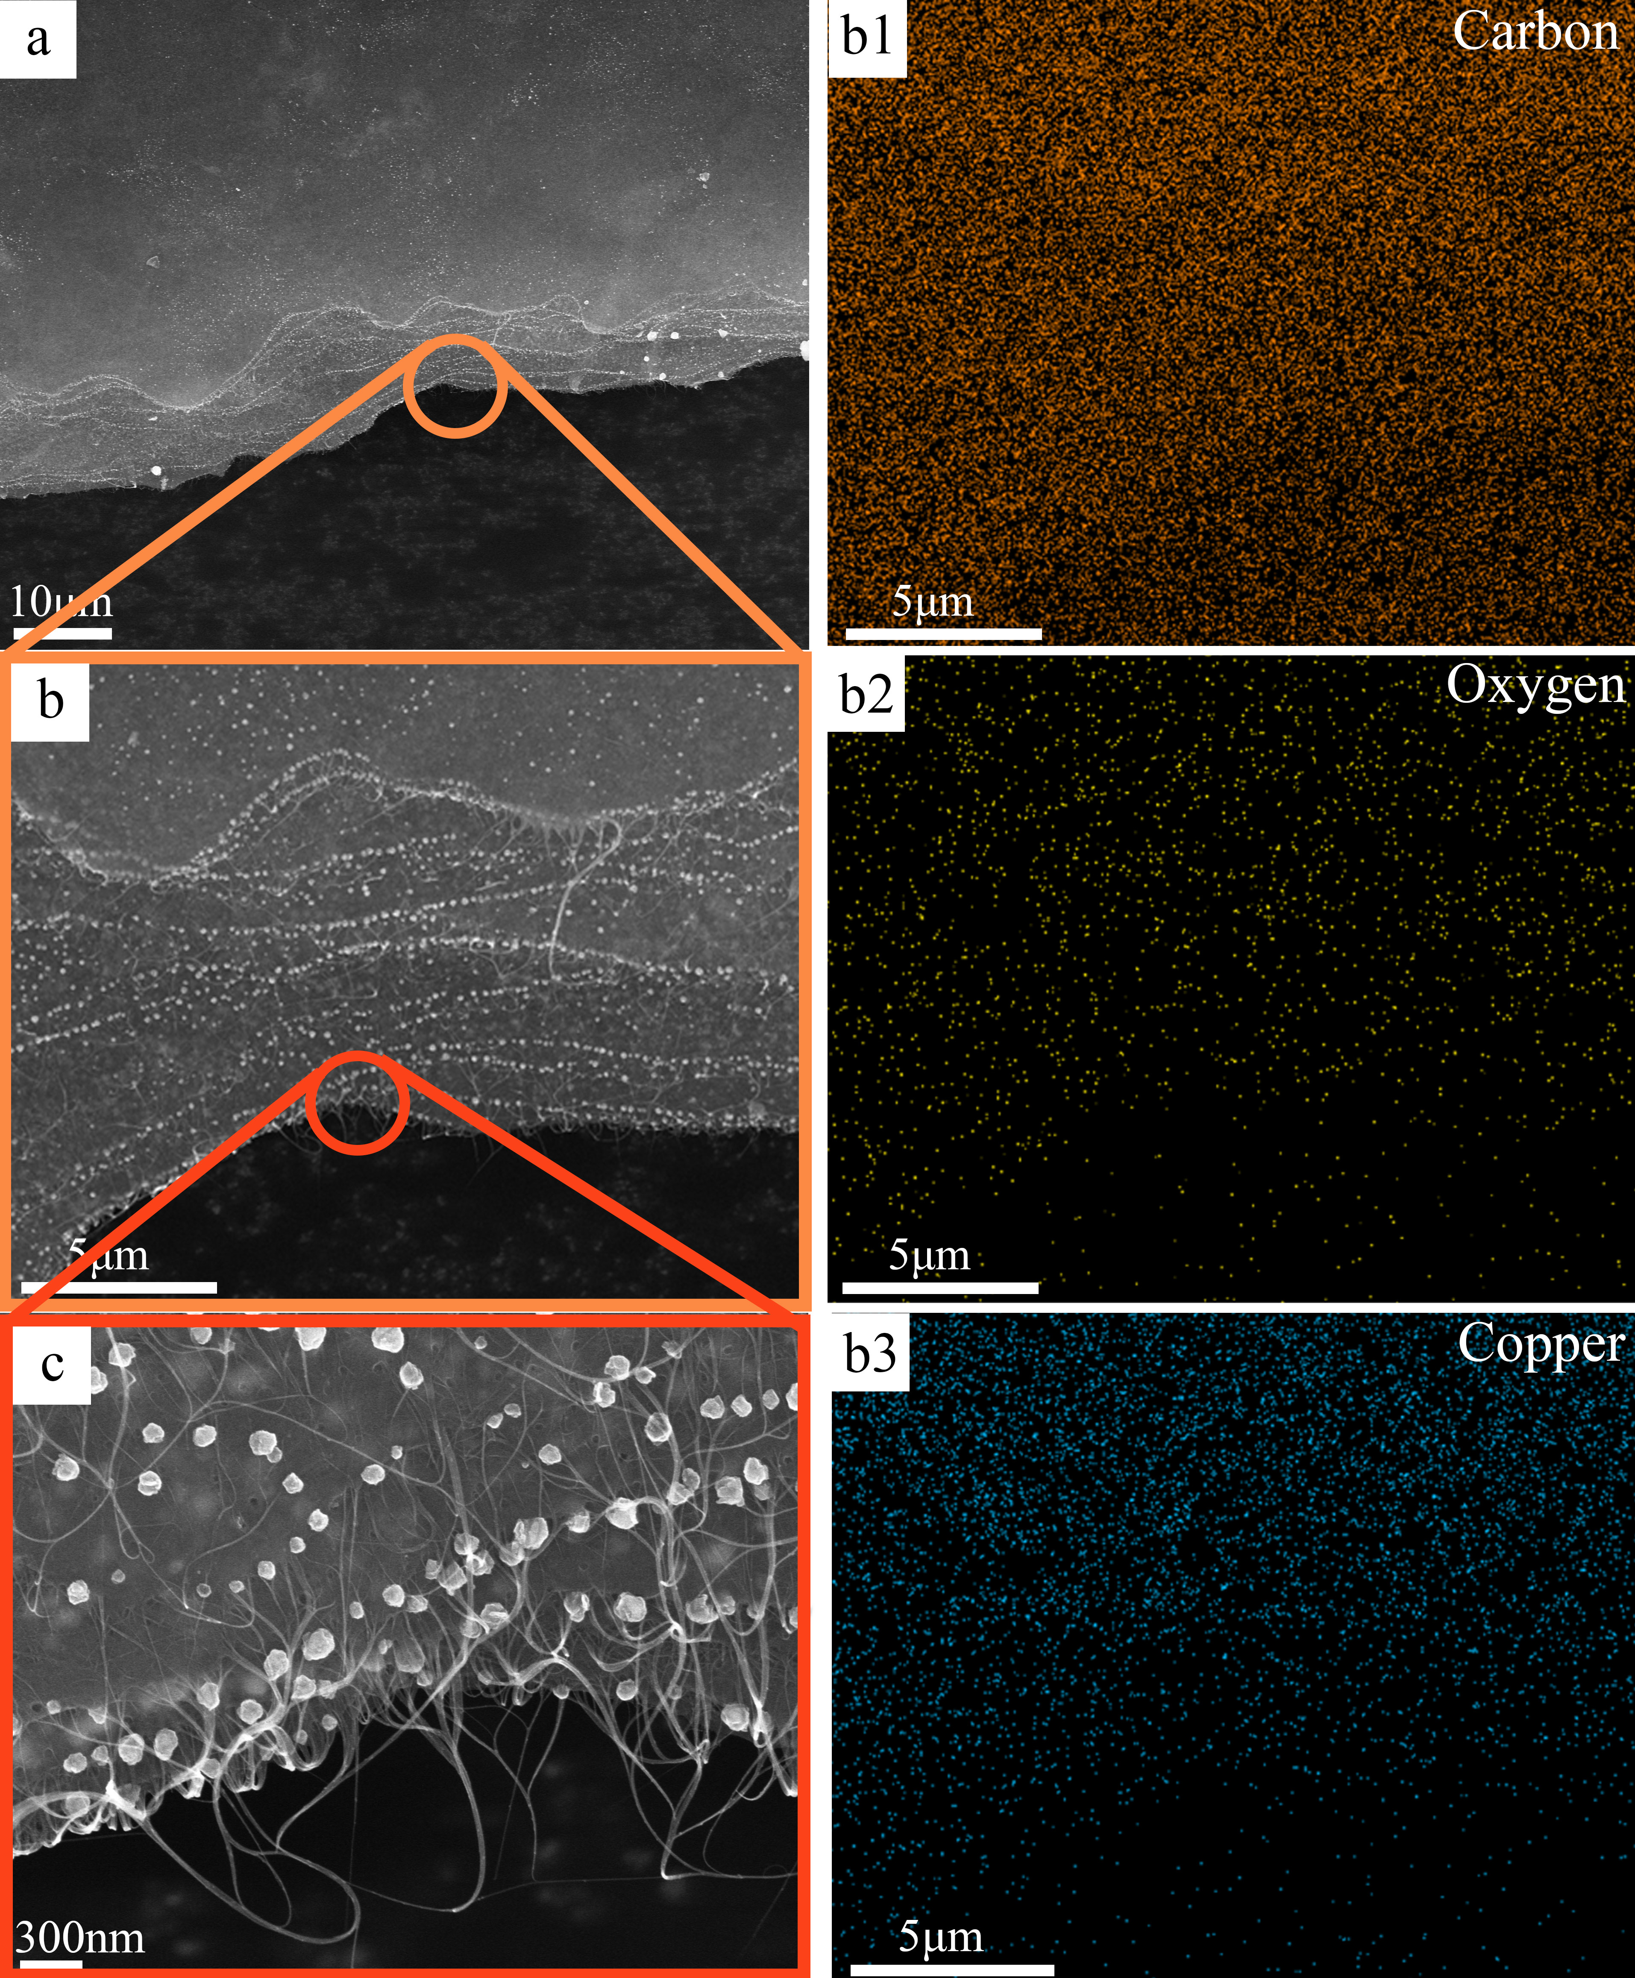
Supplementary Figure 9. The EDS and SEM of calcinated TCF on different scales. (a) 10 μm, (b) 5 μm, and (c) 300 nm. The scale bar of EDS result is 5 μm.
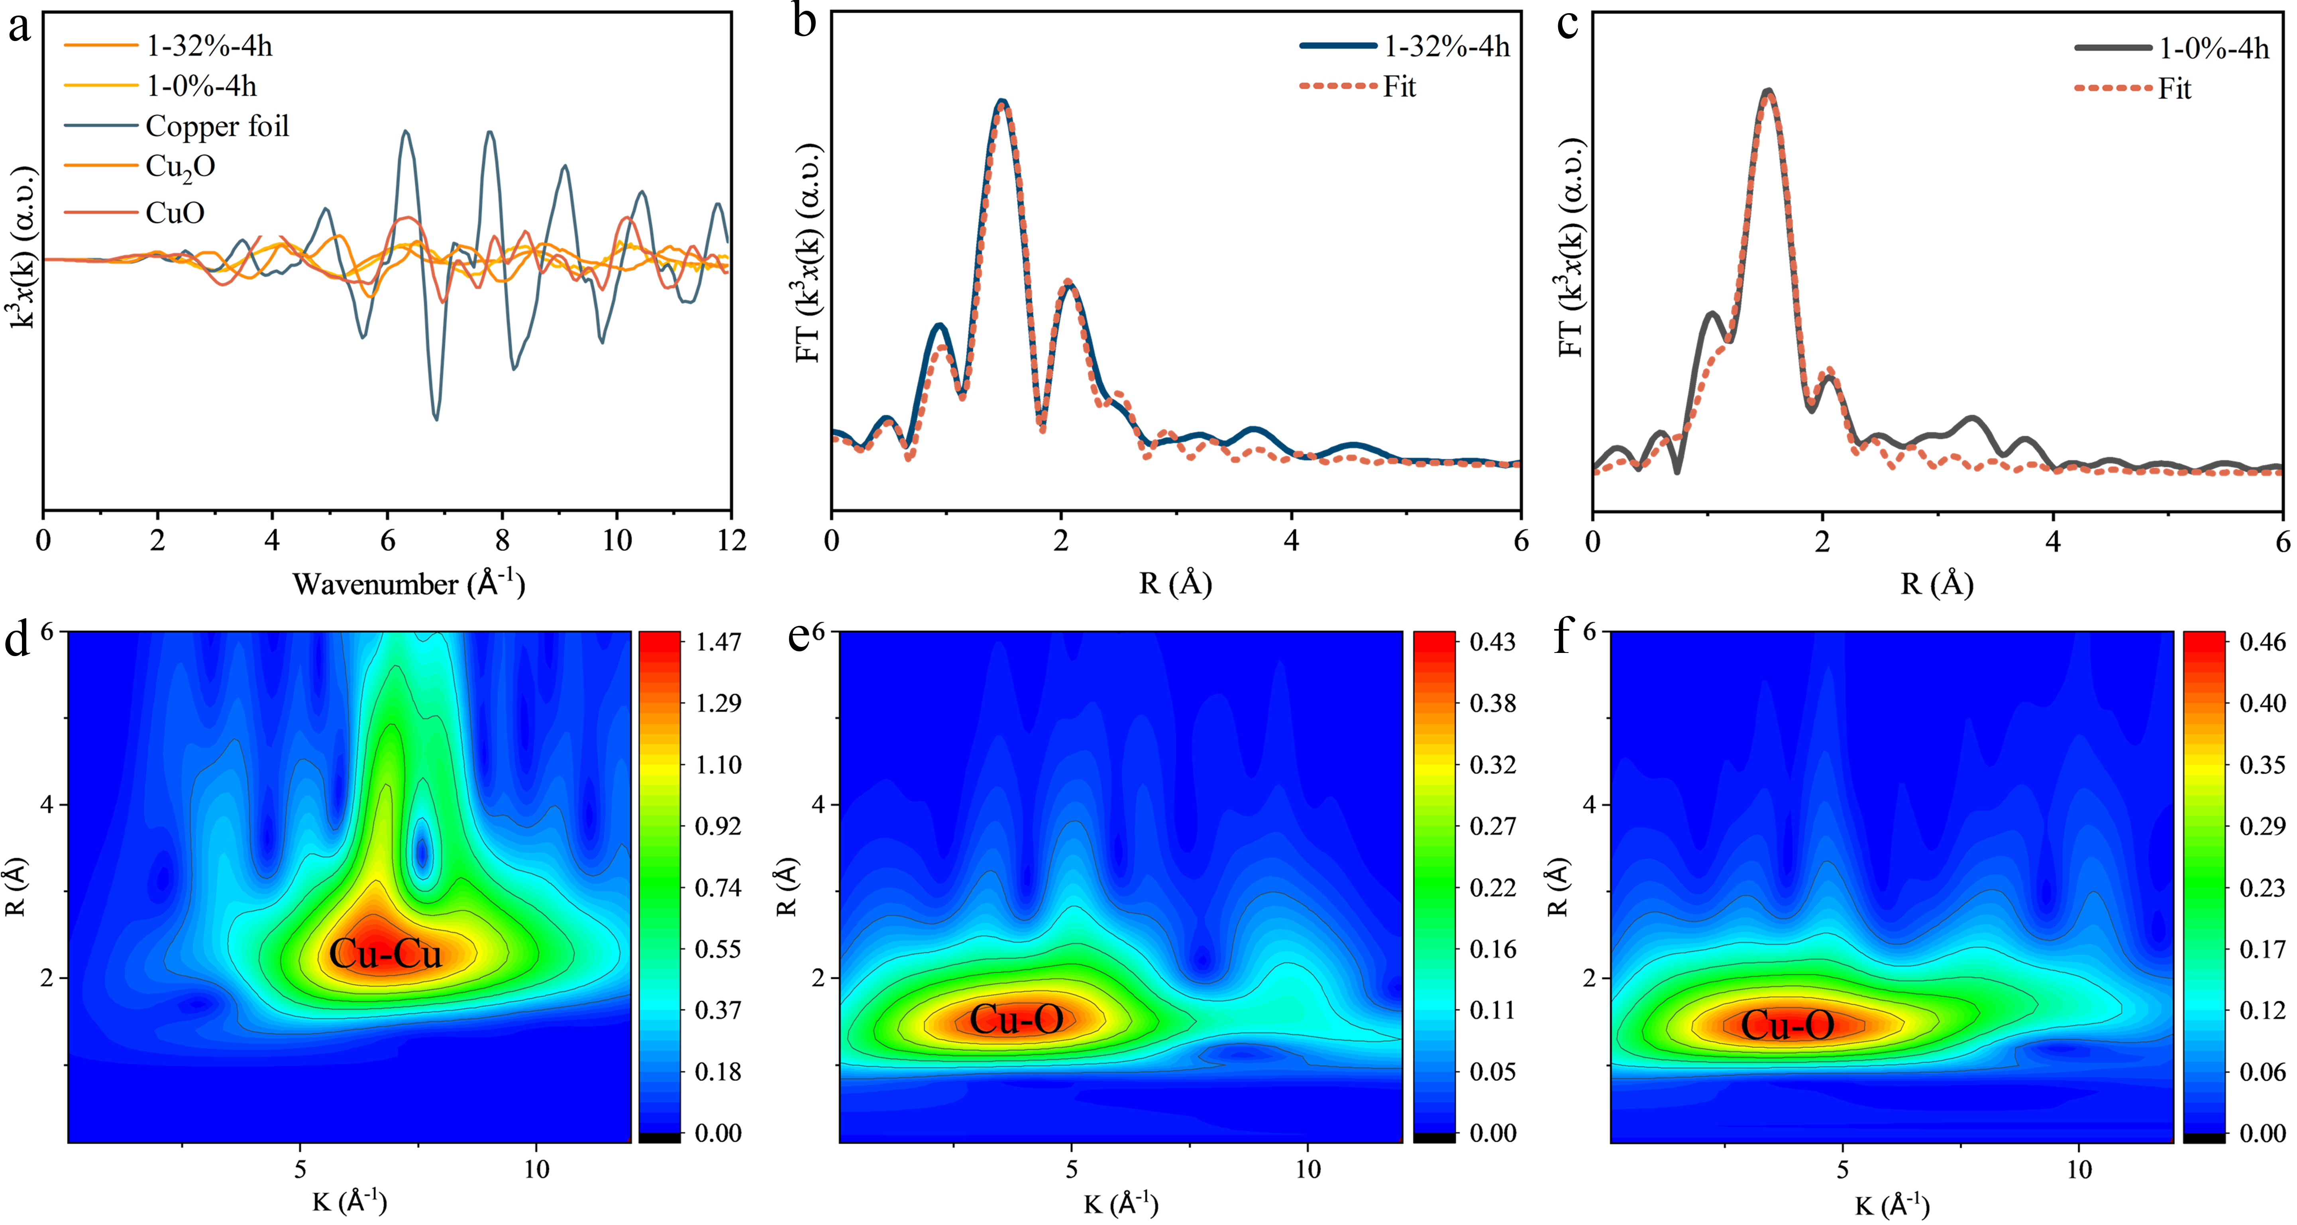
Supplementary Figure 10. XAS spectrum of 1-0%-4h CF and 1-32%-4h TCF. (a) The FT at the Cu-K edge of copper foil, CuO, Cu₂O, 1-0%-4h CF and 1-32%-4h TCF in K space. The fitting results of the EXAFS spectra of the (b) 1-0%-4h CF, and (c) 1-32%-4h TCF in R space. Wavelet Transform of (d) copper foil, (e) 1-0%-4h CF, and (f) 1-32%-4h TCF.

Supplementary Figure 11. Zeta potential of CF and TCF. (a) 1-0%-4h CF and (b) 1-32%-4h TCF before and after 4 hours incubation.

Supplementary note 1: Analysis of Zeta potential shift of CF and TCF:
Zeta potential measurements of the solutions before and after the reaction were also performed (Supplementary Fig. 11) to verify the interaction between copper ions and surface groups of the carbon materials. The initial zeta potential of the 1-32%-4h sample solution was higher than that of the 1-0%-4h solution, primarily due to the free carboxyl groups in CMC. The results show that at the same dilution concentration, the zeta potentials of the 1-0%-4h and 1-32%-4h samples increased by 26.2% and 13.2%, respectively, indicating a reduction in the negative charge on the surface of the carbon materials. This provides indirect evidence for the coordination interaction between copper ions and GO.

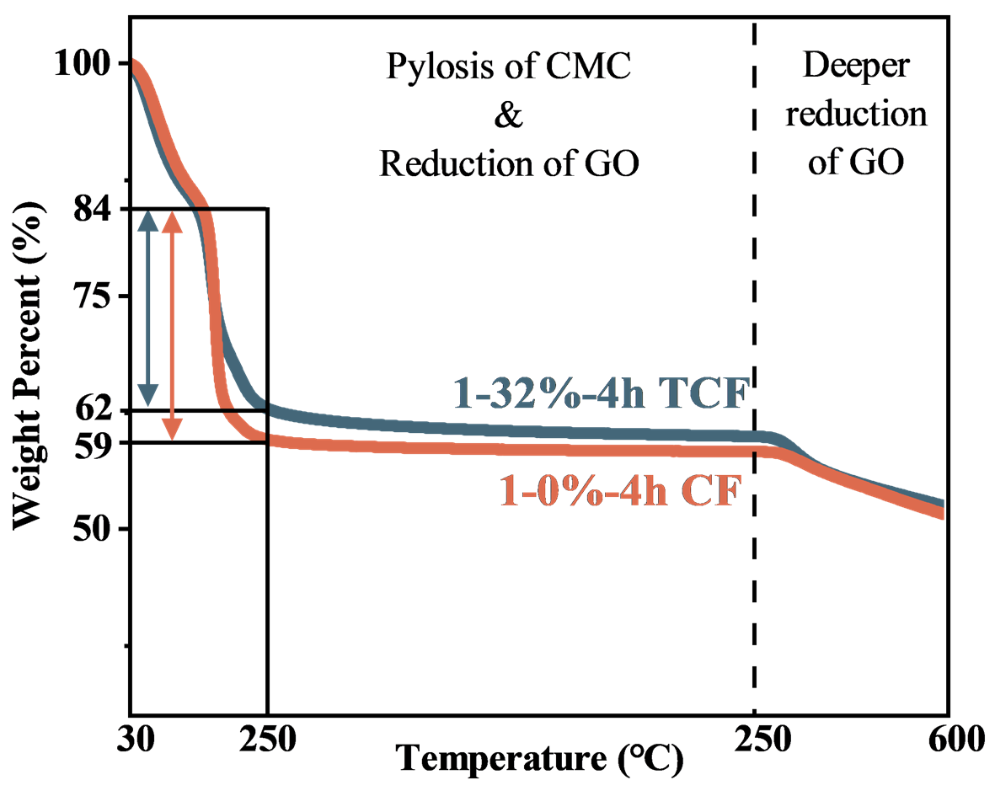
Supplementary Figure 12. The TGA analysis CF and TCF. The temperature is first raised to 250 °C at a rate of 5 ℃/mins, then held constant for 3 hours, and finally increased to 600 ℃ at a rate of 5 ℃/mins.

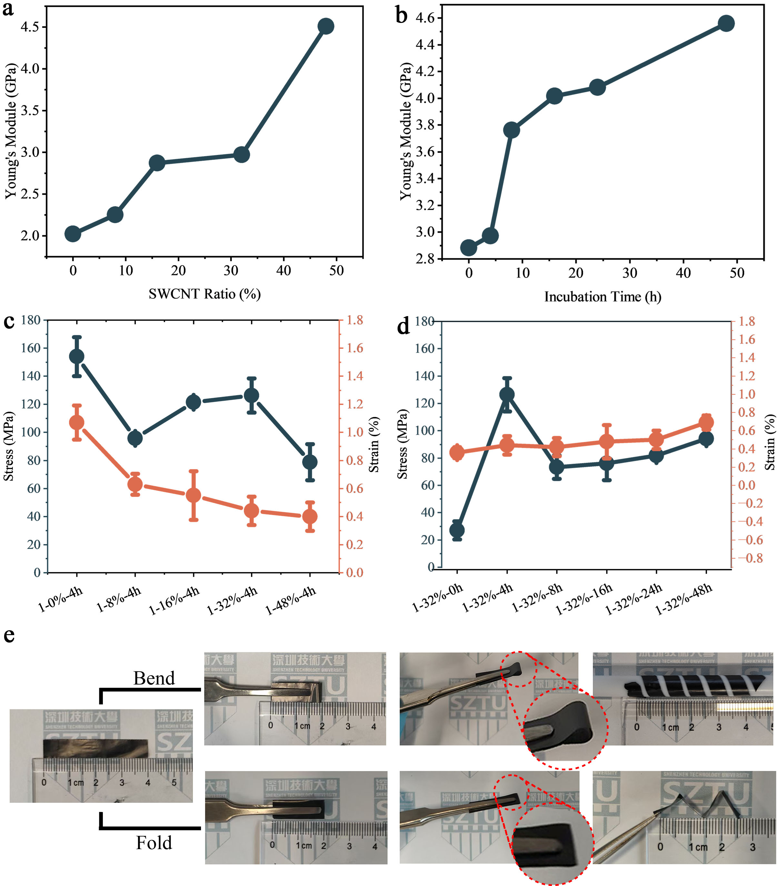
Supplementary Figure 13. Mechanical analysis of TCFs. (a-b) Young’s modulus variation of samples with SWCNT concentration gradient and deposition time gradient. (c-d) Tensile strength variation of samples with SWCNT concentration gradient and deposition time gradient. (e) Bending and recovery tests of the 32% sample.

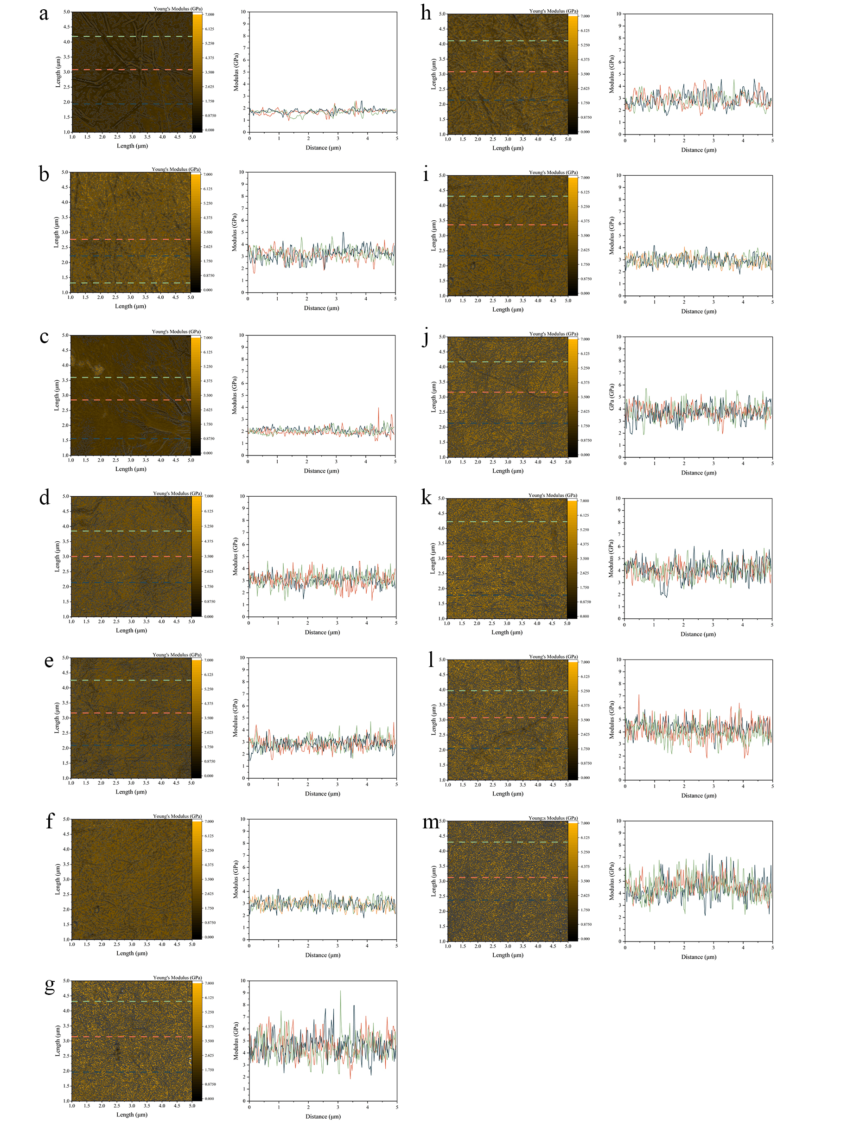
Supplementary Figure 14. Young’s modulus of TCFs. The distribution Young’s modulus of (a) GO, (b) CMC-SWCNT, (c) 1-0%-4h, (d) 1-8%-4h, (e) 1-16%-4h, (f) 1-32%-4h, (g) 1-48%-4h, (h) 1-32%-0h, (i) 1-32%-4h (j) 1-32%-8h, (k) 1-32%-16h, (j) 1-32%-24h, (m) 1-32%-48h in a 5×5 μm² area.

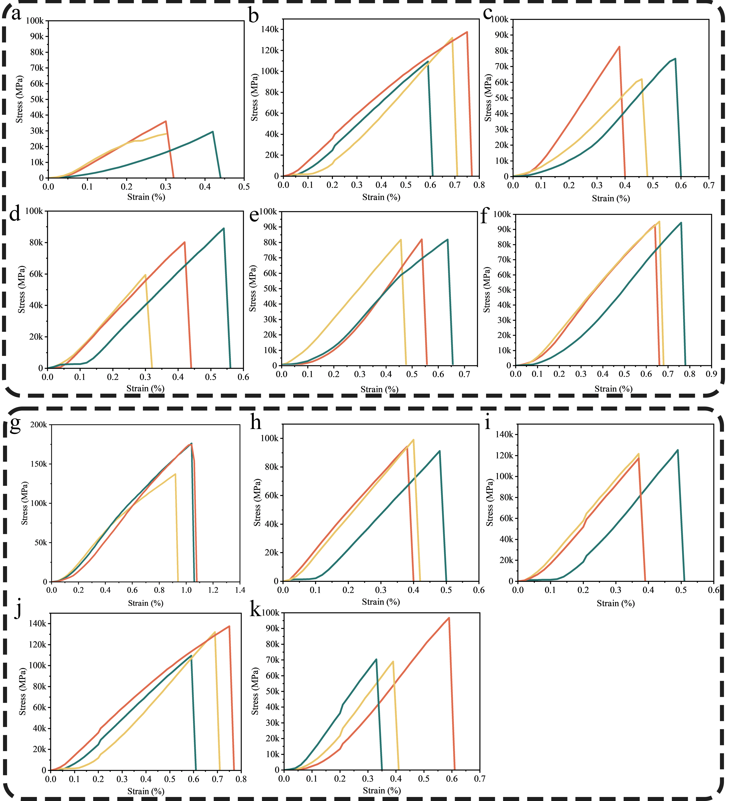
Supplementary Figure 15. The tensile strength of TCFs. (a) 1-32%-0h, (b) 1-32%-4h (c) 1-32%-8h, (d) 1-32%-16h, (e) 1-32%-24h, (f) 1-32%-48h (g) 1-0%-4h, (h) 1-8%-4h, (i) 1-16%-4h, (j) 1-32%-4h, (k) 1-48%-4h TCFs. Test was repeated for 3 times.

Supplementary note 2: Mechanical properties of TCFs:
Strong mechanical properties play a crucial role in the practical application of conductive films, and a large number of coordination bonds introduced into the films have been proven to have a certain mechanical enhancement effect.^{1–4} Herein, atomic force microscopy and a tensile tester were used to characterize the Young's modulus and tensile strength of the prepared CFs, respectively (Supplementary Figs. 13-15, Supplementary Table. 7). Compared to the pure GO film (1.7 GPa), the 1-0%-4h film (without SWCNTs) exhibited a Young’s modulus of 2.0 GPa, confirming the positive mechanical effect of coordination between in-situ generated RGO and copper ions. With SWCNT content of 8%, 16%, 32%, and 48%, the Young's modulus increased to 2.3 GPa, 2.9 GPa, 3.0 GPa, and 4.5 GPa, corresponding to 35%, 71%, 76%, 165% improvements over pure GO film; while for incubation time of 0 h, 4 h, 8 h, 16 h, 24 h, and 48 h, the values rose to 2.9 GPa, 3.0 GPa, 3.8 GPa, 4.0 GPa, 4.1 GPa, and 4.6 GPa, corresponding to 71%, 76%, 124%, 135%, 141%, and 171% improvements, respectively (Supplementary Fig. 13a-b and Supplementary Fig. 14). Comparative analysis with pure GO films showed that increasing the SWCNT content in the CFs or extending the incubation time can significantly improve the Young's modulus of the CFs. It is worth noting that the regulation efficiencies differ markedly: raising the Young's modulus from 3.0 GPa to 4.6 GPa required an additional 44 h of incubation, whereas the same improvement was achieved with only a 16% increase in SWCNT dosage.

Tensile tests ((Supplementary Fig. 13c-d and Supplementary Fig. 15) showed that the effect of deposition time on CF tensile strength was stage-dependent. Tensile strength increased significantly within the first 4 h but showed no obvious improvement afterward, likely due to the stable coordination bond number and SWCNT concentration in the film. In contrast, tensile strength decreased notably with increasing SWCNT content, which was closely related to film density and coordination bond evolution, and can be divided into two stages:
- Low SWCNT content (0%–32%): SWCNT intercalation between RGO and GO layers expanded the interlayer distance and reduced film density. The lower density overestimated the actual stress-bearing area, leading to lower tensile strength than SWCNT-free films.
- High SWCNT content (>32%): Further increasing SWCNT loading disrupted coordination bonds. Excessive CMC raised oxygen-containing group levels and hindered the redox reaction between GO and Cu foil, both of which reduced Cu-O coordination bonds. The loss of Cu-O bonds weakened interlayer connections and interfacial bridging, causing a continuous decline in tensile strength.

Even the TCF with the lowest tensile strength (48% SWCNT) still outperformed pure GO films (~20 MPa), confirming the mechanical reinforcement of the composite. Bending tests (Supplementary Fig. 13e) revealed excellent flexibility with stable structure and mechanical properties during bending, making the films suitable for flexible electronics and promising for flexible displays, sensors, and wearable devices.

Supplementary Figure 16. The heat responds of CF and TCF. The rolling and flatting process of (a) 1-0%-4h CF and (b) 1-32%-4h TCF. (c) displays the Multiphysics simulation model (effective model) of 1-32%-4h TCF’s displacement under heating and cooling procedure.

Supplementary note 3: The heat respond of TCF:
The reversible thermal deformation of flexible carbon-based films is a core prerequisite for their application in intelligent thermal switches and temperature-adaptive devices; thus, the thermal response of the CF was also investigated. As shown in SI Video 2, RGO@CM-SWCNT@GO TCFs and RGO@GO films were placed separately on a heating stage. After removal from the heating stage, RGO@CM-SWCNT@GO TCFs exhibited significant curling within 3 seconds, which relaxed and flattened completely again after 21 seconds; in contrast, RGO@GO only showed slight, insignificant curling, with similarly minor flattening after 21 seconds—indicating distinct thermal responses between the two CFs.
The difference essentially arises from the combined effects of mismatched thermal expansion coefficients (TECs), stress release, and environmental thermal equilibrium. It can be decomposed into three stages: "Flattening on the heating stage (stable state) → Immediate curling upon removal → environmental cooling-induced flattening":
Stage 1: Flattening on the Heating Stage (Stable State)
When both films are heated and flattened on the heating stage, internal stress accumulates due to mismatched TECs of the components–though the degree of stress accumulation differs significantly between the two films, origining from the "stress amplification and transfer effect" of CM-SWCNTs:
For RGO@GO, stress accumulation is weak and dispersed. GO and RGO are 2D sheets bound by weak van der Waals forces and hydrogen bonds, which cannot efficiently transfer interlayer deformation differences. Thus, internal stress is released via "interlayer micro-sliding", resulting in weak, uniform residual stress. Constrained by the heating stage, stress cannot be released, and the film remains flattened in a "stretched state" (Supplementary Fig. 16a₁).
For RGO@CM-SWCNT@GO TCFs, stress accumulation is strong and concentrated. M-SWCNTs act as "bridges" between 2D sheets, rigidly connecting adjacent layers and preventing interlayer sliding. At this point, the "deformation difference" caused by mismatched TECs of GO and RGO cannot be released via interlayer sliding and can only be accommodated by "stretching/compressing CM-SWCNTs," leading to high stress concentration at the interface between M-SWCNTs and sheets. Additionally, the axial TEC of CM-SWCNTs (~-0.5×10⁻⁶/°C) is closer to "zero expansion" than GO’s in-plane TEC (~-10×10⁻⁶/°C), exacerbating deformation mismatches and stress accumulation. Ultimately, the RGO@CM-SWCNT@GO TCFs accumulates significantly more internal stress than RGO@GO during heating; however, constrained by the "rigid support" of the heating stage, this stress is temporarily "locked," and the film remains flattened (Supplementary Fig. 16b₁).
Stage 2: Immediate curling upon removal from the heating stage (stress release)
After removing the film from the heating stage, the constraint of the heating stage is eliminated, and accumulated internal stress is released—revealing macroscopic behavioral differences between the two films:
For RGO@CM-SWCNT@GO TCFs: The strong internal stress accumulated within the film loses its constraint and is rapidly released via "macroscopic deformation." Since stress is concentrated at the interface between M-SWCNTs and sheets, and the rigid connection of CM-SWCNTs renders the film an "integral stress-bearing body" deformation occurs in the "stress-minimizing direction" typically curling along the CM-SWCNT axial direction or sheet edges to spontaneously release internal stress, resulting in obvious curling (Supplementary Fig. 16b₂).
For RGO@GO: The weak and dispersed internal stress accumulated within the film can only induce "minor interlayer contraction/expansion" after removing the heating stage, which is insufficient to drive significant macroscopic curling (Supplementary Fig. 16a₂).
Stage 3: Re-flattening (Thermal Equilibrium and Stress Relaxation)
Re-flattening is primarily driven by complete stress release and thermal equilibrium: The curling process is a "rapid stress release process," during which concentrated internal stress is fully released via curling deformation within seconds. Simultaneously, after removal from the heating stage, the film exchanges heat with ambient air, and its temperature gradually decreases to room temperature. When internal stress is fully released and temperature stabilizes (thermal deformation ceases), the film loses the "stress driving force to maintain curling" and re-flattens due to its inherent elasticity—particularly when placed on a flat surface (e.g., a desktop), surface support further assists in flattening (Supplementary Fig. 16b₃). Leveraging its exceptional thermoresponsive performance, this composite film holds substantial potential for addressing damage issues of precision electronic components (e.g., chips, microsensors, flexible circuit boards) caused by vibration and impact during transportation and storage. It enables adaptive protection without the need for additional cushioning materials, through temperature-controlled deformation of the film (Supplementary Fig. 16c).

Supplementary Figure 17. Electromagnetic shielding effectiveness of TCF. The Shielding effectiveness (SE_{T}), reflection loss (SE_{R}), and absorption loss (SE_{A}) of 1-32%-4h membrane in the range of (a) 2.60-4.95 GHz, (b) 4.00-5.99 GHz, (c) 6.00-8.10 GHz , and (d) 8.20-12.40 GHz.

Supplementary note 4: Electromagnetic shielding effect of TCF:
Graphene materials are known to exhibit electromagnetic shielding effectiveness; thus, the shielding effectiveness of CFs in the 2.6 GHz-12.4 GHz frequency range was measured using a waveguide method (Supplementary Fig. 17). The results confirm that the 1-32%-4h sample exhibits an average shielding effectiveness (SET) of over 30 dB in the 2.6 GHz-12.4 GHz range, primarily contributed by reflection loss (SER) while pure GO film showed low shielding effectiveness (~0 dB). At 2.64 GHz and 12.2 GHz, the 1-32%-4h film exhibits excellent shielding effectiveness, reaching 85 dB (31 dB/μm) and 74 dB (27 dB/μm), respectively—demonstrating great potential for electromagnetic shielding applications. It is significantly improved compared with the pure GO film (~0 dB).^{5,6}

Supplementary Table 1. Component of composite solution and incubation time of RGO@CM-SWCNT@GO TCFs.
Sample | CM-SWCNT/GO (%) | CM-SWCNT (mg) | CMC (mg) | GO (mg) | Incubation (h)
1-0%-4h | 0 | 0 | 0 | 25 | 4
1-8%-4h | 8 | 2 | 3 | 25 | 4
1-16%-4h | 16 | 4 | 6 | 25 | 4
1-32%-4h | 32 | 8 | 12 | 25 | 4
1-48%-4h | 48 | 12 | 18 | 25 | 4
Sample | CM-SWCNT/GO (%) | CM-SWCNT (mg) | CMC (mg) | GO (mg) | Incubation (h)
1-32%-0h | 32 | 8 | 12 | 25 | 0
1-32%-4h | 32 | 8 | 12 | 25 | 4
1-32%-8h | 32 | 8 | 12 | 25 | 8
1-32%-16h | 32 | 8 | 12 | 25 | 16
1-32%-24h | 32 | 8 | 12 | 25 | 24
1-32%-48h | 32 | 8 | 12 | 25 | 48

Supplementary Table 2. Specific surface areas of samples.
Sample | Specific surface area (m²/g)
air-dried GO membrane | 5.70
1-32%-4h TCFs | 8.63
H-1-32%-4h TCFs | 30.36

Supplementary Table 3. EXAFS fitting parameters at the Cu K-edge for various samples
Sample | Shell | N ª | R (Å) ^{b} | σ² (Å²·10⁻³) ^{c} | ΔE₀ (eV) ^{d} | R factor (%)
Cu foil | Cu-Cu | 12* | 2.54 | 8.77 | 4.46 | 0.2
1-32%-4h | Cu-O | 2.4 | 1.96 | 2.07 | 9.06 | 1.2
1-0%-4h | Cu-O | 3.1 | 1.98 | 5.88 | 1.53 | 0.9
ª N: coordination numbers; ^{b} R: bond distance; ^{c} σ²: Debye-Waller factors to account for both thermal and structural disorders; ^{d} ΔE₀: the inner potential correction. R factor: goodness of fit. Ѕ₀² was set as 0.88 for Cu data. which was obtained from the experimental EXAFS fit of mental foil reference by fixing CN as the known crystallographic value and was fixed to all the samples.

Supplementary Table 4. The data summary of thickness, square resistance, and conductivity of RGO@M-SWCNT@GO TCFs.
Sample | Thickness (μm) | Standard deviation (μm) | □ (Ω) | Deviation (Ω) | Conductivity (S/m)
1-8%-4h | 3.3 | 0.1 | 3588 | 143 | 84
1-16%-4h | 2.3 | 0.1 | 193 | 13 | 2259
1-32%-4h | 2.0 | 0.1 | 36 | 4 | 13812
1-48%-4h | 1.8 | 0.1 | 19 | 3 | 30030
1-32%-8h | 2.4 | 0.1 | 36 | 5 | 11721
1-32%-16h | 2.8 | 0.1 | 37 | 4 | 9810
1-32%-24h | 3.2 | 0.1 | 38 | 2 | 8311
1-32%-48h | 5.1 | 0.1 | 21 | 1 | 9249

Supplementary Table 5. The data summary of thickness, square resistance, and conductivity of H-RGO@M-SWCNT@GO TCFs.
Sample | Thickness (μm) | Standard deviation (μm) | □ (Ω) | Deviation (Ω) | Conductivity (S/m)
H-1-8%-4h | 1.3 | 0.1 | 36 | 3 | 21823
H-1-16%-4h | 1.2 | 0.1 | 15 | 2 | 54825
H-1-32%-4h | 0.82 | 0.1 | 8 | 1 | 145003
H-1-48%-4h | 0.59 | 0.1 | 14 | 1 | 150313
H-1-32%-8h | 1.4 | 0.1 | 14 | 3 | 52165
H-1-32%-16h | 1.9 | 0.1 | 11 | 1 | 47241
H-1-32%-24h | 2.3 | 0.1 | 12 | 1 | 34761
H-1-32%-48h | 3.6 | 0.1 | 14 | 1 | 24802

Supplementary Table 6. Literature of conductive carbon-based membrane.
Material | Conductivity  (S/m) | Method | Temp. | Ref.
H-1-48%-4h TCF | 150313 | This work | 250 | -
Tubular coal-based carbon membrane | 150000 | Hydrothermal | 120 | 7
H-1-32%-4h TCF (This work) | 145003 | This work | 250 | -
SW/DWCNT | 97877 | Vacuum filtration | r.t. | 8
MWCNT-graphene yarn | 90000 | Spinning | r.t. | 9
Isobornyl methacrylate/G | 60000 | Cold Pressing | r.t. | 10
PEDOT:PSS/SWCNT | 58000 | Spin coating | r.t. | 11
PE/G/GNP | 42060 | Hot Pressing | 160 | 12
nZVI-SW/DWCNT | 40098 | Vacuum filtration | r.t. | 8
Flexible graphite composite BPs | 38000 | Hot Pressing | 110 | 13
Electrochemical filtration carbon membranes | 33000 | Calcination | 950 | 14
EP/FG/GNP CGP | 32200 | Hot Pressing | 180 | 15
EP/EG/Ni@MF | 32000 | Cold Pressing | 60 | 16
1-48%-4h TCF (This work) | 30030 | This work | r.t. | -
PBA/EG | 27858 | Calcination | 800 | 17
EP/COOH-MWCNT/COOH-GNP/CF | 27300 | Hot Pressing | 140 | 18
Graphite/epoxy composites | 25470 | Hot Pressing | 190 | 19
EP/NFG/CB/Cu Fibers | 21800 | Cold Pressing | 65 | 20
EP-PF Copolymer/NFG | 20300 | Hot Pressing | 170 | 21
PVDF-graphite-CB | 17787 | Hot Pressing | 190 | 22
PANI/CM | 17400 | Electrochemical Deposition | r.t. | 23
TiO2/carbon ECM | 16800 | Calcination | 950 | 24
Carbon onions | 14710 | Calcination | 500 | 25
1-32%-4h TCF | 13812 | This work | r.t. | -
CNT/SiC-B4C | 13440 | Calcination | 1600 | 26
rGO-CNT membrane | 10000 | Bar Coating | r.t. | 27
CNT/SiC | 8064 | Calcination | 1600 | 26
Graphene paper | 7200 | Chemical reduction & Vacuum filtration | 95 | 28
SWCNT | 5000 | Spinning | r.t. | 29
VF-LBL MWNT | 4100 | Plasma treatment | r.t. | 30
G/CNT | 3600 | CVD | 1000 | 31
ECM-950 | 2948 | Calcination | 950 | 32
Chitosan-MWCNT | 2300 | Calcination | 500 | 33
PANI/GO | 2190 | Polymerization | 0 | 11
Carbonized PAN filber | 2010 | Calcination | 1000 | 34
Supplementary Table 7. The mechanical properties of TCFs.
Sample | Young’s modulus (GPa) | Tensile Stregth (MPa)
1-0%-4h | 2.0 | 147.7 ± 7.6
1-8%-4h | 2.3 | 95.8 ± 2.3
1-16%-4h | 2.9 | 121.4 ± 3.3
1-32%-4h | 3.0 | 126.3 ± 12.2
1-48%-4h | 4.5 | 78.8 ± 12.8
1-32%-8h | 3.8 | 73.2 ± 8.5
1-32%-16h | 4.0 | 76.2 ± 12.4
1-32%-24h | 4.0 | 81.8 ± 0.1
1-32%-48h | 4.6 | 94.2 ± 1.0
*The Young’s modulus of pure GO and CM-SWCNT is 1.7 GPa 3.2 GPa, respectively.

Reference：
1. Zhao, W. et al. Improved electrochemical performance of graphene oxide via copper ion cross-linking and plasma functionalization. https://doi.org/10.1039/D4TC04915B doi:10.1039/D4TC04915B.
2. Zhang, Z., Zheng, L., Huang, W. & Cheng, Q. Improving strength and toughness of graphene film through metal ion bridging. Proc. Natl. Acad. Sci. 121, e2322663121 (2024).
3. Wang, X. et al. Ultratough bioinspired graphene fiber via sequential toughening of hydrogen and ionic bonding. ACS Nano 12, 12638–12645 (2018).
4. Abraham, J. et al. Tunable sieving of ions using graphene oxide membranes. Nat. Nanotechnol. 12, 546–550 (2017).
5. Stefanović, A. et al. Determination of photothermal and EMI shielding efficiency of graphene–silver nanoparticle composites prepared under low-dose gamma irradiation. Nanomaterials 14, 912 (2024).
6. Kepić, D. et al. Investigation of the interactions and electromagnetic shielding properties of graphene oxide/platinum nanoparticle composites prepared under low-dose gamma irradiation. Sci. Rep. 15, 26924 (2025).
7. Sun, M. et al. Enhanced organic wastewater treatment performance in electrochemical filtration process of coal-based carbon membrane via the simple Fe2+ addition. Sep. Purif. Technol. 276, 119418 (2021).
8. Sutherland, A. J., Ruiz-Caldas, M.-X. & De Lannoy, C.-F. Electro-catalytic microfiltration membranes electrochemically degrade azo dyes in solution. J. Membr. Sci. 611, 118335 (2020).
9. Foroughi, J. et al. Highly conductive carbon nanotube-graphene hybrid yarn. Adv. Funct. Mater. 24, 5859–5865 (2014).
10. Wang, X. et al. Achieving high electrochemical performance of PEMFCs with ultrathin and highly conductive graphite-resin composite bipolar plates. Int. J. Hydrog. Energy 55, 654–664 (2024).
11. Liang, J., Cui, R., Zhang, X., Koumoto, K. & Wan, C. Polymer/carbon composites with versatile interfacial interactions for high performance carbon-based thermoelectrics: principles and applications. Adv. Funct. Mater. 33, 2208813 (2023).
12. Liao, W., Jiang, F., Zhang, Y., Zhou, X. & He, Z. Highly-conductive composite bipolar plate based on ternary carbon materials and its performance in redox flow batteries. Renew. Energy 152, 1310–1316 (2020).
13. Zhu, C. et al. The ultra-thin flexible graphite/epoxy bipolar plates adjusted by different surface tension modifiers and application in the fuel cell stack. Int. J. Hydrog. Energy 79, 1347–1356 (2024).
14. Pan, Z. et al. Low-cost electrochemical filtration carbon membrane prepared from coal via self-bonding. Chem. Eng. J. 385, 123928 (2020).
15. Fan, R. et al. The conductive network optimization of composite graphite plates and its morphological analysis. Chem. Eng. J. 446, 136652 (2022).
16. Mao, X., Li, Y., Hu, X., Tian, R. & Yu, W. Expanded graphite (EG)/ni@melamine foam (MF)/EG sandwich-structured flexible bipolar plate with excellent electrical conductivity, mechanical properties, and gas permeability. Appl. Energy 338, 120929 (2023).
17. Huang, Q. et al. High-performance polybenzoxazine based composites PEMFC bipolar plates with a multi-layer structure for surface enrichment of conductive phase. Int. J. Hydrog. Energy 48, 32540–32552 (2023).
18. Karoonsit, B. et al. Performance evaluation for ultra-lightweight epoxy-based bipolar plate production with cycle time reduction of reactive molding process. Polymers 14, 5226 (2022).
19. Lee, J. H. et al. Effect of carbon fillers on properties of polymer composite bipolar plates of fuel cells. J. Power Sources 193, 523–529 (2009).
20. Mathew, C., Mohamed, S. N. & Singaravelu, D. L. Novel copper fiber-filled polymer composites for enhancing the properties of bipolar plates for polymer electrolyte membrane fuel cells. Int. J. Hydrog. Energy 52, 941–953 (2024).
21. Chen, J. et al. Tailoring flexible-segment-rich resin network structure by multi-step copolymerization for improved composite bipolar plate of proton exchange membrane fuel cell. Compos. Sci. Technol. 247, 110422 (2024).
22. Hu, B. et al. Low filler and highly conductive composite bipolar plates with synergistic segregated structure for enhanced proton exchange membrane fuel cell performance. Energy 251, 123982 (2022).
23. Pan, Z. et al. Preparation and performance of polyaniline modified coal-based carbon membrane for electrochemical filtration treatment of organic wastewater. Sep. Purif. Technol. 287, 120600 (2022).
24. Li, C. et al. Preparation and application of high-performance and acid-tolerant TiO2/carbon electrocatalytic membrane for organic wastewater treatment. Chemosphere 296, 134017 (2022).
25. Zhang, W., Wang, J., Bao, L., Gao, Z. & Yu, J. Nanopores created by carbon onion conductive agent providing enhanced capacitance in supercapacitors. Diam. Relat. Mater. 96, 231–236 (2019).
26. Cai, Y. et al. Mechanical and electrical properties of carbon nanotube buckypaper reinforced silicon carbide nanocomposites. Ceram. Int. 42, 4984–4992 (2016).
27. Heo, Y.-J. et al. Large-scale conductive yarns based on twistable korean traditional paper (hanji) for supercapacitor applications: toward high-performance paper supercapacitors. Adv. Energy Mater. 8, 1801854 (2018).
28. Li, D., Müller, M. B., Gilje, S., Kaner, R. B. & Wallace, G. G. Processable aqueous dispersions of graphene nanosheets. Nat. Nanotechnol. 3, 101–105 (2008).
29. Ericson, L. M. et al. Macroscopic, neat, single-walled carbon nanotube fibers. Science 305, 1447–1450 (2004).
30. Omi, F. R., Choudhury, M. R., Anwar, N., Bakr, A. R. & Rahaman, Md. S. Highly conductive ultrafiltration membrane via vacuum filtration assisted layer-by-layer deposition of functionalized carbon nanotubes. Ind. Eng. Chem. Res. 56, 8474–8484 (2017).
31. Sheng, J. et al. Covalently bonded graphene sheets on carbon nanotubes: Direct growth and outstanding properties. Adv. Funct. Mater. 33, 2306785 (2023).
32. Pan, Z. et al. Electrochemical filtration carbon membrane derived from coal for wastewater treatment: insights into the evolution of electrical conductivity and electrochemical performance during carbonization. Sep. Purif. Technol. 247, 116948 (2020).
33. Alosime, E. M., Alshahrani, A. A., Nghiem, L. D. & In Het Panhuis, M. The preparation and characterization of buckypaper made from carbon nanotubes impregnated with chitosan. Polym. Compos. 41, 1393–1404 (2020).
34. Liao, X. et al. Extremely low thermal conductivity and high electrical conductivity of sustainable carbon­ceramic electrospun nonwoven materials. Sci. Adv. 9, eade6066 (2023).

