Supplementary material for
Multivariate synthesis optimization, comprehensive characterization, and surface ligand determination of palladium nanoparticles

Eduardo Sidinei Chaves^{1,3*}, Morgana Lurdes da Rocha¹, Isabella Tavernaro²,
Ute Resch-Genger^{2*} and Björn Meermann^{3*}

¹Federal University of Santa Catarina, Department of Chemistry, Florianópolis, Brazil.
²Federal Institute for Materials Research and Testing, Division 1.2- Biophotonics, Berlin, Germany.
³Federal Institute for Materials Research and Testing, Division 1.1- Inorganic Trace Analysis (ITALab), Berlin, Germany.

* Corresponding authors: ute.resch@bam.de
bjoern.meermann@bam.de
eduardo.chaves@ufsc.br

Content:
Tables S1 to S10
Figures S1 to S7

Table S1. Experiments, real and coded values for PdNP optimization 2⁵⁻¹ fractionated factorial design.
Experiment | Temperature  ºC | Time  Min. | Pd  µmol | Ligand  mmol | Ascorbic Acid  mmol | 1-PDI
1 | 25 (-1) | 30 (-1) | 2 (-1) | 0.02 (-1) | 0.25 (+1) | 0.800
2 | 25 (-1) | 30 (-1) | 2 (-1) | 0.14 (+1) | 0.05 (-1) | 0.793
3 | 25 (-1) | 30 (-1) | 16 (+1) | 0.02 (-1) | 0.05 (-1) | 0.700
4 | 25 (-1) | 30 (-1) | 16 (+1) | 0.14(+1) | 0.25 (+1) | 0.731
5 | 25 (-1) | 180 (+1) | 2 (-1) | 0.02 (-1) | 0.05 (-1) | 0.802
6 | 25 (-1) | 180 (+1) | 2 (-1) | 0.14 (+1) | 0.25 (+1) | 0.792
7 | 25 (-1) | 180 (+1) | 16 (+1) | 0.02 (-1) | 0.25 (+1) | 0.711
8 | 25 (-1) | 180 (+1) | 16 (+1) | 0.14 (+1) | 0.05 (-1) | 0.755
9 | 75 (+1) | 30 (-1) | 2 (-1) | 0.02 (-1) | 0.05 (-1) | 0.719
10 | 75 (+1) | 30 (-1) | 2 (-1) | 0.14 (+1) | 0.25 (+1) | 0.752
11 | 75 (+1) | 30 (-1) | 16 (+1) | 0.02 (-1) | 0.25 (+1) | 0.818
12 | 75(+1) | 30 (-1) | 16 (+1) | 0.14 (+1) | 0.05 (-1) | 0.838
13 | 75 (+1) | 180 (+1) | 2 (-1) | 0.02 (-1) | 0.25 (+1) | 0.747
14 | 75 (+1) | 180 (+1) | 2 (-1) | 0.14 (+1) | 0.05 (-1) | 0.631
15 | 75(+1) | 180 (+1) | 16 (+1) | 0.02 (-1) | 0.05 (-1) | 0.833
16 | 75 (+1) | 180 (+1) | 16 (+1) | 0.14 (+1) | 0.25 (+1) | 0.841
17 | 50 (0) | 105 (0) | 9 (0) | 0.080 (0) | 0.15 (0) | 0.833
18 | 50 (0) | 105 (0) | 9 (0) | 0.080 (0) | 0.15 (0) | 0.824
19 | 50 (0) | 105 (0) | 9 (0) | 0.080 (0) | 0.15 (0) | 0.805

Ligand: 3-mercaptopropionic acid (MPA)
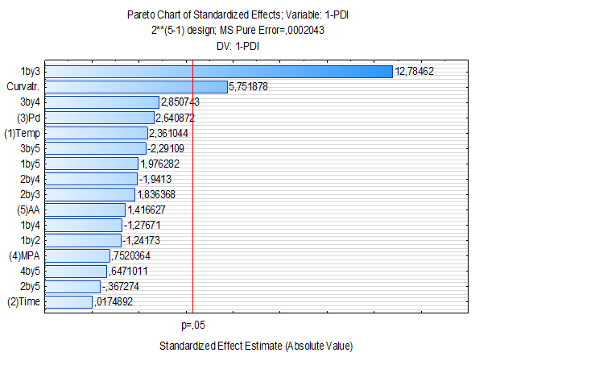
Figure S1. Pareto´s Chart for the fractionated factorial design 2⁵⁻¹ optimization of the water-based PdNPs synthesis. Effect of the synthesis´ parameters of the PdNPs, at a confidence level of 95%, significant effect on the PDI showed p<0.05.
Table S2. ANOVA of the factorial 2⁵⁻¹ design optimization of the PdNPs synthesis capped with thiol-based ligand.
Fator | SS | df | MS | F | p
Curvature | 0.006760 | 1 | 0.006760 | 33.0841 | 0.028921
(1) Temperature, ºC | 0.001139 | 1 | 0.001139 | 5.5745 | 0.142120
(2) Time, min | 0.000000 | 1 | 0.000000 | 0.0003 | 0,987634
(3) Pd, µ mol | 0.001425 | 1 | 0.001425 | 6.9742 | 0.118445
(4) Ligand, m mol | 0.000116 | 1 | 0.000116 | 0.5656 | 0.530487
(5) Ascorbic acid, m mol | 0.000410 | 1 | 0.000410 | 2.0068 | 0.292291
1 by 2 | 0.000315 | 1 | 0.000315 | 1.5419 | 0,340203
1 by 3 | 0.033398 | 1 | 0.033398 | 163.4465 | 0.006063
1 by 4 | 0,000333 | 1 | 0.000333 | 1.6300 | 0.329899
1 by 5 | 0.000798 | 1 | 0.000798 | 3.9057 | 0.186770
2 by 3 | 0.000689 | 1 | 0.000689 | 3.3722 | 0.207715
2 by 4 | 0.000770 | 1 | 0.000770 | 3.7687 | 0.191731
2 by 5 | 0.000028 | 1 | 0.000028 | 0.1349 | 0.748637
3 by 5 | 0.001661 | 1 | 0.001661 | 8.1267 | 0.104175
3 by 5 | 0.001073 | 1 | 0.001073 | 5.2491 | 0.149058
4 by 5 | 0.000086 | 1 | 0.000086 | 0.4187 | 0.583919
Pure error | 0.000409 | 2 | 0.000204
Total SS | 0.006760 | 18
R²:0.99173; Adj.: 0.92556; MS Pure error:0.0002043.
Ligand: 3-mercaptopropionic acid

Table S3. ANOVA of the Doehlert design optimization of the PdNPs synthesis capped with 3-mercaptopropionic acid (MPA) based on the 1-PDI.
Fator | SS | df | MS | F | p
(1) Pd, µ mol (L) | 0.001752 | 1 | 0.001752 | 2.666794 | 0.244063
Pd, µ mol (Q) | 0.000389 | 1 | 0.000389 | 0.591781 | 0.522161
(2) Temperature, ºC(L) | 0.001482 | 1 | 0.001482 | 2.256088 | 0.271931
Temperature, ºC(Q) | 0.000128 | 1 | 0.000128 | 0.195028 | 0.701923
1L by 2L | 0.000020 | 1 | 0.000020 | 0.030822 | 0.876805
Lack of fit | 0.000840 | 1 | 0.000840 | 1.278792 | 0.375485
Pure error | 0.001314 | 2 | 0.000657
Total SS | 0.006040 | 8
R²:0.64366; Adj.: 0.04897; 2 factors;1 block, 9 runs; MS Pure error:0.000657.

Table S4. ANOVA of the Doehlert design optimization of the PdNPs synthesis capped with L-cysteine based on the 1-PDI.
Fator | SS | df | MS | F | p
(1) Pd, µ mol (L) | 0.016576 | 1 | 0.016576 | 12.10540 | 0.073604
Pd, µ mol (Q) | 0.002803 | 1 | 0.002803 | 2.04722 | 0.288780
(2) Temperature, ºC(L) | 0.000121 | 1 | 0.000121 | 0. 08836 | 0.794300
Temperature, ºC(Q) | 0.005603 | 1 | 0.005603 | 4.09202 | 0.180426
1L by 2L | 0.000784 | 1 | 0.000784 | 0.57254 | 0.528239
Lack of fit | 0.000451 | 1 | 0.000451 | 0.32911 | 0.624095
Pure error | 0.002739 | 2 | 0.001369
Total SS | 0.027776 | 8
R²:0.88518; Adj.: 0.69381; 2 factors;1 block, 9 runs; MS Pure error:0.0013693.

Figure S2. Sulfur concentration in the PdNP-MPA and PdNP-Cys supernatant according to the washing cycles.

Table S5. ANOVA from pared t-test with 95% of confidence, comparing NTA and DLS data
 | DLS | NTA
Mean | 136 | 127,5
Variance | 1250 | 480,5
Observations | 2 | 2
Pearson Correlation | 1
Hypothesized Mean Difference | 0
df | 1
T Stat t | 0.894737
P(T<=t) one-tail | 0.267666
t critical one-tail | 6.313752
P(T<=t) two-tail | 0.535331
t critical two-tail | 12.7062

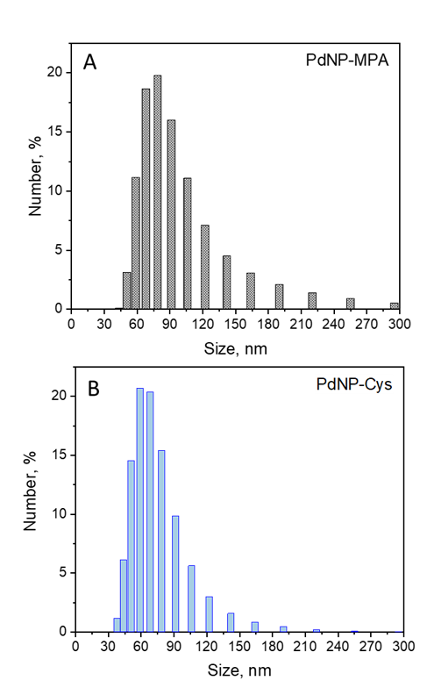
Figure S3. DLS number-based size distribution for PdNP-MPA and PdNP-Cys.
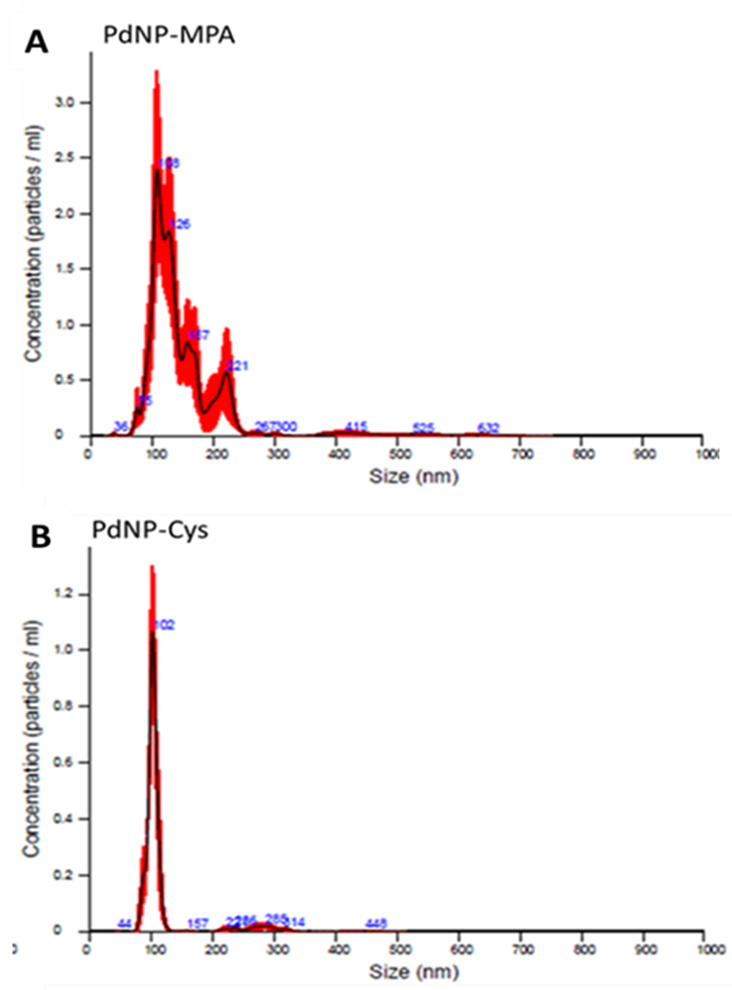

Figure S4. NTA particle size distribution for PdNP-MPA and PdNP-Cys.

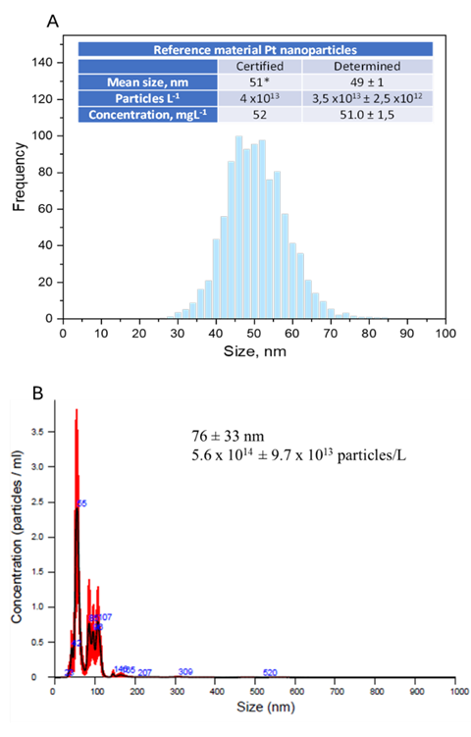
Figure S5. Size, size distribution and particle number obtained by (A) sp-ICP-MS and (B) NTA for reference material of PtNP.

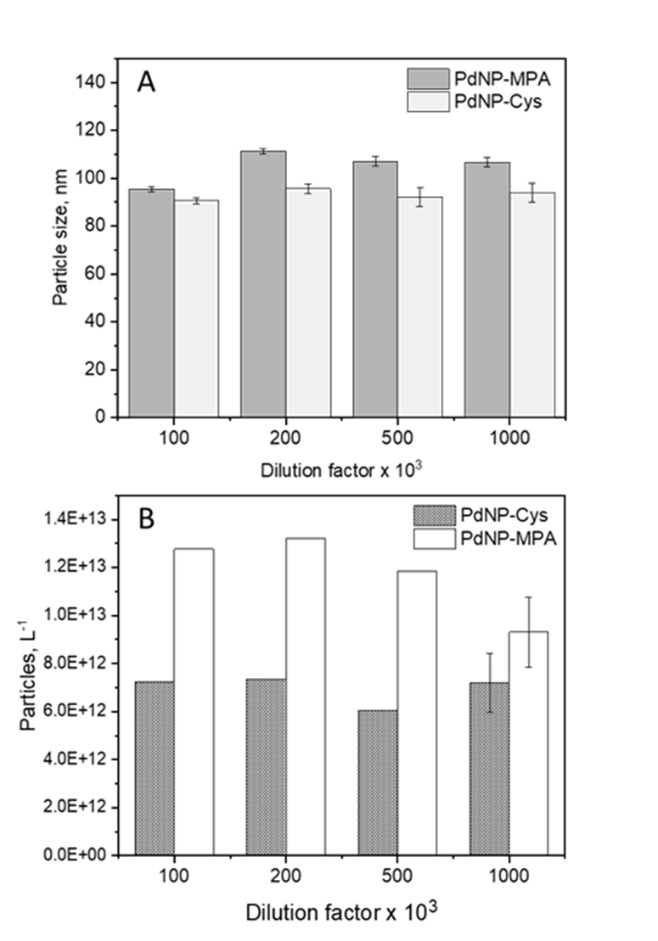
Figure S6. Dilution effect in the (A) particle size and (B) number obtained by sp-ICP-MS.

Table S6. ANOVA from pared t-test with 95% of confidence, comparing NTA and sp-ICP-MS data
 | Sp-ICP-MS | NTA
Mean | 1.63E+13 | 1.68E+15
Variance | 1.01E+25 | 1.35E+29
Observations | 2 | 2
Pearson Correlation | 1
Hypothesized Mean Difference | 0
df | 1
T Stat t | -6.4549
P(T<=t) one-tail | 0.048924
t critical one-tail | 6.313752
P(T<=t) two-tail | 0.097848
t critical two-tail | 12.7062
Table S7. ANOVA one-way with 95% of confidence, comparing the ligand density considering PdNP with different morphologies.
Source of Variation | SS | Df | MS | F | P-value | F crit
Between Groups | 18.30525742 | 4 | 4.576314354 | 1.609253 | 0.246545 | 3.47805
Within Groups | 28.43750867 | 10 | 2.843750867
Total | 46.74276609 | 14

Table S8. Variables, coded values, and levels for PdNPs synthesis by 2⁵⁻¹ fractionated factorial design.
Variables | Levels
Variables | -1 | 0 | +1
Temperature, ºC | 25 | 50 | 75
Time, min. | 30 | 105 | 180
Pd, µmol | 2 | 9 | 16
Ligand, mmol | 0.02 | 0.08 | 0.14
Ascorbic acid, mmol | 0.05 | 0.15 | 0.25

Table S9. Coded and real variables for Doehlert design optimization of the PdNPs synthesis capped with 3-mercaptopropionic acid (MPA) and L-cysteine (Cys), based on the PDI results.
Experiment | Factors |  | MPA |  | Cys
Experiment | X1(Pd, µ mol) | X2 (T, ºC) | PDI | 1-PDI | PDI | 1-PDI
1 | -1 (10) | 0 (60) | 0.237 | 0.763 | 0.181 | 0.819
2 | -0.5 (15) | -0.866 (40) | 0.244 | 0.756 | 0.229 | 0.771
3 | -0.5 (15) | 0.866 (80) | 0.201 | 0.799 | 0.212 | 0.788
4 | 0.5 (25) | -0.866 (40) | 0.239 | 0.761 | 0.258 | 0.742
5 | 0.5 (25) | 0.866 (80) | 0.205 | 0.795 | 0.297 | 0.703
6 | 1 (30) | 0 (60) | 0.165 | 0.835 | 0.347 | 0.653
7 | 0 (20) | 0 (60) | 0.243 | 0.757 | 0.289 | 0.711
8 | 0 (20) | 0 (60) | 0.222 | 0.778 | 0.293 | 0.707
9 | 0 (20) | 0 (60) | 0.192 | 0.808 | 0.355 | 0.645

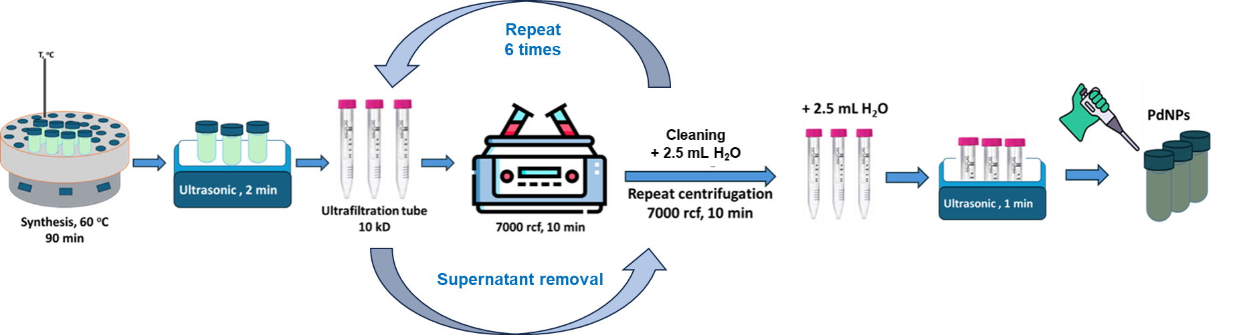
Figure S7. Schematic representation of the unbounded ligand removal of the PdNP-MPA and PdNP-Cys

Table S10. Instrumental parameters for the ICP-MS and sp-ICP-MS measurements.
RF power, W | 1550
Plasma gas flow rate, L min⁻¹ | 15.0
Auxiliary gas flow rate L min⁻¹ | 0.90
Nebulizer | Concentric
sample uptake, mL min⁻¹ | 0.346
 | sp-ICP-MS mode | ICP-MS mode
Torch injector | 1.5 mm | 2.5 mm
Dwell time, ms | 100 | 0.1
Collision / Reaction gas | No gas | He: 5.5 mL min⁻¹(Pd)  O₂: 0.3 mL min⁻¹ (S)
Gas flow nebulizer, L min⁻¹ | 0.80 | 1.07
Monitored isotopes | ¹⁰⁵Pd, ¹⁹⁴Pt | ³²S, ³²S¹⁶O⁺, ¹⁰⁵Pd, ¹⁰³Rh (IS)
Limit of detection | LOD_{size} 30 nm | Pd 10 ng L⁻¹
Limit of detection | LOD_{conc.} 1.3 ng L⁻¹ | Pd 17 ng L⁻¹

.

