Supplementary A
Table A1. Statistical distributions of wheat variables in historical data
Variable | Mean | Std Dev | Min | Max
Harvested area | 2130.49 | 4734.2 | 0.0 | 32635.01
Price | 14.59 | 11.86 | 0.0 | 102.32
Import | 1093.77 | 1753.24 | 0.0 | 8681.38
Production | 7234.96 | 13095.81 | 0.0 | 75806.3
Export | 3332.67 | 7113.99 | 0.0 | 43908.64
GDP | 845333.02 | 2289792.67 | 4187.51 | 21668957.19
Population | 32439.01 | 55768.12 | 1314.45 | 337790.07
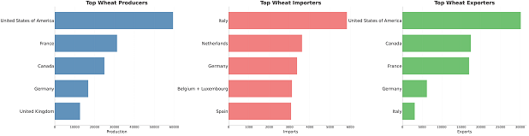
Figure A1. Overview of the top producing, importing, and exporting countries, averaged over the entire period of 1973-2019. The top importers are several western European countries, highlighting a single centralized area of demand. For production and export, the Unites States of America, France, and Canada lead, underlining a few key actors in this regard.

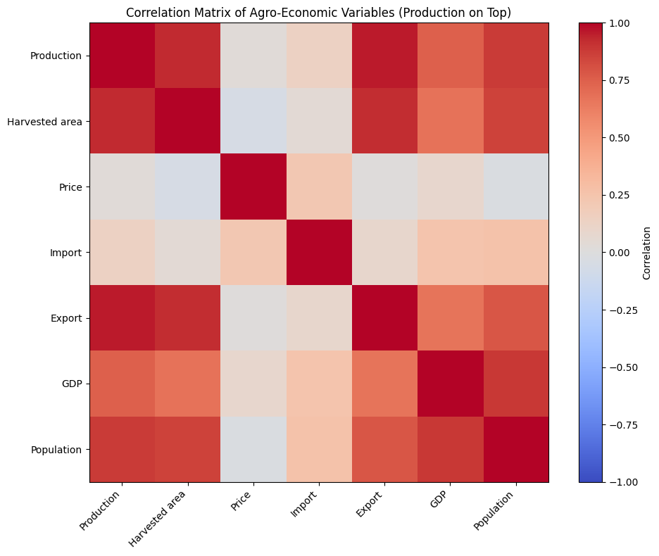
Figure A2. Correlation matrix of all main wheat variables in the historical data. Notably, production shows a strong correlation with all features except for price and export.

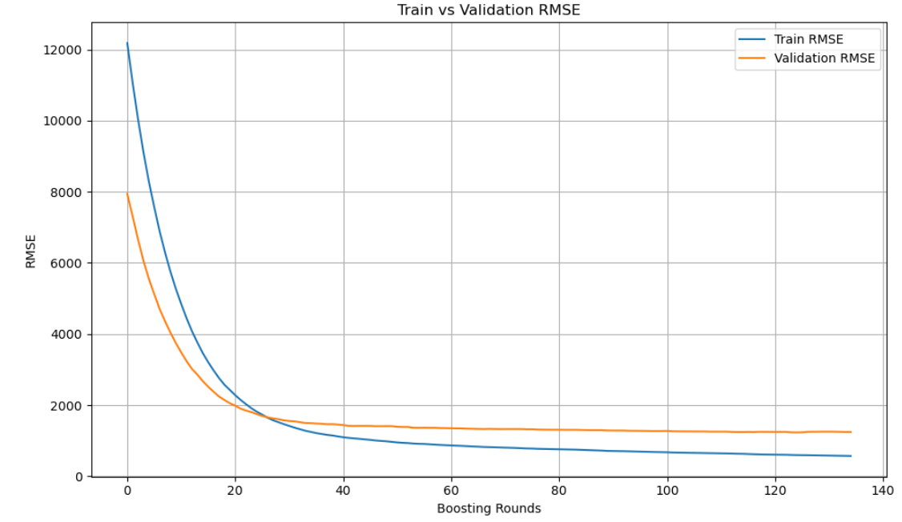Figure A3. Model learning curve for training and validation datasets. The learning curve shows the root mean squared error (RMSE) for the training and validation datasets across boosting rounds of the XGBoost regression model used to predict national wheat production. RMSE decreases rapidly in the initial iterations and stabilises after approximately 40 boosting rounds, indicating convergence and minimal overfitting. The small gap between training and validation RMSE suggests that the model generalises well within the given data, supporting its robustness for estimating wheat production based on the selected predictors.
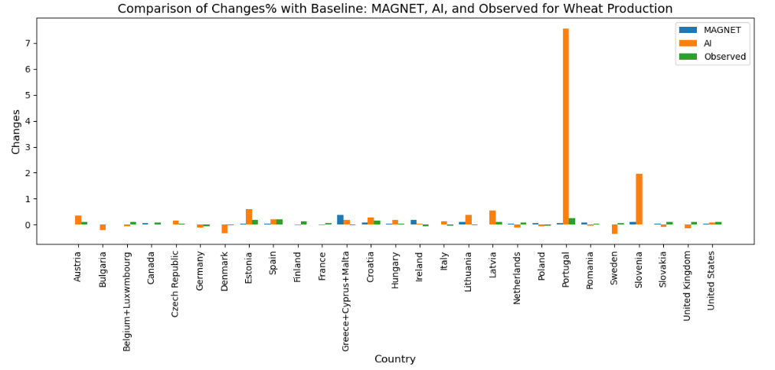
Figure A4. Comparison of percentage changes in 2019 from MAGNET, AI, and observed data, with outliers of large predicted changes.

Table A2. Shared socio-economic pathway (SSP) scenario description.
SSP | SSP name | Description*
SSP1 | Sustainability | A world that makes relatively good progress towards sustainability, with sustained efforts to achieve development goals, while reducing resource intensity and fossil fuel dependency. Elements that contribute to this are an open globalised economy, rapid development of low-income countries, a reduction of inequality (globally and within economies), rapid technology development, low population growth and a high level of awareness regarding environmental degradation. More environmental awareness reduces food waste, the appetite for meat as well as making land use regulation stricter.
SSP2 | Middle of the Road | A business as usual scenario. In this world, trends typical of recent decades continue, with some progress towards achieving development goals, reductions in resource and energy intensity at historical rates, and slowly decreasing fossil fuel dependency.
SSP3 | Regional Rivalry | A world which is separated into regions characterised by extreme poverty, pockets of moderate wealth and a bulk of countries that struggle to maintain living standards for a strongly growing population. Regional blocks of countries have re-emerged with little coordination between them. Countries focus on achieving energy and food security goals within their own region. The world has deglobalised, and international trade, including energy resource and agricultural markets, is severely restricted. Population growth in this scenario is high as a result of limited improvements in education and low economic growth.
SSP5 | Fossil-fueled development | This world stresses conventional development oriented toward economic growth as the solution to social and economic problems through the pursuit of enlightened self-interest. The preference for rapid conventional development leads to an energy system dominated by fossil fuels, resulting in high GHG emissions and challenges to mitigation. Efficiency is high in agriculture but also demand is high with a high preference for meat. Lower socio-environmental challenges to adaptation result from attainment of human development goals, robust economic growth, highly engineered infrastructure with redundancy to minimise disruptions from extreme events, and highly managed ecosystems.
* (Riahi et al., 2017)

Table A3. Scenario Assumptions for MAGNET–AI Wheat Production Analysis
Parameters | SSP1 — Sustainability (Green Road) | SSP2 — Middle of the Road | SSP3 — Regional Rivalry (Rocky Road) | SSP5 — Fossil-fueled Development (Taking the Highway)
Total GDP growth | High in low- and middle-income countries (LICs, MICs); moderate in high-income countries (HICs). | Medium, with moderate disparities across regions. | Slow economic growth globally due to regional barriers and low cooperation. | High total GDP growth driven by rapid industrial expansion and fossil fuel use.
Population growth | Low population growth due to investments in health and education. | Medium population growth following historical trends. | High population growth with limited social progress. | Low population growth driven by accelerated demographic transition with economic development.
Land-use change regulation | Strict land-use policies promoting sustainable agriculture and ecosystem conservation. | Moderate land-use regulations; continuation of existing trends. | Weak regulation; expansion of agricultural land with limited environmental oversight. | Moderate land-use control; expansion driven by high productivity and market incentives.
Agricultural productivity | High productivity growth through sustainable intensification, precision agriculture, and innovation. | Medium productivity increase through gradual adoption of improved practices. | Low productivity growth due to limited investment and innovation capacity. | High productivity gains from intensive input use and technological advances.
Trade in agricultural commodities | Trade liberalization: removal of import tariffs and export subsidies; enhanced international cooperation. | Current trade policies maintained; moderate tariffs and subsidies persist. | Increased trade protectionism: uniform import tax (~10%) on agricultural products to boost self-sufficiency. | Trade liberalization: removal of import tariffs and export subsidies supports high export competitiveness.

Supplementary B: Economic Theory
The design of our AI predictive framework is rooted in well-established principles of agricultural economics and international trade theory. Classical and modern computable general equilibrium (CGE) models, the MAGNET framework in our case, posit that crop production levels are determined by the interplay of resource endowments, market incentives, and external macroeconomic drivers. Our primary target variable is wheat production, which we interpret as an outcome determined by both domestic resource allocation (e.g., land use) and market conditions (e.g., trade balances and price signals). Complementary variables for rice and other grains capture inter-crop competition for land and inputs, reflecting opportunity costs and substitution elasticities inherent in real-world production systems. Our selection of predictor variables reflects this theoretical structure.
B.2 Production and Land Allocation (The Supply Side)
In MAGNET, the production of wheat ($Y_{w,r}$) in region $r$ is modeled using a nested structure. The top level assumes a Leontief technology, strictly binding composite value-added ($VA_{w,r}$) and intermediate inputs ($INT_{w,r}$):
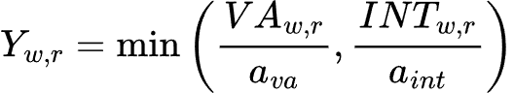
where $a_{va}$ and $a_{int}$ represent the fixed input-output technical coefficients.
At the bottom level, the composite value-added is determined by a Constant Elasticity of Substitution (CES) function, allowing producers to substitute between primary endowments—Labor ($L$), Capital ($K$), and Land ($T$):
Here, $A_{w,r}$ is a region-specific scale parameter capturing total factor productivity, and $δ_{L}$, $δ_{K}$, and $δ_{T}$ are the distribution (or share) parameters for each respective endowment. The parameter $ρ$ dictates the elasticity of substitution ($σ$) between factors, where $σ=1\text{/}(1+ρ)$.

Crucially, agricultural land is sluggish. The allocation of total available agricultural land ($T_{tot,r}$) to wheat versus competing crops is governed by a Constant Elasticity of Transformation (CET) function driven by relative land rents ($R$):
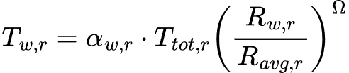
where $α_{w,r}$ is the CET shift parameter, $R_{w,r}$ is the land rent (yield value) for wheat, $R_{avg,r}$ is the average land rent across all competing agricultural sectors, and $\text{Ω}$ is the elasticity of transformation.

B.3 The Armington Trade Specification
MAGNET assumes that wheat produced domestically is not perfectly substitutable with imported wheat. This is captured via the Armington assumption using a nested CES structure. The total composite supply of wheat available for consumption in region $r$ ($Q_{w,r}$) is a mix of domestic goods ($D_{w,r}$) and an aggregate of imports ($M_{w,r}$):
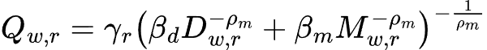
In this equation, $γ_{r}$ is the Armington shift parameter, while $β_{d}$ and $β_{m}$ are the share parameters determining the preference for domestic versus imported wheat. The parameter $ρ_{m}$ determines the Armington elasticity of substitution ($σ_{m}=1\text{/}(1+ρ_{m})$). The aggregate import volume ($M_{w,r}$) is subsequently determined by a lower-level CES nest that allocates demand across different exporting regions based on bilateral trade costs, tariffs, and relative prices.

B.4 Demand and Market Clearing Conditions
Final demand for wheat is driven by households and the intermediate food processing sectors. Household consumption is dictated by utility maximization, strictly constrained by regional income ($INC_{r}$) and population dynamics.
The general equilibrium is achieved through market clearing conditions. For the global wheat market to clear, total regional production must exactly equal the sum of domestic final demand ($D_{w,r}$), intermediate demand ($INT_{w,r}$), and international exports ($X_{w,r}$):
$$Y_{w,r}=D_{w,r}+INT_{w,r}+X_{w,r}$$
Simultaneously, global exports must equal global imports, inclusive of international transport margins.

B.5 Mapping General Equilibrium Theory to Machine Learning Features
To ensure the XGBoost emulator successfully approximates this highly interconnected theoretical system, the model's feature space was desined to represent the primary variables dictating supply, demand, and trade. The table below demonstrates the theoretical alignment of our AI inputs:

Table B1. Mapping General Equilibrium Theory to AI Feature
CGE Theoretical Concept | Corresponding AI Feature | Economic Justification
$Y_{w,r}$ (Target Equilibrium) | Wheat Production | The final market-clearing production volume the CGE model seeks to solve for.
$A_{w,r}$ (Supply: Productivity) | Year, EU Country, Country Indicators (e.g., Country_United States) | Captures region-specific scaling parameters, temporal technological advancement, and unobserved institutional fixed effects.
$L,K,T$ (Supply: Endowments) | Harvested area | Represents the primary land endowment allocated to wheat cultivation; serves as the core observable supply-side constraint in the absence of granular labor/capital data.
$R_{w,r}\text{/}R_{avg,r}$ (Supply: Competition) | Price, Rice_ variables, Other grains_ variables | Captures market-clearing signals and the relative economic incentive to allocate land toward or away from substitute crops (CET function dynamics).
$INC_{r}$ & Population (Demand) | GDP, Population | Represents the macroeconomic scale and income effects driving aggregate consumption needs and final demand.
Armington Trade Dynamics | Import, Export | Proxies the relative competitiveness of domestic versus foreign supply, buffering domestic shocks and linking national production to global market clearing.

