Supplementary Figure 1
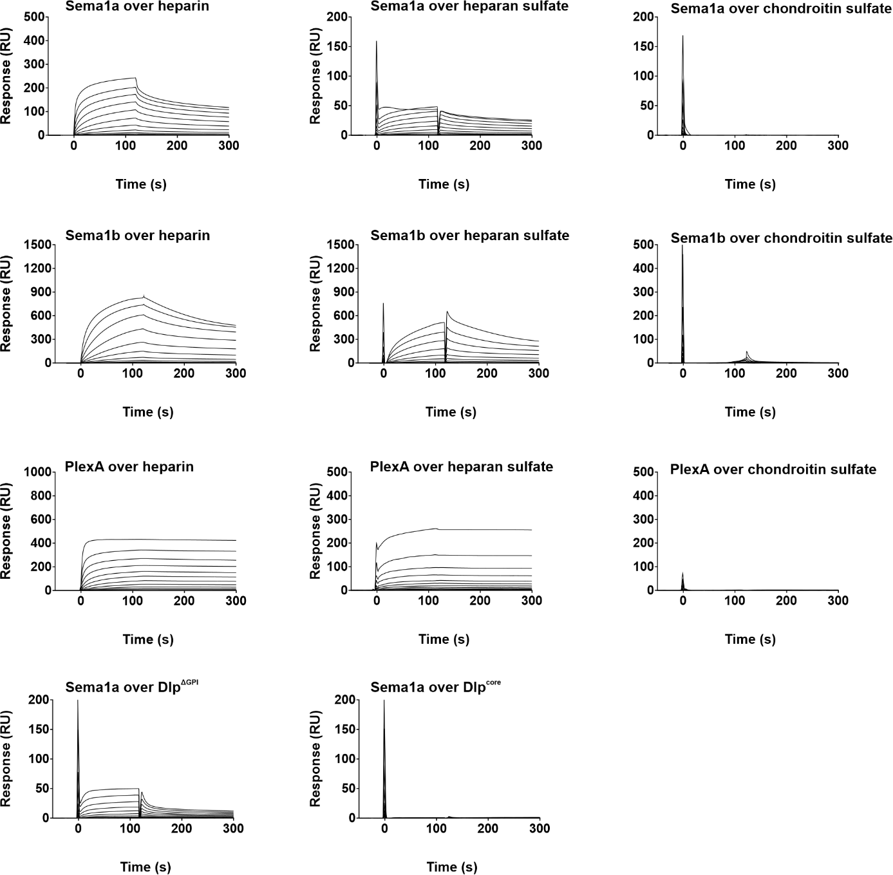

Figure S1. Binding of Sema1a, Sema1b, and PlexA ectodomains to GAG chains
Representative SPR sensorgrams showing the binding of Sema1a and Sema1b ectodomains, as well as the PlexA ectodomain, to immobilized heparin, heparan sulfate, chondroitin sulfate, Dlp^{Core}, and Dlp^{ΔGPI}. All measurements were performed at least twice using independent biological replicates.

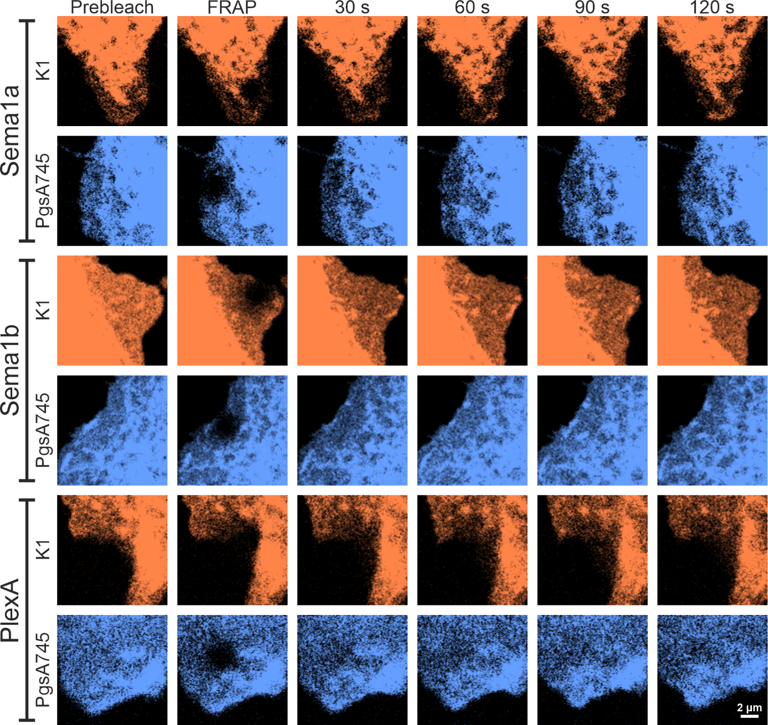
Supplementary Figure 2

Figure S2. Representative FRAP time courses for transmembrane semaphorins and PlexA on GAG-rich and GAG-deficient cells.
Representative confocal FRAP image sequences for Sema1a, Sema1b, and PlexA expressed on the plasma membrane of GAG-rich CHO-K1 cells and GAG-deficient CHO-PgsA745 cells. For each protein and cell type, six time points are shown: pre-bleach, during photobleaching, and 30 s, 60 s, 90 s, and 120 s after bleaching. A circular region of 1.5 µm diameter was photobleached, and fluorescence recovery within this region was monitored over time. Images are representative of multiple independent FRAP experiments and correspond to the quantitative recovery curves and diffusion coefficients shown in Fig. 4e–j.

