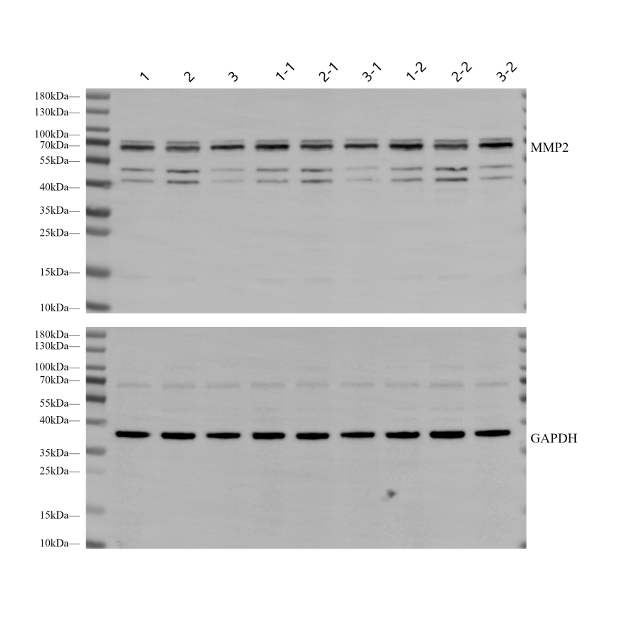
1, 1-1 and 1-2: Control; 2, 2-1and 2-2: GCK; 3, 3-1 and 3-2: GCK nanoformulation

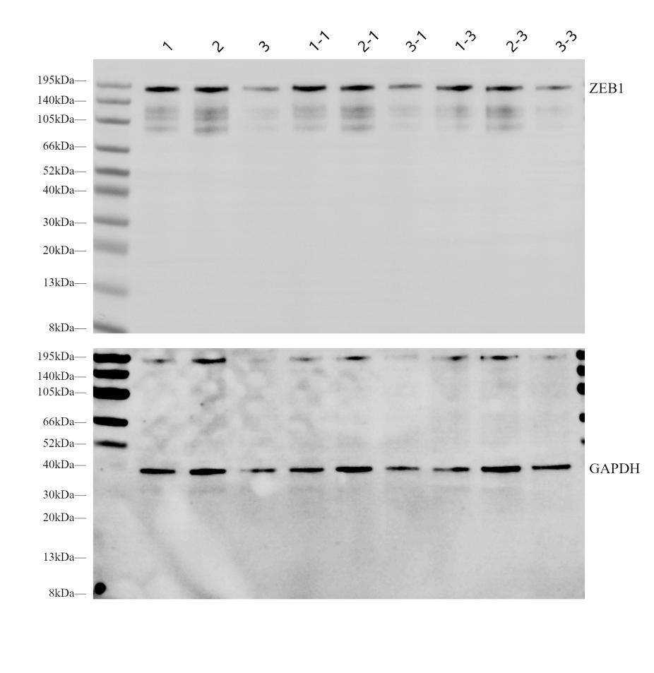

1, 1-1 and 1-3: Control; 2, 2-1and 2-3: GCK; 3, 3-1 and 3-3: GCK nanoformulation

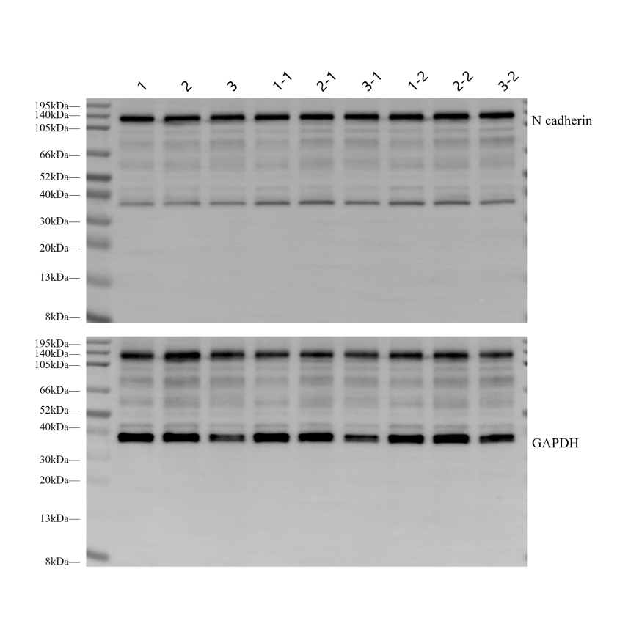
1, 1-1 and 1-2: Control; 2, 2-1 and 2-2: GCK; 3, 3-1 and 3-2: GCK nanoformulation

1, 1-1 and 1-2: Control; 2, 2-1 and 2-2: GCK; 3, 3-1 and 3-2: GCK nanoformulation

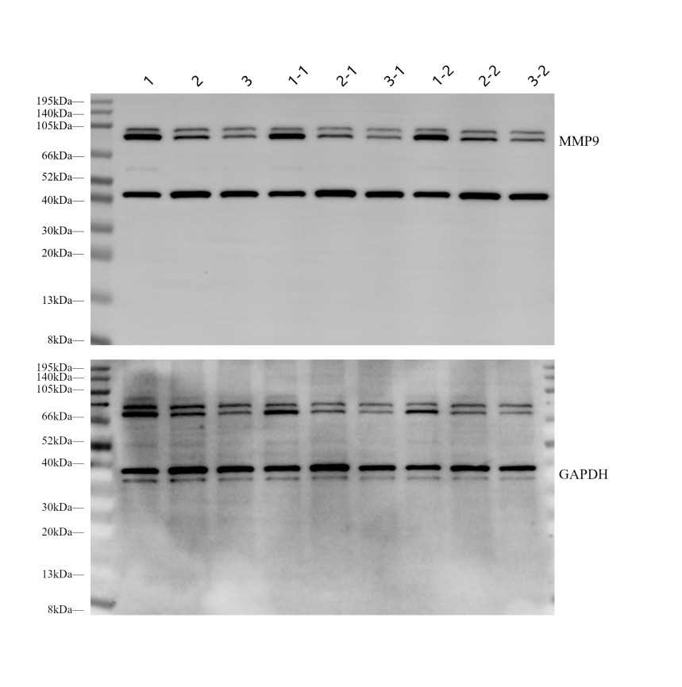
1, 1-1 and 1-2: Control; 2, 2-1 and 2-2: GCK 3, 3-1 and 3-2: GCK nanoformulation

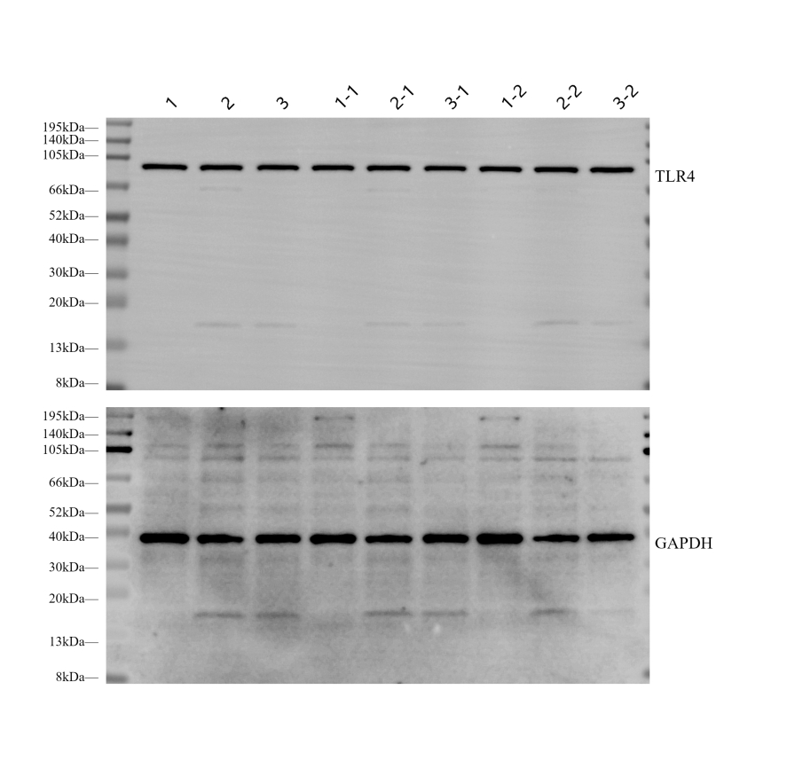
1, 1-1 and 1-2: Control; 2, 2-1 and 2-2: GCK 3, 3-1 and 3-2: GCK nanoformulation

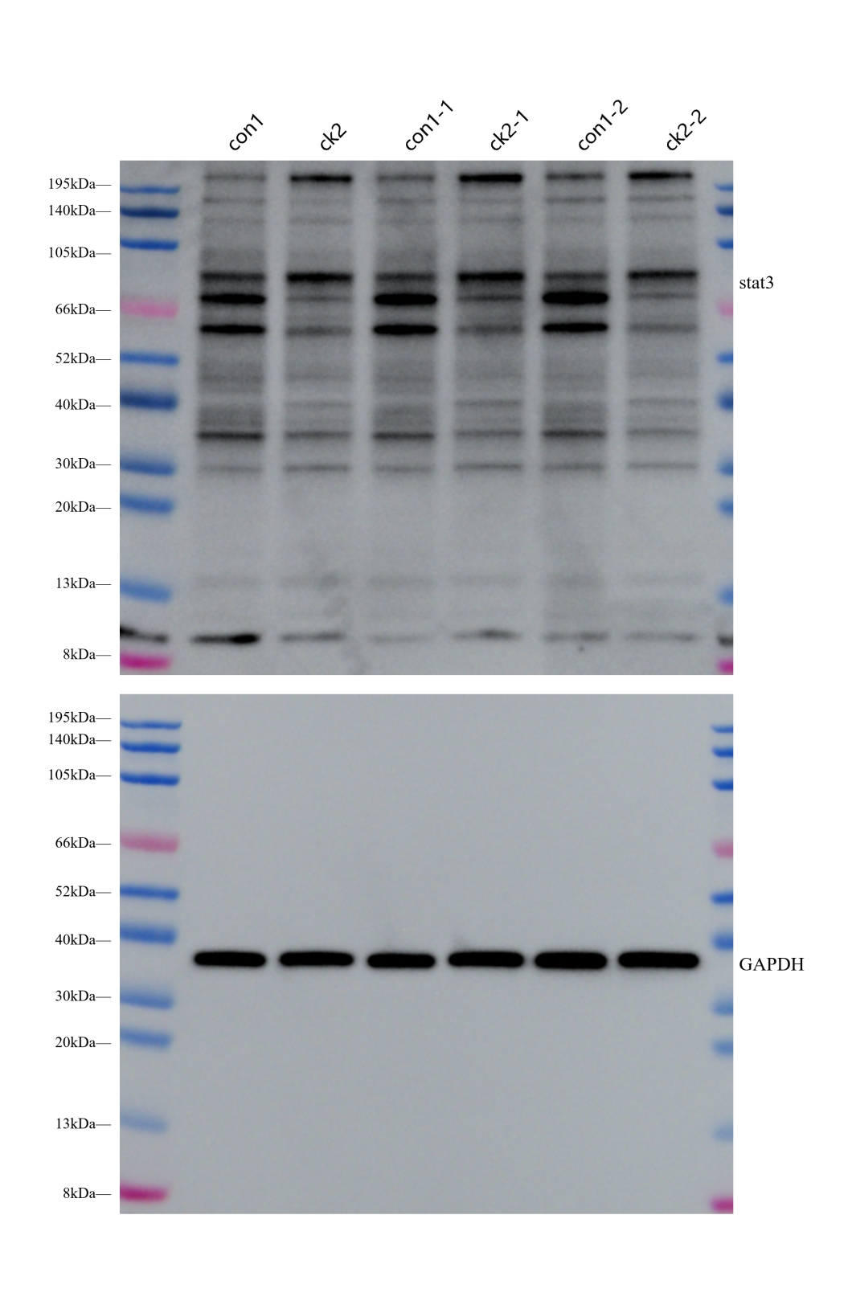
con1, con1-1 and con1-2: Control; ck2, ck2-1 and ck2-2: GCK

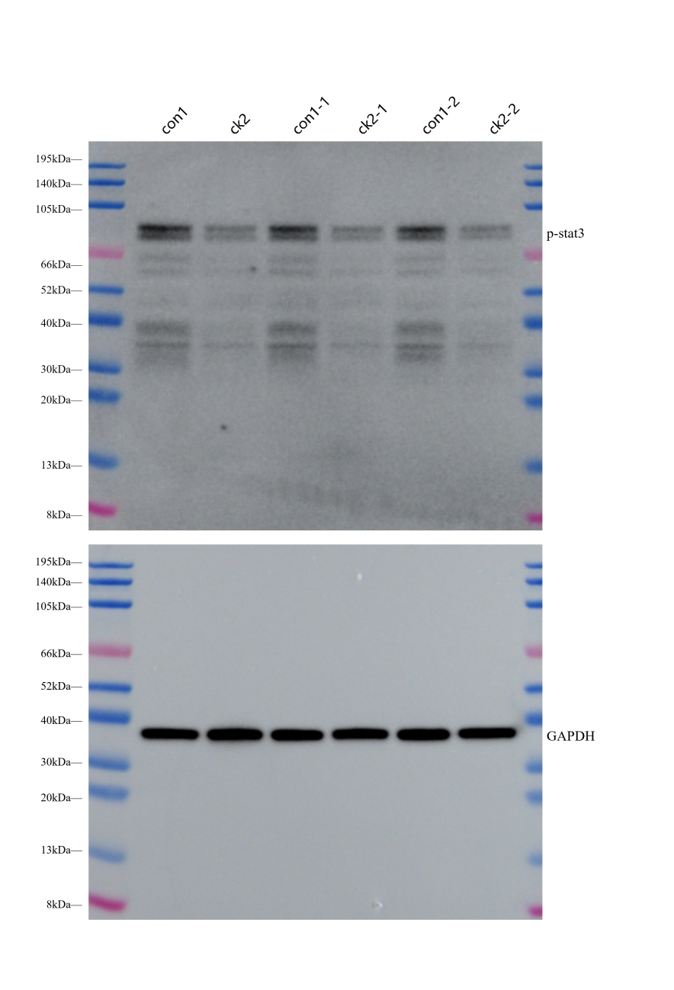
con1, con1-1 and con1-2: Control; ck2, ck2-1 and ck2-2: GCK

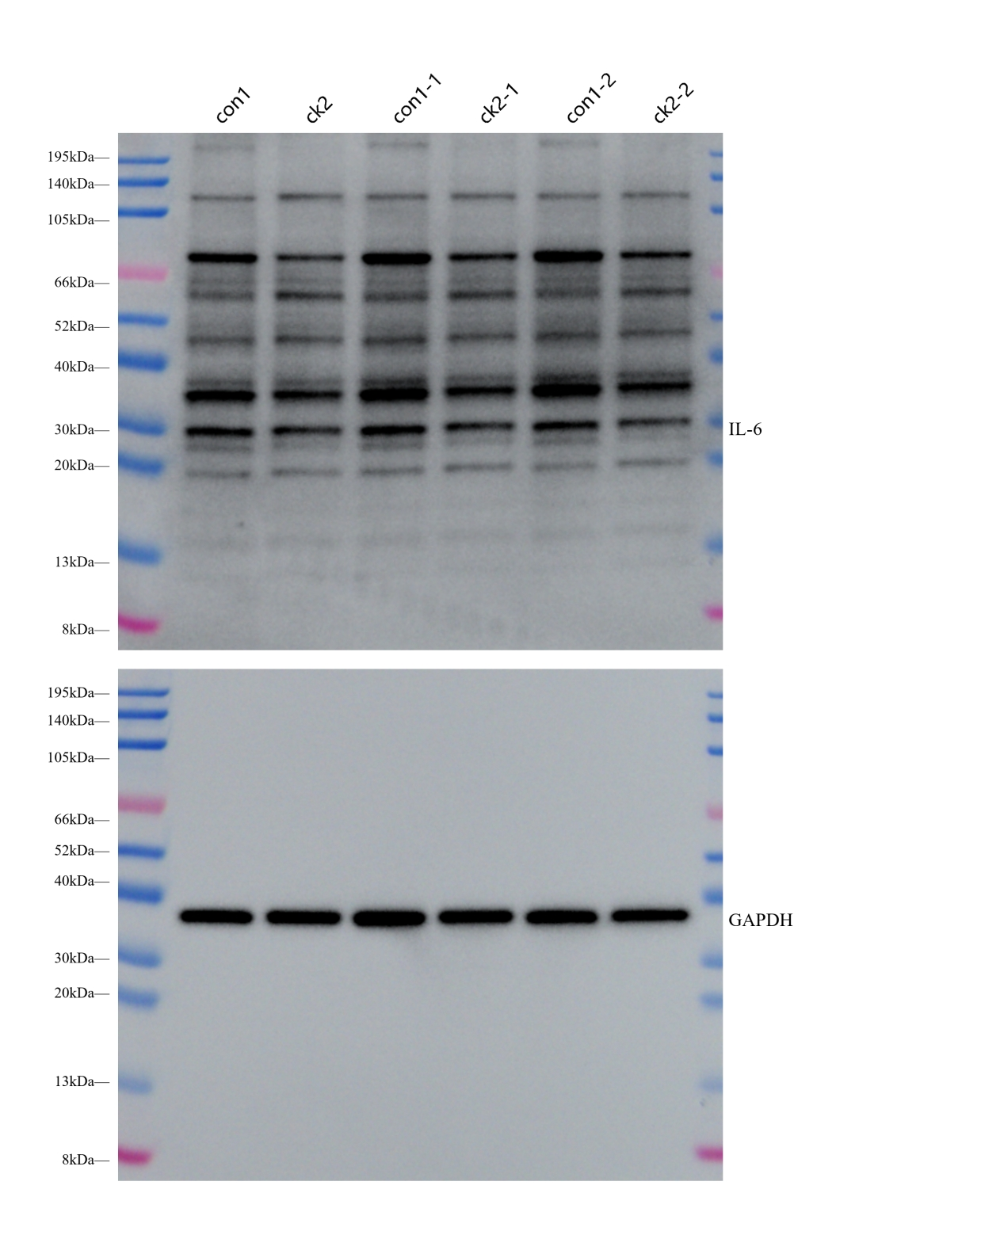
con1, con1-1 and con1-2: Control; ck2, ck2-1 and ck2-2: GCK

