Supplemental Information
Visualization of Long-Range Order in Self-Assembled Ion Barriers for Stable Perovskite Tandems

This Supplementary Information includes:

Supplementary Text
Supplementary Figs. 1–24
Supplementary Tables 1–12

Supplementary Text
Note 1: SCLC method
The N_{t} can be calculated using the following equation ¹
$$\begin{aligned}N_{t}=\frac{2εε_{0}V_{TFL}}{qL^{2}} \#\left(S1\right)\end{aligned}$$
Where q is the elementary charge, L is the perovskite film thickness, $ε_{0}$ is the vacuum permittivity, $ε$ is the relative dielectric constant, and V_{TFL} is the onset voltage of the trap-filled limit region.

The charge carrier mobility of the HTM films was measured using the SCLC technique. Hole-only devices were fabricated in a structure of ITO/C₆₀/ETL/Ag. The device characteristics were extracted by modeling the dark current under forward bias using the Mott-Gurney law ²:
$$\begin{aligned}J=\frac{9}{8}ε_{r}ε_{0}μ\frac{V^{2}}{L^{3}}\#\left(S2\right)\end{aligned}$$
Here, $ε_{r}$ is the average dielectric constant of the film, $ε_{0}$ is the permittivity of the free space, $μ$ is the carrier mobility, L is the thickness of the film, and V is the applied voltage.

Note 2: TRPL method
TRPL was performed on Delta Flex TCSPC system (Horiba, Japan), recorded at 800 nm using excitation with a 520 nm light pulse. The glass substrate was sequentially ultrasonicated in isopropyl alcohol and deionized water for 15 minutes each, followed by a 20-minute UV-ozone treatment. Front-side excitation was employed for all measurements. The PL decay time and amplitudes are modeled using a biexponential expression ³:
$$\begin{aligned}f\left(t\right)=\sum_{i}{A_{i }\exp\left(-\frac{t}{τ_{i}}+K\right)}\#\left(S3\right)\end{aligned}$$
where $A_{i }$ is the decay amplitude, $τ_{i}$ is the decay time and K is a constant for the base-line offset. The average PL decay times ($τ_{ave}$) are further estimated using the $τ_{i}$ and $A_{i }$ values from the fitted data:
$$\begin{aligned}τ_{ave}=\frac{\sum{A_{i}τ_{i}^{2}}}{\sum{A_{i}τ_{i}}}\#\left(S4\right)\end{aligned}$$

Supplementary Figures and Tables：

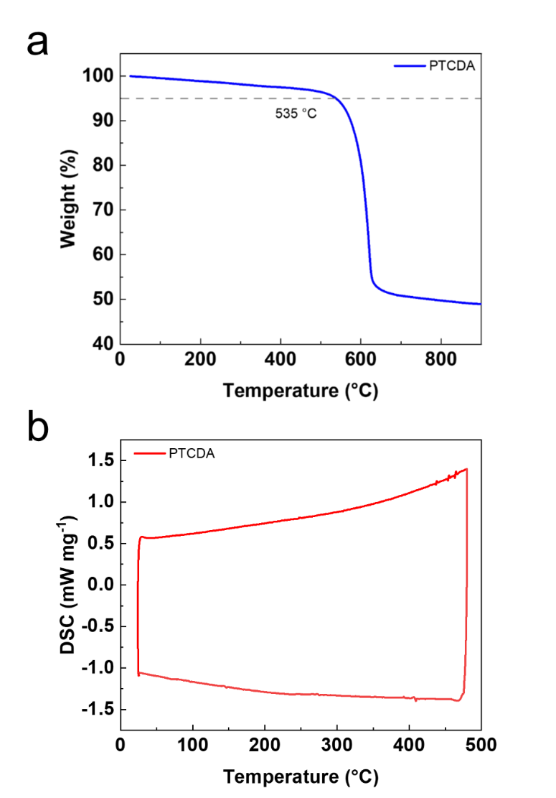
Supplementary Fig. 1. (a). Thermogravimetric analysis (TGA) curve of PTCDA. (b). Differential scanning calorimetry (DSC) heat-flow curve of PTCDA as a function of temperature.

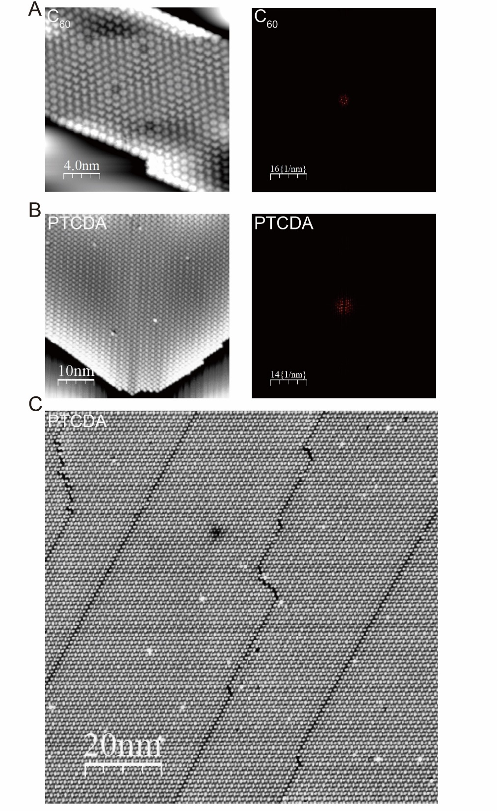
Supplementary Fig. 2. (a, b) High-resolution STM images of self-assembled C₆₀ and PTCDA on Ag(111) at 77 K. (a) C₆₀ images were acquired at scan sizes of 20 nm × 20 nm (0.9 V, 74 pA; right: FFT pattern). (b) PTCDA images were acquired at 50 nm × 50 nm (1.0 V, 110 pA; right: FFT pattern). (c) Large-area STM image of PTCDA showing long-range ordering (100 nm × 100 nm, V = 1.0 V, I = 49 pA).

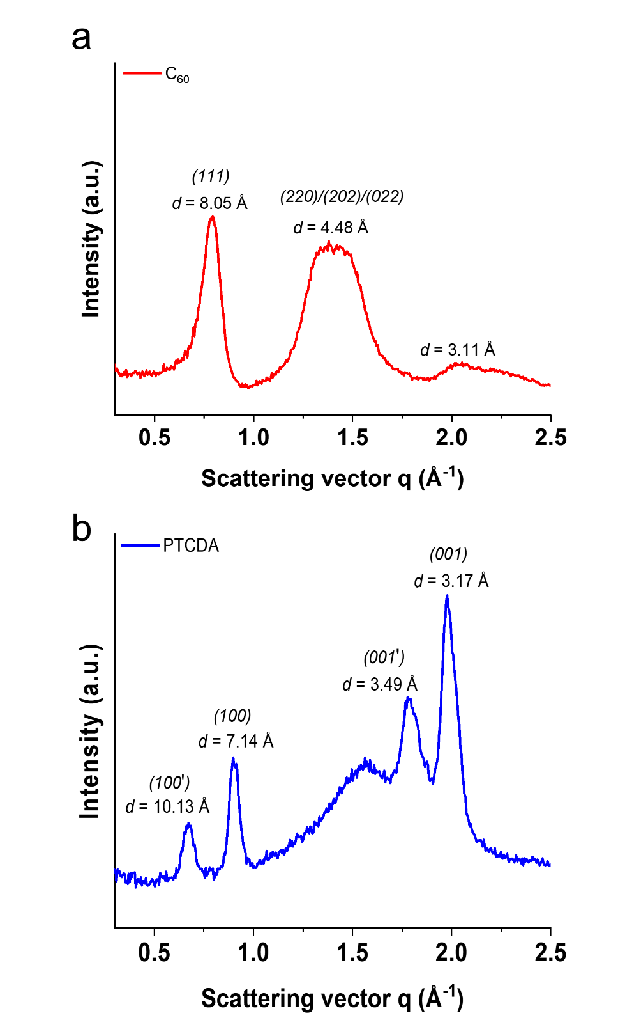
Supplementary Fig. 3. GIWAXS profiles of C₆₀ (a) and PTCDA (b) plotted as a function of the scattering vector q.

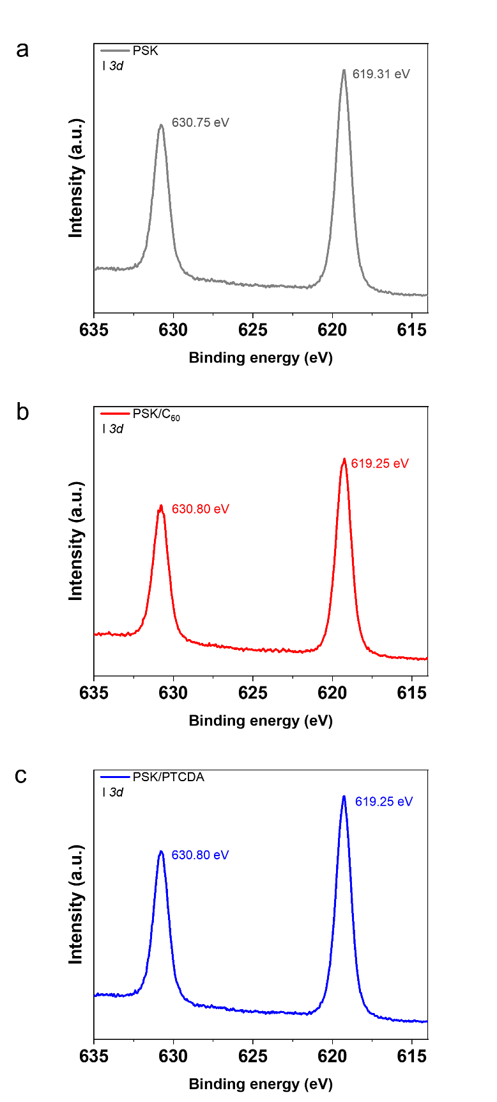
Supplementary Fig. 4. XPS I 3d spectra of PSK (a), PSK/C₆₀ (b), and PSK/PTCDA (c).

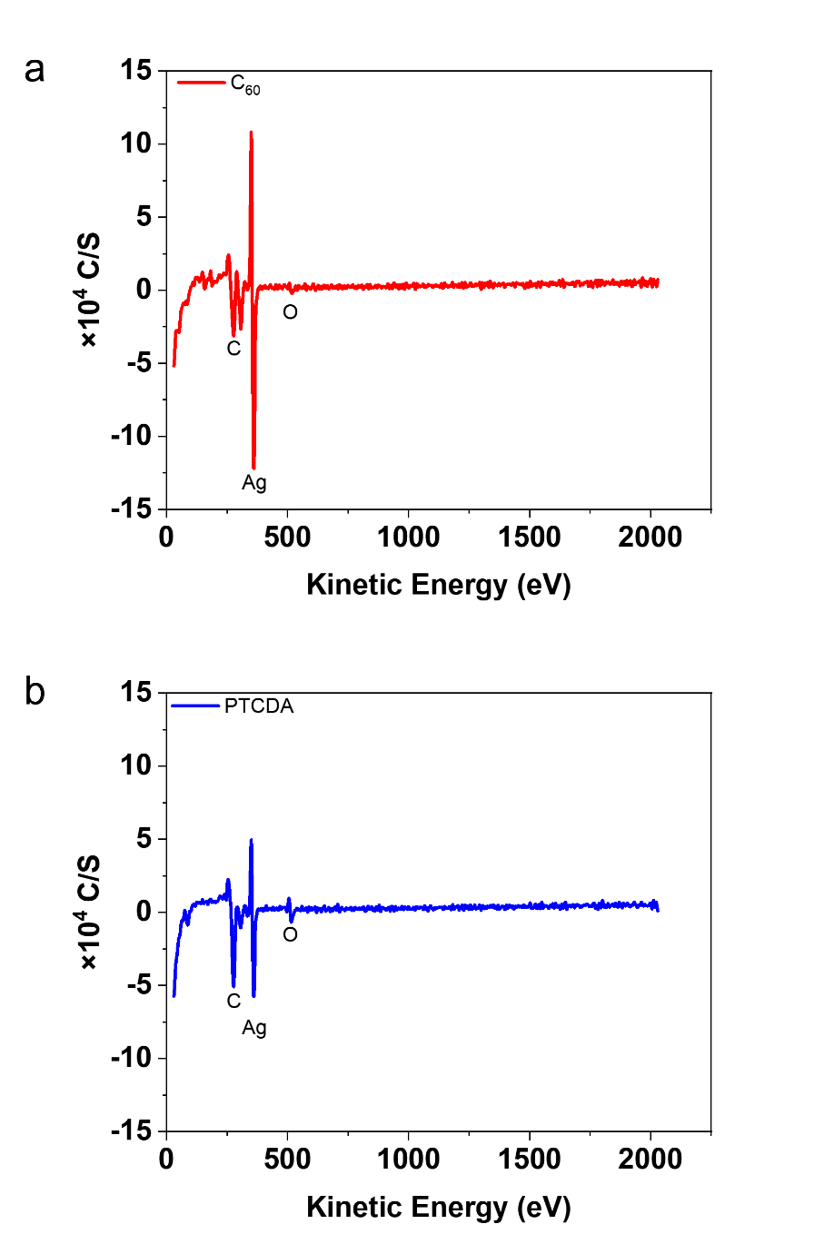
Supplementary Fig. 5. AES spectra of C₆₀ (a) and PTCDA (b) measured on Ag substrates. Characteristic C and Ag Auger features are marked.

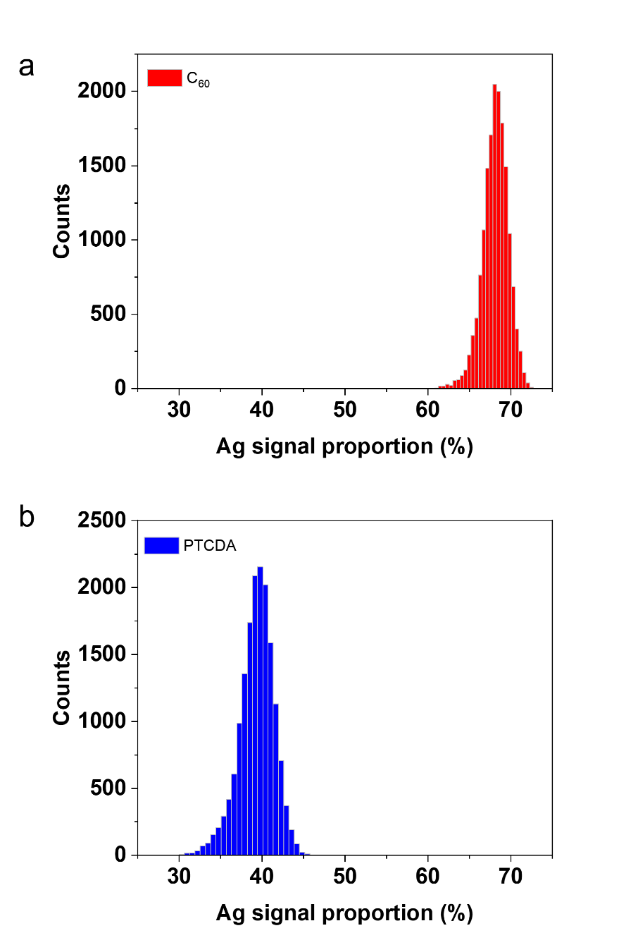
Supplementary Fig. 6. Normal distributions of the Ag signal proportion derived from the total C and Ag counts in AES spectra for C₆₀ (a) and PTCDA (b).

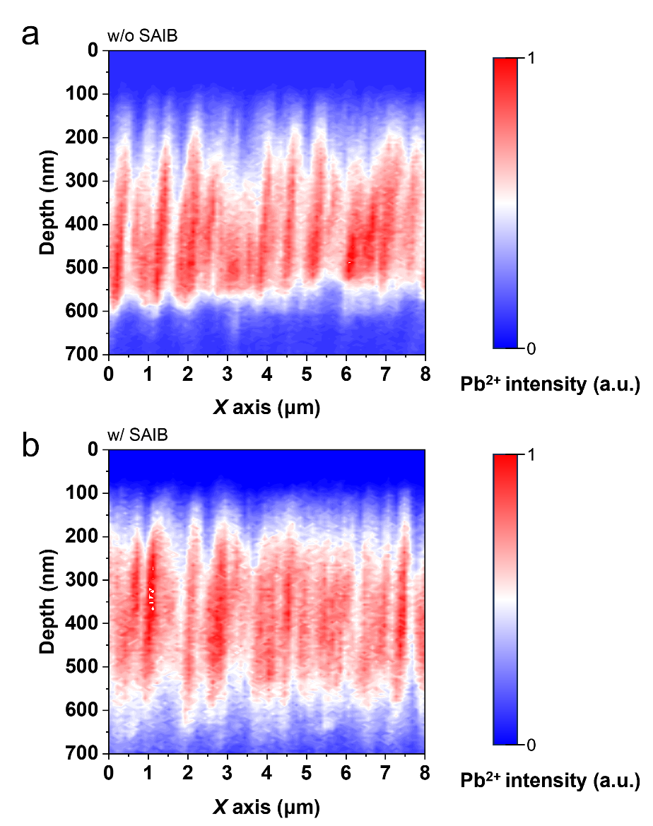
Supplementary Fig. 7. ToF-SIMS depth profiling of Pb²⁺ distribution in w/o SAIB (a) and w/ SAIB (b) PSCs after 72 h of MPPT operation.

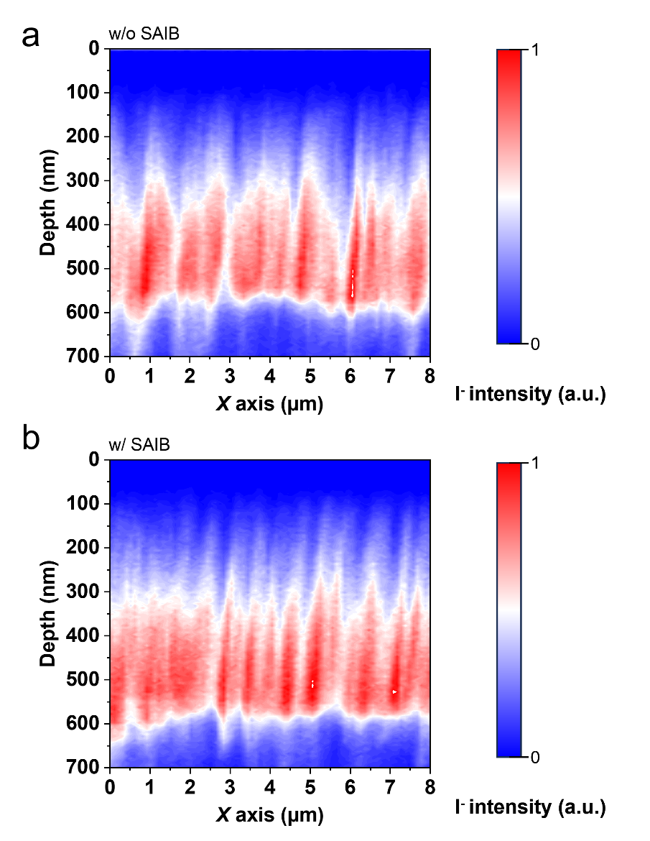
Supplementary Fig. 8. ToF-SIMS depth profiling of I⁻ distribution in w/o SAIB (a) and w/ SAIB (b) PSCs after 72 h of MPPT operation.

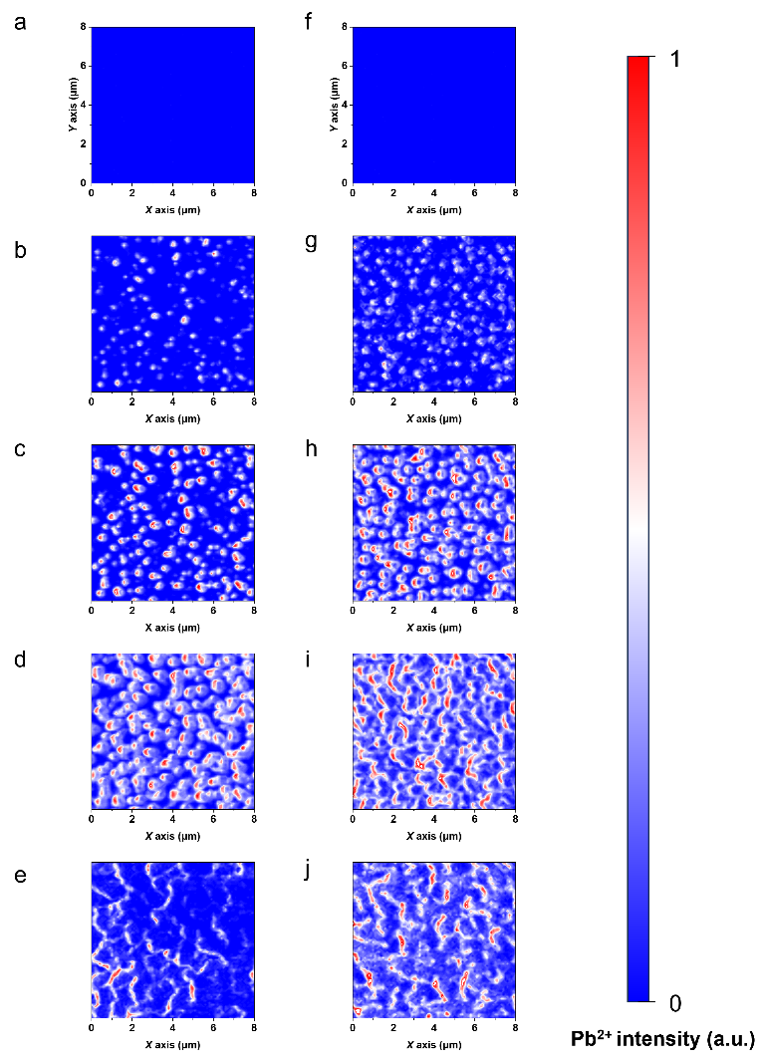
Supplementary Fig. 9. Top-view Pb²⁺ distribution maps (from five depths: 50, 100, 150, 400, and 600 nm). a–e correspond to the w/o SAIB sample, and f–j correspond to the w/ SAIB sample.

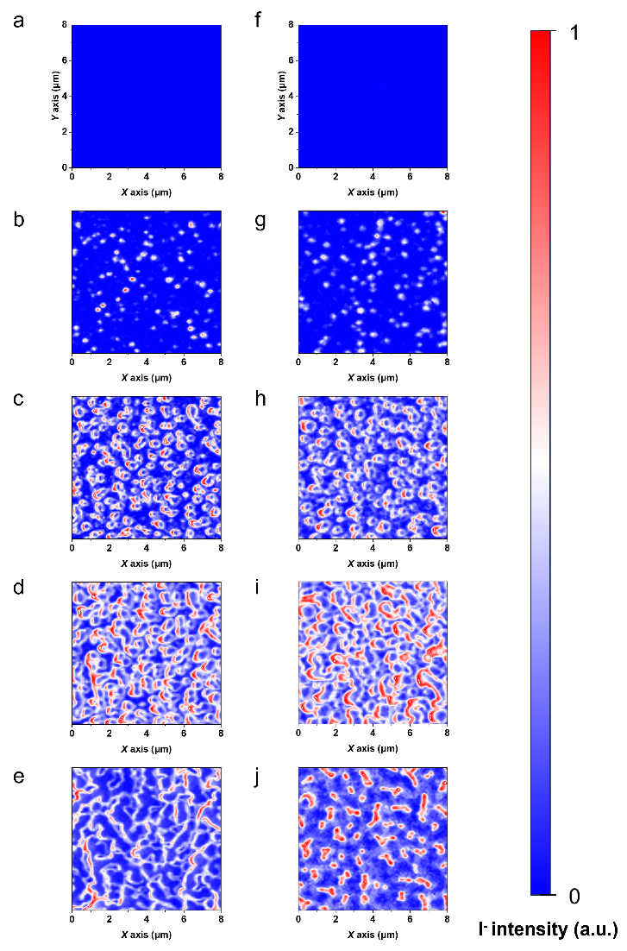
Supplementary Fig. 10. Top-view I⁻ distribution maps (from five depths: 50, 100, 150, 400, and 600 nm). a–e correspond to the w/o SAIB sample, and f–j correspond to the w/ SAIB sample.

Supplementary Fig. 11. Migration energy barriers of Ag⁺ ions along the migration pathway in the presence of C₆₀ and PTCDA.

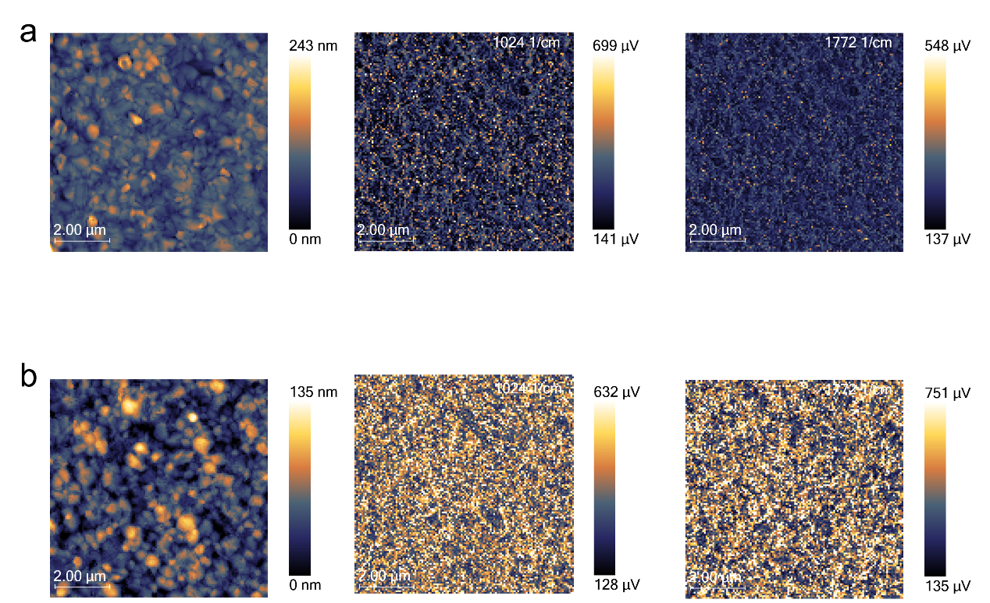
Supplementary Fig. 12. PiFM mapping of w/o and w/ SAIB samples. (a) PiFM mapping of the w/o SAIB sample at wavenumbers 1024 cm⁻¹, and 1772 cm⁻¹. (b) PiFM mapping of the w/ SAIB sample at wavenumbers 1024 cm⁻¹, and 1772 cm⁻¹.

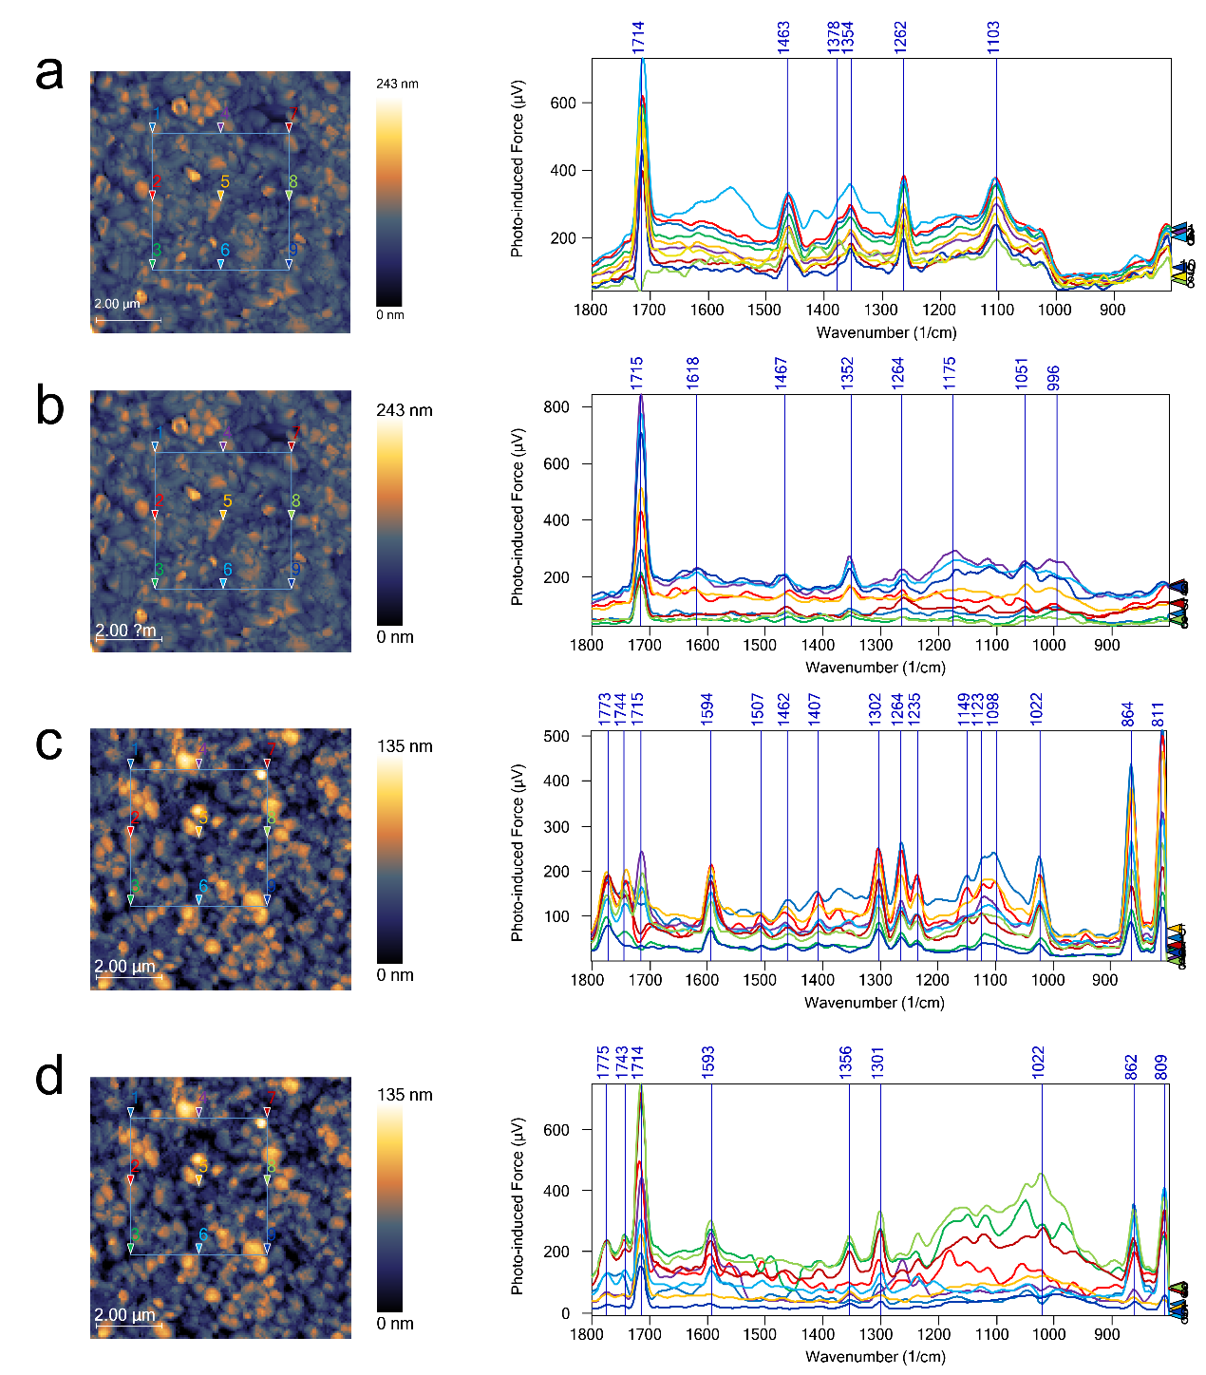
Supplementary Fig. 13. PiFM imaging and spectra of w/o and w/ SAIB samples. (a, b) Surface and bulk PiFM of w/o SAIB samples; (c, d) Surface and bulk PiFM of w/ SAIB samples.

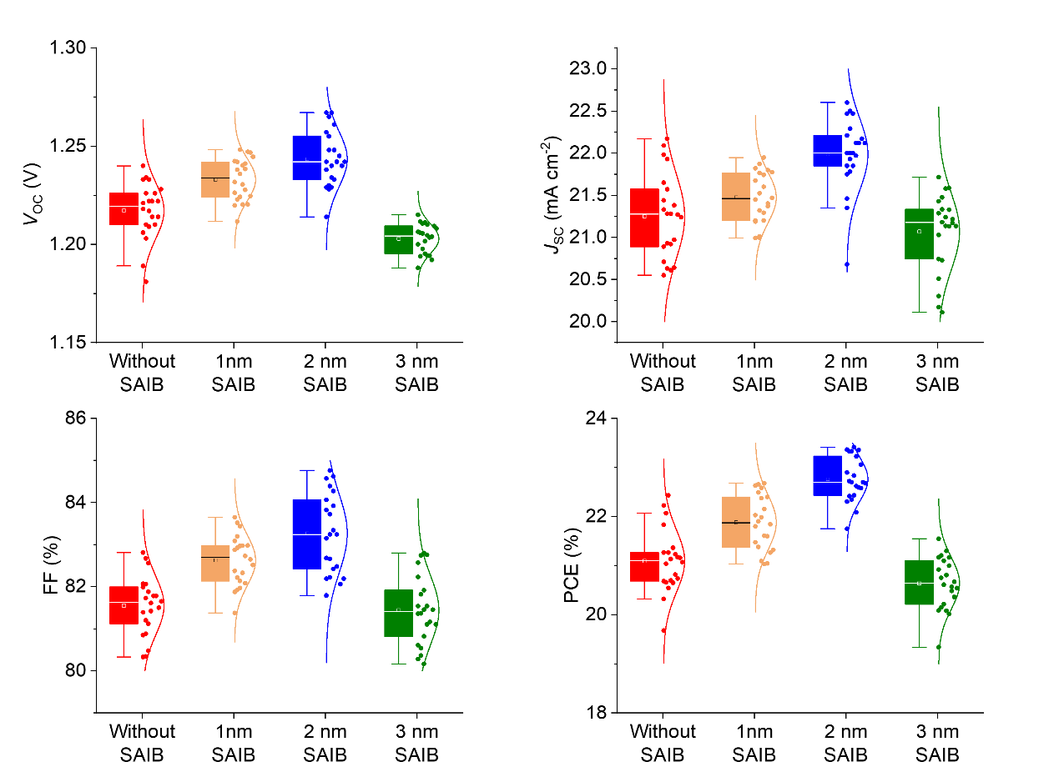
Supplementary Fig. 14. Statistical photovoltaic parameters of wide bandgap PSCs with different SAIB thicknesses; box plots show median and interquartile range, whiskers denote full data spread (n = 22 per group).

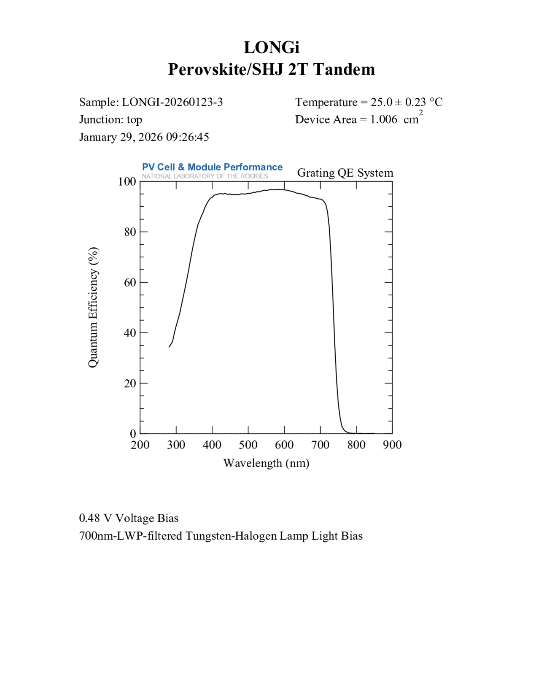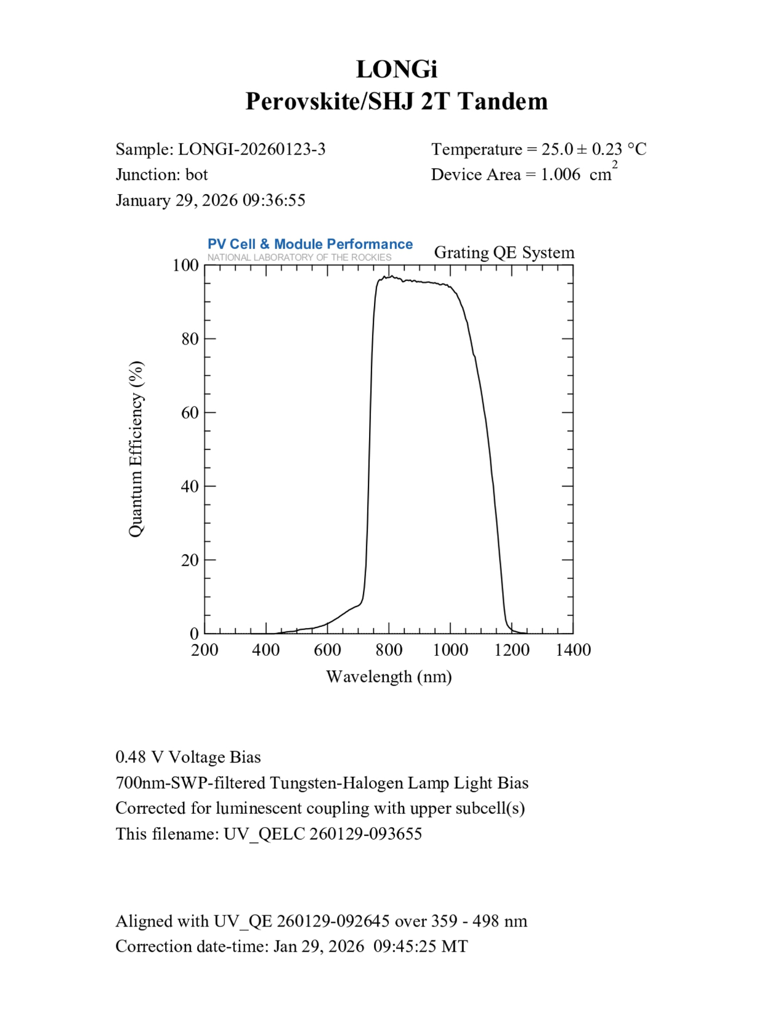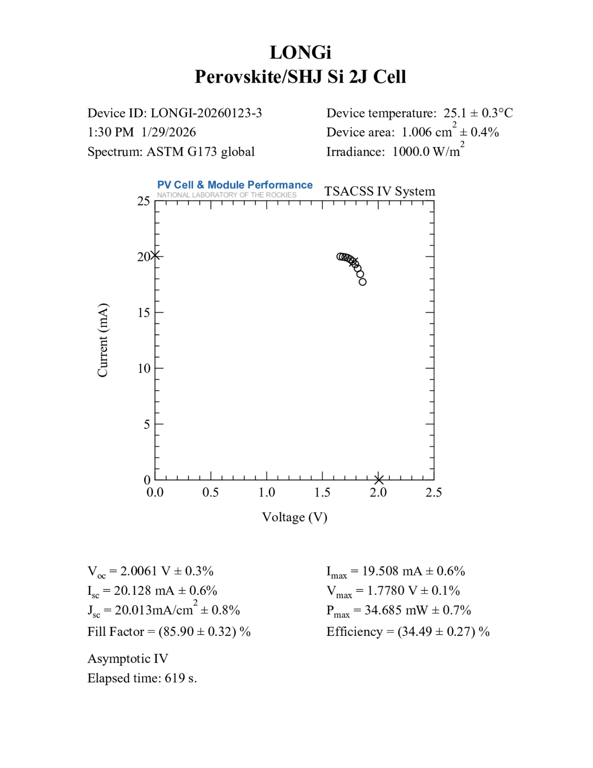
Supplementary Fig. 15. Independent efficiency verification of PSK/ Si tandem solar cells. The efficiency is verified by the NREL.

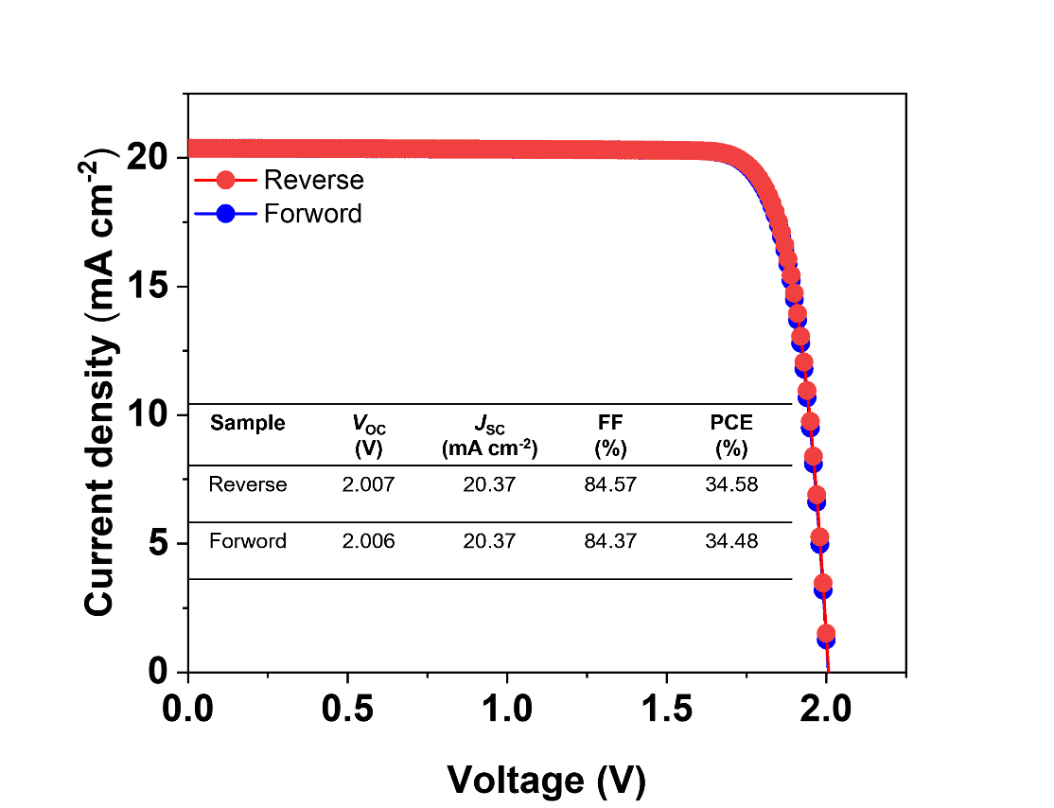
Supplementary Fig. 16. J–V characteristics of the PSK/Si tandem solar cell measured under forward and reverse scan directions.

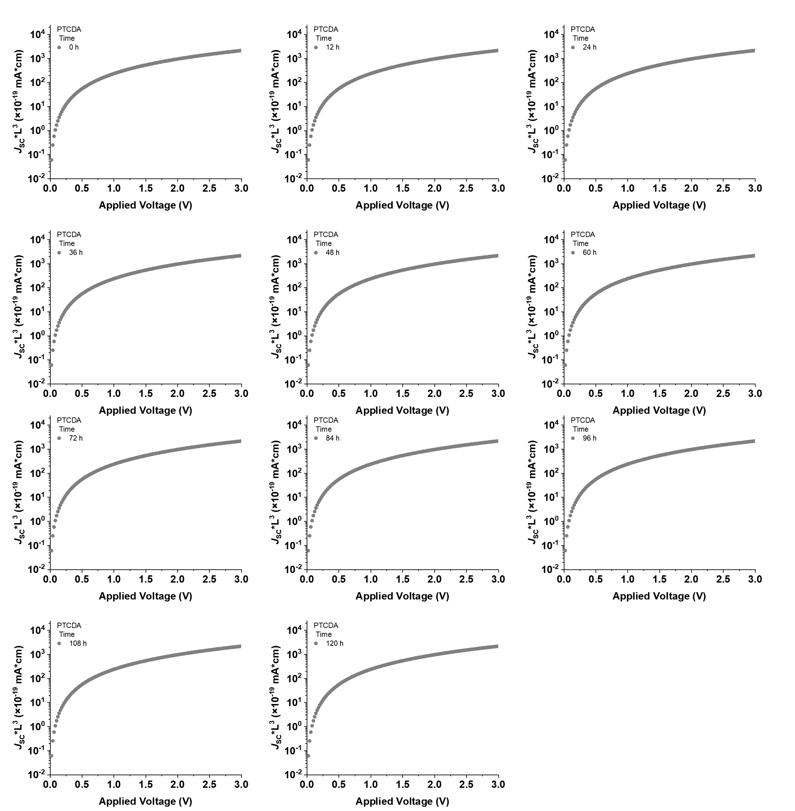
Supplementary Fig. 17. Changes in the μ_{e} of PTCDA caused by Ag⁺ migration during 0~120 h.

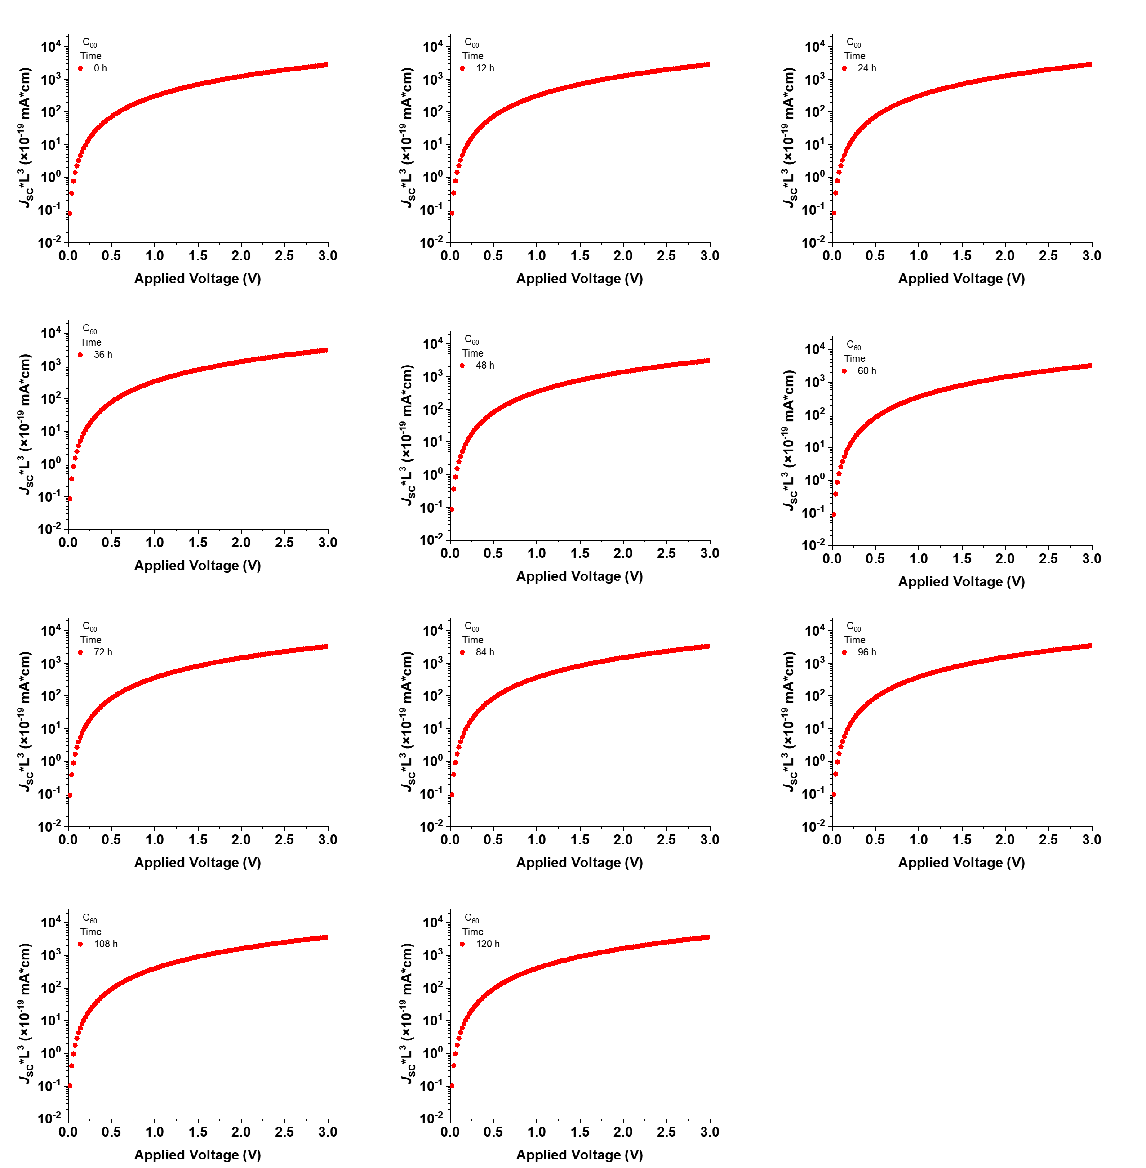
Supplementary Fig. 18. Changes in the μ_{e} of C₆₀ caused by Ag⁺ migration during 0~120 h.

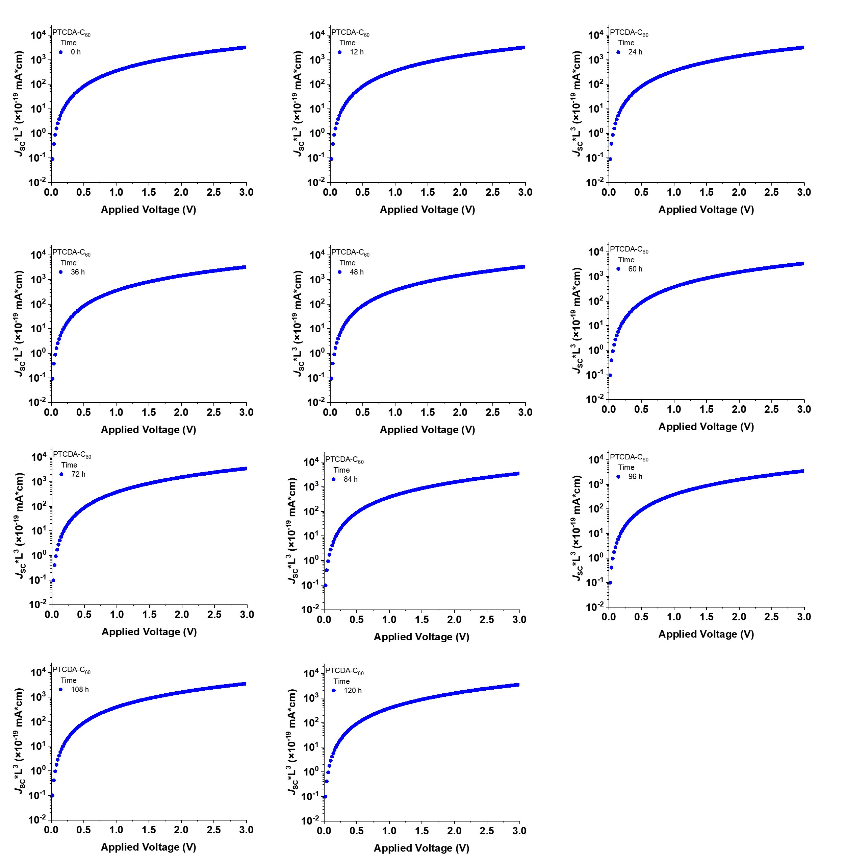
Supplementary Fig. 19. Changes in the μ_{e} of PTCDA/C₆₀ caused by Ag⁺ migration during 0~120 h.

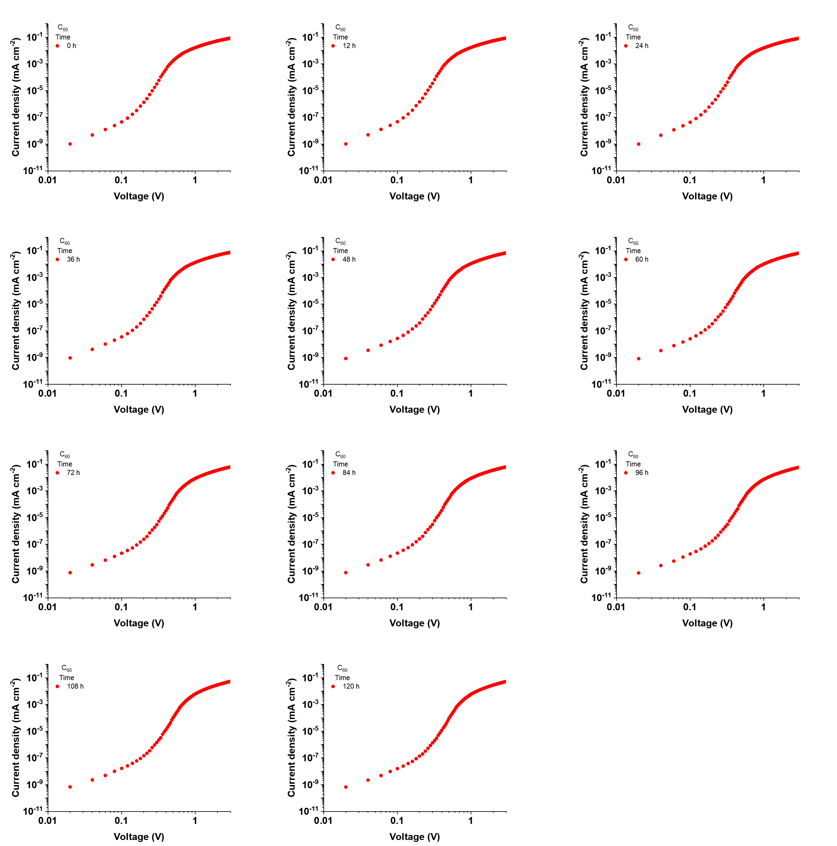
Supplementary Fig. 20. SCLC characteristics of C₆₀-based electron-only devices during 0~120 h.

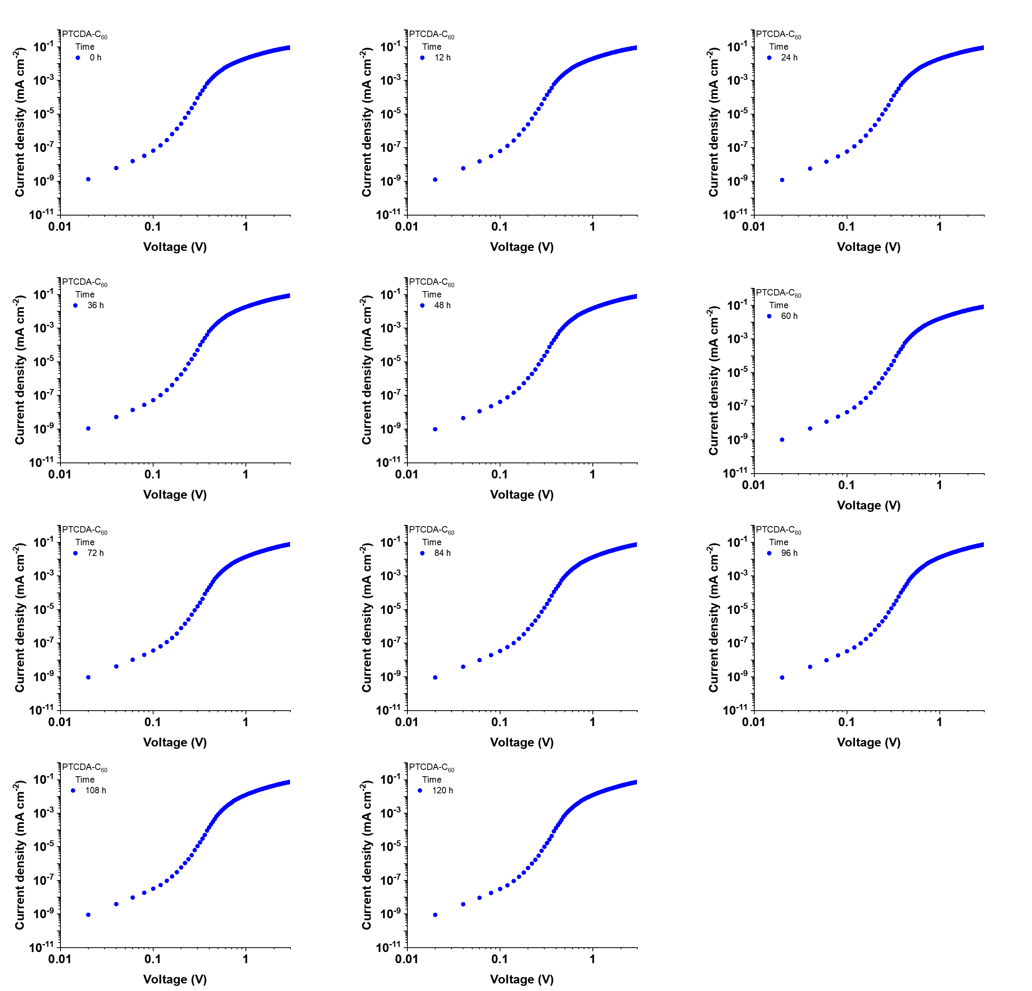
Supplementary Fig. 21. SCLC characteristics of PTCDA/C₆₀-based electron-only devices during 0~120 h.

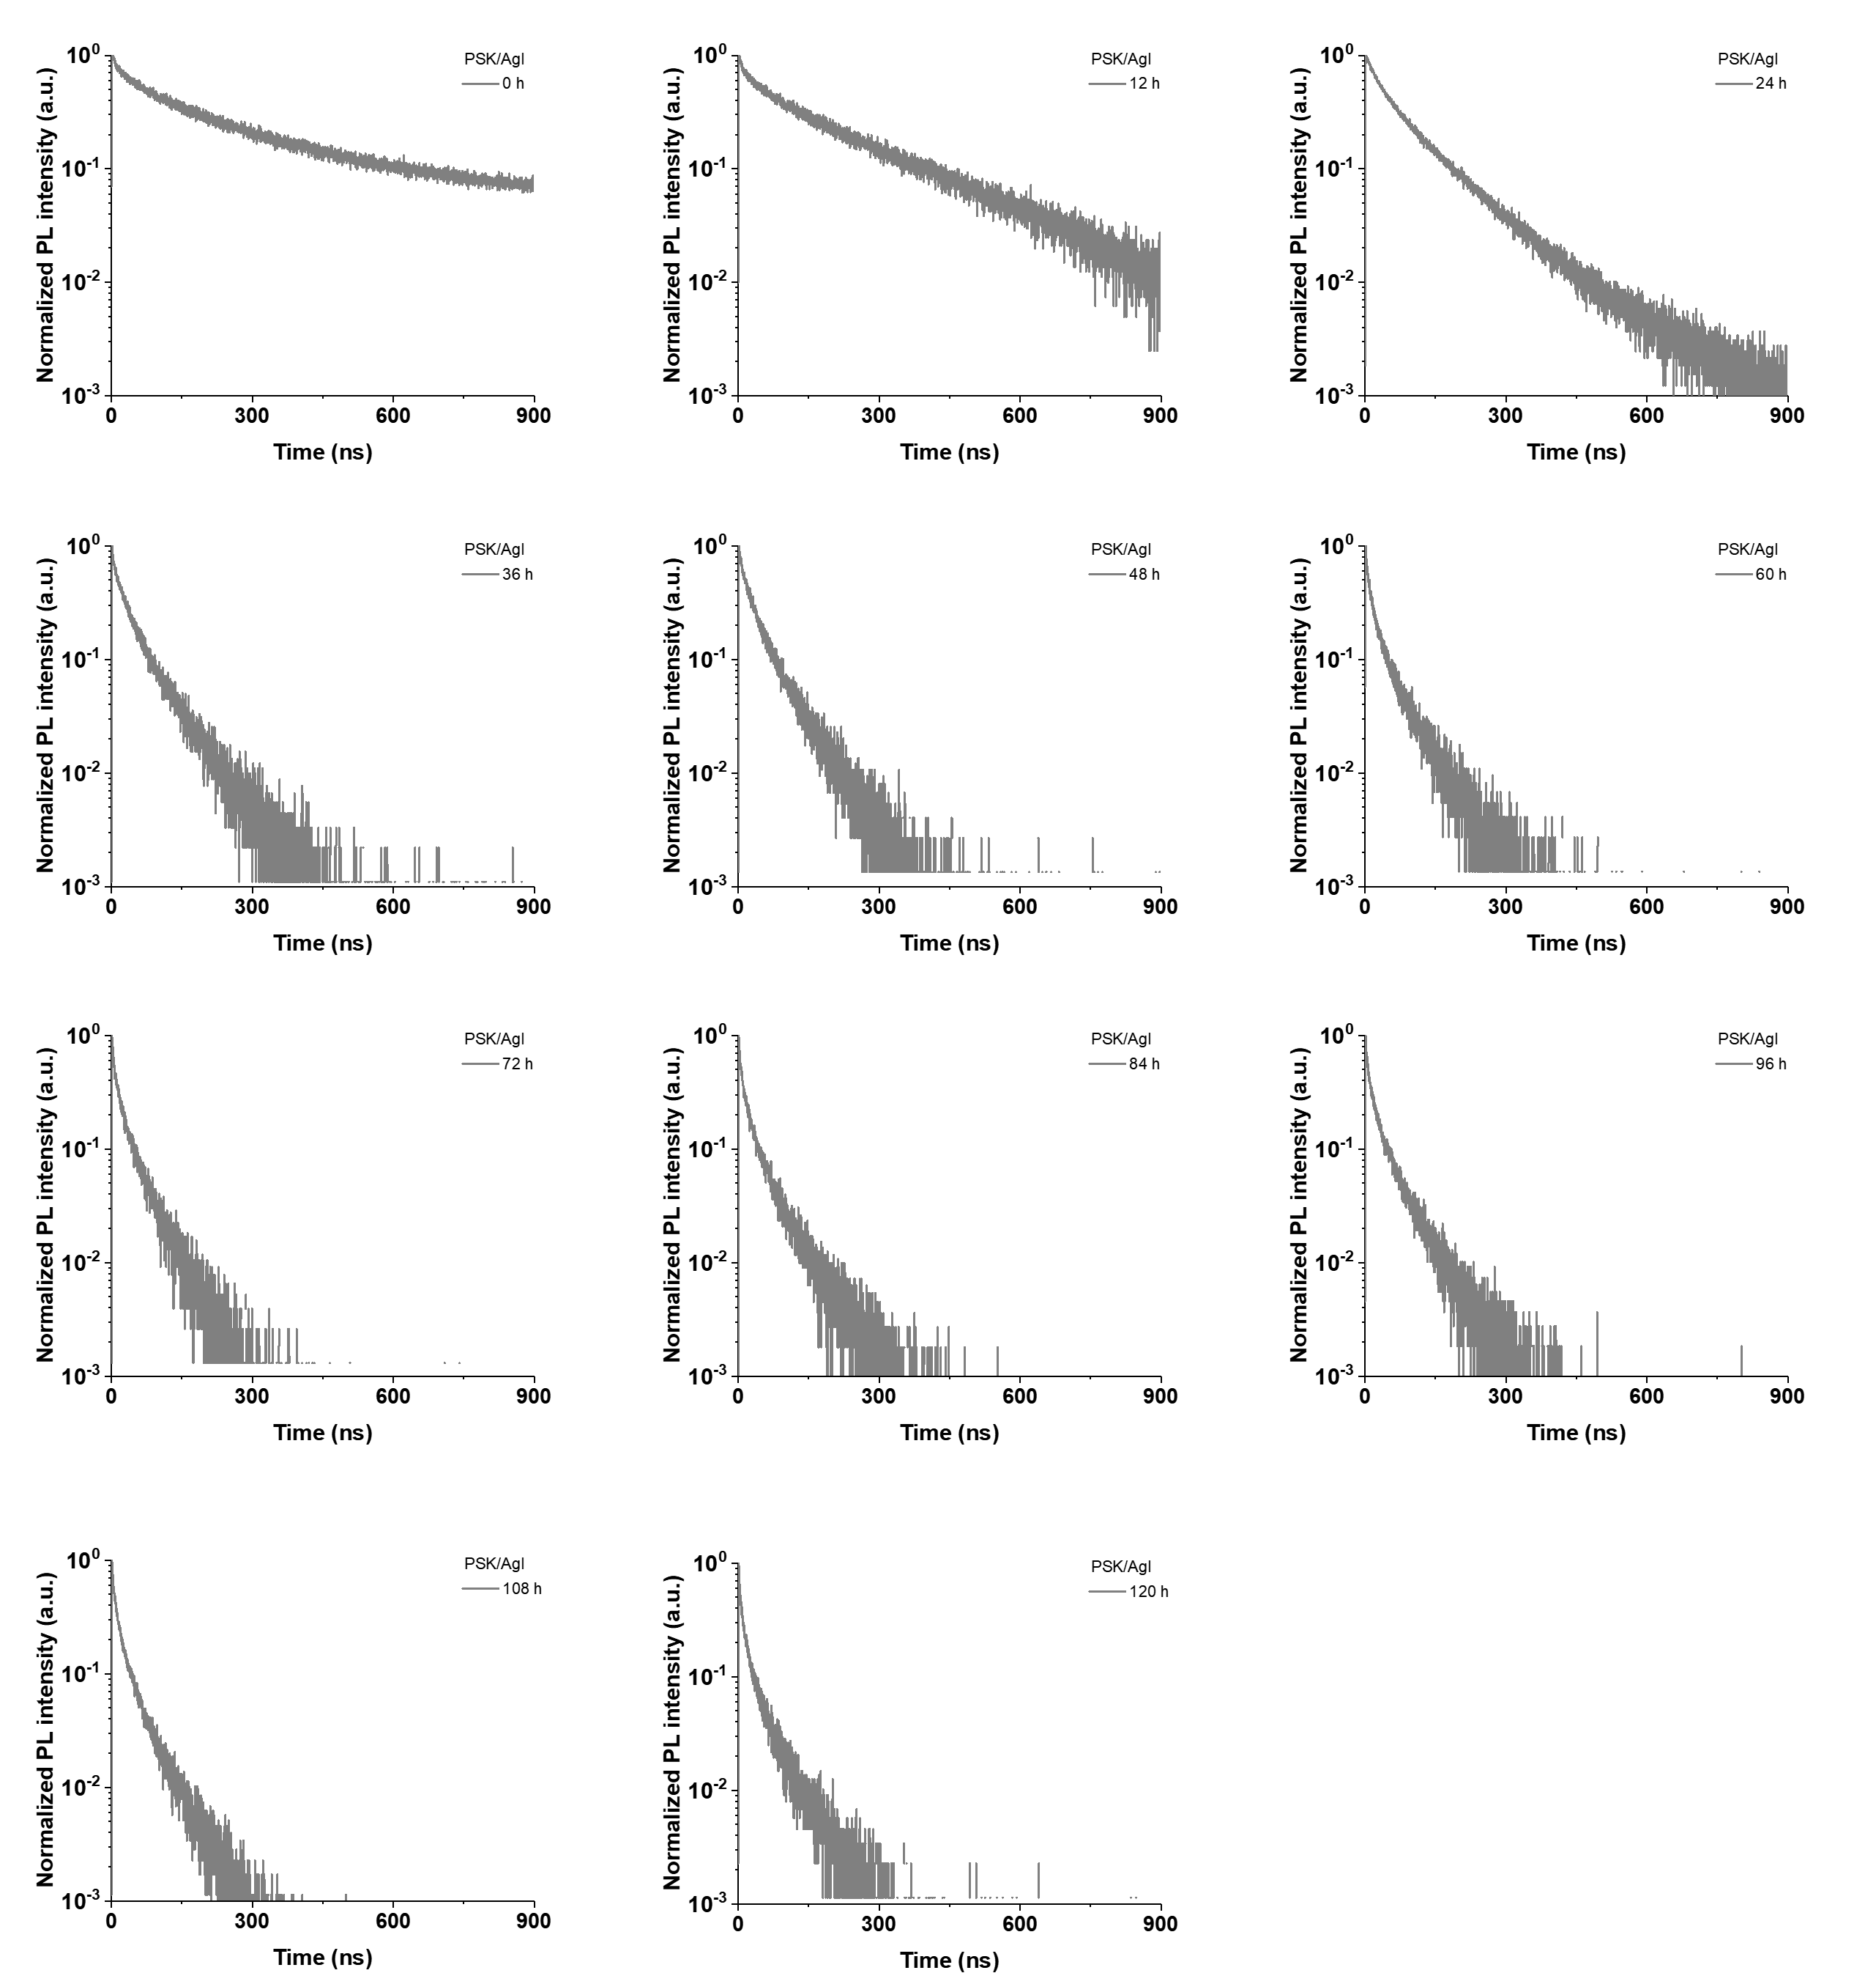
Supplementary Fig. 22. Evolution of the TRPL decay curves of PSK/AgI during 0~120 h.

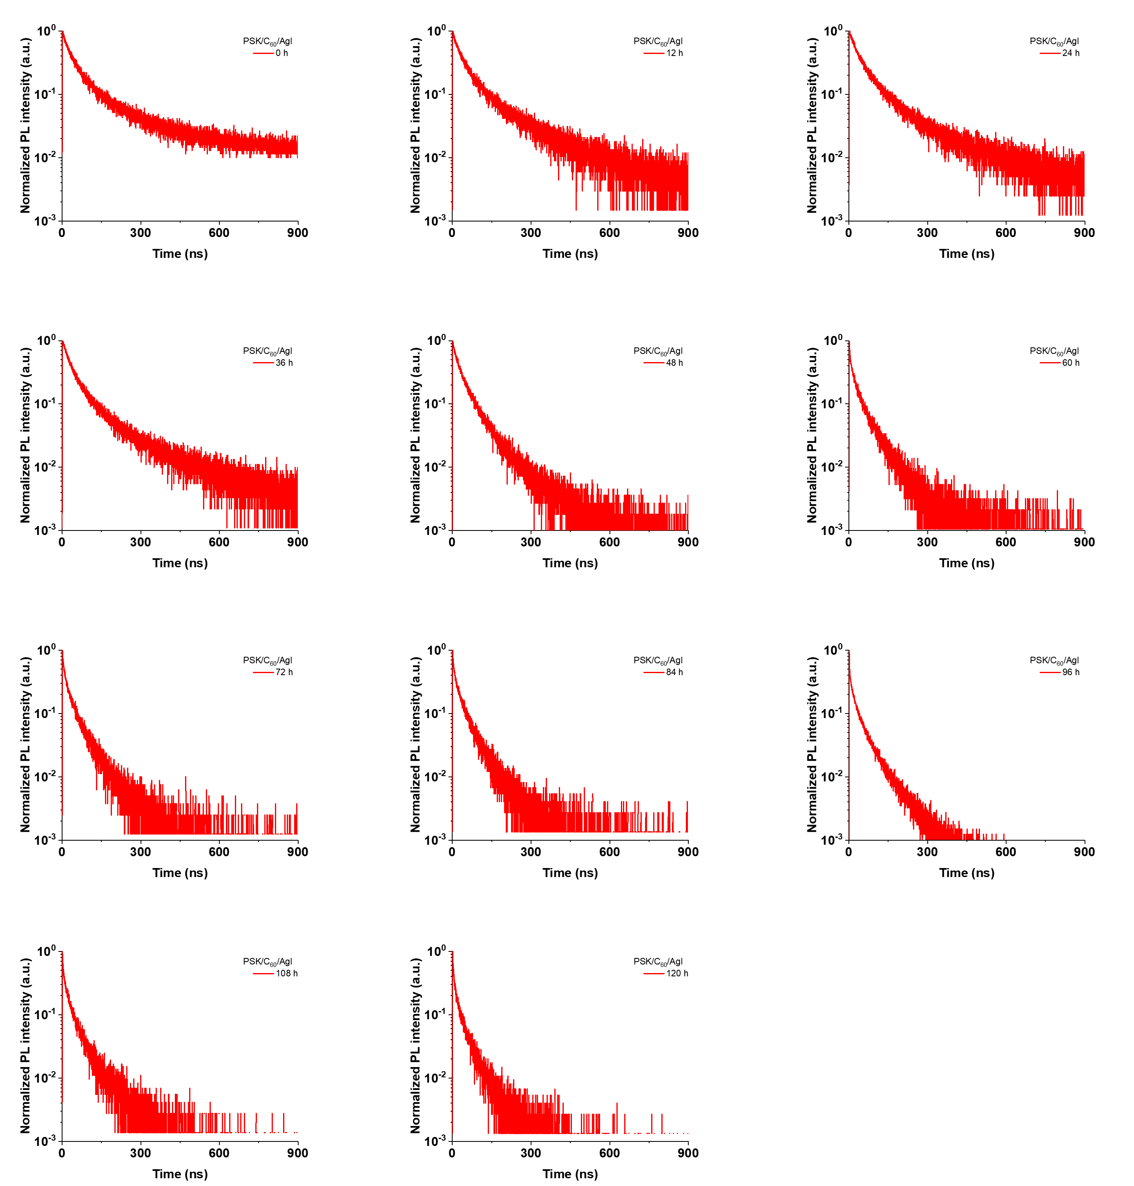
Supplementary Fig. 23. Evolution of the TRPL decay curves of PSK/C₆₀/AgI during 0~120 h.

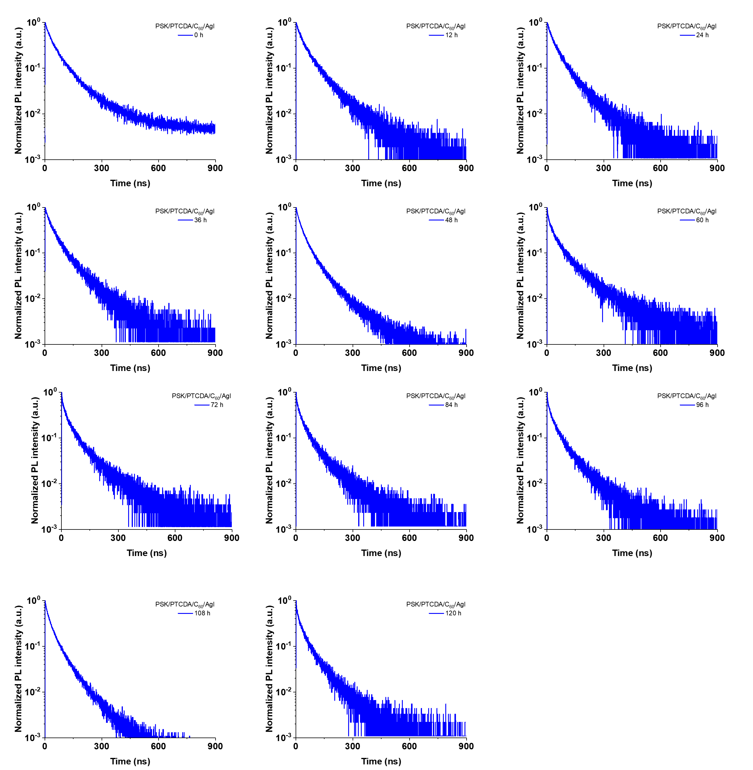
Supplementary Fig. 24. Evolution of the TRPL decay curves of PSK/PTCDA/C₆₀/AgI during 0~120 h.

Supplementary Table 1. Summary of the characteristic scattering peaks (q) and corresponding d-spacing values of C₆₀ and PTCDA films.

Sample | q (Å⁻¹) | d (Å)
C₆₀ | 0.78 | 8.05
C₆₀ | 1.40 | 4.48
C₆₀ | 2.02 | 3.11
PTCDA | 0.62 | 10.13
PTCDA | 0.88 | 7.14
PTCDA | 1.80 | 3.49
PTCDA | 1.98 | 3.17

Supplementary Table 2. Ag 3d XPS fitting parameters of the perovskite surface with different interfacial layers.
Sample | Ag⁺/(Ag⁺ + Ag⁰)  (%) | 3d_{3/2}  (eV) |  | 3d_{5/2}  (eV)
Sample | Ag⁺/(Ag⁺ + Ag⁰)  (%) | Ag⁰ | Ag⁺ | Ag⁰ | Ag⁺
Metal silver layer | 15.21 | 374.69 | 375.51 | 368.65 | 369.35
2 nm C₆₀ | 9.63 | 374.63 | 375.30 | 368.66 | 369.40
2 nm PTCDA | 1.30 | 374.80 | 375.65 | 368.78 | 369.70

Supplementary Table 3. Pb 4f XPS fitting parameters of the perovskite surface with different interfacial layers.
Sample | Pb⁰/( Pb⁰ + Pb²)  (%) | 4f_{5/2}  (eV) |  | 4f_{7/2}  (eV)
Sample | Pb⁰/( Pb⁰ + Pb²)  (%) | Pb⁰ | Pb² | Pb⁰ | Pb²
PSK | 20.12 | 142.85 | 143.40 | 137.71 | 138.45
PSK/C₆₀ | 3.96 | 142.84 | 143.39 | 137.74 | 138.44
PSK/PTCDA | 0 | none | 143.52 | none | 138.60

Supplementary Table 4. Statistical photovoltaic parameters of w/o SAIB WBG PSCs.
Sample | V_{OC} (V) | J_{SC} (mA cm⁻²) | FF (%) | PCE (%)
SAIB-free | 1.22 | 20.71 | 81.99 | 20.68
SAIB-free | 1.22 | 21.98 | 82.81 | 22.22
SAIB-free | 1.21 | 20.89 | 81.73 | 20.66
SAIB-free | 1.21 | 20.93 | 81.39 | 20.54
SAIB-free | 1.20 | 20.63 | 81.88 | 20.32
SAIB-free | 1.23 | 21.93 | 82.07 | 22.06
SAIB-free | 1.19 | 21.33 | 81.61 | 20.70
SAIB-free | 1.18 | 20.61 | 80.85 | 19.68
SAIB-free | 1.22 | 21.28 | 81.78 | 21.26
SAIB-free | 1.23 | 20.64 | 82.67 | 21.04
SAIB-free | 1.22 | 21.28 | 81.78 | 21.26
SAIB-free | 1.22 | 20.55 | 82.56 | 20.64
SAIB-free | 1.21 | 21.44 | 81.20 | 21.13
SAIB-free | 1.23 | 21.38 | 81.50 | 21.36
SAIB-free | 1.21 | 21.27 | 80.88 | 20.81
SAIB-free | 1.21 | 21.65 | 81.12 | 21.23
SAIB-free | 1.22 | 21.57 | 80.33 | 21.17
SAIB-free | 1.24 | 21.24 | 80.34 | 21.16
SAIB-free | 1.21 | 20.92 | 81.65 | 20.74
SAIB-free | 1.23 | 20.97 | 81.42 | 21.07
SAIB-free | 1.23 | 22.09 | 80.48 | 21.83
SAIB-free | 1.23 | 22.17 | 82.06 | 22.43

Supplementary Table 5. Statistical photovoltaic parameters of 1 nm SAIB WBG PSCs.
Sample | V_{OC} (V) | J_{SC} (mA cm⁻²) | FF (%) | PCE (%)
1 nm SAIB | 1.23 | 21.45 | 82.87 | 21.80
1 nm SAIB | 1.23 | 21.52 | 83.08 | 22.03
1 nm SAIB | 1.22 | 21.60 | 82.92 | 21.90
1 nm SAIB | 1.24 | 21.82 | 82.97 | 22.49
1 nm SAIB | 1.24 | 20.99 | 82.38 | 21.48
1 nm SAIB | 1.25 | 21.67 | 83.65 | 22.63
1 nm SAIB | 1.24 | 21.87 | 83.52 | 22.65
1 nm SAIB | 1.24 | 21.40 | 82.97 | 21.98
1 nm SAIB | 1.22 | 21.47 | 82.22 | 21.61
1 nm SAIB | 1.24 | 21.95 | 82.14 | 22.37
1 nm SAIB | 1.25 | 21.76 | 83.19 | 22.58
1 nm SAIB | 1.22 | 21.19 | 82.73 | 21.38
1 nm SAIB | 1.22 | 20.99 | 82.33 | 21.09
1 nm SAIB | 1.23 | 21.74 | 82.98 | 22.15
1 nm SAIB | 1.25 | 21.80 | 83.43 | 22.67
1 nm SAIB | 1.21 | 21.20 | 81.87 | 21.03
1 nm SAIB | 1.22 | 21.01 | 82.08 | 21.05
1 nm SAIB | 1.22 | 21.20 | 81.92 | 21.27
1 nm SAIB | 1.24 | 21.32 | 81.97 | 21.60
1 nm SAIB | 1.23 | 21.29 | 81.38 | 21.32
1 nm SAIB | 1.24 | 21.77 | 82.65 | 22.40
1 nm SAIB | 1.24 | 21.37 | 82.52 | 21.84

Supplementary Table 6. Statistical photovoltaic parameters of 2 nm SAIB WBG PSCs.
Sample | V_{OC} (V) | J_{SC} (mA cm⁻²) | FF (%) | PCE (%)
2 nm SAIB | 1.24 | 22.00 | 84.06 | 22.89
2 nm SAIB | 1.24 | 22.00 | 83.15 | 22.72
2 nm SAIB | 1.27 | 21.85 | 84.39 | 23.36
2 nm SAIB | 1.27 | 22.00 | 83.82 | 23.33
2 nm SAIB | 1.23 | 21.93 | 82.68 | 22.30
2 nm SAIB | 1.23 | 22.47 | 82.19 | 22.70
2 nm SAIB | 1.26 | 22.21 | 81.79 | 22.83
2 nm SAIB | 1.25 | 20.68 | 84.27 | 21.75
2 nm SAIB | 1.24 | 22.60 | 83.24 | 23.33
2 nm SAIB | 1.25 | 21.75 | 83.34 | 22.62
2 nm SAIB | 1.27 | 21.85 | 84.57 | 23.41
2 nm SAIB | 1.24 | 22.12 | 82.22 | 22.59
2 nm SAIB | 1.25 | 21.78 | 82.66 | 22.41
2 nm SAIB | 1.24 | 22.50 | 83.24 | 23.22
2 nm SAIB | 1.26 | 22.12 | 83.72 | 23.35
2 nm SAIB | 1.23 | 21.97 | 82.42 | 22.34
2 nm SAIB | 1.23 | 22.29 | 82.48 | 22.58
2 nm SAIB | 1.23 | 22.17 | 82.06 | 22.43
2 nm SAIB | 1.24 | 22.12 | 83.92 | 23.06
2 nm SAIB | 1.21 | 21.46 | 84.76 | 22.08
2 nm SAIB | 1.23 | 22.47 | 82.19 | 22.70
2 nm SAIB | 1.26 | 21.35 | 84.62 | 22.67

Supplementary Table 7. Statistical photovoltaic parameters of 3 nm SAIB WBG PSCs.
Sample | V_{OC} (V) | J_{SC} (mA cm⁻²) | FF (%) | PCE (%)
3 nm SAIB | 1.20 | 21.43 | 81.36 | 20.92
3 nm SAIB | 1.22 | 21.48 | 82.57 | 21.55
3 nm SAIB | 1.21 | 20.74 | 80.28 | 20.09
3 nm SAIB | 1.21 | 20.73 | 80.61 | 20.15
3 nm SAIB | 1.21 | 21.58 | 81.37 | 21.17
3 nm SAIB | 1.21 | 21.03 | 81.45 | 20.75
3 nm SAIB | 1.19 | 21.29 | 81.11 | 20.61
3 nm SAIB | 1.20 | 21.33 | 81.17 | 20.81
3 nm SAIB | 1.20 | 21.71 | 81.54 | 21.21
3 nm SAIB | 1.20 | 20.51 | 81.82 | 20.21
3 nm SAIB | 1.21 | 20.17 | 82.23 | 20.08
3 nm SAIB | 1.20 | 20.30 | 81.92 | 20.01
3 nm SAIB | 1.20 | 21.18 | 82.74 | 21.10
3 nm SAIB | 1.21 | 21.24 | 82.80 | 21.30
3 nm SAIB | 1.21 | 21.14 | 82.76 | 21.17
3 nm SAIB | 1.20 | 21.33 | 80.37 | 20.49
3 nm SAIB | 1.19 | 21.59 | 81.45 | 21.00
3 nm SAIB | 1.19 | 21.13 | 81.11 | 20.36
3 nm SAIB | 1.21 | 21.21 | 80.17 | 20.57
3 nm SAIB | 1.19 | 20.11 | 80.54 | 19.34
3 nm SAIB | 1.21 | 21.17 | 80.82 | 20.67
3 nm SAIB | 1.19 | 21.13 | 81.54 | 20.54

Supplementary Table 8. Statistical photovoltaic parameters of w/ SAIB PSK/Si tandem.
Sample |  | V_{OC}  (V) | J_{SC}  (mA cm⁻²) | FF  (%) | PCE  (%)
1 | Forword | 2.006 | 20.37 | 84.36 | 34.48
1 | Reverse | 2.007 | 20.37 | 84.57 | 34.58
2 | Forword | 2.003 | 20.36 | 83.76 | 34.14
2 | Reverse | 2.004 | 20.34 | 83.90 | 34.20
3 | Forword | 2.009 | 20.43 | 83.78 | 34.39
3 | Reverse | 2.010 | 20.42 | 84.03 | 34.50
4 | Forword | 2.009 | 20.43 | 83.47 | 34.26
4 | Reverse | 2.010 | 20.43 | 83.70 | 34.38
5 | Forword | 2.007 | 20.29 | 84.27 | 34.32
5 | Reverse | 2.008 | 20.28 | 84.49 | 34.42
6 | Forword | 2.007 | 20.39 | 84.02 | 34.39
6 | Reverse | 2.008 | 20.39 | 84.19 | 34.48
7 | Forword | 2.007 | 20.31 | 83.43 | 34.02
7 | Reverse | 2.008 | 20.31 | 83.56 | 34.09
8 | Forword | 2.008 | 20.43 | 83.49 | 34.26
8 | Reverse | 2.009 | 20.42 | 83.70 | 34.35
9 | Forword | 2.005 | 20.38 | 83.94 | 34.31
9 | Reverse | 2.006 | 20.38 | 84.07 | 34.37
10 | Forword | 2.003 | 20.38 | 82.98 | 33.89
10 | Reverse | 2.004 | 20.38 | 83.13 | 34.97

Supplementary Table 9. Photovoltaic parameters of the PSK/Si tandem solar cell, measured under forward and reverse J–V scans.
Sample |  | V_{OC}  (V) | J_{SC}  (mA cm⁻²) | FF  (%) | PCE  (%)
Reverse |  | 2.007 | 20.37 | 84.57 | 34.58
 | Forword | 2.006 | 20.37 | 84.36 | 34.48

Supplementary Table 10. Evolution of electron mobility (μ_{e}) in C₆₀, PTCDA/ C₆₀, and PTCDA films induced by Ag-ion migration during aging from 0 to 120 h.
Sample | C₆₀ | PTCDA-C₆₀
Sample | ×10⁻⁴ cm² V⁻¹ s⁻¹
0 h | 1.052 | 1.118
12 h | 1.055 | 1.118
24 h | 1.060 | 1.118
36 h | 1.100 | 1.202
48 h | 1.162 | 1.235
60 h | 1.188 | 1.262
72 h | 1.225 | 1.277
84 h | 1.227 | 1.282
96 h | 1.230 | 1.290
108 h | 1.233 | 1.298
120 h | 1.234 | 1.300

Supplementary Table 11. Evolution of defect density (Nₜ) in C₆₀ and PTCDA/ C₆₀ films induced by Ag-ion migration during aging from 0 to 120 h.

Sample | C₆₀ | PTCDA-C₆₀
Sample | ×10¹⁵ cm³
0 h | 1.98 | 1.85
12 h | 1.96 | 1.86
24 h | 2.02 | 1.87
36 h | 2.18 | 1.91
48 h | 2.39 | 2.07
60 h | 2.47 | 2.05
72 h | 2.62 | 2.18
84 h | 2.66 | 2.22
96 h | 2.77 | 2.21
108 h | 2.95 | 2.24
120 h | 3.01 | 2.25

Supplementary Table 12. Evolution of TRPL lifetimes of perovskite films with PSK/Ag, PSK/C₆₀/Ag, and PSK/PTCDA/C₆₀/Ag architectures during aging from 0 to 120 h.
Sample | PSK/C₆₀/AgI | PSK/PTCDA/C₆₀/AgI
Sample | ns
0 h | 80.22 | 75.21
12 h | 78.76 | 73.22
24 h | 75.79 | 68.57
36 h | 70.81 | 65.61
48 h | 62.77 | 64.53
60 h | 59.81 | 64.45
72 h | 53.88 | 63.84
84 h | 46.89 | 62.92
96 h | 42.90 | 60.16
108 h | 38.17 | 57.51
120 h | 35.62 | 52.63

References and Notes
- Shi, D. et al. Low trap-state density and long carrier diffusion in organolead trihalide perovskite single crystals. Science 347, 519–522 (2015).
- Herz, L. M. Charge-carrier mobilities in metal halide perovskites: Fundamental mechanisms and limits. ACS Energy Lett. 2, 1539–1548 (2017).
- de Quilettes, D. W. et al. Impact of microstructure on local carrier lifetime in perovskite solar cells. Science 348, 683–686 (2015).

