Supplementary Information

Visualization Evolution of Higher Alcohols from Direct Conversion of CO₂ on Fe₃O₄-Fe₅C₂-Cu Heterogeneous Catalytic Interfaces Layout

Teng Li ^{a*}, Lijun Zhang ^{c}, Zhenkun Liu ª, Jiaming Liang ª, Hao Chen ª, Linlin Zhao ª, Shunnosuke Fujii ª, Peng Qin ª, Qiang Liu ^{d,} Tao Li ^{d}, Tao Xing ^{d}, Jiancai Sui ^{d}, Yongqiang Gu ^{d}, Zhiliang Jin ^{b*}, Noritatsu Tsubaki ^{a*}

ª Department of Applied Chemistry, Graduate School of Engineering, University of Toyama, Gofuku 3190, Toyama 930-8555, Japan
^{b} School of Chemistry and Chemical Engineering, North Minzu University, Yinchuan 750021, P. R. China
^{c} School of Chemistry & Chemical Engineering, Anhui University of Technology, Ma’anshan, Anhui, 243002, China
^{d} Shandong Energy Group Co., Ltd, Jinan, Shandong 250101, China

*Corresponding author. E-mail: tengli@eng.u-toyama.ac.jp (Teng Li)
zl-jin@nun.edu.cn (Zhiliang Jin)
tsubaki@eng.u-toyama.ac.jp (Noritatsu Tsubaki)
- Experimental details Supplement
  - Synthesis of FeTiO_{x}
Titanium iron ore material FeTiO_{x} was synthesized via high-temperature calcination. The specific procedure was as follows: 20 mmol of iron acetate was dissolved in 120 mL of ethylene glycol, followed by the dropwise addition of 6.8 mL of tetrabutyl titanate under stirring conditions, with continuous stirring for 5 hours. The resulting product was centrifuged and washed, then dried overnight in an oven at 120°C. It was subsequently transferred to a muffle furnace and heated at a rate of 2°C/min to 700°C, where it was held for 4 hours. After cooling to room temperature, FeTiO_{x} was obtained.

  - Synthesis of Cu_{y}-FeTiO_{x} (y＝0.01, 0.05, 0.10, 0.25, 0.50)
The Cu-doped titanium iron ore material is prepared by the same method as described above. After adding iron acetate, an appropriate amount of copper acetate is added. Where y represents the molar ratio of Cu to Fe.

  - Synthesis of Alkali Metal (Na)-Supported Catalysts
Taking 1% Na-FeTiO_{x} as an example, weigh 1 g of FeTiO_{x} into a crucible, then weigh out 0.037 g of NaNO₃ (where the mass of sodium relative to FeTiO_{x} is 1%) and dissolve it in an appropriate amount of water. Next, add the NaNO₃ solution dropwise to the crucible and ultrasonicate to ensure the NaNO₃ is thoroughly dispersed onto the FeTiO_{x}. After ultrasonication, transfer the catalyst to a muffle furnace, heat to 400°C, hold for 2 hours, then cool to room temperature to obtain 1% Na-FeTiO_{x}.

  - Characterization methods
The crystalline structures of the catalysts were characterized by X-ray diffraction (XRD) using a Rigaku RINT 2400 diffractometer with Cu Kα radiation (40 kV, 40 mA), and data were collected over a 2θ range of 10-80°. Surface chemical states and elemental compositions were analyzed by X-ray photoelectron spectroscopy (XPS) on a Thermo Scientific ESCALAB 250Xi instrument. All spectra were calibrated using the C 1s peak at 280.80 eV as the reference.

Surface morphology and elemental distribution were investigated by field-emission scanning electron microscopy (FE-SEM, JEOL JSM-6360LV) equipped with an energy-dispersive X-ray (EDX) detector (JEOL JED2300, 100 mm² silicon drift detector). High-resolution transmission electron microscopy (HRTEM, JEOL JEM-2100F) operated at 200 kV was employed to examine lattice fringes and nanoscale structural features.

Textural properties, including specific surface area, pore size, and pore volume, were determined from N₂ adsorption-desorption isotherms measured on a BELSORP MAX II-334 analyzer. Prior to analysis, the samples were degassed under vacuum at 200 °C for 6 h.

The evolution of crystalline phases during reduction and reaction was tracked in real time using the operando X-ray diffractometer (SmartLab-TD). The sample was treated under a flow of H₂ (20 mL min⁻¹) while heating to 400 °C at a rate of 7.5 °C min⁻¹, followed by an isothermal hold for 8 h. The system was then cooled to 320 °C, after which a CO₂/H₂ gas mixture (H₂/CO₂ = 2.5) was introduced at atmospheric pressure to initiate the reaction.

Operando diffuse reflectance infrared Fourier transform spectroscopy (DRIFTS) measurements were performed on a NICOLET iS50 FTIR spectrometer. The catalysts were first pretreated in flowing H₂ at 400 °C for 2 h and subsequently cooled to 320 °C. The pressure then increased to 3.0 MPa using He, followed by switching to a CO₂/H₂ mixture (H₂/CO₂ = 2.5). Spectra were collected under these reaction conditions.

  - Catalytic activity evaluation
Catalytic performance was evaluated in a fixed-bed reactor. Typically, 0.25 g of catalyst was homogeneously mixed with 0.75 g of quartz sand and loaded into the reactor. Prior to reaction, the catalyst was reduced under a flow of pure H₂ (60 mL min⁻¹) at atmospheric pressure. The temperature increased from room temperature to 400 °C at a rate of 5 °C min⁻¹ and maintained for 8 h. After reduction, the reactor was cooled to 200 °C. The system was then pressurized to the desired value using a feed gas mixture (Ar 5 vol%, CO₂ 27 vol%, H₂ 68 vol%), while the temperature was simultaneously raised to the target reaction temperature.

The effluent gases were analyzed online using two gas chromatographs (GC-2014, Shimadzu). One GC, equipped with a thermal conductivity detector (TCD) and an activated carbon column, was used for the quantification of Ar, CO, CH₄, and CO₂. The second GC, fitted with a flame ionization detector (FID) and an HP-PLOT/Q column, was employed for C₁–C₆ hydrocarbons analysis. Quantification of C₁–C₆ products was performed online with CH₄ as an internal standard. Liquid products were collected in an ice-cooled trap containing n-dodecane as the solvent and further analyzed via two offline gas chromatographs (GC-2014) equipped with FID. The DB-624 column and InerCap 5 column were used to analyze oxygenated compounds and liquid products, respectively.

The CO₂ conversion was calculated by the following relationship:
$${\text{CO}}_{\text{2 conversion}}\text{ (\%)= }\frac{{\text{CO}}_{\text{2 in}}\text{-}{\text{CO}}_{\text{2 out}}}{{\text{CO}}_{\text{2 in}}}\text{×100\%}$$

The CO selectivity was calculated by the following relationship:
$${\text{CO}}_{\text{selectivity}} \text{(\%)}\text{= }\frac{{\text{CO}}_{\text{out}}}{{\text{CO}}_{\text{2 in}}\text{-}{\text{CO}}_{\text{2 out}}}\text{×100\%}$$

The selectivity of hydrocarbon products was according to the equation:
$${\text{C}}_{\text{i selectivity}}\text{(\%)}\text{= }\frac{\text{Mole of }{\text{C}}_{\text{i×i}}}{\sum_{\text{i=1}}^{\text{n}}{\text{Mole of }{\text{C}}_{\text{i×i}}}}\text{×100\%}$$

The STY of higher alcohols was calculated by the following relationship:

$\text{STY}\text{higher}\text{ alcohols} \text{(\%)}\text{= M}\text{ (}\text{higher alcohols}\text{)}\text{×1000×(nCO}\text{2}\text{-}\text{nCO}\text{)×}\text{C}\text{higher}\text{ alcohols Sel}\text{×100}$%

where M _{(higher alcohols)} represented the relative molecular mass of ethanol, propanol and butanol, respectively. nCO₂ and nCO represented the amount of converted CO₂ and produced CO in mol·g⁻¹·h⁻¹, respectively.

2. Supplementary Figures and Tables
Supplementary Figure 1. a CO₂ hydrogenation performance of 1% Na-Cu_{0.10}FeTiO_{x} under different temperatures. Reaction conditions: 5.0 MPa, CO₂: H₂ =1:2.5, GHSV = 4800 mL gcat⁻¹ h⁻¹. b Product distribution of CO₂ hydrogenation at 340 °C for 1% Na-Cu_{0.10}FeTiO_{x}. Reaction conditions: 5.0 MPa, 340 °C, CO₂: H₂ =1:2.5, GHSV = 4800 mL g_{cat}⁻¹ h⁻¹.
Supplementary Figure 2. a Alcohol distribution of 1% Na-Cu_{0.10}FeTiO_{x} under different temperatures. Reaction conditions: 5.0 MPa, CO₂: H₂ =1:2.5, GHSV = 4800 mL gcat⁻¹ h⁻¹. b Alcohol distribution of 1% Na-Cu_{0.10}FeTiO_{x} at 340 °C. Reaction conditions: 5.0 MPa, 340 °C, CO₂: H₂ =1:2.5, GHSV = 4800 mL g_{cat}⁻¹ h⁻¹.
Supplementary Figure 3. a Percentage of higher alcohols in the alcohol and the STY of higher alcohols for different iron-based catalysts. Reaction conditions: 5.0 MPa, CO₂: H₂ =1:2.5, GHSV = 4800 mL gcat⁻¹ h⁻¹. b Alcohol phase distribution of 1% Na-Cu_{0.10}FeTiO_{x} at 340 °C. Reaction conditions: 5.0 MPa, 340 °C, CO₂: H₂ =1:2.5, GHSV = 4800 mL g_{cat}⁻¹ h⁻¹.
Supplementary Figure 4. XRD patterns of 1%Na-FeTiO_{x}.
Supplementary Figure 5. XRD patterns of 1%Na-Cu_{0.10}FeTiO_{x}.
Supplementary Figure 6. SEM and SEM-Mapping of 1%Na-FeTiO_{x}.
Supplementary Figure 7. SEM and SEM-Mapping of 1%Na-Cu_{0.10}FeTiO_{x}.
Supplementary Figure 8. a N₂ adsorption-desorption isotherms of 1%Na-FeTiO_{x} and 1%Na-Cu_{0.10}FeTiO_{x}. b Pore size distributions of 1%Na-FeTiO_{x} and 1%Na-Cu_{0.10}FeTiO_{x}.
Supplementary Figure 9. a N₂ adsorption-desorption isotherms of 1%Na-FeTiO_{x} with different Cu doping amounts. b Pore size distributions of 1%Na-FeTiO_{x} with different Cu doping amounts.
Supplementary Figure 10. a Fe 2p XPS fine spectra of 1%Na-FeTiO_{x} and 1%Na-Cu_{0.10}FeTiO_{x}. b Ti 2p XPS fine spectra of 1%Na-FeTiO_{x} and 1%Na-Cu_{0.10}FeTiO_{x}.
Supplementary Figure 11. a Cu 2p XPS fine spectra of 1%Na-Cu_{0.10}FeTiO_{x}. b Cu LMM XPS fine spectra of 1%Na-Cu_{0.10}FeTiO_{x}.
Supplementary Figure 12. Cu 2p XPS fine spectra of spent 1%Na-Cu_{0.10}FeTiO_{x}.
Supplementary Figure 13. XRD patterns of spent 1%Na-FeTiO_{x}.
Supplementary Table 1 Catalytic performances of different iron-based catalysts.
Supplementary Table 2 Catalytic performances of 1%Na-Cu_{0.10}FeTiO_{x} under different space velocities.
Supplementary Table 3 Catalytic performances of 1%Na-Cu_{0.10}FeTiO_{x} under different temperatures.
Supplementary Table 4 The Mean pore size, Pore volume and S_{BET} of different catalysts.

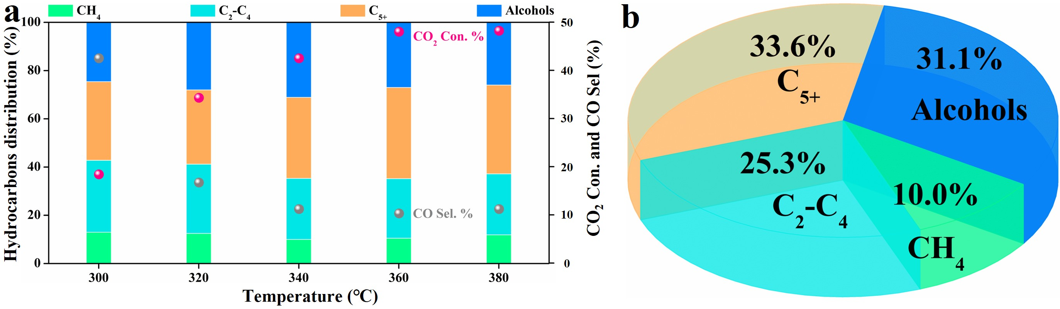
Supplementary Figure 1. a CO₂ hydrogenation performance of 1% Na-Cu_{0.10}FeTiO_{x} under different temperatures. Reaction conditions: 5.0 MPa, CO₂: H₂ =1:2.5, GHSV = 4800 mL gcat⁻¹ h⁻¹. b Product distribution of CO₂ hydrogenation at 340 °C for 1% Na-Cu_{0.10}FeTiO_{x}. Reaction conditions: 5.0 MPa, 340 °C, CO₂: H₂ =1:2.5, GHSV = 4800 mL g_{cat}⁻¹ h⁻¹.
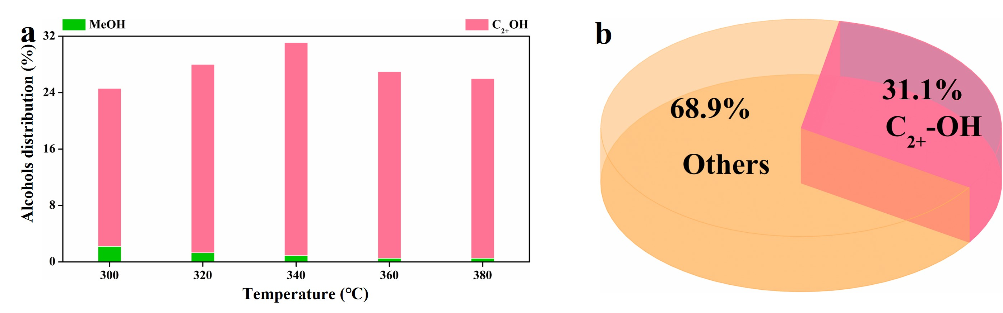
Supplementary Figure 2. a Alcohol distribution of 1% Na-Cu_{0.10}FeTiO_{x} under different temperatures. Reaction conditions: 5.0 MPa, CO₂: H₂ =1:2.5, GHSV = 4800 mL gcat⁻¹ h⁻¹. b Alcohol distribution of 1% Na-Cu_{0.10}FeTiO_{x} at 340 °C. Reaction conditions: 5.0 MPa, 340 °C, CO₂: H₂ =1:2.5, GHSV = 4800 mL g_{cat}⁻¹ h⁻¹.
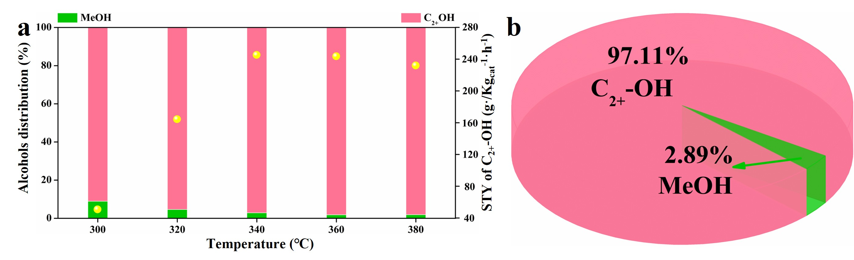
Supplementary Figure 3. a Percentage of higher alcohols in the alcohol and the STY of higher alcohols for different iron-based catalysts. Reaction conditions: 5.0 MPa, CO₂: H₂ =1:2.5, GHSV = 4800 mL gcat⁻¹ h⁻¹. b Alcohol phase distribution of 1% Na-Cu_{0.10}FeTiO_{x} at 340 °C. Reaction conditions: 5.0 MPa, 340 °C, CO₂: H₂ =1:2.5, GHSV = 4800 mL g_{cat}⁻¹ h⁻¹.
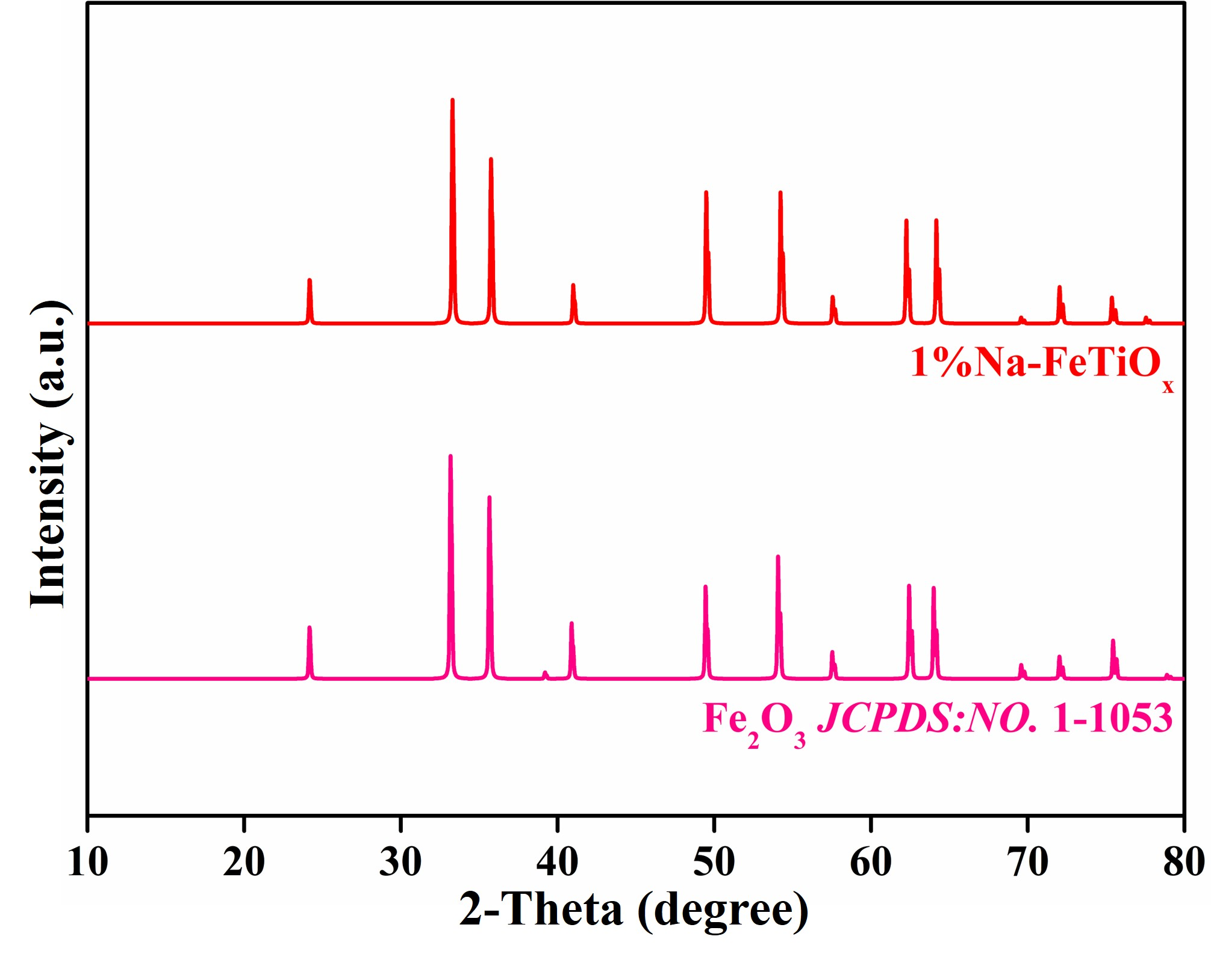
Supplementary Figure 4. XRD patterns of 1%Na-FeTiO_{x}.

Note:
The phase structure of the fresh catalyst 1%Na-FeTiO_{x} was characterized using X-ray diffraction (XRD). As illustrated in Supplementary Figure 4, the phase structure of the 1%Na-FeTiO_{x} catalyst corresponds to hematite (Fe₂O₃, JCPDS No. 1-1053) after high-temperature calcination and alkali metal impregnation. This result indicates that the synthesized 1%Na-FeTiO_{x} does not contain any phase structures corresponding to metallic titanium or titanium oxides.

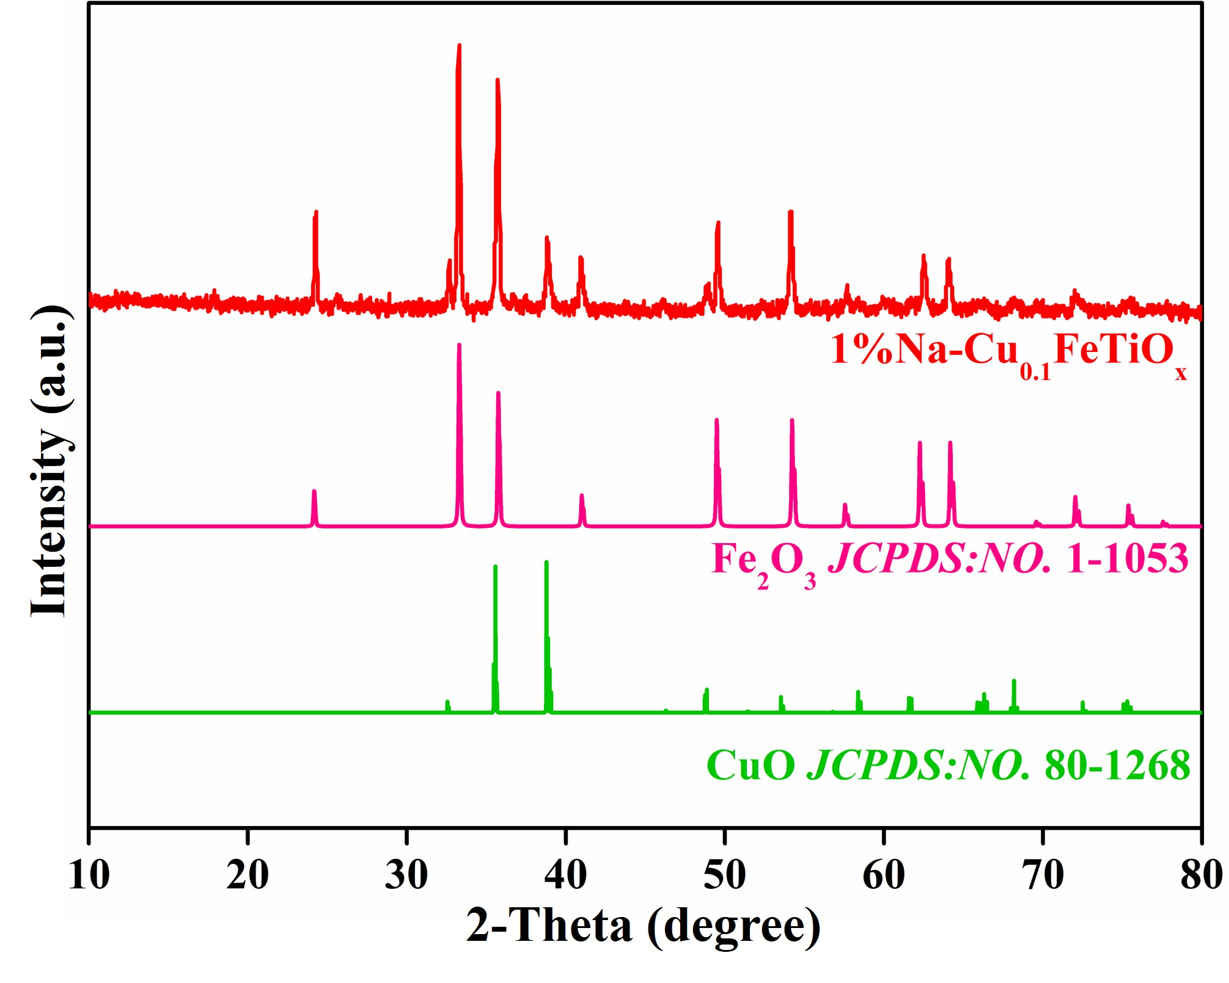
Supplementary Figure 5. XRD patterns of 1%Na-Cu_{0.10}FeTiO_{x}.

Note:
The phase structure of the fresh catalyst 1%Na-Cu_{0.10}FeTiO_{x} was analyzed by XRD. As depicted in Supplementary Figure 5, the incorporation of copper did not alter the hematite phase structure of FeTiO_{x} (Fe₂O₃, JCPDS No. 1-1053). Meanwhile, it successfully facilitated the introduction of the monoclinic phase of CuO (JCPDS No. 1-80-1268), indicating that copper was effectively integrated into the FeTiO_{x} structure.

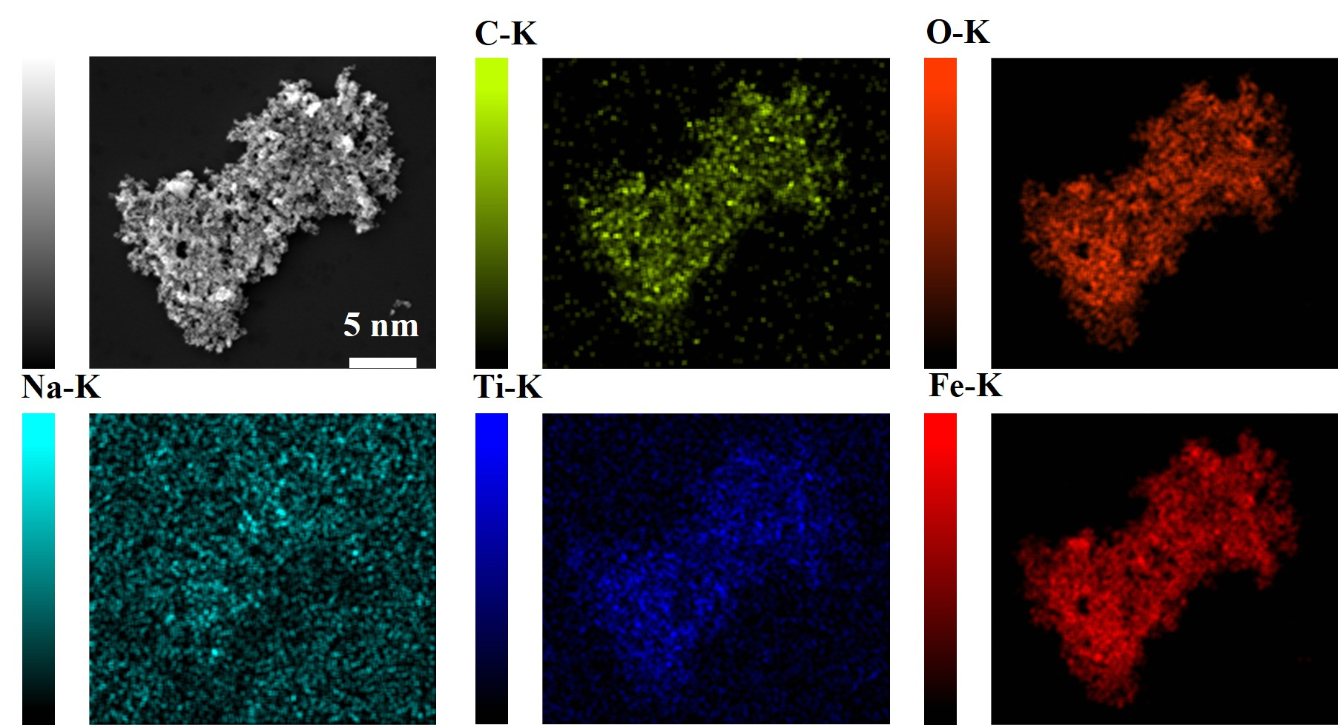
Supplementary Figure 6. SEM and SEM-Mapping of 1%Na-FeTiO_{x}.

Note:
The morphological characteristics and elemental distribution of the catalyst, 1%Na-FeTiO_{x}, are illustrated in Supplementary Figure 6, revealing a highly uniform dispersion of all metal components. Notably, the distribution regions of titanium (Ti) closely align with those of iron (Fe), oxygen (O), and carbon (C), suggesting that titanium is retained within the structure. Furthermore, an amorphous form of Ti metal can be inferred based on the XRD analysis results.

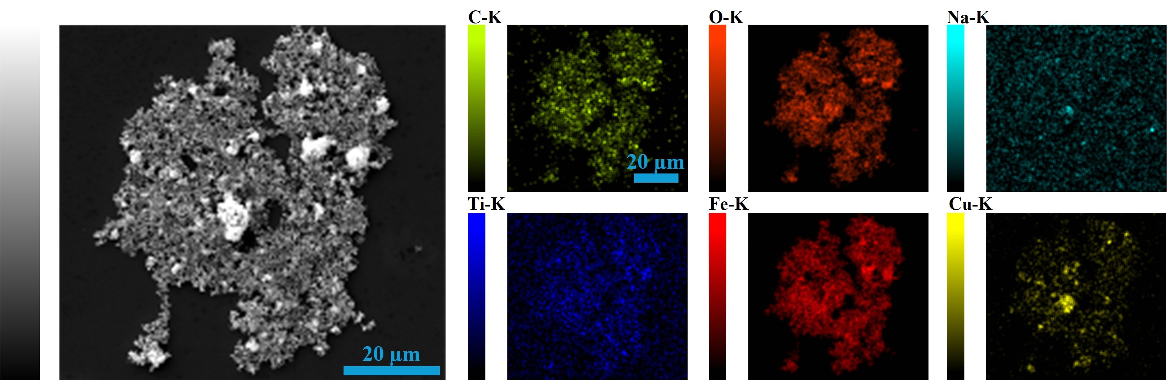
Supplementary Figure 7. SEM and SEM-Mapping of 1%Na-Cu_{0.10}FeTiO_{x}.

Note:
The morphological features and elemental distributions of the 1%Na-Cu_{0.10}FeTiO_{x} catalyst (Supplementary Figure 7) reveal that all metallic components are highly and uniformly dispersed. Notably, the spatial distribution of Ti closely mirrors that of Fe, O and C, indicating the successful incorporation of Ti into the catalyst matrix. Copper signals are also clearly detected and are largely homogeneous across the observed regions, although minor local aggregation is present. Similarly, combined with the XRD results, it can be inferred that Ti metal may exist in an amorphous form.

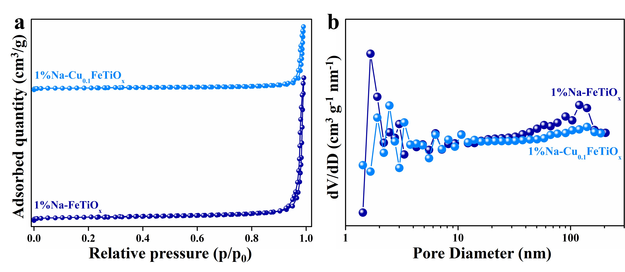
Supplementary Figure 8. a N₂ adsorption-desorption isotherms of 1%Na-FeTiO_{x} and 1%Na-Cu_{0.10}FeTiO_{x}. b Pore size distributions of 1%Na-FeTiO_{x} and 1%Na-Cu_{0.10}FeTiO_{x}.

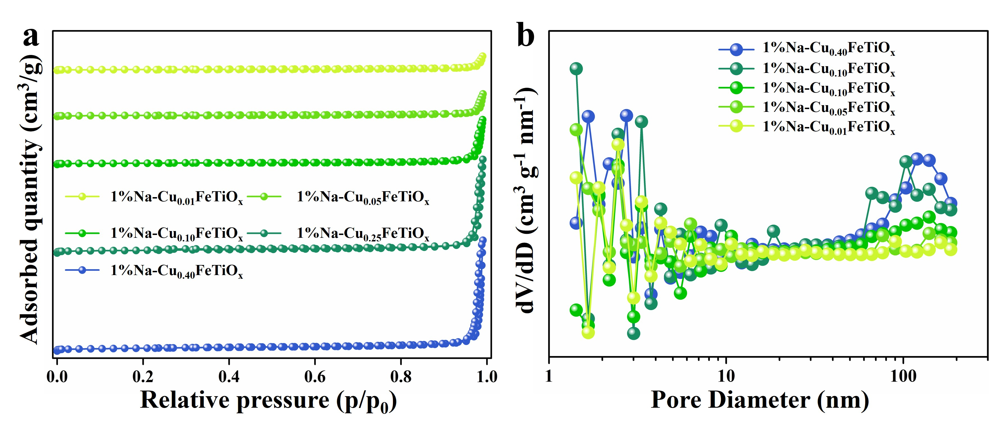
Supplementary Figure 9. a N₂ adsorption-desorption isotherms of 1%Na-FeTiO_{x} with different Cu doping amounts. b Pore size distributions of 1%Na-FeTiO_{x} with different Cu doping amounts.

Note:
The nitrogen adsorption-desorption isotherms, specific surface area, pore size distribution, and pore volume of all catalysts are shown in Figures S8 and Figures S9 and Table S4. The analysis results show that the introduction of even a very small amount of Cu metal can increase the average pore size, void volume, and specific surface area of ​​FeTiO_{x}. However, continuous introduction of Cu metal will further lead to a rapid decrease in the average pore size, void volume, and specific surface area of ​​FeTiO_{x}.

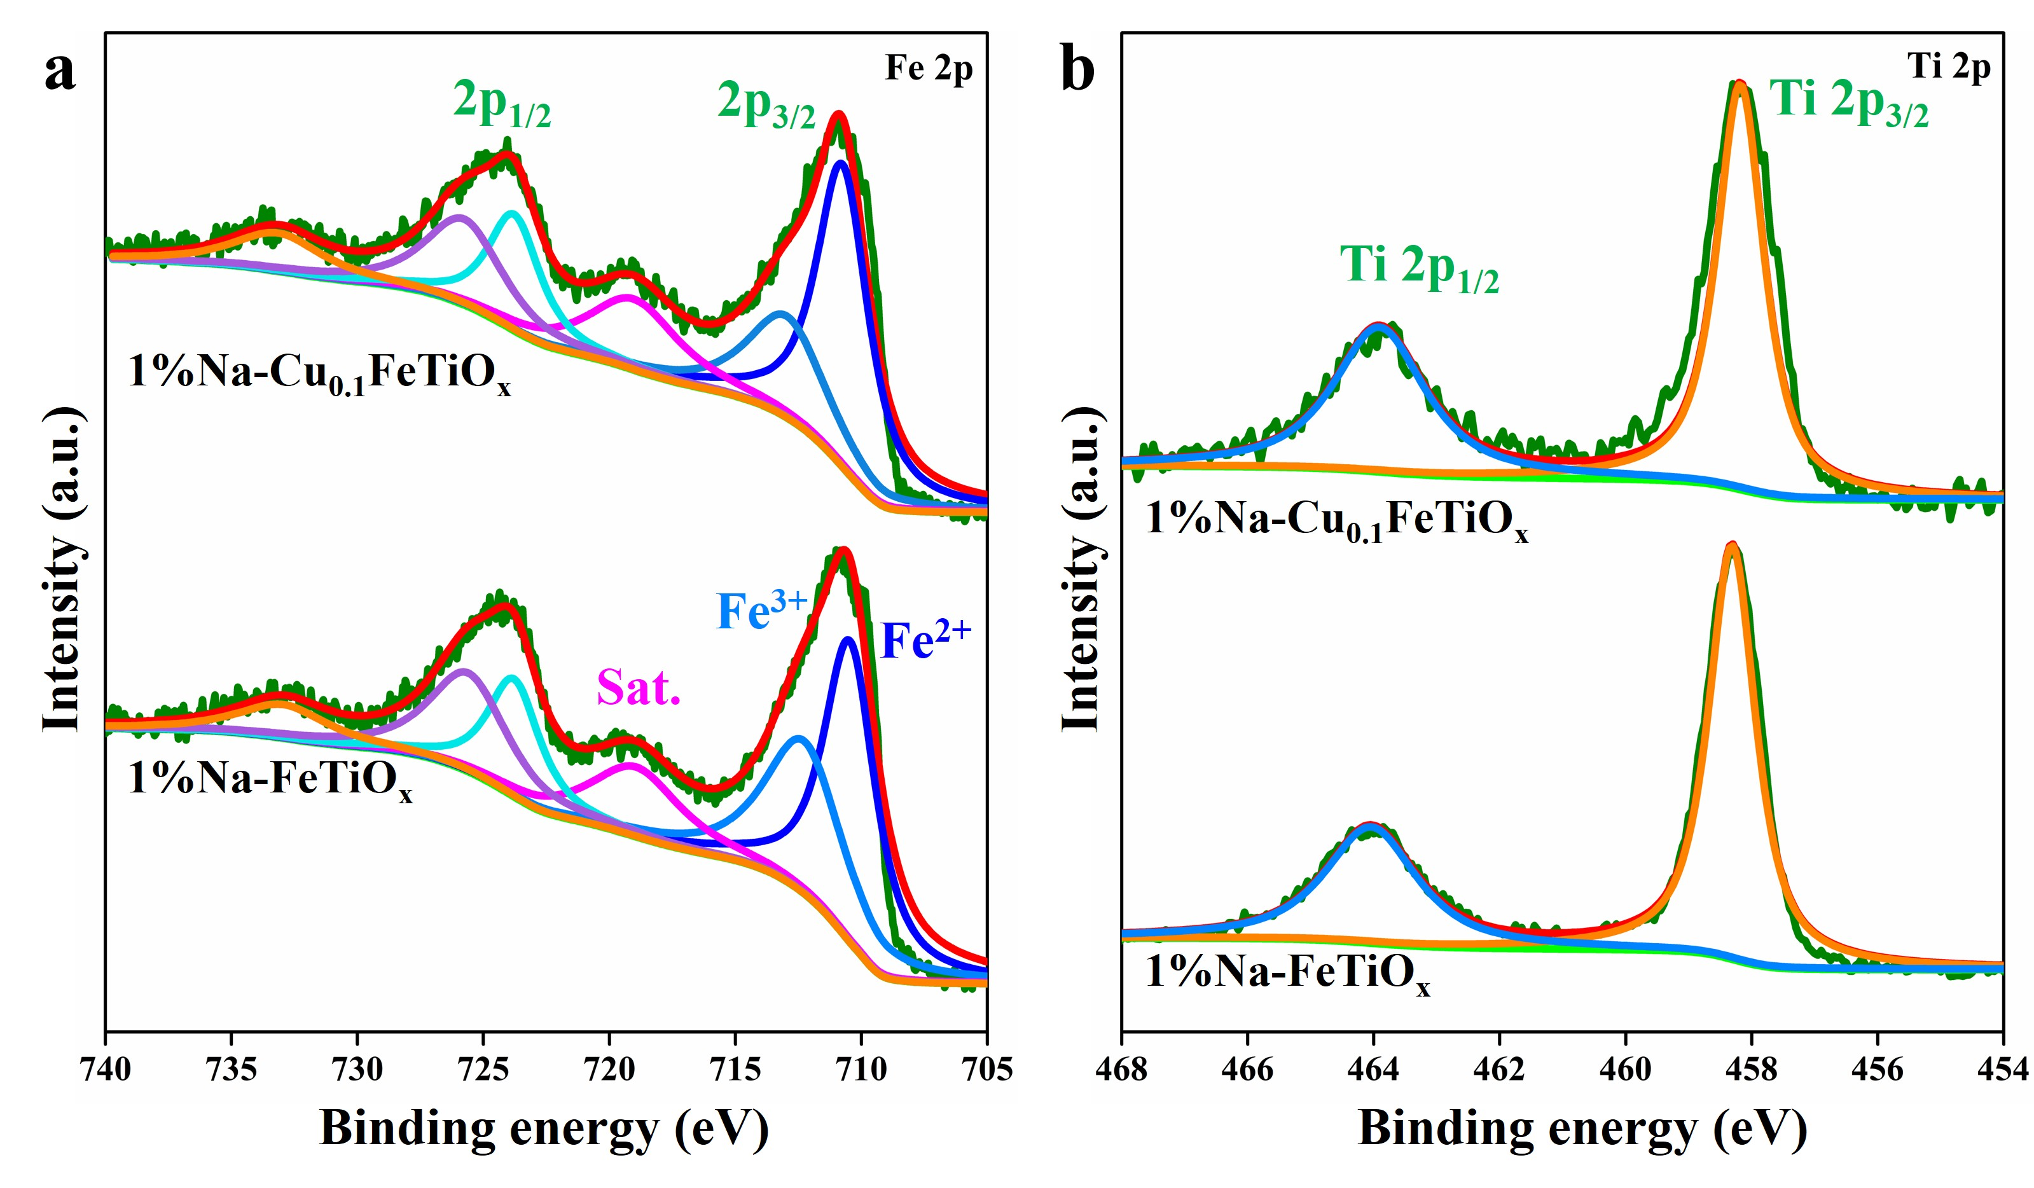
Supplementary Figure 10. a Fe 2p XPS fine spectra of 1%Na-FeTiO_{x} and 1%Na-Cu_{0.10}FeTiO_{x}. b Ti 2p XPS fine spectra of 1%Na-FeTiO_{x} and 1%Na-Cu_{0.10}FeTiO_{x}.

Note:
The high-resolution Fe 2p fine spectra of 1%Na-FeTiO_{x} and 1%Na-Cu0.10FeTiO_{x} were deconvoluted into six characteristic peaks, respectively (Supplementary Figure 10a). The binding energies at 710.59, 712.53 and 719.23 eV are assigned to Fe²⁺, Fe³⁺ and the satellite peak in the Fe 2p_{3/2} region, respectively. Additionally, the binding energies at 723.92, 725.82 and 733.14 eV are assigned to Fe²⁺, Fe³⁺ and the satellite feature in the Fe 2p_{1/2} region, respectively. Supplementary Figure 10b shows the high-resolution Ti 2p XPS fine spectra of 1%Na-FeTiO_{x} and 1%Na-Cu_{0.10}FeTiO_{x}, where the characteristic peaks at 458.31 and 464.06 eV are assigned to Ti 2p_{3/2} and Ti 2p_{1/2}, respectively.

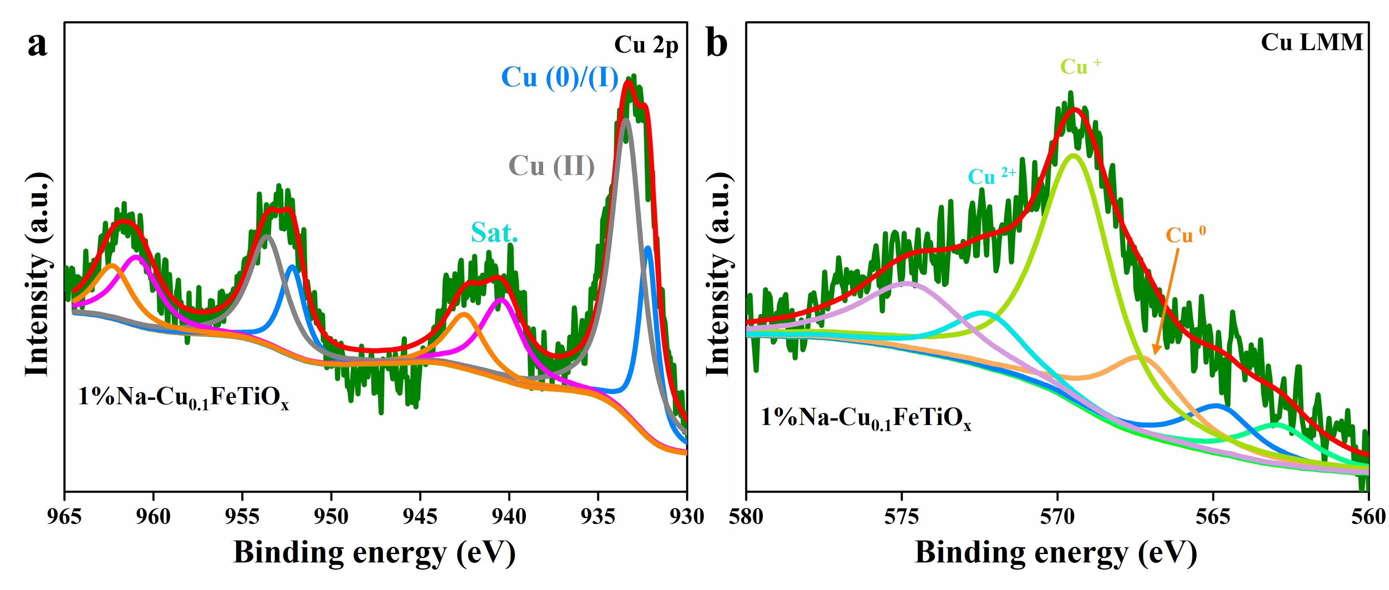
Supplementary Figure 11. a Cu 2p XPS fine spectra of 1%Na-Cu_{0.10}FeTiO_{x}. b Cu LMM XPS fine spectra of 1%Na-Cu_{0.10}FeTiO_{x}.

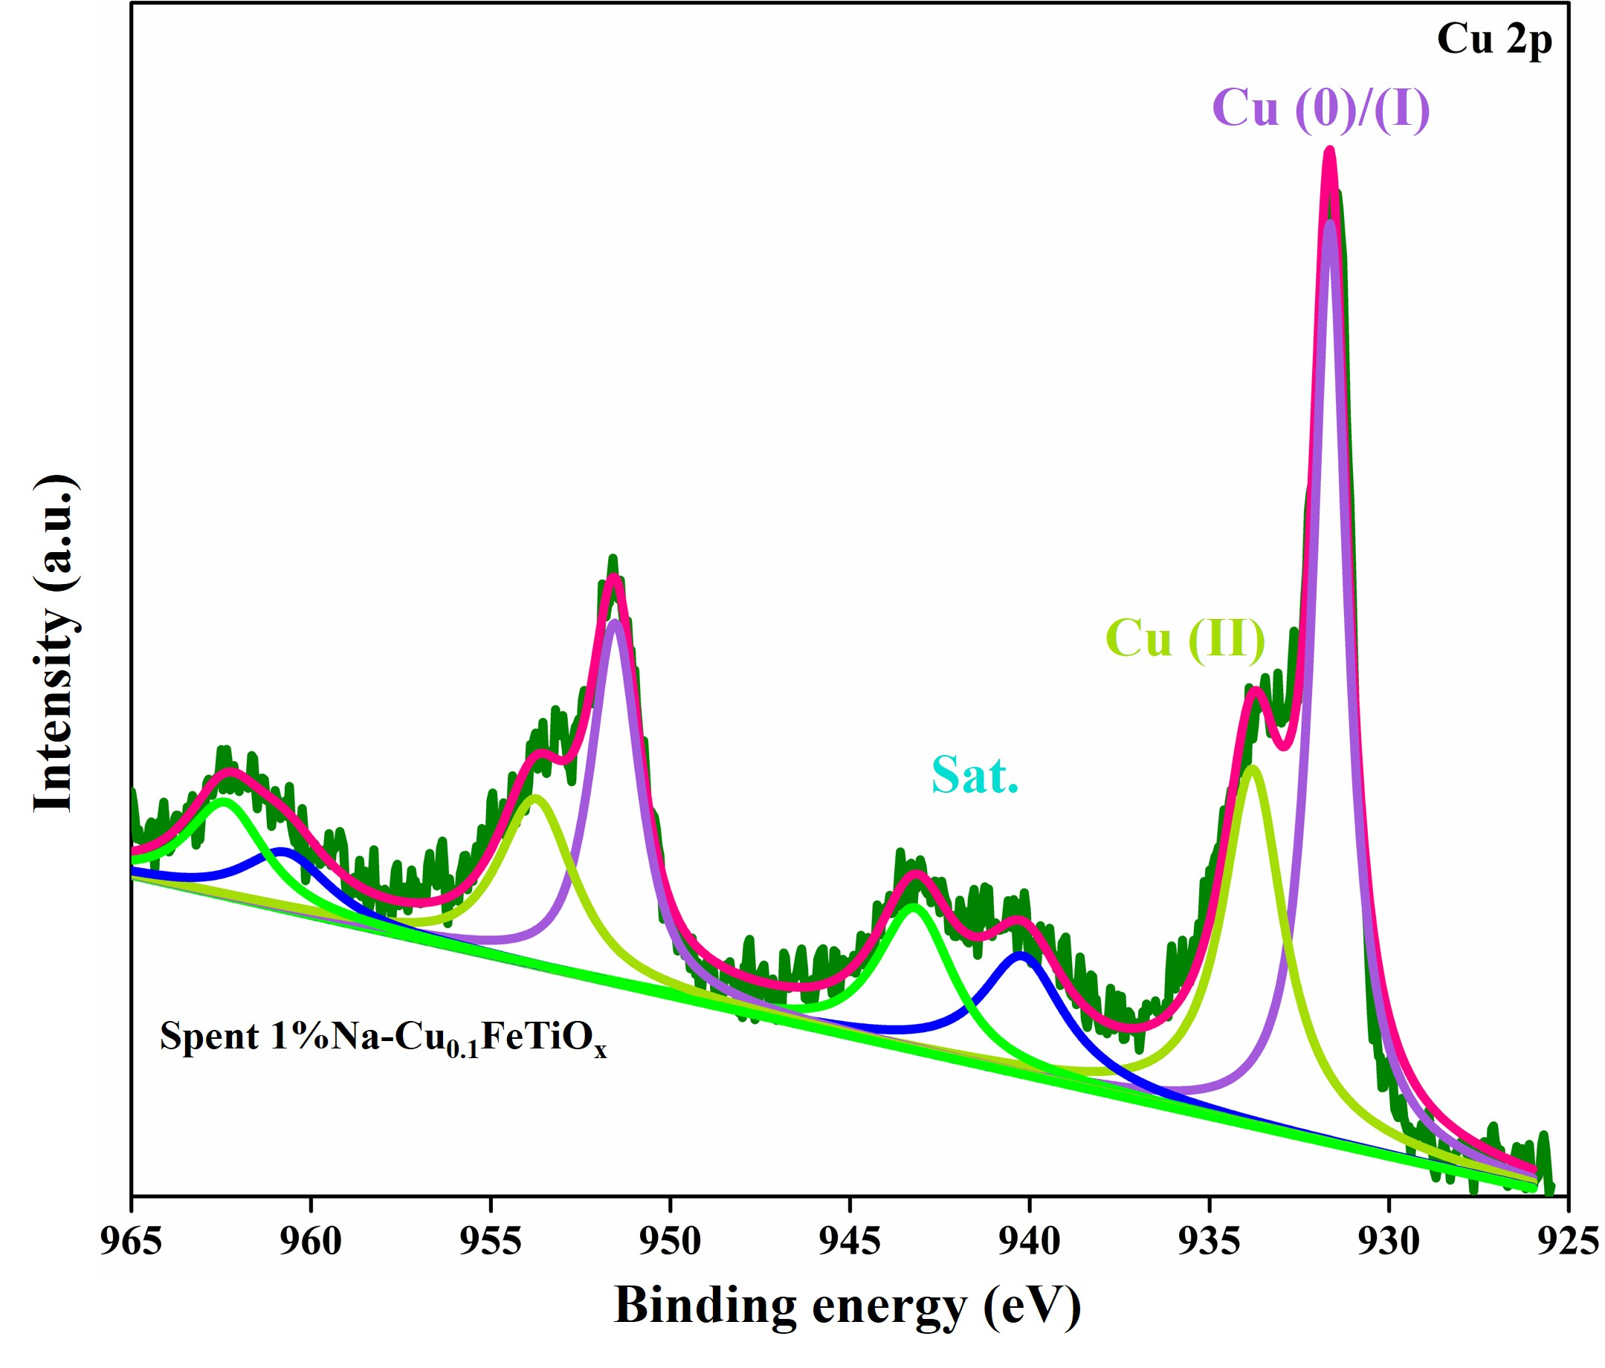
Supplementary Figure 12. Cu 2p XPS fine spectra of spent 1%Na-Cu_{0.10}FeTiO_{x}.

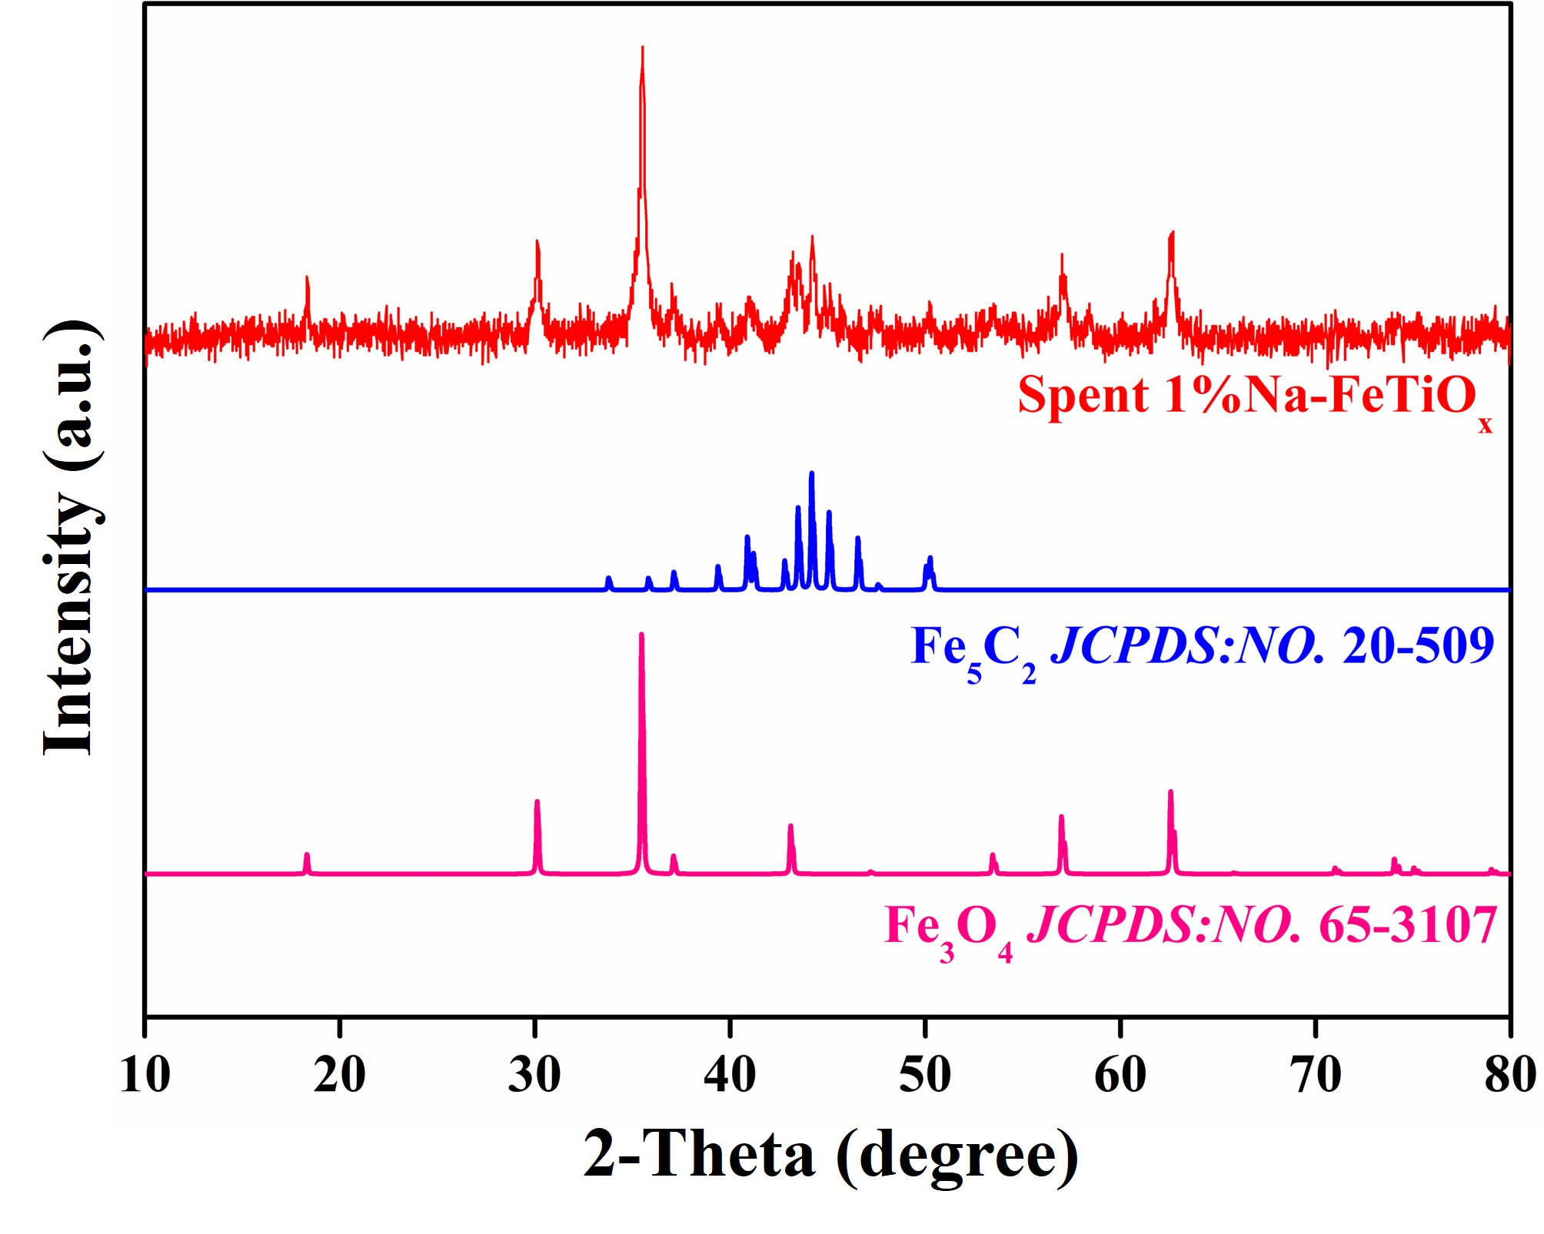
Supplementary Figure 13. XRD patterns of spent 1%Na-FeTiO_{x}.
Supplementary Table 1 Catalytic performances of different iron-based catalysts.
Catalyst | CO₂ Conv. (%) | T (ºC) | P (MPa) | CO Sel. (%) | Selectivity (%)
 |  |  |  |  | CH₄ | C₂-₄⁼ | C₂-₄^{p} | C₅⁺ | O_{xy} (C₂⁺-OH) | STY(C₂⁺-OH) g·kg_{cat}⁻¹·h⁻¹
1%Na-FeTiO_{x} | 41.7 | 320 | 5.0 | 8.8 | 9.3 | 22.0 | 5.9 | 46.4 | 16.4 (16.1) | 79.4
1%Na-Cu_{0.01}FeTiO_{x} | 41.5 | 320 | 5.0 | 9.2 | 9.4 | 21.5 | 6.0 | 44.3 | 18.8 (18.3) | 89.7
1%Na-Cu_{0.05}FeTiO_{x} | 41.0 | 320 | 5.0 | 10.6 | 10.8 | 21.0 | 7.4 | 36.6 | 24.2 (23.3) | 110.8
1%Na-Cu_{0.10}FeTiO_{x} | 39.0 | 320 | 5.0 | 12.8 | 10.9 | 19.6 | 7.7 | 33.8 | 28.0 (26.9) | 118.4
1%Na-Cu_{0.25}FeTiO_{x} | 39.0 | 320 | 5.0 | 12.8 | 11.1 | 23.0 | 6.6 | 33.4 | 25.9 (24.7) | 108.7
1%Na-Cu_{0.40}FeTiO_{x} | 35.6 | 320 | 5.0 | 16.9 | 12.9 | 21.3 | 9.4 | 30.8 | 25.6 (24.4) | 93.5

Reaction conditions: 5.0 MPa, 320 °C, CO₂: H₂ =1:2.5, TOS = 8 h, GHSV = 4800 mL g_{cat}⁻¹ h⁻¹.

Supplementary Table 2 Catalytic performances of 1%Na-Cu_{0.10}FeTiO_{x} under different space velocities.
GHSV (mL g_{cat}⁻¹ h⁻¹) | CO₂ Conv. (%) | T (ºC) | P (MPa) | CO Sel. (%) | Selectivity (%)
 |  |  |  |  | CH₄ | C₂-₄⁼ | C₂-₄^{p} | C₅⁺ | O_{xy} (C₂⁺-OH) | STY(C₂⁺-OH) g·kg_{cat}⁻¹·h⁻¹
4800 | 39.0 | 320 | 5.0 | 12.8 | 10.9 | 19.6 | 7.7 | 33.8 | 28.0 (26.9) | 118.4
6000 | 36.3 | 320 | 5.0 | 14.7 | 11.2 | 21.7 | 7.6 | 31.3 | 28.2 (27.2) | 136.3
8000 | 34.3 | 320 | 5.0 | 16.7 | 12.5 | 20.3 | 8.4 | 30.8 | 28.0 (26.7) | 164.5
12000 | 30.1 | 320 | 5.0 | 21.2 | 13.3 | 22.0 | 10.5 | 31.2 | 23.0 (22.0) | 169.1
24000 | 25.4 | 320 | 5.0 | 25.1 | 14.7 | 23.7 | 11.2 | 29.2 | 21.2 (20.3) | 249.7

Reaction conditions: 5.0 MPa, 320 °C, CO₂: H₂ =1:2.5, TOS = 8 h.

Supplementary Table 3 Catalytic performances of 1%Na-Cu_{0.10}FeTiO_{x} under different temperatures.
Temperature  (℃) | CO₂ Conv. (%) | P (MPa) | CO Sel. (%) | Selectivity (%)
 |  |  |  | CH₄ | C₂-₄⁼ | C₂-₄^{p} | C₅⁺ | O_{xy} (C₂⁺-OH) | STY(C₂⁺-OH) g·kg_{cat}⁻¹·h⁻¹
300 | 18.4 | 5.0 | 42.5 | 13.0 | 22.2 | 7.6 | 32.6 | 24.6 (22.4) | 50.9
320 | 34.3 | 5.0 | 16.7 | 12.5 | 20.3 | 8.4 | 30.8 | 28.0 (26.7) | 164.5
340 | 42.5 | 5.0 | 11.2 | 10.0 | 19.3 | 6.0 | 33.6 | 31.1 (30.2) | 245.4
360 | 48.0 | 5.0 | 10.3 | 10.5 | 19.9 | 4.8 | 37.8 | 27.0 (26.5) | 243.7
380 | 48.2 | 5.0 | 11.2 | 11.9 | 19.8 | 5.5 | 36.8 | 26.0 (25.5) | 232.1

Reaction conditions: 5.0 MPa, CO₂: H₂ =1:2.5, TOS = 8 h, GHSV = 8000 mL g_{cat}⁻¹ h⁻¹.

Supplementary Table 4 The Mean pore size, Pore volume and S_{BET} of different catalysts.
Catalyst | Mean pore size /nm | Pore volume /cm³ g⁻¹ | S_{BET} /m² g⁻¹
1%Na-FeTiO_{x} | 64.64 | 2.49 | 10.84
1%Na-Cu_{0.01}FeTiO_{x} | 62.90 | 2.92 | 12.71
1%Na-Cu_{0.05}FeTiO_{x} | 57.13 | 2.73 | 11.96
1%Na-Cu_{0.10}FeTiO_{x} | 53.90 | 1.22 | 5.30
1%Na-Cu_{0.25}FeTiO_{x} | 34.16 | 1.06 | 4.62
1%Na-Cu_{0.40}FeTiO_{x} | 29.60 | 0.83 | 3.61

